The main goal of the show action is to display all feeds contained in the category. So we have two different views: if there are some feeds in category and if category is empty
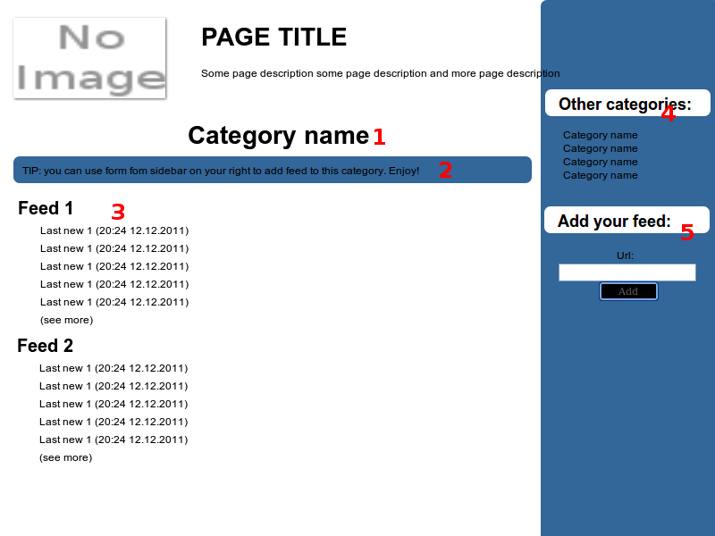
- Category name as a header
- Tip says to use form in sidebar to add new feed in this category. It should be different style than notification less worth looking
- feeds partials ordered by time of last news in feed. We can use pagination here – 10 feeds per page. Each feed partial includes:
  - feed name – linked to feed show action
  - titles of 5 last entries with time of publication – linked to entry show action
  - (see more) – linked to feed show action
- Other categories – list or other categories (excluding current). Each position linked to category show action
- New feed form – label + text field + submit button. After form submit:
  - form is reset
  - tip is removed and notification about new created feed is displayed.
  - Feed is waiting for admin acceptance so we don't have display it now

empty
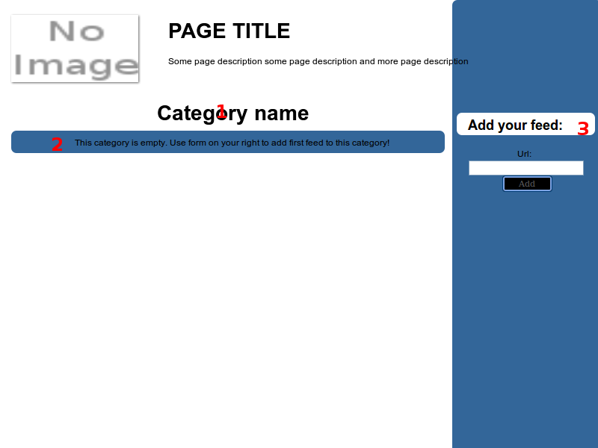
- Category name as header
- Notification says there is nothing to display here and you can add new feed to this category by form in sidebar
- new feed in category form. The same like in normal with when it's submit the notification form point 2 change text to the same like after submit this form in normal view (Thanks for add, feed is waiting for acceptance)

