Categories index is also our main page. We display here all categories with last 5 messages (without pagination) and last 10 message from all categories on sidebar. There is also variant where there is no categories in database – in this case we display simple notification.

Index
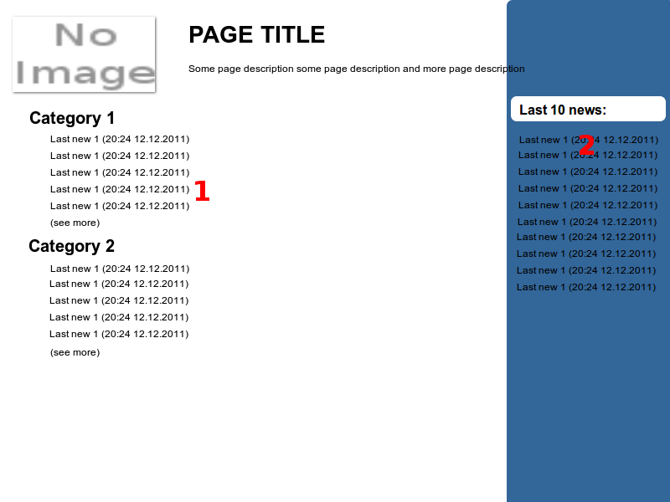
- Partial for each category where we have:
- category name linked to this category show action
- listed 5 last entries in category. Each one is linked to own entry show action (title and publication timedate as link text)
- (see more) linked to this category show action
- Last 10 entries in all categories in sidebar
- header
- last 10 entries from all categories. Linked to each entry show action

- notification – there is no categories in our database, pleasy try again latter (notification text is no important at this point)

