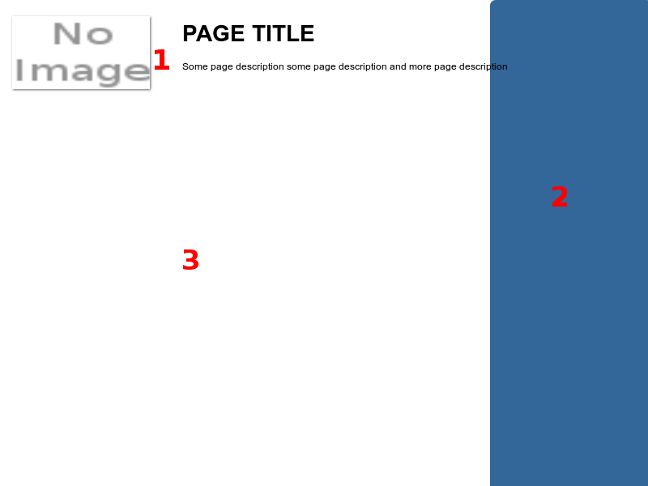
- Page header contains 3 elements
  - page logo
  - page title
  - short page description
- Sidebar – extra content and actions connected with action
- Action content is displayed here

