CO2_ASSIGNMENT

Terraform

1. Create a repository in git using infrastructure as a code
2. Create Ec2(AWS) machine using terraform
3. Create a s3 bucket and host a static webpage using the same.

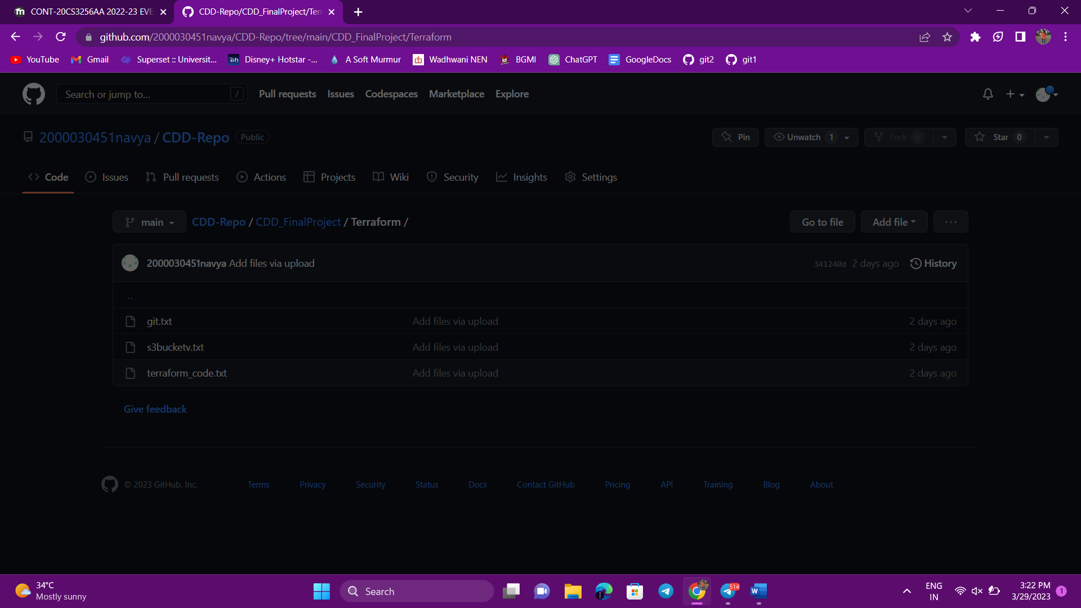

Created git repository through git bash

And added .tf files into it

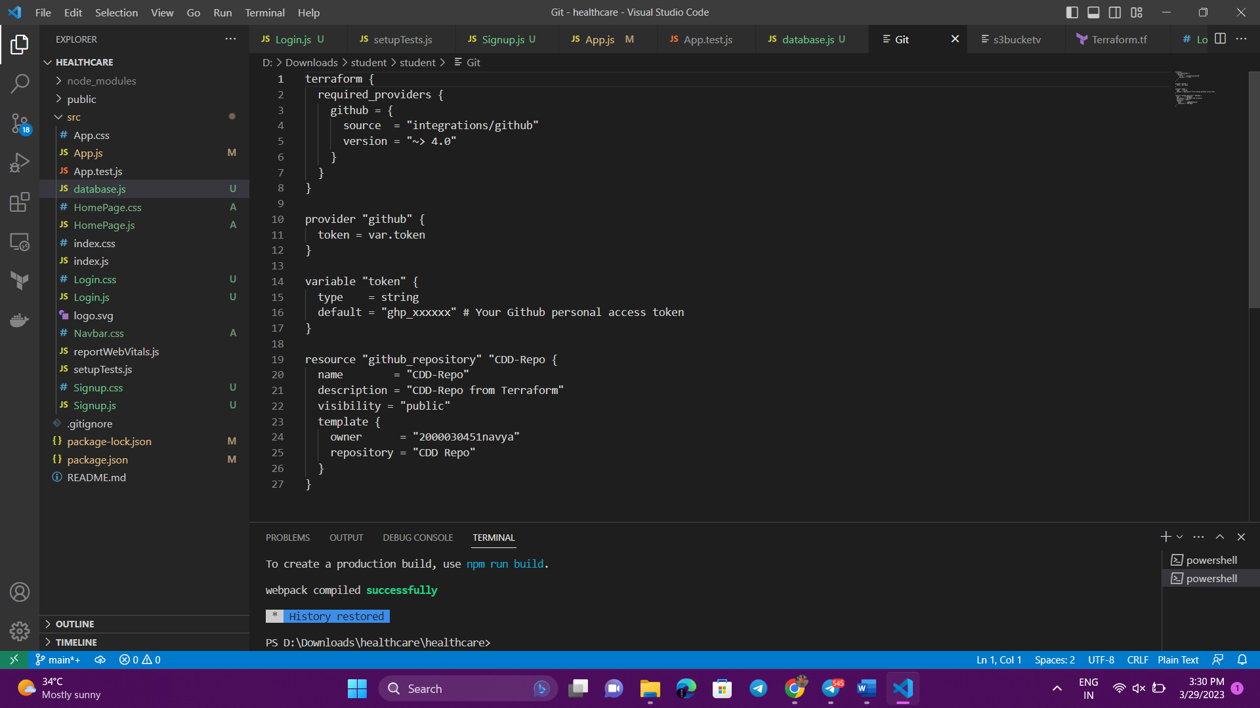

Create s3 bucket



