

**TITLE OF THE PROJECT:**

**“AGRUCULTURE AND AQUACULTURE BUSSINESS SYSTEM (AAS)”**

**PROJECT MEMBERS:**

**2000031504- M. Veera Vamshi**

**2000031450- P.S.P. Vamsi**

**2000031545- P. Prudhvi Raju**

**ABSTRACT:**

The agriculture and aquaculture information system provides its users and researches to get online information about, the crop and water, statistical details and new tendencies. The trends of the crops and aqua farming act so that these will be pretty important to the users who access these via the Internet. The main features of the information system include information retrieval facilities for users from anywhere in the form of obtaining statistical information about fertilizer, research institutes and researches, land availability, diseases, suitable soil concentration for the corresponding crops, statistical information about exports and etc. In addition, this provides individual information about Intercrops related to main crops. The system allows the retrieving facilities but also the updating facilities to the authorized persons in the corresponding institutes. Java was used to create the front end for the system and SQL Server was used for the back end. The graphical user interface of the front-end use Java Applets, ASP Interfaces and access the back-end SQL Server Database using embedded SQL Queries for the retrieval and update. The front end and back-end is connected using a SQL Server They will be able to use the this via Internet. Users will be given logon name and pass word so that they can log-in to the database. Netscape Communicator version 4.0, Explorer 4 or Hot Java can be used to browse the information.

**INTRODUCTION:**

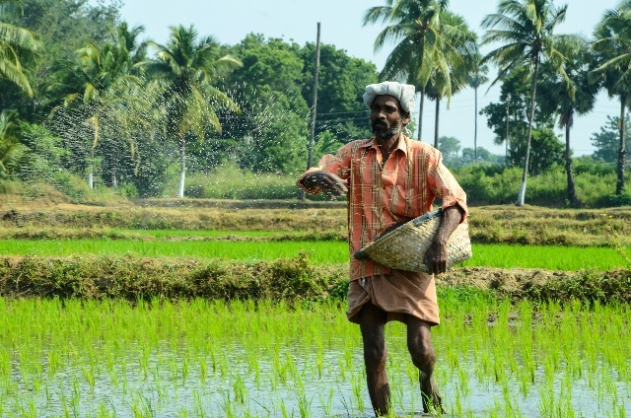 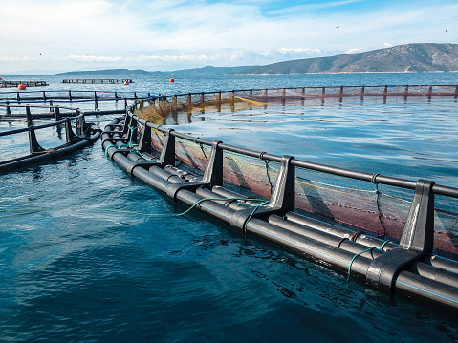

Agriculture is facing a great triple challenge that involves producing more food for a growing population, conserving the environment and ensuring food security. It is estimated that food production will need to double by 2030 to feed the projected global human population.

Increased income is also changing diets towards consumption of more animal products At the same time, opportunities for the expansion of agricultural systems are declining, and one billion people are currently estimated to be undernourished, even when food production is enough to satisfy the existing demand. Therefore, producing more food has proven to be not enough to

solve the problem of hunger.

Traditional farming systems have proven to be capable of producing food in a environmentally sound manner and especially in supplying food to most vulnerable groups such as the rural poor Aquaculture is being recognized as an important way of increasing food production Aquaculture is the farming of aquatic organisms such as animals and plants Fish proteins accounts for 15.3% of total world animal protein, being especially important in the poorest countries, where its contribution to total animal protein consumption reaches 18.5% Fish plays an important role in food security by providing many nutrients, including high-quality protein, omega-polyunsaturated

fatty acids, and micronutrients During the last several decades, global demand for ﬁsh has increased as a consequence of population growth and increases in income, and ﬁsh has played an important role in the rapid growth of the consumption of animal products in developing countries

**Literature survey:**



Indian farm sector is highly recognized for its diversified trend of climate, cultivation pattern and numerous policy recommendations. It cannot be said confidently that we have achieved an absolute self-sufficiency in terms of food grain production due to the existence of poverty, malnutrition and hunger. The policy reform alone is not enough to raise agricultural growth. The policy reforms must be accompanied by appropriate and efficient investments in public goods such as rural infrastructure, irrigation, agricultural research and extension of education and health of rural people. However, **our future of farm sector depends on the budgetary policy framework of the government and right kind of public investments, Robert E. Evenson et al. (1999).** Today India agriculture research is considered as one of the largest research works in the world. It has now achieved the progressive scale of agricultural and aquaculture growth due to adoption of modern technology and innovation. In many developed countries there is found declining trend of R & D for which there is found substantial down fall of overall productivity. **The restoration of the growth in spending on agricultural R&D may be necessary to prevent a longer-term food price crisis, Julian M. Alston et al (2009).** In developed countries, there have been a wide range of technological advances for agriculture, genetic improvement, usage of chemical fertilizers and pesticides, adoption of farm equipment and machinery, cultural and management practices. Research in both public and private sectors has been the principal source for new technologies and management. **In fact, Private sector agricultural R&D expenditures have been growing much faster than public agricultural research expenditures, Wallace E. Huffman (2010)**. Recently, attempts have been made to combine both eco innovation and pro-environmental activities for the effective outcome of product, process and practice in the farm sector. With the adoption of Eco- innovation approach, we can have lower consumption of natural resources, lower volume of carbon emission and high encouragement for eco-friendly business practices. Some innovative agricultural core business can actually raise the farm productivity and its contribution towards GDP. The impact of environment and climatic change could be observed thoroughly which plays the most important role for production and any other economic activity. **Along with the objectives of storage, marketing facilities, recycling process, employment facilities, and customers-based strategy on the entire idea of go green seems to be positive in the farm and rural environment Lynn Martin et al (2013).** The economic survey report has mentioned following drawbacks of the Indian agriculture and aquaculture sector.

**MAJOR DRAWBACKS of FARM AND AQUA SECTOR IN INDIA:**

1. The growth rates of productivity in agriculture and aquaculture sector are far below than the global standards.
2. The productivity levels of rice, wheat have declined after the green revolution of the 1980s.
3. Due to declining fertilizer-use efficiency there is found gradual decline in the soil and water fertility. Also, the food subsidy has increased substantially in the past few years.
4. According to the survey, GDP declined to 15.2% during the Eleventh Plan and then further decreased to 13.9% in 2021-22.
5. Indian agriculture and aquaculture is still dependent on rainfall. About 60 per cent of the total food grains and oilseeds produced being grown in the kharif season, and with just about 35 per cent of the total area being irrigated.
6. Currently, India is in an anomalous situation of being essentially self-sufficient with large stocks of food grains on the one hand and recording high food inflation. Artificial scarcity has become the major cause for the high inflation rate.
7. In both domestic and international marketing, the excess of government interventions that were used to build a marketing set up have actually served as barriers to trade.

**PICTURES OF SURVEY:**

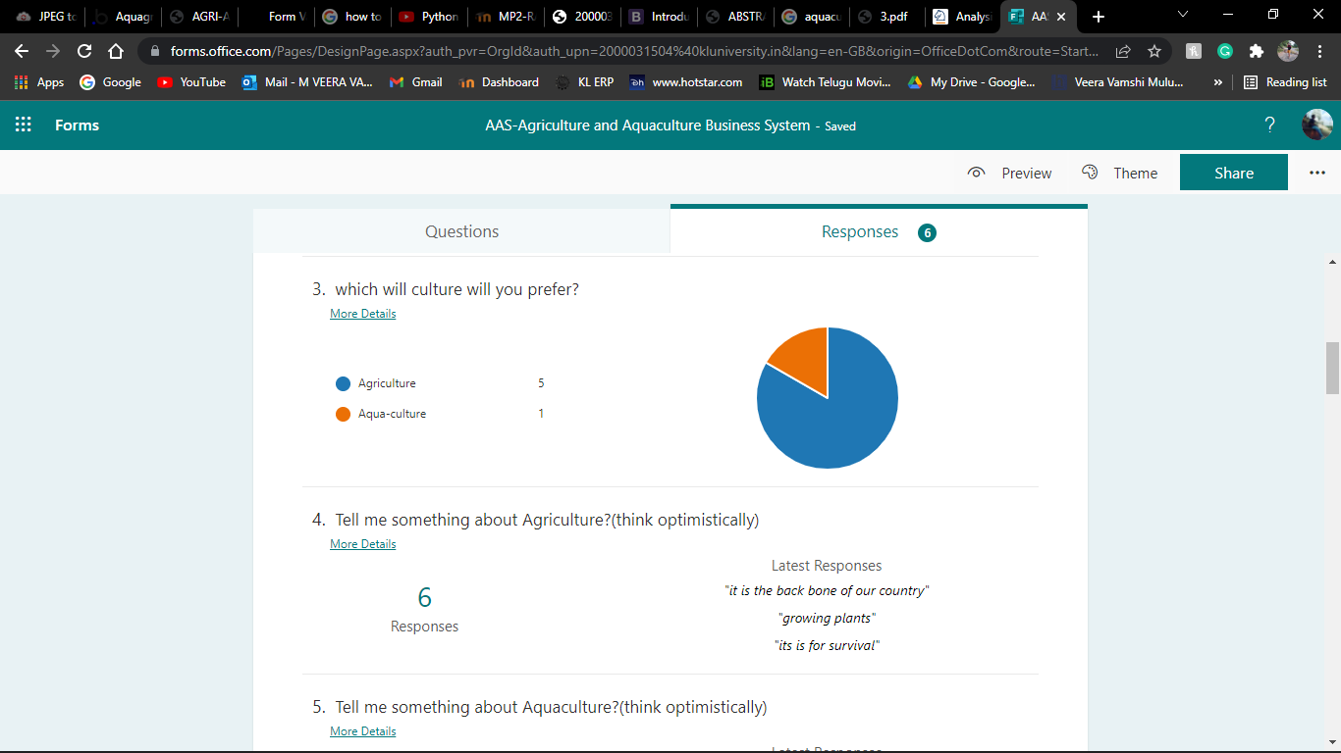

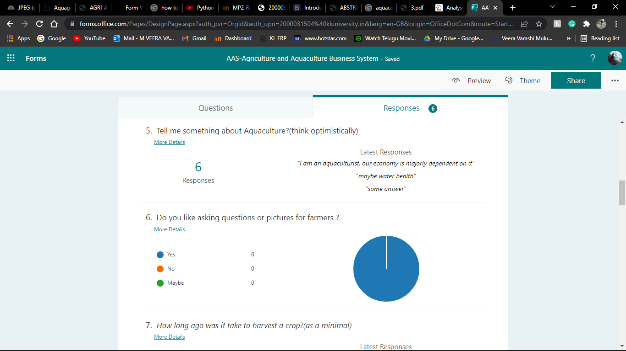

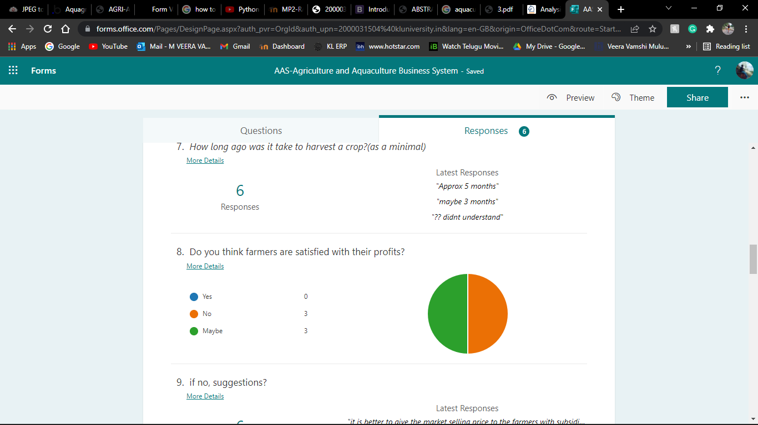

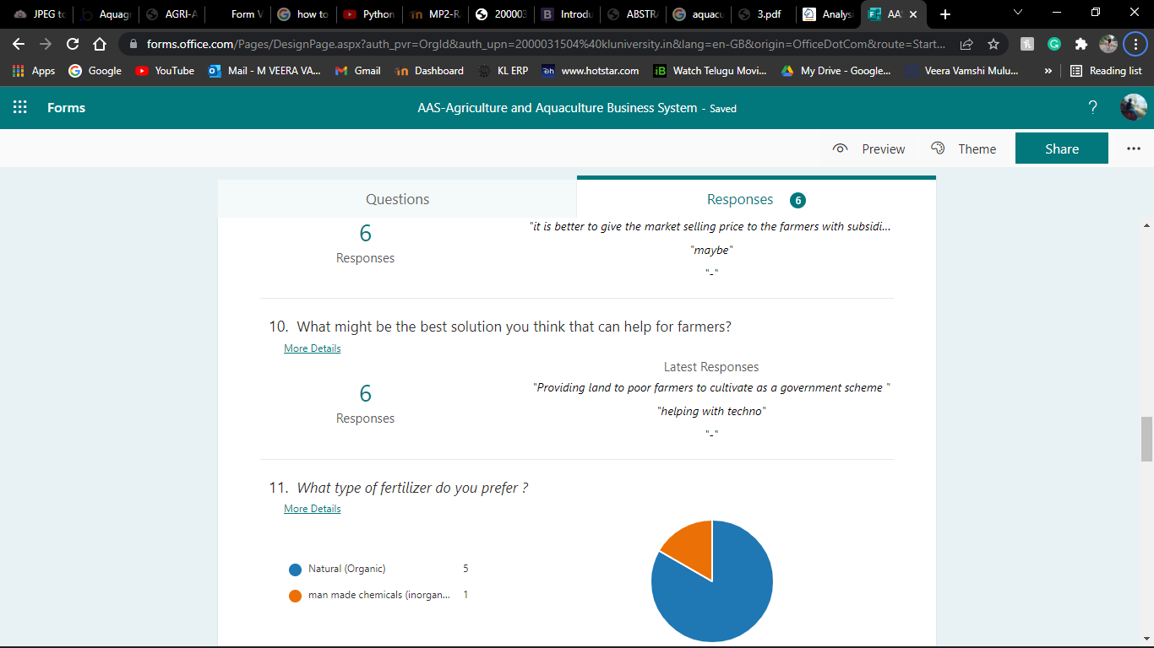

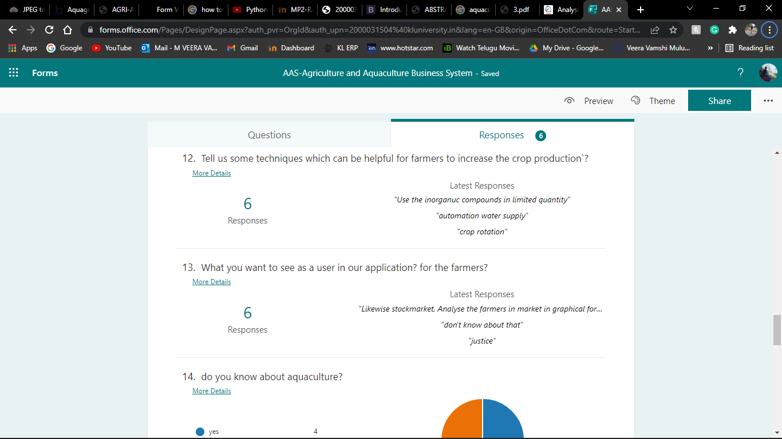

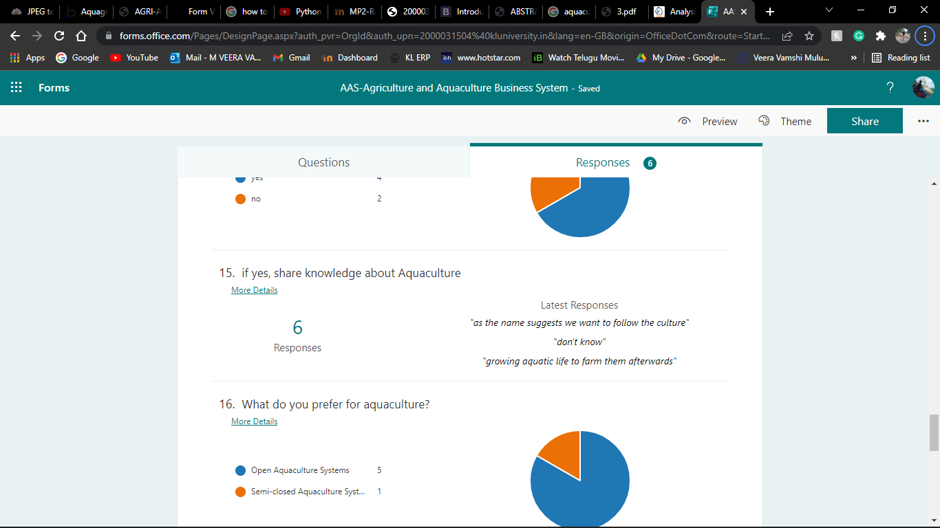

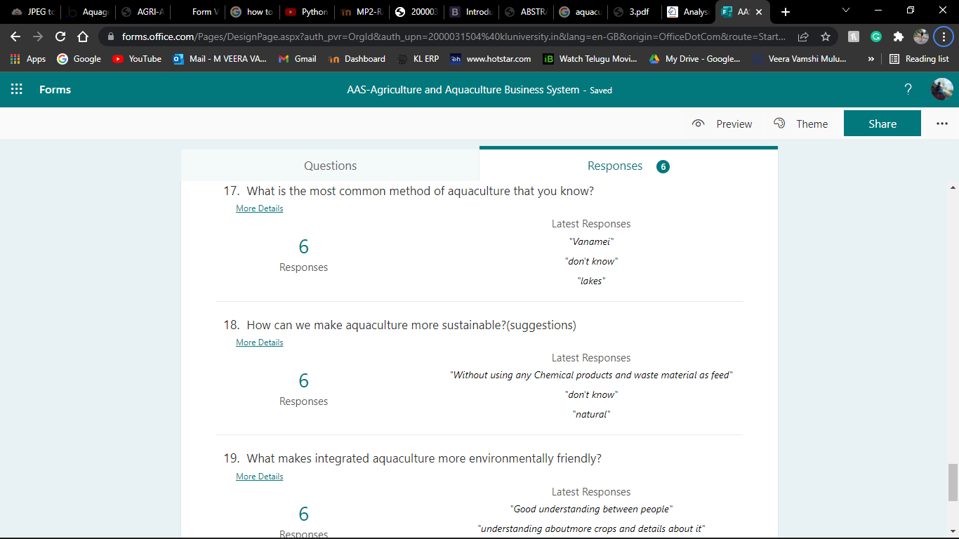

**Model Used and its description:**

**Software**

1. Web authoring tool as front-end FLASK, DJANGO
2. Web browsing Tools Ex. Internet explorer, Netscape
3. Database SQL server, Oracle or my SQL for Back-end
4. User Interfaces Python 3.9.1
5. Windows Plat forms or Linux Plat form
6. Web server Apache or IIS

**Hardware:**

**1**. I-9 or higher processor

**2**. Internet connection least or dial up connection

**Live ware:**

**1.** System administrator / Data Administrator

**2**. Programmer who has knowledge in on line databases

**STRUCTURE OF THE PROJECT:**

The internet is a worldwide collection of thousands of interconnected computer networks, which is used by many millions of people daily. And also, it is a

* Networks of Networks
* User-friendly Interface
* Set of Universal Standers
* Specialized Culture

This Information System is Composed of a collection of components as given below which related to internet architecture.

Concepts using Computer Networks:

* Application layer

* Transport layer

* Network layer

* Physical layer

**DTI Layered approach:**

* Empathizing – we went to through an online review and 2 persons from offline called ‘Ramamurthy and his wife’ and the most of them are saying that ‘profits and maintaining the crops with perfect harvest’
* Defining – There are increasing pressures from **climate change, soil erosion, and biodiversity loss and from consumers' changing tastes in food and concerns about how it is produced**. And the natural world that farming works with – plants, pests, and diseases – continues to pose its own challenges.
* Ideation,- so, we got an idea that we will ask some questions to the farmers, regarding the crops which they would like to grow and we ask each and every minute detail of that farmer interested to grow the crop, that questions also in the form of pictorial representation such that farmers can easily understand the what to do, so we will give the complete picture of the crop when, where, and how including fertilizers. this can be very helpful for the farmer in addition farmer gains extra knowledge on other new techniques of irrigation and aqua cultivations.
* Prototype and
* Testing – it’s done up to now

**MODULES INVOVLED:**

* Modules are basically the number of files we used for creating our application there basically 6 at present:
* Flask module
* Pandas
* NumPy
* WTF
* Pymongo
* Jinja 2
* Sqlalchemy, these are basic modules required for building project

**Modules in the Project:**

* **Aquaculture**
  + Questions
  + Analysis (Finalizing the user answers)
  + Suggestions (according to the answers)
  + Pros and cons
  + Pricing
  + Checkout if items are purchased else
  + Thankyou
* **Agriculture**
  + Questions
  + Analysis (Finalizing the user answers)
  + Suggestions (according to the answers)
  + Pros and cons
  + pricing
  + Checkout if items are purchased else
  + Thankyou

**Design of front-end using templates and boot-strap codes:**

* **Templates: (at present)**
* Home
* About-us
* Contact-us
* Agriculture
* Aquaculture
* Login-form
* Navigation

**PROJECT STATUS:**

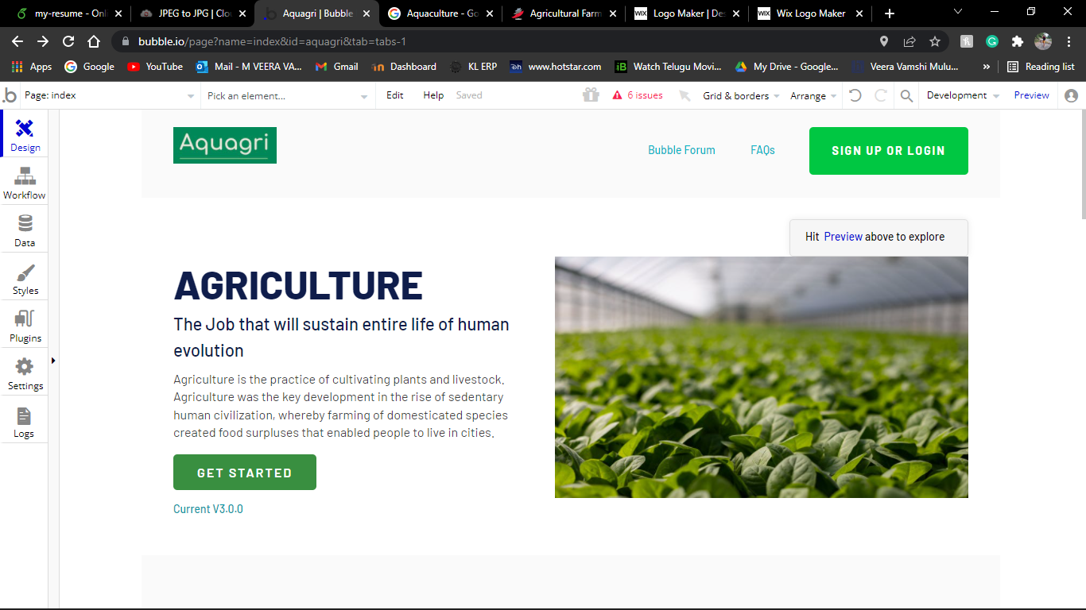

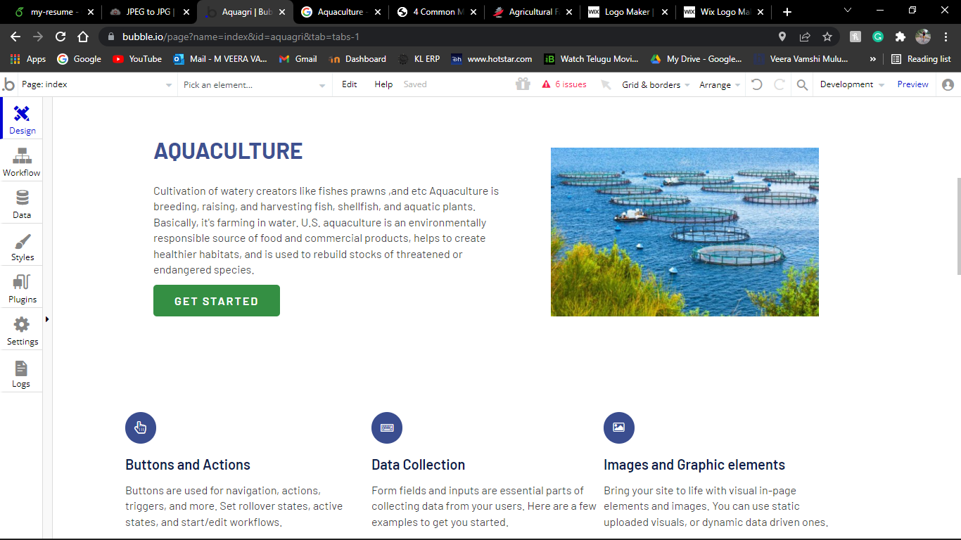



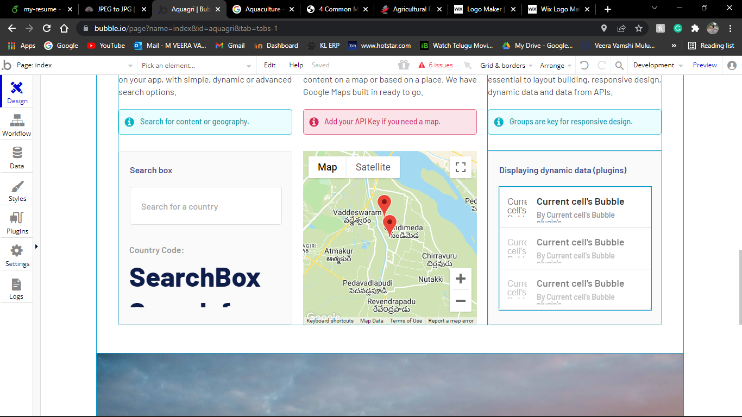

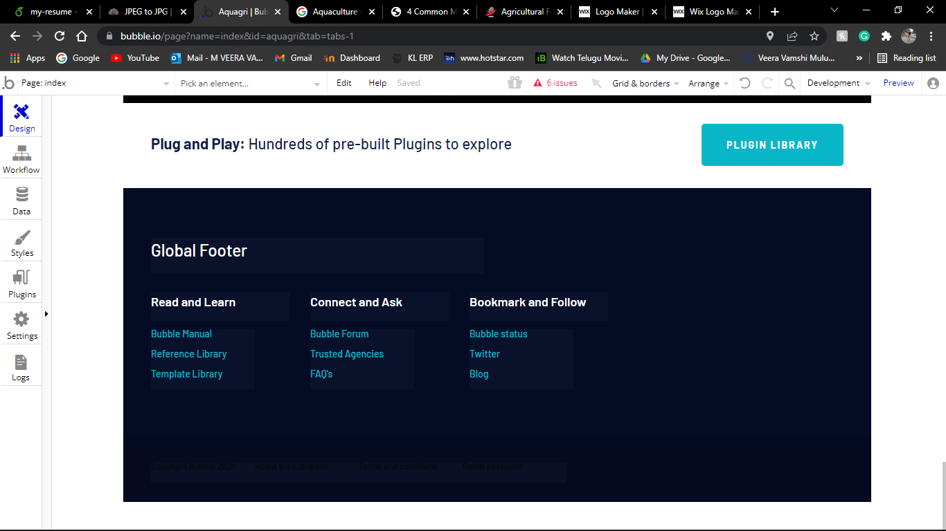

**Result Analysis:**

our project called ‘Aquagri’, will gives huge knowledge about agriculture and aquaculture irrigation techniques as well as it gives complete picture of “from the scratch to the harvesting”

where farmer can know everything where to start? when to start?

**Conclusion:**

We have gone through the current structural, institutional and technological reforms for the overall growth of the economy. It is necessary on the part of the government to give due priorities to key segments like marketing, price mechanism, technology, R &D and trade. Similarly, it has been observed with the support of the government and private interference the goal of sustainable agricultural and aquacultural growth can be attained. At the same time priorities must be given to enhance the overall standard of living of the rural poor so that it would go a long way for eliminating socio-economic constraints like poverty, hunger and malnutrition. This would be an appropriate way for giving the true justice to our father of nation, Mr M K Gandhi’s intent for the villages, “the true India is not to be found in its few cities but in its seven hundred thousand villages, if the villages perish, India will perish too”.

**References:**

* Balakrishnan, P. (2000), “Agriculture and Economic Reforms: Growth and Welfare”, Economic and Political Weekly, March
* **Online Agriculture:** [**https://en.wikipedia.org/wiki/Agriculture**](https://en.wikipedia.org/wiki/Agriculture)
  + **Aquaculture:** [**https://en.wikipedia.org/wiki/Aquaculture#:~:text=Aquaculture%20(less%20commonly%20spelled%20aquiculture,aquatic%20plants%20(e.g.%20lotus**](https://en.wikipedia.org/wiki/Aquaculture#:~:text=Aquaculture%20(less%20commonly%20spelled%20aquiculture,aquatic%20plants%20(e.g.%20lotus)**)**
  + **For graphical view:** [**https://apsac.ap.gov.in/dashboard-staging/ap-aquaculture-information-system/**](https://apsac.ap.gov.in/dashboard-staging/ap-aquaculture-information-system/)