Overall, the constraints are divided into two parts: point-to-point constraints and eye-to-point constraints. To illustrate the constraints design, diagram of the ghost will be included. The actual distances between the points are calculated at runtime and it does not really relate to the design, so the actual distance will not be included.

# Point-to-Point Constraints

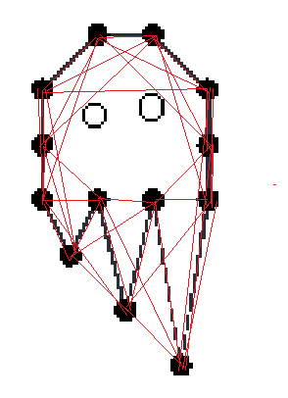

The above image shows the point-to-point constraints. The red line connecting two points means that there is a constraint of distance between the two point. Since the image is not easy to read, the constraint design will be explained:

1. First the points are labelled from 0 to 12
2. For each point $i∈range(0,12)$, connect $i$ with $\left(i+1\right) \% 13$, $\left(i+2\right) \% 13, \left(i+3\right) \% 13$
3. Calculate the distances between pairs to formulate the distance constraint

(The Document continues in next page !!!!!!)

# Eye-to-Point Constraints

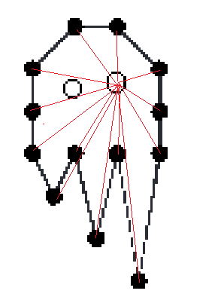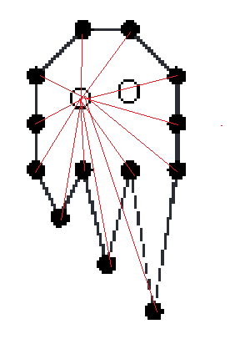

Similar to the constraints above, the eye-to-point constraint is created by maintaining the distance from right and left eyes to each point of the ghost.

# Further Comment

Notice that there are no angular constraints for the ghost. This is mainly for 2 reasons: 1. The complexity of point-to-point constraints implicitly governed the angular constraints in some degree. 2. Without the angular constraints, the ghost tends to look floppier when interacting with the cannon ball :), At least from my point of view.