## Explanation of the slider:

1. P.S.R: player spawn rate (default 5 per 5 seconds, max 10 per five seconds)
2. N.A: number of advertisers (default 5, max 10)
3. S: advertiser observing distance (default 5, max 30)
4. R: sale success distance (default 5, max 30)
5. K: rate to try to put a flyer (default 0.2, max 1)
6. P: probability of successful put a flyer at each try (default 0.5, max 1)

## Colored object representations:

1. Normal Shopper: 
2. Shoppers going to seat and eat: 
3. Flyered Shopper: 
4. Advertiser without any sales delivered: 
5. Advertiser with 1 sale delivered: 
6. Advertiser with 2 sales delivered:  (once get 3 sales delivered, the advertiser is despawned immediately)
7. Advertiser tryin
8. g to pursuit and deliver a sale 
9. Shop: 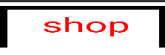
10. Table: 
11. Seat: 
12. Planter

## Steering behavior for Shoppers

The diagram above shows a brief representation of the shopper’s state machine. At each state, the shopper has different (combination of) steering forces (the **seeking** force already takes **arrival** into consideration):

1. Go to Exit: **Flowing field following (right)** and **obstacle avoidance**
2. Go to Shop and Go to seat: **Seeking** and **obstacle avoidance**
3. In shop: no steering force
4. Seat and Leave Seat: **Seeking**
5. Flyered: no steering force

## Steering behavior for advertiser

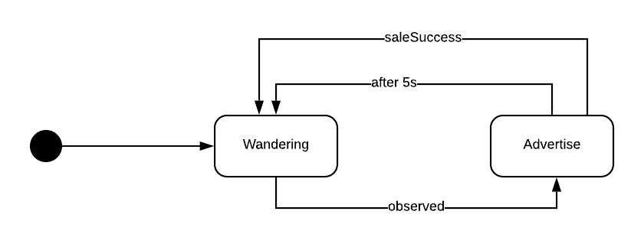

The diagram above shows a brief representation of the advertiser’s state machine. At each state, the shopper has different (combination of) steering forces (the **seeking** force already takes **arrival** into consideration):

1. Wandering: **wandering**, **seeking (**target randomly change in one area with time**), obstacle avoidance** and **flee** (from other advertisers)
2. Advertise: **pursuit (**target one of the shoppers**)** and **obstacle avoidance.**

## Steering Approach

I use the three stage behavior approach for integrate steering behavior and the high level behaviors following this diagram: 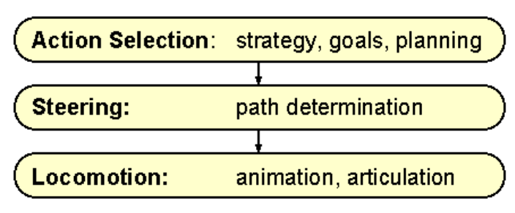

1. Action selection: for changing the state, pick the target and drop the flyer, etc.
2. Steering: for calculate steering forces
3. Locomotion: to actually apply steering forces to the agent and update the position of the agent.