**Important Instructions to be followed by Pre-Incubators:**

|  |  |  |
| --- | --- | --- |
| Sr. no | Parameters | Important Points |
| 1. | Basic Formalities | Documents which should constitute the following   * Resume of the students and Professor In-charge * details of the idea/project supported, * duration of the project, * fund disbursement details * milestones |
| 2. | Project Outcome | * Weekly tracking the progress will be done by the expert team of BoB. * The outcome of the project will be analyzed based on the following parameters.   + Should have the working prototype within timeline. |
| 3. | Guidelines to usage of Funds | Guidelines for Use of funds by the Pre-Incubator   1. Raw material/ Consumables/Spares original bill to be submitted to BoBIC.   **It will not be used:**   1. To pay the grantee/relatives. 2. To repay loans/commitments made earlier. 3. To pay rent of own accommodation, creation of infrastructure facility like shed etc. should not form the component of support/funds.  * **The support/funds should be mainly for prototype development work/proof of concept.** * **BoBIC will have no responsibility in case of any loss is caused to any life or property due to accident, fire or any other reasons. The Host is required to take appropriate safety and insurance measures to safeguard against any loss to human life and property.** * **In case of project failure due to technical failure BoB operational monitoring committee has the power to close the file.** |
| 3. | **project completion** | **Project completion report has to be submitted to Bank of Baroda Innovation Centre along with complete documentation of the Project.** |

Date: 9.6.22

Project: Start-up-Portal

Name and Signature of Pre-Incubators: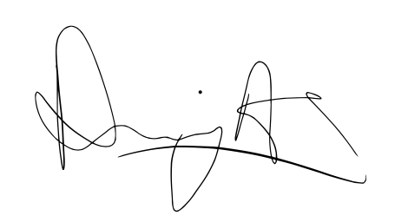

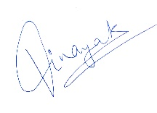

(Anuj Agrawal) (Narsimha Reddy) (Vinayak Mittal) (Roma Pandya)

Professor In-Charge:

(Prof. Ganesh Ramakrishnan)