React Behind The Scene

* How does react work:
  + A react is js library for building user interface.
  + ReactDOM is interface to web.

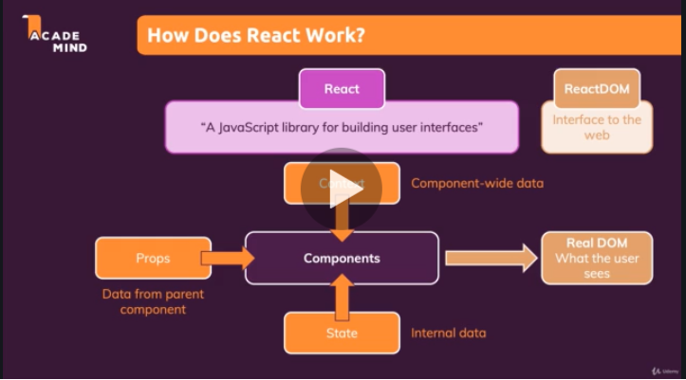

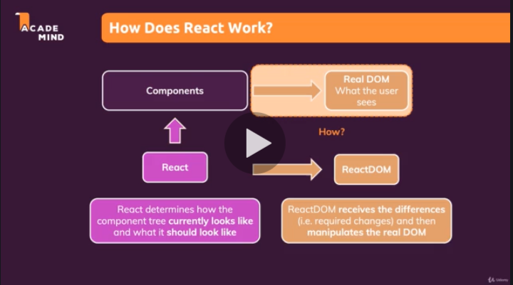

* React.memo( ):
* To avoid unnecessary re-render of component we use React.memo( ) function. If we use this only when the props of the component changes then component will be re-render
* If the parent component of component change and the props of this component are not change then the component will not re-render(execution will be skiped)
* ( Note : whenever conponent props, states , context are change the component will be re-render as component re-render its child component also re-render )

Ex:

Import React from ‘react’;

const compo = props =>{

return(

<div>

Stmts

</div>

)

}

export default React.memo(compo);

* useCallback( ) hooks:
* to do React.memo for function in react component we use useCallback( ) hook which takes first args, as function and second arg as array of depandencies.
* It will stop re-excution of fucntio if not necessary.

useCallback( ( ) => { } , [depandencies] )

* useMemo( ) hooks :
* like useCallback( ) hooks store function useMemo( ) hooks stores data.
* Same as useCallback( )