SE Experiment-8
(Batch-A/A3)
Team Details
Dev Gaglani-2024300057
Stavan Desai-2024300042
T.E. Computer Engineering – A
Aim:
To implement and test at least two core modules of the chosen case study, the Inventory and Stock Management System (ISMS). The two core modules are Module 1: Authentication & Role-Based Access Control and Module 2: Voice-Enabled Inventory & Omnichannel Synchronization. Both are implemented exactly as specified in the SRS, use case, class, sequence, activity and data-flow diagrams prepared in Experiments 1–7, and are verified with documented test cases and automated tests. The other five SRS feature modules (Supplier Management, Purchase Orders, Sales, Forecasting, Notifications) and the platform module were also built, so that the two core modules run inside a complete system.
Theory:
The implementation phase of the software development life cycle converts the design (use-case, class, sequence and activity diagrams and DFDs) into working source code. A large system is implemented module by module: each module covers a related set of functional requirements, has a clear interface (here, REST API endpoints and WebSocket channels), and can be built and tested independently before being integrated with the rest of the system.
Software testing checks that the implementation behaves as the requirements say. The levels of testing used in this experiment are:
• Unit testing: individual classes and methods (e.g. VoiceInterpreter.interpret(), BCrypt hashing) are tested in isolation.
• Integration testing: several components are tested together through the real REST API and a real PostgreSQL database (controller → service → entity → database), using JUnit 5, Spring Boot Test and MockMvc.
• System testing: complete end-to-end scenarios are executed in the browser exactly as an administrator, warehouse staff member or sales person would, and the results are captured as screenshots.
Test cases are designed using black-box techniques: equivalence partitioning (valid / invalid credentials, valid / invalid voice command), boundary value analysis (the 4th versus the 5th failed login, voice confidence just below and at the 0.75 threshold, stock of 1, 0 and −1 units), and negative testing (reused password-reset token, forged token, wrong role, duplicate SKU). White-box checks cover each branch of the activity diagram and sequence diagrams, for example both outcomes of the decisions “Credentials valid?”, “Account locked?”, “Use Voice Command?”, “Confidence ≥ threshold?” and the alt branch of SD-1 (“quantity < reorder point” versus “no alert required”).
Each test case records the input, the expected result derived from the SRS, the actual result observed, and a pass / fail status. The automated tests can be re-run after every change with one command (./mvnw test), which provides regression testing.
Problem Description
The Inventory and Stock Management System must track, control and optimise stock across multiple warehouses and sales channels. Only authenticated users may use it, and every action is restricted by role: Administrators manage users and system settings, Managers oversee suppliers, purchase orders and forecasts, Warehouse Staff keep stock accurate (also hands-free by voice) and confirm goods receipts, and Sales Personnel record physical sales and returns while marketplace orders arrive by webhook.
The SRS (moodle/moodle.md, Document A) groups the functional requirements into seven feature areas. For this experiment the two features on which all the others depend were selected:
1. Authentication & RBAC: SRS 4.1 Auth.*, SE-1 to SE-5, BR-1, BR-5; use cases “Manage Users and Roles” and “View System Reports & Audit Logs”; classes User and Administrator; DFD process 1.0 (and 2.0 for user management), data store D1.
2. Voice-Enabled Inventory & Omnichannel Synchronization: SRS 4.2 Inventory.*, Voice.Command.*, Sync.Channel.*, BR-3, PE-1, PE-2; use case “Manage Inventory (Stock)” with its «include» operations and the «extend» “Voice Command”; classes Product, StockRecord and WarehouseStaff; sequence diagram SD-1; DFD process 4.0 (Level 2 steps 4.1–4.5), data stores D3 and D4.
Both modules had to be implemented and tested, including their failure paths: a wrong password, the fifth failed login, a forged or reused reset token, a user opening a page outside their role, a duplicate SKU, deleting a product that still has stock, a negative quantity, two simultaneous sales of the last unit and a voice command below the confidence threshold.
Implementation:
ISMS was implemented as a full-stack web application in which every screen and API call is traceable to the SE documents from the earlier experiments. The finished system lives in the GitHub repository 2000stavan/lala, and its history is rebuilt module by module in a new repository (one branch and one commit per module, see section 3 and github.md).
1. Technology Stack
Layer | Technology | Purpose in ISMS
Frontend | React 18 + Vite, TypeScript, Tailwind CSS, Recharts | Role-based web client with light and black dark themes; one page per module
Backend | Java 21, Spring Boot 3.3 (Web, Security, Data JPA, Validation, WebSocket, Mail, AOP) | REST API; one service class per class-diagram class
Domain layer | Java service + JPA entity classes | Implements the class diagram: User, Product, StockRecord, Supplier, PurchaseOrder, SalesOrder, Forecast, Notification …
Database | PostgreSQL 16, Flyway migrations V1–V6 | Data stores D1–D8 of the DFD; CHECK constraints enforce BR-3 in the database
Security | JWT (30-minute sliding), BCrypt, RBAC with @PreAuthorize, HMAC-SHA256 | Login, lockout after 5 failures, role checks on every endpoint, signed marketplace webhooks
Real time | Spring WebSocket (/ws/stock, /ws/alerts) | Live stock updates and alerts within the 5-second budget (PE-2)
Reporting | OpenPDF, in-process Holt-Winters forecasting | PDF invoices; demand forecast without an external ML service
Testing | JUnit 5, Spring Boot Test, MockMvc, Vitest, smoke_test.sh | 70 backend tests, 1 frontend test and 53 live API checks

2. System Architecture
The system follows a layered (3-tier) architecture:
• Presentation tier: the React client. Each role sees only its own menu and a route guard blocks pages outside the role. The sidebar, theme switch, onboarding walkthrough and help button are shared by every page.
• Application tier: Spring Boot controllers → service classes → JPA entities. The service classes carry the names of the class-diagram operations (approvePo, deductStock, captureVoiceCommand …) and an AOP aspect (CallTraceAspect) records the order of the calls, so the sequence-diagram tests can compare the running code with SD-1, SD-2 and SD-3 message by message.
• Data tier: a PostgreSQL database created only by Flyway migrations. Tables map to the DFD data stores, and the schema is checked against schema.md by an automated test.
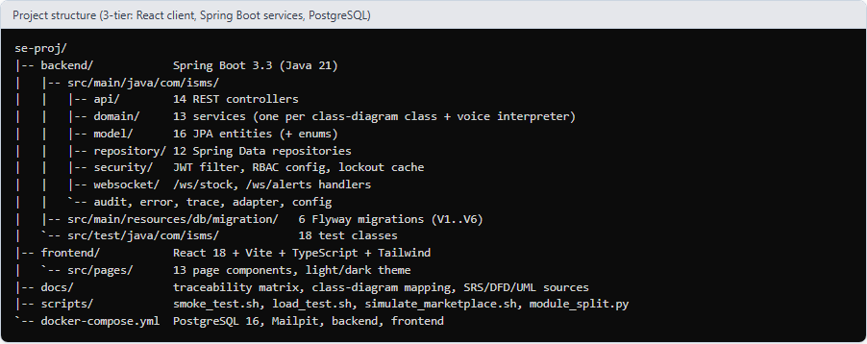
Fig. 1: Project structure: the three tiers and the number of files in each package
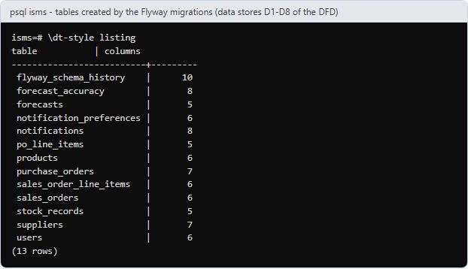
Fig. 2: Database tables created by the Flyway migrations (data stores D1–D8 plus the line-item and support tables)
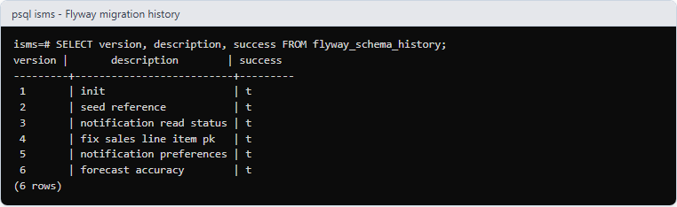
Fig. 3: Flyway migration history: V1 schema, V2 reference users, V3–V6 notification status, sales line-item key, preferences and forecast accuracy
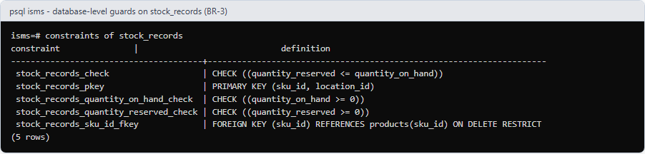
Fig. 4: Database-level guards on stock_records: quantity_on_hand >= 0 enforces business rule BR-3 even if the application were bypassed
3. Module Division and Teamwork
The seven modules are the seven feature areas of the SRS (section 4.1 to 4.7); Module 8 contains everything else. The work was divided in alternating order: Dev Gaglani implemented and pushed the odd-numbered modules (1, 3, 5, 7) and Stavan Desai the even-numbered ones (2, 4, 6, 8). Each module is one branch (module-<n>-<name>) with one commit, reviewed by the other team member through a pull request before it is merged, and every stage compiles on its own (verified for all eight stages).
# | Module (SRS feature) | What it covers | Done by | Branch
1 | Auth & RBAC (4.1) | Secure login and role-specific access control for admins, managers, warehouse staff and sales personnel; also carries the project foundation (schema, entities, app shell) | Dev | module-1-auth-rbac
2 | Voice-Enabled Inventory & Omnichannel Sync (4.2) | Full CRUD on products and stock through the standard UI or hands-free voice commands, real-time sync to all channels | Stavan | module-2-voice-inventory-sync
3 | Supplier Management (4.3) | Vendor profiles, contact details, performance rating and procurement history | Dev | module-3-suppliers
4 | Purchase Order Management (4.4) | Creates, approves and tracks inbound POs; stock rises automatically on receipt | Stavan | module-4-purchase-orders
5 | Sales Tracking & Order Management (4.5) | Physical and digital sales, marketplace webhooks, invoicing, returns, automatic stock deduction | Dev | module-5-sales
6 | Predictive Analytics & AI Forecasting (4.6) | Revenue and stock dashboards; demand forecast, seasonality and reorder points | Stavan | module-6-forecasting
7 | Multimodal Notification System (4.7) | Real-time low-stock and shipping-delay alerts by e-mail, SMS and audio; inbox and preferences | Dev | module-7-notifications
8 | Platform hardening (the rest) | Demo data, non-functional tests, class-diagram tests, load/smoke scripts, traceability and documentation | Stavan | module-8-platform-hardening

A few files travel with an earlier module because of real code dependencies (for example the notification engine ships with Module 2, because every stock change can raise a low-stock alert). These are listed in github.md.
4. How the System Works, Step by Step
The numbered flow below follows one typical working day and names the module and DFD process that handles each step. It is the order in which the modules are explained in the rest of this report.
1. Sign in (Module 1, DFD 1.0). Every user signs in with a user ID or e-mail and a password. The server checks the BCrypt hash, issues a 30-minute sliding token containing the role and shows only the menu items allowed for that role. Five wrong passwords lock the account.
2. Administer users (Module 1, DFD 2.0, D1). The Administrator creates users, assigns roles, unlocks accounts and reads the audit log; every action is logged.
3. Maintain stock (Module 2, DFD 4.0, D3/D4). Warehouse staff create and update products and change quantities through the form or by voice (“add 20 units of SKU-002 to location WH-01” → read-back → confirm). Every change is made under a database row lock and pushed live to every open screen.
4. Get alerted (Module 7, DFD 7.0, D8). When stock falls below the reorder point the system raises a low-stock alert by e-mail, SMS, audio and in the inbox.
5. Buy goods (Modules 3 and 4, DFD 2.0/6.0, D2/D7). Managers keep supplier records and create purchase orders; larger orders need an Administrator; Warehouse Staff confirm receipt, which raises stock (back to step 3).
6. Sell goods (Module 5, DFD 3.0, D5). Sales Personnel sell in the shop; marketplaces send signed webhooks. Stock is deducted atomically, a PDF invoice is produced and returns restore stock.
7. Forecast (Module 6, DFD 5.0, D6). Every sale feeds the forecast. The Manager sees predicted demand, reorder points and can turn a suggestion into a draft purchase order (back to step 5).
8. Run and prove (Module 8). Demo data, scripts, automated tests, the traceability matrix and this report make the system repeatable.
5. Traceability to the Earlier Experiments
Every module is traced to the requirement, use case, class, sequence diagram and DFD process it implements. The diagrams below are the ones submitted in Experiments 2 to 6; the complete requirement-by-requirement matrix is in docs/traceability.md.
Module | SRS feature | Use case (Exp. 2) | Classes (Exp. 3) | Sequence (Exp. 4) | DFD (Exp. 6)
1 | 4.1 Auth & RBAC | Manage Users and Roles; View System Reports & Audit Logs | User, Administrator | – | 1.0, 2.0 · D1
2 | 4.2 Inventory, voice, sync | Manage Inventory (Add / Update / Adjust / Delete / Search); Voice Command | Product, StockRecord, WarehouseStaff | SD-1 | 4.0 · D3, D4
3 | 4.3 Supplier | Manage Suppliers | Supplier | SD-2 (first messages) | 2.0 · D2
4 | 4.4 Purchase Order | Manage Purchase Orders; Receive Goods / Update Stock | PurchaseOrder, Manager, WarehouseStaff | SD-2 | 6.0 · D7
5 | 4.5 Sales | Process Sales Order; Process Returns / Cancellations | SalesOrder, SalesPersonnel | SD-3 | 3.0 · D5
6 | 4.6 Forecasting | Generate Demand Forecast; View Analytics Dashboard | Forecast | – | 5.0 · D6
7 | 4.7 Notifications | Low Stock Alert, Shipping Delay Alert («extend») | Notification | SD-1 alt, SD-2 opt | 7.0 · D8

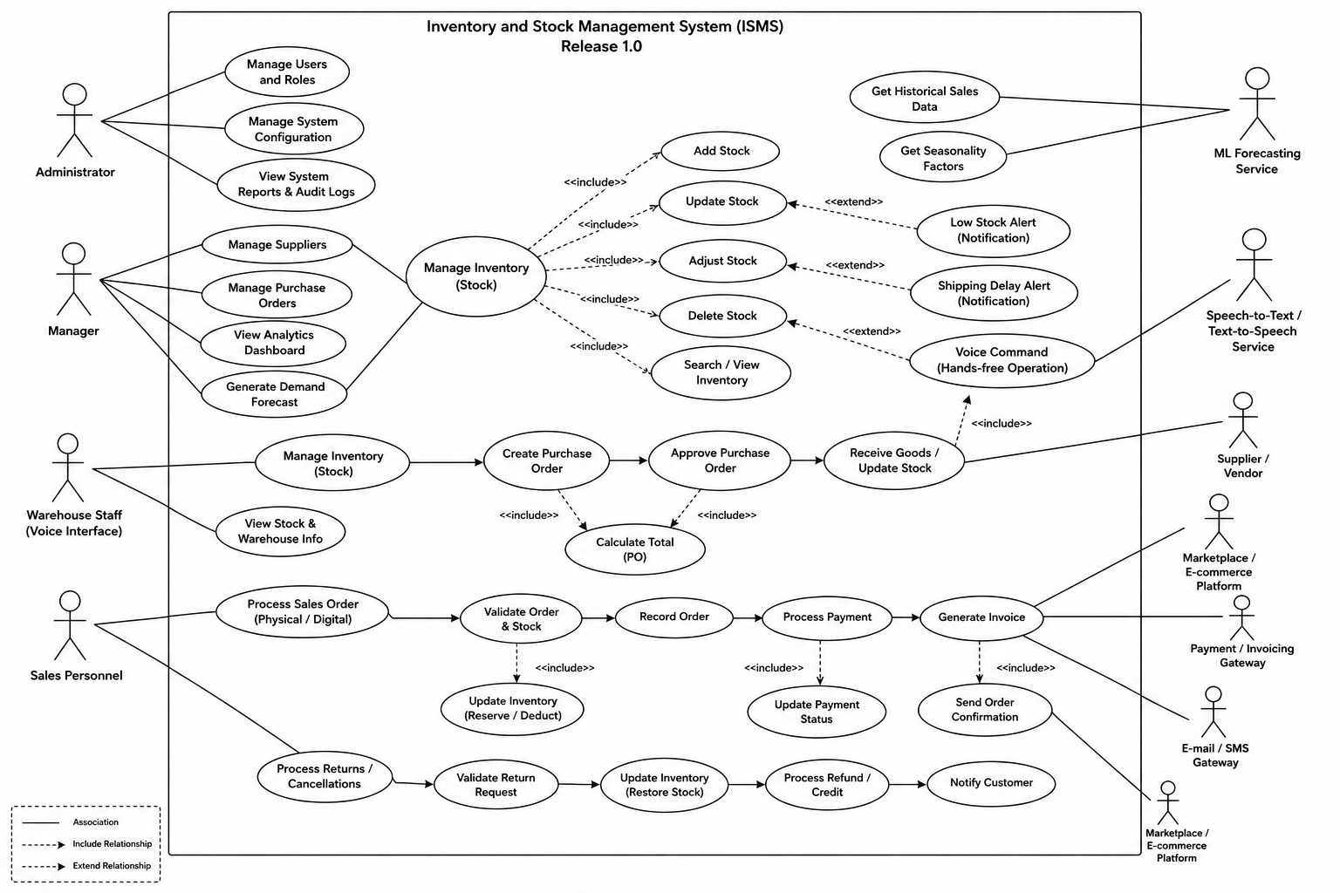
Fig. 5: Use-case diagram (Experiment 2): the use cases implemented by the seven modules
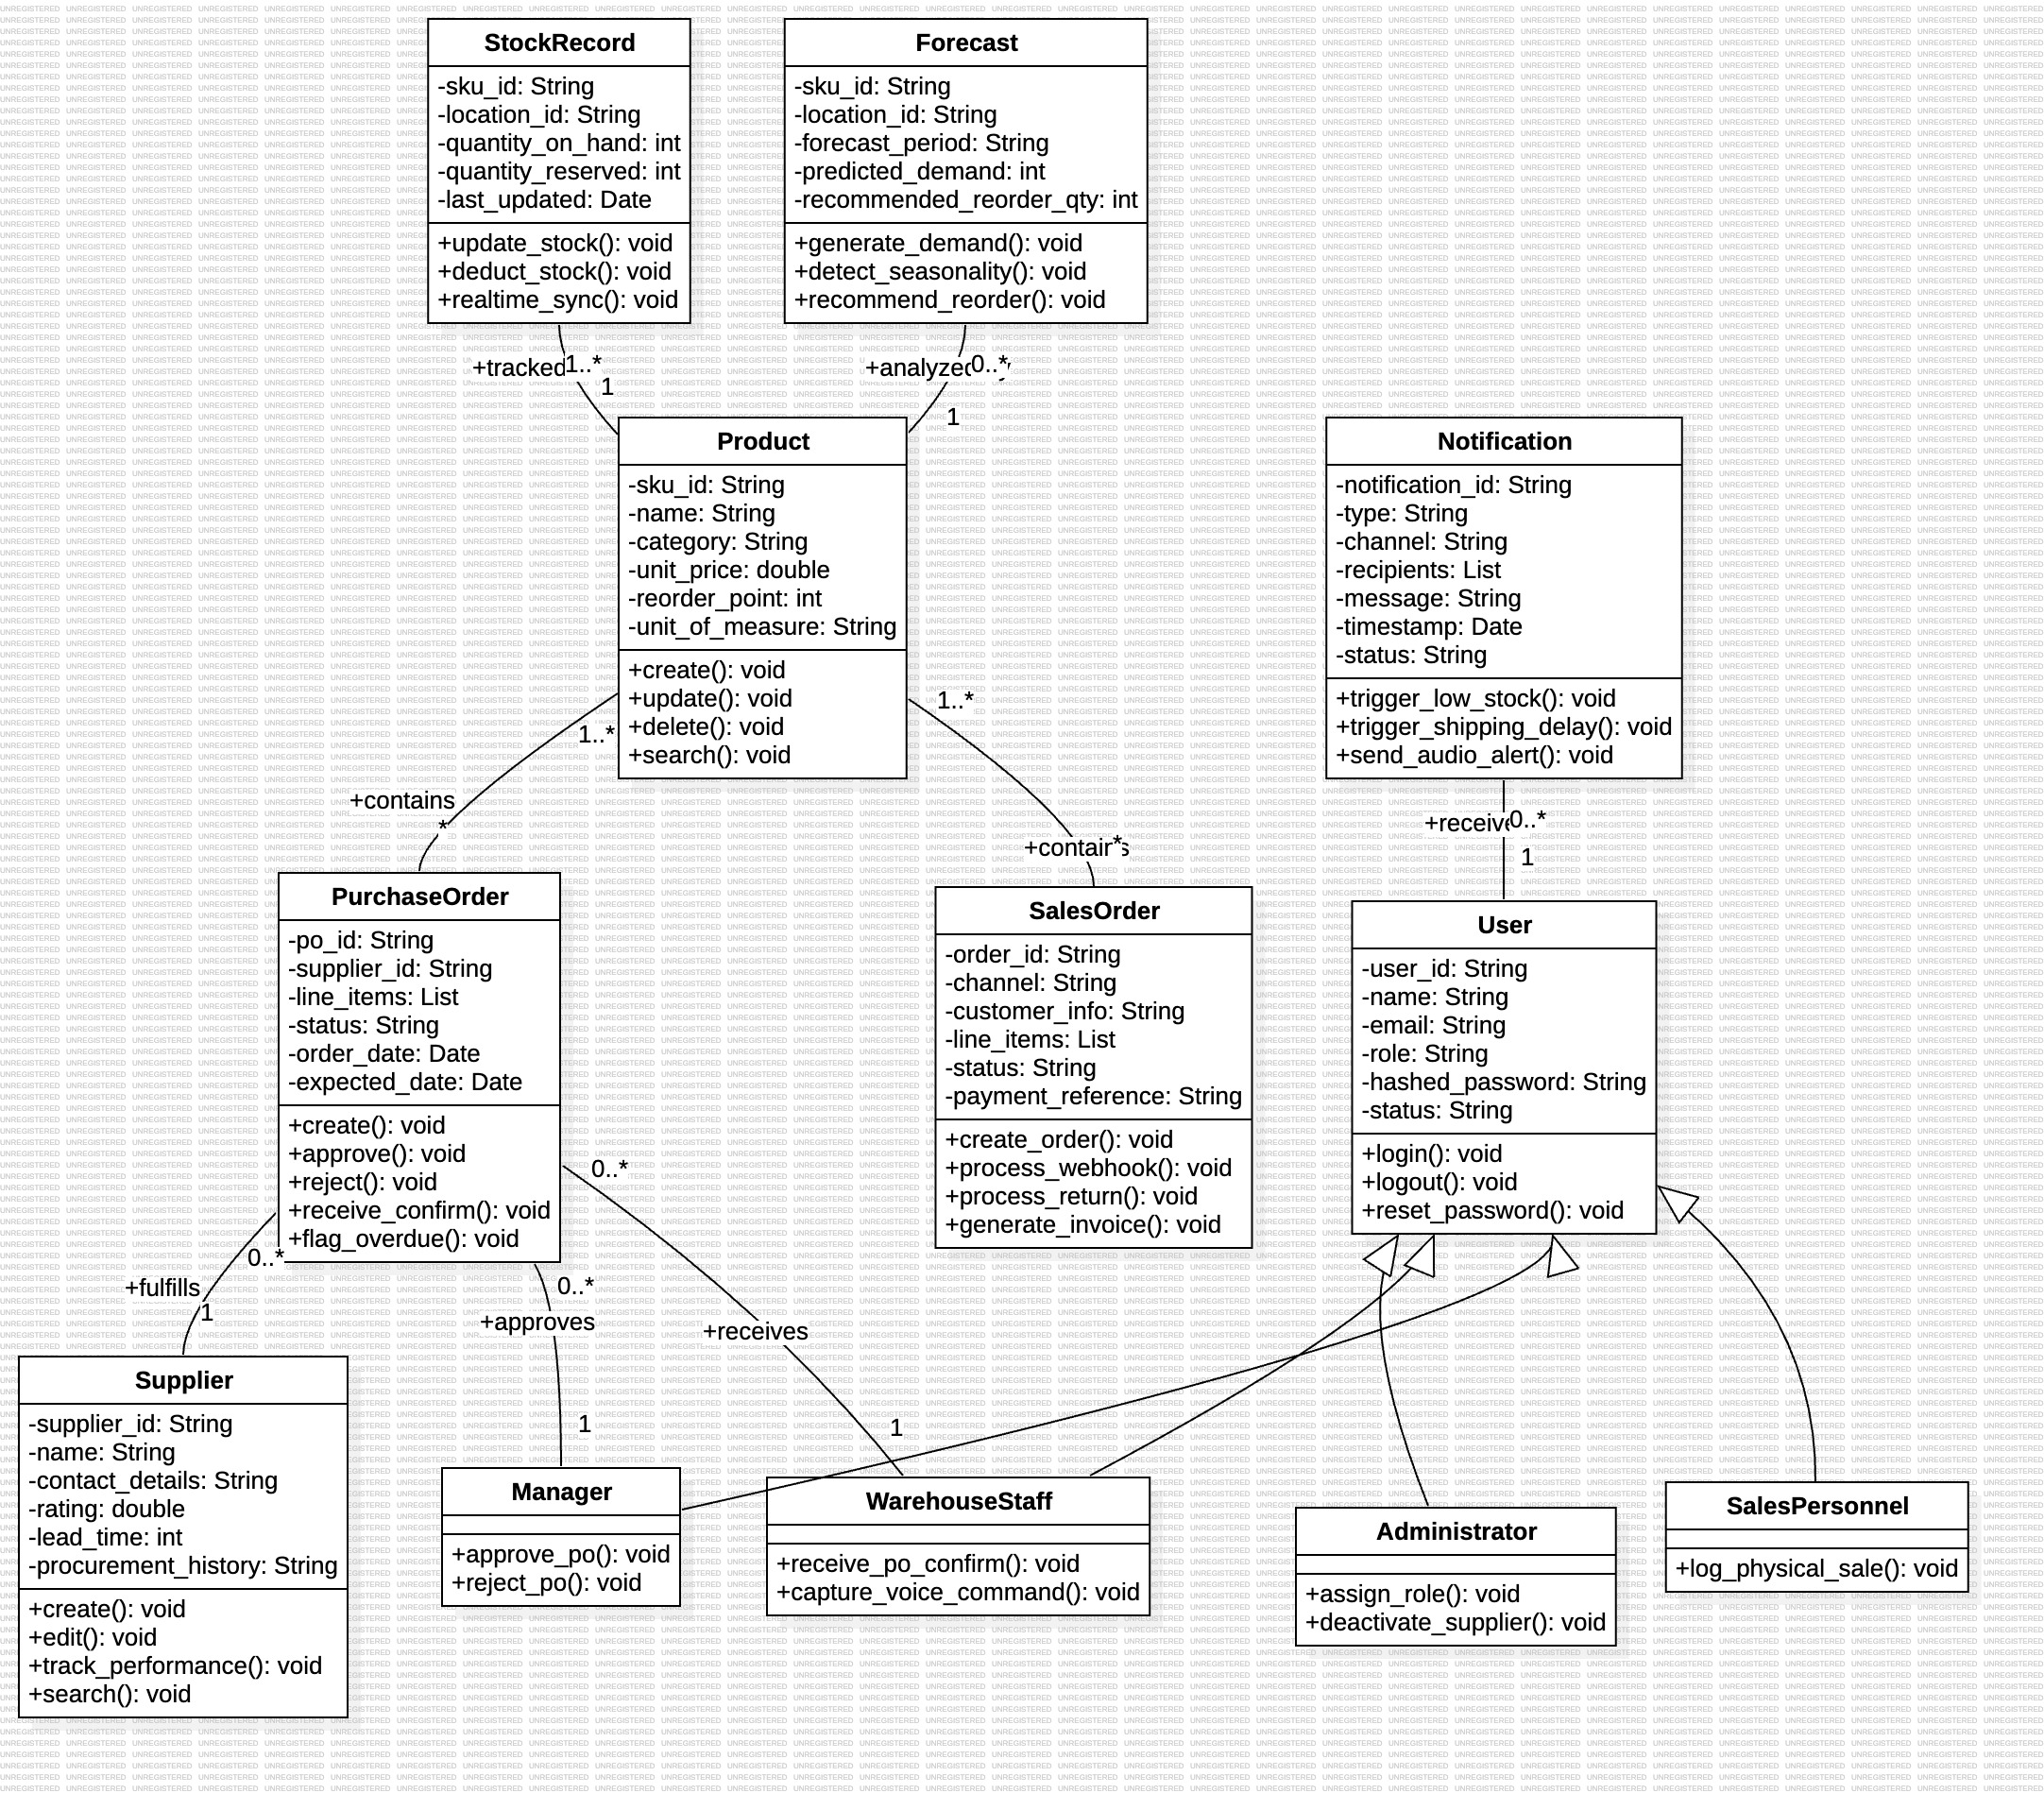
Fig. 6: Class diagram (Experiment 3): 12 classes, 43 operations and 9 relationships; each is checked by ClassContractTest and ClassDiagramStructureTest
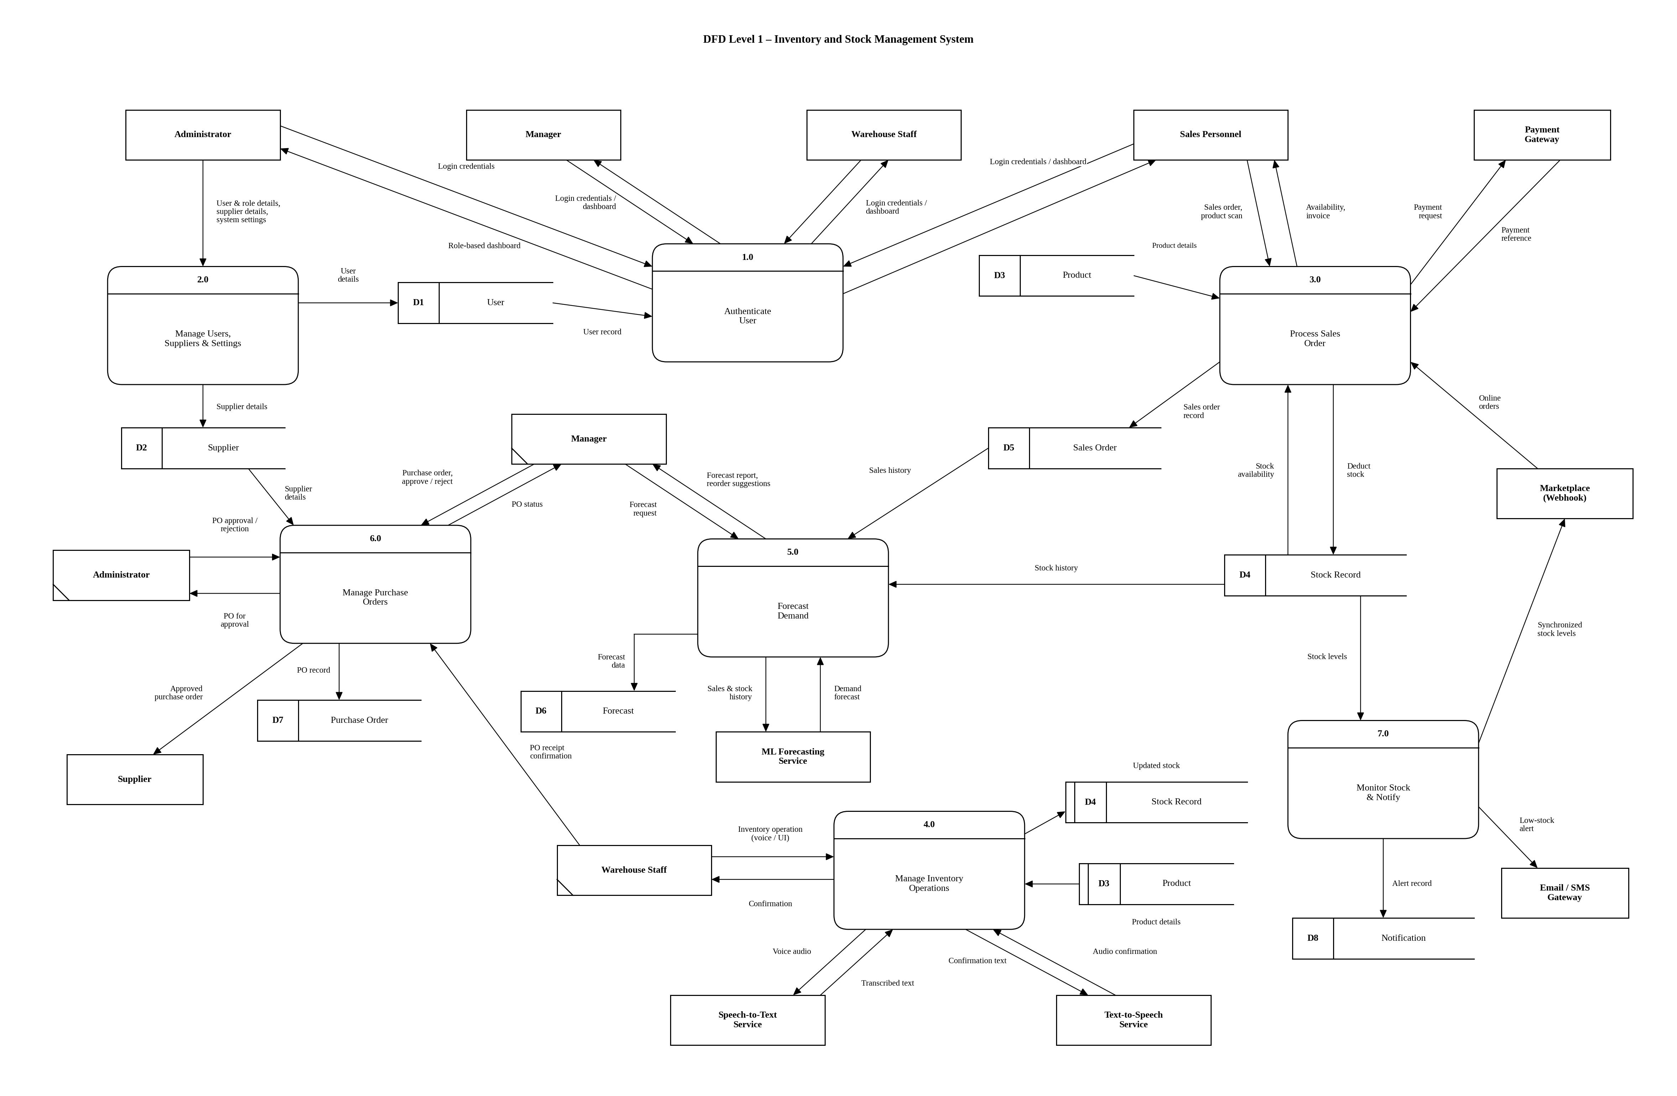
Fig. 7: DFD Level 1 (Experiment 6): processes 1.0–7.0 and data stores D1–D8
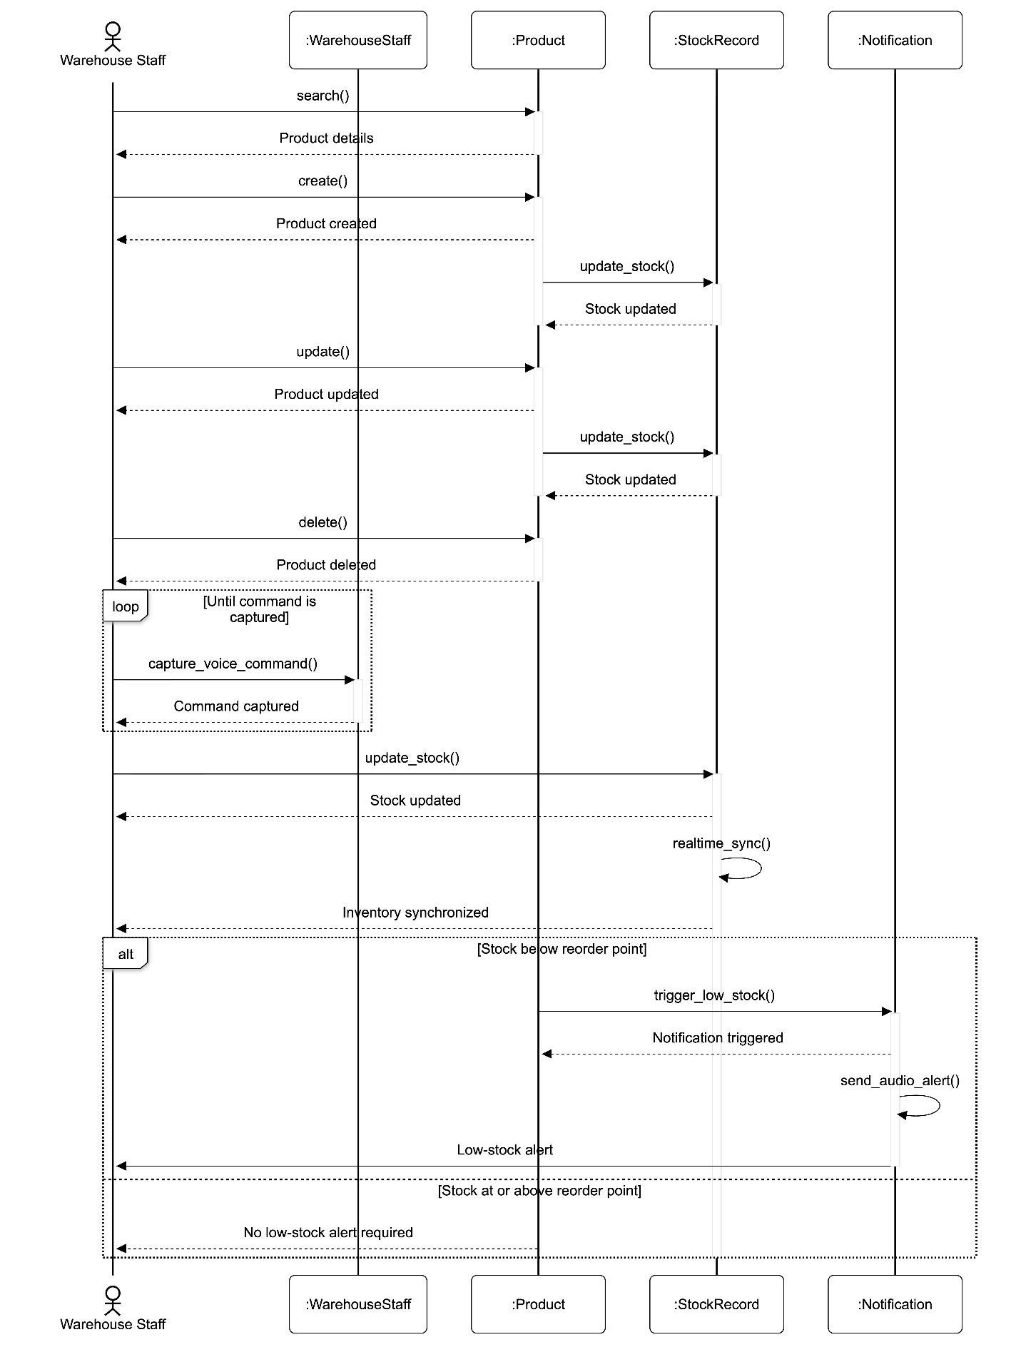
Fig. 8: Sequence diagram SD-1 (Experiment 4): inventory update and voice command, replayed message by message by Seq1InventoryTest
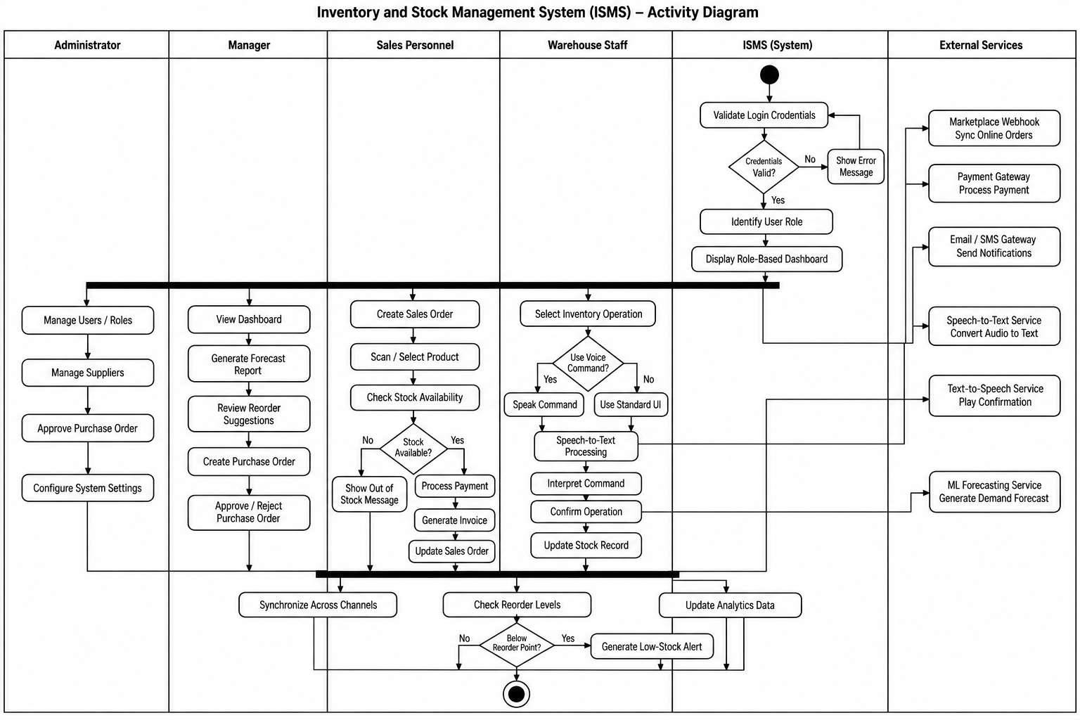
Fig. 9: Activity diagram (Experiment 5): the swimlane flow whose decisions are covered by the white-box test cases
3. Core Module 1: Authentication & Role-Based Access Control
Traceability: SRS 4.1 (Auth.Login, Auth.Login.Fail, Auth.Password.Reset, Auth.RBAC.Roles, Auth.RBAC.Assign, Auth.RBAC.Enforce, Auth.Session.Timeout, Auth.Audit.Log) · SE-1, SE-2, SE-3, SE-5, BR-1, BR-5, UI-1, UI-2, UD-1, UD-2 · Use cases “Manage Users and Roles”, “View System Reports & Audit Logs” · Classes User (login, logout, reset_password) and Administrator (assign_role, deactivate_supplier) · DFD 1.0 Authenticate User (Validate Login Credentials → Identify User Role → Display Role-Based Dashboard) and 2.0, data store D1 · Activity nodes “Credentials valid?”, “Account locked?”.
Functionalities implemented
• Login with generic failure: user ID or e-mail plus password, BCrypt verification. A wrong user or a wrong password returns the same message, so an attacker cannot learn which user IDs exist.
• Account lockout (SE-1): five consecutive failures within 15 minutes lock the account. The lock is stored in the database (users.status = locked), so the Administrator sees it in the user list and unlocks it; even the correct password is refused while locked.
• Password reset by e-mail: a single-use, 30-minute token is e-mailed to the registered address; the request always answers the same generic message so existing accounts are not revealed.
• Role-based access control: four roles. The server checks the role on every endpoint (401 without a valid token, 403 for the wrong role); the client hides menu items and shows an “Access Restricted” page if a user types a forbidden address.
• Sliding 30-minute session: every response carries a refreshed token (X-Refreshed-Token); after 30 idle minutes the next request is answered with 401 and the client returns to the login page.
• Administration (class `Administrator`): create users with inline validation, assign a role, deactivate or unlock accounts, and read the system limits (read-only).
• Audit log (SE-5): every login, failed login, lock, logout, user creation and role change is written as a structured, timestamped event and shown to the Administrator with filters.
• Design system (UI-1, UI-2): one visual language for all roles, a persistent help button that reopens the role walkthrough, and a light / black dark theme.
Key implementation code
Listing 1: The fifth failed login locks the account and the lock is committed (SE-1, Auth.Login.Fail)
// UserService.java
// noRollbackFor: the 5th failed login throws ACCOUNT_LOCKED *after* setting status=locked; that change must be
// committed, otherwise the lock exists only in memory and the Administrator never sees (or can unlock) the account.
@Transactional(noRollbackFor = ApiException.class)
public Map<String, Object> login(String identifier, String password) {
if (identifier == null || identifier.isBlank() || password == null) {
throw new ApiException(HttpStatus.BAD_REQUEST, "INVALID_INPUT", "Identifier and password are required");
}

if (loginAttemptCache.isLocked(identifier)) {
throw new ApiException(HttpStatus.FORBIDDEN, "ACCOUNT_LOCKED", "Account locked due to 5 failed attempts in 15 minutes");
}

User user = userRepository.findByUserIdOrEmail(identifier).orElse(null);

if (user == null || !passwordEncoder.matches(password, user.getHashedPassword())) {
int failures = loginAttemptCache.recordFailure(identifier);
if (user != null && failures >= 5) {
user.setStatus(UserStatus.LOCKED);
userRepository.save(user);
auditLogger.log(user.getUserId(), "ACCOUNT_LOCKED", "users", Map.of("reason", "5_failed_logins"));
throw new ApiException(HttpStatus.FORBIDDEN, "ACCOUNT_LOCKED", "Account locked due to 5 failed attempts in 15 minutes");
}
auditLogger.log(identifier, "LOGIN_FAILED", "users", Map.of("failure_count", failures));
throw new ApiException(HttpStatus.UNAUTHORIZED, "INVALID_CREDENTIALS", "Invalid user ID/email or password");
...

Listing 2: Unauthenticated requests are 401 and wrong-role requests 403 (Auth.RBAC.Enforce, Auth.Session.Timeout; package names abridged)
// SecurityConfig.java
http
...
// Unauthenticated / expired-token requests must be 401 (not Spring's default 403)
// so the UI's session-timeout handling can redirect to the login page.
.exceptionHandling(ex -> ex
.authenticationEntryPoint(new HttpStatusEntryPoint(HttpStatus.UNAUTHORIZED))
.accessDeniedHandler((req, res, e) -> res.setStatus(HttpStatus.FORBIDDEN.value())))
.addFilterBefore(jwtAuthFilter, UsernamePasswordAuthenticationFilter.class);

Listing 3: Sliding session: the token is renewed on every authenticated request
// JwtAuthFilter.java
if (claims != null && SecurityContextHolder.getContext().getAuthentication() == null) {
String userId = jwtService.getUserId(claims);
Role role = jwtService.getRole(claims);

String roleName = "ROLE_" + role.name();
SimpleGrantedAuthority authority = new SimpleGrantedAuthority(roleName);

UsernamePasswordAuthenticationToken authentication =
new UsernamePasswordAuthenticationToken(userId, null, Collections.singletonList(authority));
authentication.setDetails(claims);
SecurityContextHolder.getContext().setAuthentication(authentication);

// Sliding expiration: send refreshed token in header
String refreshed = jwtService.refreshToken(claims);
response.setHeader("X-Refreshed-Token", refreshed);
}

Output screenshots: Module 1
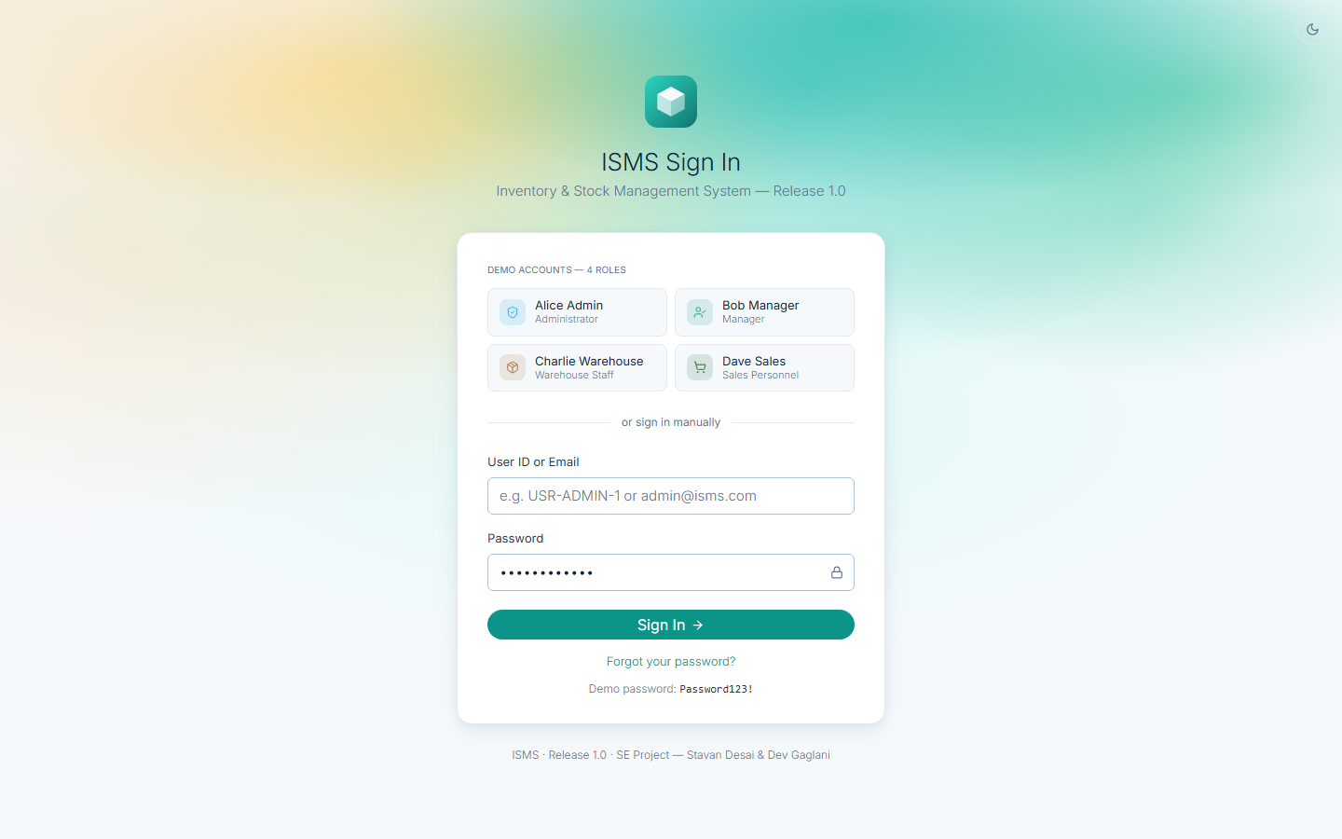
Fig. 10: Login page: demo accounts for the four roles, manual sign-in and the “Forgot your password?” link
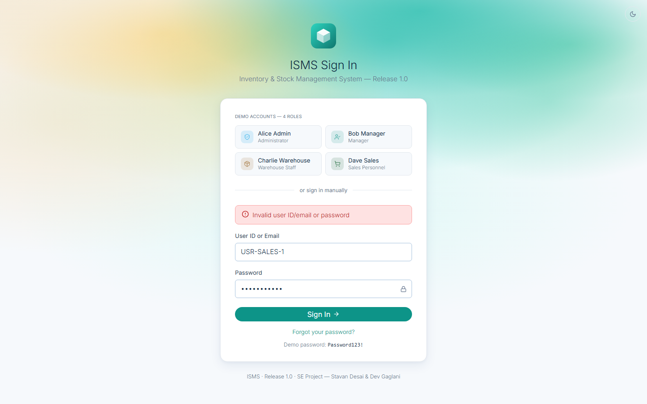
Fig. 11: Wrong password: a generic error that does not reveal whether the user exists (Auth.Login.Fail)
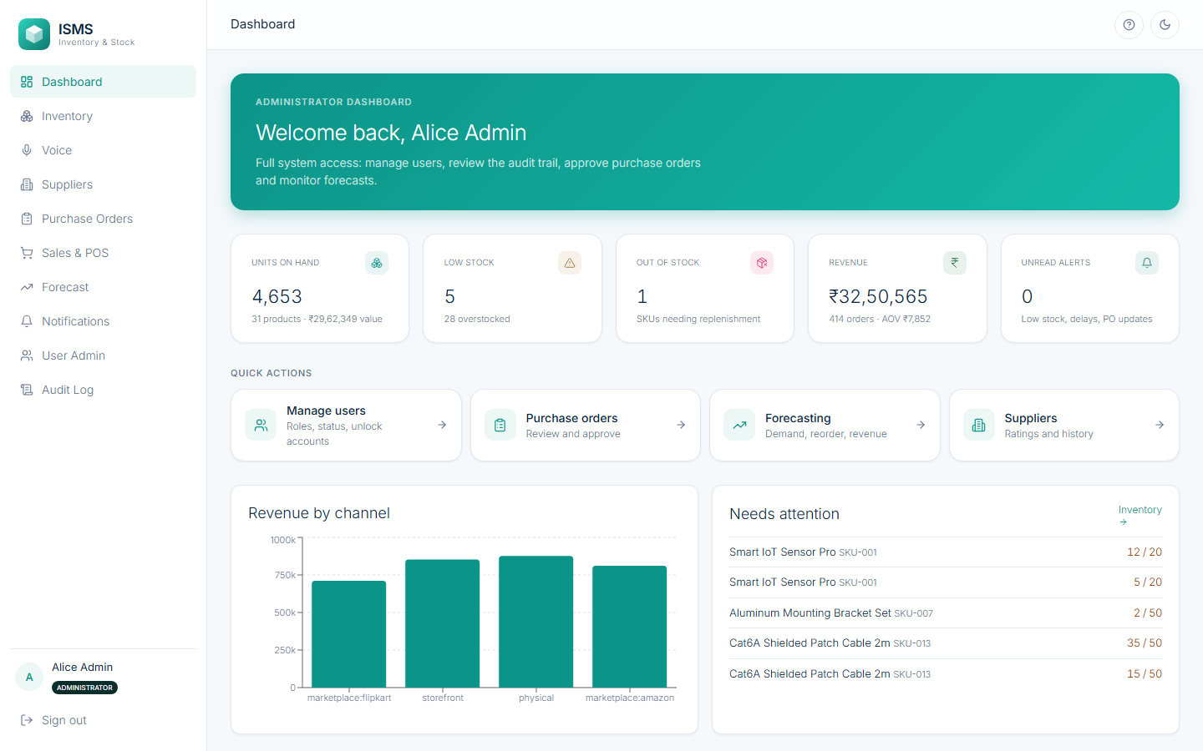
Fig. 12: First sign-in: the role-specific onboarding walkthrough (UD-1, UD-2); it can be reopened from the help button
Fig. 13: Administrator dashboard (DFD 1.0 “Display Role-Based Dashboard”): live KPIs, quick actions and the full menu
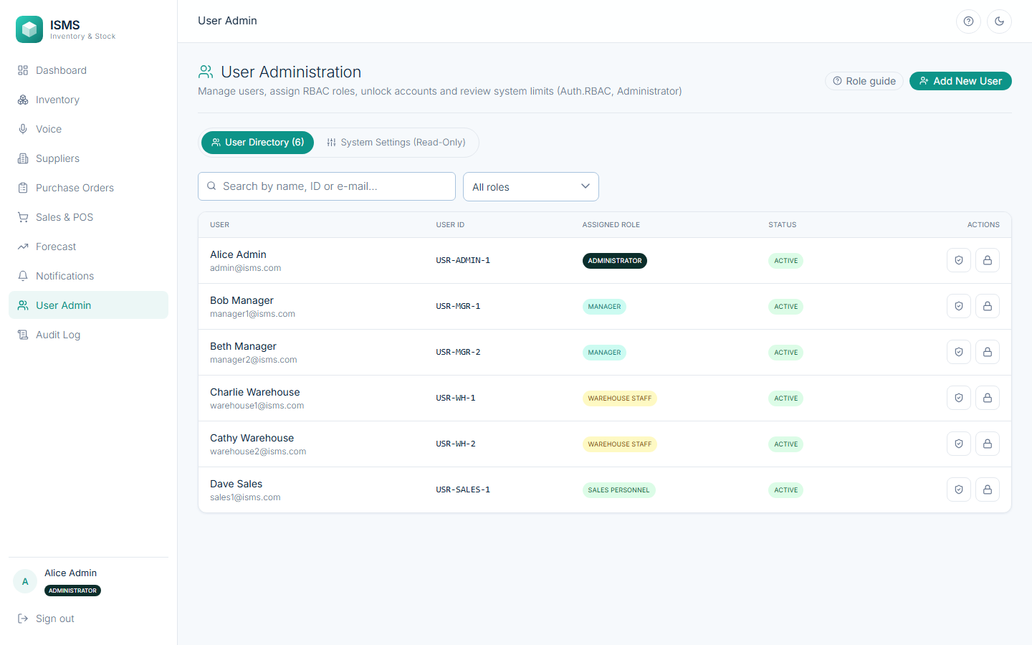
Fig. 14: User Administration: directory with role and status of every user (Administrator only)
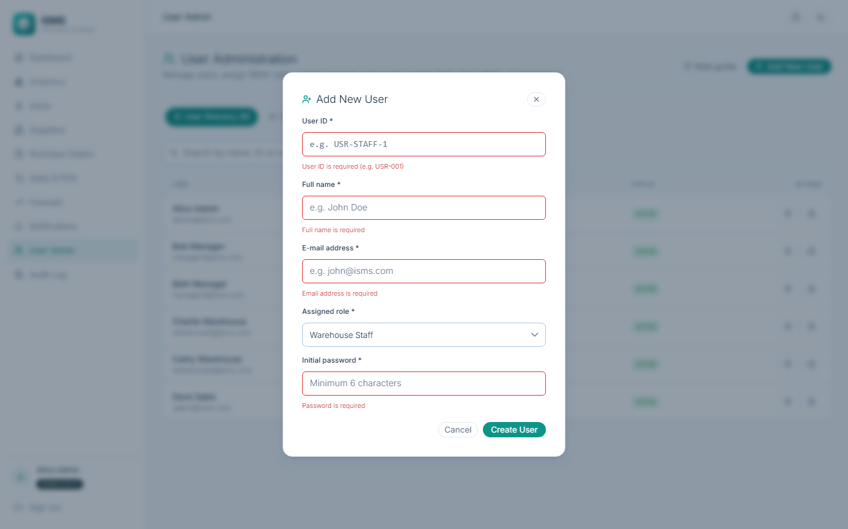
Fig. 15: Inline validation (UI-4): the empty form shows field-level messages before anything is sent to the server
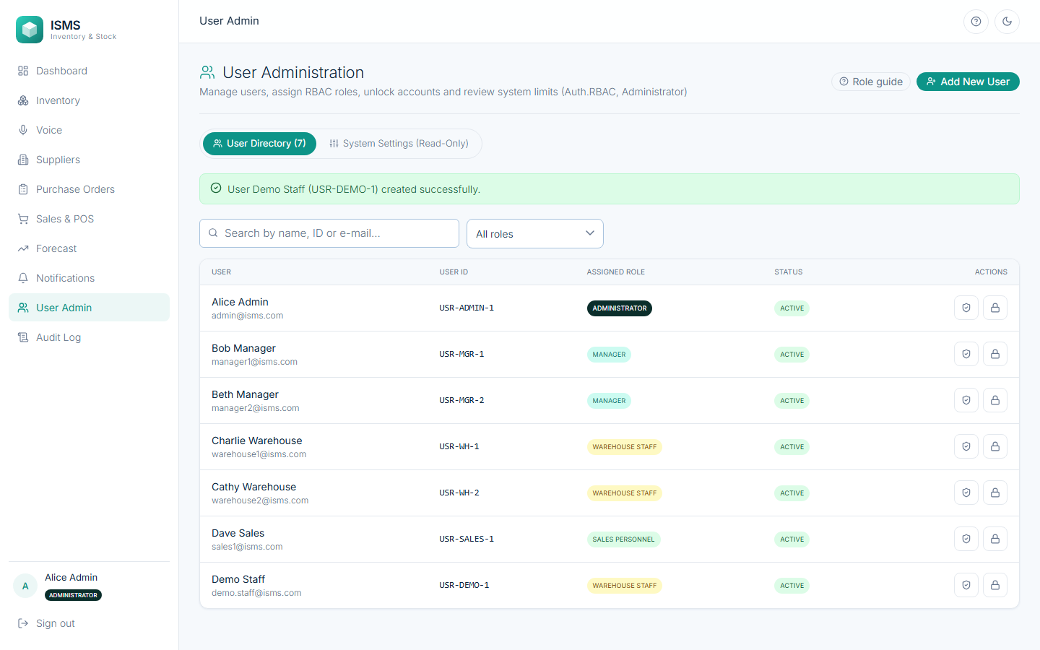
Fig. 16: User created: the new Demo Staff row appears with the Warehouse Staff role
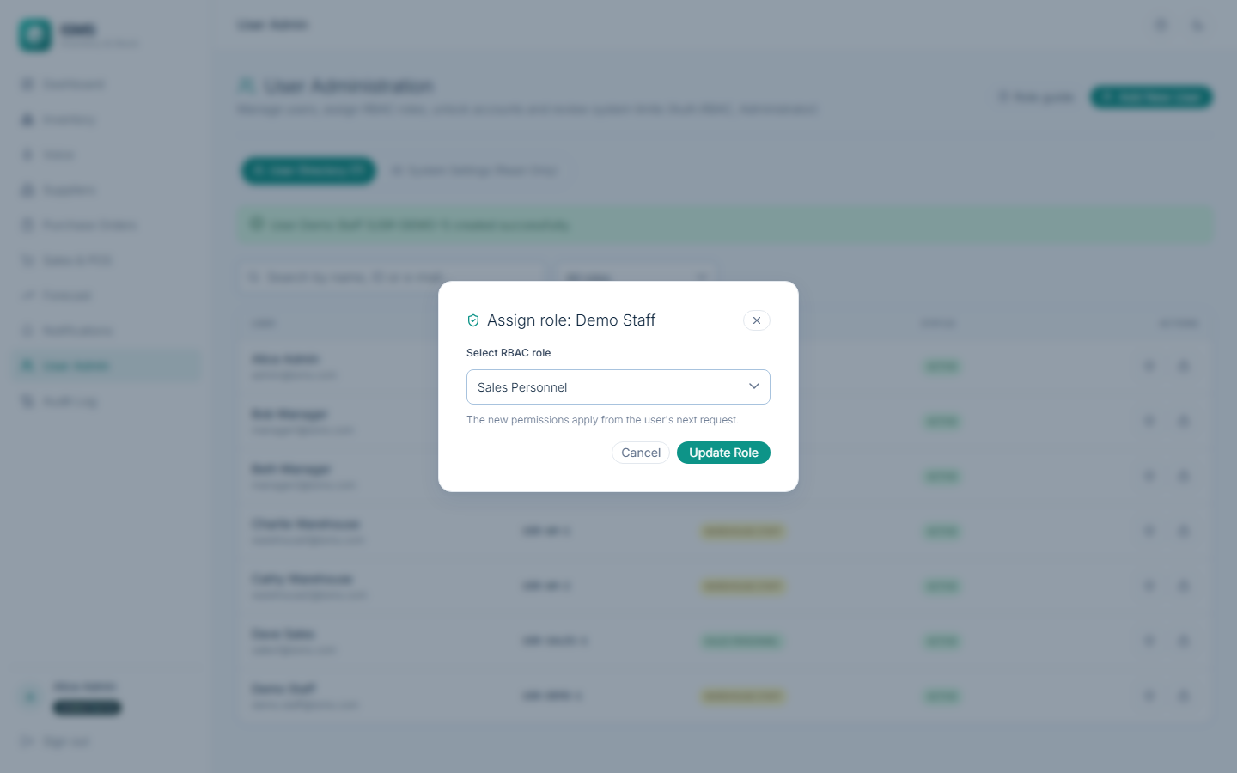
Fig. 17: Assign role (Administrator.assign_role): Demo Staff is changed to Sales Personnel
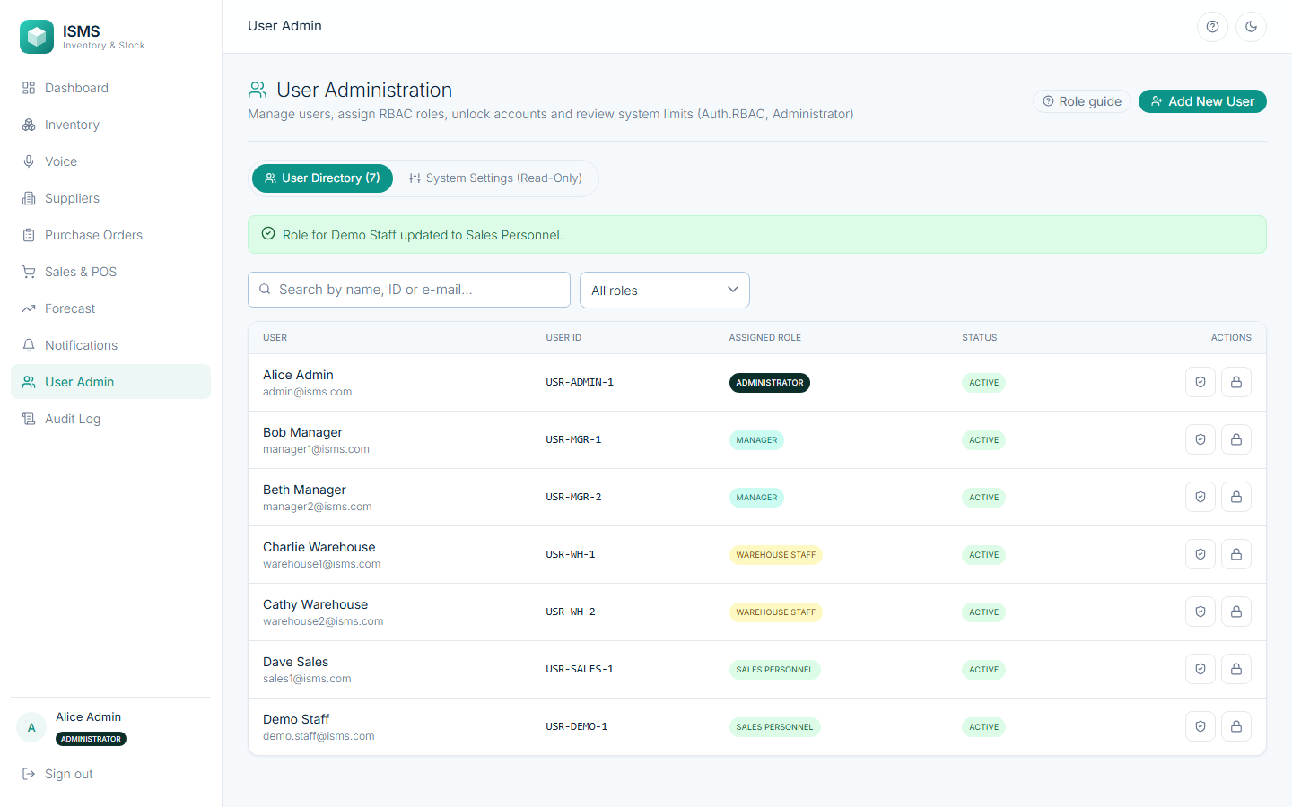
Fig. 18: Role updated; the change applies from the user's next request
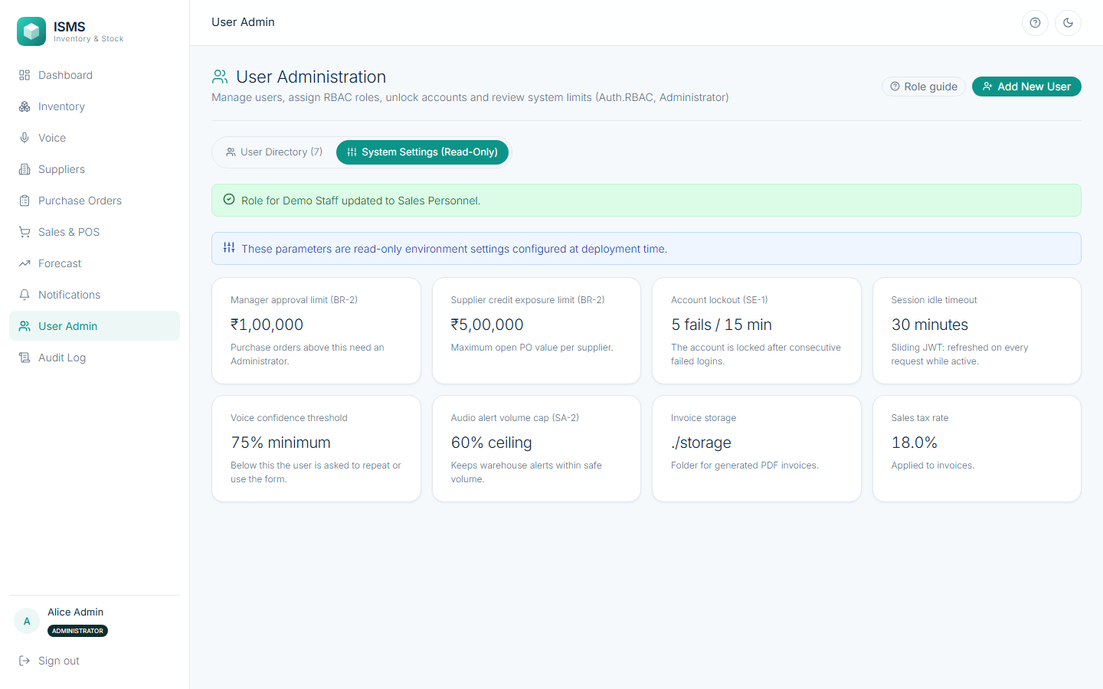
Fig. 19: System Settings (read-only): approval limit, credit limit, lockout policy, session timeout, voice threshold, volume cap
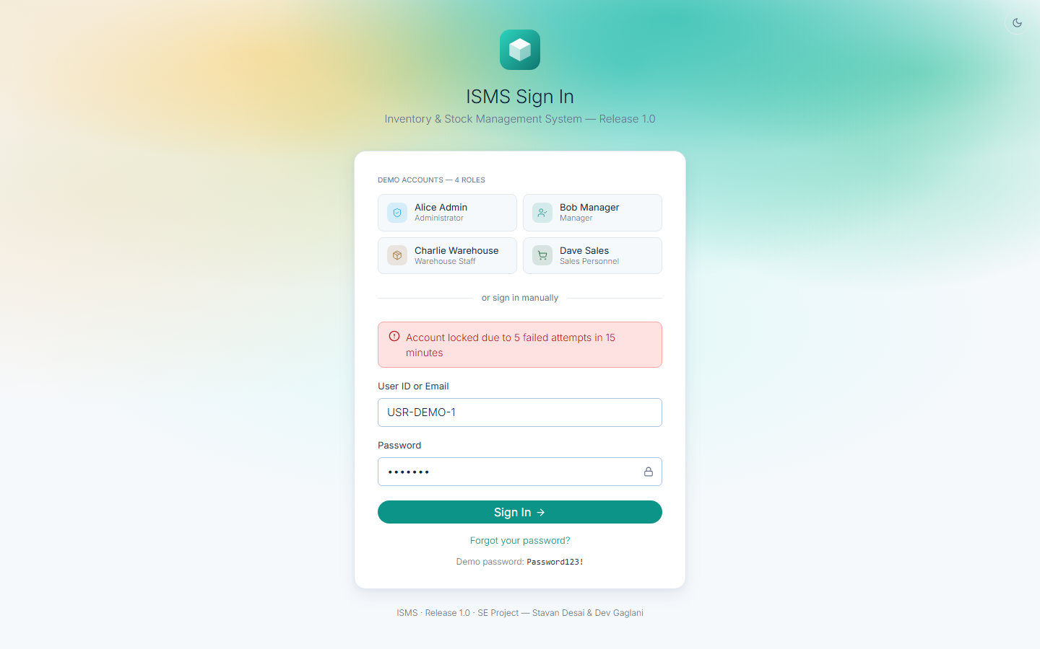
Fig. 20: Fifth consecutive wrong password for USR-DEMO-1: the account is locked (SE-1)
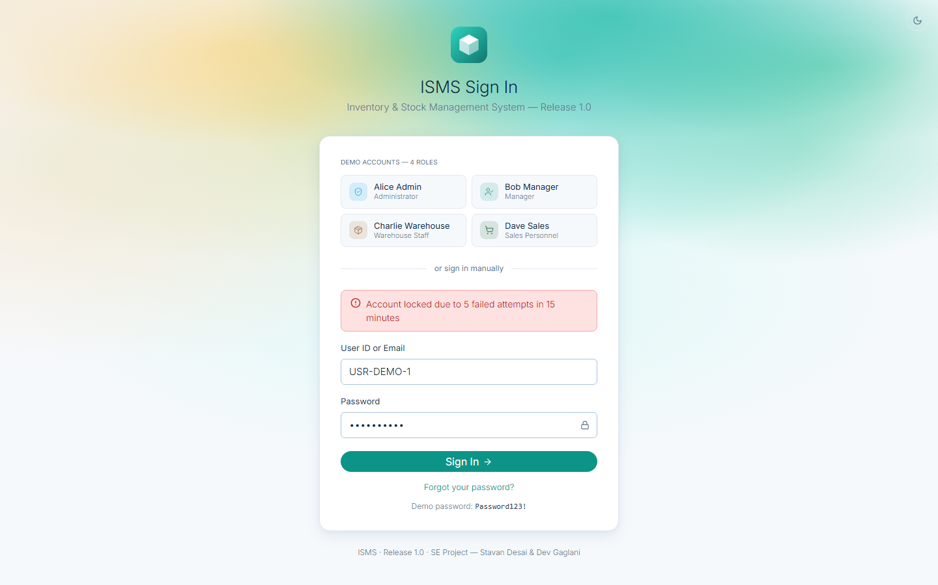
Fig. 21: While locked, even the correct password is refused
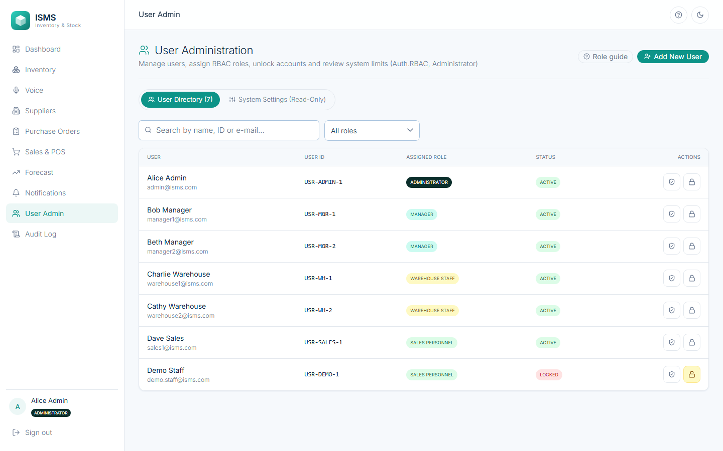
Fig. 22: Administrator view: the locked user is visible with a highlighted unlock action, because the lock is stored in users.status
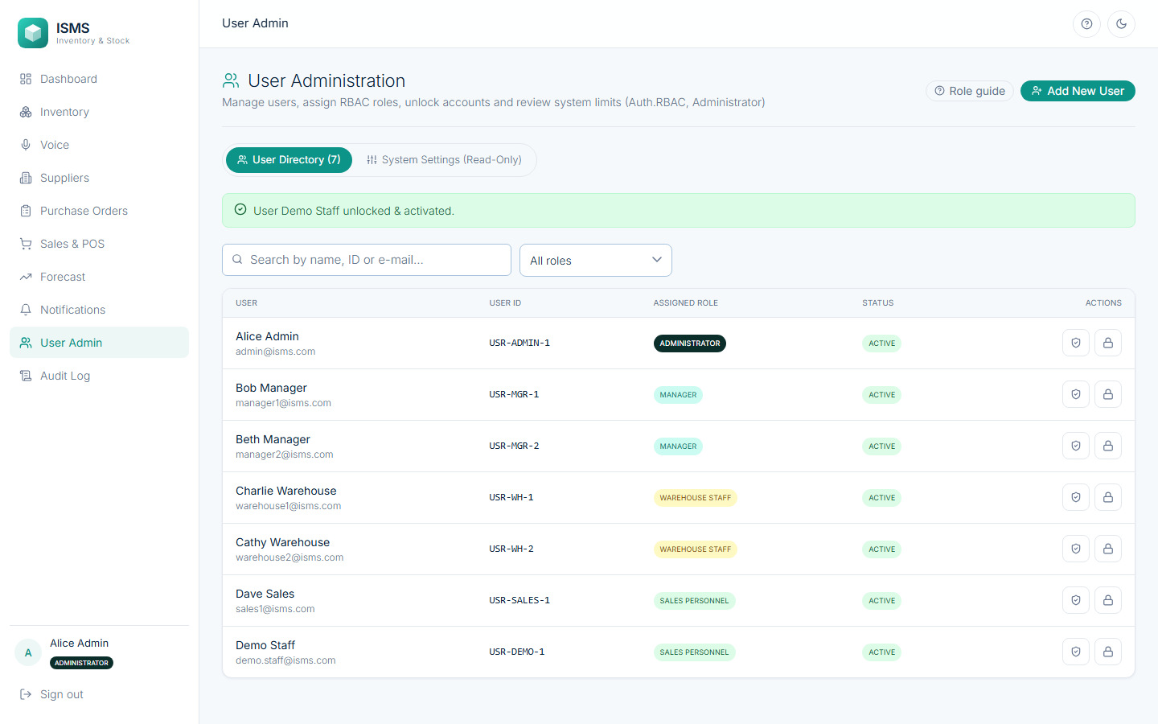
Fig. 23: After the Administrator unlocks the account, the user is Active again and can sign in
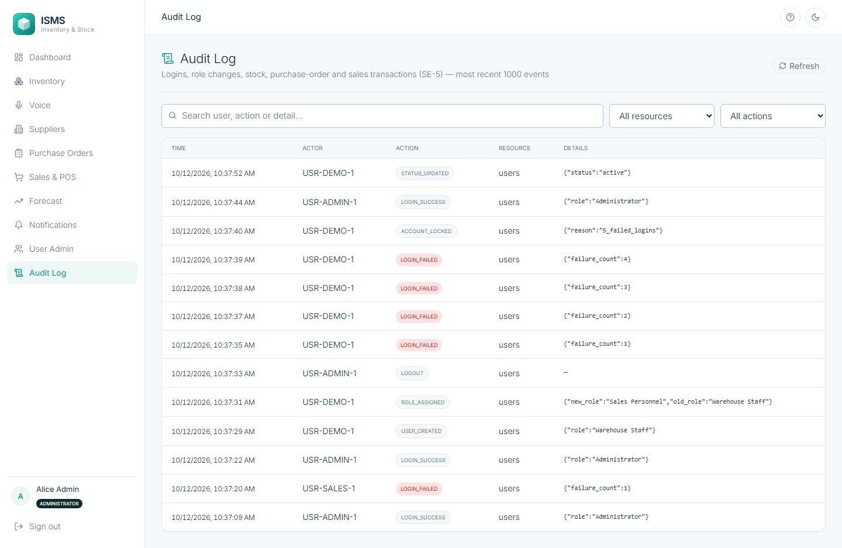
Fig. 24: Audit log (SE-5): LOGIN_SUCCESS, LOGIN_FAILED, ACCOUNT_LOCKED, LOGOUT, USER_CREATED and ROLE_ASSIGNED events with actor and time
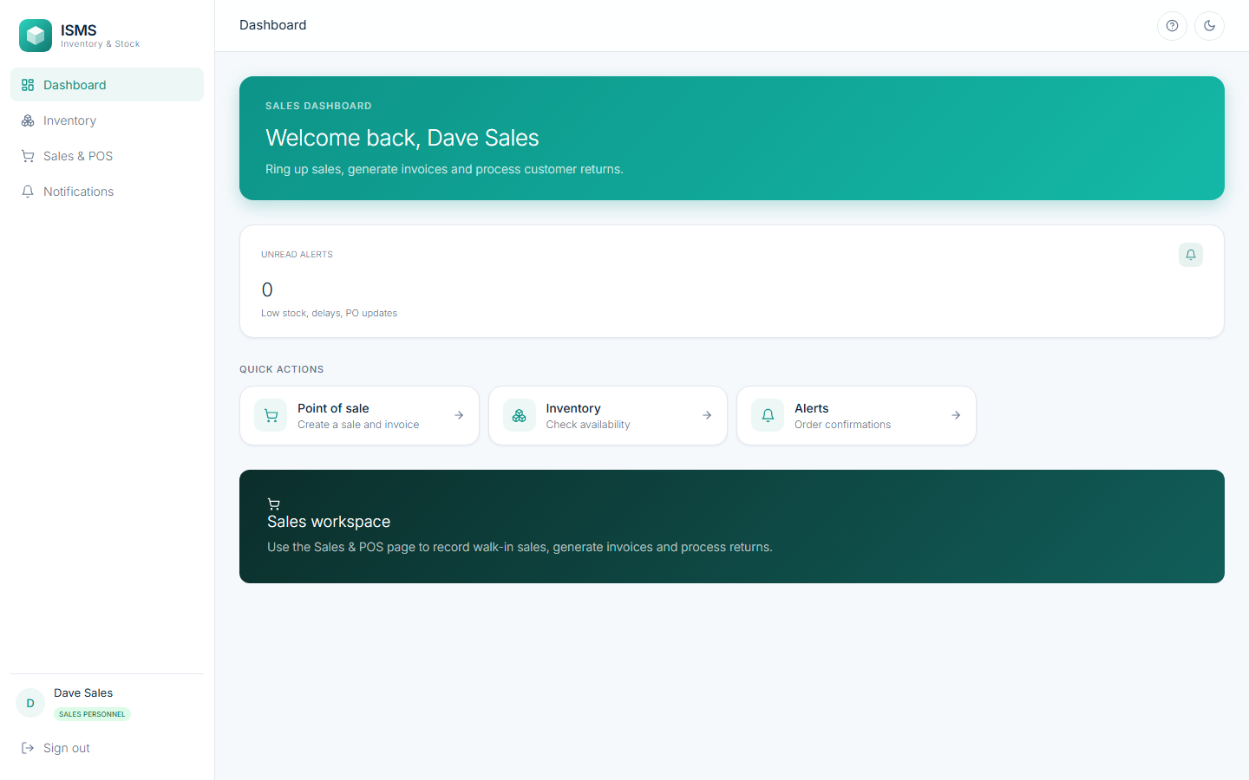
Fig. 25: Sales Personnel: only the menu items allowed for the role are shown (Auth.RBAC.Enforce)
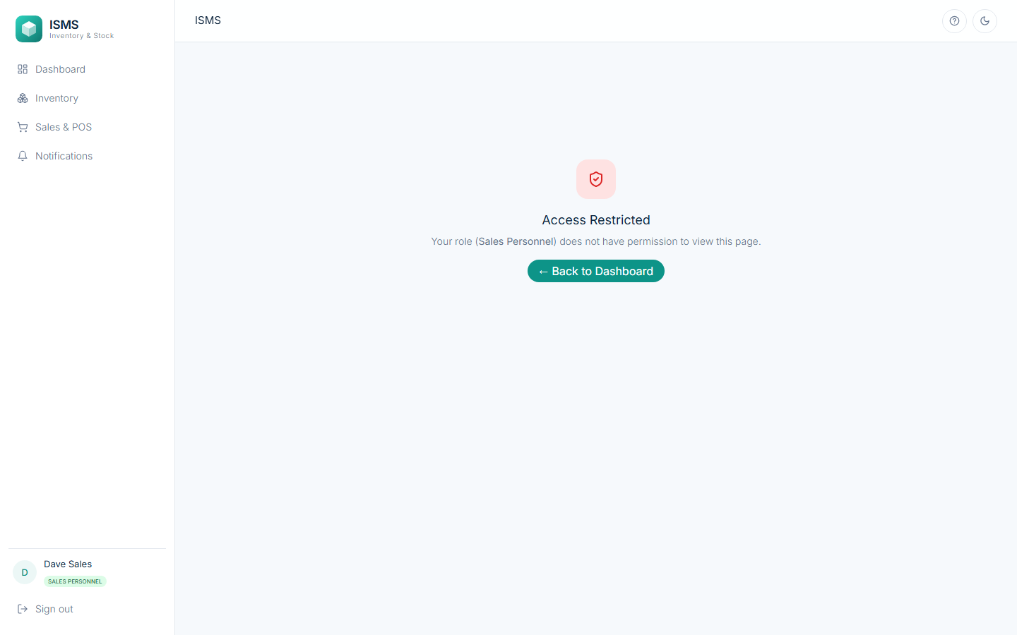
Fig. 26: A Sales Personnel user who types /users in the browser is shown “Access Restricted”
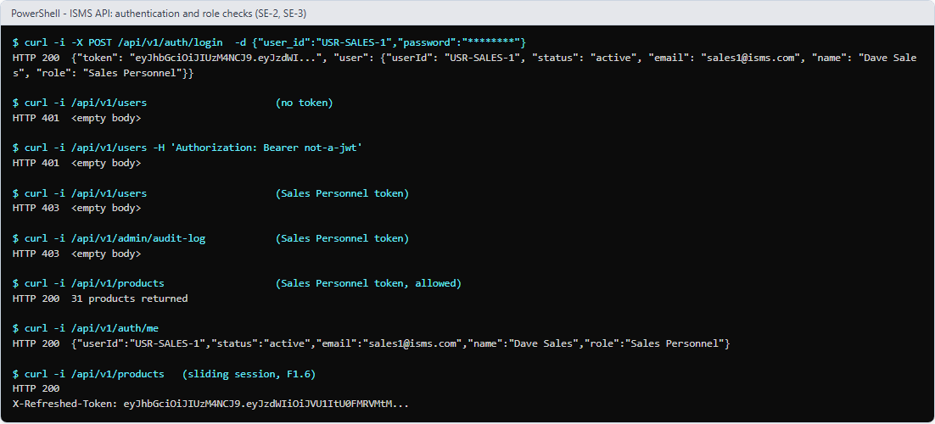
Fig. 27: The API enforces the same rules: 401 without a valid token, 403 for the wrong role, 200 for allowed calls, and a refreshed token on each request
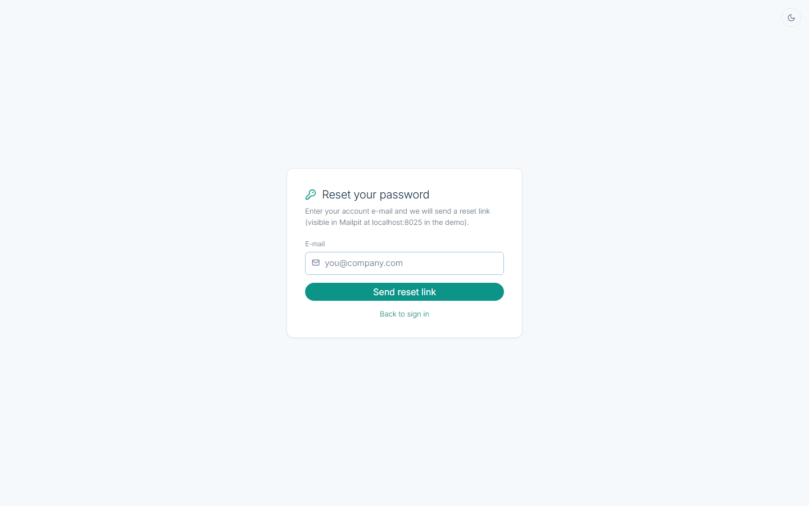
Fig. 28: Password reset, step 1: request a link for the registered e-mail address
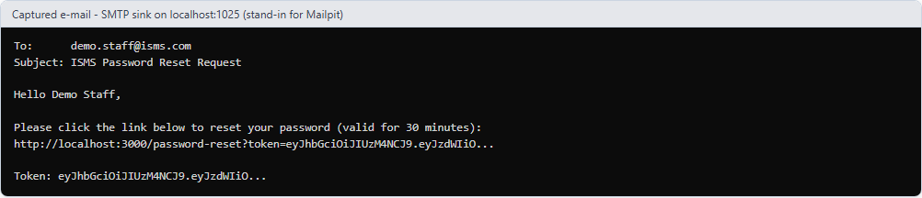
Fig. 29: Password reset, step 2: the e-mail received (captured by a local SMTP server on port 1025; Mailpit in the Docker set-up)
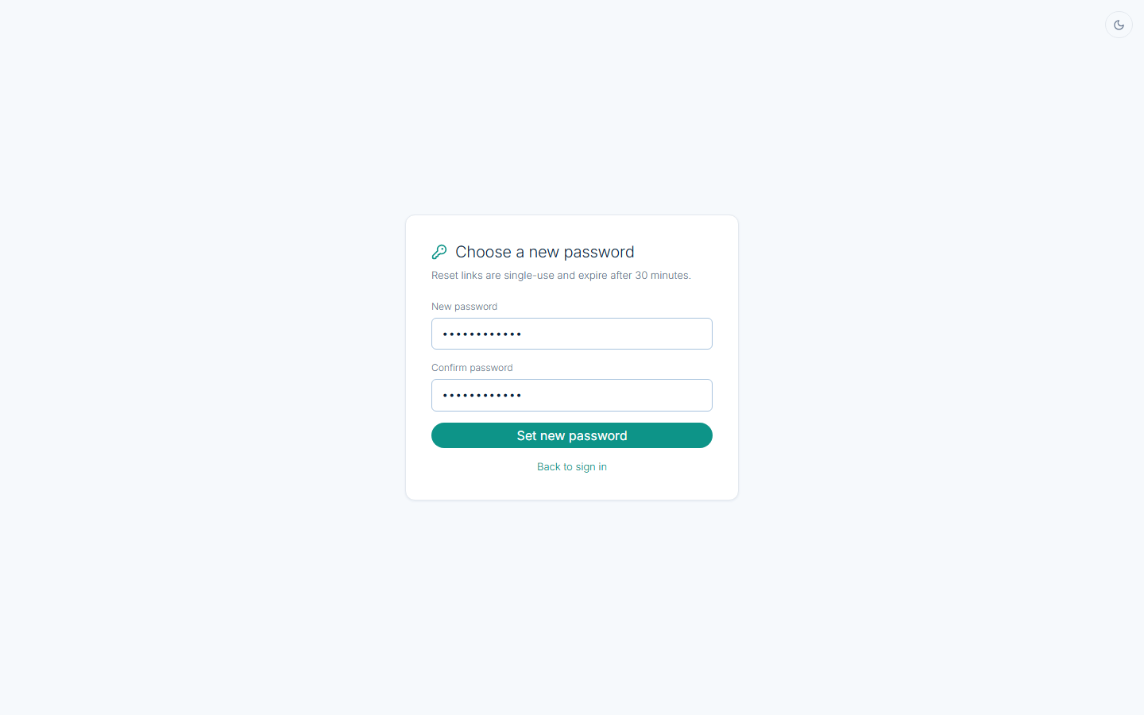
Fig. 30: Password reset, step 3: choose a new password using the single-use link
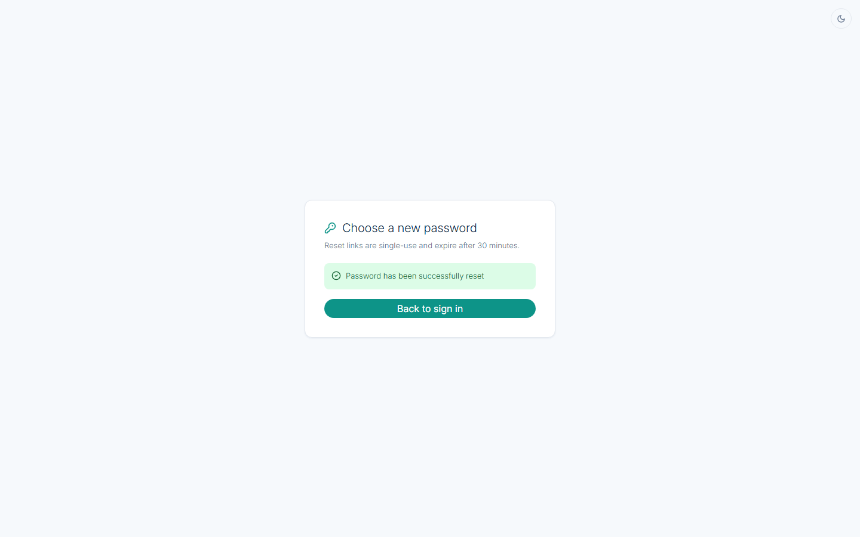
Fig. 31: Password changed successfully; the same link cannot be used a second time
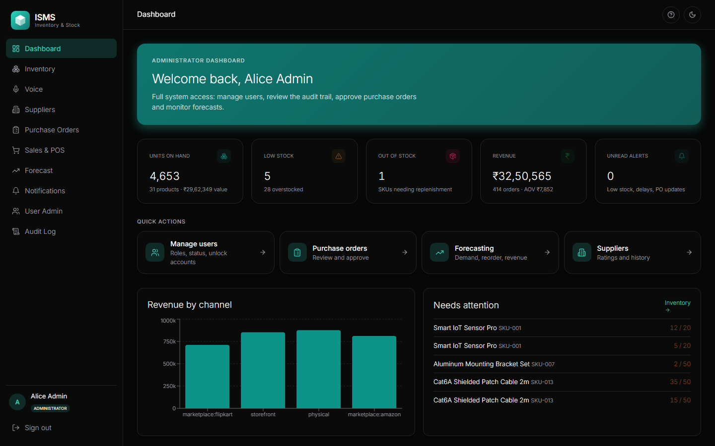
Fig. 32: Black dark theme of the same dashboard (switch at the top right; remembered per browser)
4. Core Module 2: Voice-Enabled Inventory & Omnichannel Synchronization
Traceability: SRS 4.2 (Inventory.CRUD.Create / Update / Delete, Inventory.Search, Voice.Command.Capture / Interpret / Confirm / LowConfidence, Sync.Channel.Realtime, Sync.Channel.Conflict) · BR-3, PE-1, PE-2, SA-2, Robustness-1, UI-3 · Use case “Manage Inventory (Stock)” «include» Add / Update / Adjust / Delete Stock and Search / View Inventory, with the «extend» “Low Stock Alert” and “Voice Command (Hands-free Operation)” · Classes Product (create, update, delete, search), StockRecord (update_stock, deduct_stock, realtime_sync) and WarehouseStaff (capture_voice_command) · Sequence diagram SD-1 (search → create → update_stock → update → update_stock → delete → loop capture_voice_command → update_stock → realtime_sync → alt trigger_low_stock / send_audio_alert) · DFD 4.0 Manage Inventory Operations, Level 2 steps 4.1 Select Inventory Operation → Use Voice Command? → 4.2 Speech-to-Text → 4.3 Interpret → 4.4 Confirm (Text-to-Speech) → 4.5 Update Stock Record · Data stores D3 Product, D4 Stock Record.
Functionalities implemented
• Product CRUD: create a product with SKU, name, category, unit, price and reorder point (an initial stock record is created); edit its attributes; delete it. A duplicate SKU is rejected with 409, and a delete is refused (`409 STOCK_EXISTS`) while any location still holds stock.
• Search and filter: by SKU or name and by category, with stock on hand, reserved quantity and a status of In Stock / Low Stock / Out of Stock.
• Stock updates under a row lock: every change reads the stock row FOR UPDATE, so simultaneous requests are serialised. A change can never take stock below zero (BR-3); the same rule is also a database CHECK constraint.
• Last-unit conflict (Sync.Channel.Conflict): when two channels try to take the last unit at the same moment, the first confirmed transaction wins and the other receives an out-of-stock rejection.
• Real-time synchronisation (PE-2): after the commit, the new quantity is pushed over WebSocket /ws/stock to every open screen and to the channel adapters; an open Inventory page updates without reloading.
• Low-stock alert (SD-1 `alt`): after any stock change, if the quantity is below the reorder point a Low Stock notification and an audio alert are raised; otherwise the “no alert required” branch runs.
• Voice commands: the Warehouse Staff screen captures speech (or a typed fallback), interprets action, SKU, quantity and location (including spoken numbers such as “twenty”), reads the command back and waits for confirmation. Below the confidence threshold (0.75) the user is asked to repeat or use the form. Commands issued offline are queued and replayed idempotently by client_id.
Key implementation code
Listing 4: Stock deduction: row lock, fresh read, then the BR-3 check (StockRecord.deduct_stock)
// StockRecordService.java
StockRecord stock = stockRecordRepository.findBySkuIdAndLocationIdForUpdate(skuId, locationId)
.orElseGet(() -> {
StockRecord newStock = new StockRecord(
new StockRecordId(skuId, locationId),
product,
0,
0,
OffsetDateTime.now()
);
return stockRecordRepository.save(newStock);
});

stock.setQuantityOnHand(quantityOnHand);
stock.setLastUpdated(OffsetDateTime.now());

Listing 5: Voice step of SD-1: the “Confidence ≥ threshold?” decision and the read-back before confirmation
// WarehouseStaffService.java
public Map<String, Object> captureVoiceCommand(String transcript, double confidence, String deviceId) {
double threshold = appProperties.voice().confidenceThreshold();
if (confidence < threshold) {
return Map.of(
"status", "low_confidence",
"action", "repeat_or_use_ui",
"confidence", confidence,
"threshold", threshold
);
}

VoiceInterpreter.InterpretationResult result = voiceInterpreter.interpret(transcript);
if (!result.valid()) {
return Map.of(
"status", "low_confidence",
"action", "repeat_or_use_ui",
"error", result.error() != null ? result.error() : "Could not understand command"
);
}

String token = "VCT-" + UUID.randomUUID().toString().substring(0, 8);
pendingTokens.put(token, result);

return Map.of(
"status", "needs_confirmation",
"token", token,
"spoken_text", result.spokenText(),
...

Output screenshots: Module 2
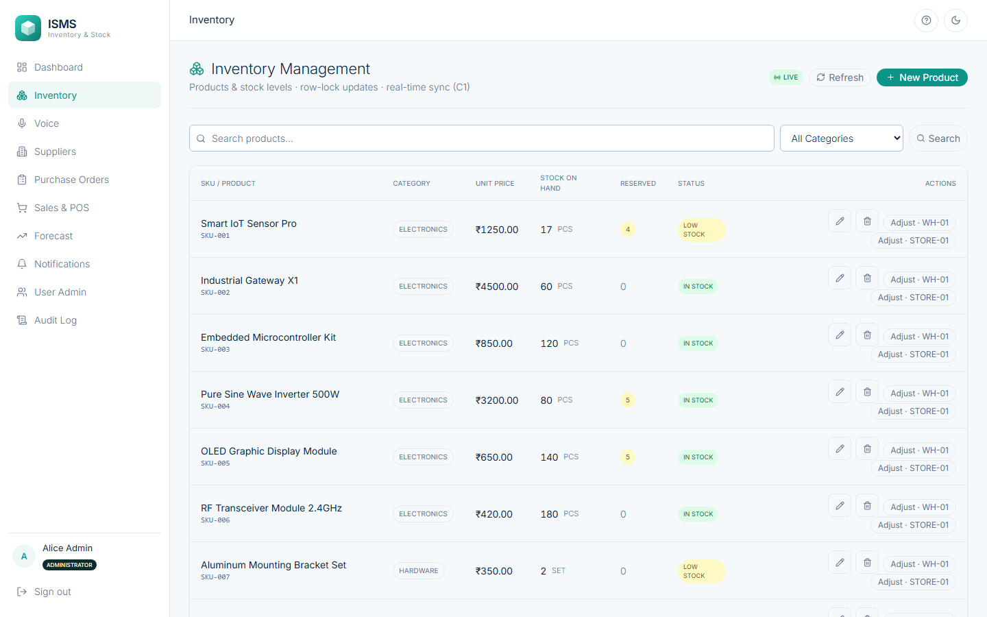
Fig. 33: Inventory list: products with stock on hand, reserved quantity and status; the LIVE badge shows the WebSocket connection
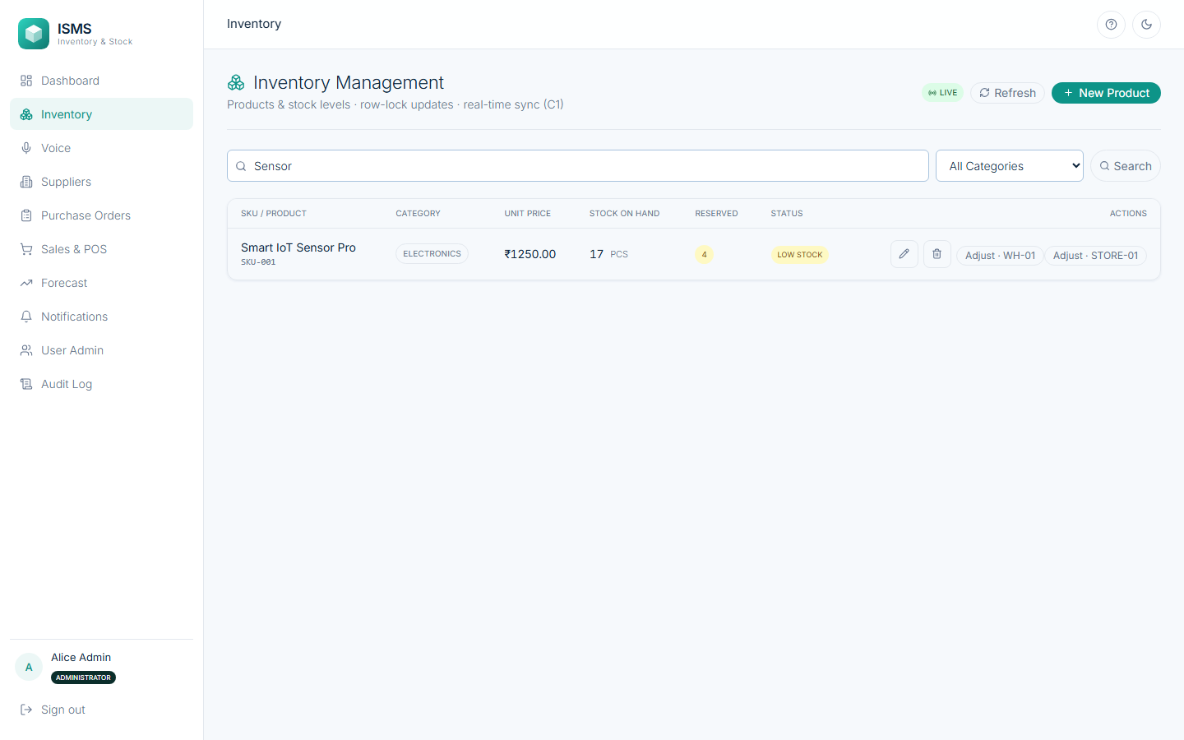
Fig. 34: Search by name: only the matching product is listed (Inventory.Search)
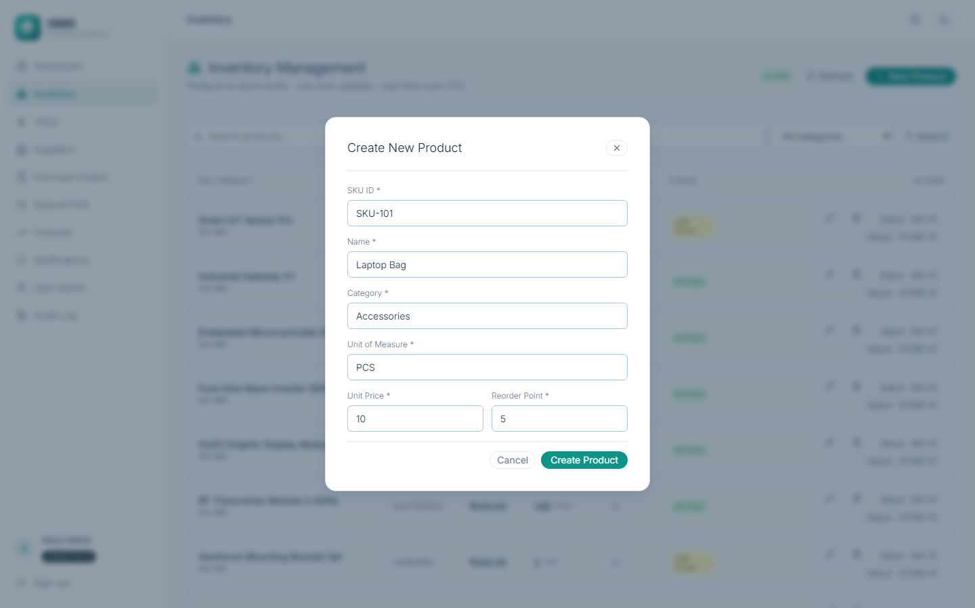
Fig. 35: Create a product: SKU, name, category, unit of measure, price and reorder point (Inventory.CRUD.Create)
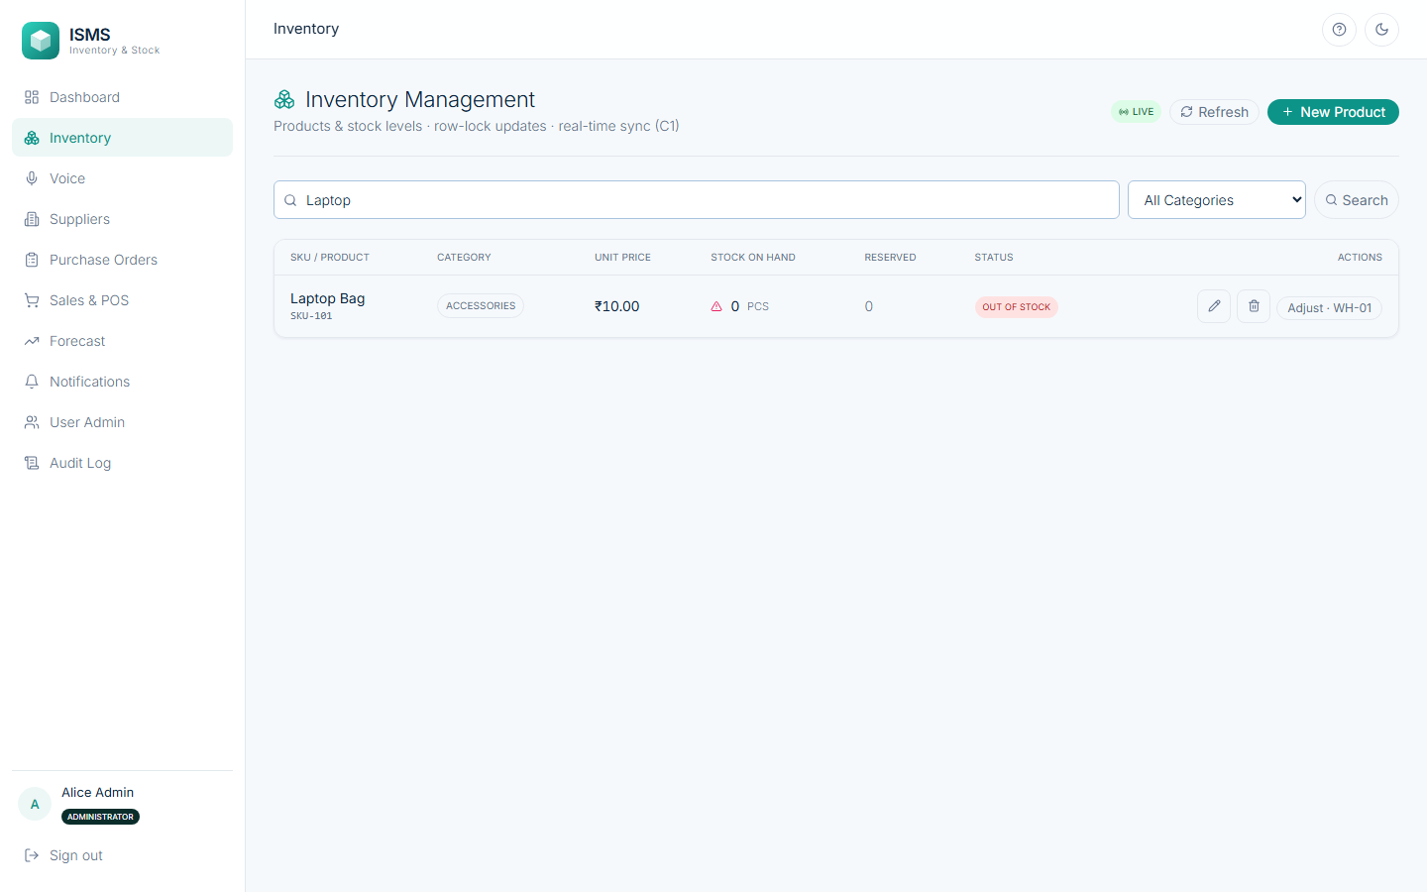
Fig. 36: Product SKU-101 created with an initial stock of 0
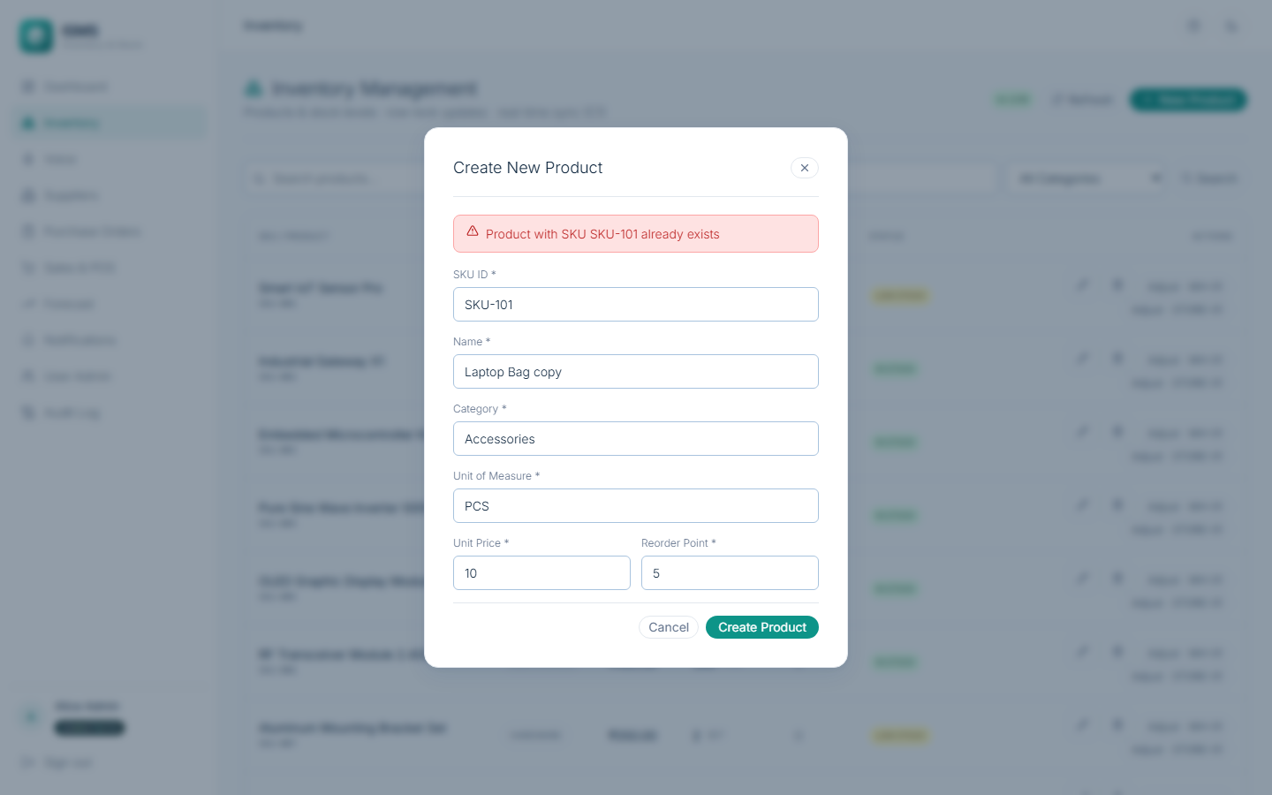
Fig. 37: Duplicate SKU: the second create is refused with a clear message (409)
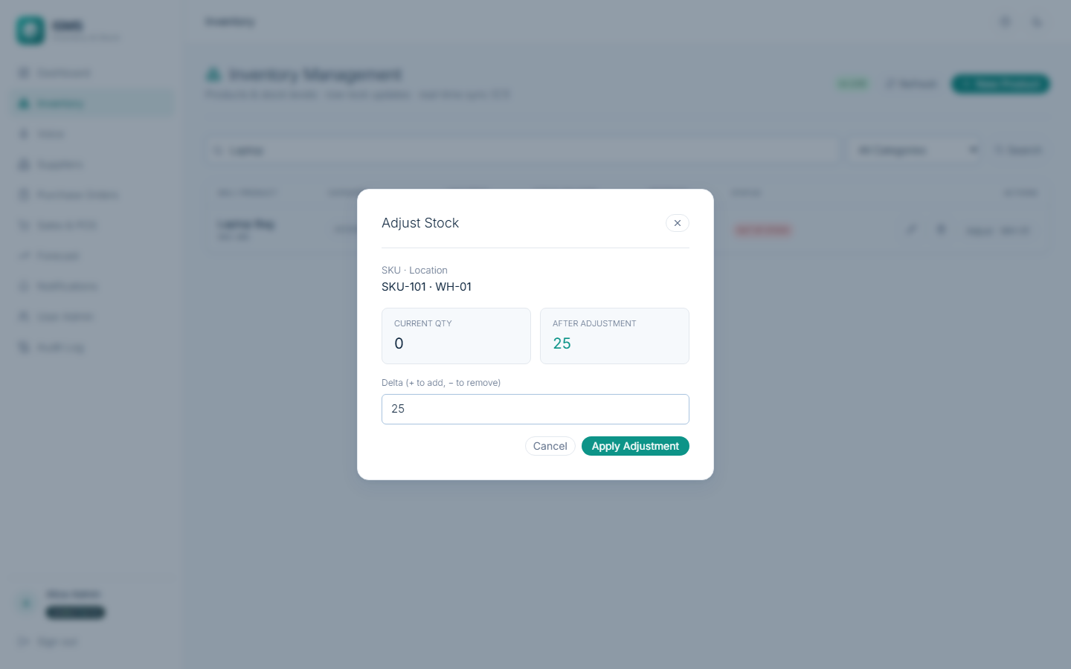
Fig. 38: Adjust stock: the dialog shows the current quantity and the quantity after the adjustment
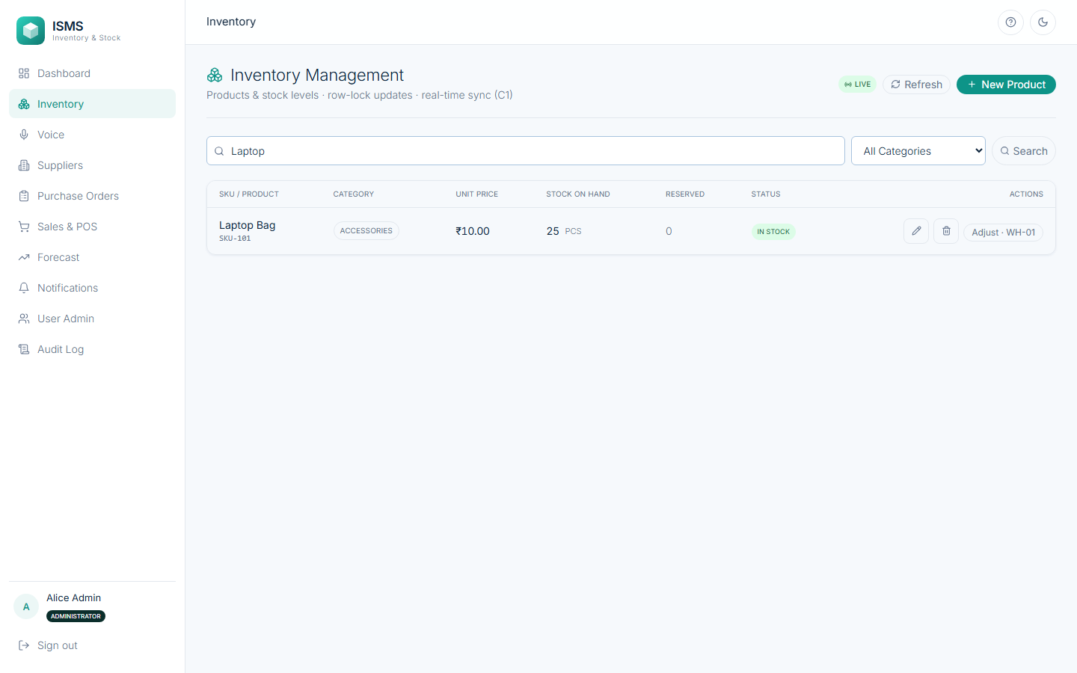
Fig. 39: Stock of SKU-101 is now 25 units (StockRecord.update_stock)
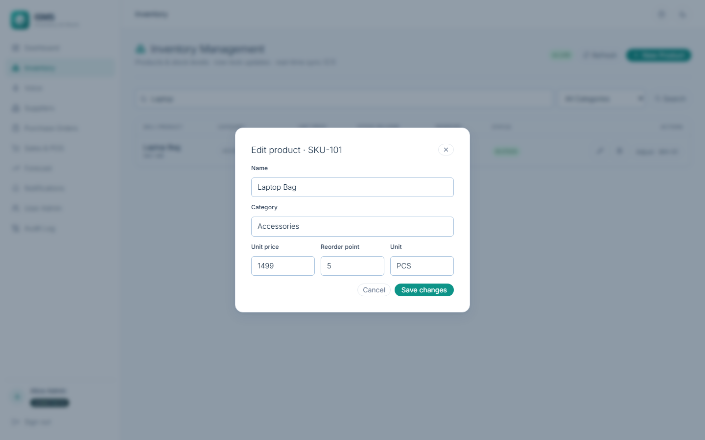
Fig. 40: Edit product: price changed to 1499 (Inventory.CRUD.Update)
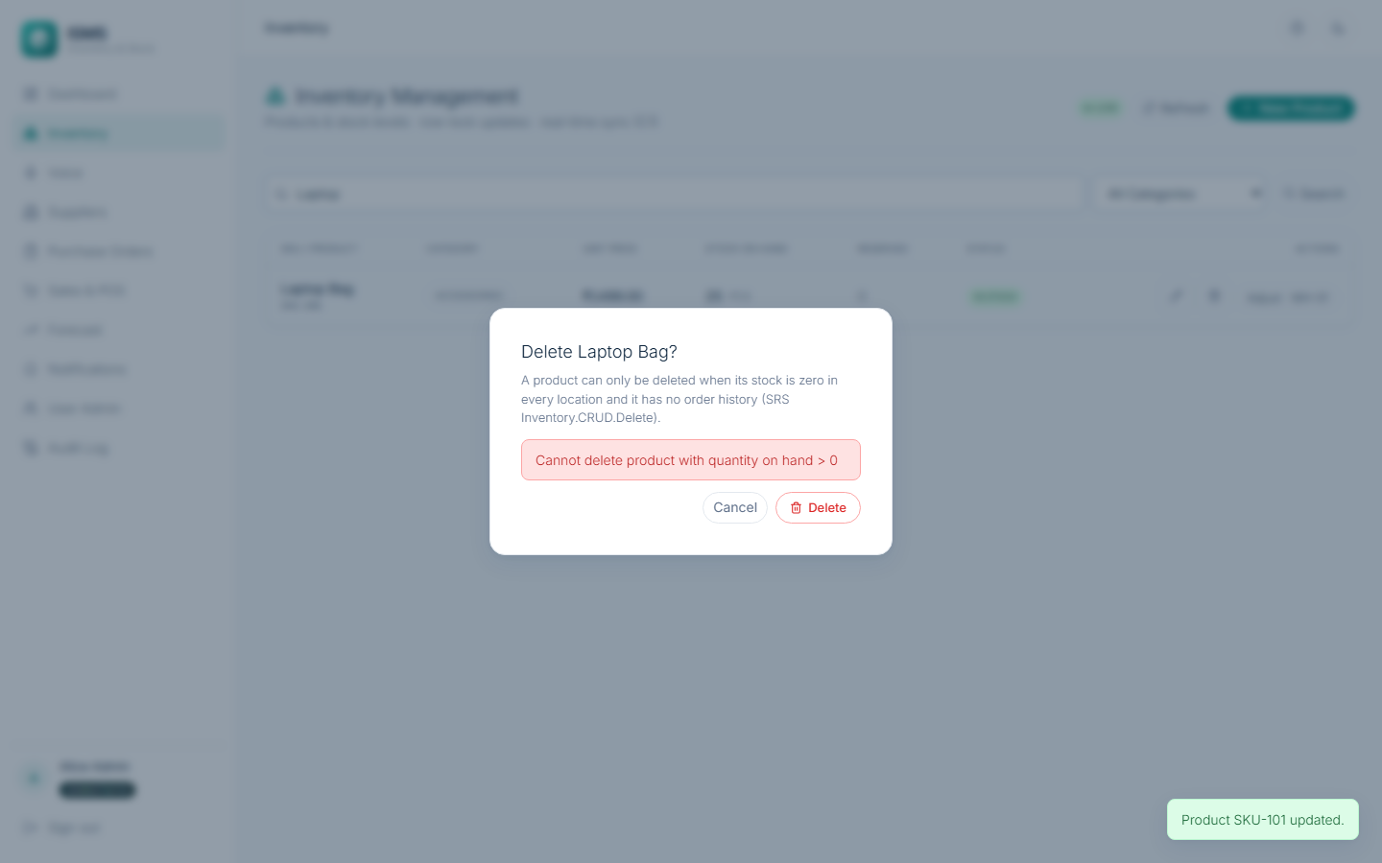
Fig. 41: Delete refused while stock exists: “Cannot delete product with quantity on hand > 0” (Inventory.CRUD.Delete)
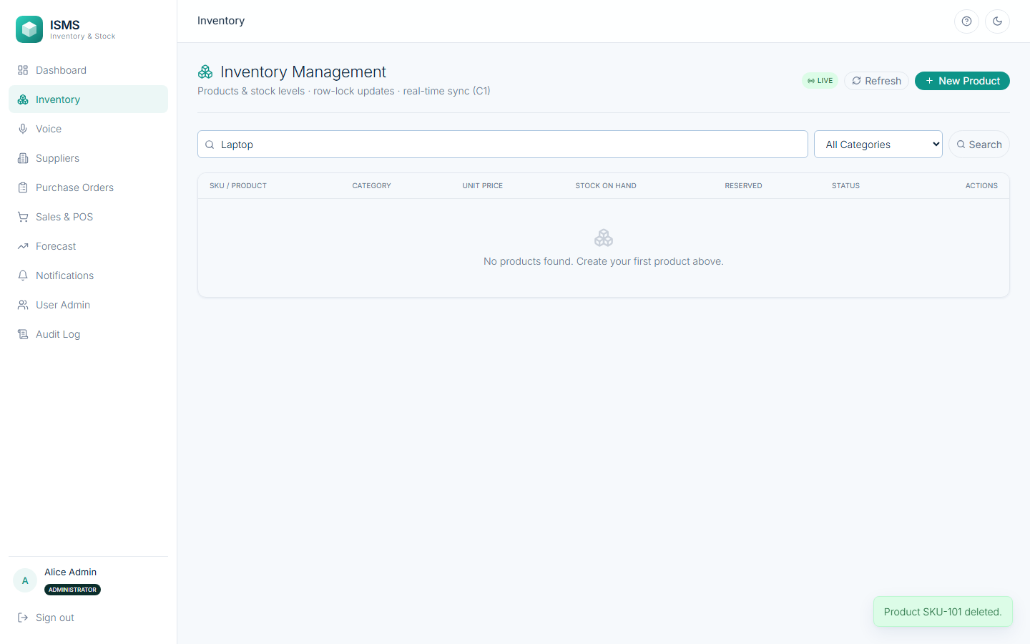
Fig. 42: After the stock is brought to zero, the same product can be deleted
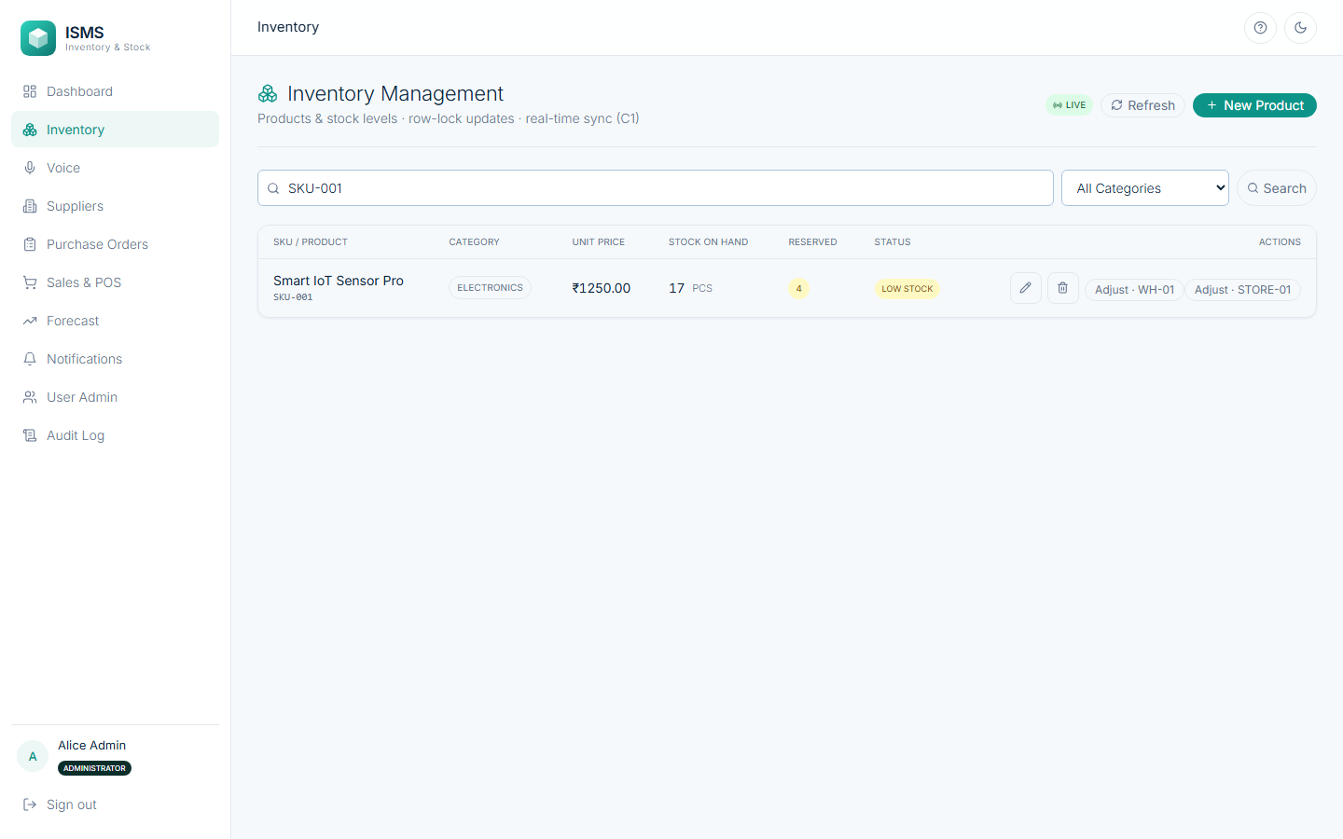
Fig. 43: Real-time sync, before: SKU-001 shows 17 units on one open screen
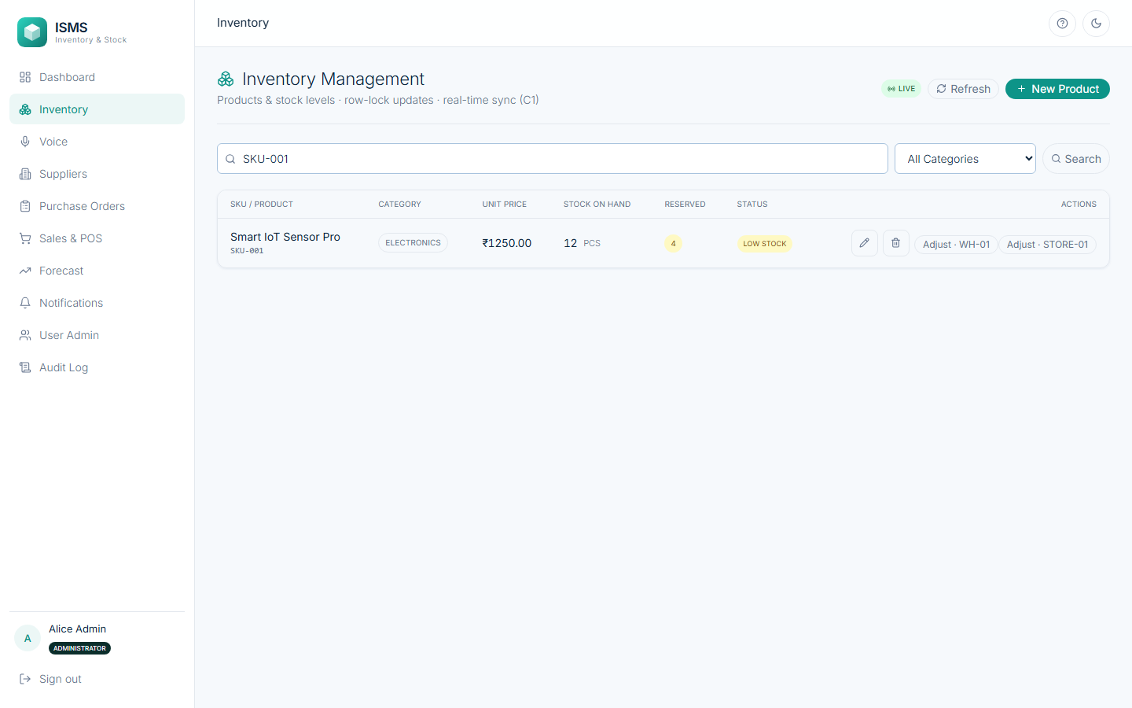
Fig. 44: Real-time sync, after: another user lowered WH-01 to 7 units; this screen now shows 12 (7 + 5) without a reload and the status turned Low Stock
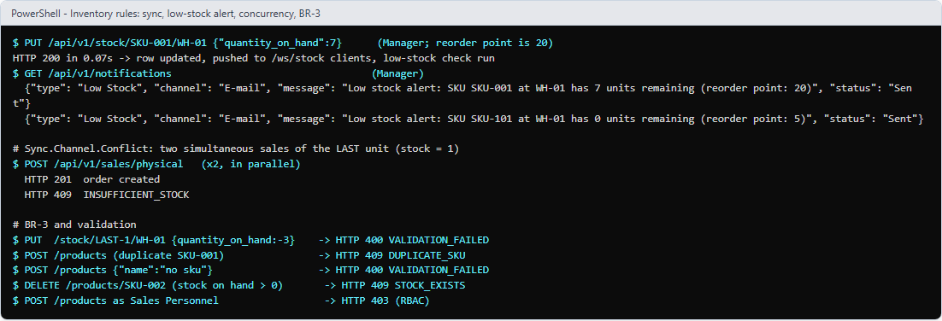
Fig. 45: Business rules in the API: sync time, the low-stock alert, the last-unit race (one 201, one 409), BR-3 and validation errors, guarded delete and RBAC
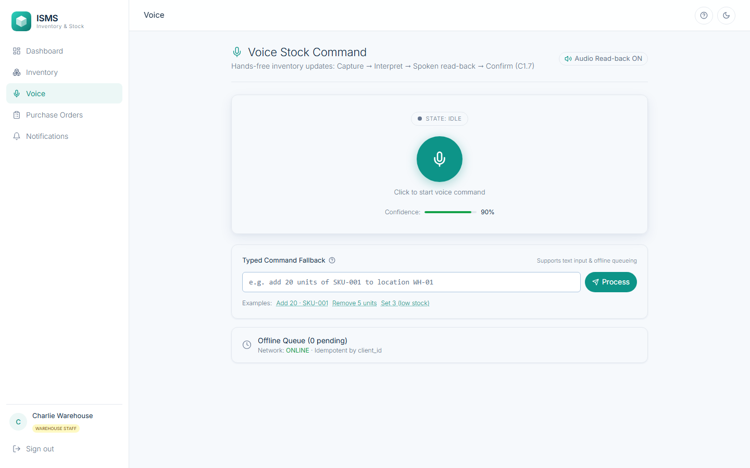
Fig. 46: Voice Stock Command (Warehouse Staff): microphone, state indicator (UI-3), typed fallback and offline queue
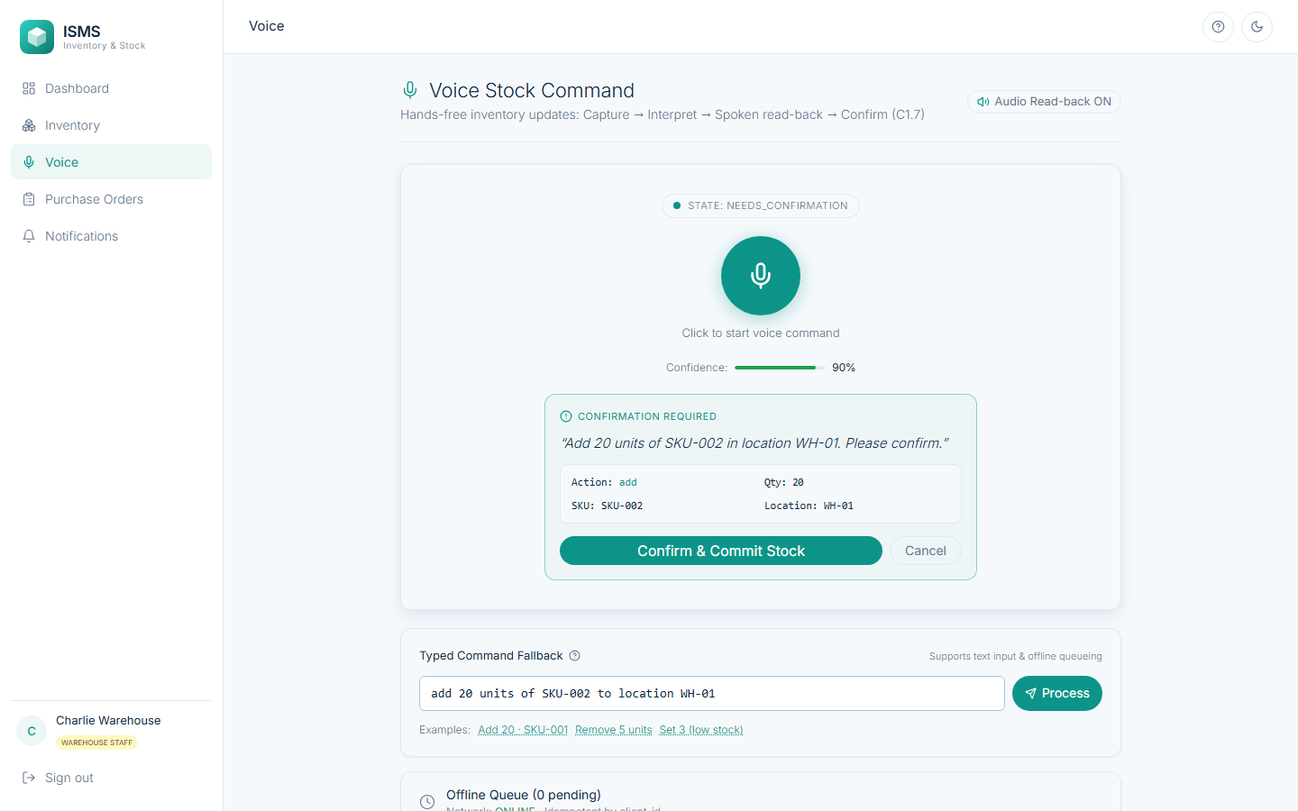
Fig. 47: Interpretation and read-back: “Add 20 units of SKU-002 in location WH-01. Please confirm.” with action, quantity, SKU and location
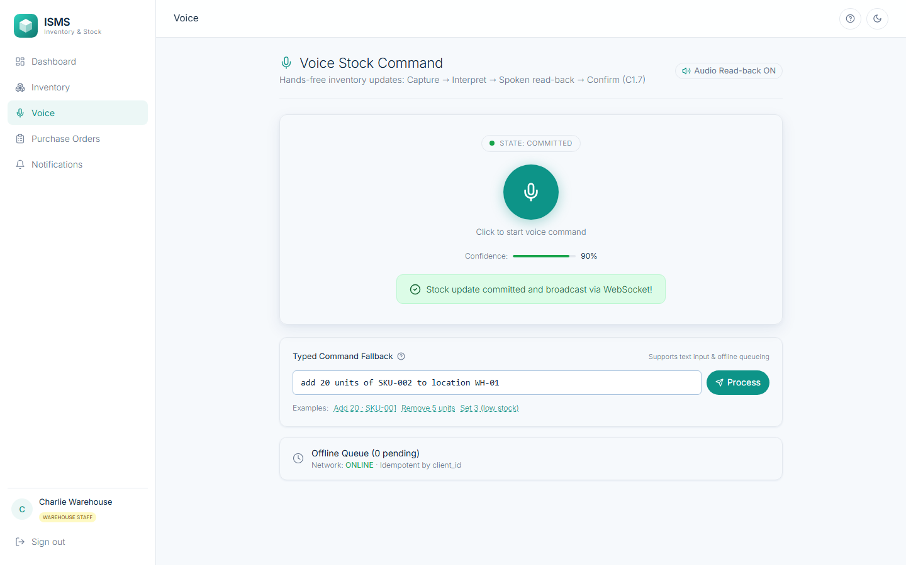
Fig. 48: After confirmation the stock update is committed and broadcast over WebSocket (state: COMMITTED)
5. Supporting Modules Implemented
To run the two core modules inside a complete system, the remaining SRS features were also implemented. They are summarised below with screenshots; their automated tests are listed in the Testing section.
5.1 Module 3: Supplier Management (SRS 4.3, DFD 2.0, D2) — Dev
Managers and Administrators create and edit supplier profiles, search them ranked by rating, and view each supplier's purchase-order history and on-time rate. The rating is recalculated only when a purchase order reaches Received or Cancelled (BR-4), and only an Administrator may deactivate a supplier, and only when no purchase order is open (BR-5).
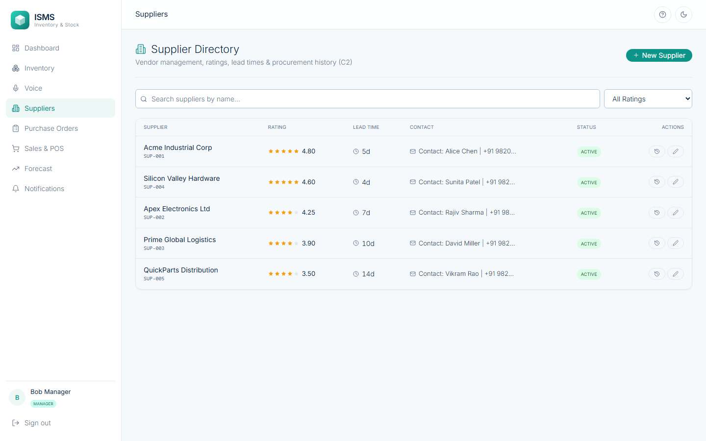
Fig. 49: Suppliers: rating, lead time, contact and status
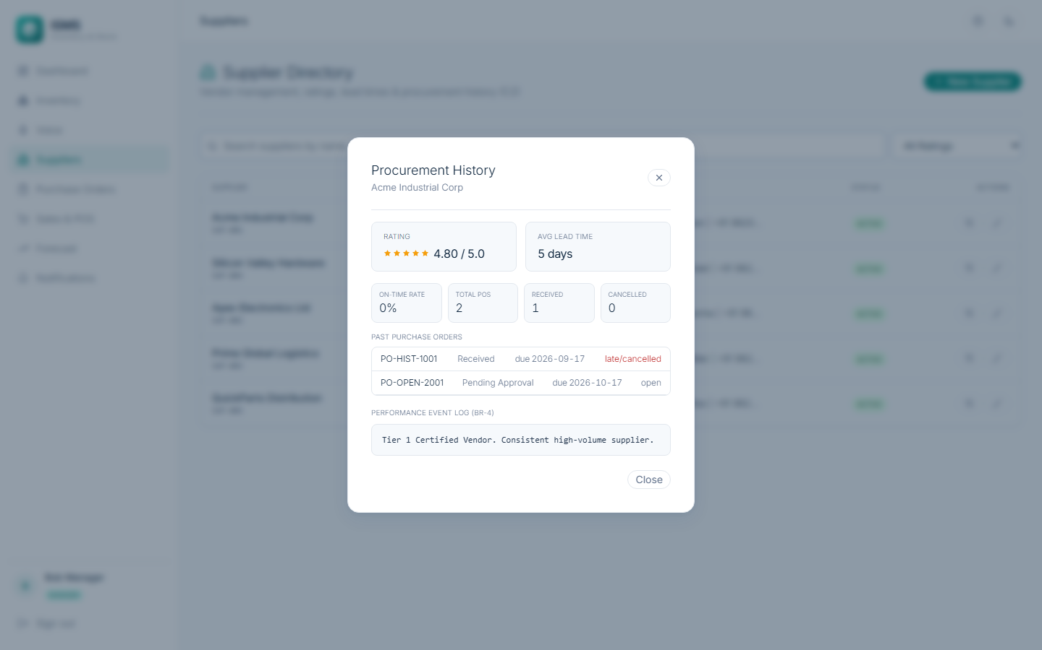
Fig. 50: Supplier performance history: rating, on-time rate and past purchase orders (Supplier.Performance.View)
5.2 Module 4: Purchase Order Management (SRS 4.4, DFD 6.0, D7, SD-2) — Stavan
A purchase order moves through six states: Draft, Pending Approval, Approved, Partially Received, Received and Cancelled. Only a Manager or Administrator may create, approve or reject (BR-1); a Manager's approval is limited by a configurable amount and every PO must keep the supplier within its credit limit (BR-2); a rejection returns the PO to Draft with the reason sent to the creator. Warehouse Staff confirm receipt per line, partial receipts keep the rest open, and each receipt raises stock.
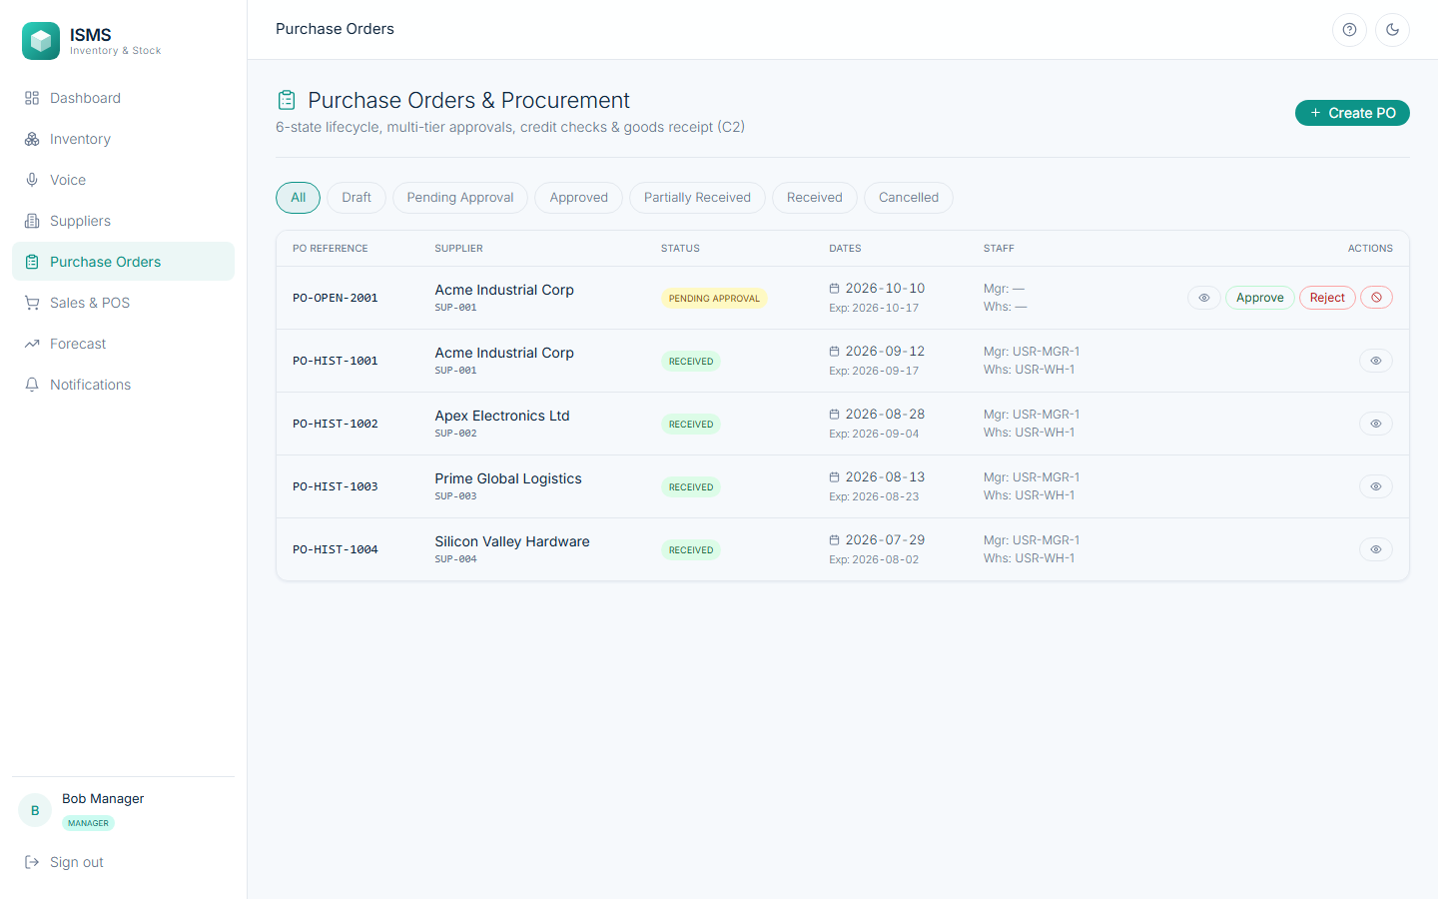
Fig. 51: Purchase orders with status, supplier, dates and the actions allowed for the signed-in role
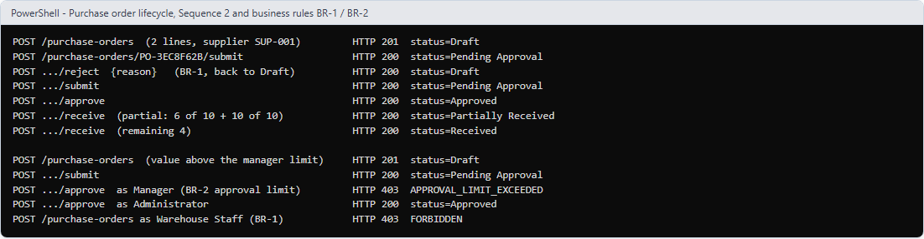
Fig. 52: Sequence SD-2 and BR-1/BR-2 through the API: reject back to Draft, partial then full receipt, manager refused above the limit while the Administrator may approve
5.3 Module 5: Sales Tracking & Order Management (SRS 4.5, DFD 3.0, D5, SD-3) — Dev
Sales Personnel log physical sales at the POS terminal (barcode-wedge input or quick-add). The stock is checked and deducted atomically, a PDF invoice with items, quantities, prices and tax is generated, and returns restore stock. Marketplace orders arrive as webhooks whose HMAC-SHA256 signature is verified; repeated events change nothing. If stock is insufficient the order is rejected, kept as Rejected and the Manager is notified.
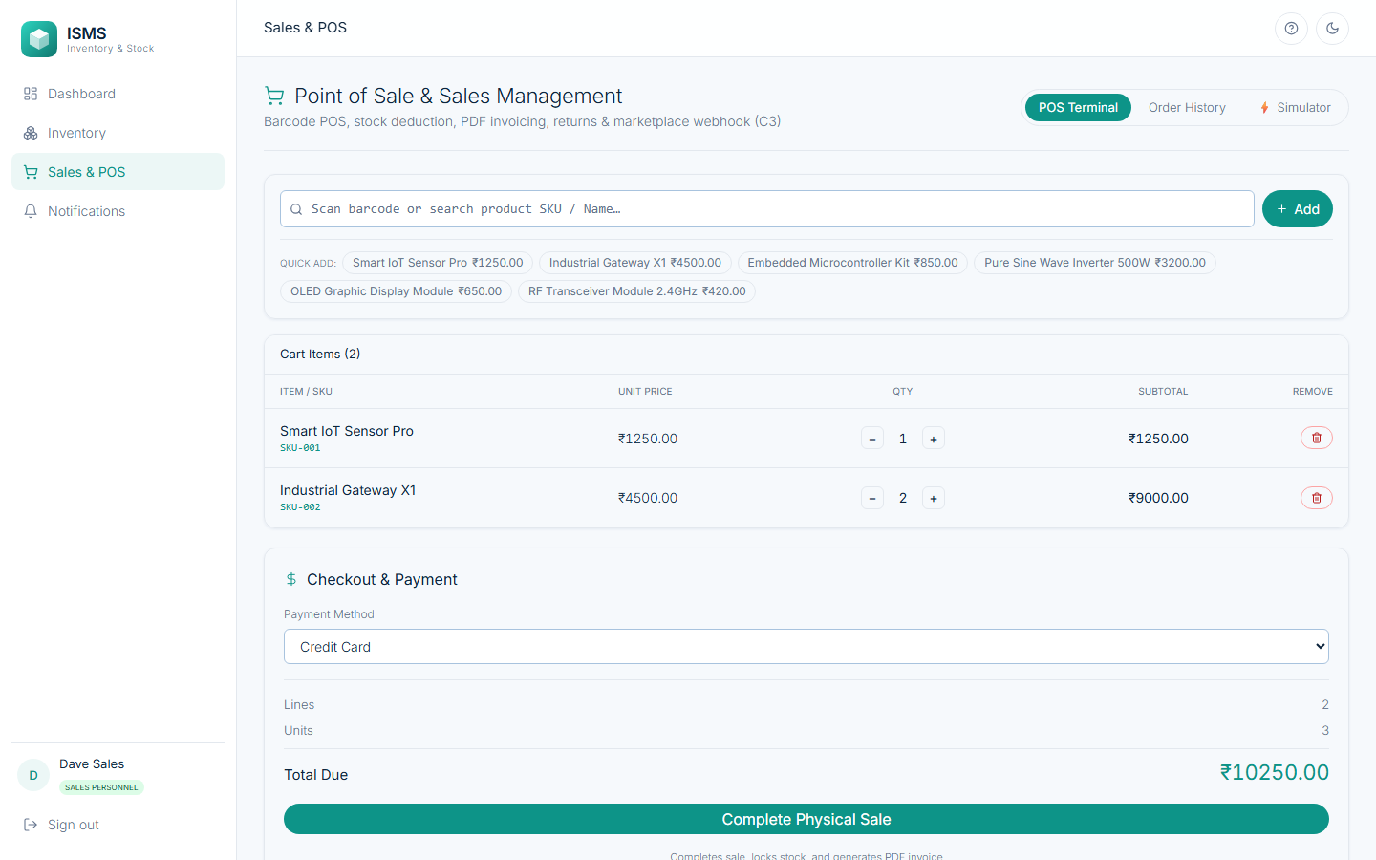
Fig. 53: POS terminal: cart built with quick-add, payment method and total due
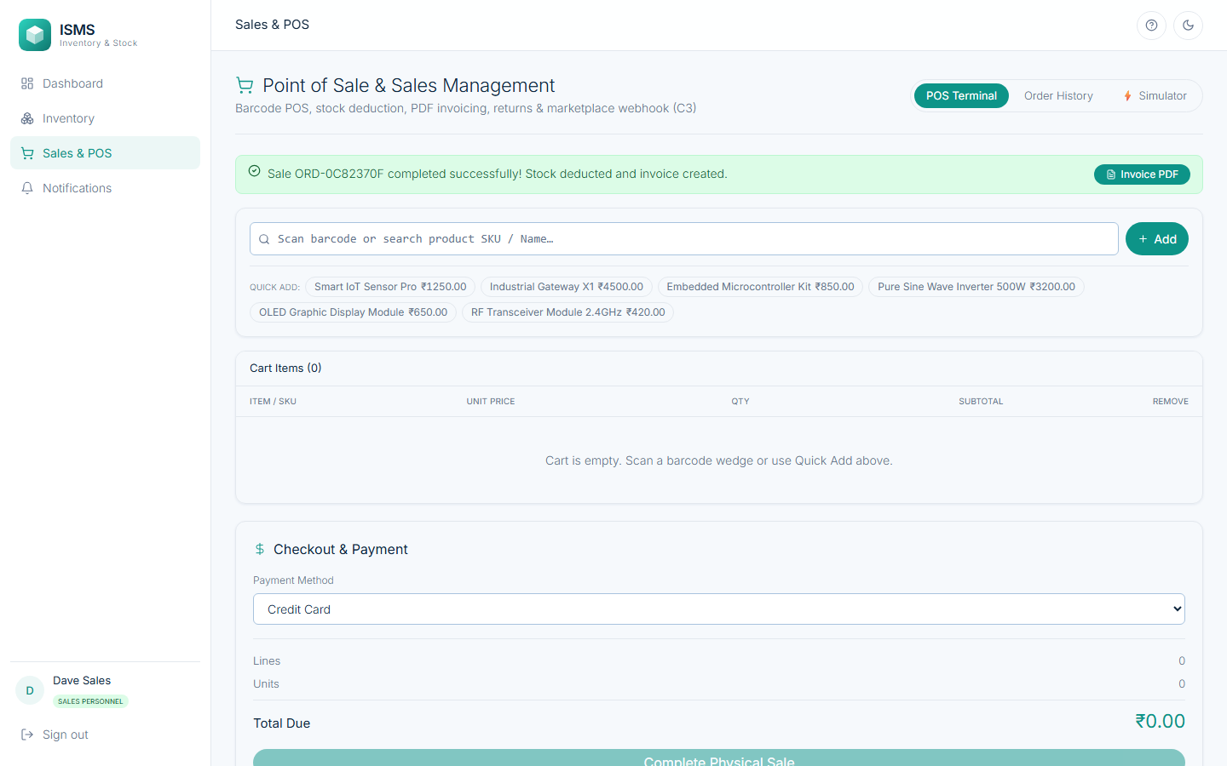
Fig. 54: Sale completed: stock deducted and the invoice is available as a PDF
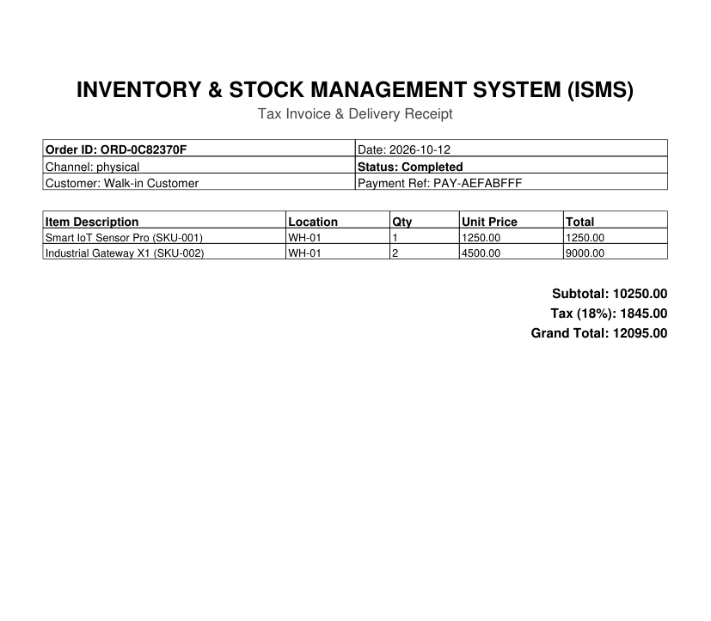
Fig. 55: The generated PDF invoice (OpenPDF)
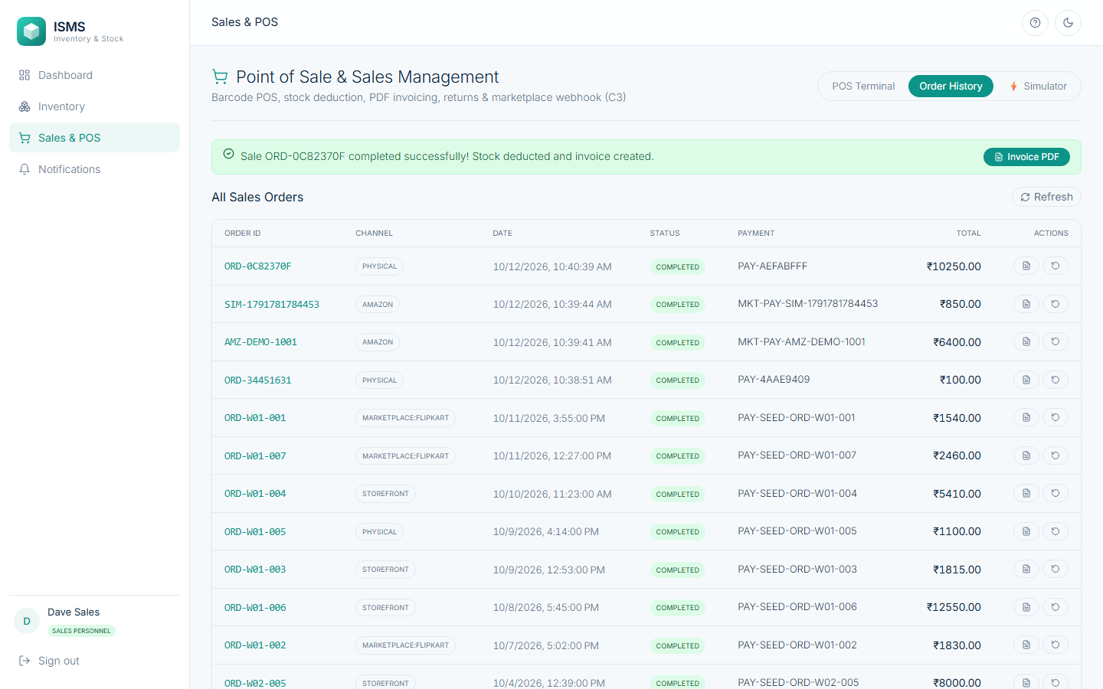
Fig. 56: Order history with channel, status, payment reference and total; invoice and return actions per order
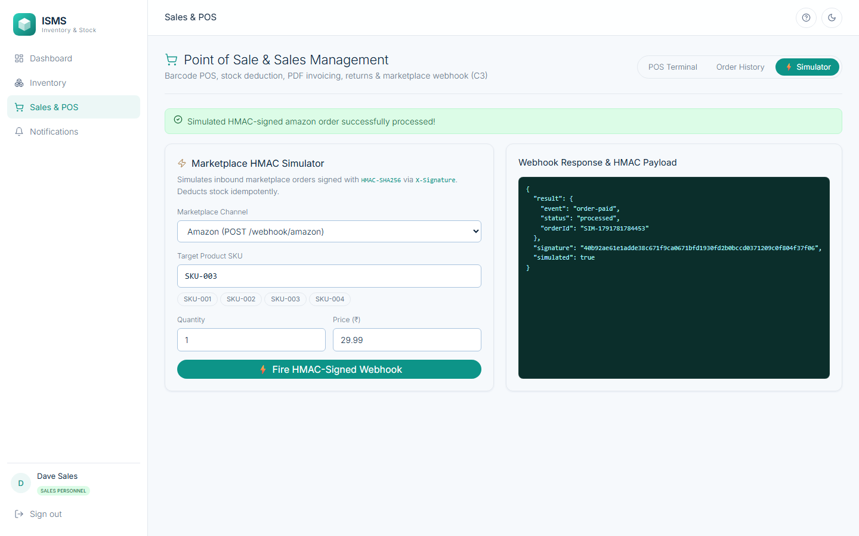
Fig. 57: Marketplace simulator: an HMAC-signed order is posted to the webhook and the response is shown
5.4 Module 6: Predictive Analytics & AI Forecasting (SRS 4.6, DFD 5.0, D6) — Stavan
A Holt-Winters additive model (with a seasonal-naive fallback for short histories) forecasts weekly demand per SKU. The page shows the forecast, recommended reorder quantity (from supplier lead time), one-click draft purchase orders, forecast accuracy (predicted versus actual, fed by every sale) and revenue and stock analytics.
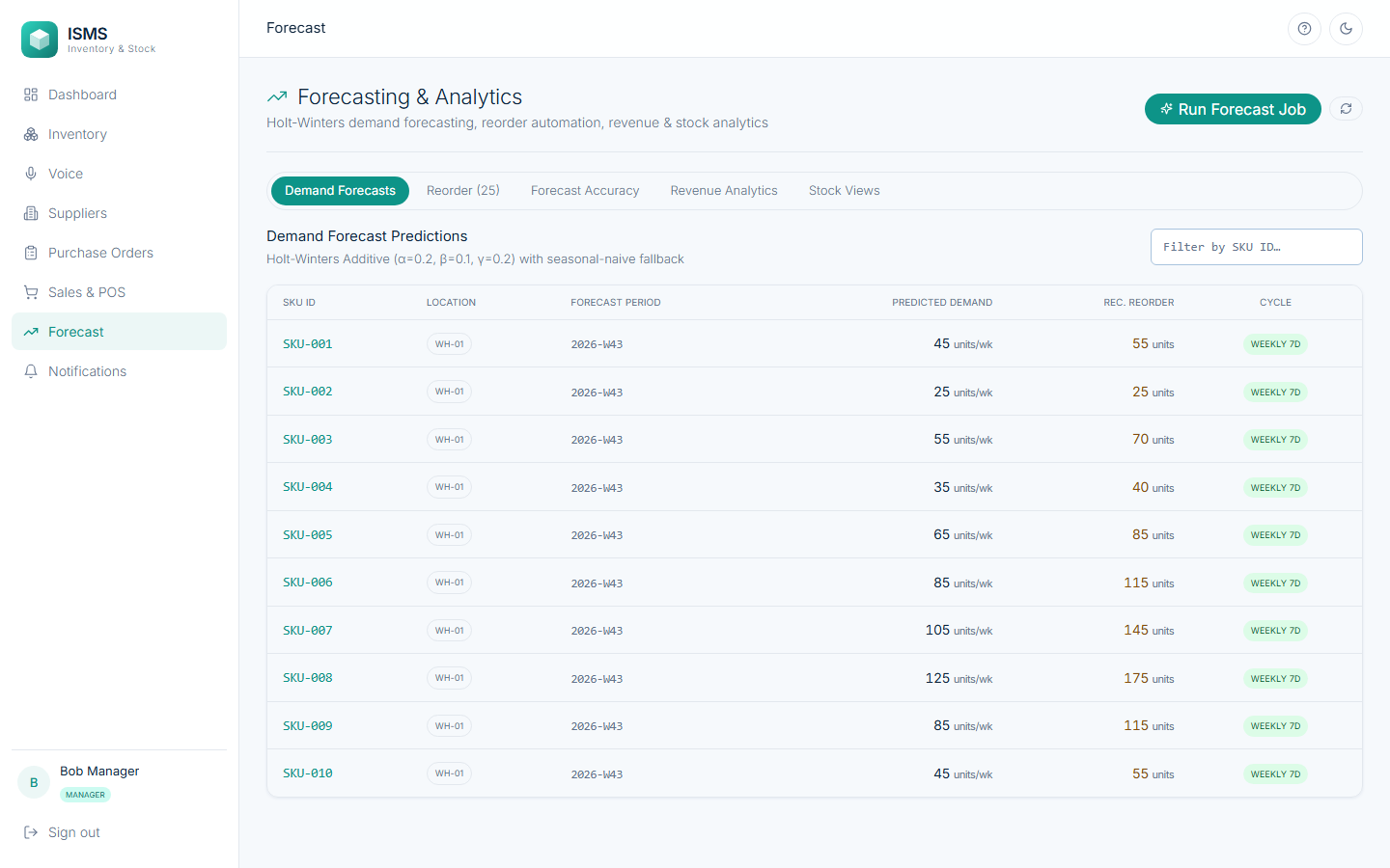
Fig. 58: Demand forecast per SKU with the recommended reorder quantity and the detected cycle
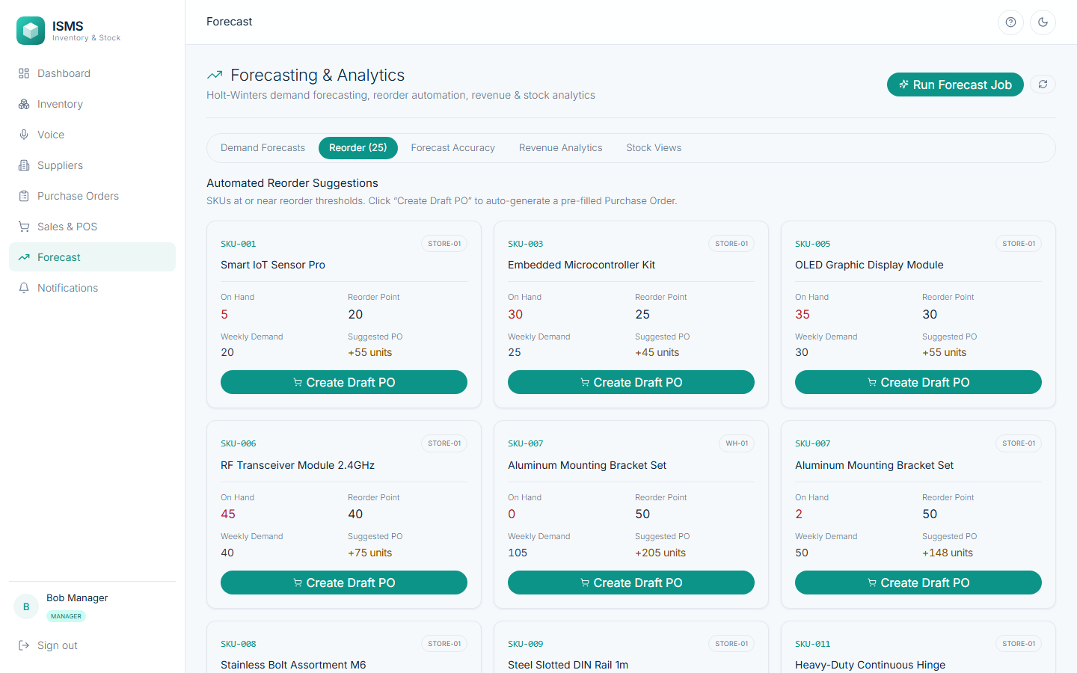
Fig. 59: Reorder suggestions: SKUs near their reorder point with a one-click “Create Draft PO”
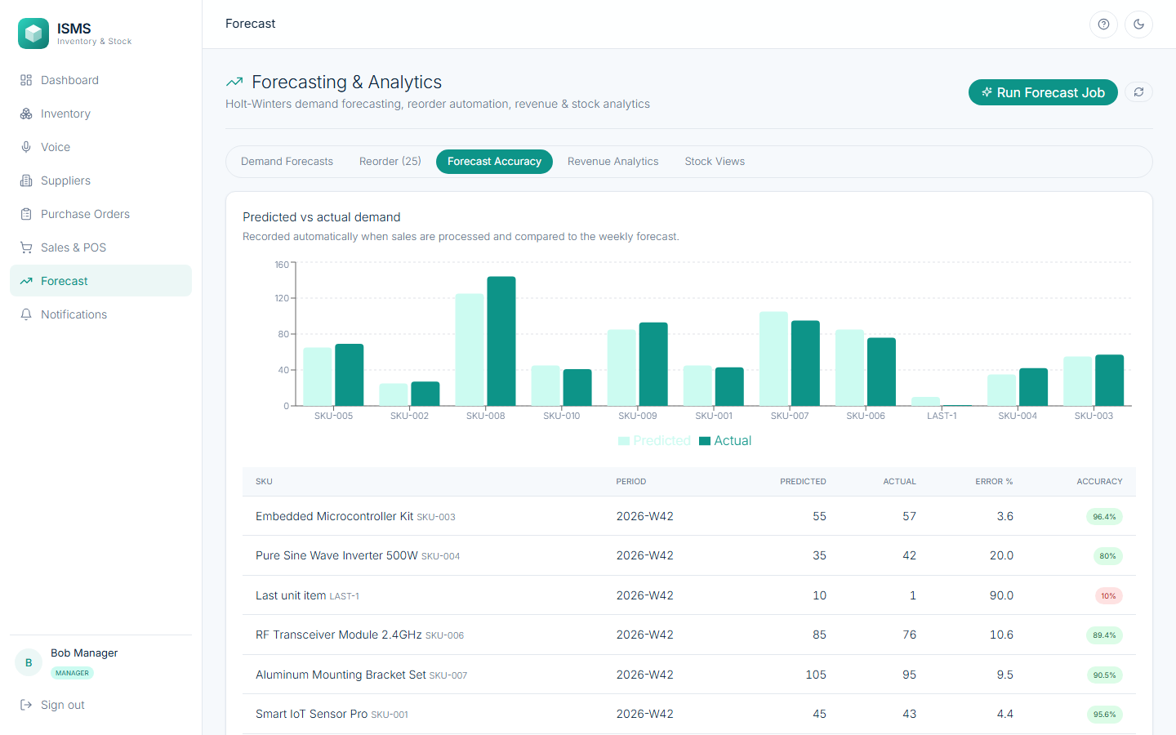
Fig. 60: Forecast accuracy: predicted versus actual demand (Forecast.Accuracy.Track)
5.5 Module 7: Multimodal Notification System (SRS 4.7, DFD 7.0, D8) — Dev
Low-stock and shipping-delay alerts are logged for every recipient and channel (e-mail, SMS, audio) and shown live in the inbox, where they can be marked as read. Each user chooses which alert types reach which channels. The notification engine itself is shared with Module 2 (it is called by every stock change).
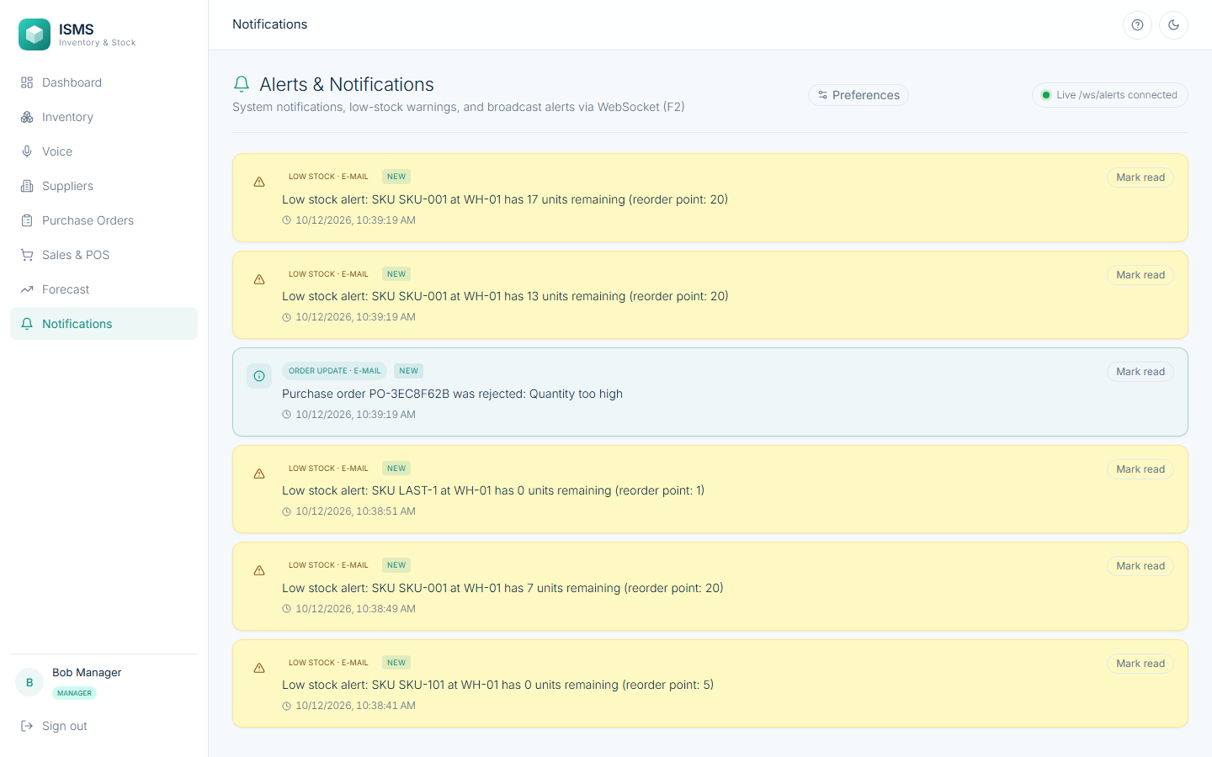
Fig. 61: Notification inbox: low-stock alerts and a PO-rejection notice with NEW badges and “Mark read”; the live /ws/alerts connection is shown
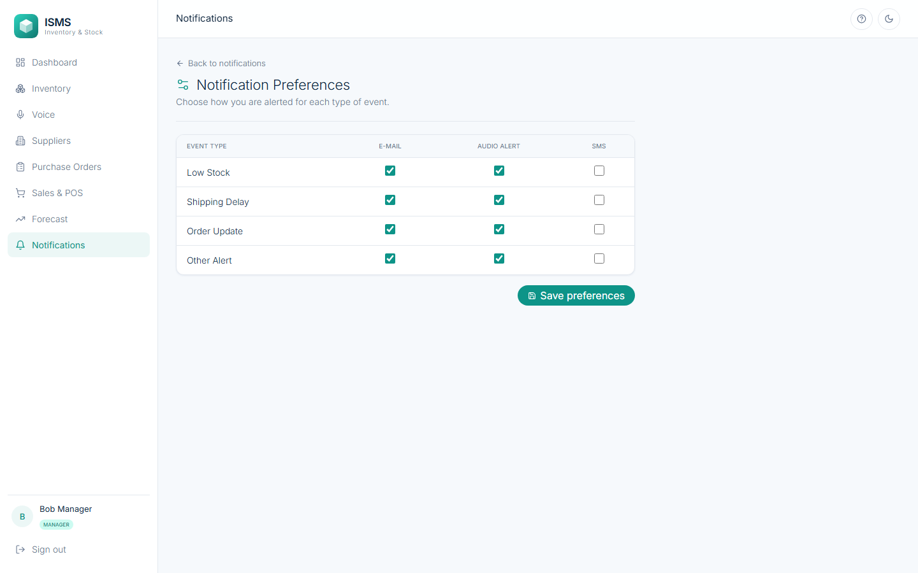
Fig. 62: Notification preferences per alert type and channel (Notify.Preferences.Configure)
5.6 Module 8: Platform Hardening (the rest) — Stavan
The remaining work makes the system demonstrable and verifiable: a demo-data seeder (5 suppliers, 31 SKUs, purchase orders and 443 sales over 52 weeks), non-functional tests (login lockout, session renewal, stock-sync latency, voice throughput), the two class-diagram tests, a load script, a 53-check end-to-end smoke script, the traceability matrix and the module-wise hand-off plan.
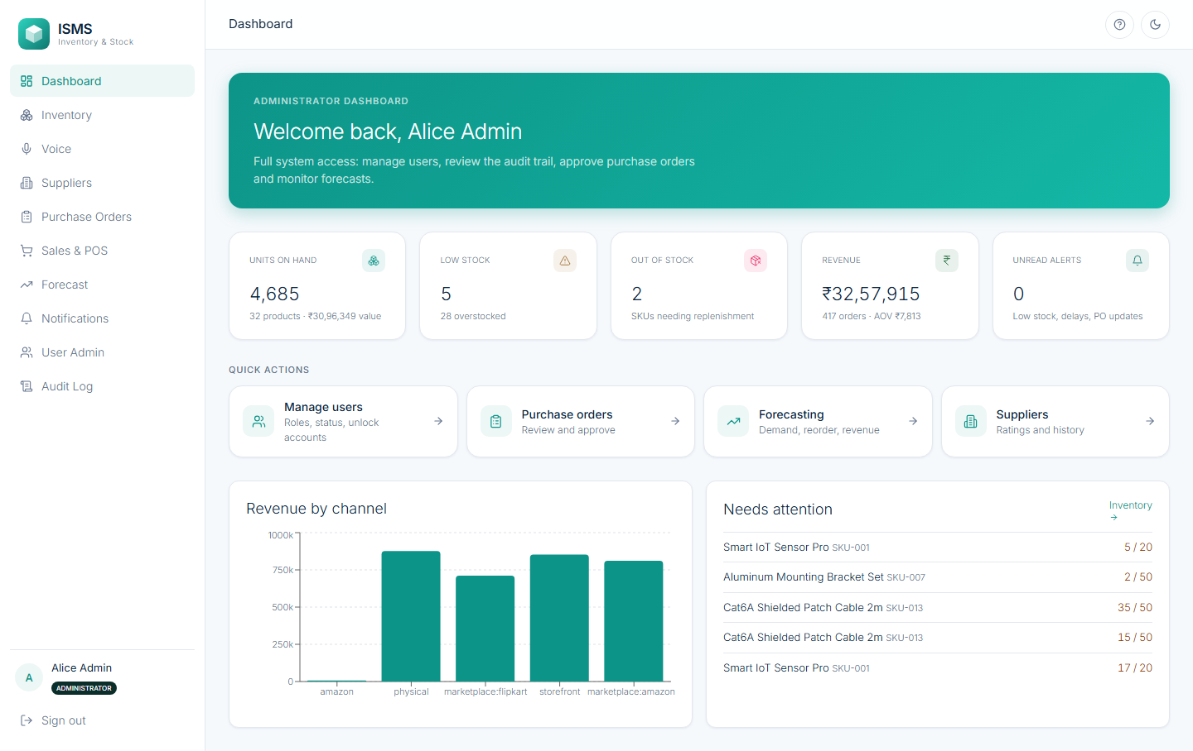
Fig. 63: Dashboard on the seeded demo data: units, low and out-of-stock counts, revenue, revenue by channel and the low-stock list
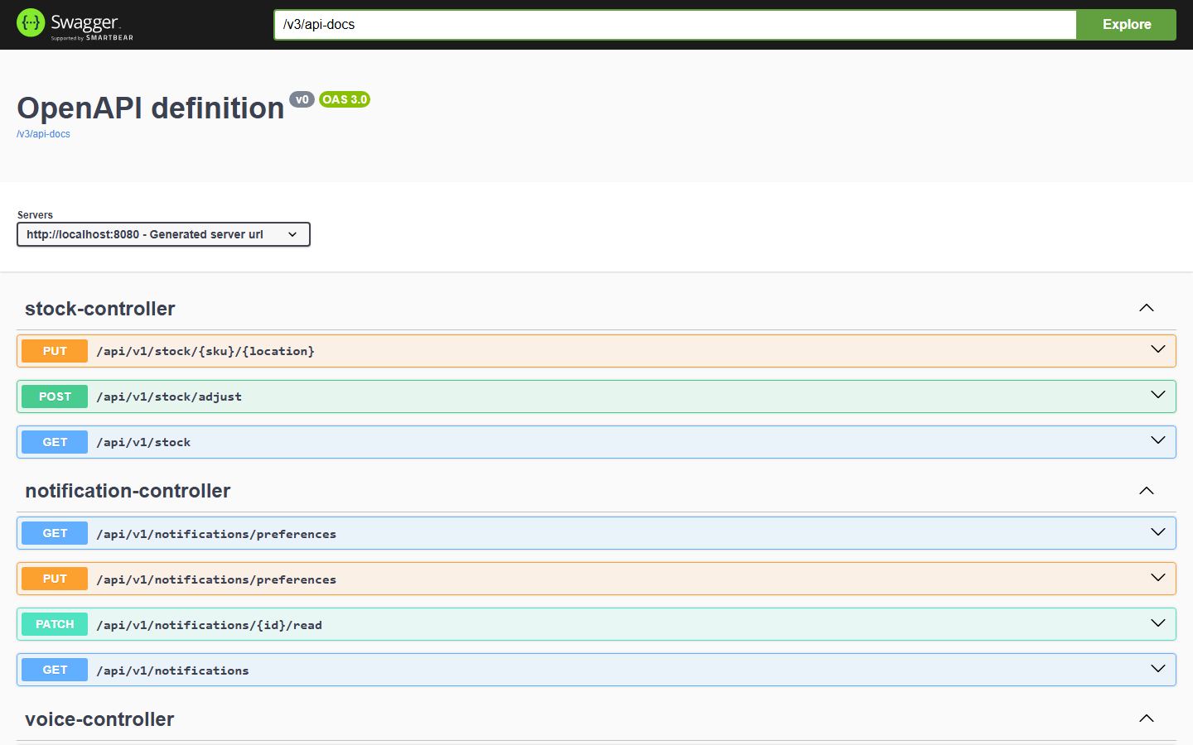
Fig. 64: OpenAPI / Swagger UI listing every REST endpoint of the seven modules
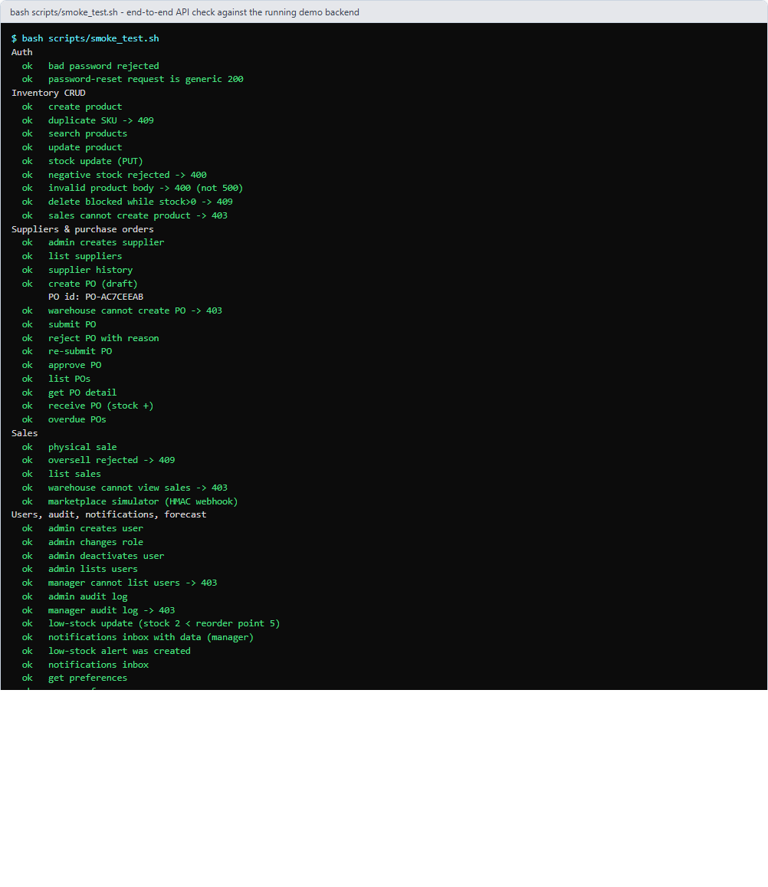
Fig. 65: scripts/smoke_test.sh against the running demo backend: 53 end-to-end checks across all modules and roles, all passing
Testing:
Testing was done at three levels:
• Automated unit and integration tests: JUnit 5, Spring Boot Test and MockMvc drive the real REST API against a real PostgreSQL database.
• Concurrency tests: simultaneous stock deductions, and six simultaneous sales of the last unit.
• Manual system testing in the browser and a live API smoke test: the screenshots above and scripts/smoke_test.sh.
All 70 backend tests pass, together with the frontend test (type-check, production build and Vitest) and the 53 live API checks. Of the 70 backend tests, 12 cover Module 1 (AuthIntegrationTest 5, AdminTest 3, RbacMatrixTest 1, BcryptTest 1, HealthControllerTest 1, SchemaMatchesSpecTest 1) and 9 cover Module 2 (StockConcurrencyTest 2, VoiceInterpreterTest 4, Seq1InventoryTest 2, SalesConcurrencyTest 1); the 4 non-functional tests (lockout, session renewal, stock-sync latency, voice throughput) cover both. The remaining 45 cover Modules 3–8 and the class diagram.
Test Cases: Module 1 (Authentication & Role-Based Access Control)
ID | Test case | Input / steps | Expected result | Actual result | Status
TC-1.1 | Sign in with each role | USR-ADMIN-1, USR-MGR-1, USR-WH-1, USR-SALES-1, password Password123! | 200, token and role; role-specific menu | All four roles signed in; menus differ by role (Fig. 13, 25) | Pass
TC-1.2 | Wrong password | USR-SALES-1 with an invalid password | 401, generic message; LOGIN_FAILED audited | “Invalid user ID/email or password” (Fig. 11, 24) | Pass
TC-1.3 | Lockout boundary (4th vs 5th failure) | 5 wrong passwords for one user in a row | Attempts 1–4: 401. Attempt 5: 403 ACCOUNT_LOCKED | 4 × 401 then 403 (Fig. 20; automated) | Pass
TC-1.4 | Locked account, correct password | Correct password after the lock | 403 ACCOUNT_LOCKED | Refused (Fig. 21) | Pass
TC-1.5 | Lock is persisted and visible | Open User Admin after the lock | Status Locked in the directory; unlock action available | Locked pill and highlighted unlock button (Fig. 22; automated: testLockIsPersistedAndAdminCanUnlock) | Pass
TC-1.6 | Administrator unlocks | Click unlock for the locked user | Status active; correct password works again | Active again, login returns 200 (Fig. 23) | Pass
TC-1.7 | Reset request, unknown vs known e-mail | POST password-reset/request for both | Same generic 200; an e-mail only for the known address | Identical response; one e-mail with a 30-minute link (Fig. 28, 29) | Pass
TC-1.8 | Reset with a valid token | New password via the e-mailed link | Password changed; login with the new password succeeds | Password changed, login 200 (Fig. 30, 31) | Pass
TC-1.9 | Reset token reused | Submit the same token again | 400 TOKEN_ALREADY_USED | 400 returned (negative test) | Pass
TC-1.10 | No token / forged token | GET /users without a token; with “not-a-jwt” | 401 both | 401 and 401 (Fig. 27; automated) | Pass
TC-1.11 | Wrong role on the API | Sales token on GET /users and /admin/audit-log | 403 | 403 and 403 (Fig. 27; RbacMatrixTest) | Pass
TC-1.12 | Wrong role in the UI | Sales user opens /users in the browser | “Access Restricted” page, no data | Shown (Fig. 26) | Pass
TC-1.13 | Sliding session | Any authenticated request | Response carries a refreshed token | X-Refreshed-Token present (Fig. 27; testSlidingTokenHeader, NfrTest) | Pass
TC-1.14 | Create user, inline validation | Submit the empty form; then a valid form | Field messages and no request; then the user is created and audited | Messages shown, then user created (Fig. 15, 16) | Pass
TC-1.15 | Assign a role | Change Demo Staff to Sales Personnel | Role updated; ROLE_ASSIGNED audited | Updated (Fig. 17, 18, 24; AdminTest.testAssignRole) | Pass
TC-1.16 | Audit log access | Open the audit log as Administrator, then as another role | Events listed for the Administrator only (403 otherwise) | All events listed (Fig. 24) | Pass
TC-1.17 | System settings are read-only | Open the Settings tab | Limits shown, nothing editable | Eight values shown (Fig. 19) | Pass
TC-1.18 | Database schema matches the design | Compare the live schema with schema.md | No difference | SchemaMatchesSpecTest passes | Pass

Test Cases: Module 2 (Voice-Enabled Inventory & Omnichannel Sync)
ID | Test case | Input / steps | Expected result | Actual result | Status
TC-2.1 | List and search products | Open Inventory; search “Sensor” | All products with stock; filter returns the match | 31 products listed; one match (Fig. 33, 34) | Pass
TC-2.2 | Create a product | SKU-101 “Laptop Bag”, price 10, reorder point 5 | 201; initial stock record of 0 | Created, stock 0 (Fig. 35, 36) | Pass
TC-2.3 | Duplicate SKU | Create SKU-101 again | 409 DUPLICATE_SKU | Refused (Fig. 37, 45) | Pass
TC-2.4 | Missing required field | POST /products with only a name | 400 VALIDATION_FAILED (not 500) | 400 returned (Fig. 45) | Pass
TC-2.5 | Adjust stock | Set SKU-101 at WH-01 to 25 | Stock 25; audited | 25 units (Fig. 38, 39) | Pass
TC-2.6 | Edit a product | Change the unit price to 1499 | Price updated | Updated (Fig. 40) | Pass
TC-2.7 | Delete with stock (boundary: stock > 0) | Delete SKU-101 while it holds 25 units | 409 STOCK_EXISTS | Refused with the message (Fig. 41) | Pass
TC-2.8 | Delete at zero stock (boundary: stock = 0) | Set stock to 0, then delete | Deleted | Deleted (Fig. 42) | Pass
TC-2.9 | Negative quantity (BR-3) | PUT stock = −3 | 400, stock unchanged | 400 returned (Fig. 45; DB CHECK as second guard) | Pass
TC-2.10 | Real-time sync within 5 s (PE-2) | Keep the page open; another user changes WH-01 to 7 | The open screen updates without reload | 17 → 12 shown live; API call took 0.06 s (Fig. 43, 44; NfrTest.testStockSyncLatency) | Pass
TC-2.11 | Low-stock alert branch of SD-1 | Stock below the reorder point; then above | Alert + audio alert; “no alert” when above | Alert created (Fig. 45; testSequence1WithLowStockAlert, testSequence1NoAlertBranch) | Pass
TC-2.12 | Last-unit conflict | Two simultaneous sales of the last unit | Exactly one succeeds, the other 409 | 201 + 409 (Fig. 45; testLastUnitConflict) | Pass
TC-2.13 | Stress: six simultaneous sales of one unit | 6 threads, stock 1 | 1 order, stock ends at 0 | 1 order, stock 0 (SalesConcurrencyTest) | Pass
TC-2.14 | Concurrent deductions never negative | Many parallel deductions | Stock never below 0 | As expected (StockConcurrencyTest) | Pass
TC-2.15 | Voice command, numeric | “add 20 units of SKU-002 to location WH-01” | action add, qty 20, SKU-002, WH-01; read-back text | Interpreted and read back (Fig. 47; testStandardCommandNumeric) | Pass
TC-2.16 | Voice command, spoken number | “add twenty units …” | Quantity 20 | 20 (testWordNumbers) | Pass
TC-2.17 | Confirm a command | Press Confirm & Commit Stock | Stock raised by 20; broadcast; state COMMITTED | Committed (Fig. 48) | Pass
TC-2.18 | Low confidence (boundary 0.75) | Confidence below the threshold | status low_confidence: repeat or use the form | As expected (testLowConfidenceThreshold); at or above → needs_confirmation | Pass
TC-2.19 | 100 concurrent voice commands (PE-1) | 100 parallel interpretations | Done in under 3.0 s | Passed (NfrTest.testConcurrentVoiceInterpretationThroughput) | Pass
TC-2.20 | Role restriction | Sales Personnel posts a new product | 403 | 403 (Fig. 45) | Pass

Test Cases: Modules 3–8 (summary)
Module | Main behaviours verified | Automated tests | Result
3 Supplier | Create/search, rating only after Received/Cancelled (BR-4), deactivation blocked with open POs (BR-5), history | Seq2PurchaseOrderTest (deactivate), smoke test | Pass
4 Purchase Orders | 6-state lifecycle, illegal transitions rejected, approval limit, credit limit, reject to Draft, partial receipt, overdue alert | PoStateMachineTest 3, Seq2PurchaseOrderTest 7 | Pass
5 Sales | Physical sale, invoice PDF, return, webhook (valid, missing, invalid, replayed), insufficient stock keeps a REJECTED order and notifies the Manager | Seq3SalesTest 4, WebhookSecurityTest 4, SalesConcurrencyTest 1 | Pass
6 Forecasting | Forecast pipeline call order, reorder suggestions and PO payload, stock analytics | ForecastTest 3 | Pass
7 Notifications | Low-stock and shipping-delay triggers, inbox with data, preferences | Seq1/Seq2 tests, smoke test | Pass
8 Platform | Class diagram (12 classes, 43 operations, 9 relationships), NFRs, schema | ClassContractTest 12, ClassDiagramStructureTest 12, NfrTest 4 | Pass

Automated Test Execution
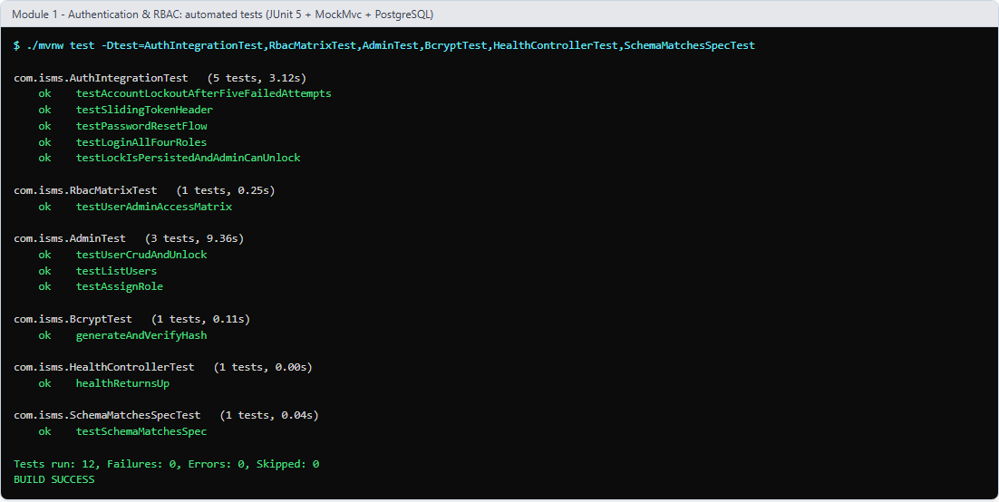
Fig. 66: Module 1 automated tests: 12 / 12 passed (each test method listed)
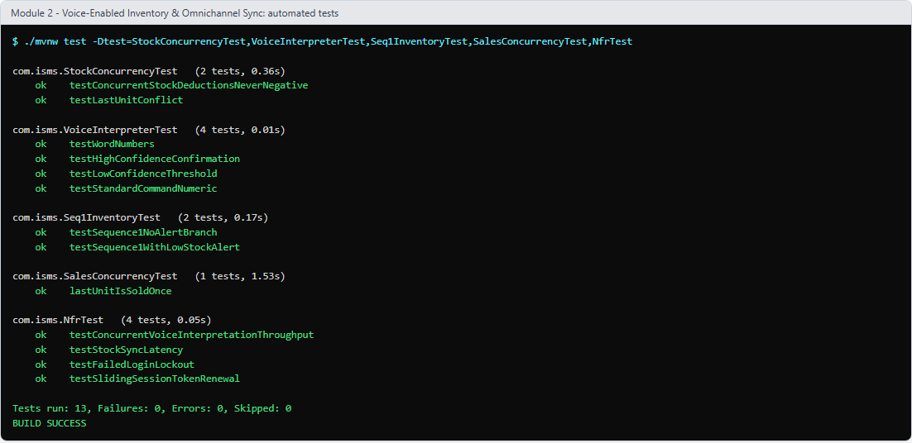
Fig. 67: Module 2 automated tests (with the non-functional tests): 13 / 13 passed
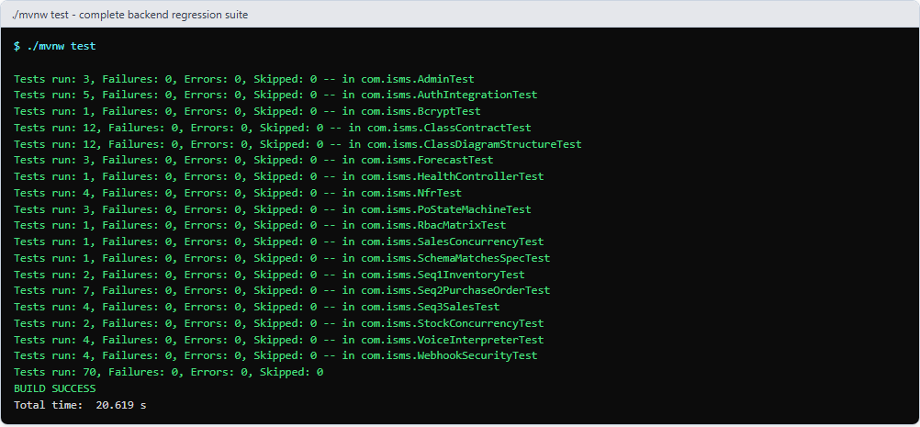
Fig. 68: Complete backend regression suite (./mvnw test): 70 / 70 tests passed, BUILD SUCCESS
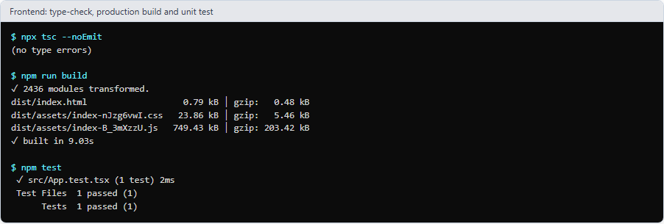
Fig. 69: Frontend: TypeScript type-check, production build and unit test all pass
Conclusion:
Thus, the two core modules of the Inventory and Stock Management System, Authentication & Role-Based Access Control and Voice-Enabled Inventory & Omnichannel Synchronization, were successfully implemented and tested, together with the five other SRS feature modules and the platform module. The implementation follows the SRS, use-case, class, sequence, activity and DFD models from the earlier experiments: all 12 classes, 43 operations and 9 relationships of the class diagram exist in the code and are verified by tests, and the call order of SD-1, SD-2 and SD-3 is asserted automatically. Login, the persisted account lockout, password reset, role-based access, the audit log, product CRUD with guarded delete, row-locked stock updates, the last-unit conflict rule, real-time synchronisation and confirmed voice commands all work correctly, including their failure paths. 38 documented test cases for the two core modules, 70 automated backend tests and 53 live API checks pass, which confirms that the modules meet their functional requirements and business rules. The work was divided between the two team members in alternating modules (Dev: 1, 3, 5, 7; Stavan: 2, 4, 6, 8) and every stage was verified to build on its own.

