**Registration Code Structure**

**Full folder structure for application:**

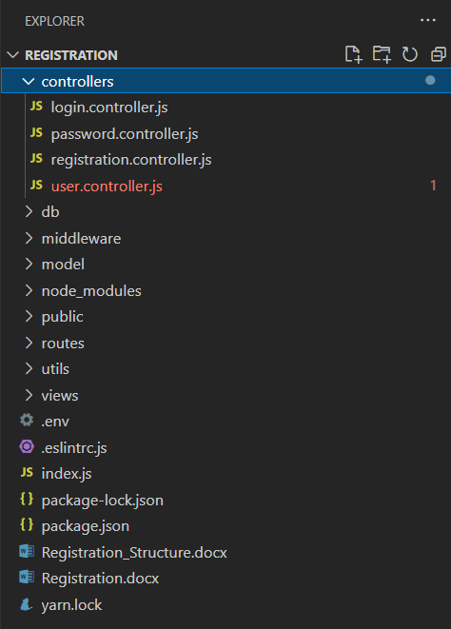

1. **Controller:**

We are using below 4 controllers for the application.

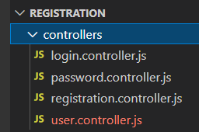

* 1. **Login.controller =>** Login operations and home page rendering
  2. **Password.controller =>** Forgot password operation.
  3. **Registration.controller =>** New user registration.
  4. **User.controller =>** user related operation like as all user information, edit user, check existing user etc.

1. **Db**

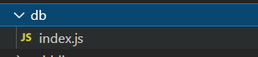

Here we are creating new database connection.

1. **Middleware**

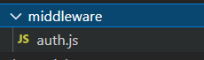

Generating new jwt based token for respective user’s email id. Which is applicable till user sessions.

1. **Model**



Here we are defining the database schema for User collection.

1. **Public**

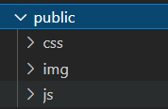

Here we are maintaining the all assets like style sheet, jQuery etc.

1. **Routes**

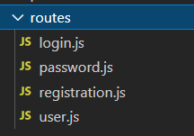

We have the 4 routes as per the module

1. Login: Authentication for user
2. Password: forgot password
3. Registration: To lock new user in system.
4. User: To fetch, update user information etc.
5. **Utils**

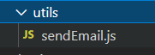

This is out utility folder. Application related utilities we are keeping here.

sendEmail : helping to send email with newly generated password.

1. **Views**

We are using “**JADE**” handlebar for rendering the pages.

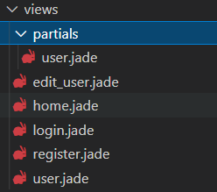

1. User: All user information display with edit and delete feature.
2. Home: this is for landing page
3. Login: authentication page
4. Register: new user registration