CODING-CHALLENG-2 RESULTS:

THE FOLLOWING IMAGES SHOW THAT THE FIRST FOUR REQUIREMENTS WERE MET:

-- ADD AT LEAST 3 RECORED INTO EACH TABLE;

-- ADD EMPLOYEE TINA SMITH;

-- ADD DEPARTMENT MARKETING;

-- LIST ALL EMPLOYEES IN MARKETING;

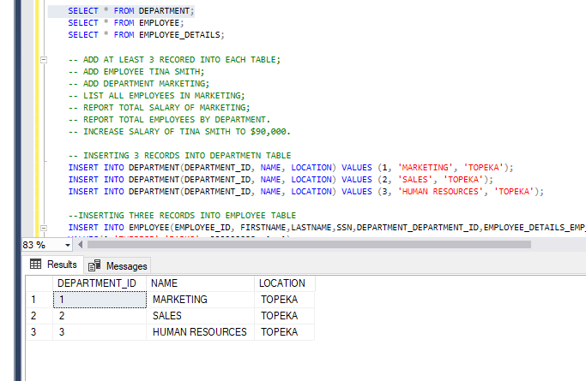

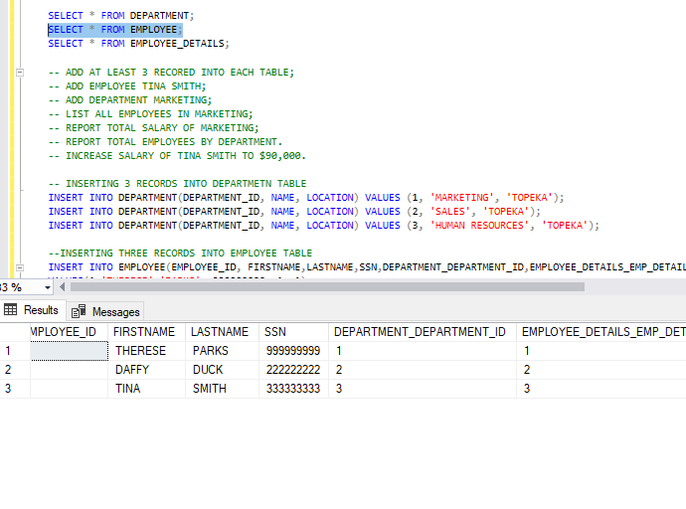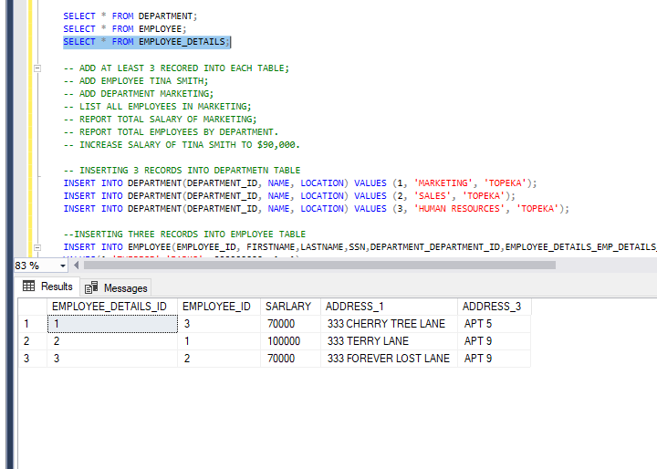

--LiST ALL EMPLOYESS IN MARKETING

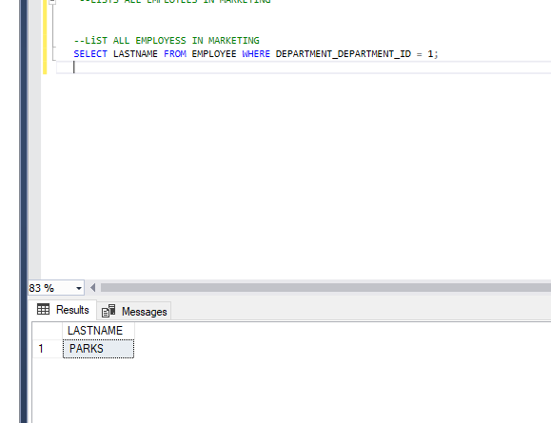

-REPORTING TOTAL EMPLOYEES BY DEPARTMENT

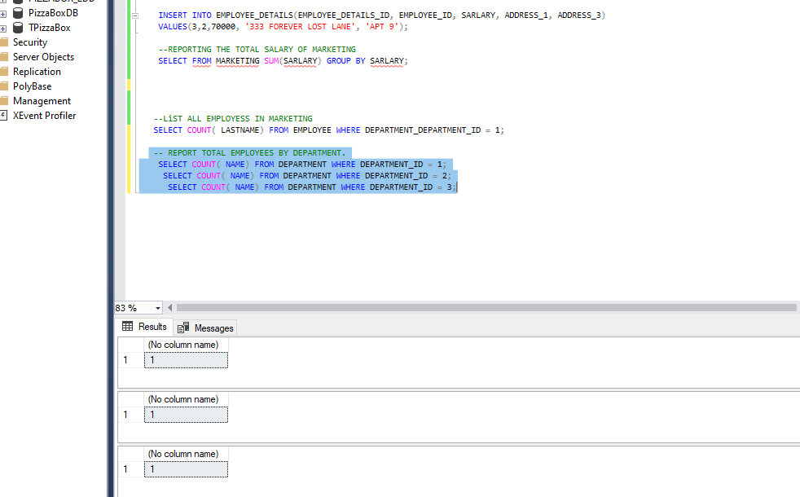

-- REPORT TOTAL SALARY OF MARKETING;

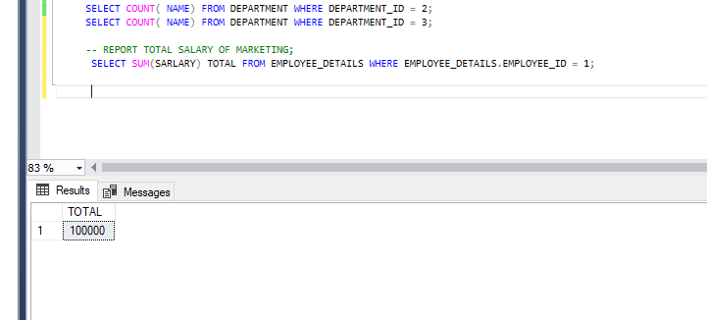

-- INCREASE SALARY OF TINA SMITH TO $90,000.

