Shrikant Mane 240340520082

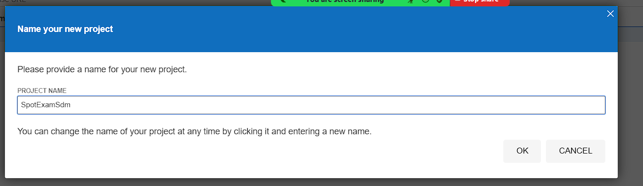

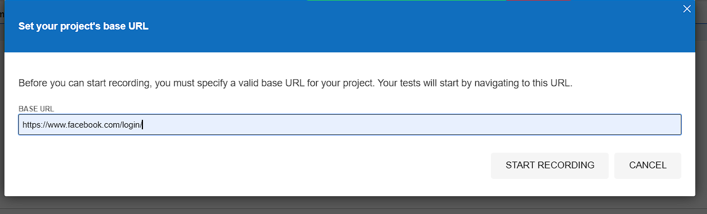

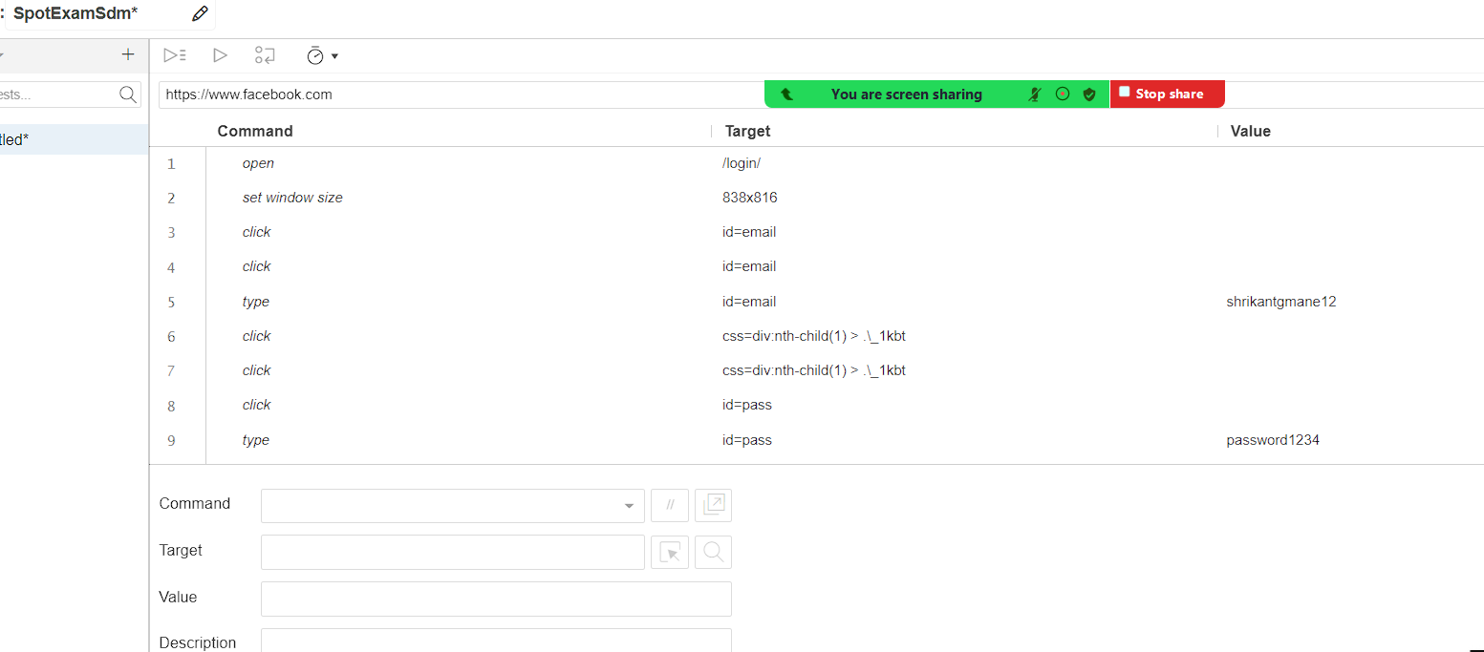

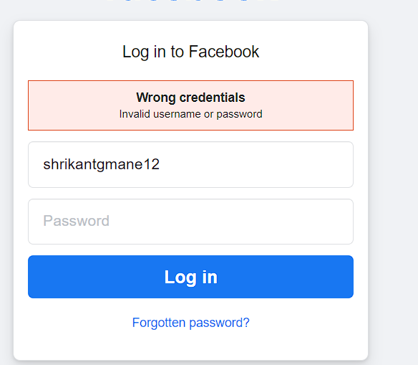

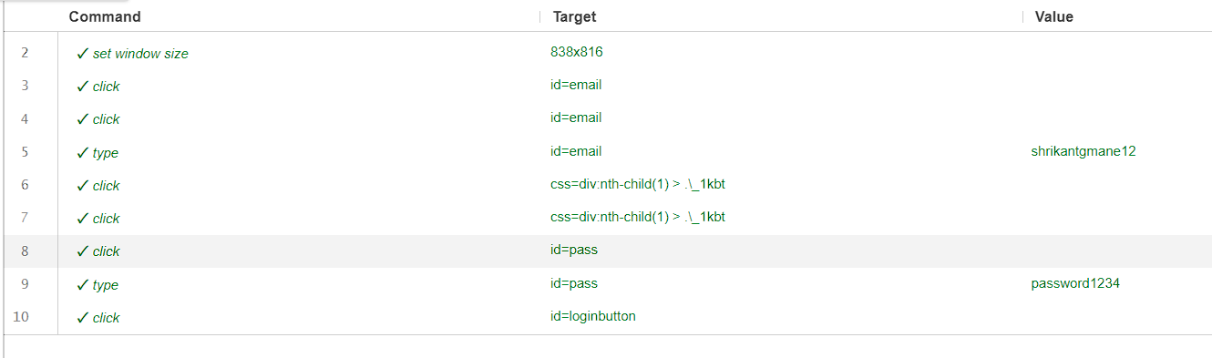

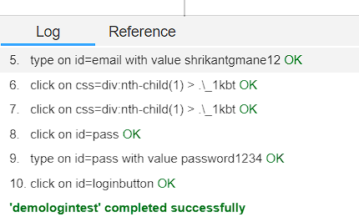

// Generated by Selenium IDE

using System;

using System.Collections;

using System.Collections.Generic;

using System.Linq;

using System.Threading;

using OpenQA.Selenium;

using OpenQA.Selenium.Chrome;

using OpenQA.Selenium.Firefox;

using OpenQA.Selenium.Remote;

using OpenQA.Selenium.Support.UI;

using OpenQA.Selenium.Interactions;

using NUnit.Framework;

[TestFixture]

public class DemologintestTest {

private IWebDriver driver;

public IDictionary<string, object> vars {get; private set;}

private IJavaScriptExecutor js;

[SetUp]

public void SetUp() {

driver = new ChromeDriver();

js = (IJavaScriptExecutor)driver;

vars = new Dictionary<string, object>();

}

[TearDown]

protected void TearDown() {

driver.Quit();

}

[Test]

public void demologintest() {

driver.Navigate().GoToUrl("https://www.facebook.com/login/");

driver.Manage().Window.Size = new System.Drawing.Size(838, 816);

driver.FindElement(By.Id("email")).Click();

driver.FindElement(By.Id("email")).Click();

driver.FindElement(By.Id("email")).SendKeys("shrikantgmane12");

driver.FindElement(By.CssSelector("div:nth-child(1) > .\\_1kbt")).Click();

driver.FindElement(By.CssSelector("div:nth-child(1) > .\\_1kbt")).Click();

driver.FindElement(By.Id("pass")).Click();

driver.FindElement(By.Id("pass")).SendKeys("password1234");

driver.FindElement(By.Id("loginbutton")).Click();

}

}

Q.B)

using System;

using System.Collections.Generic;

using System.Linq;

using System.Text;

using System.Threading.Tasks;

namespace TestProject1

{

internal class MathEngine

{

public int Add(int a, int b) => a + b;

public int Subtract(int a, int b) => a - b;

public int Multiply(int a, int b) => a * b;

public int Divide(int a, int b) => a / b;

}

}

using Microsoft.VisualStudio.TestTools.UnitTesting;

namespace TestProject1

{

[TestClass]

public class UnitTest1

{

private MathEngine _mathEngine;

[TestInitialize]

public void Setup()

{

_mathEngine = new MathEngine();

}

[TestMethod]

public void TestAddition()

{

Assert.AreEqual(5, _mathEngine.Add(2,3));

}

[TestMethod]

public void TestSubtraction()

{

Assert.AreEqual(1, _mathEngine.Subtract(3, 2));

}

[TestMethod]

public void TestMultiplication()

{

Assert.AreEqual(6, _mathEngine.Multiply(2, 3));

}

[TestMethod]

public void TestDivision()

{

Assert.AreEqual(10, _mathEngine.Divide(100, 10));

}

}

}

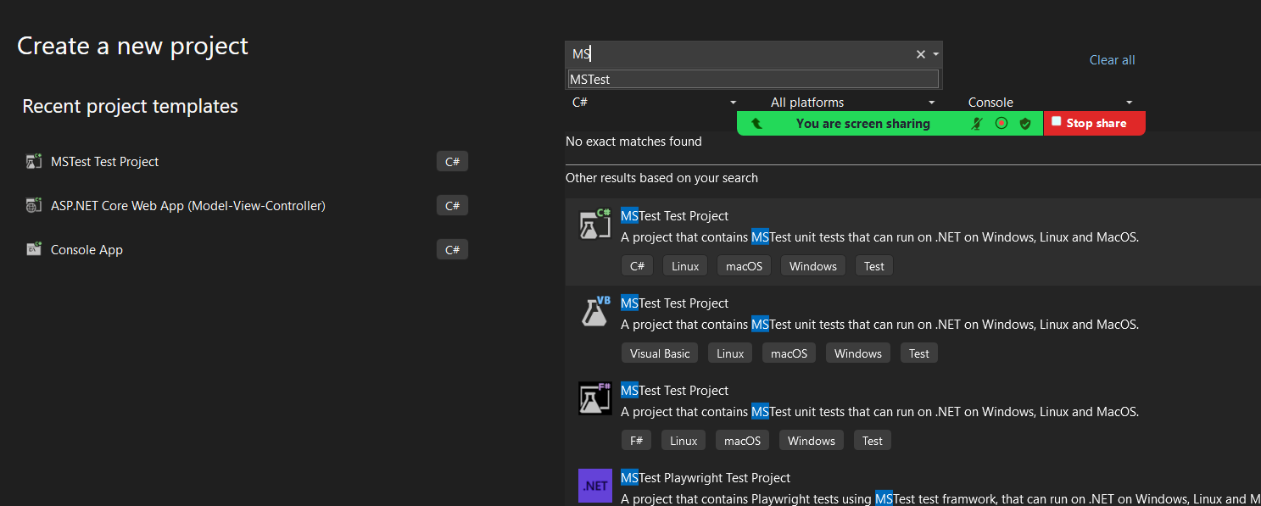

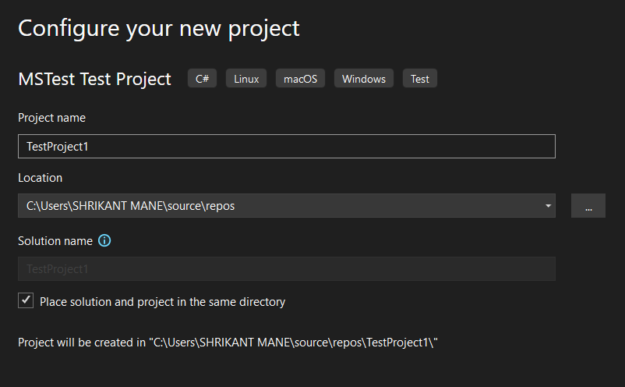

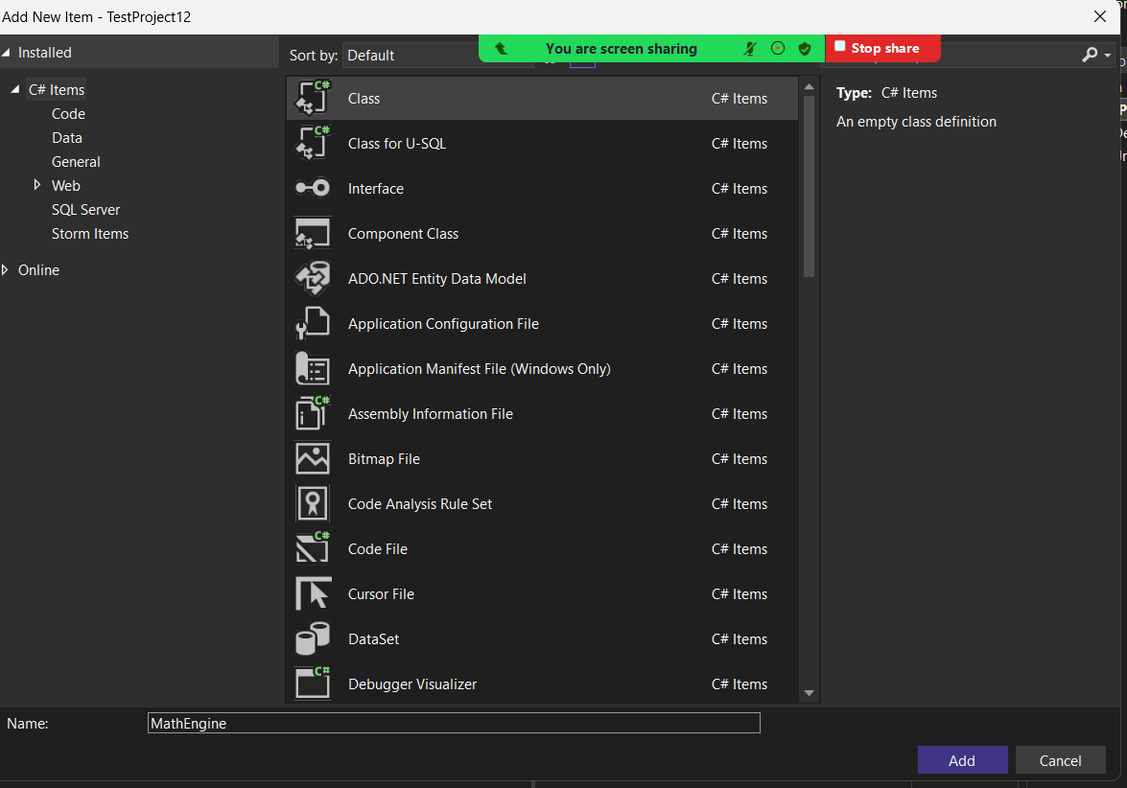

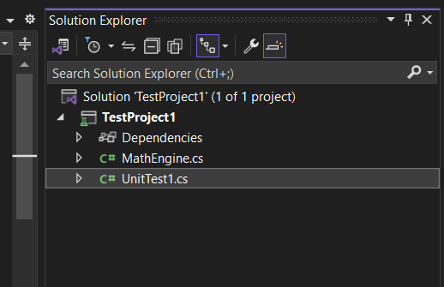

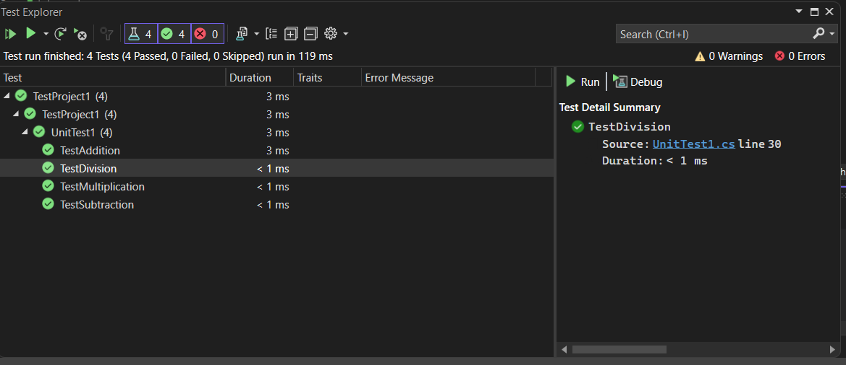

Q.C)

A. Docker file for Node.js application

FROM node:14

WORKDIR /app

COPY . /app

RUN npm install

CMD ["node","-e","console.log('Hello ' + process.env.NAME)"]

sudo apt update

sudo apt install docker.io

docker -version

sudo systemctl status docker

sudo docker images //shows available images

git clone **link of repository**

sudo docker build -t nodeproject

sudo docker run -d -p 8000:8000 nodeproject

B. Docker file for Java application

FROM openjdk:11

COPY Demo.java /user/src/myapp

WORKDIR /user/src/myapp

RUN javac Demo.java

CMD ["java","Demo"]

sudo apt update

sudo apt install docker.io

docker -version

sudo systemctl status docker

sudo docker images //shows available images

git clone **link of repository**

sudo docker build -t javaproject

sudo docker run -d -p 8000:8000 javaproject