**Module (Bootstrap Basic & Advanced) – 6**

1. What are the advantages of Bootstrap?

=> Bootstrap offers many advantages for web designers and developers, such as saving time and effort by providing ready-made components like navbar, forms, carousel, badges, slider and many more. We don’t have to type the whole code simply copy the code and paste it where we want to use.

2. What is a Bootstrap Container, and how does it work?

=> Containers are the most basic layout element in Bootstrap and are required when using our default grid system.

It is of 2 types:

* container
* container-fluid
* <!DOCTYPE html>
* <html lang="en">
* <head>
* <meta charset="UTF-8">
* <meta name="viewport" content="width=device-width, initial-scale=1.0">
* <title>Document</title>
* <link href="https://cdn.jsdelivr.net/npm/bootstrap@5.0.2/dist/css/bootstrap.min.css" rel="stylesheet" integrity="sha384-EVSTQN3/azprG1Anm3QDgpJLIm9Nao0Yz1ztcQTwFspd3yD65VohhpuuCOmLASjC" crossorigin="anonymous">
* </head>
* <body>
* <div class="container">Lorem ipsum dolor sit amet, consectetur adipisicing elit. Autem, tempore laborum officia, ducimus placeat quos dolorem accusantium exercitationem fugiat odit unde iste labore rerum earum reiciendis soluta nisi odio aut.</div>
* <div class="container-fluid">Lorem ipsum dolor sit amet consectetur adipisicing elit. Saepe quas vel modi quia non porro. Eveniet quos provident aliquam excepturi deleniti id illum officia, iste molestiae doloremque quasi possimus amet.</div>
* </body>
* </html>

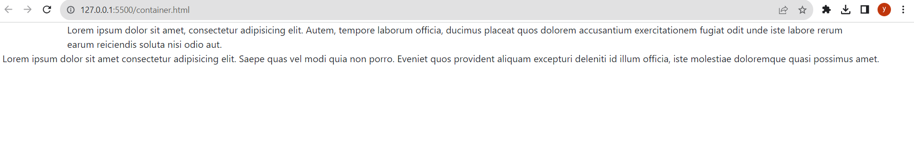

3. What are the default Bootstrap text settings?

=> Bootstrap 5 uses a default font-size of 1rem (16px by default), and its line-height is 1.5.

4. What do you know about the Bootstrap Grid System?

=> Bootstrap grid system gives the responsiveness with six breakpoints.

* Extra small (xs)
* Small (sm)
* Medium (md)
* Large (lg)
* Extra large (xl)
* Extra extra large (xxl)
* <!DOCTYPE html>
* <html lang="en">
* <head>
* <meta charset="UTF-8">
* <meta name="viewport" content="width=device-width, initial-scale=1.0">
* <title>Document</title>
* <link href="https://cdn.jsdelivr.net/npm/bootstrap@5.0.2/dist/css/bootstrap.min.css" rel="stylesheet" integrity="sha384-EVSTQN3/azprG1Anm3QDgpJLIm9Nao0Yz1ztcQTwFspd3yD65VohhpuuCOmLASjC" crossorigin="anonymous">
* </head>
* <body>
* <div class="row">
* <div class="col-12 col-sm-12 col-md-6 col-lg-3" style="background-color: aqua;">abc</div>
* <div class="col-12 col-sm-4 col-md-6 col-lg-3" style="background-color: blueviolet;">efg</div>
* <div class="col-12 col-sm-4 col-md-6 col-lg-3" style="background-color: chocolate">hij</div>
* <div class="col-12 col-sm-4 col-md-6 col-lg-3" style="background-color: crimson">klm</div>
* </div>
* </body>
* </html>

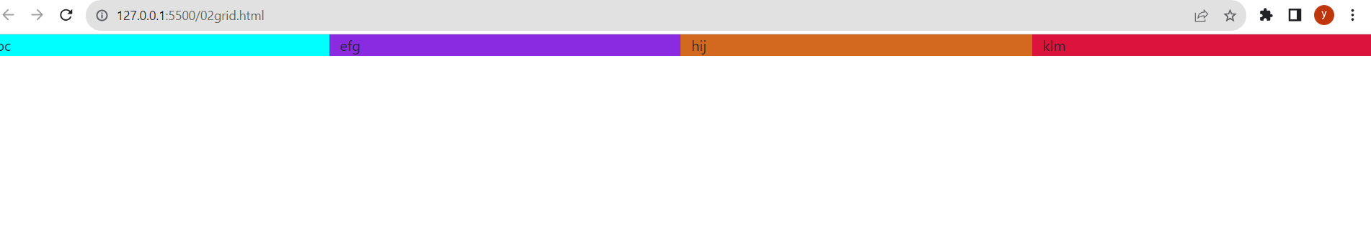

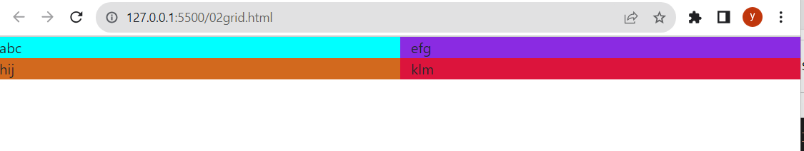

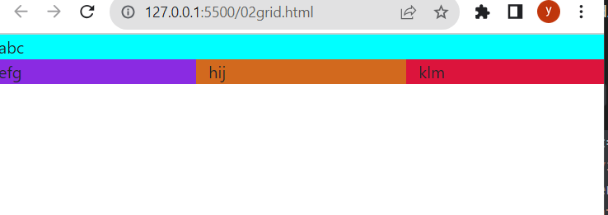

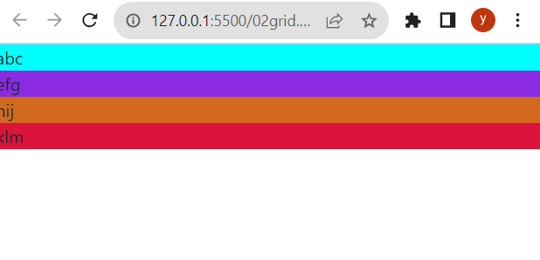

5. What is the difference between Bootstrap 4 and Bootstrap 5

=>

| Bootstrap 5 | Bootstrap 4 | Bootstrap 3 |
| --- | --- | --- |
| No support for I.E | No support for I.E 8 and 9 only | Support Internet Explorer 8 and 9 |
| Separate both Portrait and Landscape mode on Smartphones. | Separate both Portrait and Landscape mode on Smartphones. |  |
| Container size 1320px | Container Size 1140px |  |
| Six Class prefixes, i.e col-xxl, col-xl, col-lg-, col-md- , col-sm-, col- . | Five Class prefixes, i.e col-xl, col-lg- , col-md- , col-sm-, col- . |  |
| Use [CSS Flexbox](https://tutorial.techaltum.com/css-flexbox.html), [CSS functions and variables](https://tutorial.techaltum.com/css-variables-functions.html) | Use [CSS Flexbox](https://tutorial.techaltum.com/css-flexbox.html). |  |
| Only responsive layout . | Only responsive layout . |  |
| Use better Cards | Use Cards instead of wells and panels. |  |
| Inverse Table Option. | Inverse Table Option. |  |

6. What is a Button Group, and what is the class for a basic Button Group?

=> Button Group is the class for the button and there is some basic buttons

<!DOCTYPE html>

<html lang="en">

<head>

    <meta charset="UTF-8">

    <meta name="viewport" content="width=device-width, initial-scale=1.0">

    <link href="https://cdn.jsdelivr.net/npm/bootstrap@5.0.2/dist/css/bootstrap.min.css" rel="stylesheet" integrity="sha384-EVSTQN3/azprG1Anm3QDgpJLIm9Nao0Yz1ztcQTwFspd3yD65VohhpuuCOmLASjC" crossorigin="anonymous">

    <script src="https://cdn.jsdelivr.net/npm/bootstrap@5.0.2/dist/js/bootstrap.bundle.min.js" integrity="sha384-MrcW6ZMFYlzcLA8Nl+NtUVF0sA7MsXsP1UyJoMp4YLEuNSfAP+JcXn/tWtIaxVXM" crossorigin="anonymous"></script>

    <title>Document</title>

</head>

<body>

    <div class="btn-group">

        <button class="btn-primary">Button_1</button>

        <button class="btn-secondary">Button_2</button>

        <button class="btn-danger">Button_3</button>

        <button class="btn-warning">Button_4</button>

        <button class="btn-info">Button_5</button>

        <button class="btn-light">Button_6</button>

    </div>

</body>

</html>

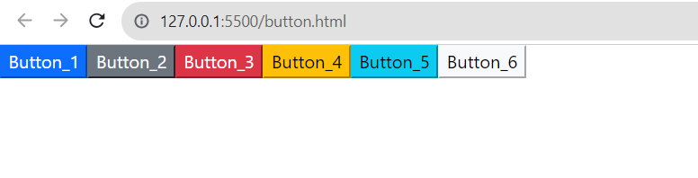

7. How can you use Bootstrap to make thumbnails?

=> In bootstrap to make thumbnails use the class= “img-thumbnail”

<!DOCTYPE html>

<html lang="en">

<head>

    <meta charset="UTF-8">

    <meta name="viewport" content="width=device-width, initial-scale=1.0">

    <link href="https://cdn.jsdelivr.net/npm/bootstrap@5.0.2/dist/css/bootstrap.min.css" rel="stylesheet" integrity="sha384-EVSTQN3/azprG1Anm3QDgpJLIm9Nao0Yz1ztcQTwFspd3yD65VohhpuuCOmLASjC" crossorigin="anonymous">

    <script src="https://cdn.jsdelivr.net/npm/bootstrap@5.0.2/dist/js/bootstrap.bundle.min.js" integrity="sha384-MrcW6ZMFYlzcLA8Nl+NtUVF0sA7MsXsP1UyJoMp4YLEuNSfAP+JcXn/tWtIaxVXM" crossorigin="anonymous"></script>

    <title>Document</title>

</head>

<body>

    <img src="https://encrypted-tbn0.gstatic.com/images?q=tbn:ANd9GcTCHlQint9QtNTSMSN_OIVXSv13UPtOZ8crMy2mvKlouIVl-mru65BM3ct_hABzHEYZQbk&usqp=CAU" alt="image" class="img-thumbnail">

</body>

</html>

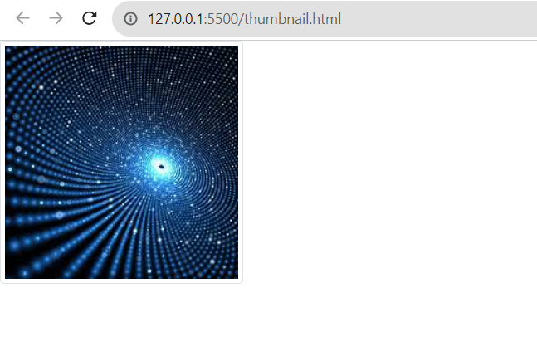

8. In Bootstrap 4, what is flexbox?

=> In this use the class d-flex of the bootstrap

<!DOCTYPE html>

<html lang="en">

<head>

    <meta charset="UTF-8">

    <meta name="viewport" content="width=device-width, initial-scale=1.0">

    <link href="https://cdn.jsdelivr.net/npm/bootstrap@5.0.2/dist/css/bootstrap.min.css" rel="stylesheet" integrity="sha384-EVSTQN3/azprG1Anm3QDgpJLIm9Nao0Yz1ztcQTwFspd3yD65VohhpuuCOmLASjC" crossorigin="anonymous">

    <script src="https://cdn.jsdelivr.net/npm/bootstrap@5.0.2/dist/js/bootstrap.bundle.min.js" integrity="sha384-MrcW6ZMFYlzcLA8Nl+NtUVF0sA7MsXsP1UyJoMp4YLEuNSfAP+JcXn/tWtIaxVXM" crossorigin="anonymous"></script>

    <title>Document</title>

</head>

<body>

    <div class="d-flex p-3 bg-info text-white">

        <div class="p-2 bg-secondary">Flex item 1</div>

        <div class="p-2 bg-warning">Flex item 2</div>

        <div class="p-2 bg-danger">Flex item 3</div>

    </div>

    <br><br>

    <div class="d-inline-flex p-3 bg-info text-white">

        <div class="p-2 bg-secondary">Flex item 1</div>

        <div class="p-2 bg-warning">Flex item 2</div>

        <div class="p-2 bg-danger">Flex item 3</div>

    </div>

    <br><br>

    <div class="d-flex flex-row bg-info">

        <div class="p-2 bg-secondary">Flex item 1</div>

        <div class="p-2 bg-warning">Flex item 2</div>

        <div class="p-2 bg-danger">Flex item 3</div>

    </div>

      <br>

    <div class="d-flex flex-row-reverse bg-info">

        <div class="p-2 bg-secondary">Flex item 1</div>

        <div class="p-2 bg-warning">Flex item 2</div>

        <div class="p-2 bg-danger">Flex item 3</div>

    </div>

</body>

</html>

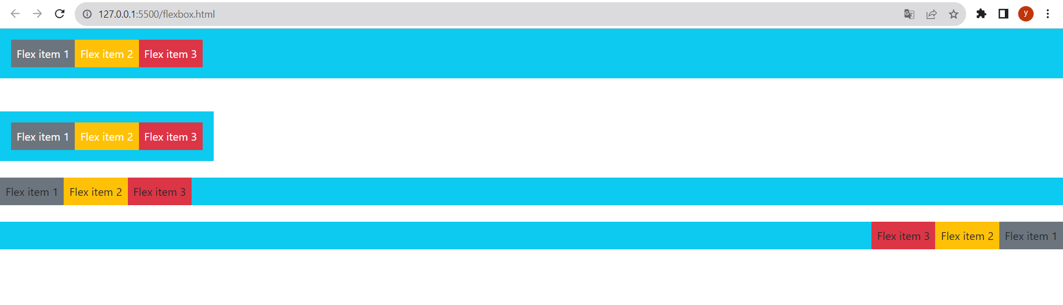

9. How can one create an alert in Bootstrap?

=> Create an alert in bootstrap using class = “alert”

<!DOCTYPE html>

<html lang="en">

<head>

    <meta charset="UTF-8">

    <meta name="viewport" content="width=device-width, initial-scale=1.0">

    <link href="https://cdn.jsdelivr.net/npm/bootstrap@5.0.2/dist/css/bootstrap.min.css" rel="stylesheet" integrity="sha384-EVSTQN3/azprG1Anm3QDgpJLIm9Nao0Yz1ztcQTwFspd3yD65VohhpuuCOmLASjC" crossorigin="anonymous">

    <script src="https://cdn.jsdelivr.net/npm/bootstrap@5.0.2/dist/js/bootstrap.bundle.min.js" integrity="sha384-MrcW6ZMFYlzcLA8Nl+NtUVF0sA7MsXsP1UyJoMp4YLEuNSfAP+JcXn/tWtIaxVXM" crossorigin="anonymous"></script>

    <title>Document</title>

</head>

<body>

    <div class="alert alert-primary" >

        This is a primary alert—!

      </div>

      <div class="alert alert-secondary" >

        This is a secondary alert—!

      </div>

      <div class="alert alert-success">

        This is a success alert—!

      </div>

      <div class="alert alert-danger" >

        This is a danger alert—!

      </div>

      <div class="alert alert-warning">

        This is a warning ale!

      </div>

      <div class="alert alert-info" >

        This is a info alert!

      </div>

      <div class="alert alert-light">

        This is a light alert!

      </div>

      <div class="alert alert-dark">

        This is a dark alert—!

      </div>

</body>

</html>

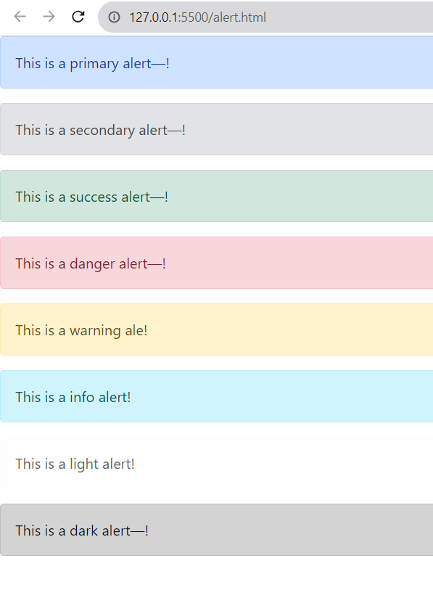

10. What is a bootstrap card and how would you create one?

=> Use the class = “card” of bootstrap

<!DOCTYPE html>

<html lang="en">

<head>

    <meta charset="UTF-8">

    <meta name="viewport" content="width=device-width, initial-scale=1.0">

    <link href="https://cdn.jsdelivr.net/npm/bootstrap@5.0.2/dist/css/bootstrap.min.css" rel="stylesheet" integrity="sha384-EVSTQN3/azprG1Anm3QDgpJLIm9Nao0Yz1ztcQTwFspd3yD65VohhpuuCOmLASjC" crossorigin="anonymous">

    <script src="https://cdn.jsdelivr.net/npm/bootstrap@5.0.2/dist/js/bootstrap.bundle.min.js" integrity="sha384-MrcW6ZMFYlzcLA8Nl+NtUVF0sA7MsXsP1UyJoMp4YLEuNSfAP+JcXn/tWtIaxVXM" crossorigin="anonymous"></script>

    <title>Document</title>

</head>

<body>

    <div class="card" style="width: 18rem;">

        <img src="image.png" class="card-img-top img-thumbnail bg-secondary" alt="">

        <div class="card-body">

          <h5 class="card-title">Richard Taylor</h5>

          <p class="card-text">Lorem ipsum dolor sit amet.</p>

          <a href="#" class="btn btn-primary">See Profile</a>

        </div>

      </div>

</body>

</html>

