**Module (JQuery Basic, Effects & Advanced) – 5**

1. What is jQuery?

=> The purpose of jQuery is to make it much easier to use JavaScript. It is a lightweight, "write less, do more", JavaScript library. All functionality call with the $ sign and also add the jQuery cdn link in script tag in head section of the html page.

2. How to Apply CSS Using JQuery, How to Add Class and Remove Class in Jquery , JQuery Animation?

=> Apply CSS Using JQuery: -

<!DOCTYPE html>

<html lang="en">

<head>

    <meta charset="UTF-8">

    <meta name="viewport" content="width=device-width, initial-scale=1.0">

    <title>Document</title>

    <script src="https://cdnjs.cloudflare.com/ajax/libs/jquery/3.7.0/jquery.min.js"></script>

</head>

<body>

    <div>bkfgidhlerhcgd</div>

    <button>xyz</button>

    <script>

        $(document).ready(function () {

            $("button").click(function (){

                $("div").css({"background-color" : "black", "color" : "white"})

            })

        })

    </script>

</body>

</html>

Output Before Button Click to Apply CSS: -

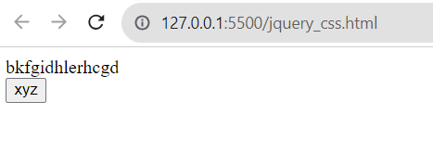

Output After Button Click to Apply CSS: -



=> Add Class: -

<!DOCTYPE html>

<html lang="en">

<head>

    <meta charset="UTF-8">

    <meta name="viewport" content="width=device-width, initial-scale=1.0">

    <title>Document</title>

    <script src="https://cdnjs.cloudflare.com/ajax/libs/jquery/3.7.0/jquery.min.js"></script>

    <style>

        .one{

            background-color: black;

            color: wheat;

            font-size: 150px;

        }

    </style>

</head>

<body>

    <button>Click</button>

    <div>ABCD</div>

    <script>

        $(document).ready(function(){

            $("button").click(function(){

                $("div").addClass("one")

            })

        })

    </script>

</body>

</html>

Output Before Button Click to Add Class: -

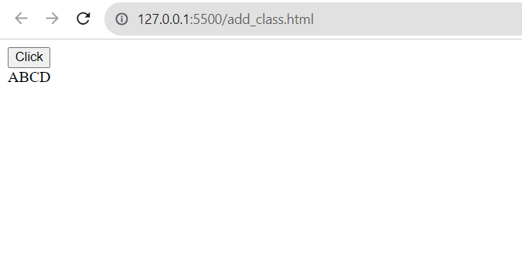

Output After Button Click to Add Class: -



=> Remove Class: -

<!DOCTYPE html>

<html lang="en">

<head>

    <meta charset="UTF-8">

    <meta name="viewport" content="width=device-width, initial-scale=1.0">

    <title>Document</title>

    <script src="https://cdnjs.cloudflare.com/ajax/libs/jquery/3.7.0/jquery.min.js"></script>

    <style>

        .one{

            background-color: black;

            color: wheat;

            font-size: 150px;

        }

    </style>

</head>

<body>

    <button>Click</button>

    <div class="one">ABCD</div>

    <script>

        $(document).ready(function(){

            $("button").click(function(){

                $("div").removeClass("one")

            })

        })

    </script>

</body>

</html>

Output Before Button Click to Remove Class: -

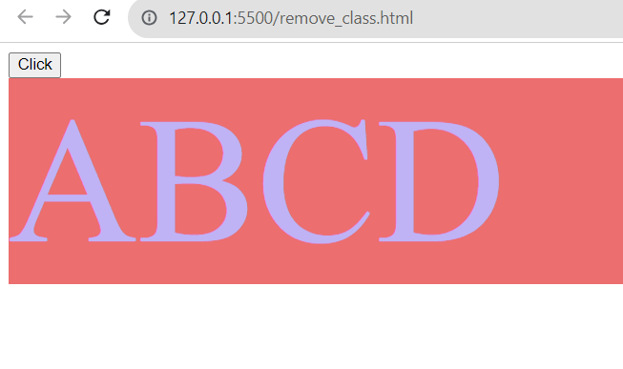

Output After Button Click to Remove Class: -



=> jQuery Animation: -

<!DOCTYPE html>

<html lang="en">

<head>

    <meta charset="UTF-8">

    <meta name="viewport" content="width=device-width, initial-scale=1.0">

    <title>Document</title>

    <script src="https://cdnjs.cloudflare.com/ajax/libs/jquery/3.7.0/jquery.min.js"></script>

    <style>

        div{

            height: 100px;

            width: 100px;

            background-color: black;

            position: relative;

        }

    </style>

</head>

<body>

    <div></div>

    <button>xyz</button>

    <script>

        $(document).ready(function (){

            $("button").click(function (){

                $("div").animate({"left" : "50%"}).css({"background-color" : "aqua"})

            })

        })

    </script>

</body>

</html>

Output Before Button Click to Animation: -



Output After Button Click to Animation: -

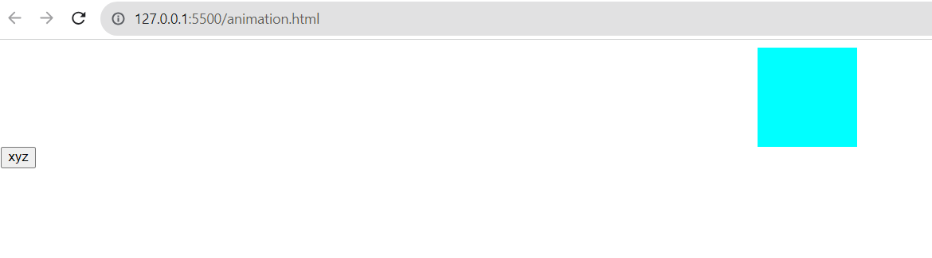

3. How to create slider with animation?

=> <!DOCTYPE html>

<html lang="en">

<head>

   <meta charset="UTF-8">

   <meta name="viewport" content="width=device-width, initial-scale=1.0">

   <title>Document</title>

   <link rel="stylesheet" href="https://cdnjs.cloudflare.com/ajax/libs/font-awesome/6.4.2/css/all.min.css">

   <script src="https://cdnjs.cloudflare.com/ajax/libs/jquery/3.7.1/jquery.min.js"></script>

   <style>

      .slider{

         width: 90% !important;

         height: 600px !important;

         margin: 50px auto;

         position: relative;

         box-shadow: 0px 0px 10px 3px grey;

         overflow: hidden;

         border: 5px solid #a8b1e9;

      }

      .slider figure{

         margin: -4px;

         position: relative;

         width: 500%;

         left: 0px;

         transition: 1s ease-in-out;

      }

      .slider figure img{

         width: 20%;

         height: 100%;

         float: left;

      }

      .btn-prev, .btn-next{

         position: absolute;

         top: 45%;

         cursor: pointer;

         color: black;

         background-color: #8794e7;

         padding: 20px;

         font-size: 50px;

         border: none;

         z-index: 1;

      }

      .btn-next{

         right: 0px;

      }

      .btn-prev{

         left: 0px;

      }

   </style>

</head>

<body>

   <div class="slider">

      <figure>

         <img src="1.jpg" alt="">

         <img src="2.jpg" alt="">

         <img src="3.jpg" alt="">

      </figure>

      <button class="btn-prev"><</button>

      <button class="btn-next">></button>

   </div>

   <script>

      $(document).ready(function(){

         x = 0;

         $(".btn-next").click(function(){

            x = (x<=300)?(x+100):0;

            $("figure").css('left',-x+"%");

         })

         $(".btn-prev").click(function(){

            x = (x<=300)?(x+100):0;

            $("figure").css('left',-x+"%");

         })

      })

   </script>

</body>

</html>



