**Module (JAVASCRIPT BASIC & DOM) – 4**

1. What is JavaScript?

=> It is a client-side scripting language. It is also case-sensitive language, JavaScript code written in <script> tag.

2. What is the use of isNaN function?

=> isNaN() method returns true if a value is Not-a-Number. isNaN() converts the value to a number before testing it.

3. What is negative Infinity?

=> The negative infinity in JavaScript is a constant value that is used to represent a value that is the lowest available. This means that no other number is lesser than this value. It can be generated using a self-made function or by an arithmetic operation.

4. Which company developed JavaScript?

=> JavaScript was developed by Brendan Eich at Netscape Communications Corporation in 1995. It was originally called LiveScript, but was renamed to JavaScript in 1995 to capitalize on the popularity of the Java programming language.

5. What are undeclared and undefined variables?

=> Undefined**:**It occurs when a variable has been declared but has not been assigned any value. Undefined is not a keyword.

Undeclared**:**It occurs when we try to access any variable that is not initialized or declared earlier using the var or const keyword.

6. Write the code for adding new elements dynamically

=> New elements can be created in JS by using the createElement**()** method.

For eg:- document.createElement("<tagName>");

<!DOCTYPE html>

<html lang="en">

<head>

    <meta charset="UTF-8">

    <meta name="viewport" content="width=device-width, initial-scale=1.0">

    <title>Document</title>

</head>

<body>

    <div id="innerdiv"></div>

    <button id="mybutton"> Click to Add HTML element </button>

<script>

     document.getElementById("mybutton"). addEventListener("click", function () {

        document.getElementById("innerdiv").innerHTML += "<h3>Hello</h3>";

        });

</script>

</body>

</html>

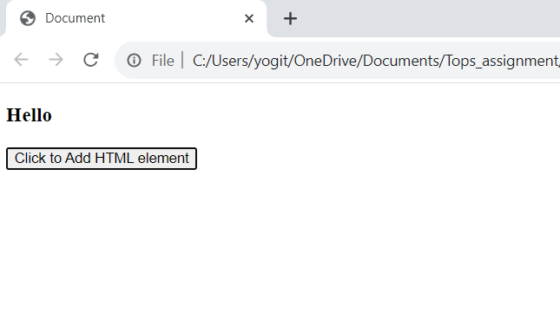

7. What is the difference between ViewState and SessionState?

=> View state:- It can only be visible from a single page and not multiple pages. Information is stored on the client’s end only. ViewState values are lost/cleared when new page is loaded.  It can be used to store information that you wish to access from same web page.

Session state:- Session state value availability is across all pages available in a user session. In session state, user data remains in the server. Data is available to user until the browser is closed or there is session expiration. Information is stored on the server. It can be used to store information that you wish to access on different web pages.

8. What is === operator?

=> It is one of the comparison operator. It compare the value with datatype also

e.g:- <!DOCTYPE html>

<html lang="en">

<head>

    <meta charset="UTF-8">

    <meta name="viewport" content="width=device-width, initial-scale=1.0">

    <title>Document</title>

</head>

<body>

    <script>

        var a = 10;

        var b = "10";

        document.write(a===b);

    </script>

</body>

</html>

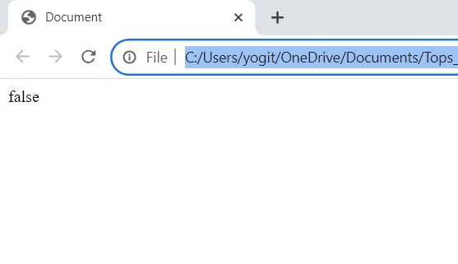

It returns false, because one is number and one is string.

9. How can the style/class of an element be changed?

=> <!DOCTYPE html>

<html lang="en">

<head>

    <meta charset="UTF-8">

    <meta name="viewport" content="width=device-width, initial-scale=1.0">

    <title>Document</title>

</head>

<body>

    <p id="demo">Hello World</p>

    <script>

        document.getElementById("demo").style.color = "red";

    </script>

</body>

</html>

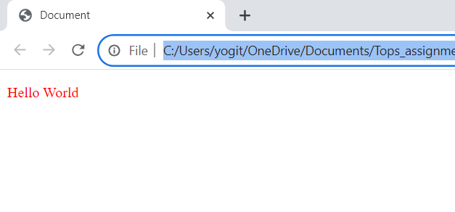

10. How to read and write a file using JavaScript?

=> Read File syntax:- fs.readFile( file_name, encoding, callback_function )

Write File syntax:- fs.writeFile( file_name, data, options, callback )

11. What are all the looping structures in JavaScript?

=> These are the loops:- For loop, while loop, do while loop, for in loop

<script>

// for loop

        for (let i = 0; i <=5; i++) {

            // console.log(i);

            document.write(i + "<hr>");

            // document.write("tops" + "<hr>");

        }

        // while loop

        let j=0;

        document.write ("<br>" + "<br>");

        while (j<=5) {

            document.write(j + "<hr>");

            j++;

        }

        // do while loop

        let k = 0

        document.write ("<br>" + "<br>");

        do {

          document.write(k + "<hr>") ;

          k++

        } while (k<=5);

 // for in loop

        const courses = {

                            firstCourse: 'JavaScript',

                            secondCourse: 'React',

                            thirdCourse: 'Angular'

                        };

        let value = '';

        //using for in loop

        for (let item in courses) {

            value += courses[item] + " ";

        }

        console.log(value);

    </script>

12. How can you convert the string of any base to an integer in JavaScript?

=> parseInt() method convert string into an integer

E.g:- var a = "50.25String";

        document.writeln(Number.parseInt(a) + "<br>");

It returns 50.

13. What is the function of the delete operator?

=> The delete operator removes a property from an object.

e.g:- let emp = {

     firstName: "Raj",

     lastName: "Kumar",

     salary: 40000

}

console.log(delete emp.salary);

console.log(emp);

output:- true

{"firstName":"Raj","lastName":"Kumar"}

14. What are all the types of Pop up boxes available in JavaScript?

=> <!DOCTYPE html>

<html lang="en">

<head>

    <meta charset="UTF-8">

    <meta name="viewport" content="width=device-width, initial-scale=1.0">

    <title>Document</title>

</head>

<body>

    <button onclick="a()">Click</button>

    <p id="one"></p>

    <button onclick="b()">Clickeddd</button>

    <p id="two"></p>

    <button onclick="c()">Clicking</button>

    <script>

        //alert box

        function a(){

            alert("404")

        }

        //confirm box

        var text

        function b(){

            if(confirm("Enter your name")){

                text = "OK"

            }else{

                text = "No"

            }

            document.getElementById("one").innerHTML = text

        }

        //prompt box

        function c(){

            var textValue

            var person = prompt("please enter your name")

            if(person == "" || person == null){

                textValue = "pleae Enter your name"

            }else{

                textValue = "Hi " + person + " How are you"

            }

            document.getElementById("two").innerHTML = textValue

        }

    </script>

</body>

</html>

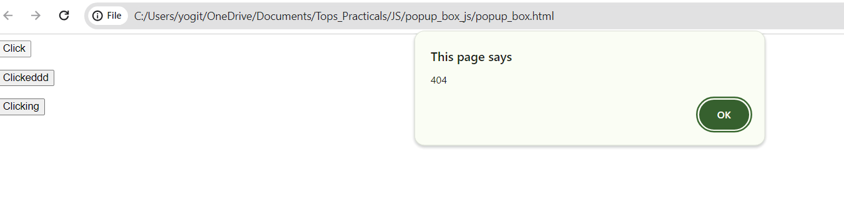

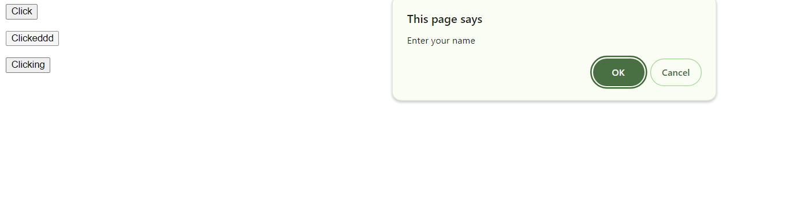

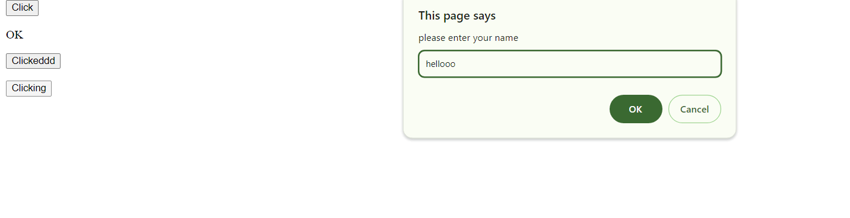

15. What is the use of Void (0)?

=> Void 0 means do nothing, no reload page then we give href = void(0)

<a href="javascript:void(0)">it will do nothing</a>

16. How can a page be forced to load another page in JavaScript?

=> Use the window. location property inside the script tag to forcefully load another page in Javascript.

 window.location = "https://www.amazon.in";

17. What are the disadvantages of using innerHTML in JavaScript?

=> The use of innerHTML very slow.

Appending to innerHTML is not supported.

Contentis replaced everywhere.

**MODULE: 1 (Introduction and Code Quality)**

1. Write a program to Show an alert

=>

<!DOCTYPE html>

<html lang="en">

<head>

    <meta charset="UTF-8">

    <meta name="viewport" content="width=device-width, initial-scale=1.0">

    <title>Document</title>

</head>

<body>

    <button onclick="a()">Click to Alert</button>

    <script>

        function a(){

            alert("hello, this is an alert!!")

        }

    </script>

</body>

</html>

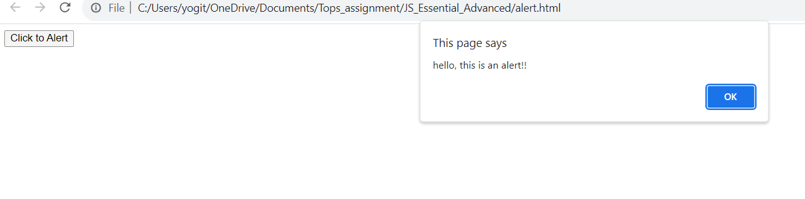

2. What will be the result for these expressions?

=> 5<4

 <script>

        console.log(5>4);

    </script>

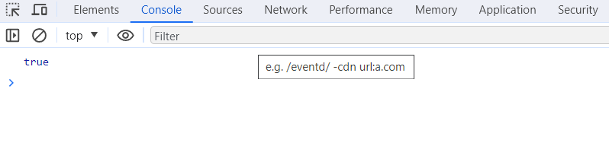

=> "apple" > "pineapple"

<script>

        console.log("apple" > "pineapple");

    </script>

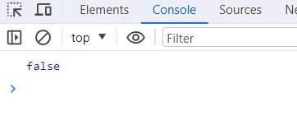

=> "2" > "12"

<script>

        console.log("2" > "12");

    </script>

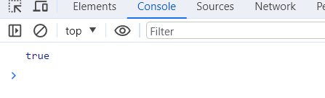

=> undefined == null

<script>

        console.log(undefined == null);

    </script>

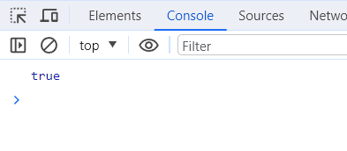

=> undefined === null

 <script>

        console.log(undefined === null);

    </script>



=> null == "\n0\n"

<script>

        console.log(null == "\n0\n" );

    </script>

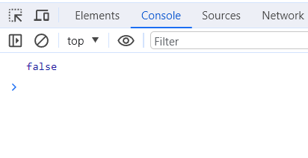

=> null === +"\n0\n"

<script>

        console.log(null === +"\n0\n");

    </script>

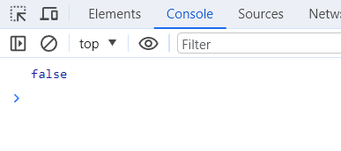

3. Will alert be shown? if ("0") { alert( 'Hello'); }

=> Yes, alert is shown



4. What is the code below going to output? alert( null || 2 || undefined );

=> The answer is 2, that’s the first truthy value.

<script>

       alert( null || 2 || undefined );

    </script>



5. The following function returns true if the parameter age is greater than 18. Otherwise it asks for a confirmation and returns its result:

function checkAge(age)

{

if (age> 18) { return true; }

else {

return confirm (‘did parents allow you?');

}

}

=>  <button onclick="checkAge(17)">Click to Alert</button>

<script>

       function checkAge(age) {

        if (age > 18) {

        return true;

        } else {

        return confirm('Did parents allow you?');

        }

    }

</script>

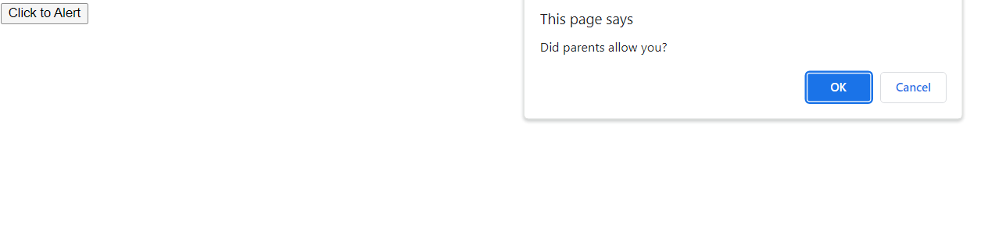

<button onclick="checkAge(20)">Click to Alert</button>

<script>

       function checkAge(age) {

        if (age > 18) {

        return true;

        } else {

        return confirm('Did parents allow you?');

        }

    }

</script>



6. Replace Function Expressions with arrow functions in the code below:

=> <script>

      function ask(question, yes, no) {

        if (confirm(question)) yes();

         else no();

        }

        ask(

        "Do you agree?",

        () => alert("You agreed."),

        () => alert("You canceled the execution.")

        );

    </script>

