MODULE: 1

SE – Overview of IT Industry

1. What is software? What is software engineering?

=> Software is basically a set of instructions or commands that tell a computer what to do like MS Excel, MS Word.

Software engineering is the branch of computer science that deals with the design, development, testing, and maintenance of software applications.

2. Explain types of software

=> Types of software are: -

* Application Software: - It is a type of software application that helps in the automation of the task based on the users input.
* It can perform single or multiple tasks at the same time.
* Examples are Microsoft Office, Paint, PowerPoint, etc.
* System Software: - These software programs are designed to run a computer’s application programs and hardware.
* System software coordinates the activities and functions of the hardware and software.
* It controls operation of computer hardware and provides an environment or platform for all the other types of software to work in it.
* OS is the best example of system software
* Examples are Notepad and Calculator.
* Driver Software: - Also known as device drivers, this software is often considered a type of system software.
* Device drivers controls the devices and peripherals connected to a computer, enable them to perform specific task.
* Example are Audio driver and Video driver.
* Middleware: - The term middleware describes the software that mediates between application and system software or between two different kind of application software.
* Example is like the middleware enables Microsoft Windows to talk to Excel and Word.
* Programming Software: - Computer programmers use programming software to write code.
* Programming software and programming tools enable developers to develop, write, test and debug other software programs.
* Example are Turbo C, Sublime, etc.

3. What is SDLC? Explain each phase of SDLC

=> SDLC stands for Software development lifecycle.

SDLC is a process that enables the production of high-quality, low-cost software, in the shortest possible production time. SDLC consists of various phases, such as planning, design, coding, testing, and deployment.

1. Planning: - The first stage of SDLC is all about “What do we want?” Project planning is a vital role in the software lifecycle.
2. Analysis: - The second step of SDLC is gathering maximum information from the client requirements for the product. Discuss each detail and specification of the product with the customer. The development team will then analyze the requirements keeping the design and code of the software in mind.
3. Design: - In this phase, the software design is created, which includes the overall architecture of the software, data structures, and interfaces. It has two steps:

* High-level design (HLD): It gives the architecture of software products.
* Low-level design (LLD): It describes how each and every feature in the product should work and every component.

1. Implementation or coding: - The design is then implemented in code This is the longest phase in SDLC model.

* This phase consists of Front end + Middleware + Back-end.
* In front-end: Development of coding is done here like how it looks all design part is here and functionality also.
* In Middleware: They connect both the front end and back end.
* In the back-end: A database is created.

1. Testing & Integration: - The software is thoroughly tested to ensure that it meets the requirements and works correctly. And asfter successful testing, The software is deployed to a production environment and made available to end-users.
2. Maintenance: - This phase includes ongoing support, bug fixes, and updates to the software.

4. What is DFD? Create a DFD diagram on Flipkart

=> DFD stands for Data Flow Diagram

The flow of data of a system or a process is represented by DFD.

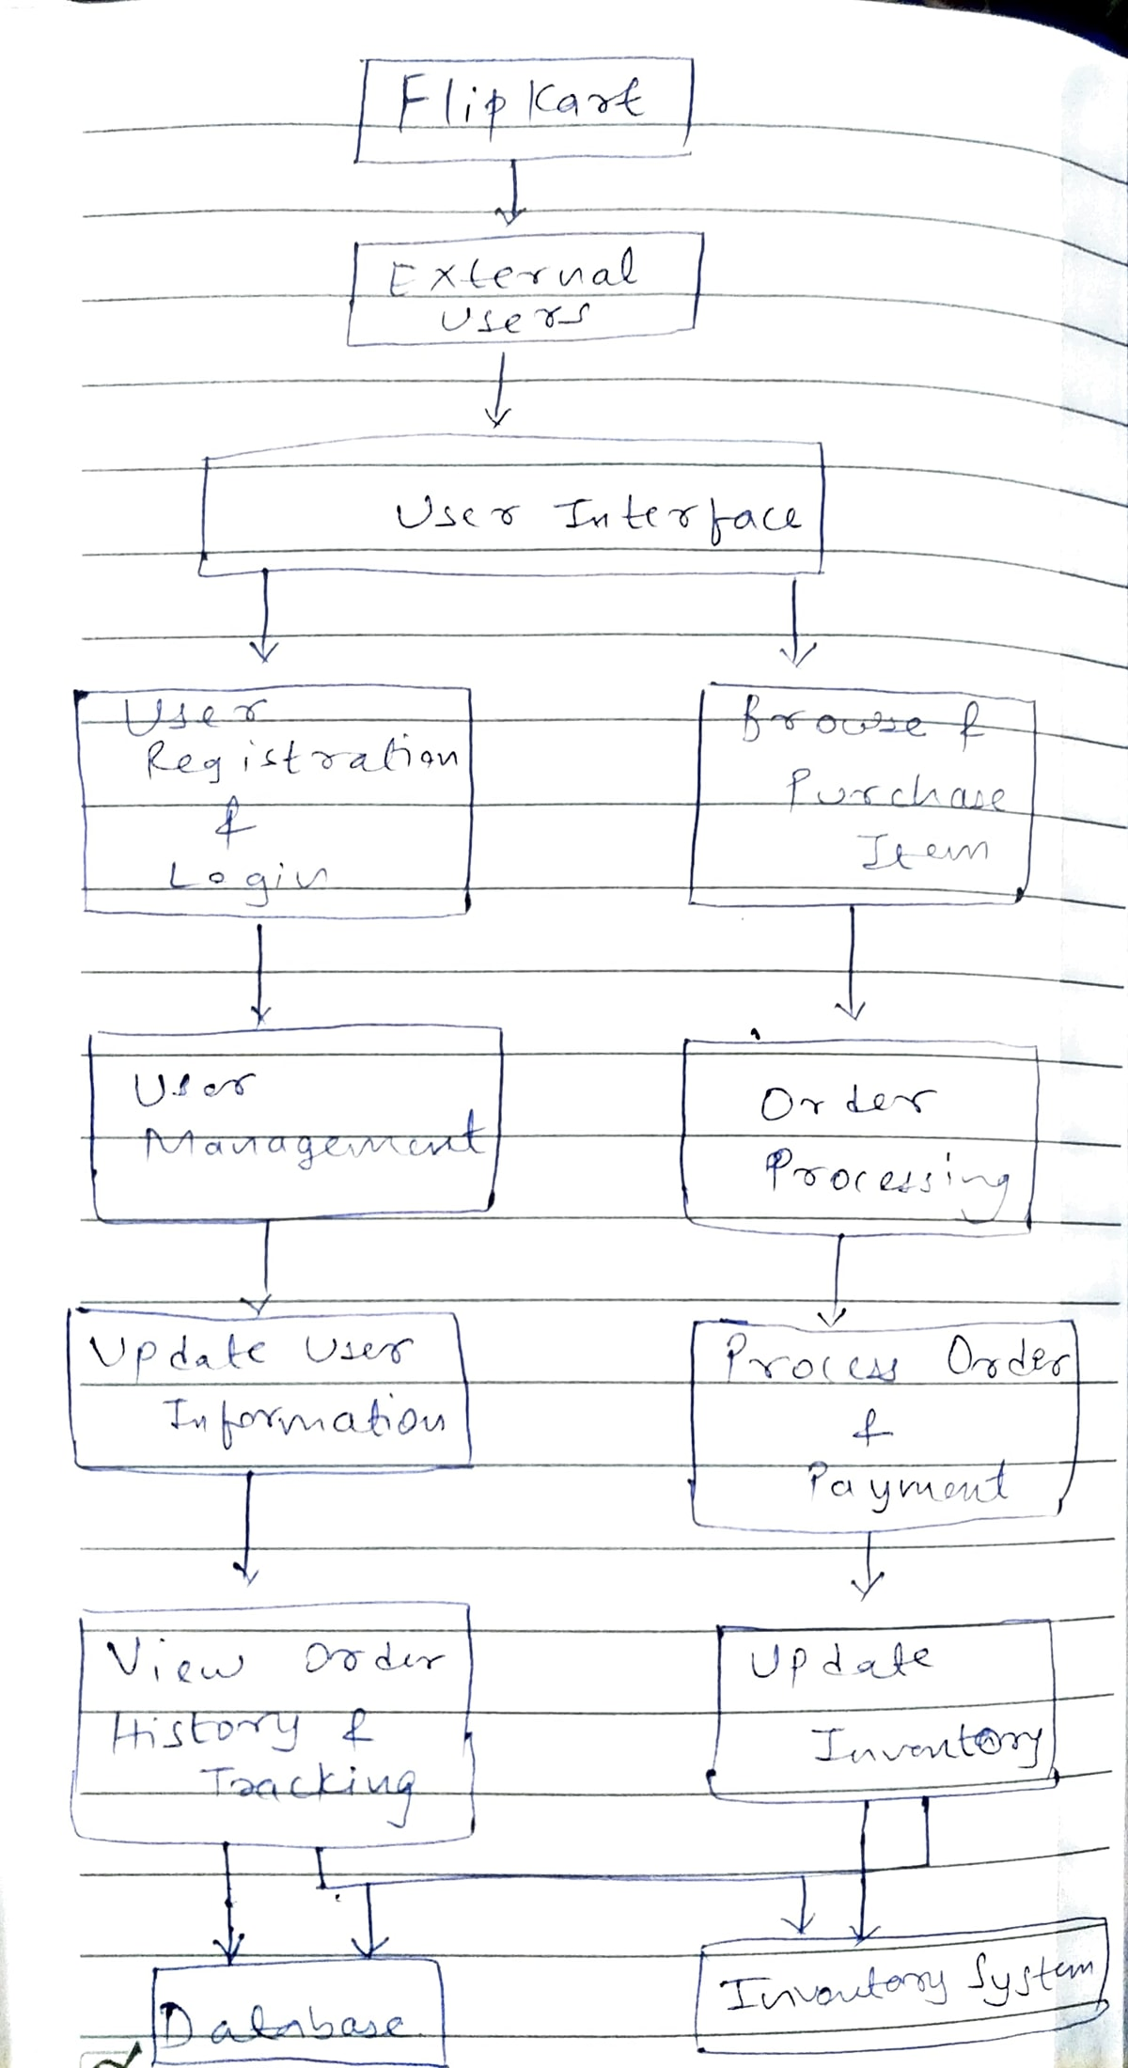

* External Users interact with the User Interface.
* User Interface handles User Registration, Login, Browsing, and Purchasing Items.
* User Management deals with updating user information and preferences.
* Order Processing manages processing orders and payments.
* Inventory System handles updating the inventory.
* Database has all the data.

5. What is Flow chart? Create a flowchart to make addition of two numbers

=> A flowchart is a diagram that illustrates the steps, sequences, and decisions of a process or workflow. A flowchart is a visual representation of a process or algorithm.

* Flowchart of sum of 2 numbers

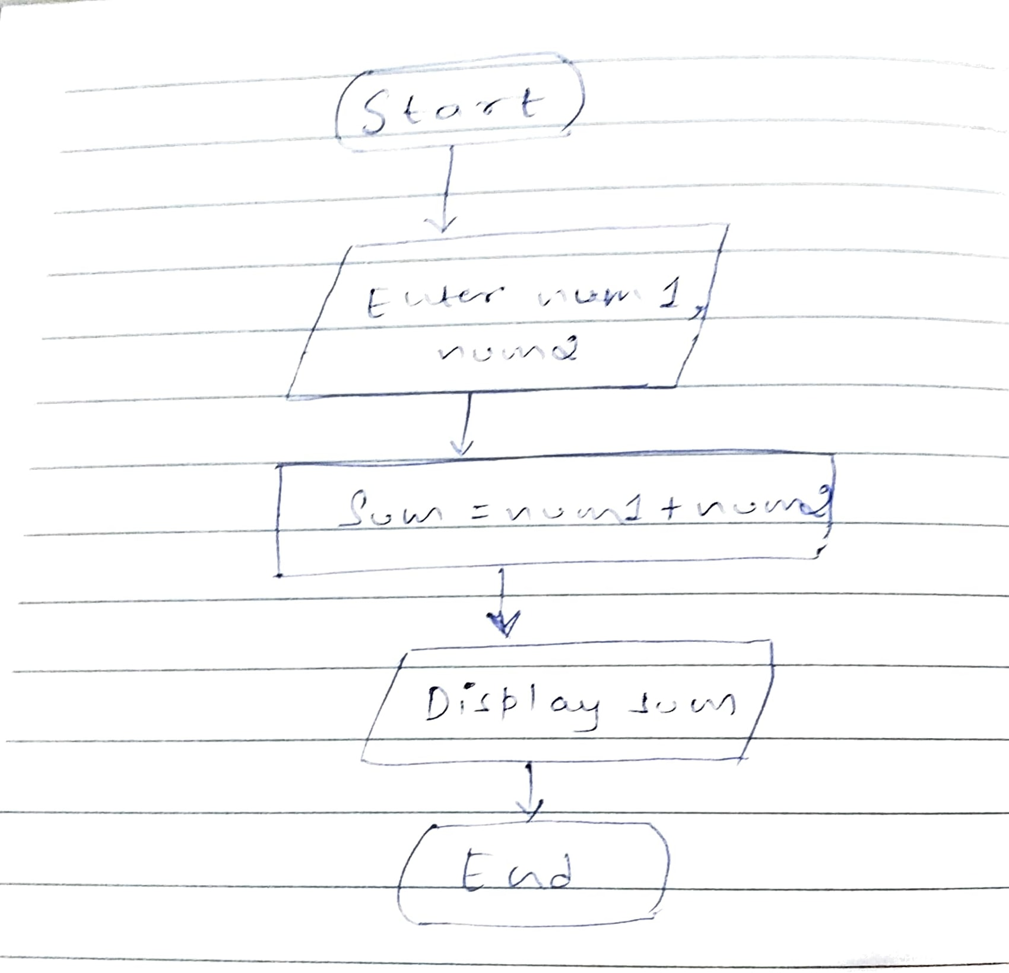

6. What is Use case Diagram? Create a use-case on bill payment on paytm.

=> A Use Case Diagram is a visual representation of the interactions between different actors (users or systems) and a system. The Use-Case Diagram is used to prepare, present and understand functional requirements of the system.

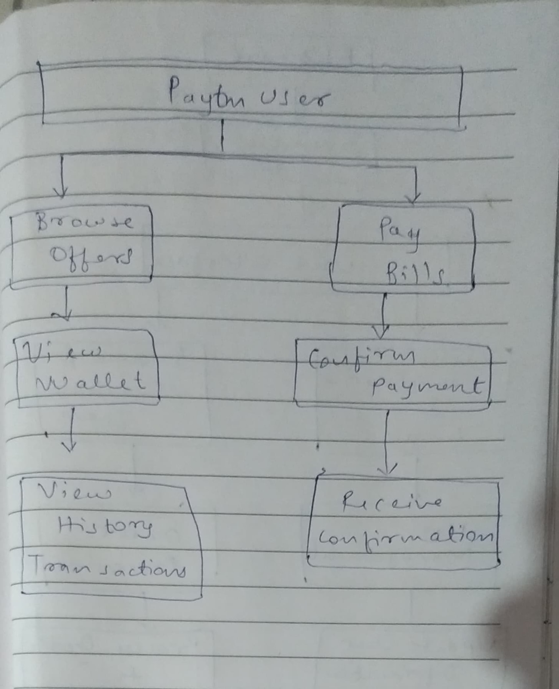

1. Paytm User: Represents the user interacting with the Paytm system.
2. Browse Offers: The user can explore various offers available on the Paytm platform.
3. Pay Bills: The primary use case for paying bills. It involves several sub-processes:
   * View Bills: The user can view details of bills to be paid.
   * Select Bill: The user selects a specific bill to pay.
   * Enter Details: Entering necessary details such as bill amount, account details, etc.
   * Confirm Payment: The user confirms the bill payment.
4. View Wallet: The user can check the balance and view details of their Paytm wallet.
5. Confirm Payment: After entering bill details, the user confirms the payment, which may involve additional steps for security verification.
6. View History Transactions: The user can view the history of their transactions, including bill payments.
7. Receive Confirmation: After completing the payment, the user receives a confirmation of the successful transaction.