**LAB-1**

**SQL Operators (AND, OR & NOT) AND KEYWORDS**

**Theory:** The WHERE clause can be combined with AND, OR, and NOT operators.

The AND and OR operators are used to filter records based on more than one condition:

* The AND operator displays a record if all the conditions separated by AND are TRUE.
* The OR operator displays a record if any of the conditions separated by OR is TRUE.

The NOT operator displays a record if the condition(s) is NOT TRUE.

Example:

* Given:Create a Table Student
* StudentID, StudentName, Course, Program, Credits
* Add 10 record in Student table
* Display Student data whose credits lies in range of 8-9
* Display student Data whose Program in B.Tech
* Display Student Names starts from Letter :”A and S’
* Alter table and add column as ‘Dept’
* Display Altered table
* Drop Table

**Implementation:**

-Table creation

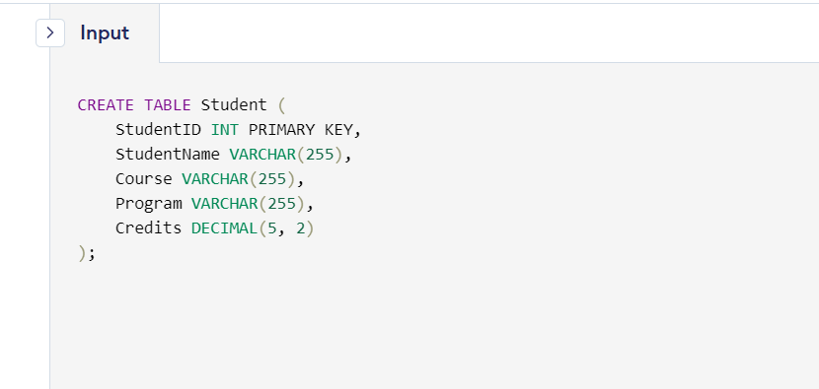

-Value insertion

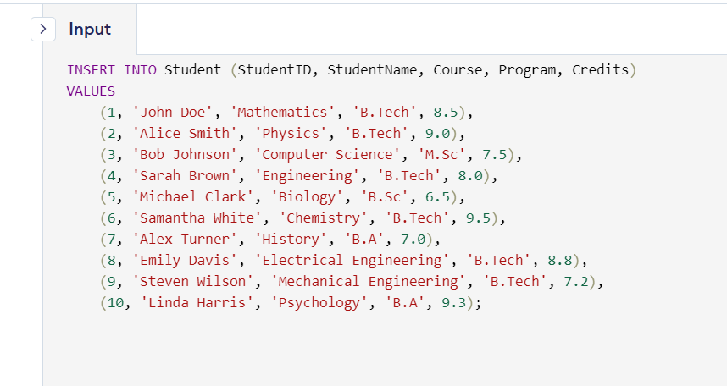



**-**Student data whose credits lies in range of 8-9

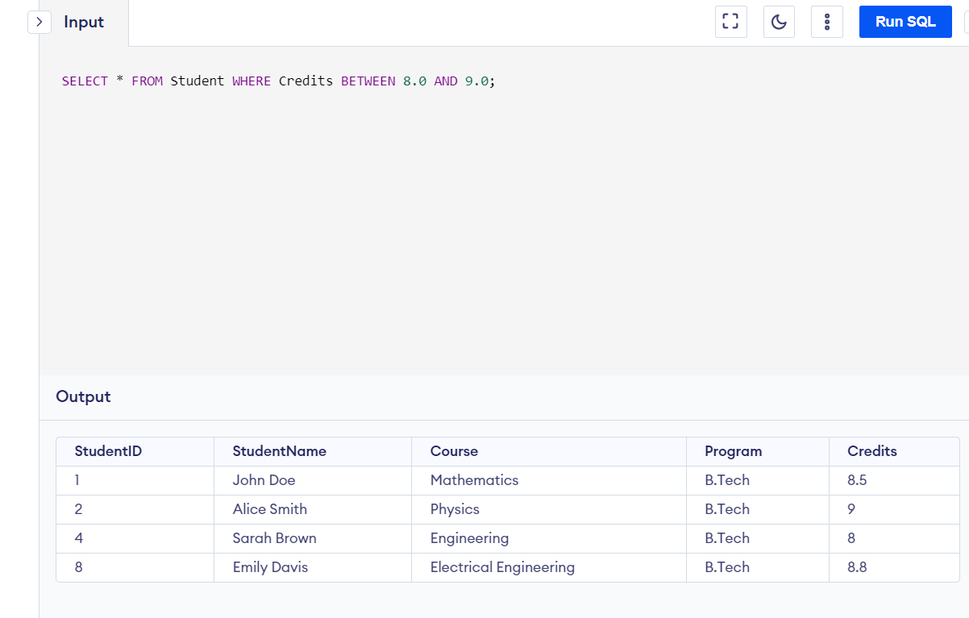

**-**student Data whose Program in B.Tech

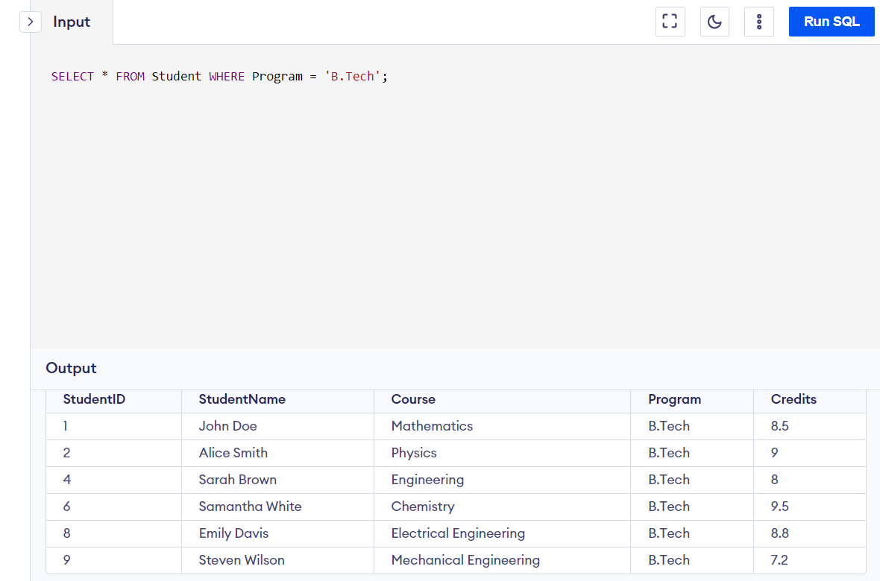

**-**Student Names starts from Letter :”A and S’

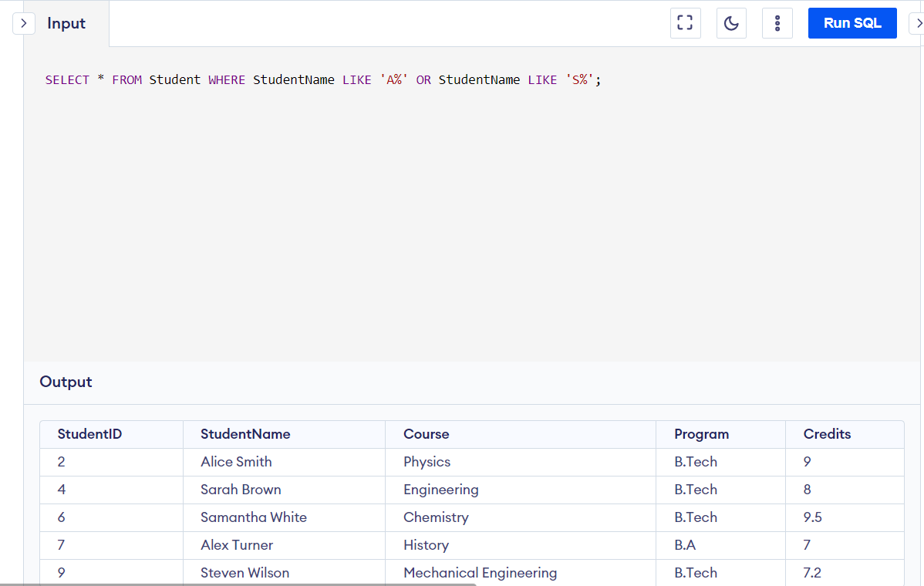

-Alter table and column as ‘Dept’ added

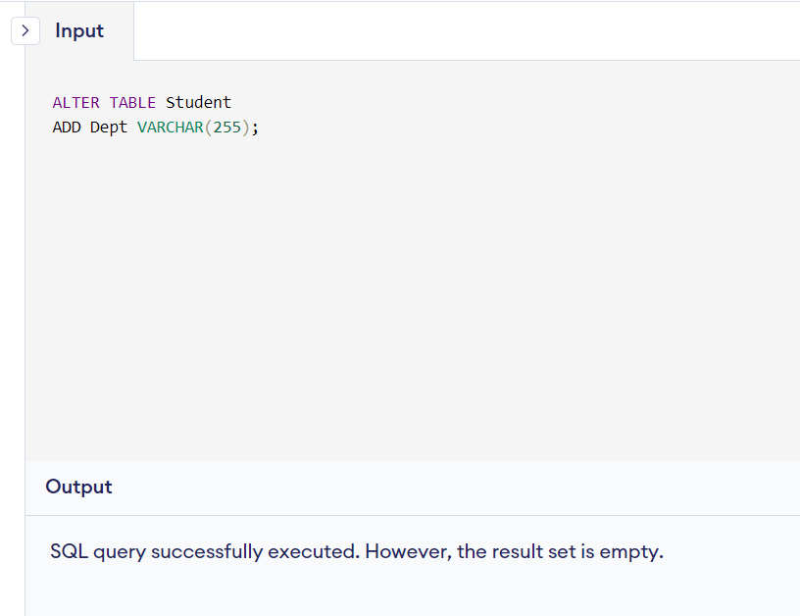



-Table drop

