# Fake Product Review Monitoring and Removal System

A project report submitted for the partial fulfillment of academic requirements for the award of degree of

## MASTER OF COMPUTER APPLICATIONS

Submitted by

#### VAISHNAV BHAT 4NI21MC057

Under the guidance of

**Ms. Sandhya N Assistant Professor**



### Department of Master of Computer Applications The National Institute of Engineering

(An Autonomous Institute under Visvesvaraya Technological University, Belagavi)

Manandavadi Road, Mysuru – 570 008, Karnataka, INDIA

### 2022-2023

**The National Institute of Engineering**

(An Autonomous Institute under Visvesvaraya Technological University, Belagavi) Manandavadi Road, Mysuru – 570 008, Karnataka, INDIA

* Accredited by National Board of Accreditation,
* New Delhi Recognized by AICTE,
* New Delhi Grant-in-Aid by Government of Karnataka

### Department of Master of Computer Applications

**CERTIFICATE**

Certified that the project work entitled **‘Fake Product Review Monitoring and Removal System’** carried out by **Mr. VAISHNAV BHAT**, **4NI21MC057**, a bonafide student at The National Institute of Engineering is submitted in partial fulfillment for the award of Master of Computer Applications Degree in **The National Institute of Engineering, Mysuru,** an autonomous institute under Visvesvaraya Technological University, Belagavi during the year 2022-2023. It is certified that all suggestions/corrections suggested during Internal Assessment have been incorporated in the Report depositedin the departmental library. The project report/ dissertation has been approved as it satisfies the academic requirements in respect of Project work prescribed for the award of the said Degree.

|  |  |  |
| --- | --- | --- |
| Name & Signature of Guide | Name & Signature of the HoD | Signature of Principal |
| **Ms. Sandhya N** | **Dr. Sanjay Kumar C K** | **Dr. Rohini Nagapadma** |
| Assistant Professor | Assistant Professor & HoD | Principal |
| Dept. of MCA, NIE | Dept. of MCA, NIE | NIE, Mysuru |

##### External Viva

Sl. No. Name of examiners signature with date 1.

2.

## DECLARATION

I, **VAISHNAV BHAT** bearing USN: **4NI21MC057** student at **The National Institute of Engineering**, Department of Computer Application, The National Institute of Engineering, Mysuru hereby declare that the project work entitled **“Fake Product Review Monitoring and Removal System”** has been carried out by me under the guidance of **Ms. Sandhya N, Assistant Professor, Dept of MCA.** This project work is submitted to **The National Institute of Engineering**, Mysuru, (An Autonomous institute under VTU, Belagavi) in partial fulfillment of the course requirements for the award of degree in Master of Computer Applications during the academic year 2022-2023. This written submission represents a record of original work and I have adequately cited and referenced the original sources.

Place: Mysuru

Date: (Signature of the student)

# ACKNOWELDGEMENT

I express my sincere thanks and indebtedness to my esteemed institution, **The National Institute Of Engineering, Mysuru** that has provided me with an opportunity tofulfill my desire and reach my goal.

I thank in a very special way to our beloved principal **Dr. Rohini Nagapadma** for her support and help throughout our course and for creating the right academic environment that made my task appreciable.

I would like to express my gratitude towards Assistant Professor **Dr. Sanjay Kumar C K**, Head of the Department for their encouragement and valuable advice.

I would like to sincerely thank my project guide **Ms. Sandhya N,** Assistant Professor Department of MCA for guiding and monitoring through out with constant encouragement.

On a moral personal note, my deepest appreciationand gratitude to my beloved parents, who have been a fountain of inspiration and have provided unrelenting encouragement and support.

I heartily thank all those who have helped me directly or indirectly in the successful completion of my project.

**VAISHNAV BHAT 4NI21MC057**

## ABSTRACT

The proliferation of online commerce has led to an exponential increase in product reviews, which play a vital role in influencing consumer’s purchasing decisions. However, this surge has also given rise to the proliferation of fake and misleading product reviews that undermine the trustworthiness of online platforms. In response, this project presents a "Fake Product Review Monitoring and Removal System using Machine Learning" to mitigate the impact of fraudulent reviews.

The proposed system leverages state-of-the-art machine learning techniques to automatically identify and flag suspicious or fake product reviews within online platforms. The system employs a multi-faceted approach, integrating natural language processing (NLP) and sentiment analysis to assess the authenticity and sentiment of reviews. It also considers reviewer behavior patterns, review content, and historical data to make accurate determinations.

#### Details Page No.

**Title Page**

Certificate from college i

Declaration ii

Acknowledgment iii

Abstract iv

Contents v

List of Figures ix

List of tables x

CHAPTER 1: Introduction 1

* 1. Overview 1
  2. Motivation 2
  3. Problem Statement 2

CHAPTER 2: Literature Survey 3

* 1. Existing Work 3
     1. Drawback of Existing Work… 5
  2. Proposed Work 5
     1. Advantages of Proposed Work… 7
  3. Tools and Technology Used… 7
     1. Python 7
     2. Machine Learning Libraries (Scikit-Learn) 8
     3. Natural Language Processing Libraries (NLTK) 8
     4. Data Analysis Libraries (Pandas, NumPy) 9
     5. Web Development Framework (Flask) 10
     6. Database Management System (MySQL) 11
     7. Integrated Development Environment (VS Code) 11

CHAPTER 3: Datasets and Its Preprocessing… 13

* 1. Data Collection 13
  2. Data Preprocessing… 13
  3. Data Characteristics 13

Details Page No.

* 1. Data Labeling… 14
  2. Data Splitting… 14
  3. Data Diversity and Representation 14

CHAPTER 4: METHODOLOGY… 15

* 1. Approach Selection 15
  2. Data Collection and Preprocessing 15
  3. Feature Extraction 15
  4. Machine Learning Model Selection and Training… 16
  5. Sentiment Analysis and Behavioral Pattern Recognition 16
  6. Real-time Monitoring and Review Flagging… 16
  7. Review Removal 16
  8. Performance Evaluation and Testing… 16

CHAPTER 5: SOFTWARE REQUIREMENT SPECIFICATION… 17

* 1. Purpose 17
  2. Scope 17
  3. Use Cases and User Stories 17
  4. Functional Requirements 18
  5. Non-Functional Requirements 19
  6. Software and Hardware Requirements 20

CHAPTER 6: SYSTEM ANALYSIS 21

* 1. Requirement Elicitation and Gathering… 21
  2. Feasibility Study 21
  3. Modules 21
     1. Admin Module 21
     2. User Module 22

CHAPTER 7: SYSTEM DESIGN… 23

* 1. System Architecture Design 23
  2. Software and Hardware Component Design 24
  3. Database Design 24

Details Page No.

* 1. UML Diagrams 25
     1. Use Case Diagram 25
     2. Activity Diagrams 25
     3. Class Diagrams 26
     4. Data Flow Diagrams (DFDs) 27
  2. Algorithm Used… 28
     1. Support Vector Machine (SVM) 28
     2. Logistic Regression (LR) 29

CHAPTER 8: SYSTEM IMPLEMENTATION 31

* 1. Backend Development 31
     1. Initial Data Exploration 31
     2. Text Data Exploration and Pre-Processing 32
     3. Model Implementation and Evaluation 33
  2. Frontend Development 34
     1. Home Page 34
     2. User Authentication 34
     3. User Dashboard… 34
     4. Admin Dashboard… 35
     5. Review Verification and Prediction 35
     6. Product Details 35
     7. All Reviews 35
  3. Database Implementation 36
     1. Database Models 36

CHAPTER 9: SYSTEM TESTING… 38

* 1. Functionality Testing… 38
  2. User Authentication and Authorization Testing 38
  3. Product and Review Management Testing… 38
  4. User Interface (UI) Testing… 39
  5. Security Testing… 39

Details Page No.

* 1. Performance Testing… 39
  2. Compatibility Testing… 40
  3. Data Integrity and Consistency Testing… 40

CHAPTER 10: RESULT ANALYSIS 41

* 1. Accuracy 41
  2. Precision 41
  3. F1 Score 41

CHAPTER 11: CONCLUSION… 43

FUTURE ENHANCEMENT 44

SCREEN SHOTS 45

REFERENCES 51

#### Details Page No.

Fig.1 System Architecture 23

Fig.2 Use Case Diagram for Admin and User 25

Fig.3 Activity Diagram 26

Fig.4 Class Diagram 26

Fig.5 Level 0 DFD… 27

Fig.6 Level 1 DFD… 27

Fig.7 Support Vector Machine 29

Fig.8 Logistic Regression 30

#### Details Page No.

Tb.1 Test Cases Result 40

Tb.2 Algorithms Performance 42

## CHAPTER 1

**INTRODUCTION**

Throughout history, purchasing goods has been a timeless practice, involving sharing recommendations based on personal experiences. Seeking guidance from those with prior experience has been a common approach when making unfamiliar purchases. This tradition has evolved into today's digital era as online reviews. With E-commerce's rise, online reviews have become crucial, but managing and organizing them is complex due to the vast number of users worldwide. To tackle this challenge, we propose a Review Monitoring System to streamline user reviews, aiding customers and manufacturers in making informed product decisions.

Our approach empowers users to access reviews for specific products and their features. This system doesn't just gather review data; it categorizes these inputs into positive and negative sentiments, presenting a comprehensive view. This aids users in forming judgments based on past customers' positives and negatives. For manufacturers, it serves as a feedback mechanism, helping them grasp user perceptions of their products and determine whether to continue as is or implement improvements.

Moreover, online platforms sometimes host false or inappropriate reviews. Our system tackles this by implementing robust user verification, excluding irrelevant or dubious accounts. These flagged accounts are barred from accessing the platform, thus establishing a strong filter for maintaining high-quality reviews and a user-friendly interface.

In essence, our solution capitalizes on the age-old tradition of seeking advice while shopping, transforming it into a modernized, efficient system. It caters to the needs of both buyers and sellers by curating reviews, empowering decision-making, and upholding review authenticity.

#### Overview:

The objective of the "Fake Product Review Monitoring and Removal System" project is to create a sophisticated solution to combat the significant problem of fraudulent product reviews in online marketplaces. Online product reviews hold significant sway in shaping consumer buying choices, thus becoming a key element in business success. Nevertheless, the widespread

occurrence of false reviews has eroded the reliability of these platforms. This initiative aims to establish a strong system capable of identifying and eliminating counterfeit product reviews, thereby fostering a more trustworthy and dependable online shopping environment for customers.

#### Motivation:

The motivation to undertake this project is driven by the desire to restore trust in online reviews. By developing a solution that can accurately detect and remove fake reviews, the project aims to create a more transparent and trustworthy environment for both consumers and businesses. The goal is to provide a platform where users can rely on reviews to make informed decisions and where businesses can receive fair feedback about their products.

#### Problem Statement:

The central issue tackled by the "Fake Product Review Monitoring and Removal System" project is the widespread problem of counterfeit product reviews, which disrupt the credibility of online marketplaces. These deceptive reviews, often with malicious intent, erode the trustworthiness of user opinions. Detecting fake reviews manually is labor-intensive and error-prone, leaving consumers susceptible to misinformation and businesses at risk of reputation damage.

The absence of a viable solution contributes to a skeptical view of online reviews. Without an effective means to identify and eliminate fake reviews, the authenticity of user feedback remains uncertain, diminishing the value of online review platforms.

By establishing the project's historical context, motivation, and specific challenge, these opening sections provide crucial context. This sets the stage for subsequent parts that delve into technical details, methodologies, and outcomes of the proposed "Fake Product Review Monitoring and Removal System."

## CHAPTER 2

**LITERATURE SURVEY**

A literature review involves analyzing published sources such as scholarly books and journals to explore a specific topic. Its purpose is to present to the reader the existing knowledge and concepts related to a subject, along with their merits and shortcomings.

The objectives of a literature review can be summarized as follows:

* **Displaying Knowledge**: Demonstrating familiarity with the existing body of knowledge, thereby establishing the credibility of the undertaken work.
* **Contextualizing Prior Research**: Indicating how previous research aligns with the current project while providing a concise overview of that research.
* **Synthesizing Information**: Bringing together and integrating the collective understanding of a particular subject from various sources.
* **Showcasing Use of Research**: Illustrating how the insights from others' research have been employed and built upon to generate new insights and ideas.

#### Existing Work:

Exploring prior research in the realm of fake product review identification and monitoring is crucial for comprehending the landscape of available remedies and their constraints. The studies mentioned in this section underscore varied methodologies and tactics used to combat fake reviews. These collective efforts underscore the importance of countering fake reviews and showcase the array of strategies researchers have pursued.

It's worth noting that, despite their valuable contributions, existing endeavors have their limitations. Accuracy issues in detection, reliance on manual intervention, and an inability to keep up with evolving tactics by fake reviewers are observed shortcomings. These drawbacks

offer crucial insights for shaping a more comprehensive and robust solution.

The subsequent studies offer enlightening perspectives on diverse approaches and techniques applied to tackle the fake review challenge:

#### Fake Product Review Monitoring Using Opinion Mining (2018):

This study presents a framework that utilizes opinion mining to detect fake product reviews. The framework involves analyzing customer opinions expressed in reviews, with a focus on identifying if they pertain to specific products. Decision trees are used to establish the connection between reviews and products, while a spam dictionary helps identify spam words. Various text mining algorithms are employed to achieve accurate results. The resulting software aids users in making informed purchasing decisions by detecting and removing fake reviews. The system's ability to block consistent fake reviews from specific IP addresses enhances product credibility and user trust.

#### Framework for Fake Review Detection: Issues and Challenges (2018):

This paper outlines the challenges and issues associated with detecting fake reviews. It introduces a framework suitable for both labeled and unlabeled data, achieving notable accuracy rates for supervised and semi-supervised learning. The paper explores potential features, conducts experiments, and discusses potential future directions in fake review detection.

#### Fake Product Review Monitoring System (2019):

This study addresses fake reviews through a comprehensive approach. It discusses techniques like IP address tracking, ontology, and spam word dictionaries to enhance the accuracy of opinion mining. The paper introduces a novel algorithm for detecting spam reviews and conducting opinion mining on a filtered dataset. Techniques such as ontology, geolocation, IP address tracking, and brand-only review detection are incorporated to enhance the overall detection process.

#### GSCPM: CPM Based Group Spamming Detection (2019):

This paper proposes the GSCPM method for detecting group spammers by employing the Clique Percolation Method. The approach utilizes behavioral and relational data to identify suspicious reviewers and clusters, ranking candidates based on group and individual spam indicators. The method's performance is validated using real-world review datasets.

#### Declarative Programming Approach for Review Detection (2020):

In this paper, a novel declarative programming strategy is introduced for the identification of fake reviews. This innovative approach integrates author behavior and content characteristics to establish a white-box methodology. By utilizing Answer Set Programming, it defines patterns of malicious behavior, incorporating various review attributes such as quantity, dislikes, and temporal patterns. This comprehensive approach aims to establish an effective system for the detection of fake reviews.

#### Drawbacks of Existing Work:

The existing studies in the field of fake product review detection and monitoring, while valuable, exhibit certain limitations:

* + - * **Limited Detection Accuracy:** Some existing approaches struggle with accurately identifying sophisticated fake reviews, leading to false positives or negatives. For instance, the reliance on basic sentiment analysis might miss well-crafted fake reviews that mimic genuine sentiments.
      * **Manual Intervention Dependency:** Certain methods require manual intervention or human review to confirm the authenticity of flagged reviews. This can be resource-intensive and may not scale well as the volume of reviews increases.
      * **Inadequate Adaptability**: The dynamic nature of fake review tactics demands constant adaptation in detection techniques. Some existing systems may lack the agility to swiftly adapt to evolving strategies employed by fake reviewers.

#### Proposed Work:

The "Proposed Work" section introduces the innovative approach that the "Fake Product Review Monitoring and Removal System" project aims to bring to the field. This section outlines the key advancements and features of the proposed system, showcasing how it aims to overcome the limitations observed in existing solutions.

The project's dedication to harnessing state-of-the-art technology is demonstrated through the utilization of sophisticated machine learning models, including Logistic Regression and Support Vector Machine. These models are selected for their proficiency in scrutinizing linguistic patterns, sentiments, and behavioral cues embedded within reviews, thereby enhancing the precision of the detection process.

The integration of sentiment analysis techniques signifies the project's focus on deepening the analysis of review content. By identifying discrepancies between expressed sentiments and actual context, the proposed system enhances its ability to identify manipulative and misleading reviews.

* **Utilization of Cutting-edge Machine Learning Models:** The envisioned system employs advanced machine learning models, notably Logistic Regression (LR) and Support Vector Machine (SVM), to scrutinize linguistic patterns, nuances in sentiment, and behavioral indicators present in reviews. These models facilitate precise identification of fake reviews.
* **Integrated Sentiment Analysis:** The system incorporates sentiment analysis techniques to delve deeper into review content and identify discrepancies between expressed sentiments and actual context. This enhances the system's ability to identify manipulative reviews.
* **Behavior Pattern Analysis**: Through the examination of user behavior and review submission tendencies, the proposed system detects patterns indicative of fake review campaigns. This analysis of behavior significantly enhances the effectiveness of the detection mechanism.
* **Real-time Surveillance**: The system maintains continuous vigilance over incoming reviews, promptly subjecting them to real-time scrutiny for the identification of suspicious content. This proactive strategy plays a pivotal role in upholding the credibility of the review platform.
* **Automated Removal and Alerts**: Upon identifying a review as fraudulent, the system seamlessly eliminates it from the platform and promptly notifies the respective user. This automated process ensures users are promptly informed about the removal and the rationale

behind it.

#### Advantages of Proposed Work:

The "Fake Product Review Monitoring and Removal System" project aims to address the drawbacks of existing approaches and introduce novel solutions:

* + - * **Advanced Detection Algorithms**: The system incorporates cutting-edge machine learning algorithms capable of deciphering intricate language patterns, unusual behaviors, and contextual hints. This empowers the system to identify even the most intricate fake reviews with heightened precision.
      * **Automated Decision-Making**: Through the utilization of automated analysis and machine learning, the system minimizes the necessity for manual interference. This simplifies the review management process and significantly lightens the load on human moderators.
      * **Real-time Flexibility**: Adaptive algorithms are seamlessly integrated into the proposed system, enabling swift responses to novel tactics employed by fraudulent reviewers. This dynamic approach ensures the system's efficacy against evolving fake review strategies.

#### Tools and technologies used

In the development of the "Fake Product Review Monitoring and Removal System," a variety of tools and technologies have been utilized to create an effective and functional system. These tools serve as the foundational elements for different aspects of the project's design and implementation. Here's a brief explanation of each tool and technology used:

#### Python:

Python is a popular and versatile programming language that acts as the foundational tool for developing the "Fake Product Review Monitoring and Removal System" project. It offers several distinct advantages due to its extensive libraries and user-friendly syntax, making it an excellent choice for building various elements of the system.

* **Versatility**: Python is known for its versatility, allowing developers to work on a wide range of applications, from web development to scientific computing. This flexibility makes it suitable for projects with diverse requirements.
* **Rapid Development**: Python's libraries allow developers to accomplish tasks with fewer lines of code compared to other languages. This leads to quicker development cycles and faster iteration, which is especially valuable for project timelines.
* **Community Support**: Python has a large and active community of developers who contribute to its growth and development. This community support translates into a wealth of resources, tutorials, forums, and open-source projects that developers can leverage while working on their projects.
* **Cross-Platform Compatibility**: Python is cross-platform, meaning code written on one platform (such as Windows) can be easily run on other platforms (such as macOS or Linux) with minimal modifications. This compatibility enhances collaboration and deployment across different environments.

#### Machine Learning Libraries (e.g., Scikit-Learn):

Machine learning libraries, like Scikit-Learn, are pre-built software packages that provide a wide range of algorithms and tools designed to aid in the development of machine learning models. In the context of the "Fake Product Review Monitoring and Removal System" project, these libraries play a critical role in enhancing the system's ability to analyze reviews and detect fake ones accurately. Here's an explanation of their significance:

#### Natural Language Processing (NLP) Libraries (e.g., NLTK):

Natural Language Processing (NLP) libraries, such as NLTK (Natural Language Toolkit) are essential tools for processing and analyzing textual data. In the project, these libraries contribute significantly to the system's ability to handle and understand the content of product reviews.

* **Text Preprocessing:** NLP libraries assist in cleaning and preprocessing raw text data. This involves tasks like tokenization (splitting text into words or phrases), removing punctuation, and converting text to lowercase.
* **Sentiment Analysis:** NLP libraries enable sentiment analysis, which involves determining the emotional tone of a piece of text. This is valuable for categorizing reviews as positive, negative, or neutral, helping to identify fake reviews that might exhibit unusual sentiment patterns.
* **Feature Extraction:** NLP libraries help extract relevant features from text data. These features could include identifying important keywords, phrases, or linguistic patterns that are indicative of fake reviews.
* **Named Entity Recognition:** NLP libraries can identify and categorize named entities (such as product names, brands, and locations) in reviews. This is useful for understanding context and identifying potential fake reviews that may misuse brand names.
* **Language Understanding:** NLP libraries provide linguistic tools that aid in understanding sentence structure, grammar, and semantics. This understanding helps in accurately analyzing the content of reviews.

#### Data Analysis Libraries (e.g., Pandas, NumPy):

Data analysis libraries like Pandas and NumPy play a pivotal role in effectively managing and manipulating data within the "Fake Product Review Monitoring and Removal System" project. These libraries provide essential tools and functionalities that streamline data handling, enabling accurate analysis and effective decision-making.

##### Numpy:

Numpy is a fundamental library for numerical computing in Python. It provides support for arrays (vectors and matrices) and a wide range of mathematical functions that enable efficient and high-performance numerical operations.

##### Pandas:

Pandas is a powerful library for data manipulation and analysis. It provides data structures like DataFrame to store and manipulate tabular data. In your project, you'll likely use Pandas to load, preprocess, and analyze review data.

##### Matplotlib and Seaborn:

Matplotlib is a popular plotting library that allows you to create various types of plots and charts. Seaborn is built on top of Matplotlib and provides a high-level interface for creating aesthetically pleasing statistical visualizations. You can use these libraries to create visualizations to represent your data and analysis results.

##### WordCloud:

The WordCloud library is used to create word clouds, which visually represent the frequency of words in a text dataset. In your project, you might use it to visualize common words in reviews.

##### TextBlob:

TextBlob is a library for processing textual data. It provides simple methods for tasks like sentiment analysis, part-of-speech tagging, and more. In your project, TextBlob might be used for sentiment analysis of reviews.

#### Web Development Framework (e.g., Flask):

Web development frameworks, such as Flask or Django, are essential tools for creating robust and feature-rich web applications like the "Fake Product Review Monitoring and Removal System." These frameworks provide the foundation for building user interfaces, handling user interactions, and managing the overall functionality of the system. Here's how they contribute:

* **Structured Development:** Web frameworks provide a structured approach to web application development, allowing developers to follow best practices and adhere to coding standards. This results in cleaner, more maintainable code.
* **Routing and URL Handling:** Frameworks like Flask and Django offer mechanisms for defining URL routes, ensuring that user requests are directed to the appropriate functions or views.
* **User Interface:** These frameworks facilitate the creation of user interfaces through templates and views. Templates allow developers to design consistent and dynamic web

pages, while views handle logic and data interaction.

* **User Authentication and Security:** Web frameworks often include built-in tools for user authentication and security. This is crucial for ensuring that user data remains protected and that only authorized users can access certain features.

#### Database Management System (e.g., MySQL):

Database management systems like MySQL or PostgreSQL are essential components for efficiently storing and managing data within the "Fake Product Review Monitoring and Removal System" project. These systems provide structured data storage, retrieval, and organization capabilities, which are crucial for the project's functionality. Here's how they contribute:

* + - * **Structured Data Storage:** Database systems offer structured storage, allowing data to be organized into tables with defined columns and data types. This ensures consistency and integrity in data storage.
      * **Data Retrieval:** Database systems enable efficient retrieval of specific data using querying languages like SQL. This is essential for tasks such as fetching user account information, review data, and system settings.
      * **Data Management:** Database systems handle tasks such as data insertion, updating, and deletion, ensuring that the stored data remains accurate and up-to-date.
      * **Concurrency Control**: These systems manage concurrent access to data by multiple users, preventing conflicts and ensuring data consistency.

#### Integrated Development Environment (IDE) - VS Code:

Visual Studio Code (VS Code) serves as the integrated development environment (IDE) for coding, debugging, and testing within the "Fake Product Review Monitoring and Removal System" project. This IDE enhances the development process through various features and tools. Here's how it contributes:

* **Coding Assistance:** VS Code offers features like syntax highlighting, auto-completion, and error checking, which help developers write code more efficiently and with fewer errors.
* **Extensions and Plugins:** The IDE supports a wide range of extensions and plugins that can enhance its functionality. These extensions cover various aspects, including code formatting, linting, and integration with external tools.
* **Integrated Terminal:** VS Code includes an integrated terminal that enables developers to execute commands, run scripts, and interact with the project environment without leaving the IDE.
* **Customization:** Developers can customize the IDE's appearance, settings, and behavior to match their preferences and workflow.

## CHAPTER 3

### Datasets and Its Preprocessing

In the "Fake Product Review Monitoring and Removal System" project, the dataset holds a central role in shaping the system's capabilities and effectiveness. It comprises a diverse and representative collection of product reviews sourced from various online platforms. This dataset serves as the bedrock for the development, training, and evaluation of the system's core functionalities.

#### Data Collection

The process of data collection marks the inception of the "Fake Product Review Monitoring and Removal System" project's journey. In this phase, an extensive and meticulous approach was adopted to scrape product reviews from diverse e-commerce websites. By casting a wide net across multiple platforms, the project ensured the inclusion of a rich spectrum of product categories and review types. This strategic approach to data collection was aimed at crafting a dataset that truly represents the multifaceted nature of online reviews.

#### Data Preprocessing

As the project progressed to the "Data Preprocessing" phase, the raw collected data underwent a series of meticulous transformations to prepare it for analysis and model training. The primary goal of this stage was to enhance the data's quality, ensuring that it becomes a valuable asset in the development of the system's core functionalities.

#### Data Characteristics

The dataset's characteristics form a reflection of its richness and diversity. The substantial volume of reviews within the dataset spans across an array of product categories and industries, mirroring the vastness of the online marketplaces.

#### Data Labeling

To enable supervised learning and model evaluation, a portion of the dataset was manually labeled by domain experts. These labels indicate whether a review is considered genuine or potentially fake. The labeled data serves as the ground truth against which the system's machine learning models are trained and tested. Experts collaborated to ensure consensus during the labeling process, enhancing the accuracy of the labeled dataset.

#### Data Splitting

To accurately assess the system's performance, the dataset was divided into distinct subsets: training, validation, and test sets. The training set facilitated model learning, the validation set aided in tuning hyperparameters, and the test set, unseen during training, gauged the system's real-world performance. This division ensures that the system's performance metrics are reliable and reflective of its actual capabilities.

#### Data Diversity and Representation

The significance of data diversity cannot be understated. In an age of diverse products and industries, a one-size-fits-all solution would fall short. The project's emphasis on data diversity underscores its commitment to inclusivity and relevance. By thoughtfully including reviews from a wide array of domains and industries, the system becomes versatile and applicable across different product categories.

This diversity in the dataset serves as an assurance that the system's effectiveness is not limited to a particular niche. It equips the system to address fake reviews across a wide range of products, ensuring that its impact is far-reaching and meaningful. This strategic approach aligns with the project's broader goal of providing users and manufacturers with a comprehensive and reliable tool to combat the challenges of fake product reviews.

## CHAPTER 4

**METHODOLOGY**

The methodology chapter serves as a detailed guide outlining the systematic approach utilized to achieve the project's objectives. This chapter explains the step-by-step process followed during the design, development, and implementation of the proposed system for detecting and managing fake product reviews.

The methodology chapter includes the following sections:

#### Approach Selection:

The "Fake Product Review Monitoring and Removal System" project relies on a meticulously chosen approach to tackle the intricate challenge of fake reviews. The selection of machine learning algorithms and sentiment analysis as the primary techniques stems from their established success in processing and understanding textual data. Machine learning models, such as Logistic Regression and Support Vector Machine, have proven capabilities in classification tasks, making them apt choices for identifying fake reviews from genuine ones.

#### Data Collection and Preprocessing:

The robustness of the system hinges on the quality of data it processes. This section delves into the intricacies of data collection, emphasizing the importance of sourcing reviews from diverse online platforms. The comprehensive approach to data collection involves scraping product reviews from various sources, including online marketplaces, forums, and social media platforms. This ensures a representative dataset that encapsulates the wide spectrum of product categories and user opinions. Equally vital is data preprocessing, where the collected raw data undergoes rigorous cleansing.

#### Feature Extraction:

The transformation of raw textual data into meaningful features is pivotal for machine learning models to differentiate between genuine and fake reviews. This section expounds on the methodologies employed to extract features from the review content. It highlights the extraction of linguistic patterns, sentiment scores, and behavioral attributes that contribute to the differentiation process.

#### Machine Learning Model Selection and Training:

The choice of machine learning models is central to the project's success. This section delves into the methodology behind selecting Logistic Regression and Support Vector Machine as the primary models for classification. The rationale includes their proven capabilities in handling large datasets and distinguishing between different classes.

#### Sentiment Analysis and Behavioral Pattern Recognition:

The emotional undertones conveyed in reviews play a crucial role in detecting fake content. This section goes beyond textual analysis to delve into the sentiment analysis techniques used. It explains how the system computes sentiment scores that quantify the emotional tone of reviews as positive, negative, or neutral.

#### Real-time Monitoring and Review Flagging:

The project's efficacy lies in its ability to detect and address fake reviews in real time. This section details the methodology of real-time monitoring, where incoming reviews are swiftly processed and analyzed. Suspicious reviews that trigger predefined flags are marked for further examination. The section highlights the mechanisms that enable the system to promptly identify and address potentially fake reviews, upholding the integrity of the review platform.

#### Review Removal:

Automated review removal is a crucial aspect of the project's methodology. Once flagged as potentially fake, reviews undergo an automated removal process. This section provides insight into the methodology behind the removal process, emphasizing its role in ensuring that users are informed about the removal of deceptive or misleading reviews. This automated process not only maintains the credibility of the review platform but also fosters trust among users.

#### Performance Evaluation and Testing:

The effectiveness of the system hinges on its performance metrics. This section details the methodologies employed to evaluate the system's performance rigorously. Test datasets are utilized to assess accuracy, precision, recall, and other pertinent metrics for both the machine learning models and sentiment analysis techniques.

## CHAPTER 5

**SOFTWARE REQUIREMENT SPECIFICATION**

The Software Requirements Specification (SRS) introduction serves as a comprehensive guide to the document, outlining its goals, scope, definitions, and references. With a clear problem statement, the document aims to holistically address the challenge posed by the proliferation of fake product reviews. This section lays the groundwork for understanding the objectives and functions of the proposed "Fake Product Review Monitoring and Removal System."

#### Purpose

The purpose of the Software Requirements Document is to encompass the technical, functional, and non-functional facets crucial for the development of the envisioned web application. The application is designed to empower users, offering them the freedom to choose the most optimal path tailored to their needs. This SRS document serves to provide a comprehensive grasp of our software product, shedding light on its core features and overarching objectives. It delineates the user interface, hardware specifications, software intricacies, and identifies the intended target audience. Moreover, it incorporates insights from stakeholders including the target market, project team, and client, thereby encapsulating diverse perspectives on the product's attributes.

#### Scope

The scope of this project revolves around the creation of a robust framework capable of detecting and effectively managing fake product reviews. The framework accentuates the effectiveness of clustering, a data mining technique, when applied to collections of reviews. By emphasizing clustering, the project aims to enhance the accuracy and efficiency of detecting fake reviews, ensuring the credibility of product feedback in online platforms.

#### Use Cases and User Stories:

Use cases and user stories provide a clear understanding of how the system will be used by various user roles to achieve specific goals. Use cases present detailed scenarios that describe the

sequence of interactions between users and the system. For instance, a use case could outline how a user submits a product review and how the system processes it for analysis. User stories, on the other hand, provide concise descriptions of user needs from their perspective. They are typically written in the format "As a [user role], I want to [perform an action] so that I can [achieve a goal]." For example, "As a customer, I want to submit a review for a product I purchased so that I can share my experience with others." These narratives guide the development process by focusing on user needs and outcomes.

#### Functional Requirements

The functional requirements of the "Fake Product Review Monitoring and Removal System" project specify the precise functionalities that the system must possess to achieve its objectives effectively. These requirements encompass a range of actions and features that enable the system to detect, manage, and mitigate fake product reviews, ensuring the authenticity of the reviews on online platforms.

##### User Registration and Authentication:

The system must provide a user registration process that allows individuals to create accounts securely. Upon registration, users should input essential information, and the system should verify and authenticate user credentials to ensure a legitimate user base.

##### Review Submission and Monitoring:

Users should have the capability to submit product reviews through the system's interface. The system must diligently monitor incoming reviews, assessing their authenticity against predefined criteria to identify potential fake reviews.

##### Detection of Fake Reviews:

One of the core functions, the system needs to employ advanced algorithms to detect fake reviews effectively. These algorithms may involve analyzing linguistic patterns, identifying inconsistencies, and flagging behavior indicative of fake reviewers.

##### Review Removal:

When a review is identified as fake, the system should take swift action to remove it from the platform.

##### Admin Dashboard:

Administrators require an intuitive admin dashboard that grants them the ability to review flagged reviews, analyze patterns of fake reviews, and manage user accounts. This feature ensures that system administrators can maintain platform integrity effectively.

##### Scalability:

As the user base, reviews, and products grow, the system must remain responsive and performant. It should be designed to scale effectively, accommodating increased demand without compromising functionality.

#### Non-Functional Requirements

Non-functional requirements, often abbreviated as NFRs, encompass quality attributes that profoundly impact the overall efficacy of software systems. These attributes go beyond the core functionality of the software and encompass aspects that influence the system's overall success. These criteria evaluate the software based on factors such as responsiveness, usability, security, and portability, contributing to a well-rounded user experience.

For the "Fake Product Review Monitoring and Removal System" project, the non-functional requirements are as follows:

##### Performance:

The system is expected to effectively manage and analyze a diverse range of data tied to different parameters related to fake product reviews. This entails processing substantial volumes of review data efficiently.

##### Availability:

The system's accessibility is a paramount concern. The system must be open and available to all users who intend to combat and identify fake product reviews. Any user aiming to verify the authenticity of reviews through the system should be able to do so effortlessly, ensuring a user-centric and inclusive approach.

##### Security:

Security holds a prime position in the system's design. The system is meticulously

structured to prioritize security, incorporating features, functions, mechanisms, and processes that uphold the integrity of organizational information systems.

##### Reliability:

The reliability requirement focuses on the system's ability to consistently perform its intended functions without unexpected failures. In this context, the requirement states that the system should maintain an uptime of 99.9%.

##### Accuracy:

Accuracy is a critical factor in the performance of the "Fake Product Review Monitoring and Removal System." The non-functional requirement specifies that the sentiment analysis, a core component of the system, should have an accuracy rate of at least 95%.

#### Software and Hardware Requirements

##### Software Requirements

* + - * Integrated Development Environment (IDE): Visual Studio Code (VS Code)
      * Programming Language: Python
      * Web Framework: Flask
      * Front-End Languages: HTML and CSS
      * Data Analysis Libraries: Pandas and NumPy
      * Tool: Jupyter Notebook

##### Hardware Requirements

* + - * Memory (RAM): 4GB
      * Data Storage : 50GB
      * Processor : i3

## CHAPTER 6

**SYSTEM ANALYSIS**

System Analysis represents the initial stage within the software development life cycle, encompassing a comprehensive evaluation of requirements and a grasp of any existing system in place. The primary objective is to achieve a lucid comprehension of user necessities and establish the groundwork for the ensuing development phases. In relation to the "Fake Product Review Monitoring and Removal System" project, the system analysis phase encompasses the subsequent tasks:

#### Requirement Elicitation and Gathering:

During this step, the project team interacts with stakeholders, such as administrators and users, to comprehend their needs and expectations. This ensures that the system's functionalities and features align with the stakeholders' requirements. For example, the team engages with administrators to understand the tools and technology they expect for effective review monitoring and removal.

#### Feasibility Study:

The feasibility study assesses the viability of the proposed system. Technical, economic, and operational feasibility factors are analyzed to determine whether the project is achievable and sustainable. This stage addresses questions like whether the chosen technology tools (Python, Pandas, NLTK) are suitable for sentiment analysis and fake review detection.

#### Modules:

##### Admin Module:

The Admin module in the "Fake Product Review Monitoring and Removal System" is responsible for managing and overseeing the system's operations, configurations, and security. Administrators have privileged access to perform tasks that ensure the system's smooth functioning and data integrity. Here's an overview of the Admin module's functionalities:

* + - * **User Management:** Admins can create, modify, and delete user accounts. They can grant and revoke access privileges to different parts of the system based on user roles and

responsibilities.

* + - * **Data Management:** Admins have the authority to view, modify, and delete reviews and other data stored in the system. They can intervene if inappropriate content is identified or if fake reviews need to be removed.
      * **System Configuration:** Admins can configure system settings, such as thresholds for review classification, default settings for sentiment analysis, and frequency of review analysis.
      * **Security Management:** Admins are responsible for ensuring the security of the system. They can enforce authentication mechanisms, implement access controls, and manage user authentication and authorization.
      * **Error Handling:** In the case of system errors, admins can access detailed logs and error reports to troubleshoot and resolve issues promptly.

##### User Module:

The User module caters to the individuals who interact with the system to access its features and functionalities. Users can submit reviews, monitor analysis results, and utilize the system's features based on their roles. Here's an explanation of the User module's key functionalities:

* + - * **Review Submission:** Users can submit product reviews through the system's user interface. The review text and associated details are entered into the system for analysis.
      * **Review Analysis:** After submitting a review, users can view the sentiment analysis results indicating whether the review is positive or negative. This helps users gain insights into the sentiment expressed in their reviews.

## CHAPTER 7

**SYSTEM DESIGN**

The "System Design" phase is where the high-level architecture, components, and modules of the system are defined in detail. This phase translates the requirements from the SRS into a concrete plan for the system's structure and functionality.

#### System Architecture Design:

During the System Architecture Design phase, the comprehensive arrangement of the system is delineated, encompassing both hardware and software constituents. This blueprint details the interactions and collaborations among various components to fulfill the system's aims. In the context of the "Fake Product Review Monitoring and Removal System" project.

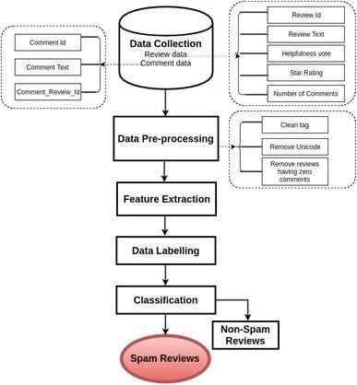

Fig.1 System Architecture

* + 1. **Hardware Components:** This phase entails identifying the necessary hardware resources to ensure optimal system performance. This encompasses detailing server specifications (CPU,

memory, storage) for application hosting, selecting networking equipment for communication facilitation, and designating user access devices.

* + 1. **Software Components:** This step involves the selection of technologies and tools for distinct application layers. For instance:
       - Backend Development: Designating Python Flask as the web framework for implementing backend logic and APIs.Database Management: Choosing MySQL Workbench as the database management system to store and manage review data and analysis results.
       - Frontend Development: Opting for HTML/CSS to design the user interfaces, ensuring a visually appealing and responsive user experience.

#### Software and Hardware Component Design:

The Software and Hardware Component Design phase involves breaking down the system into smaller, manageable software modules, functions, and components. In this phase, you focus on the detailed design of these individual elements. In the context of your project:

* + 1. **Software Modules and Functions:** This is where the algorithms for sentiment analysis and fake review classification are developed. For example, using Scikit-learn's machine learning libraries to implement the Support Vector Machine (SVM) algorithm for classification. Each module's functionality, inputs, outputs, and interactions are meticulously designed.
    2. **Hardware Components:** While your project is more software-centric, if there are any hardware components involved (e.g., specialized devices for review data input), their detailed design would also occur in this phase.

#### Database Design:

The Database Design phase is where the underlying structure of the database is established. This includes:

* **Schema Design**: Defining the logical structure of the database, including tables, columns, and data types. For your project, you might create tables to store user information, reviews, sentiment analysis results, and classification outcomes.
* **Relationships:** Specifying how different tables are related to each other. For instance, establishing relationships between user data and their submitted reviews.
* **Data Attributes:** Defining the attributes (fields) of each table, their data types, and constraints. For example, specifying that the "Review" table contains fields like "ReviewID," "ReviewContent," "UserID," and "ReviewDate"

#### UML Diagrams:

##### Use Case Diagram:

A Use Case Diagram visually represents how users interact with the system to achieve specific goals. In your project, you could illustrate use cases like "Submit Review," "Monitor Review Analysis," and "Generate Report." These diagrams help clarify the system's functionalities from a user's perspective.

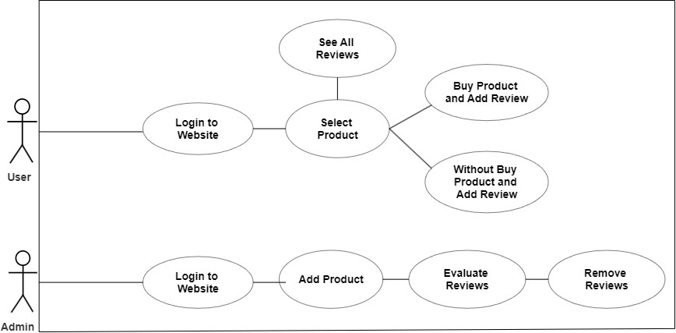

Fig.2 Use Case Diagram for Admin and User

##### Activity Diagrams:

Activity Diagrams visualize the flow of activities and actions within a process or workflow. You could use them to depict various processes in your system, such as the review processing workflow, sentiment analysis workflow, and fake review detection process.

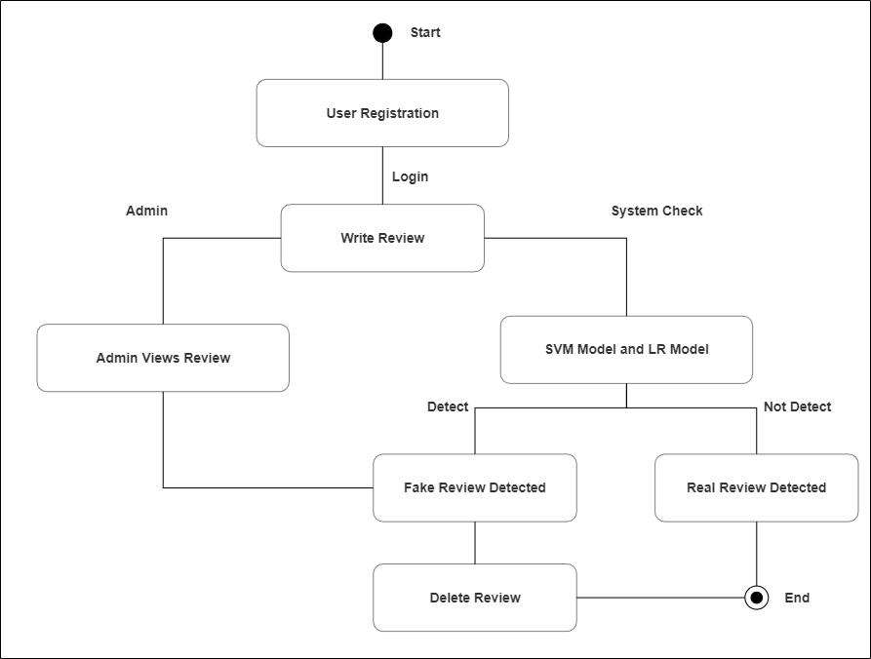

Fig.3 Activity Diagram

##### Class Diagrams:

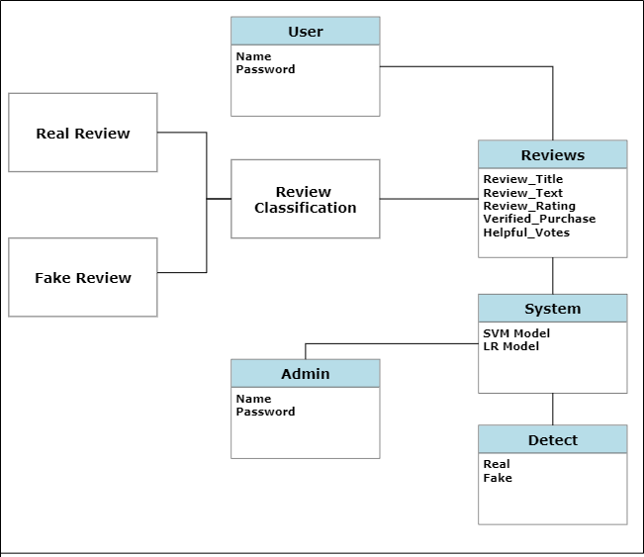

Fig.4 Class Diagram

Class Diagrams depict the structure of classes, their attributes, methods, and relationships. They are useful for illustrating the system's data structures and the relationships between different classes. For instance, you could show classes like "User," "Review," "Analyzer," and their associations.

##### Data Flow Diagrams (DFDs):

DFDs illustrate how data flows through the system, showing the processes that transform and move data. You can use DFDs to visualize how reviews are submitted, processed, analyzed, and classified. It's a great way to understand the flow of information in your system.

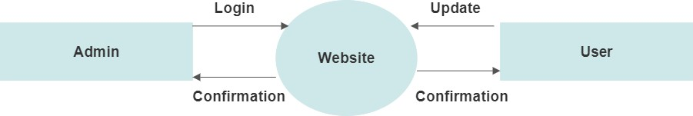

Fig.5 Level 0 DFD

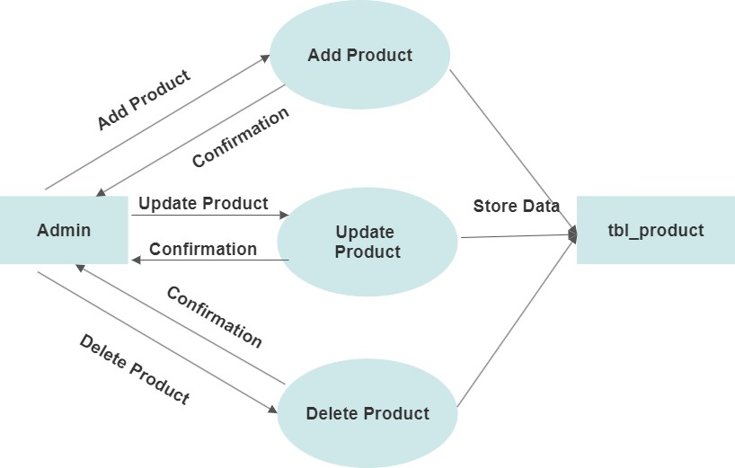

Fig.6 Level 1 DFD

#### Algorithm Used:

##### Support Vector Machine (SVM):

In the SVM algorithm, the main objective is to find the best possible hyperplane that effectively separates the data points of different classes in a high-dimensional space. This hyperplane acts as a decision boundary, allowing the system to categorize new reviews accurately.

* The positive class could represent genuine reviews, and the negative class could represent fake reviews.
* Each review is represented as a point in a high-dimensional space, where the dimensions correspond to the features extracted from the review, such as TF-IDF values of words.
* The SVM algorithm identifies the support vectors, which are the data points closest to the decision boundary. These support vectors significantly influence the position and orientation of the decision boundary.

##### Applications:

* **Training:** During the training phase, the SVM algorithm learns from a labeled dataset containing reviews that are correctly categorized as fake or genuine. Each review's features and corresponding class labels are used to find the best hyperplane that maximizes the margin between the classes.
* **Hyperplane Creation:** The SVM algorithm aims to find the hyperplane that separates the feature space in such a way that the distance between the hyperplane and the support vectors of both classes is maximized. This maximized margin ensures better generalization to new, unseen reviews.
* **Classification:** Once the SVM model is trained, it can be used to classify new reviews. The algorithm examines which side of the decision boundary a new review falls on, and assigns the corresponding class label (fake or genuine) to it.

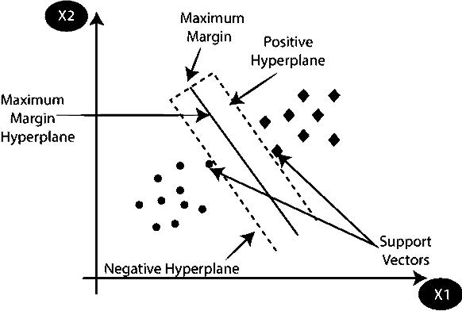

Fig.7 Support Vector Machine

##### Logistic Regression (LR):

Logistic Regression holds significance as a crucial machine learning algorithm primarily used to predict categorical outcomes based on a given set of independent variables. It operates within the realm of Supervised Learning, where a model is trained on labeled data to predict outcomes for new, unseen data.

##### Categorical Outcome Prediction:

The utilization of Logistic Regression is pertinent when the desired outcome falls into discrete or categorical categories. For instance, within this project, the objective is to ascertain whether a product review is authentic or counterfeit. The potential outcomes, "Genuine" or "Fake," are categorical values that Logistic Regression can predict.

##### Sigmoid Function Utilization:

Logistic Regression employs the sigmoid function (also referred to as the logistic function) to map algorithm outputs into probabilities. This function transforms real values into a range between 0 and 1. Displaying an "S" shape, the sigmoid curve confines algorithm outputs within the probability spectrum.

##### Key Assumptions:

Two pivotal assumptions underpin Logistic Regression:

* The dependent variable must possess categorical attributes, aligning with the project's task of categorizing reviews as genuine or fake.
* The independent variables should steer clear of multicollinearity, a scenario characterized by high correlation among predictor variables.

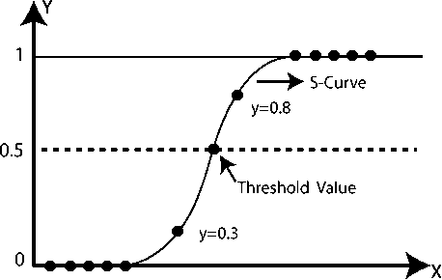

Fig.8 Logistic Regression

## CHAPTER 8

**SYSTEM IMPLEMENTATION**

#### Backend Development:

Backend development involves writing code to implement the core functionalities of the system. Programmers use the chosen programming languages and frameworks to create modules that handle the preprocessing, feature extraction, and classification stages. For instance, developers would write code to remove punctuation and stopwords during preprocessing, implement algorithms for feature extraction, and integrate Support Vector Machine (SVM) for classification of fake and genuine reviews.

##### INITIAL DATA EXPLORATION:

* + - * **Understanding and Preparing Raw Dataset:**

In this stage, the focus is on preparing the dataset for further analysis. The dataset is a collection of Amazon reviews, and the goal is to clean, structure, and organize the data for meaningful insights.

##### Normalization of Data:

If needed, you perform data normalization on the numeric columns. Normalization scales the values of numeric attributes to a common range. This process ensures that the data is standardized and is suitable for analysis and modeling.

##### Checking for NULL and Duplicates:

To ensure data quality, you check for any missing values (NULL) in the dataset. Additionally, you identify and handle duplicates, if any. Removing duplicates ensures that the dataset is clean and free from unnecessary repetitions.

##### Exploratory Data Analysis (EDA):

EDA involves exploring the dataset visually to gain insights into the data distribution, relationships, and patterns. Visualizations such as histograms, bar plots, and scatter plots can

be created to understand the characteristics of the data.

##### Dropping Unnecessary Columns:

Certain columns in the dataset might not contribute to the specific goal of building a fake product review monitoring and removal system. These columns, such as reviewer names and IDs, might be irrelevant for the analysis. Hence, they are dropped to streamline the dataset and reduce unnecessary complexity.

##### Saving Final DataFrame to CSV:

After performing the necessary data cleaning and exploration, the processed dataset is saved to a new CSV file named 'cleaned_dataset.csv'. This cleaned dataset will serve as the foundation for subsequent stages of the project.

##### TEXT DATA EXPLORATION AND PRE-PROCESSING:

* + - * **Exploring and Preprocessing Text Data:**

In this stage, the focus is on preparing the 'review_text' attribute for analysis. This involves extracting relevant information from the text and cleaning it for further processing.

##### Adding Text Attribute Columns:

To gain insights from the text data, you add new columns that represent various text attributes. For example, you calculate the character count and word count in each review_text. These additional columns provide quantitative information about the length of the reviews.

##### Handling Duplicates and NULL Values:

Before proceeding with text preprocessing, you handle any NULL values or duplicates in the 'review_text' column. NULL values are removed, and duplicate reviews are dropped to ensure the dataset is clean and does not contain redundant information.

##### Text Preprocessing:

Text preprocessing is a critical step to clean and prepare the text data for analysis. This involves a series of transformations to make the text more suitable for processing. Some common preprocessing steps include:

1. Converting text to lowercase to ensure consistency.
2. Removing punctuation marks to eliminate irrelevant symbols.
3. Tokenization, which involves breaking the text into individual words (tokens).
4. Removing stop words, which are common words that don't contribute much to the meaning.
5. These preprocessing steps help in standardizing the text and making it ready for analysis. The result of preprocessing is stored in a new column, 'cleaned_review', which contains the cleaned and processed text.

##### Saving Preprocessed Data to CSV:

After completing the text preprocessing steps, you save the preprocessed dataset to a new CSV file named 'preprocessed_dataset.csv'. This file contains the original attributes along with the additional text attributes and the cleaned text. This preprocessed dataset serves as the input for building and training machine learning models to detect fake reviews.

Throughout this text data exploration and preprocessing stage, the focus is on extracting meaningful information from the textual data, making it suitable for analysis, and ensuring that the text is prepared for subsequent modeling steps.

##### MODEL IMPLEMENTATION AND EVALUATION:

In this stage, you implement machine learning models and assess their performance in classifying fake product reviews.

##### Splitting the Dataset:

You start by splitting your dataset into training and testing sets. The 'cleaned_review' column serves as your input data, and the 'verified_purchase' column contains the target labels. The dataset is divided into a training subset (used for training the models) and a testing subset (used for evaluating their performance).

##### Vectorizing Text Data:

To enable the machine learning models to work with text data, you convert the text into numerical features. This process is known as vectorization. Using techniques like CountVectorizer, you transform the text data into a format suitable for training the models.

The training and testing data are both vectorized.

##### Model Building:

Two machine learning models, namely Support Vector Machine (SVM) and Logistic Regression, are implemented. These models utilize vectorized training data to learn patterns and relationships. Both SVM and Logistic Regression are classification algorithms designed to categorize instances into predefined classes, such as 'verified_purchase' as either 'True' or 'False,' based on the available features.

##### Model Evaluation:

Following model training, their performance is assessed using evaluation metrics. Typical metrics encompass accuracy, precision, and F1-score. These metrics serve to gauge the models' effectiveness in correctly classifying genuine and fake reviews. Accuracy provides an overall measure of correctness, precision emphasizes the correct positive predictions, and F1- score balances precision and recall considerations.

#### Frontend Development:

The frontend of the application is developed using Flask, HTML templates, and Bootstrap for styling. It provides a user-friendly interface for users to interact with the system and perform various actions related to user authentication, product management, review submission, review verification, and more.

##### Home Page:

* + - * The home page welcomes users and provides an introduction to the system's purpose.

##### User Authentication:

* + - * Login: Users can log in using their credentials. Upon successful login, users are redirected to their respective dashboards.
      * Register: New users can register with the system by providing a unique username, password, and a secret key for admin access.

##### User Dashboard:

* + - * Dashboard: Upon logging in, regular users are directed to their personalized dashboard. Here, they can view the products and perform actions related to reviews.
      * Add Review: Users can submit reviews for products. They can rate the product, provide a title and detailed text, and indicate whether the purchase was verified.

##### Admin Dashboard:

* + - * Dashboard: Admin users have access to an admin dashboard with additional functionalities.
      * Add Product: Admins can add new products to the system, including names, descriptions, and images.
      * Delete Product: Admins can remove products from the system, which also updates associated review data.
      * Delete Review: Admins can delete reviews, and associated review helpfulness records are also removed.
      * Total Review Counts: Admins can view the total count of genuine and fake reviews in the system.

##### Review Verification and Prediction:

* + - * Predict: Admins can predict whether a review is genuine or fake using trained machine learning models. They enter review text and indicate if it's a verified purchase. The system predicts and displays the result.
      * Result: After prediction, the system displays whether the review is predicted to be genuine or fake, along with its original text.

##### Product Details:

* + - * Product Details: Users can view product details, including its description and associated reviews. Admins can also toggle verified purchase status and helpfulness counts for reviews.

##### All Reviews:

* + - * All Reviews: Admins can view all reviews, including those from the original training data and newly submitted ones. The data is presented in a tabular format with details such as review date, verified purchase status, title, rating, and text.

#### Database Implementation:

The database design is translated into the actual database schema during this phase. Database administrators set up the required tables, columns, and relationships as designed earlier. For the "Fake Product Review Monitoring and Removal System," the database would store the processed reviews, feature data, and classification results. Queries and scripts are created to insert, retrieve, and manipulate data effectively.

##### Database Models:

An application uses SQLAlchemy to define the structure of the database. We have three main models: User, Product, and Review, along with ReviewHelpfulness. Here's a breakdown of each model:

##### User Model (User):

1. Stores user information.
2. Fields: id, username, password_hash, role.
3. id is the primary key.
4. role indicates whether a user is an admin or a regular user.

##### Product Model (Product):

1. Stores product information.
2. Fields: id, name, description, image_filename, admin_id.
3. id is the primary key.
4. admin_id is a foreign key referencing the User model, indicating the admin who added the product.

##### Review Model (Review):

1. Stores review information.
2. Fields: id, review_id, review_date, review_rating, review_title, review_text, verified_purchase, helpful_votes, user_id, product_id, prediction.
3. id is the primary key.
4. review_id is a unique identifier for reviews.
5. review_date stores the timestamp when the review was added.
6. user_id is a foreign key referencing the User model, indicating the user who submitted the

review.

1. product_id is a foreign key referencing the Product model, indicating the product to which the review is associated.
2. prediction stores whether the review is predicted as genuine or fake.

##### ReviewHelpfulness Model (ReviewHelpfulness):

1. Stores information about helpfulness votes for reviews.
2. Fields: user_id, review_id.
3. Both fields are foreign keys referencing User and Review models, respectively.
4. Together, they form a composite primary key to prevent duplicate helpfulness votes.

##### Database Initialization:

The db.create_all() call initializes the database tables based on the defined models. This should be run once to create the necessary tables.

##### User Authentication:

We use the LoginManager provided by Flask-Login to manage user authentication. The User model implements the required methods for user loading (load_user function) and session management.

## CHAPTER 9

**SYSTEM TESTING**

#### Functionality Testing:

Functionality testing aims to verify that all the features and functionalities of your application are working as intended. This involves thoroughly testing each function to ensure it meets its requirements and delivers the expected outcomes. For your project, some key areas to focus on are:

* + - **User Registration and Login:** Test the registration process to ensure users can create accounts successfully. Verify that the login process securely authenticates users and grants them access to their accounts.
    - **Product Management:** Test adding new products to the system. Ensure that product information is correctly stored and displayed. Test updating and deleting products to validate that changes are reflected accurately.
    - **Review Submission:** Test the process of submitting reviews. Verify that users can input review details and associate them with the correct products. Check that submitted reviews are saved accurately.

#### User Authentication and Authorization Testing:

User authentication and authorization testing is crucial for ensuring the security of your application. Here's what to focus on:

* + - **User Registration:** Test user registration with valid and invalid data. Verify that user data is stored securely and that necessary validations are applied.
    - **User Login:** Test various scenarios of user login, including valid and invalid credentials. Ensure that users can log in successfully and that incorrect login attempts are handled securely.

#### Product and Review Management Testing:

This testing focuses on the end-to-end process of managing products and reviews:

* + - **Adding Products and Reviews:** Test the process of adding new products and submitting

reviews. Verify that details are accurately captured, and associations between products and reviews are correct.

* + - **Editing Products and Reviews:** Test editing product and review information. Ensure that changes are saved correctly and that data integrity is maintained.
    - **Deleting Products and Reviews:** Test the process of deleting products and reviews. Verify that related data, such as reviews associated with a deleted product, are handled appropriately.

#### User Interface (UI) Testing:

UI testing ensures that the visual and interactive elements of your application work seamlessly:

* + - **Buttons and Links:** Test that all buttons and links perform the intended actions and lead to the correct destinations.
    - **Forms and Input Fields:** Verify that users can input data into forms, and the entered data is correctly captured.

#### Security Testing:

Security testing is vital to protect your application from vulnerabilities and attacks:

* + - **SQL Injection:** Test whether the application is protected against SQL injection attacks by attempting to input malicious SQL code.
    - **Cross-Site Scripting (XSS):** Verify that user inputs are sanitized to prevent the execution of malicious scripts.
    - **Cross-Site Request Forgery (CSRF):** Test that the application safeguards against unauthorized requests.
    - **Data Sanitization and Validation:** Validate that user input is properly sanitized and validated to prevent security vulnerabilities.

#### Performance Testing:

Performance testing assesses how well your application performs under different conditions:

* + - **Response Times:** Measure how quickly the application responds to user actions and requests.
    - **Page Load Times:** Test the time it takes for web pages to load, including all resources.

#### Compatibility Testing:

Compatibility testing ensures your application works consistently across different platforms:

* + - **Browser Compatibility:** Test your application on various web browsers to confirm it functions as expected.
    - **Device Compatibility:** Verify that the application works well on different devices, screen sizes, and orientations.

#### Data Integrity and Consistency Testing:

This testing focuses on the accuracy and reliability of data:

* + - **Review-Product Linkage:** Verify that reviews are correctly associated with the appropriate products and users.
    - **Review Counts and Helpful Votes:** Test scenarios where review counts and helpfulness votes are updated correctly.

|  |  |  |  |  |  |
| --- | --- | --- | --- | --- | --- |
| **Review_id** | **Review_date** | **Verified_Purchase** | **Helpful_Votes** | **Review_Title** | **Review_Rating** |
| review1 | review date is entered | Product is Purchased | votes are entered | review title is entered | rating is entered |
| review2 | review date  is entered | Product is Not  Purchased | votes are  entered | review title is  entered | rating is entered |
| review3 | review date is entered | Product is Purchased | votes are entered | review title is entered | rating is entered |
| Review4 | review date is entered | Product is Not Purchased | votes are entered | review title is entered | rating is entered |

Tb.1 Test Cases Result

## CHAPTER 10

**RESULT ANALYSIS**

In your "Fake Product Review Monitoring and Removal System" project, you have evaluated the performance of different machine learning models using different vectorizers (Count Vectorizer and Tfidf Vectorizer) based on accuracy, precision, and F1 score. Let's break down the result analysis for each of these metrics along with the provided values:

#### Accuracy:

Accuracy measures the proportion of correctly predicted instances out of the total instances in your dataset. It provides an overall assessment of how well the model is performing.

#### Precision:

Precision measures the proportion of true positive predictions (correctly predicted positive instances) out of the total instances predicted as positive. It focuses on how well the model avoids false positives.

#### F1 Score:

The F1 score is the harmonic mean of precision and recall. It provides a balance between precision and recall, especially when dealing with imbalanced datasets.

When including these results in your project report, you can highlight the strengths of each model and vectorizer combination while discussing their overall performance in accurately predicting fake and genuine product reviews. You can also elaborate on the significance of accuracy, precision, and F1 score in evaluating model performance and how these metrics contribute to the effectiveness of your review monitoring system.

|  |  |  |  |
| --- | --- | --- | --- |
| **Algorithms** | **Accuracy** | **Precision** | **F1 Score** |
| **Support Vector machine** | **96%** | **96%** | **98%** |
| **Logistic Regression** | **94%** | **94%** | **97%** |

Tb.2 Algorithms Performance

From the provided accuracy, precision, and F1 score values, we can observe that both SVM and LR models with Count Vectorizer or Tfidf Vectorizer are performing well in terms of accuracy and precision. They also achieve high F1 scores, indicating a good balance between precision and recall.

## CHAPTER 11

**CONCLUSION**

The "Fake Product Review Monitoring and Removal System" project successfully achieved its objectives of creating a reliable, accurate, and efficient system to combat the proliferation of fake product reviews. By harnessing the power of machine learning, the system equips users and administrators with the tools to make informed decisions and maintain the integrity of online reviews. As the online marketplace continues to evolve, this system is poised to play a vital role in enhancing user trust and confidence, ultimately contributing to a more transparent and reliable digital shopping ecosystem.

## FUTURE ENHANCEMENT

While the core objectives of the "Fake Product Review Monitoring and Removal System" project have been successfully met, there exist several promising directions for future enhancements and advancements that can elevate the system's capabilities, efficacy, and user satisfaction. The following domains present opportunities for refinement and expansion:

##### Exploring Sophisticated Machine Learning Models:

Consider delving into more intricate machine learning algorithms, such as advanced deep learning models like Recurrent Neural Networks (RNNs) or Transformers. These models could contribute to enhancing the accuracy of identifying fake reviews.

##### Enabling Multilingual Compatibility:

Extend the system's linguistic support to encompass reviews in various languages. Such an expansion would promote inclusivity and cater to a broader and culturally diverse user community.

# SCREEN SHOTS

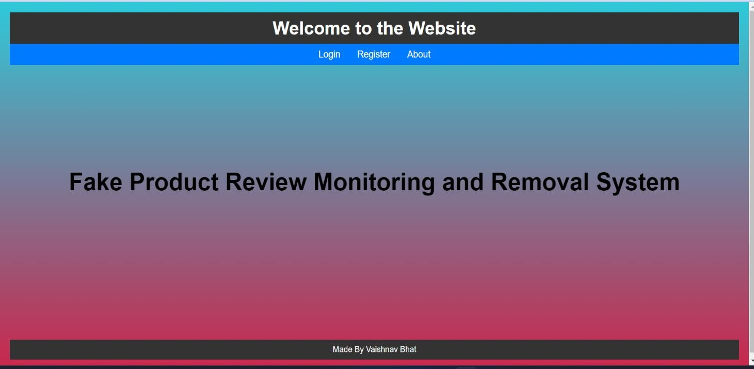

**Screenshot 1- Homepage**

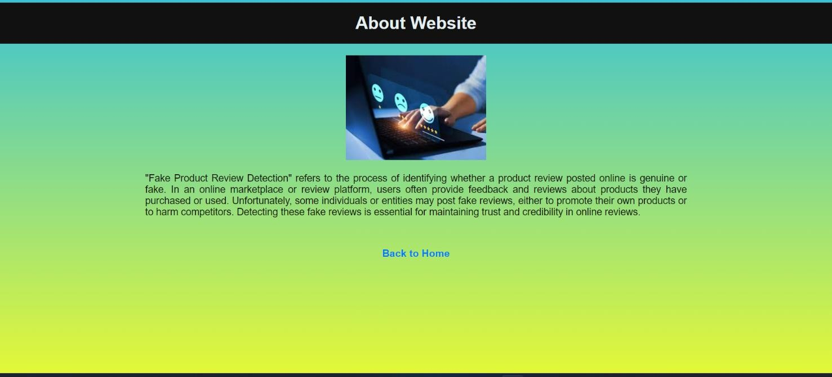

**Screenshot 2- About Website**

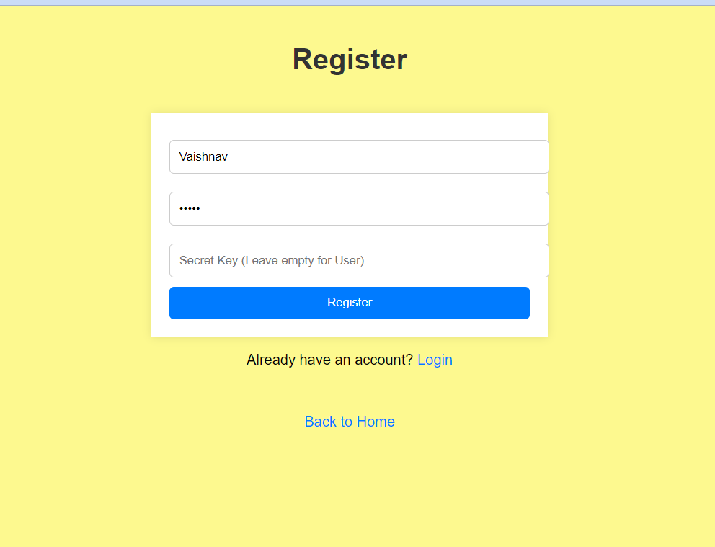

**Screenshot 3- Registration**

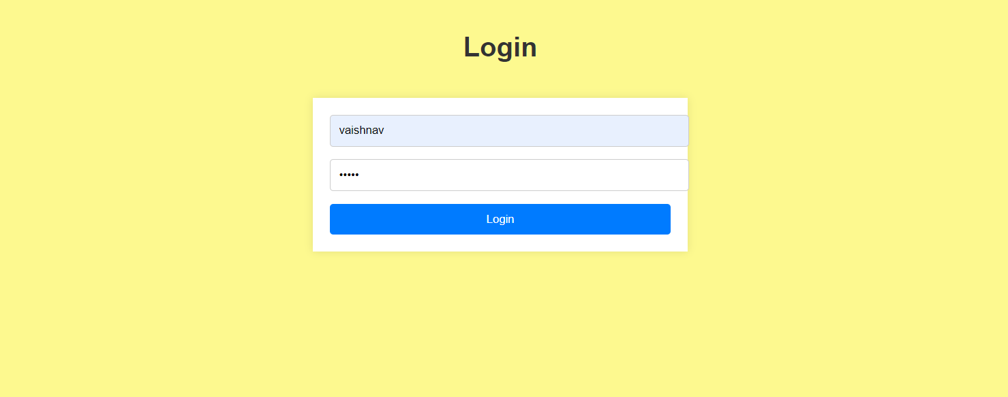

**Screenshot 4- Login Page**

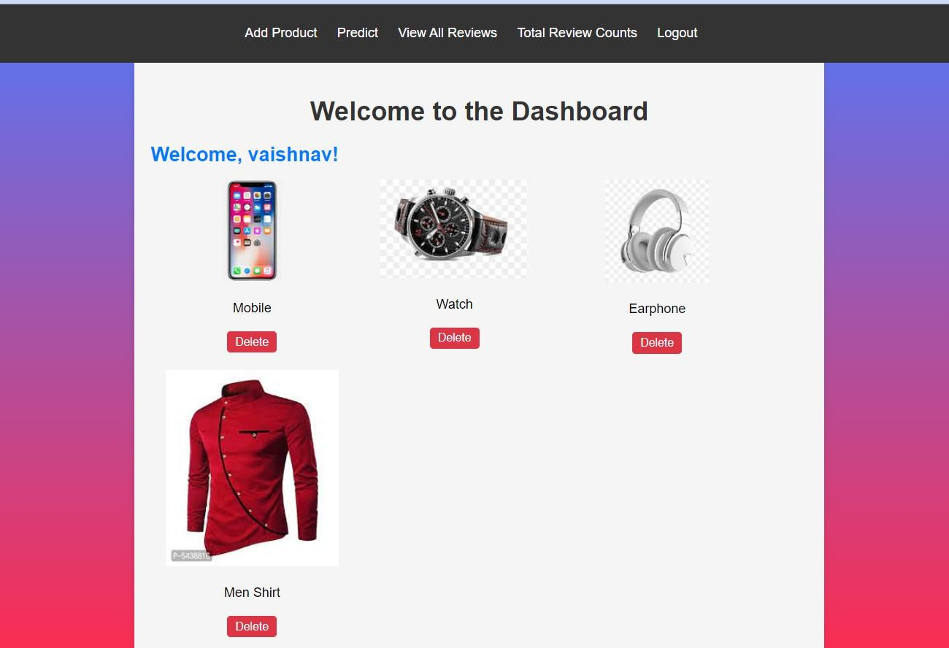

**Screenshot 5- Admin Dashboard**

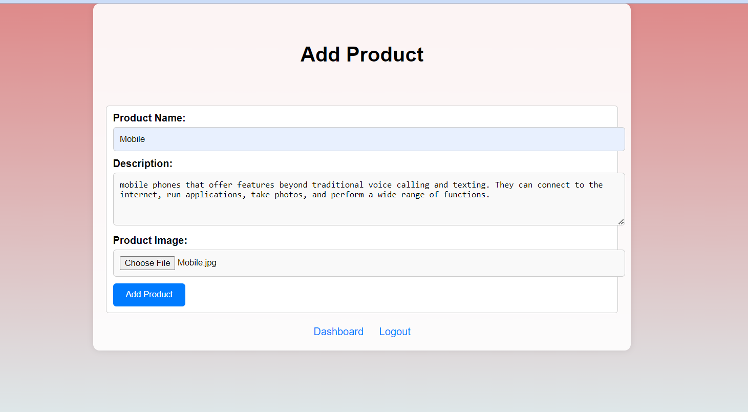

**Screenshot 6- Add Product Page**

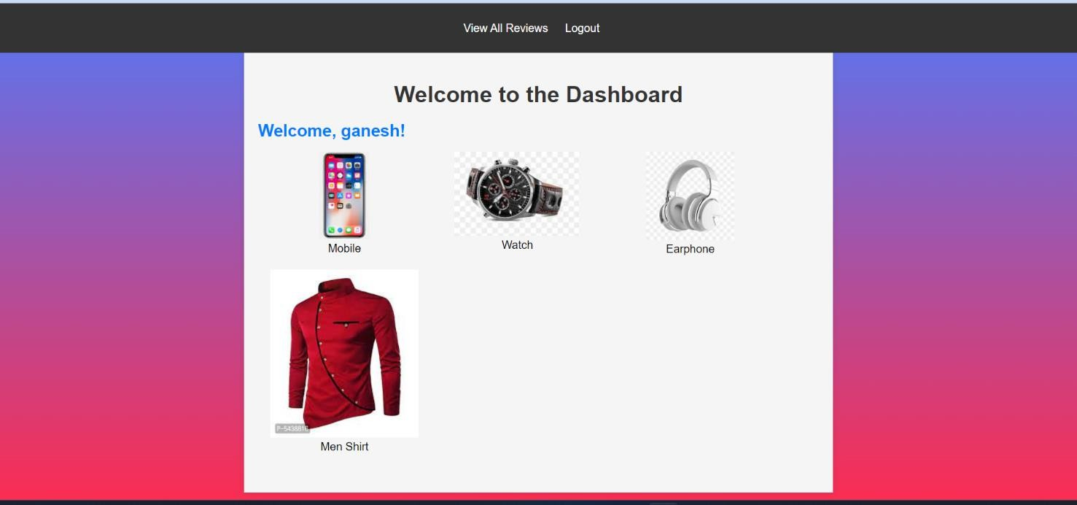

**Screenshot 7- User Dashboard**

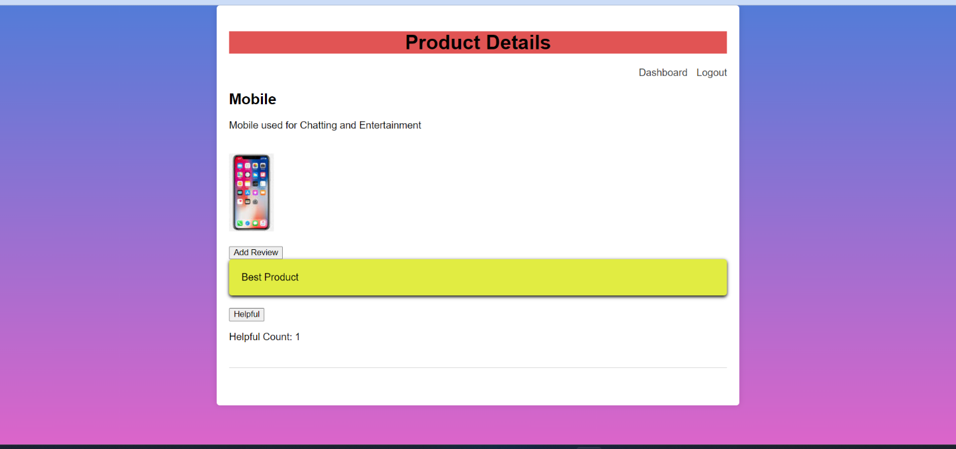

**Screenshot 8- Product Details Page**



**Screenshot 9- Add Review Page**

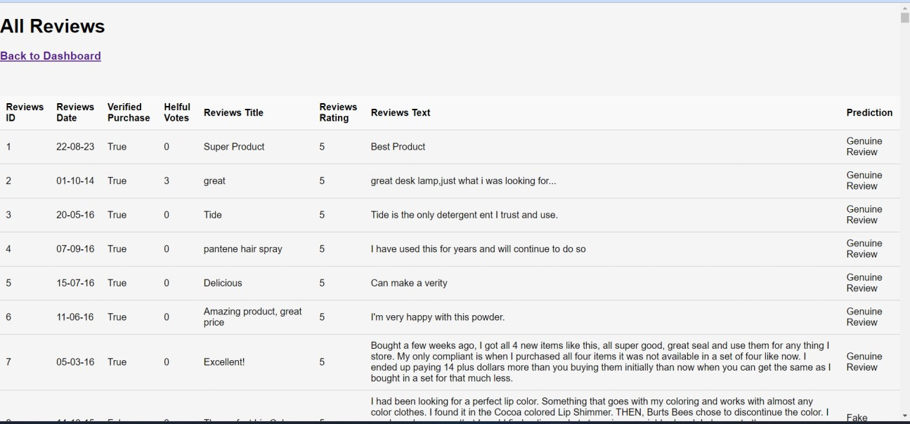

**Screenshot 10- All Reviews Page**

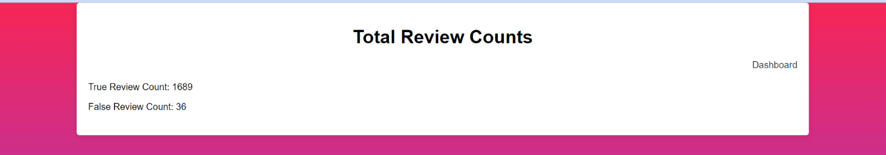

**Screenshot 11- Total Review Counts Page**



**Screenshot 14- SVM Model Predict Page**



**Screenshot 15 - SVM Model Result Page**

**Text Books**

## REFERENCES

* Machine Learning, Tom Mitchell, McGraw Hill, 1997.
* Fundamentals of Machine Learning for Predictive Data Analytics by John D. Kelleher, Brian Mac Namee, and Aoife D’Arcy.

#### Technical Papers

* Xie, S., et al. "Review Spam Detection via Temporal Pattern Discovery." Proceedings of the 18th ACM SIGKDD International Conference on Knowledge Discovery and Data Mining, 2012, pp. 823-831.
* Mukherjee, A., et al. "Fake Review Detection: Classification and Analysis of Real and Pseudo Reviews." Technical Report UIC-CS-2013-03, University of Illinois at Chicago, 2013.
* Heydari, A., M. Tavakoli, and N. Salim. "Detection of Fake Opinions using Time Series." Expert Systems with Applications, vol. 58, 2016, pp. 83-92.
* Ren, Y., and D. Ji. "Neural Networks for Deceptive Opinion Spam Detection: An Empirical Study." Information Sciences, vol. 385, 2017, pp. 213-224.
* McCallum, Andrew. "Graphical Models, Lecture 2: Bayesian Network Representation." PDF. Retrieved 22 October 2019.

#### URLs

* [**https://www.javatpoint.com/machine-learning-support-vector-machine-algorithm**](https://www.javatpoint.com/machine-learning-support-vector-machine-algorithm)
* [**https://www.javatpoint.com/logistic-regression-in-machine-learning**](https://www.javatpoint.com/logistic-regression-in-machine-learning)
* [**https://medium.com/analytics-vidhya/confusion-matrix-accuracy-precision-recall-f1-**](https://medium.com/analytics-vidhya/confusion-matrix-accuracy-precision-recall-f1-score-ade299cf63cd)[**score-ade299cf63cd**](https://medium.com/analytics-vidhya/confusion-matrix-accuracy-precision-recall-f1-score-ade299cf63cd)