BUSINESS ANALYST INTERN TECHNICAL ASSESSMENT – SET C
Submitted By: Surbhi Jain

SECTION 1 – DATA QUALITY CHECKS

C1. How many bookings have num_rooms = 0? What does this imply about the upstream pipeline?
There are 60 bookings with num_rooms = 0.
This indicates a data quality issue in the booking pipeline because a booking cannot logically exist without any rooms being reserved. The presence of these records suggests that input validation is either missing or not being enforced consistently in the upstream booking system.

C2. How many bookings have booking_date earlier than customer_signup_date? Give two plausible explanations.
There are 163 bookings where the booking date occurs before the customer's signup date.
Possible Explanation 1: Legacy System Migration
Some customers may have made bookings on a previous platform before the current customer database was implemented. During migration, the recorded signup date may represent the migration date rather than the customer's true first interaction date.
Possible Explanation 2: Guest Booking Followed by Registration
Customers may have initially booked as guests and later created accounts to access loyalty benefits, booking history, or promotional offers. In such cases, the booking date would legitimately precede the recorded signup date.
Business Impact
Although these records represent a temporal integrity issue, they do not necessarily indicate data corruption. However, they can distort customer lifetime value (LTV), customer tenure calculations, and retention analysis.

C3. What percentage of bookings have no review? Break down by booking status. Does the pattern make sense?
Overall, 57.12% of bookings do not have a review rating.
Breakdown by Booking Status
Booking Status | Missing Review %
Cancelled | 97.83%
Completed | 45.40%
No-Show | 100.00%
Interpretation
The pattern generally makes business sense.
- Completed bookings have the lowest proportion of missing reviews because guests actually stayed at the property and had an opportunity to provide feedback.
- Cancelled bookings rarely contain reviews because the stay never occurred.
- No-Show bookings have no reviews because customers did not check in and therefore could not experience the property.
However, any cancelled bookings that contain review ratings should be flagged as a data quality issue because a customer cannot logically review a stay that never took place.

SECTION 2 – VIP VS VOLUME STRATEGY
C1. Defining VIP Customers Three Ways
VIP customers were identified using only Completed bookings under three separate definitions:
- Top 10% by Total Spend
- Top 10% by Booking Count
- Top 10% by Lifetime Value Rate (Total Spend ÷ Months Since Signup)
Each definition produced a VIP group of 80 customers.
Overlap Analysis
The overlap between the three VIP definitions revealed:
- 10 customers appeared in all three VIP groups.
- 54 customers appeared in exactly two VIP groups.
- 112 customers appeared in only one VIP group.
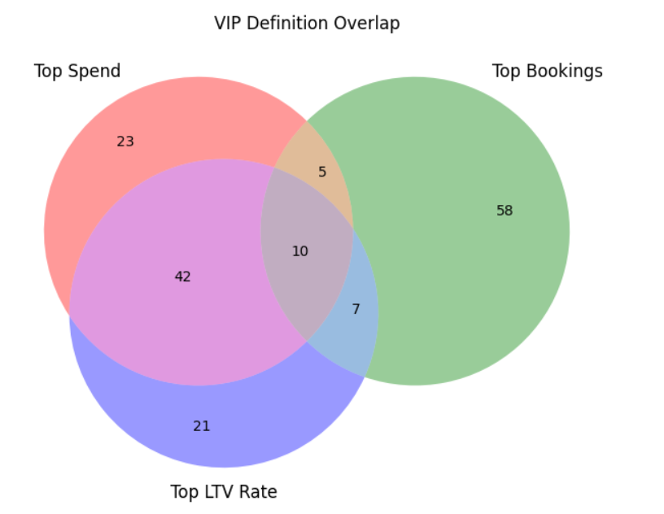
Interpretation
The relatively small overlap across all three definitions demonstrates that VIP status is highly sensitive to the metric used.
Some customers generate high revenue through large transactions, while others qualify because of frequent bookings or strong spending relative to their customer tenure.
This finding supports the Operations team's concern that “VIP” is not a universally defined concept and that the chosen definition can significantly influence business strategy and marketing investment decisions.

C2. VIP Risk Profile
For the VIP Risk Profile, the Top 10% of customers by Total Spend was selected as the primary VIP definition.
This definition was chosen because revenue generation is the most direct contributor to business performance and aligns closely with the objective of maximizing customer lifetime value.
Revenue Contribution
The VIP cohort contributes 26.84% of total realized revenue, despite representing only 10% of the customer base. This confirms that a relatively small group of customers generates a disproportionately large share of platform revenue.
Cancellation Behaviour
Customer Group | Cancellation Rate
VIP | 17.06%
Non-VIP | 19.45%
VIP customers demonstrate a lower cancellation rate than Non-VIP customers, indicating stronger booking commitment and lower operational risk.
Discount Intensity
Customer Group | Average Discount
VIP | ₹3,967
Non-VIP | ₹1,440
VIP customers currently receive significantly larger discounts than Non-VIP customers. On average, the platform provides approximately 2.75 times more discount value to VIP customers.
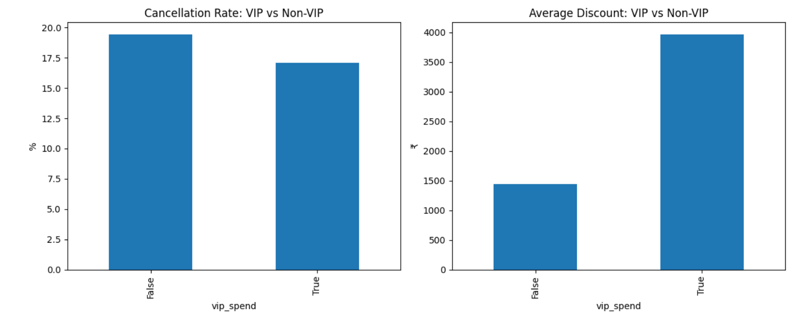
Interpretation
The analysis suggests that VIP customers are a lower-risk customer segment because they cancel less frequently while contributing a substantial share of revenue.
The platform is also investing considerably more discount value in VIP customers, indicating an existing retention-focused strategy. While this investment appears justified by their revenue contribution and lower cancellation behavior, future retention spending should be evaluated against measurable revenue impact to ensure profitability.

C3. Acquisition Math
The platform has an incremental budget of ₹50 lakhs available for customer acquisition.
Assuming an average Customer Acquisition Cost (CAC) of ₹3,000 per customer:
- New Customers Acquired = ₹50,00,000 ÷ ₹3,000
- New Customers Acquired = 1,667 customers
The average customer lifetime spend, calculated from completed bookings, is ₹368,574.74.
Therefore:
- Gross Lifetime Revenue = 1,667 × ₹368,574.74
- Gross Lifetime Revenue ≈ ₹61.46 Crore
The assessment assumes that newly acquired customers generate approximately 20% of their lifetime spend during the first year.
Therefore:
- Year-1 Revenue = ₹61.46 Crore × 20%
- Year-1 Revenue ≈ ₹12.29 Crore
Interpretation
The acquisition strategy has the potential to generate significant long-term revenue. A ₹50 lakh investment in customer acquisition could theoretically bring approximately 1,667 new customers to the platform and generate over ₹61 crore in lifetime revenue, with roughly ₹12.29 crore realized during the first year.

C4. Retention Math
The platform has ₹50 lakhs available for retention initiatives.
Assuming a retention cost of ₹500 per customer:
- Customers Retained = ₹50,00,000 ÷ ₹500
- Customers Retained = 10,000 customers
However, the dataset contains only 800 unique customers.
This means the retention budget is theoretically capable of retaining more customers than currently exist in the customer base. Therefore, the practical retention capacity is constrained by the size of the existing customer population rather than by budget availability.
Key Assumption
The calculation assumes that every retained customer requires only ₹500 in annual retention incentives and that all targeted customers are equally responsive to retention efforts.
In reality, retention effectiveness varies across customer segments, and not all at-risk customers can be retained successfully.
Interpretation
The retention strategy appears highly scalable relative to the current customer base. Given the relatively low retention cost compared to acquisition cost, even a modest improvement in customer retention could protect a significant amount of future revenue.
Final Recommendation and Sensitivity Analysis
The analysis indicates that both acquisition and retention strategies generate value; however, retention offers a significantly lower cost per customer and a substantially lower break-even threshold.
The average customer lifetime spend is ₹368,575, while the retention cost is only ₹500 per customer. This implies a break-even retention rate of approximately 0.14%, meaning that retaining even a very small portion of customer value is sufficient to justify the investment.
VIP customers contribute 26.84% of realized revenue and exhibit a lower cancellation rate (17.06%) than Non-VIP customers (19.45%). This suggests that retaining high-value customers can protect a disproportionate share of platform revenue.
Acquisition remains attractive, with an estimated Customer Acquisition Cost (CAC) of ₹3,000 and an expected lifetime value of ₹368,575 per customer. A ₹50 lakh acquisition investment could bring approximately 1,667 new customers and generate an estimated ₹61.46 crore in lifetime revenue.
Sensitivity Analysis
Even under a conservative assumption that only 10% of average customer lifetime value is preserved through retention efforts, the retained value per customer (₹36,858) remains significantly higher than the retention cost (₹500). Therefore, the retention strategy remains economically attractive across a wide range of assumptions.
Recommended Budget Split
- Retention Strategy: 70% (₹35 Lakhs)
- Acquisition Strategy: 30% (₹15 Lakhs)
This allocation balances short-term revenue protection with long-term customer growth. Retention should receive the larger share because of its lower cost and stronger near-term economic return, while acquisition should continue to receive investment to sustain future platform expansion.

SECTION 3 – SQL CHALLENGE
Schema Design Approach
The original dataset was provided as a denormalized flat file containing customer, property, booking, and review information within a single table. To improve data integrity, reduce redundancy, and support efficient querying, the dataset was normalized into separate tables for Customers, Properties, Bookings, and Reviews.
The Customers table stores customer-specific information such as customer name, segment, signup date, home city, and loyalty tier. The Properties table stores hotel-related attributes including property name, city, star rating, property type, and total rooms. The Bookings table stores transactional booking information and references both customers and properties using foreign keys. A separate Reviews table can be used to store customer review data independently.
Constraint Design
A CHECK constraint was implemented to ensure that checkout_date is always later than checkin_date.
CHECK (checkout_date > checkin_date)
This constraint directly addresses one of the data quality issues identified in the assessment. During exploratory analysis, a small number of records contained invalid stay durations where the checkout date occurred on or before the check-in date. Such records represent impossible hotel stays and should not be allowed into the database.
Index Recommendation
An index was created on customer_id within the bookings table.
CREATE INDEX idx_customer_id ON bookings(customer_id);
This index improves performance for customer-level analysis because customer_id is frequently used in filtering, grouping, joins, and window functions. It is particularly beneficial for the booking sequence analysis performed in Query 1.
SQL Query 1 – Customer Booking Sequence Analysis
The objective of this query was to analyze how customer spending changes across repeat bookings. A ROW_NUMBER() window function was used to assign a booking sequence number to each completed booking for every customer.
Results:
• First Booking Average Value: ₹33,574.92
• Second Booking Average Value: ₹30,879.13
• Third or Later Booking Average Value: ₹31,462.04
Interpretation
The results indicate that customers spend the highest amount during their first booking. Spending decreases slightly during the second booking but stabilizes for subsequent bookings. This suggests that newly acquired customers often make larger initial purchases, while repeat customers maintain relatively consistent spending behaviour. The pattern indicates healthy customer retention because spending remains stable rather than declining sharply over time.
SQL Query 2 – Top Rated Properties
The objective of this query was to identify the highest-rated properties while correctly handling the review scale mismatch described in the assessment. Corporate customer reviews were recorded on a 1–10 scale, whereas Individual and Group customer reviews were recorded on a 1–5 scale.
To ensure fair comparison, Corporate ratings were normalized by dividing them by two before calculating average ratings.
Results:
• Hilltop Inn (Udaipur) – 3.92
• Indigo Lodge (Bangalore) – 3.92
• Ivory Retreat (Jaipur) – 3.92
• Mango Lodge (Bangalore) – 3.91
• Saffron Residency (Pune) – 3.91
Interpretation
The top-performing properties achieved consistently high customer satisfaction scores after rating normalization. The relatively small difference between the highest-rated properties suggests a generally consistent guest experience across premium-performing hotels. These properties may serve as operational benchmarks for service quality, customer satisfaction, and review management practices.

SECTION 4 – MULTI-CURRENCY REVENUE REPORTER

Objective
The objective of this mini-project was to build a working revenue reporting solution that integrates a live external API and enriches the booking dataset with foreign exchange information. The project was designed to help international stakeholders understand business performance in currencies other than INR.
API Integration
The Frankfurter FX API was used to retrieve foreign exchange rates without requiring authentication or API keys.
The implementation included:
• Live API calls using the requests library.
• Error handling using try-except blocks.
• Timeout management to prevent system crashes.
• Historical exchange-rate retrieval for monthly analysis.
The API integration ensures that exchange-rate information is dynamically retrieved rather than manually maintained.
Revenue Conversion Methodology
Only Completed bookings were included in revenue calculations because cancelled and no-show bookings do not represent realized revenue. Monthly revenue was aggregated from completed bookings and then converted into USD using historical monthly exchange rates obtained from the Frankfurter API.
Using historical exchange rates is more accurate than applying current exchange rates because it reflects the actual economic conditions present when revenue was generated.
Historical FX Adjustment
The project calculated monthly revenue in INR and then applied the corresponding historical USD exchange rate for each month. This created an FX-adjusted revenue series that could be compared directly against the original INR-based revenue trend.
The resulting analysis allowed the separation of operational performance from exchange-rate fluctuations.
Business Insight
The comparison between INR revenue trends and FX-adjusted revenue trends revealed that overall business performance remained largely consistent after currency adjustment.
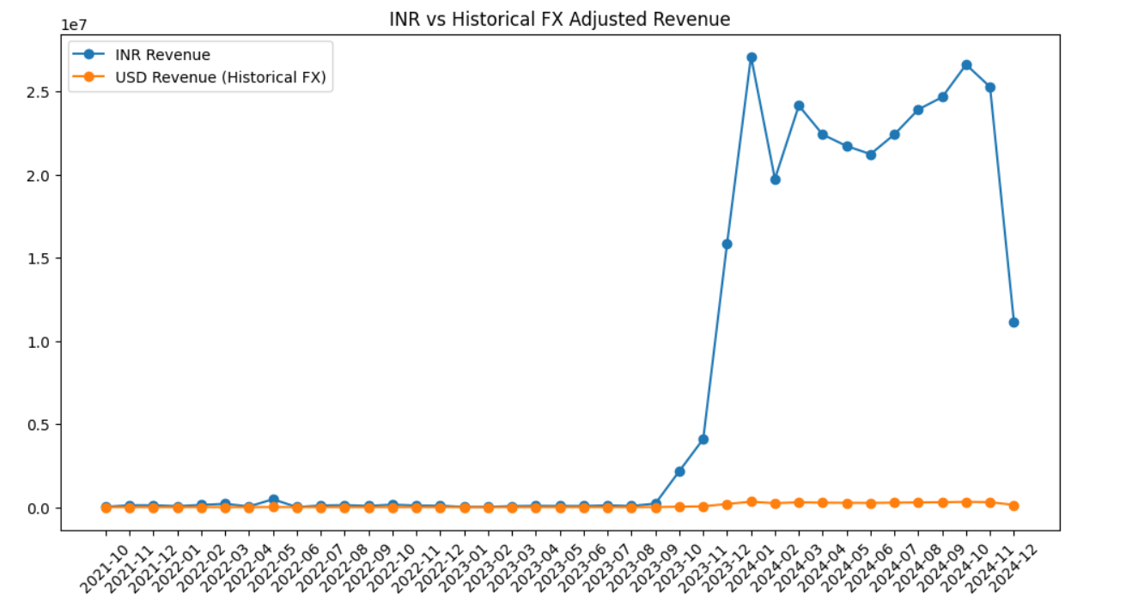
This finding suggests that the observed revenue growth was primarily driven by genuine booking activity rather than favorable currency movements. In other words, the platform's performance improvements reflected underlying business growth rather than foreign-exchange effects.
Project Deliverables
The solution successfully delivered:
• Live API integration.
• Historical FX-rate retrieval.
• Revenue conversion from INR to USD.
• Monthly FX-adjusted revenue reporting.
• Trend comparison visualizations.
• Exportable reporting output.
README Summary
- Load hotel booking data.
- Retrieve historical exchange rates using the Frankfurter API.
- Aggregate monthly realized revenue.
- Convert INR revenue into USD.
- Generate FX-adjusted revenue trends.
- Export results for reporting purposes.
AI Usage Note
AI assistance was used to generate an initial framework for API integration and revenue conversion logic. Manual corrections were made to historical date handling, exchange-rate retrieval, API exception management, and realized revenue calculations. Additional validation was performed to ensure compliance with the business rules specified in the assessment, particularly the requirement to include only completed bookings in realized revenue calculations.

POWER BI DASHBOARD SUMMARY
Dashboard Components:
• KPI Cards
• Booking Status Distribution
• Revenue by Booking Channel
• Revenue by Customer Segment
• Monthly Revenue Trend
• Interactive Slicers
Key Insights:
• Completed bookings represent 77.78% of bookings.
• OTA channels generate the highest revenue.
• Individual customers contribute the largest revenue share.
• Revenue shows stronger performance in later months.
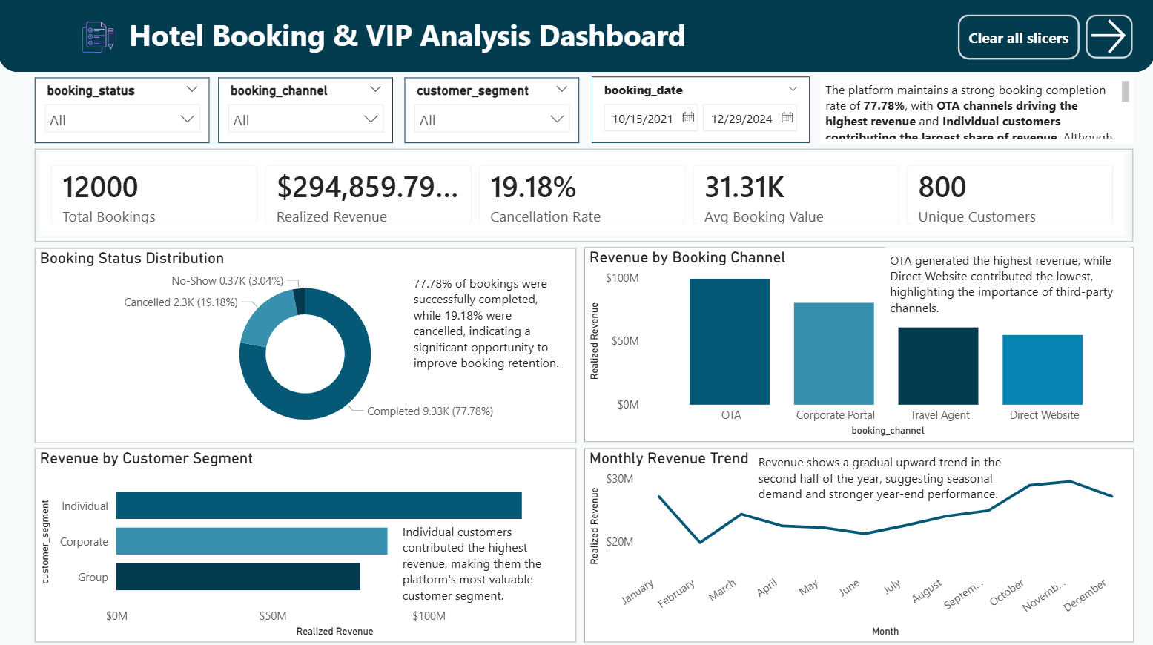

CONCLUSION
The analysis identified key data quality issues, defined VIP customers through multiple approaches, evaluated acquisition versus retention economics, designed a normalized SQL schema and built a multi-currency reporting solution using a live API. VIP customers contribute a disproportionate share of revenue while exhibiting lower cancellation risk, and FX-adjusted analysis confirms that growth is primarily operational rather than currency-driven.

