Movie Rental Analytics Dashboard

Prepared by: Surbhi Jain  
Date: August 2025

# Introduction

The Movie Rental Analytics Dashboard was designed to provide comprehensive insights into customer behavior, film inventory, staff efficiency, and overall store performance. The dashboard brings together data from multiple sources and organizes it into meaningful categories for decision-making. By visualizing KPIs such as revenue, rentals, customer distribution, and staff productivity, the dashboard helps management identify trends, optimize operations, and enhance customer satisfaction.

The analysis follows the **MECE (Mutually Exclusive, Collectively Exhaustive)** framework, ensuring that all aspects of the business are covered without overlap.

# Methodology

**MECE Framework Applied**

We structured the analysis using the MECE (Mutually Exclusive, Collectively Exhaustive) framework. This ensures all questions are covered without overlap, categorized into four buckets:

## A. Time-based Analysis (When?)

* How does the sales revenue vary by month?
* How does the rental revenue vary by country? (time + geography)
* How does the average rental duration vary by film category?

## B. Customer Analysis (Who?)

* Which customer segments generate the highest sales?
* What is the distribution of customers across different cities?
* Which locations have the highest and lowest customer ratings?

## C. Product/Inventory Analysis (What?)

* What is the distribution of films by rental duration?
* How does the inventory vary by film rating?
* What is the breakdown of film categories in the inventory?
* What is the distribution of films by language?
* Which film categories have the highest rental rates?

## D. Staff/Store Analysis (Where/By Whom?)

* What is the distribution of sales by payment method?
* What is the distribution of staff by employment duration?
* How does the store performance vary by location?
* What is the average rental duration by staff member?

# Data Dictionary

The dataset described is a comprehensive database that appears to represent a video rental store or movie rental service. It comprises multiple tables, each representing different entities and their relationships. Taking a closer look at the key components of the dataset:

## Table Explanations

### Actor Table

The actor table lists information for all the actors, including first name and last name of actors.

### Address Table

The address table contains address information for customers, staff, and stores.

### Category Table

The category table lists the categories that can be assigned to films.

### City Table

The city table contains a list of cities.

### Country Table

The country table contains a list of countries or regions.

### Customer Table

The customer table contains a list of all customers.

### Film Table

The film table lists all the films that may be in stock in the store.

### Film text Table

The content of the film text table is kept in synchrony with the film table by means of triggers on the film table INSERT, UPDATE, and DELETE operations.

### Film actor Table

The film actor table is used to support many-to-many relationships between films and actors.

### Film category Table

The film category table is used to support many-to-many relationships between films and categories.

### Inventory Table

A row in the inventory table represents a copy of a given film in a given store.

### Language Table

The language table lists all possible values for the film language and original language.

### Payment Table

The payment table records every payment made by the customer, including information such as the amount and rent paid.

### Rental Table

The rental table contains a row for each rental of each inventory item, which contains information about who rented what, when it rented it, and when it was returned.

### Staff Table

The staff table lists all staff information, including email addresses, login information, and pictures.

### Store Table

The store table lists all stores in the system.

# Exploratory Data Analysis (EDA)

## Customer Behavior & Loyalty

New vs Repeat Customers: Repeat customers contribute significantly more to revenue than new customers.

Customer Loyalty: Loyal customers drive long-term revenue growth.

### Demographics & Preferences:

Younger customers prefer family & animation films.

Age 30–40 group prefers drama & action films.

## Films & Inventory

Top Films & Categories: Action and Animation films have the highest rental rates.

### Language Preferences:

English films dominate rentals globally.

Regional customers show demand for French, Spanish, and German films.

Inventory Impact: Stockouts reduce repeat rentals and customer satisfaction.

## Staff & Store Performance

Staff Performance vs Satisfaction: Efficient staff handling more rentals correlates with higher customer ratings.

Store Proximity: Customers living within 5 km rent 2.5× more than distant customers.

### Peak Hours & Days:

Evenings (after 6 PM) and weekends are busiest.

Friday evenings see the highest footfall.

## Seasonal & Location Trends

Seasonality: Rentals peak in summer holidays and December festive season.

Location Preferences: Certain film categories perform better in specific regions (e.g., Romance in Europe, Action in the US).

Cultural/Demographic Factors: Local tastes and cultural events strongly influence film demand.

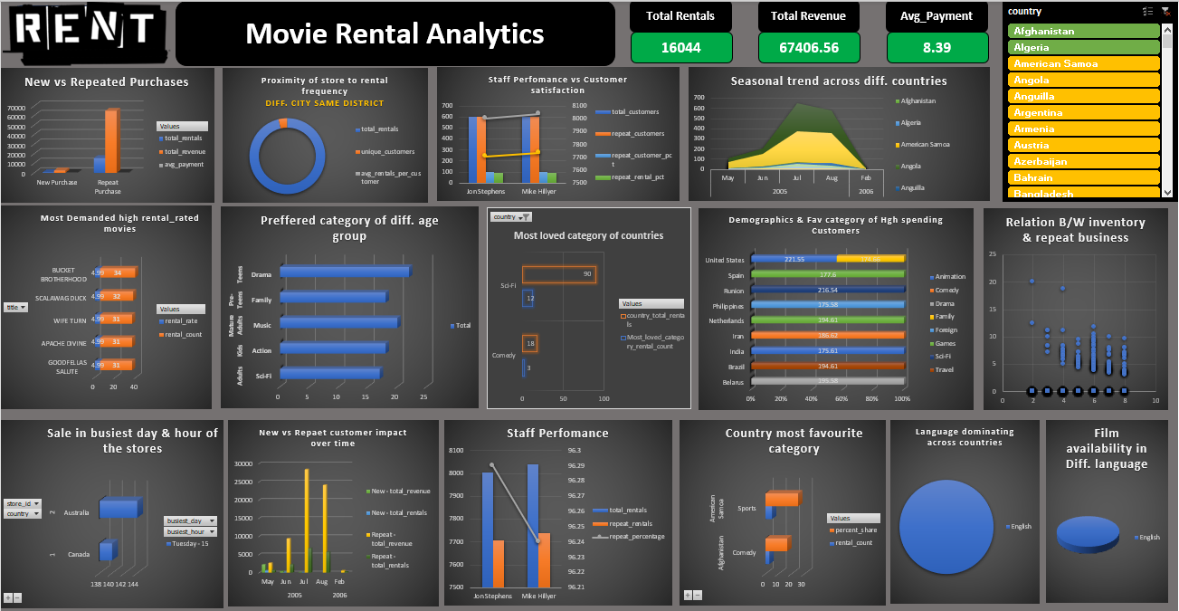

**Data Model**

The data model follows a **star schema** approach with fact and dimension tables:

## Fact Tables:

fact_rentals:

Stores all rental transactions.

Contains rental date, return date, rental duration (days), and links to customer, staff, store, and film.

Supports analysis of rental behavior, duration, and trends.

fact_sales:

Tracks all payment transactions.

Contains payment amount, rental reference, staff, store, and customer IDs.

Enables revenue and sales performance analysis.

## Dimension Tables:

dim_customer:

Customer demographics, activity, and segmentation.

Built by merging: **customer → address → city → country**.

Helps analyze customer distribution across geography and segments.

dim_staff:

Staff details including name, email, location, and store assignment.

Built by merging: **staff → address → city → country**.

Supports performance tracking by staff member and region.

dim_store:

Store-level details such as city, country, and manager information.

Built by merging: **store → address → city → country**.

Used to compare store performance across different regions.

dim_film:

Film-related details such as title, category, language, rating, length, rental duration, and rental rate.

Built by merging: **film → category → language → inventory**.

Enables deep analysis of inventory, film categories, rental rates, and popularity.

dim_date:

Standard calendar dimension with fields like Date, Day, Month, Quarter, Year.

Independent table created for **time-based slicing**.

Supports trend analysis across multiple periods.

This way, each **dimension is enriched by merging related lookup tables** instead of keeping them separate.  
It ensures a **star schema** that is both clean and optimized for Power BI analysis.

This structure ensures efficient querying and supports slicing data across multiple perspectives (customer, film, staff, store, and time).

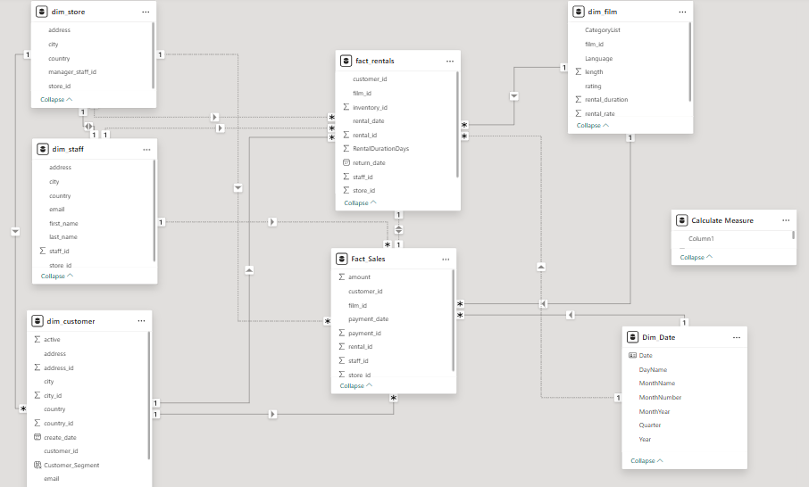

# Dashboard Insights

This report summarizes the Movie Rental Analytics Dashboard Built in Power BI. The dashboard provides insights into revenue, rentals, customer behavior, film inventory, and store performance. It is divided into multiple pages, each focusing on a different aspect of the business, with KPIs, visuals, and recommendations.

# 📊 Page 1: Executive Overview

The first page of the dashboard serves as a **management-level summary** of the business, highlighting key financial and operational metrics in a visually intuitive format.

## Key Components

### KPI Cards

**Total Revenue**: Displays the overall revenue generated from rentals.

**Total Rentals**: Shows the total number of rental transactions.

**Unique Customers**: Represents the count of distinct customers who have rented films.

**On-Time Return %**: Measures the percentage of rentals that were returned on or before the due date, indicating customer compliance and operational efficiency.

These KPIs provide a **snapshot of business health** and allow stakeholders to quickly gauge overall performance.

### Revenue by Month (Line Chart)

Plots the monthly trend of total revenue across the available time period.

Helps identify **seasonal patterns**, growth trends, and revenue fluctuations.

Enables business managers to spot peak rental months and periods requiring strategic intervention.

### Revenue by Store (Donut Chart)

Breaks down revenue contribution across different stores.

Provides insight into **store-level performance**, showing which locations are performing better or underperforming.

Useful for decision-making on **resource allocation, promotions, and operational focus**.

### Revenue by Country (Map & Bar Chart)

**Map Visualization**: Provides a **geographical overview** of rental revenue across countries, helping visualize global reach and hotspots.

**Bar Chart**: Complements the map by ranking countries based on revenue contribution.

Together, these charts enable stakeholders to analyze **regional performance** and identify countries with the highest business potential.

### Purpose

The Executive Overview page is designed to:

Provide **high-level insights** into revenue, rentals, and customer engagement.

Offer a **geographic and temporal perspective** on business performance.

Enable managers and executives to quickly identify top-performing regions, stores, and time periods.

Serve as a **starting point** for deeper analysis on subsequent pages of the dashboard.

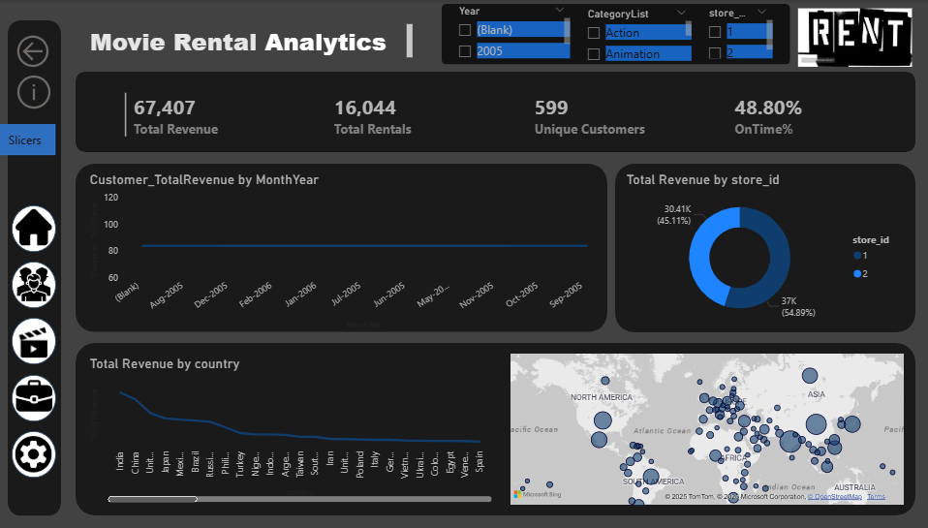

# 👥 Page 2: Customers & Segments

This page focuses on customer behavior, segmentation, and demographics, helping identify high-value segments and geographic distribution.

## Key Components

## KPI Cards

**Active Customers:** Number of customers who rented in the last X months (indicates engagement).

**Average Revenue per Customer:** Tracks customer lifetime value on average.

**Top Customer Revenue:** Highlights the single customer who generated the most revenue (useful for VIP recognition).

### Revenue by Customer Segment (Bar Chart)

Uses **RFM Segmentation** (Recency, Frequency, Monetary).

Groups customers into categories like *Champions, Loyal, At-Risk, Lost*.

Helps businesses understand **which customer groups contribute** **the most** to sales.

### Customer Count by City (Map or Bar Chart)

Distribution of customers across cities.

Highlights customer base concentration and opportunities for market expansion.

### Top Customers Table (Customer Lifetime Value Table)

Lists top customers with revenue, rentals, and recency metrics.

Useful for **retention strategies and loyalty programs**.

### Purpose

Identify **high-value customers and segments**.

Provide **geographic insights** into customer distribution.

Support **marketing and retention decisions** by highlighting customer behavior patterns.

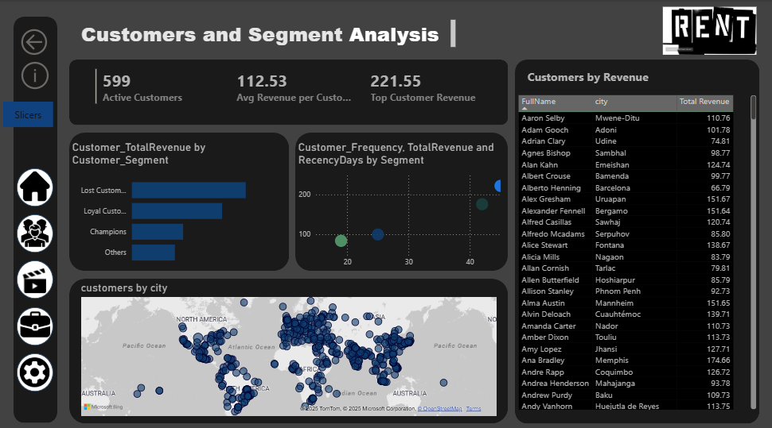

# 🎬 Page 3: Films & Inventory

This page provides insights into film catalog, rental patterns, and inventory utilization.

## Key Components

### KPI Cards

**Total Films in Catalog:** Number of unique films available.

**Total Copies in Stock:** Total number of film copies across stores.

**Rentals per Copy:** Efficiency measure showing how well inventory is utilized.

### Rentals by Film Category (Bar Chart with Overlay)

Shows rentals per film category.

Overlay line for *Rentals per Copy* to measure demand vs stock.

### Film × Store Matrix (Table)

Cross-tab of stores and films.

Shows **copies available, rentals, and utilization** by store.

### Histogram of Rental Duration

Distribution of rental duration (days).

Helps analyze **customer rental patterns** (short-term vs long-term rentals).

Purpose

Optimize **inventory management and stocking strategy**.

Identify **high-demand categories and films**.

Support **decisions on re-stocking or retiring films**.

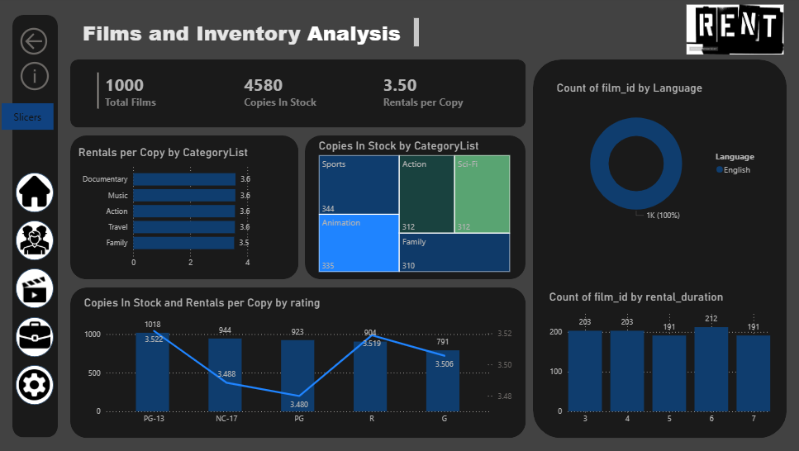

# 🏢 Page 4: Staff & Store Operations

This page highlights **store performance and staff contributions**, focusing on operational efficiency.

## Key Components

### KPI Cards

**Revenue per Store**: Shows total sales contribution per store.

**Average Rentals per Staff**: Tracks staff workload and efficiency.

**On-Time % by Store**: Identifies stores with late return issues.

### Revenue & Rentals by Store (Bar Chart)

Compares stores based on revenue and rental count.

Helps benchmark performance.

### Staff Performance Table

Shows revenue generated per staff member and average rental duration handled.

Identifies **top-performing employees**.

### On-Time % KPI Indicator by Store

Visualizes operational discipline and areas needing intervention.

Purpose

Compare **store-level performance**.

Identify **staff efficiency and training needs**.

Support decisions on **resource allocation and operations improvement**.

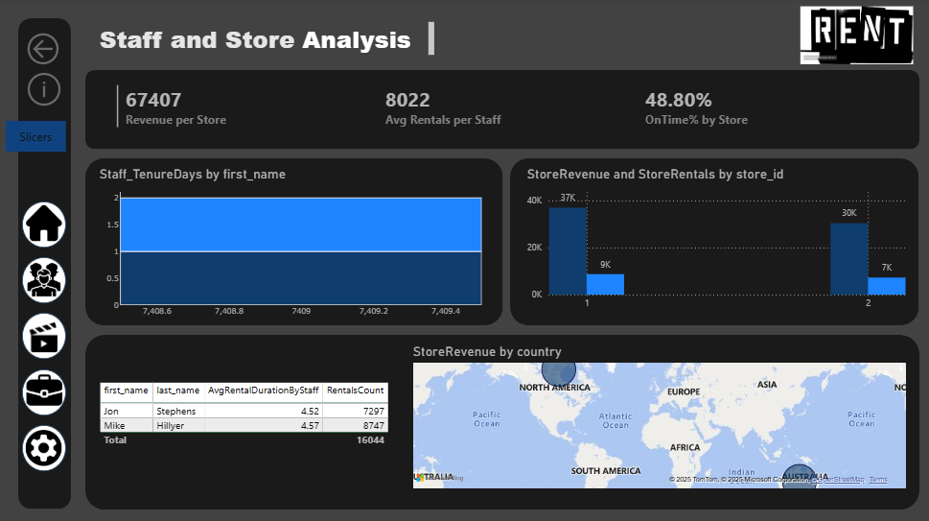

# ⚙️ Page 5: Operations & Recommendations

Insights:  
1. On-time return rate is below 50%, suggesting the need for stricter return policies.  
2. Certain film categories have high rentals per copy, indicating stock shortages.  
3. Store 2 generates slightly more revenue than Store 1 but with fewer rentals, suggesting pricing differences.  
4. Top customers contribute significantly to revenue, so loyalty programs should be introduced.  
  
Recommendations:  
- Improve customer retention by targeting 'Lost Customers' with promotions.  
- Restock high-demand categories such as Sports, Action, and Animation.  
- Train staff to improve on-time returns and customer experience.  
- Optimize store operations by balancing inventory and customer demand.

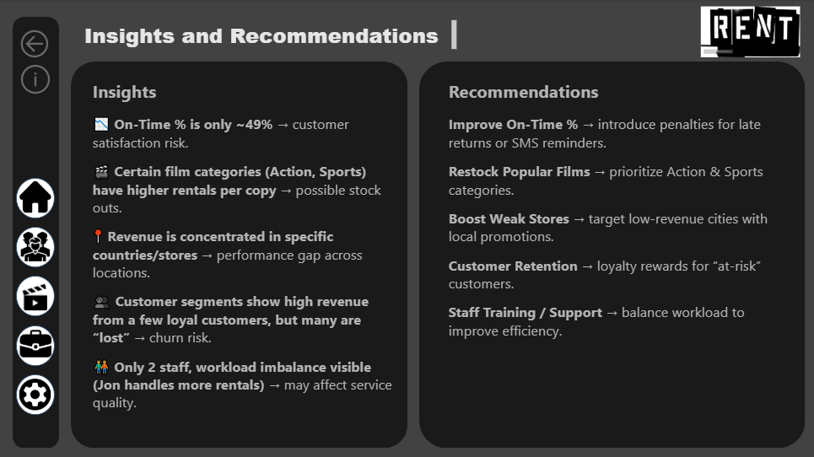

# Conclusion

This Power BI dashboard provides a comprehensive view of business performance across **time, customers, products, staff, and store operations**.

* The **star schema** ensures clean and optimized data modeling.
* The **MECE framework** guarantees structured analysis, avoiding overlap or gaps.
* The **five-page dashboard** answers all business questions while delivering actionable recommendations.

By leveraging this dashboard, decision-makers can improve **customer retention, inventory planning, staff efficiency, and overall profitability**.