Exam Behaviour Analysis Dashboard
Data Analyst Assignment Submission
Submitted By: Surbhi Jain

Project Overview
This project analyzes candidate behaviour during a large-scale online examination using 8.24 million event logs generated by 88,001 candidates. PostgreSQL was used for data processing and SQL analysis, while Power BI was used to build an interactive dashboard.

Dataset Summary
Total Candidates: 88,001
Total Events: 8,246,901
Languages: English and Hindi
Question Types: MCQ and Comprehension
Sections: 1–4

Data Processing & Validation
• Restored PostgreSQL dump file.
• Performed missing value analysis.
• Created SQL queries for activity, language, review behaviour, response and time analysis.
• Validated composite key (log_id + candidate_id).
• Total rows = Unique composite keys, confirming no duplicate records.

Dashboard Page 1 – Executive Summary

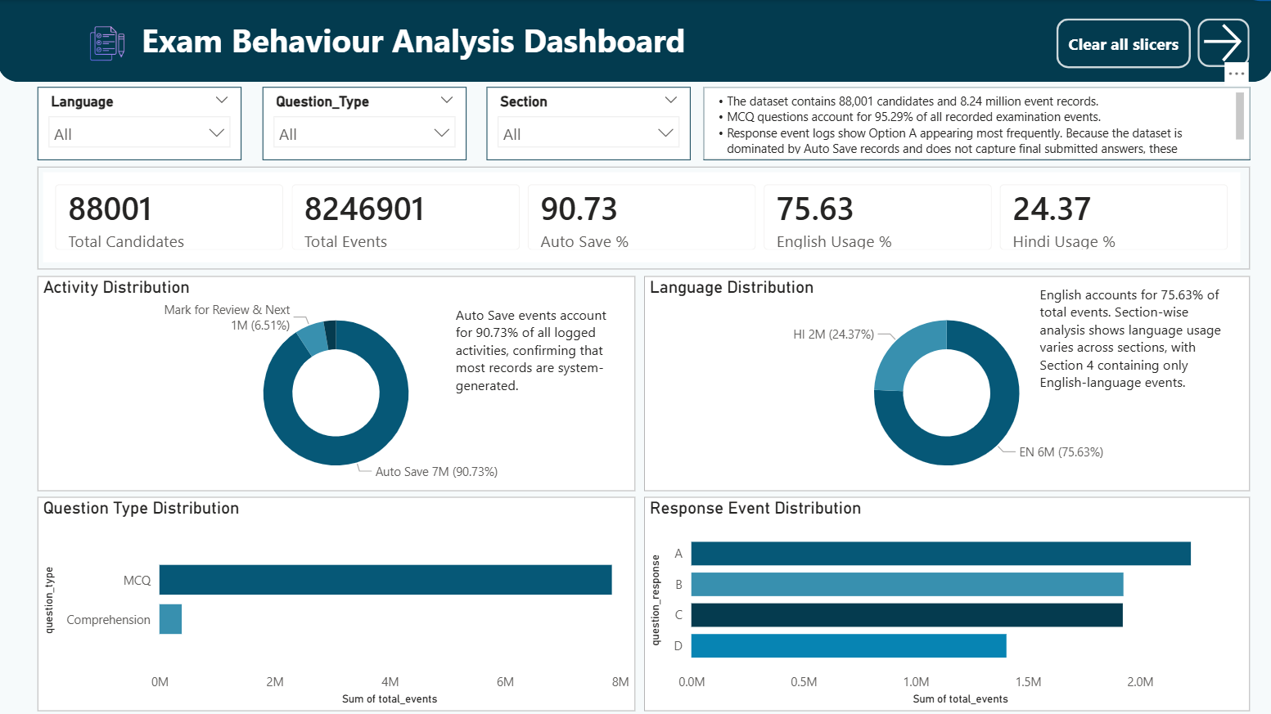
Auto Save events account for 90.73% of all records. English represents 75.63% of total activity. MCQ questions account for 95.29% of examination activity. Response event counts should not be interpreted as final answer selections because the dataset is dominated by Auto Save records.

Dashboard Page 2 – Candidate Behaviour Analysis

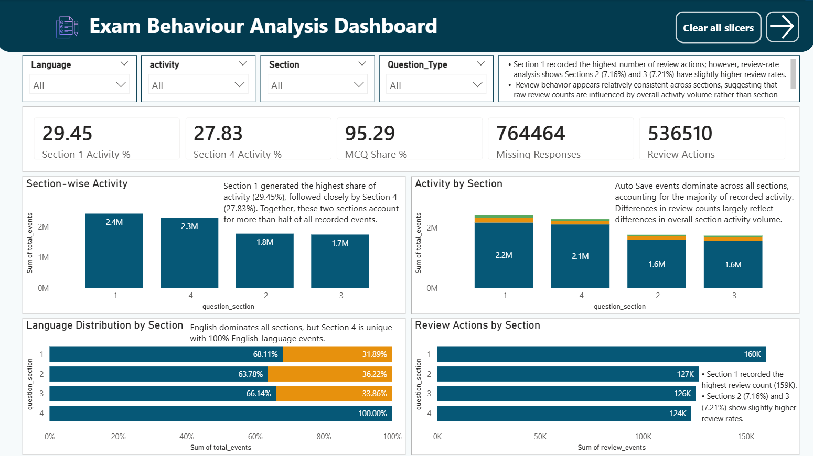
Sections 1 and 4 generated the largest share of activity. Review-count analysis initially suggested Section 1 had the highest review activity; however, review-rate analysis shows Sections 2 (7.16%) and 3 (7.21%) have slightly higher review rates than Section 1 (6.58%). Section 4 contains only English-language events.

Dashboard Page 3 – Time & Data Quality Analysis

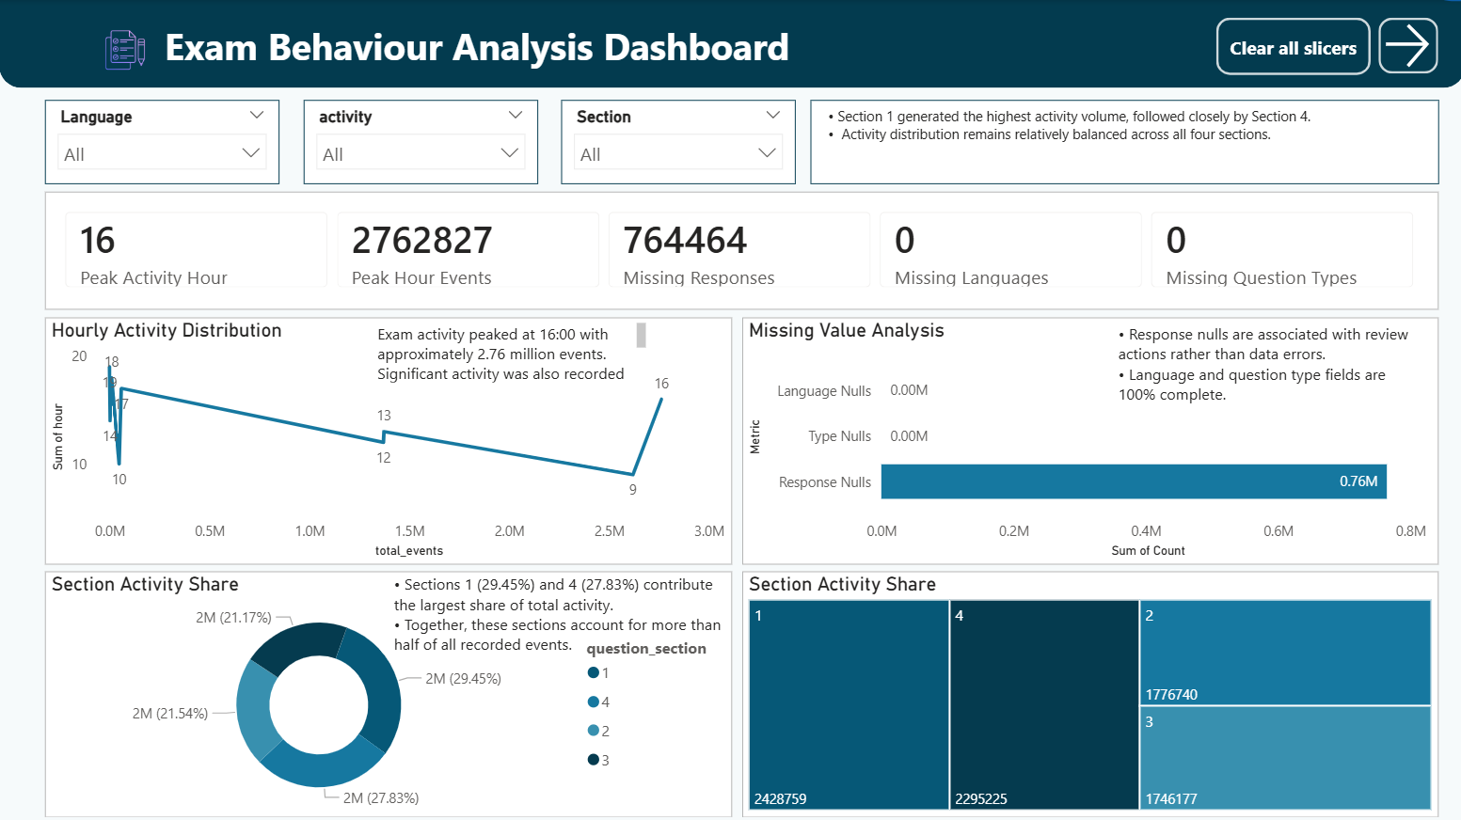
Peak activity occurred at 16:00. Missing response values are primarily associated with review-related activities and should not be treated as data quality errors. Language and question type fields are 100% complete.

Key Findings
• Auto Save events account for 90.73% of records.
• English accounts for 75.63% of total activity.
• MCQ questions represent 95.29% of examination events.
• Sections 1 and 4 generated the largest share of activity.
• Sections 2 and 3 show slightly higher review rates.
• Section 4 contains only English-language events.
• Peak activity occurred at 16:00.

Reviewer Feedback Corrections
✓ Corrected interpretation of response-event distribution.
✓ Added review-rate analysis.
✓ Reclassified missing responses as expected review-event behaviour.
✓ Added section-wise language analysis.
✓ Corrected chart interpretations.
✓ Documented composite-key validation.
✓ Updated README and dashboard insights.

Recommendations
1. Focus behavioural analysis on review actions rather than Auto Save events.
2. Use review-rate metrics instead of raw review counts.
3. Monitor language preferences at section level.
4. Continue leveraging telemetry data to improve candidate experience.

