PRODIOSLABS | DATA ANALYST ASSIGNMENT
Exam Behaviour Analysis Dashboard
Submitted By: Surbhi Jain

Executive Summary
The objective of this project was to analyze candidate behaviour during a large-scale online examination using event-level telemetry logs. The analysis focused on activity patterns, section engagement, language preference, review behaviour and data quality.

Dataset Overview
Database: exam_event_logs
Table: candidate_log
Total Candidates: 88,001
Total Events: 8,246,901
Languages: English and Hindi
Sections: 1-4
Question Types: MCQ and Comprehension

Data Limitations
1. Around 91% of records are Auto Save events.
2. Login and navigation events were filtered from the dataset.
3. No answer keys were provided, therefore scoring analysis was not possible.

Data Processing & Transformation Log
PostgreSQL was used to restore the dump file. SQL queries were used for candidate counts, activity distribution, language analysis, section analysis, review behaviour, response distribution, hourly activity trend and missing value analysis.

Key Findings
• Auto Save events account for 90.73% of all records.
• English is the dominant language (75.63%).
• MCQ questions account for 95.29% of activity.
• Sections 1 and 4 generated the highest activity.
• Peak activity occurred at 16:00.
• Missing responses = 764,464 while language and question type have no missing values.

Recommendations
Focus behavioural analysis on review actions rather than Auto Save events. Investigate Section 1 due to high review activity. Continue monitoring missing responses and use telemetry data to improve future exam experiences.

Dashboard Page 1 - Executive Summary
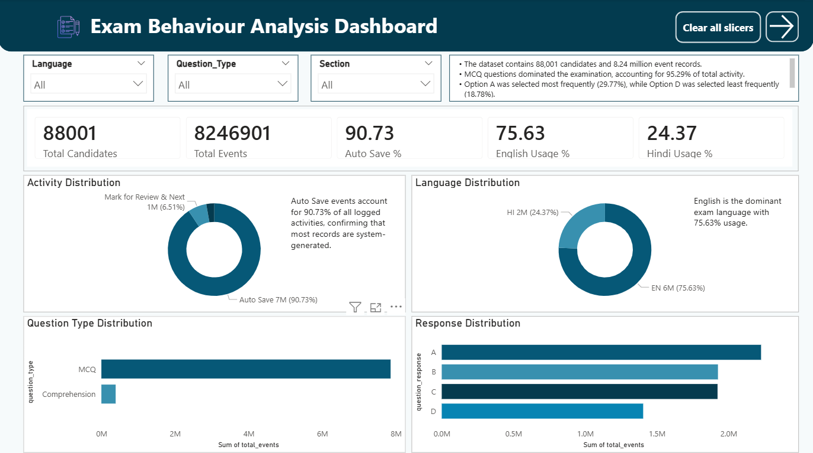
Dashboard screenshot and insights visualization for this analysis page.

Dashboard Page 2 - Candidate Behaviour Analysis
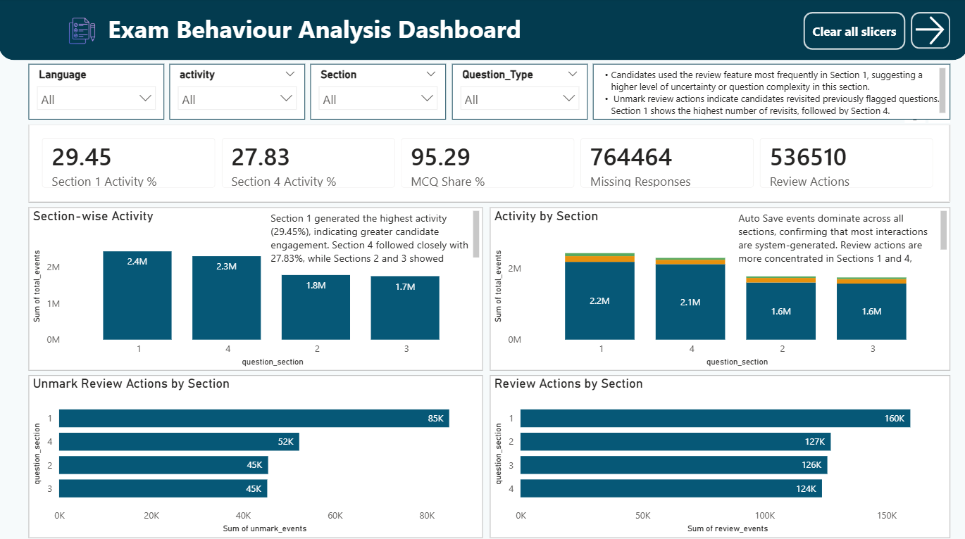
Dashboard screenshot and insights visualization for this analysis page.

Dashboard Page 3 - Time & Data Quality Analysis
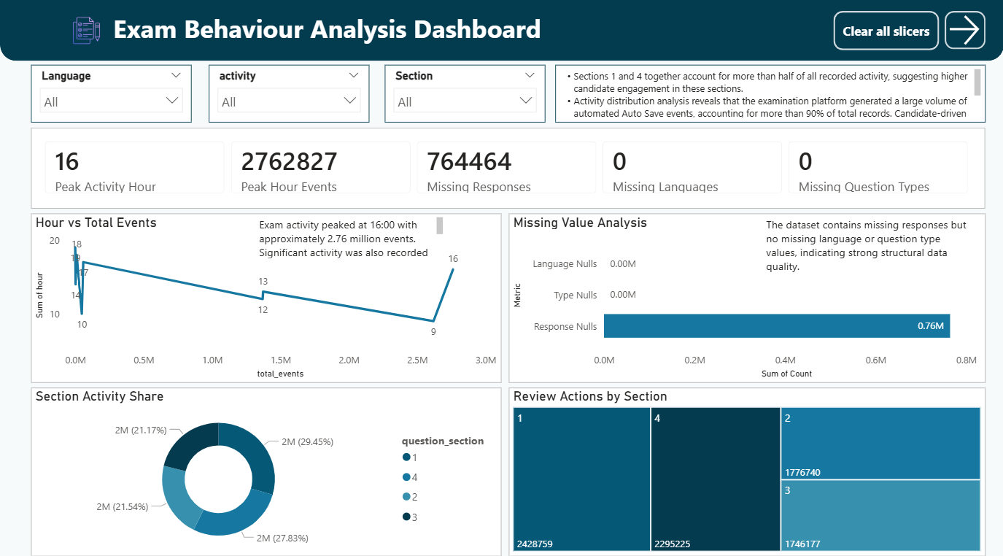
Dashboard screenshot and insights visualization for this analysis page.

