Data Analyst Intern Assignment

Question 1: Data Cleaning & Preparation
I began the analysis by thoroughly cleaning all three datasets to ensure data quality and reliability. I removed empty rows, handled missing primary keys, converted date columns into proper datetime format, filtered only valid orders, removed invalid revenue values, handled missing categorical fields, and removed duplicates. These steps ensured the data was accurate and ready for meaningful analysis.
Assumptions Made:
- user_id corresponds to customer_id across datasets.
- Only 'valid' orders represent successful revenue transactions.
- Missing acquisition channel values were treated as organic.
- net_sales represents final transaction value after discount.

Question 2: User Engagement → Purchase Funnel
Total Users with Events: 147336
Total Users with Valid Orders: 32964
Conversion Rate: 22.37%
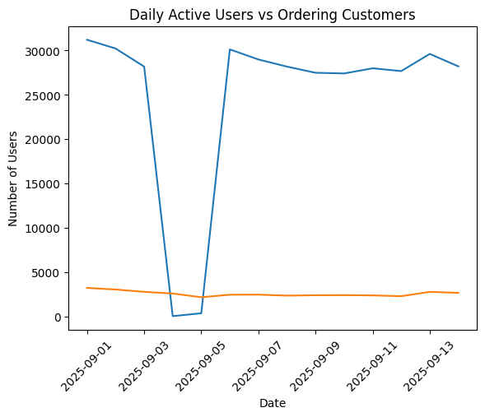
The analysis shows a noticeable gap between daily engagement and purchasing behavior. Although a large number of users interact with the platform, only a portion complete a purchase. This indicates that while engagement is strong, there is an opportunity to optimize the conversion funnel.

Question 3: Customer Behavior Insight
I joined the customers and orders datasets using customer_id and analyzed total revenue by acquisition channel to identify which channel contributes the most to overall revenue.
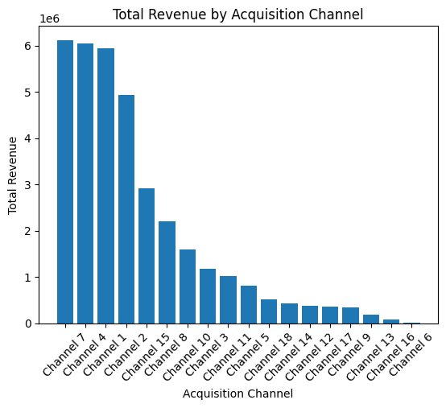
The analysis shows that the Channel 7 channel generates the highest total revenue. This suggests that this channel is currently the most effective revenue driver for the business.

Final Conclusion
Overall, the platform demonstrates strong user engagement but a moderate conversion rate of 22.37%. By improving the purchase journey and focusing marketing efforts on high-performing acquisition channels, the business can increase revenue and improve overall efficiency. This analysis highlights clear opportunities for optimizing both customer acquisition and conversion strategy.

