THE OPEN UNIVERSITY OF SRI LANKA
FACULTY OF ENGINEERING TECHNOLOGY
DEPARTMENT OF ELECTRICAL & COMPUTER ENGINEERING
BACHELOR OF SOFTWARE ENGINEERING PROGRAMME

EEX5362 – PERFOMANCE MODELLING

MINIPROJECT
REPORT

FASTFOOD RESTAURANT QUEUE SIMULATION

M.Z.F. ZAZNA
522516467
S22009997

Repository link for GitHub: https://github.com/2001zaz/EEX5362_MP_QueueSimulation.git

System Description
I have selected Fast food restaurant Queue simulation. Fast food restaurants nowadays are working very quickly and without any inconvenience. When there are lots of customer at a particular time it becomes hard for them to work as it exceeds the service capacity of available staffs. This could lead to long of waiting time and long queue and customer dissatisfaction. To solve this problem Fastfood queue management simulation helps to understand on how the different in number of workers would affect the performance.
In fast food restaurants customers arrive to place order and each order would take time to process depending on the complexity and the speed of cashier’s work. When customer come faster and if their order is not yet ready, they should wait and it led to a queue waiting. At this point it will lead to overcrowding which will make the customer get frustrated. And also, if they hire too many staff that would end up in higher cost. So, simulation will provide a low-cost model for this system and analyze the staffing level that will affect the service performance.

Performance Goals
The main purpose of the system is to model and analyze the performance of service at the fast food restaurant. It helps to understand the relationship between number of cashiers and performance metrics that affect customer experience.

The key performance objectives are
- To minimize customer waiting time
- To reduce average queue length
- To maximize throughput that is customers served per minute
- To optimize cashier utilization without overloading staff
- To maintain high service efficiency during both normal and peak hours
- To identify service bottlenecks to improve overall system performance
- To identify whether increasing the number of cashiers improves service performance.

Aspect of performance
- Average waiting time – How long the customers wait before they get their orders
- Average queue length – Average length of the queue waiting.
- Throughput – Total customers served per minute
- Utilization – Percentage of cashier busy time
- Service efficiency – Percentage of customers served out of total arrivals

Modeling Approach and Assumptions
The fast food restaurant queue simulation is created using discrete-event simulation model using SimPy. This takes no of cashiers, arrival interval and average service time as main entities and it handles key events such as arrival of customer, service start time and service end time. Arrival of customer is taken using exponential distribution with arrival interval as this represent the randomness of real-world arrivals calculated and taken from real data from csv file and same goes with service time. Customer joins first in first out queue when the cashier is busy with a customer and a cashier will serve one customer at a time. This simulation tracks important performance metrics such as average wait time, average queue length, throughput, utilization and customer efficiency using customer arrived and customer served. These metrics output is taken to analyze and compare in different scenarios such as changing number of cashiers or changing arrival rate, which will help to understand the real-world view of the system.
The modeling approach combines real-world data and simulated what-if scenarios
- Real transaction data is used to estimate key parameters such as arrival interval and average service time.
- These parameters are then applied in the simulation to evaluate alternative staffing and demand scenarios.
Key assumptions made in the model include
- Customer arrivals follow an exponential distribution (Poisson arrival process).
- Service times follow an exponential distribution.
- All cashiers provide service at the same average rate.
- Customers are served as first come first served (FCFS) basis.
- Customers do not abandon the queue once they arrive.

Data Description and Methodology
Raw Dataset
The raw dataset attached with this doc in Github repo named “Queue simulation_raw dataset.csv” shows the activity of each customer. This raw data presents it with assumption of having 2 cashiers and at a normal period (non-peak). The details of the parameter in dataset is given below.
Parameter | Description
customer_id | ID assigned to each customer
arrival_time | The time each customer arrives at the restaurant
service_start_time | The time when the cashier starts serving the customer
service_end_time | The time when the serving for the customer is completed
cashier_id | Cashier who served customer
From this dataset, the following metrics were calculated,
- waiting_time = Service_Start_Time − Arrival_Time
- service_time = Service_End_Time − Service_Start_Time
- total_time = max(Service_End_Time)
- num_customers = len(rows)
- arrival_interval_real = total_time / num_customers
- avg_service_time_real = mean(service_time)
so that the arrival inerval and service are gained as,
- Average arrival interval ≈ 2.16 minutes
- Average service time ≈ 3.91 minutes
Then these values are used as inputs to the simulation model. The simulation was executed for different scenarios to see how it work respectively including increased cashier and peak-time to test the system performance under different conditions.
Performance Metrices
Parameters | Description
average_waiting_time | The average time customers spend waiting before getting served.
average_queue_length | The average number of customers waiting in the queue at any given time
Throughput | The number of customers served per minute
Utilizationn | The proportion of total working time to their available time
Service_efficiency | The percentage of customers successfully served compared to total arrivals

Detailed Analysis and Findings
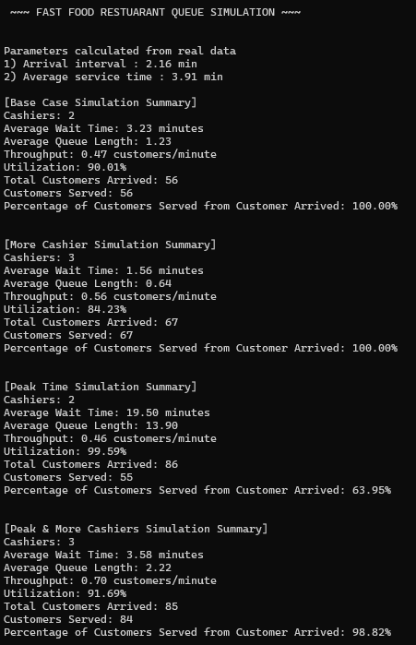
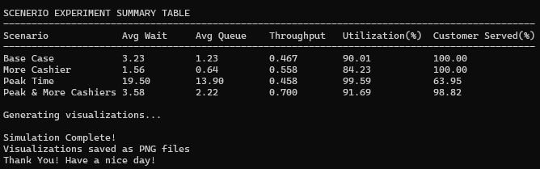
The system is tested with four different scenarios to know the activity of system with different conditions.
- Base Case – two cashiers available with real average customer arrival interval and real service time as this shows the real-world condition in normal restaurant setup. The waiting time and queue length are at a medium level but cashiers are busy full time this means the system is working close to its limit. So, we can understand that even a small increase in customers can cause long queues and delays.
- More cashiers – three cashiers available with real average customer arrival interval and real service time to see how additional resources affect the queue. To check wat happens when we increase cashier without changing demand. The system improves here. Customers wait for a shorter time, and queues become smaller. The cashiers are less overloaded, which creates a healthier balance between service speed and staff workload.
- Peak time – Here it shows how the work is done in busy time where the arrival of customer increases as arrival interval is taken as real average customer arrival interval * 0.7 and other are same as base case. To simulate busy period with high demand conditions. his causes long queues and very high waiting times. Cashiers are overworked, and the system becomes inefficient. This scenario shows poor customer experience and a clear service bottleneck.
- Peak & with more cashier – Here it shows how the work is done with three cashiers available with average customer arrival interval as real average customer arrival interval * 0.7 and same service time. To simulate busy period with three cashiers employed to manage load. Waiting times and queues are still higher than normal conditions, but much lower than the peak-time scenario with only two cashiers. This proves that increasing staff during busy periods helps manage demand better.
From above results we can understand that system performance mostly depends on customer arrival rate and the number of cashiers. As when in peak time adding more cashiers reduces waiting time and queues. Therefore, the restaurant can increase the no. of cashier when there is peak time so this will help to improve customer satisfaction and system stability.

Visualizations
The simulation will give graphs for each performance metric across different scenarios. These graphs will make us clearly understand the difference between each scenario.
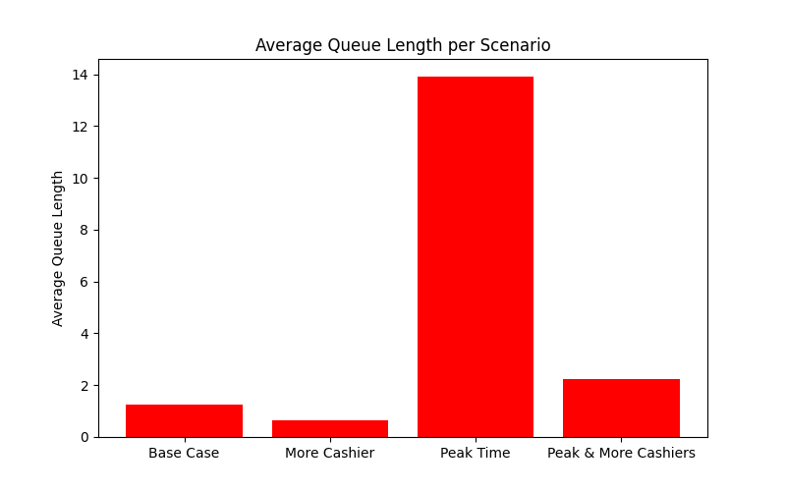
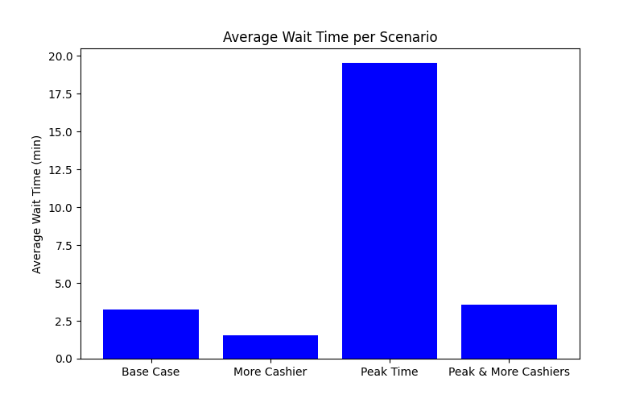

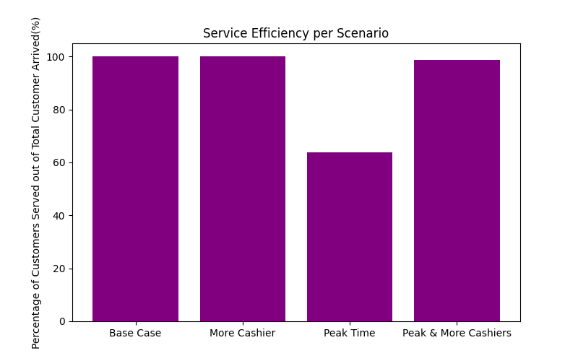
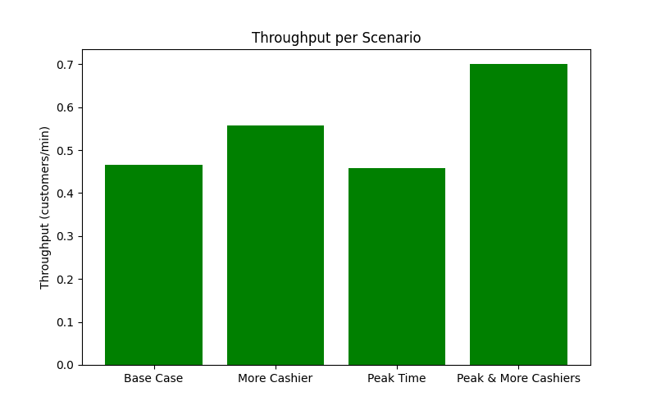
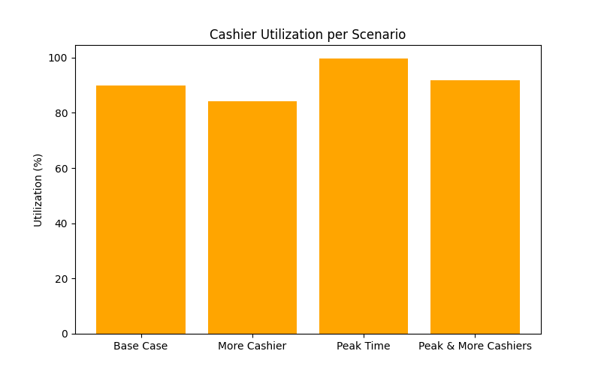

Limitations and Future Extensions
Simulation give worthful result and make us understand it easily but there are still some limitation
- The model uses exponential arrival and service distributions which may not perfectly represent real customer behavior.
- Customer impatience and abandonment are not modeled.
- Cashier skill differences and order complexity variations are not considered.
- The simulation time is limited and does not cover an entire business day.
Improvements that could be done is they can add more cashiers only during peak hours, implementing self-service machine that will reduce cashier load and make service faster that would decrease average service time. They can also take online orders in advance that would make customer avoid queue and help to improve overall throughput.

References (IEEE/Harvard)
- "SimPy in 10 Minutes," [Online].
Available: https://simpy.readthedocs.io/en/latest/simpy_intro/index.html.

- J. Zhané, "SimPy: Simulating Real-World Processes With Python," real python, [Online].
Available: https://realpython.com/simpy-simulating-with-python/.

- "Pandas Step-by-Step Guide," geeksforgeeks, [Online].
Available: https://www.geeksforgeeks.org/python/pandas-step-by-step-guide/.

- "Reading CSV files in Python," geeksforgeeks, [Online].
Available: https://www.geeksforgeeks.org/pandas/reading-csv-files-in-python/.

Appendix
Repository link for GitHub: https://github.com/2001zaz/EEX5362_MP_QueueSimulation.git

