**REVATURE DOGS**

By: Abraham Bergerson, Angelica Velez, Russell David Gehan, Tod Jones

**Introduction**

Revature Dogs is a simple yet incredibly entertaining game where you can adopt any number of dogs and interact with them at your own leisure. Watch them grow from a pup into a legendary great wolf perhaps? In this game, you will need to fulfill your pet’s needs. This includes feeding them, walking them, and giving them attention. You better watch out though, because your dogs will die if you fail to take care of them! This game will also have features such as the ability to train your pet various tricks, so that you can improve your score and compare it with other players.

**Value Proposition**

This project will provide our novice team with experience using the tools and techniques that are

currently used in real world applications and project design. In addition, we will learn about the

importance of DevOps when working in a team environment as well as the value of tools such as

SonarCloud and Microsoft Azure for project deployment and publishing. We will learn the value of

single-page applications implementing API and Angular techniques using best practices.

**User Story**

* As a Player, I want to be able to create an account so that I can log in and play.
* As a Player, I want to be able to adopt one or many dogs so that I can take care of them.
* As a Player, I want to be able to choose a breed of dog so I can adopt the one I want.
* As a Player, I want to be able to select a dog from my collection of dogs so that I can interact with them individually.
* As a Player, I want to be able to check my dog's hunger so that I can know when to feed them.
* As a Player, I want to know how my dog’s hunger decreases with time so that I can figure out how often I should feed them.
* As a Player, I want to be able to check my dog's current status so that I can read their mood.
* As a Player, I want to know how my dog’s mood decreases with time so that I can figure out how often I should play with them.
* As a Player, I want to be able to feed my dog(s) so that I can improve their hunger.
* As a Player, I want to be able to play with my dog(s) so that I can improve their mood.
* As a Player, I want to practice new tricks with my dog(s) so that they can progress towards learning that trick.
* As a Player, I want to be able to teach my dog(s) new tricks so that I can have them perform those tricks.
* As a Player, I want to know when my dog(s) die so that I can stop worrying about them.
* As a Player, I want to know my dog’s life expectancy so that I can tell when they’ll die due to old age.
* As a Player, I want to know when my dog(s) die due to negligence because that should decrease my score.

*Extensible:*

* *As a Player, I want to enroll my dog(s) in competitions so that I can compete with other players.*
* *As a Player, I want to be able to have my dog(s) perform tricks in a competition so that I can get a better score.*

**Data Model**

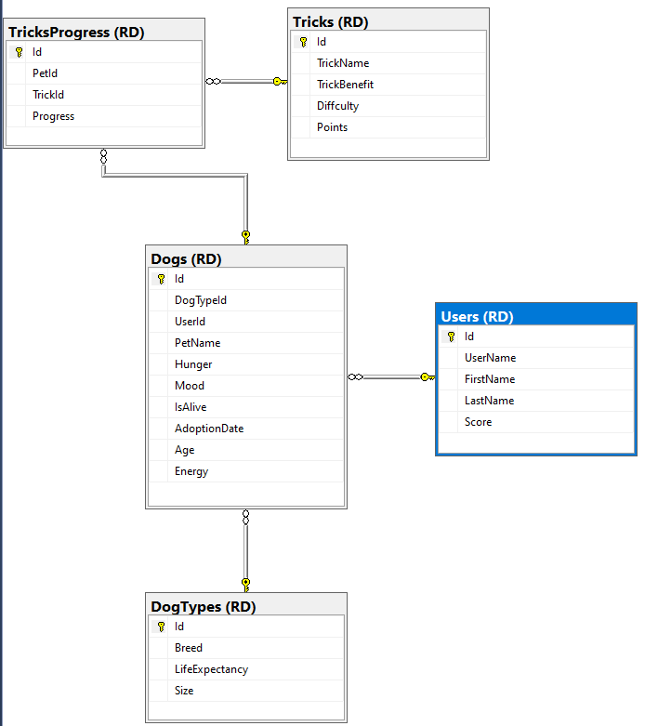

**Technologies**

* Angular
* Azure App Services
* Azure SQL Server
* Azure Pipelines
* Visual Studio/Visual Studio Code
* Azure Data Studio
* SQL Server Management Studio
* GitHub
* SonarCloud
* Postman

**Extensible Features**

* A Dog Status feature could describe how close our dog is to becoming a legendary dog. For example, a dog that’s learned every trick in the book before a certain age can become a legendary dog. Legendary dogs can have an increased life expectancy or none at all so that they can live forever!
* An in-game currency feature could allow players to “purchase” in-game items, such as: dog food, treats, and toys. Players should be able to earn currency by teaching their dogs new tricks or participating in competitions.
* Competitions could be a fun way for players to have their dogs compete by performing tricks so that they can win prizes, such as in-game currency or rare in-game items.