What is version control system
Version control also known as source control is tracking and managing software code changes

Famous VCS:
Git (most popular)

Intro of GIT

What is Git ?
Git is a free and open-source version control system(tool). Unlike older centralized version control systems such as SVN and CVS
Git also has excellent support for branching, merging, and rewriting repository history, which has led to many innovative and powerful workflows and tools.

Pull requests are one such popular tool that allows teams to collaborate on Git branches and efficiently review each other’s code and deliver code independently.
Basic Flow of Commands Between Local and Remote Repositories:
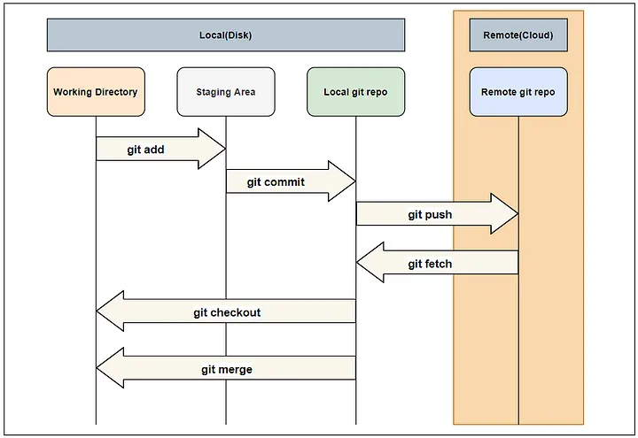

Let's start with basics step by step >
Basics

1 > Git installation

Apt install git -y
Or
Yum install git -y

2 > Setting Up Git
Once Git is installed, the first step is to set your username and email, which will be attached to your commits
replacing “Your Name” with your actual name and “your.email@domain.com” with your email address
git config --global user.name "Your Name"
git config --global user.email "your.email@domain.com"

3 > Your First Repository
To start using Git, you first need to initialize a repository, which is a designated folder that Git will track for version control

git init
4 > Add files (adding file to staging area)
The first command you’ll need is git add, which adds files to the staging area to be committed. For example, to add a file named index.html, you would run the following command

git add index.html

5 > git commit
After adding the file to the staging area, you can make a commit using the git commit command. A commit is a record of the changes you have made to the repository. To commit the staged files with a meaningful message

git commit -m "Add initial homepage"

6 > check the status
use the git status command to check the status of your repository, including which files are staged, unstaged, or untracked

git status

7 > Git log
This command displays the entire commit history using the default format. You can use this command with the customized options to see different format output.

git log

8 > git diff
Show the difference between your index(staging area) and the working directory

git diff

9 > Restore changes form staging area
Use this command to un-stage changes from the staging area after adding them using the git add command. This command is helpful when you want to change/update a file that you have just staged.

git restore --staged <file>

10 > Restore changes form staging area
Show a log of changes to the local repository’s HEAD. Add --relative-date flag to show date info or --all to show all refs
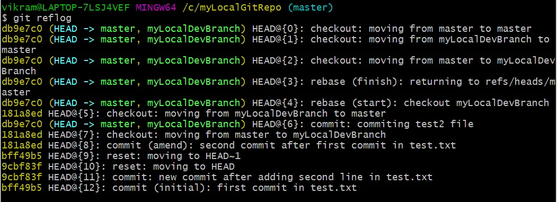

11 > Revert the changes
git revert <commit>: Create a new commit that undoes all of the changes made in <commit>, then apply it to the current branch

git revert <commit>

12 > Remove <file> from the staging area
Remove <file> from the staging area, but leave the working directory unchanged. This un-stages a file without overwriting any changes

git reset <file>

Branching and Workflows

13 > Create a branch
One of Git’s most powerful features is branching, which allows you to experiment with different versions of a project by diverging from the main line of development. The main branch is conventionally called main, although it was previously referred to as master.

To create a new branch, use the git branch command followed by the desired branch name. For example, to create a branch named new-feature, run the following command

git branch new-feature

14 > Changing branch
Once you have created a branch, you can start working on it by switching to the branch using the git checkout command

git checkout new-feature

15 > Merge branch
Any commits you make on this branch will be separate from the main branch and won’t affect it. This allows you to work on new features or bug fixes without disrupting the stability of the main branch.

When your feature is complete, you can merge the changes back into the main branch. To do this, switch to the main branch using git checkout and then run the following command

git merge new-feature

16 > to see branch

Git branch - - list

Working with Remote Repositories on GitHub

While Git allows you to work with local repositories on your machine, collaborating and sharing code often requires a remote repository hosted on a platform like GitHub. To work with a remote repository, you first need to create a new empty repository on GitHub.com

17 > Add repo

git remote add origin https://github.com/your-account/repo-name.git

git remote -v

18 > Push your code to the repository
This associates your local repository with the GitHub repository. You can then push your code to GitHub using the git push command

git push -u origin main

19 > Pull the latest code of the remote repository
To pull the latest code from GitHub, use the following command

git pull origin main

Forking and Cloning Repositories

Forking and cloning repositories are essential techniques for contributing to open-source projects. Forking allows you to create a copy of a repository under your GitHub account. You can then clone this forked repository to your local machine using the following command

20 > Cloning the repository

git clone https://github.com/your-account/forked-repo.git

21 > Create a branch
You can create a new branch for your changes using the git checkout -b command

git checkout -b improvements

22 > push the changes
After making the desired changes, commit them and push the branch to your forked repository

git push origin improvements

