

SCHOOL OF ENGINEERING

|  |
| --- |
| Data Analytics Foundation – EN6001 |
|  |

COURSE PROJECT

# Business Analytics Dashboard

# Group 2: Adventure Works (Paper 2)

Enrollment Id Enrollment No.

Shambhavi Goswami AU19B1006

Bachelor of Technology

(2021-2022)

**PROBLEM STATEMENT**

Studying the provided date set and creating business dashboards with drill through options, cascading of filters and proper navigation.

**PROJECT BRIEF**

The Adventure works dataset includes various dimensions such as date, country, state, city , category ,product with measure values such as Standard cost, Unit Price, Order Quantity, Freight and Tax amount. Some measure values are calculated using combination of values such as sales and profit. Using these attributes the analytical questions are visualized forming different graphs and maps that would describe the essence of the graph in the most suitable and simplest way. This includes usage of filters, actions, parameters, sets to obtain the correct values.

**DASHBOARD DESIGN**

**Color Palette**

 Colors play a major role in branding of a company while bringing it closer to the target audience. Following is the color palette used:

* **Primary Colors:**

1. **Red**

Red evokes a passionate and visceral response. It is a color that is generally associated with energy, excitement, and passion. It’s one of the colors that are attention-grabbing, while it can also be provocative and excitable.

1. **Blue**

Blue is the most popular color choice for the top brands. It is thought to put people at ease, as it reminds them of the sky and the ocean. Blue is also associated with trust, security, and confidence which make a great combination for the brand logo.

1. **Black**

Black is another popular color option for brands and it tends to be one of the most classic options. It’s both classic and sophisticated and it can make a brand identity stand out. It seems to work perfectly with luxury products, blending the classic and powerful elements. Black is one of the colors that can be combined with others to add a stronger emotion, without losing the classical appeal.

Combination of all the above three color evokes a friendly and adventurous feeling. Also these colors can represent the categories that the company sells such as accessories, bikes and clothing.

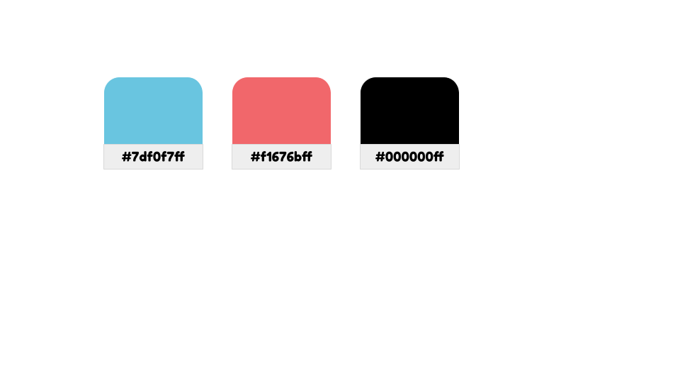

* **Secondary Colors:**

These colors are used for highlighting the graphs, background color and borders for the worksheets

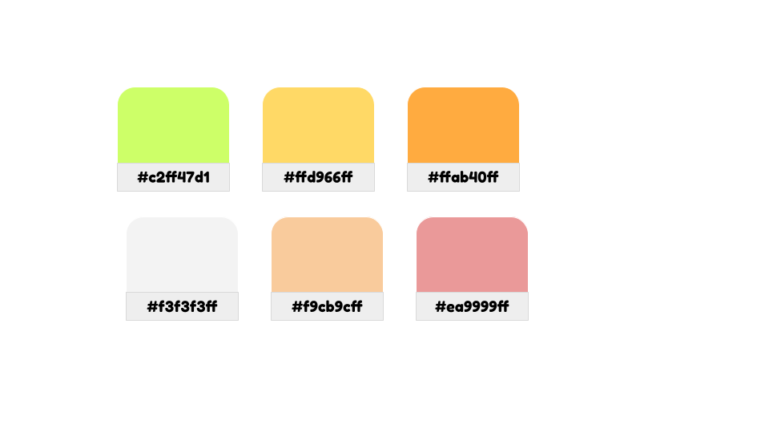

**Typeface**

The typeface includes the variation in design of lettering including size, weight (e.g. bold), slope (e.g. italic), width (e.g. condensed)

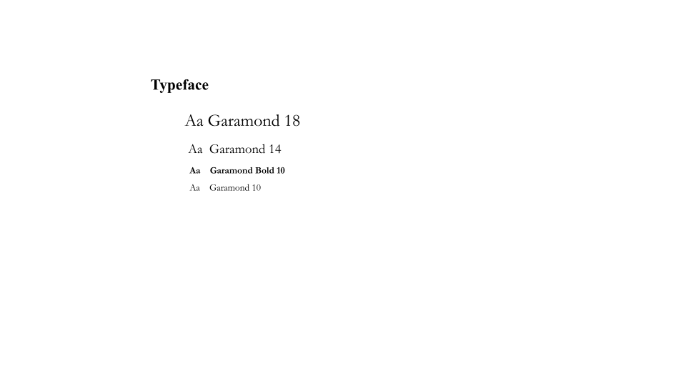

**Brand Logo for Adventure Works**

Using the primary colors, the brand logo is made representing youthfulness, vitality, playful and power. Also considering the color psychology of warm(Red) and cool (Blue) colors which can draw the consumers eye and can convey about the products that the company sells like Helmet, Tire, Bikes, Bike Stand, Jersey, Gloves and vests which are mostly found in blue ,red and black shades

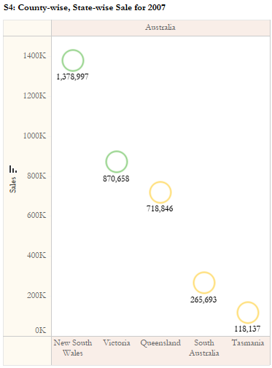**THOUGHT PROCESS**

1. **Preparing Visualization Worksheets**

* Arranging Measure Values and Measure Names in the column and rows.

Columns: Country, State

Rows: Sales

* Choosing appropriate chart type: Column Graph with mark type as shapes.
* Creating Calculated Field for sale contribution with if else condition for greater or less than 70%.

Then putting the calculated field in the colors, profit and profit percentage in the tooltip.

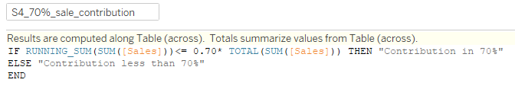

* Formulas used in calculating following measures:

1. Sales = ([Unit Price]+[Freight]+[Tax Amt])*[Order Quantity]
2. Profit = SUM([Sales])-SUM([Standard Cost])
3. Contrinution_Total_Sale = (SUM([Sales])/TOTAL(SUM([Sales])))*100
4. Profit Percentage = ((SUM([Sales])-SUM([Standard Cost]))/SUM([Sales]))*100

* Filters

Using year and country filter for selecting specific year and country which can also be selected for all countries if required.

1. **Creating Dashboards**

* Actions are applied on the two worksheets as source and target sheets with the menu option.
* Using drill through on menu the cascading of filters are applied by using add to context and setting up the filters to be applied on selected worksheet for using the context values.

1. **Dashboard Presentation**

* Placing up the filters on the right pane of the dashboard.
* Using the color palette based on the theme which are applied on different mark types.
* Using significant font hierarchy as per the typeface decided.
* Labeling up the required points based on the graph scale.
* Aligning the text direction as suitable for the representation of graph.
* Reducing the gutter spaces between the graph if present.

**Report Format**

Following type of graphs are utilized in the presentation of dashboard:

* Tree Map : Used in product wise and city –wise Sales
* Column Bars : Top Products, customers and cities
* Side by side bars : Month-wise , country-wise sales
* Density Graph : Country-wise ,state-wise sales
* Line chart : Change in Sales and profit
* Table : Customers with profit and profit percentage.

**Sales Performance Dashboard**

S1: Country-wise Sale for Selected Year. Show the % contribution to the total sale and Profit in tooltip.

S5: Drill through from S1 and show month-wise Sale for selected category along with % change in sale and profit over last month.

S6: Drill down from S5 and show product-wise sale.

S8: Drill through from S1 and show month-wise Sale for selected category. Color the months with sale 20% above average sale per month as Green, 10% below average as Red and rest as Yellow

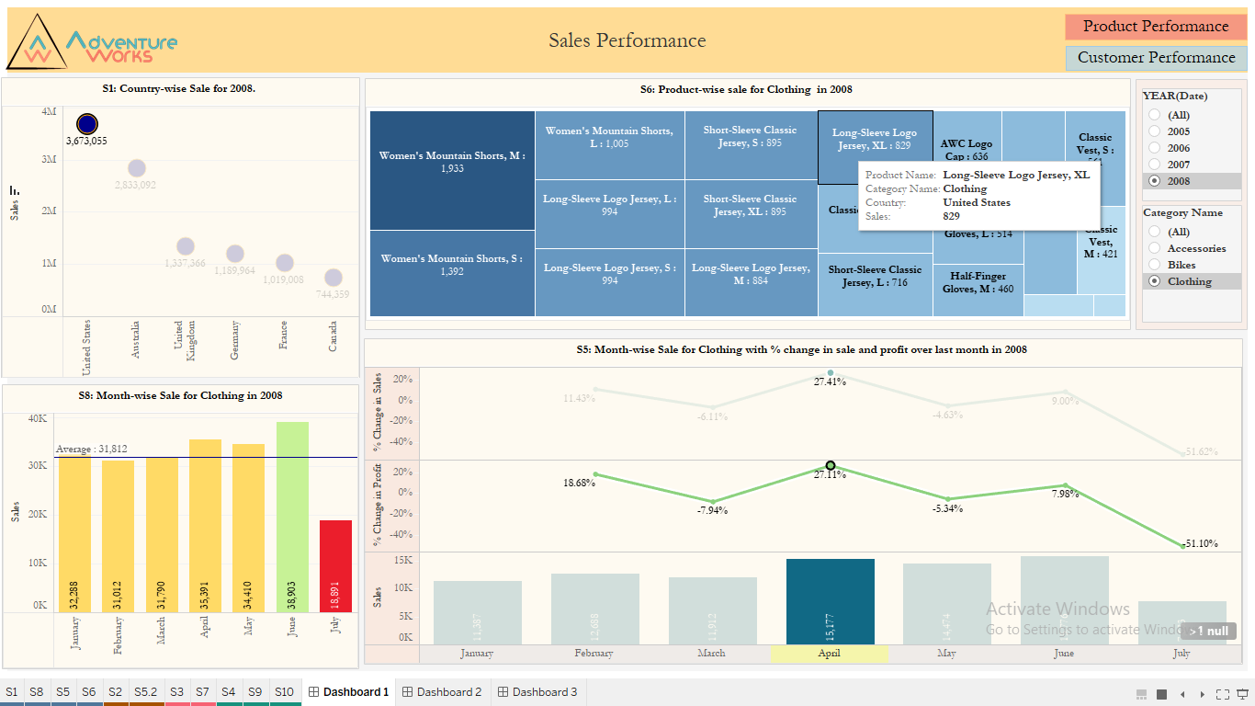

**Product Performance Dashboard**

S4: County-wise, State-wise Sale for Selected Year. Mark States contributing to 70% sale as Green and rest as Yellow. Show the profit in tooltip

S9: Drill through from S4 and show City-wise Sale. Use divergent colors based on profit.

S10: Drill though from S9 and show top n products by sale. Show profit in tooltip.

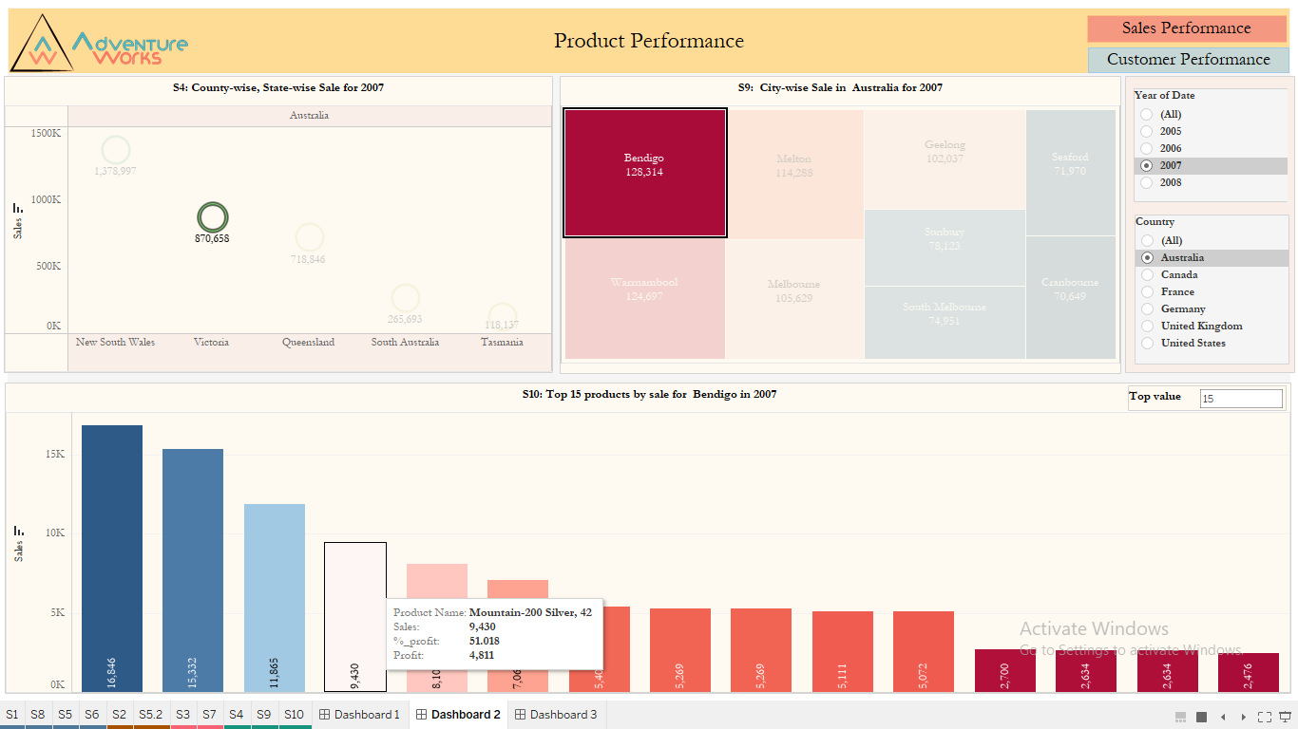

**Profit –Sales performance based on Customer Dashboard**

S2: Country-wise top n Cities by Sale.

S3: Month-wise Country-wise Sale for Selected Category. Show the % contribution of country sale to total sale for each month.

S5: Drill through from S2 and show top n customers by sale.

S7: Drill through from S3 and show Customer generating 80% of profit.

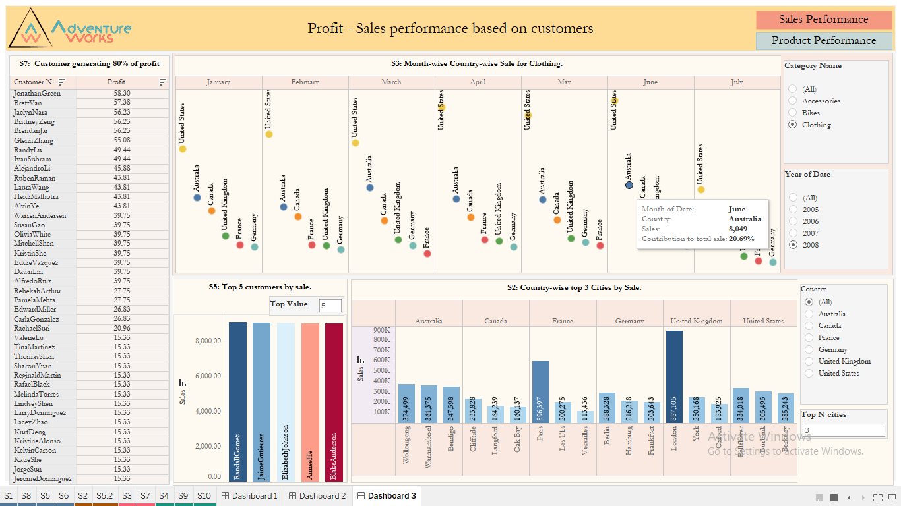

**Inference**

Business requirements are analyzed using different visual representations made with the Tableau tool including various types of graphs and maps. The data set includes different dimensions and measure values which are consolidated in the form of interactive dashboards for representing the trends and patterns in the data. The visualization process includes the creation of calculated fields, parameters, sets filters, window functions, table calculation, and actions applied on the worksheets. The message implicated from the graphs will help the country in making data-driven decisions which would help in solving real-world challenges that may arise in the business.

Tableau Link: [AU19B1006_G2_Adventure Works | Tableau Public](https://public.tableau.com/app/profile/shambhavi.goswami/viz/AU19B1006_G2_AdventureWorks/Dashboard3?publish=yes)