**Mini Project Report on**



**Online Code Editor (React)**



**Submitted in partial fulfilment of the requirement for the award of the degree of**

**BACHELOR OF TECHNOLOGY**

**IN**

**COMPUTER SCIENCE & ENGINEERING**

**Submitted by:**

**Student Name: Kumari Neha University Roll No: 2017650**

***Under the Mentorship of***

**Ms Tanusha Mittal**

**Assistant professor**



**Department of Computer Science and Engineering**

**Graphic Era (Deemed to be University)**

**Dehradun, Uttarakhand**

**July-2023**



**CANDIDATE’S DECLARATION**

I hereby certify that the work which is being presented in the project report entitled **“Online Code Editor (React)”** in partial fulfillment of the requirements for the award of the Degree of Bachelor of Technology in Computer Science and Engineeringof the Graphic Era (Deemed to be University), Dehradun shall be carried out by the under the mentorship of **Ms Tanusha Mittal, Assistant professor**, Department of Computer Science and Engineering, Graphic Era (Deemed to be University), Dehradun.

**Name: Kumari Neha University Roll no: 2017650**

**Table of Contents**

|  |  |  |
| --- | --- | --- |
| **Chapter No.** | **Description** | **Page No.** |
| Chapter 1 | Introduction | 4-5 |
| Chapter 2 | Literature Survey | 6-7 |
| Chapter 3 | Methodology | 8-9 |
| Chapter 4 | Result and Discussion | 10-12 |
| Chapter 5 | Conclusion and Future Work | 13 |
|  | References | 14 |

**Chapter 1**

**Introduction**

**1.1 Statement**

**Online Code Editor (React).**

The problem addressed by the Online Code Editor project is the need for a versatile and user-friendly platform that enables developers to write, test, and execute code directly within a web browser. Traditional code editors often require installation and lack features such as real-time collaboration and interactive code execution. Therefore, there is a demand for an online code editor that leverages the power of React to provide a dynamic and efficient coding environment.

Many developers face challenges when they need to access their coding environment from different devices or locations. Installing and configuring a code editor on multiple machines can be cumbersome. An online code editor eliminates these limitations by providing a web-based platform accessible from any device with an internet connection.

**1.2 Motivation**

As a Student of B.Tech Computer Science, our purpose is to focus on and explore different and new Technologies.

React is popular JavaScript library for building user interfaces. I found this problem best suited for learning more about the web development. React was developed by Facebook and is widely used in the industry for developing interactive and dynamic web applications.

Developing an online code editor project is an excellent way to learn and improve my skills in web development, particularly in React. It allows me to explore various concepts such as rendering dynamic content, handling user input, integrating external libraries (e.g., CodeMirror), and managing state.

**1.3 Technologies used:**

   IDE: Visual Studio Code

1.React

2.React-CodeMirror2

3.HTML, CSS, JavaScript

4.npm

**1.4 Introduction**

The Online Code Editor using React project is a web-based platform designed to provide developers with a convenient and efficient environment for writing, testing, and executing code directly within a web browser.

Leveraging the power of React, this project aims to create a dynamic and interactive code editing experience with features like syntax highlighting, code auto completion, and real-time collaboration. BY utilizing React’s component-based architecture and integrating external libraries such as CodeMirror, the online code editor project offers a versatile and user-friendly solution for developers to enhance productivity and streamline their coding workflow.

* This web app provides a Online Code Editor for three languages HTML, CSS and JAVASCRIPT. This application will help in such a way Developers can easily organize their HTML, CSS, and JavaScript code into separate components, enhancing code organization and maintainability. Here the application provides the separate blocks to write code for HTML, CSS, and JavaScript.

**Chapter 2**

**Literature Survey**

* 1. **Title: A Survey on Online Code Editor**

**Authors:** Ms. Lynsha Helena Pratheeba H P

Srivasthsa Kunikullaya H

Shashi Bhavan C K

Thippeswamy Chandra Shekhar Pulipati

Veeresh Amaragatti

**Abstract**

[Online Compiler and code](https://www.google.com/search?rlz=1C1GCEA_enIN933IN933&sxsrf=AB5stBgBGI8bhYUA7vtp44G1vvshR3NJ3A:1689018106267&q=Online+Compiler+and+code+editors+main+objective+is+to+implement+Code+without+installing+compiler+in+the+system,+directly+the+code+can+be+compiled+and+run.+An+online+compiler+has+the+same+basic+functionality+as+a+conventional+compiler,+however+with+one+significant+difference:+all+of+a+project+or+application%27s+source+code+is+stored+and+executed+online+via+a+web+browser.+Thus,+we+aim+to+develop+a+website+where+users+can+write+C+code+and+paste+into+the+C-code+editor+and+compiler+and+then+press+the+run+button.+The+system+will+send+information+to+server+where+compiler+is+installed+and+it+will+test+the+code+at+server+side+and+send+result+information+to+client+within+a+few+seconds.+So,+this+application+will+save+time+in+installing+the+entire+C+compiler+with+DOS+which+is+a+time+taking+process.+Therefore,+people+can+directly+use+this+online+compiler+which+is+a+fast+and+straightforward+method.&spell=1&sa=X&ved=2ahUKEwi71Pjh8oSAAxWzpVYBHRFYClwQBSgAegQIDRAB)*[editors](https://www.google.com/search?rlz=1C1GCEA_enIN933IN933&sxsrf=AB5stBgBGI8bhYUA7vtp44G1vvshR3NJ3A:1689018106267&q=Online+Compiler+and+code+editors+main+objective+is+to+implement+Code+without+installing+compiler+in+the+system,+directly+the+code+can+be+compiled+and+run.+An+online+compiler+has+the+same+basic+functionality+as+a+conventional+compiler,+however+with+one+significant+difference:+all+of+a+project+or+application%27s+source+code+is+stored+and+executed+online+via+a+web+browser.+Thus,+we+aim+to+develop+a+website+where+users+can+write+C+code+and+paste+into+the+C-code+editor+and+compiler+and+then+press+the+run+button.+The+system+will+send+information+to+server+where+compiler+is+installed+and+it+will+test+the+code+at+server+side+and+send+result+information+to+client+within+a+few+seconds.+So,+this+application+will+save+time+in+installing+the+entire+C+compiler+with+DOS+which+is+a+time+taking+process.+Therefore,+people+can+directly+use+this+online+compiler+which+is+a+fast+and+straightforward+method.&spell=1&sa=X&ved=2ahUKEwi71Pjh8oSAAxWzpVYBHRFYClwQBSgAegQIDRAB)*[main objective is to implement Code without installing compiler in the system, directly the code can be compiled and run. An online compiler has the same basic functionality as a conventional compiler, however with one significant difference: all of a project or application's source code is stored and executed online via a web browser. Thus, we aim to develop a website where users can write C code and paste into the C-code editor and compiler and then press the run button. The system will send information to server where compiler is installed and it will test the code at server side and send result information to client within a few seconds. So, this application will save time in installing the entire C compiler with DOS which is a time taking process. Therefore, people can directly use this online compiler which is a fast and straightforward method.](https://www.google.com/search?rlz=1C1GCEA_enIN933IN933&sxsrf=AB5stBgBGI8bhYUA7vtp44G1vvshR3NJ3A:1689018106267&q=Online+Compiler+and+code+editors+main+objective+is+to+implement+Code+without+installing+compiler+in+the+system,+directly+the+code+can+be+compiled+and+run.+An+online+compiler+has+the+same+basic+functionality+as+a+conventional+compiler,+however+with+one+significant+difference:+all+of+a+project+or+application%27s+source+code+is+stored+and+executed+online+via+a+web+browser.+Thus,+we+aim+to+develop+a+website+where+users+can+write+C+code+and+paste+into+the+C-code+editor+and+compiler+and+then+press+the+run+button.+The+system+will+send+information+to+server+where+compiler+is+installed+and+it+will+test+the+code+at+server+side+and+send+result+information+to+client+within+a+few+seconds.+So,+this+application+will+save+time+in+installing+the+entire+C+compiler+with+DOS+which+is+a+time+taking+process.+Therefore,+people+can+directly+use+this+online+compiler+which+is+a+fast+and+straightforward+method.&spell=1&sa=X&ved=2ahUKEwi71Pjh8oSAAxWzpVYBHRFYClwQBSgAegQIDRAB)

# Title: Real-time Code Editor Application for Collaborative Programming

# Authors: Aditya Kurniawan1

# Aditya Kurniawan2

# Christine Soesanto3

# Joe Erik Carla Wijaya4

**Abstract**

The world of Internet is growing rapidly, many applications that previously created on the desktop start moving to the web. Many applications could be accessed anytime and anywhere easily using Internet. Developers need tools to create their applications, one of them named code editor. The purpose of this research is to design and develop a real-time code editor application using web socket technology to help users collaborate while working on the project. This application provides a feature where users can collaborate on a project in real-time. The authors using analysis methodology which conducting on a study of the current code editor applications, distributing questionnaires and conducting on literature study. CodeR is a web application that provides workspace to writing, perform, display the results of the code through the terminal, and collaborate with other users in real-time. The application main features are providing workspace to make, execute and build the source code, real-time collaboration, chat, and build the terminal. This application supports C, C++, and Java programming languages.

* 1. **Title: Building an Online Code Editor using React**

**Authors:** Mark Erikson

**Abstract**

This article provides an overview of building an online code editor using React. It covers key concepts such as code editing functionality, syntax highlighting, and collaboration features.

**2.4 Title: Online Code Editor Using React**

**Authors:** Nishant

Neetu Raj Bharti

**Abstract**The world of Internet is growing rapidly, many applications that previously created on the desktop start moving to the web. Many applications could be accessed anytime and anywhere easily using Internet. Developers need tools to create their applications, one of them named code editor. The purpose of this research is to design and develop a real-time code editor application using web socket technology to help users collaborate while working on the project. This application provides a feature where users can collaborate on a project in real-time. The authors using analysis methodology which conducting on a study of the current code editor applications, distributing questionnaires and conducting on literature study. Codesk is a web application that provides workspace to writing, perform, display the results of the code through the terminal, and collaborate with other users in real-time. The application main features are providing workspace to make, execute and build the source code, real-time collaboration, chat, and build the terminal. This application supports C, C++, and Java programming languages.

**Chapter 3**

**Methodology**

Building up a project on Online Code Editor (React) was a great piece of experience, it not only help me in gathering information about new technologies but also made me realize the use of programming in real life.

Discussing about how this learning process started and journey up to building up this project goes like this:

This project was mainly developed to create a web-based platform that allows users to write, test, and execute code directly within a web browser.

**Architecture and Features**

The project has three folder that is node_modules which contains all the installed dependencies for the project , public folder contains mainly the index.html which is displayed on the browser , src the folder on which we are working during development, this folder contains the starting point of the react project (index.js), inside src folder a component folder is present which contains all the necessary JSX components for the project. Apart from these three folders four files are present in the project that are gitignore, package_lock.json (ensures consistent installation of the dependencies for the project) , package.json(this file contains the dependencies and scripts that are required for the development of the project), README.md(contains the important notes).

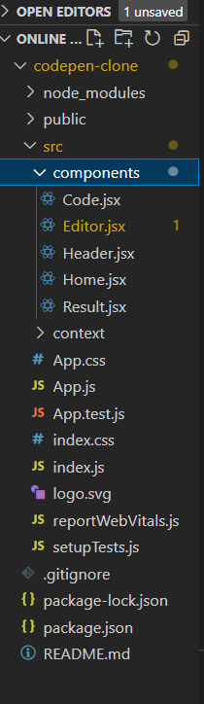

The application starts with a page that contains three blocks in which you can separately write the code. In first block the user can write the HTML code, in the second block the user can write the CSS code and in third block user can write the JAVASCRIPT code. The corresponding result from the code is displayed on the same page on the lower half portion.

To make the application following tools are used:

**React**

React is a JavaScript library developed by Facebook which, among other things, was used to build Instagram.com. It aims to allow developers to create fast user interfaces for websites and applications alike easily. The main concept of React. js is virtual DOM.

**Material UI**

Material UI is an open-source React component library that implements Google's Material Design. It includes a comprehensive collection of prebuilt components that are ready for use in production right out of the box.

**CodeMirror React**

CodeMirror is a code-editor component that can be embedded in Web pages. The core library provides only the editor component, no accompanying buttons, auto-completion, or other IDE functionality. It does provide a rich API on top of which such functionality can be straightforwardly implemented.

**Flow of application**

1. The user interacts with the online code editor interface.

2. The user enters HTML, CSS, and JavaScript code into the code input area.

3. The code is passed to the HTML editor and CSS editor components for editing and validation.

4. The HTML and CSS editors validate the code for correctness and provide a preview of the

rendered output.

5. The validated HTML and CSS code is passed to the JS editor component along with the

JavaScript code.

6. The JS editor validates the JavaScript code and executes it.

7. The output of the executed code is displayed in the output **area.**

8. Refresh the page to write the fresh code.

**Chapter 4**

**Result and Discussion**

**Flow diagram of Application**

**start**

**|**

**v**

**+----------------------------------+**

**| Online Code Editor |**

**+----------------------------------+**

**| |**

**| Code Input |**

**| (HTML/CSS/JS) |**

**+-----------+---------+-----------+**

**| |**

**v v**

**+-----------------------+-------------+**

**| HTML Editor | CSS Editor |**

**+--------------------+----------------+**

**| |**

**| Code Validation & Preview |**

**+---------------------+----------------+**

**| |**

**v v**

**+---------------+-------------+**

**| JS Editor | Output |**

**+---------------+-------------+**

**| |**

**| Code Validation & |**

**| Execution |**

**+---------------+--------------+**

**| |**

**v v**

**+-------+---------+**

**| Run | Reset |**

**+-------+---------+**

**| |**

**v v**

**end start**

**Screenshots**

**Application UI:**

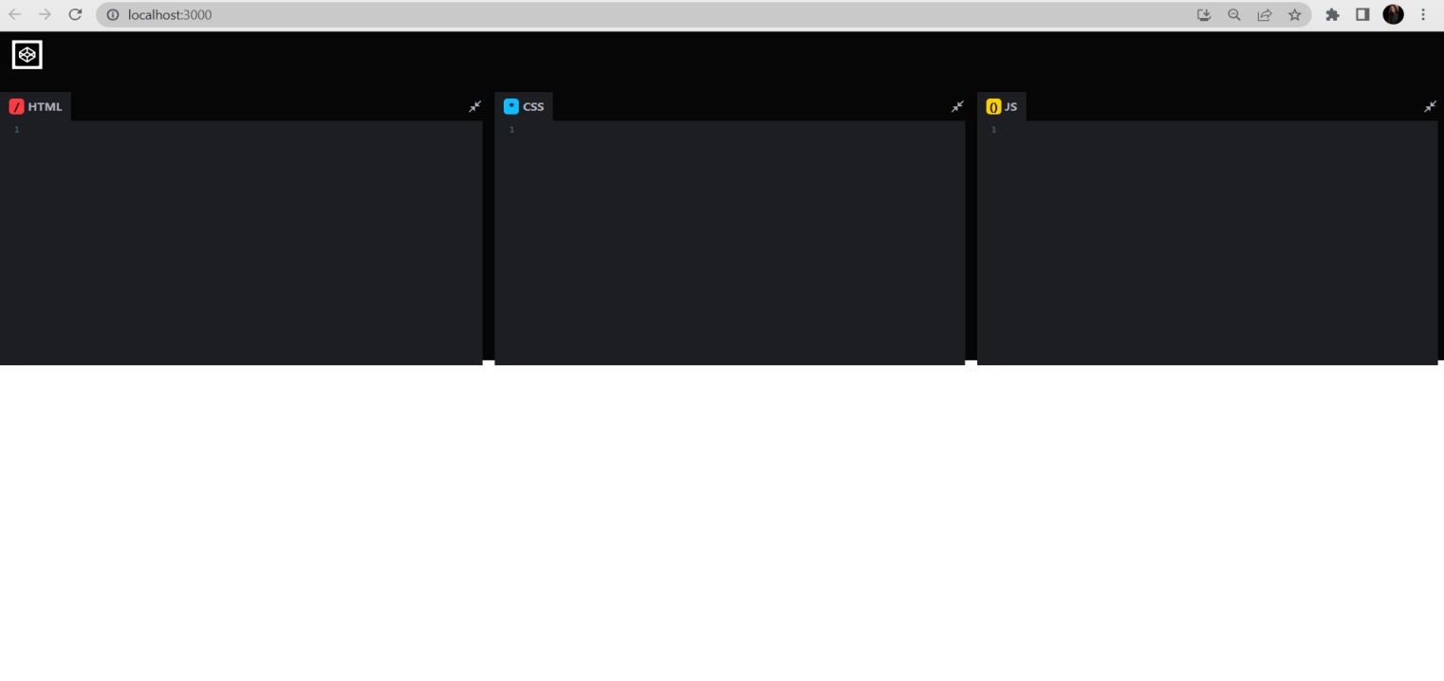

**Adding HTML code:**

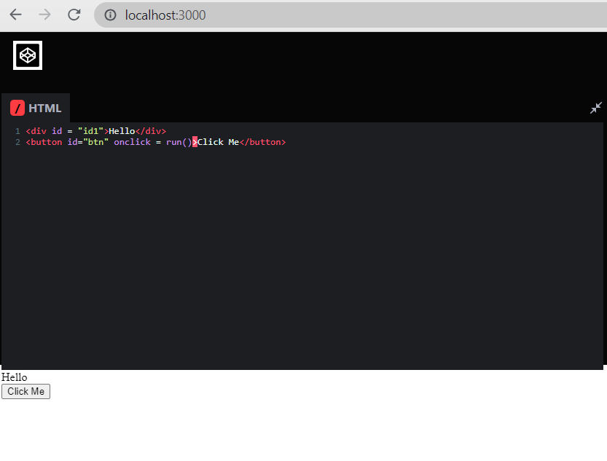

**Adding CSS to the code:**

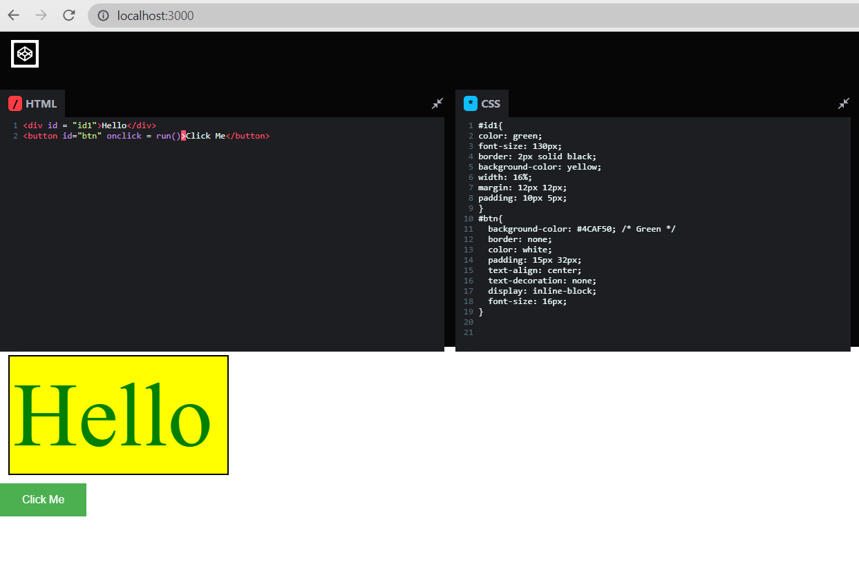

**Adding JavaScript to the code:**

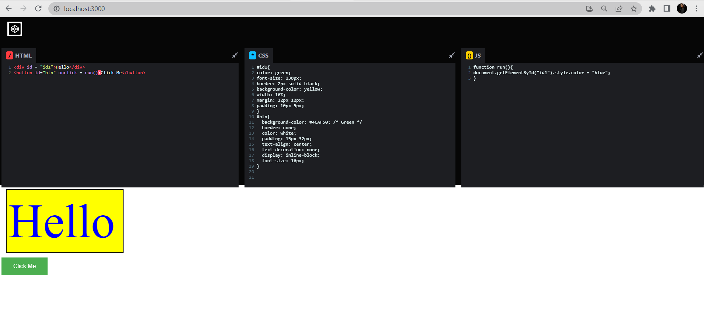

**Chapter 5**

**Conclusion and Future Work**

The completion of the project went quiet well, I learned much new things while I was building up it, and I get up to know various platforms which help us to learn all this stuff. I was able to learn real life use of Online Code Editor, and why it is so important.

The major goal of the project is to identify potential bottlenecks in your process and fix them so work can flow through it cost-effectively at an optimal speed or throughput.

Overall working on this project was great fun as I came up with great piece of knowledge and understanding of the topic.

By building this project, I gained experience in working with React Components, managing code input and output, and implementing code validation and execution. I have created a useful tool for Developers, Students, or anyone interested in learning or practicing Web Development.

While my project is already functional, there are several areas where I can continue to improve and enhance it:

Code optimization

Additional Language Support

Collaboration Features

File Management

Customization Options

Error Handling and Feedback

Testing and Bug Fixes

**References**

 [1] **Youtube , Google**

 [2**] https://codepen.io/Neha-Kumari-the-builder/pen/oNQorEG**

[3 **https://www.freecodecamp.org/news/how-to-build-react-based-code-editor/** **(Example : Website)**

[4]**https://mui.com/material-ui/react-app-bar/**