Wireframes

Aloka Kavitha De Silva

# **A screenshot of a computer Description automatically generatedHome page- Wire frame**

**Desktop version** :

## **Mobile phone version :**

# **Introduction Page - Wire frame**

Mobile phone version :

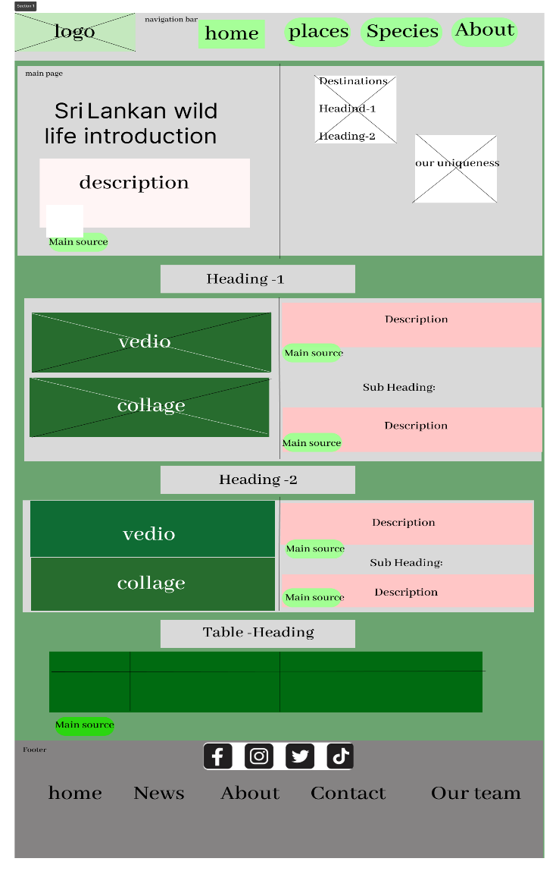**Desktop version** :

## 

## 

## **Conservation Page - Wire frame Mobile phone version**

**Desktop version :**

**

# **Srilankan Leopard – wireframe**

**Desktop version mobile phone**

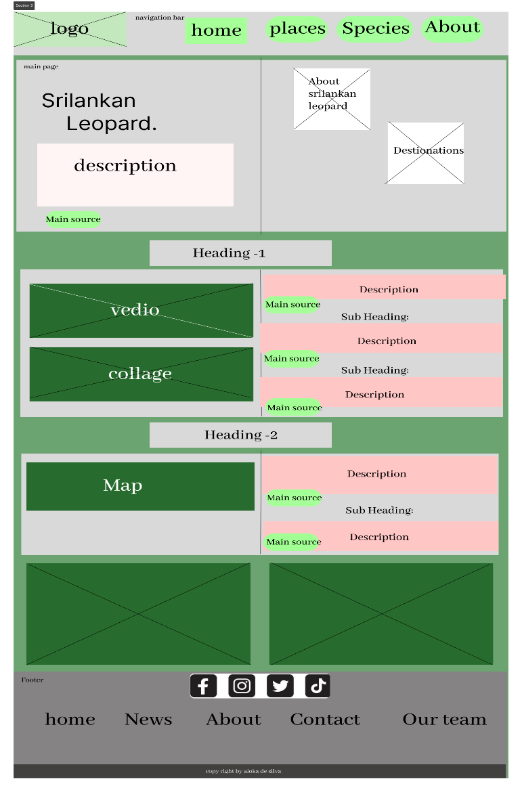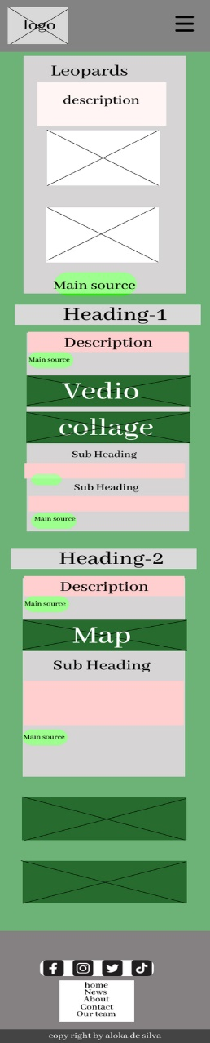

**Animals In Srilanka**

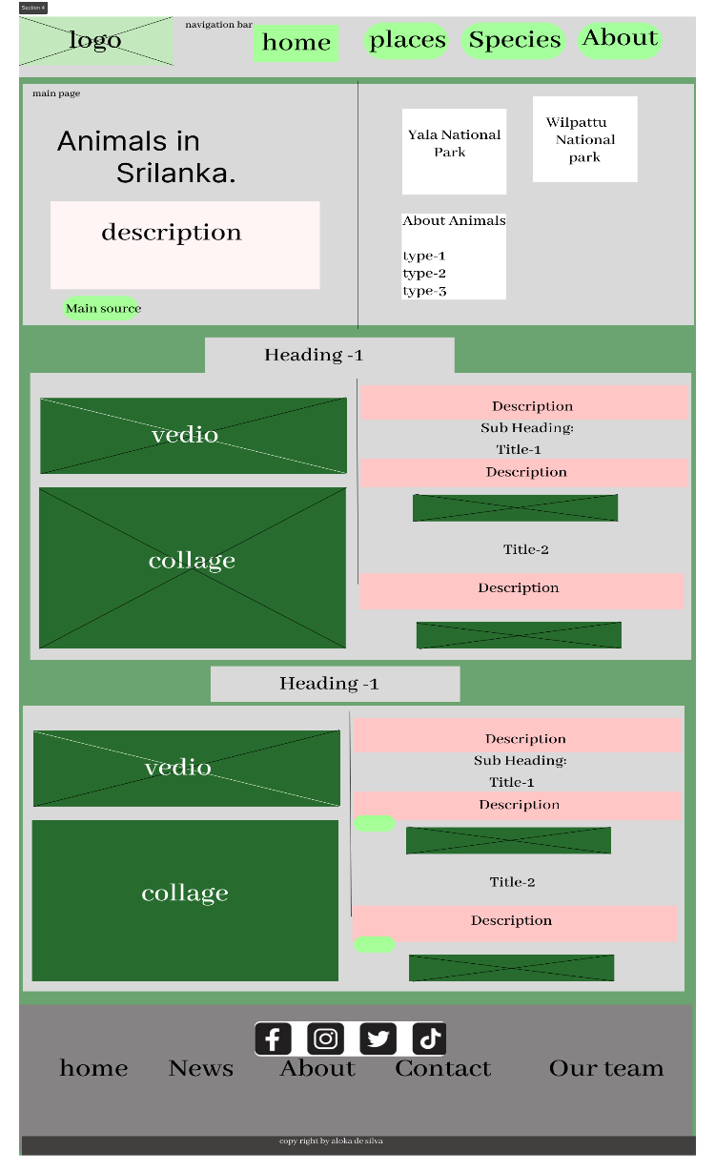**Desktop version** **mobile**

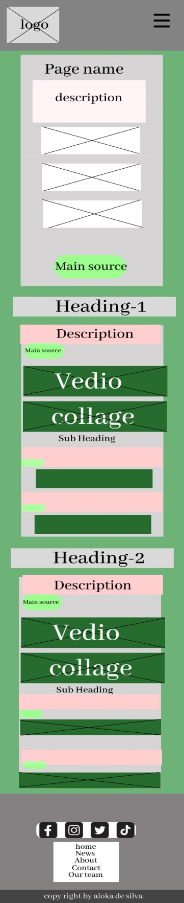

**Yala National Park-Wireframe**

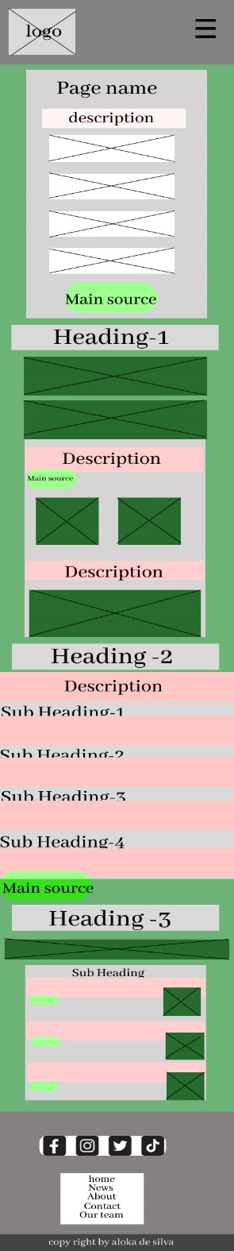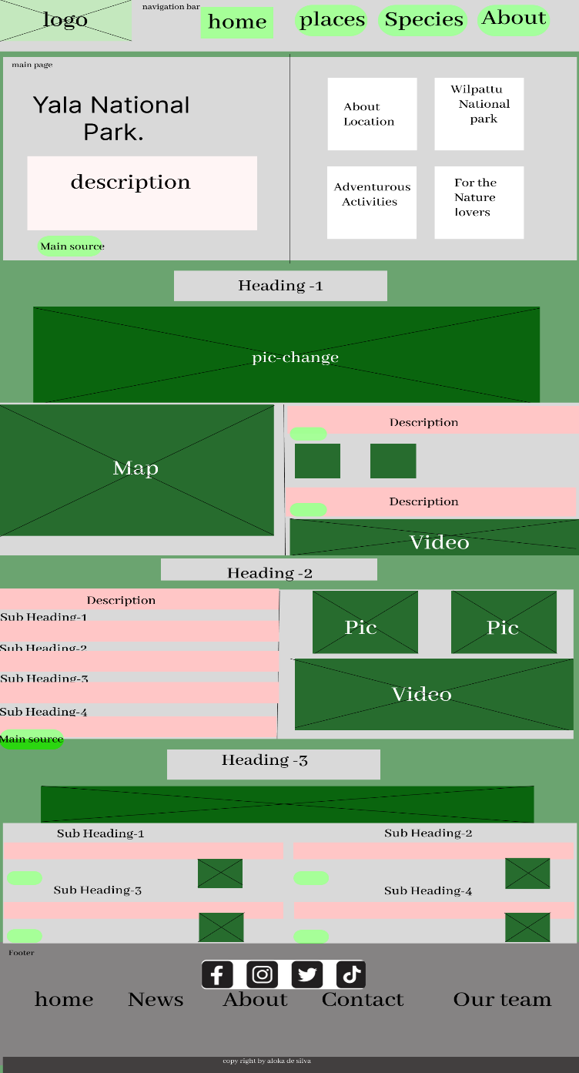**Desktop Mobile**

**Wilpattu National Park-Wireframe**

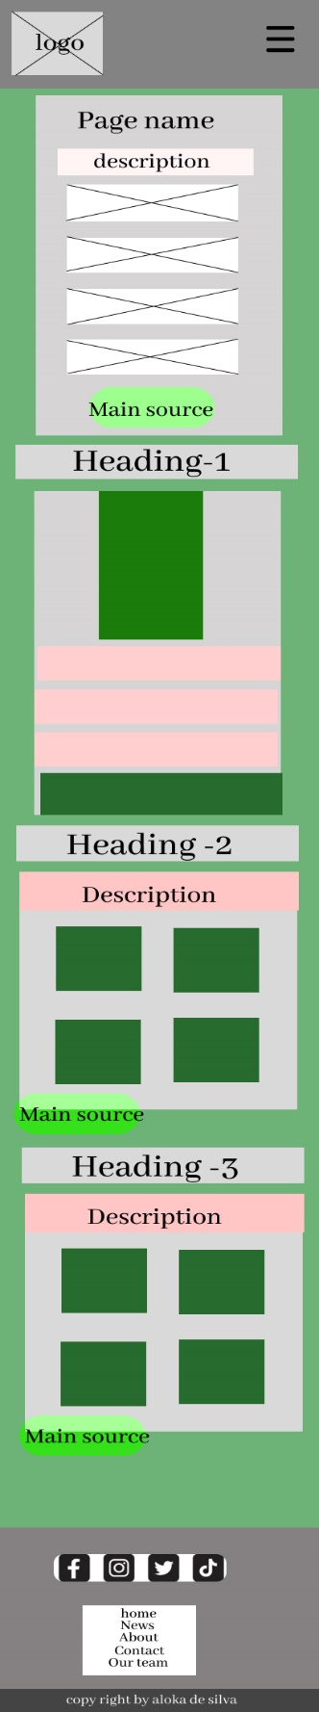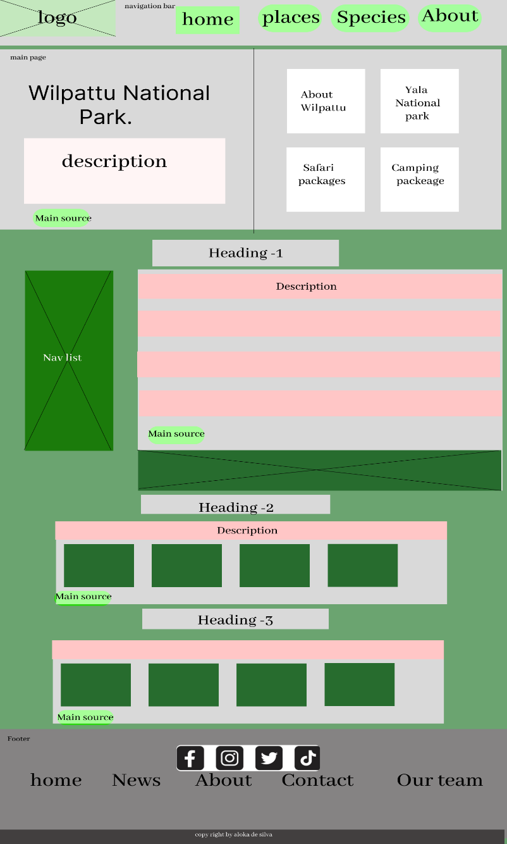**Desktop Mobile**