Contractor Project

**Test Plan**

*Purpose: To Test Program for its functions*

**Team members: Collin**

**Date/Version: 25/05/2024**

# Overview

## Purpose

Context of testing

* The project is to make an application that is able to assign contractors into jobs.
* These tests are to see if all functions of this application work the intended way, whether if its to add contractors correctly, or calculate ID of new Contractors.

Test Methodology

* Unit Tests and functional tests are conducted in MS Test.
* I will be making tests for all of this application’s functions.
* Test cases will be based on other people’s experience of the app, especially the workflow, and if the application makes sense.

Test Environment

* This will be done in class, and at home.
* The computers will be using visual studio for coding.

Types of tests

* Unit tests for verification of individual functions in the code (mostly in the data manager class)
* Functional tests to see if the app functions as expected, or if the client has gripes with how the workflow happens in the application.

Standards

* We’ll be mostly following the coding conventions based on the documentation provided by TAFE (in the assessment 2, part A)

Test Deliverables

* By the end of the assessment, a functional program should be presented, a testing plan document, and a test progress report outlining passes, fails and changes made to the code.

Test Scope

* The testing scope should include functional aspects indicated in the business requirements (e.g. adding contractors, assigning contractors).
* Non-functional aspects should also be included, like the workflow, and how testable the code should be.

## Context

The context of this application is that a local recruitment agency has contacted our company to develop an application to manage and track their contractors.

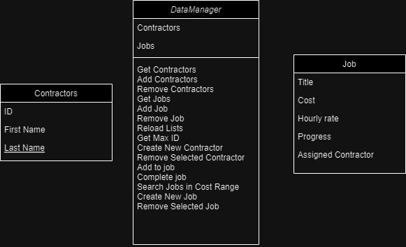

## Methodology

Black Box Testing

* This would be done by showing it to colleagues and seeing how they interact with the application.
* If the workflow isn’t straightforward for the user (e.g. the buttons are too obscure, or no message boxes explaining an error), then it could be considered an issue.
* This could be something like how the button would assign a contractor to job (do they need to select from the other list to assign, do they need to open another window)
* This could show bugs on the UI as well (could be adding 2 contractors at once)
* Benefits of this allows for better understanding of what the client wants on the application.
* More communication with the client allows for a better end product, and better UI.

White Box Testing

* This would be done using Unit Testing
* Would be done to see if certain functions work by using code to verify logic within the main code.
* This could be used for something like completing a job, to see if it is executed, it would return the assigned contractor to null, and put the contractor back on the available contractor pool, while returning with the right ID number.
* You would be checking if the lists contain the correct data using assertions.
* Benefits of this allows for more precise issue resolution, through validation of logic.

## Test environment

The unit testing framework I used was MS Test.

* Visual studio 2022 is also used, to create a WPF application.
* Used for the individual methods stated in the Data manager class.
* Assertions like IsNotNull, AreEqual, IsTrue, IsFalse will be used to confirm logic in the code.

# Testing Plan

## Scope of Testing

### Functional tests



## Debugging Screenshot

Earlier on the Project, When I was moving one value to another list box, I’ve noticed that the ID would just reset to 0 everytime you move it from one to another.

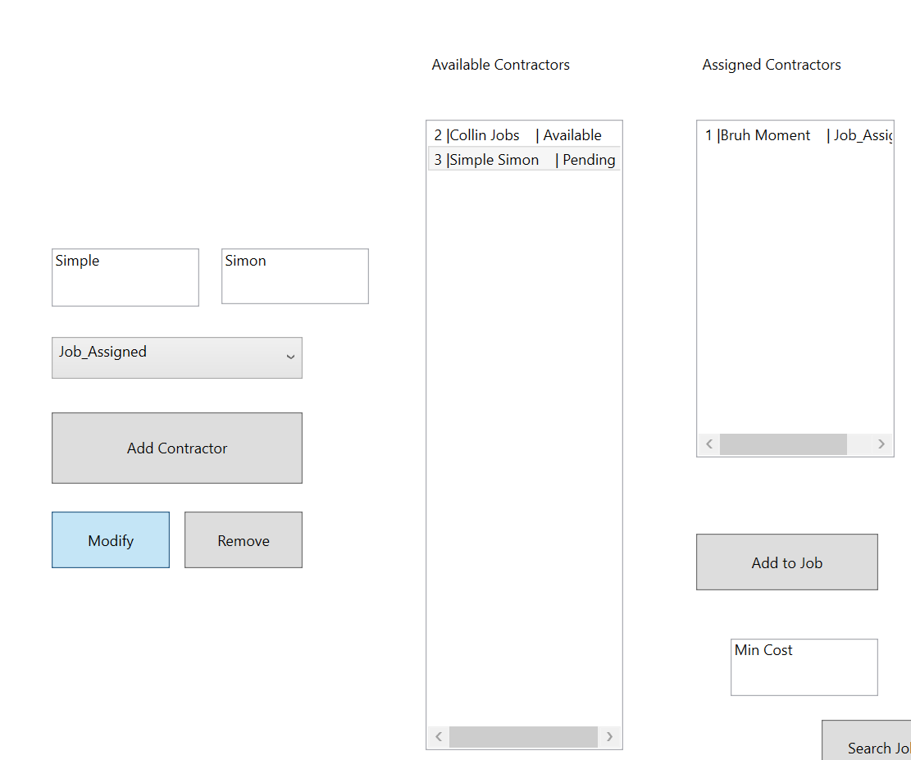

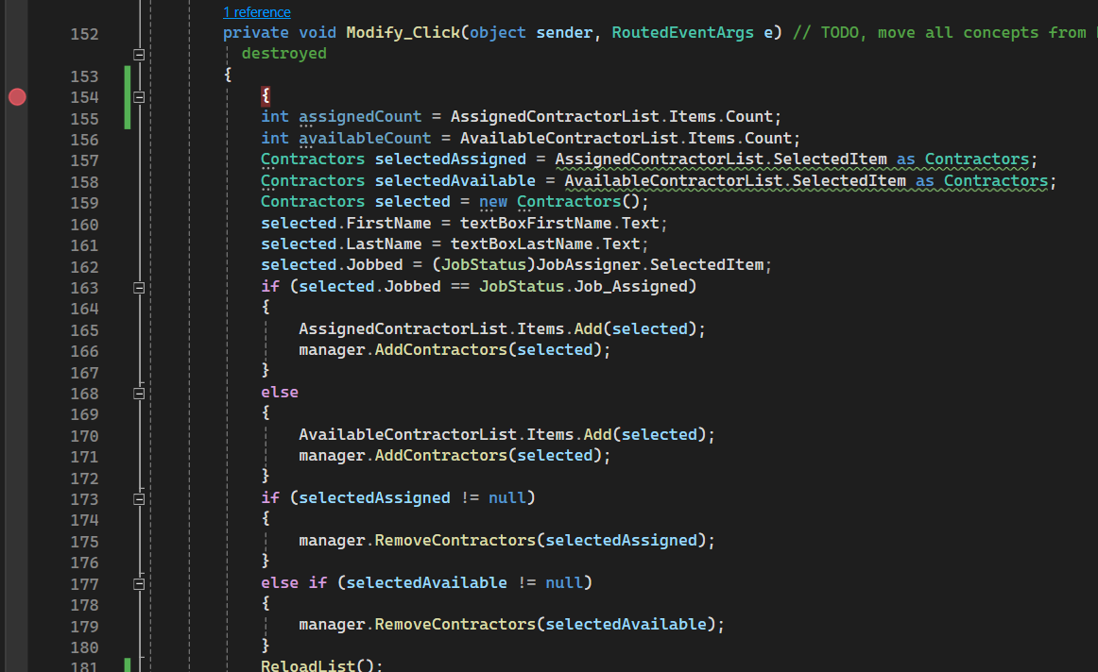

This method did not take care of the ID at all, only added and removed a contractor to another list.



This led to a creation of a ID method that would return the max ID, with it being incremented by one every time a new contractor is added, to avoid confusion for 2 employees that may have common names.

This would find the biggest id in the contractor list

Then when adding a contractor with the button, it would produce a new ID for the new contractor.