Milestone 1: Defining problems / problem understanding.

Activity 1: Specify the problem. Refer project description.

activity 2. Electrical vehicle charge and range analysis. End bold India in different states. Identifying the pattern and trend overtime. Identifying affection factors. Creating interactive dashboards and reports. Identifying areas for improvement. Comparing the. Industrial average and creating forecasting model for further performance. The ultimate Gain insane and improve performance through data visualization techniques.

Activity 3 Literature survey

. Literature survey for analysing the electrical vehicle involves research and review. Free Viewing Previous studies, articles, and reports on this topic. This includes information on the method and technique used for analysing the. Electrical vehicle charge and range as well as result concludes of these studies.

Activity 4: social or business impact

Social impact resolving or helping to solve biggest issue in EV India.

More people will understand and But the EV instead of Ice’s.

Business model/impact:

This project can provide the insight for the car/battery manufacturers, and it can also provide the insights for the people who are using the EV or thinking to enter in EV market.

Milestone 2:

Data Collection & Extraction from Database Data collection is the process of gathering and measuring information on variables of interest, in an established systematic fashion that enables one to answer stated research questions, test hypotheses, evaluate outcomes and generate insights from the data.

Activity 1:

Collect the datasets given by your guide.

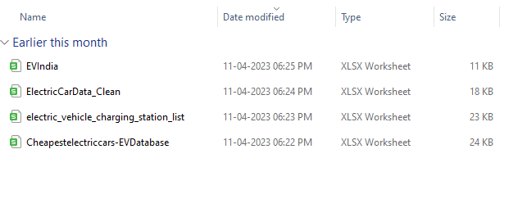

Activity 1.1:

**Understand the data**

Data contains all the meta information regarding the columns described in the CSV

files. we have provided 4 CSV files:

1. EV India

2. Electric _vehicle _charging _station_ list

3. Electric Car Data_ Clean

4. Cheapest electric cars-EV Database

**Column Description for EV India:**

1. Car - Car Brand name and model

2. Style Range - Style range of car

3. Transmission- Transmission type

4. Vehicle Type – Type of vehicle

5. Price Range (Lakhs) - Price Range in Lakhs

6. Capacity - Capacity of car

7. Boot Space – Boot space of the car

8. Base Model – Base model name

9. Top Model – Top model name

**Column Description for Electric_ vehicle _ charging _station _list:**

1. region: This column represents the region of the charging station.

2. address: This column represents the address of the charging station.

3. aux address: This column represents the auxiliary address of the charging

station.

4. latitude: This column represents the latitude of the charging station.

5. longitude: This column represents the longitude of the charging station

6. type: This column represents the type of the charging station.

7. power: This column represents the power of the charging station.

8. service: This column represents the type of service at the charging station.

**Column Description for Electric Car Data _Clean:**

1. Brand

2. Model

3. Accel Sec

4. Top Speed _Km/H

5. Range _Km

6. Efficiency W/h/Km

7. Fast Charge _ Km/H

8. Rapid Charge

9. Power Train

10. Plug Type

11. Body Style

12. Segment13. Seats

14. Price Euro

**Column Description for Cheapest electric cars-EV Database:**

1. Name

2. Subtitle

3. Acceleration

4. Top Speed

5. Range

6. Efficiency

7. Fast Charge Speed

8. Drive

9. Number of Seats

10. Price in Germany

11. Price in UK

Activity 2:

By watching the video in the project manual link the datasets in SQL

Activity 3:

Connect the database with tableau with the explanation video in project manual.

**Milestone 3: Data Preparation**

**Activity 1: Prepare the Data for Visualization**

Preparing the data for visualization involves cleaning the data to remove irrelevant or missing.

data, transforming the data into a format that can be easily visualized, exploring the data to

identify patterns and trends, filtering the data to focus on specific subsets of data, preparing.

the data for visualization software, and ensuring the data is accurate and complete. This

process helps to make the data easily understandable and ready for creating visualizations to

gain insights into the performance and efficiency

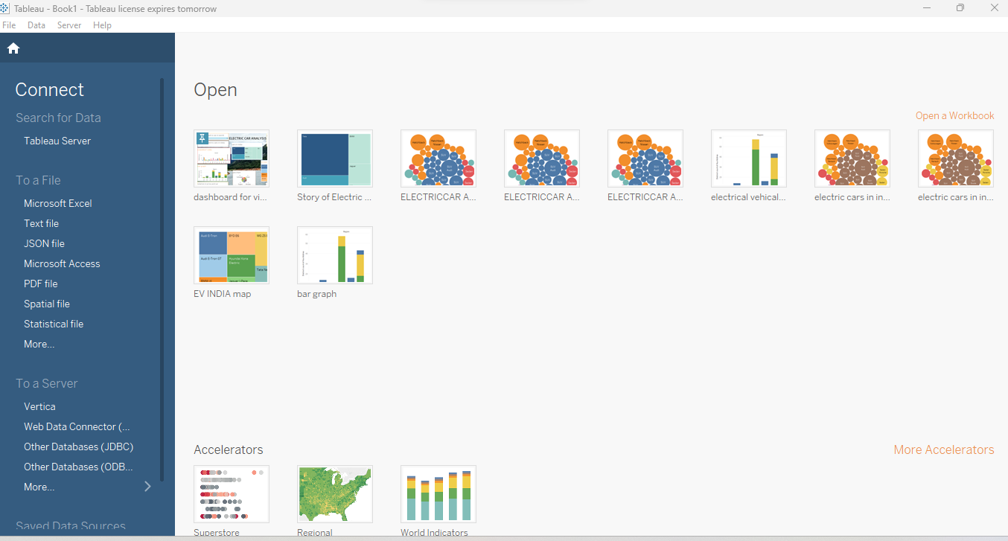

**Milestone 4: Data Visualization**

Data visualization is the process of creating graphical representations of data in order to help people

understand and explore the information. The goal of data visualization is to make complex data sets

more accessible, intuitive, and easier to interpret. By using visual elements such as charts, graphs,

and maps, data visualizations can help people quickly identify patterns, trends, and outliers in the

data.

**Activity 1: No of Unique Visualizations**

**Activity 1.1: Charging Stations by region and type in India**

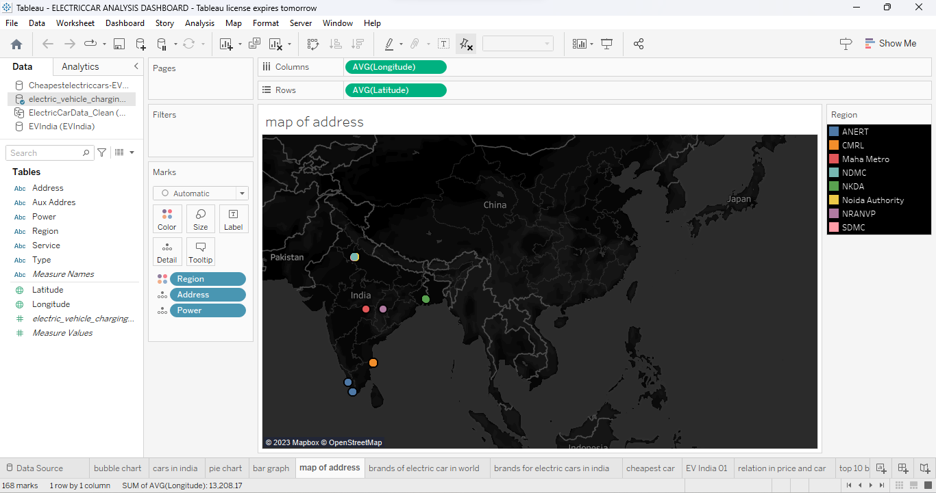

Like this we need to complete for all videos in guided project.

Milestone 5:

A dashboard is a graphical user interface (GUI) that displays information and data in an organized,

easy-to-read format. Dashboards are often used to provide real-time monitoring and analysis of data,

and are typically designed for a specific purpose or use case. Dashboards can be used in a variety of

settings, such as business, finance, manufacturing, healthcare, and many other industries. They can

be used to track key performance indicators (KPIs), monitor performance metrics, and display data in

the form of charts, graphs, and tables.

Activity 1- Responsive and Design of Dashboard Once you have created views on different sheets in Tableau, you can pull them into a dashboard. Explanation video link:

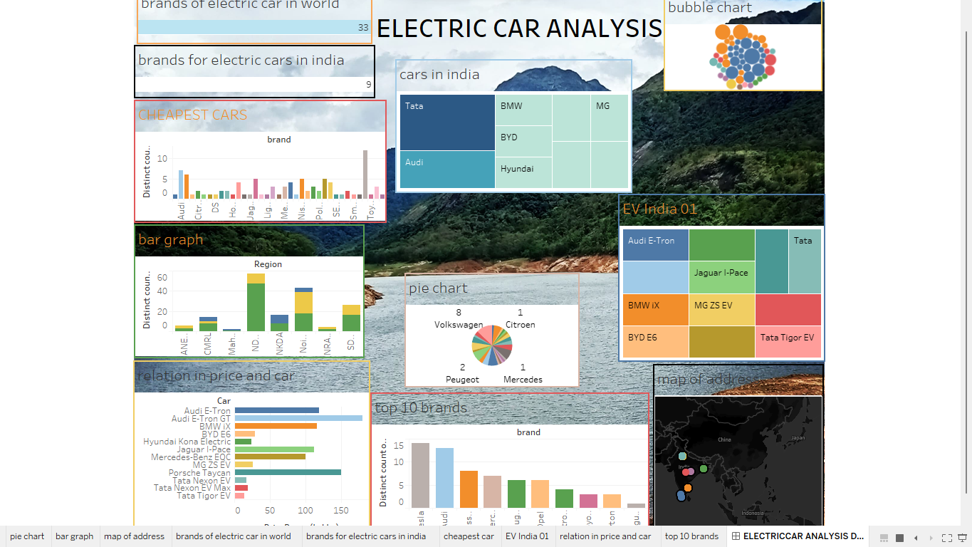

Milestone 6: Story A data story is a way of presenting data and analysis in a narrative format, intending to make the information more engaging and easier to understand. A data story typically includes a clear introduction that sets the stage and explains the context for the data, a body that presents the data and analysis logically and systematically, and a conclusion that summarizes the key findings and highlights their implications. Data stories can be told using a variety of mediums, such as reports, presentations, interactive visualizations, and videos.

Activity 1- No of Scenes of Story The number of scenes in a storyboard for a data visualization analysis of the performance of banks will depend on the complexity of the analysis and the specific insights that are trying to be conveyed. A storyboard is a visual representation of the data analysis process, and it breaks down the analysis into a series of steps or scenes. Explanation video link:

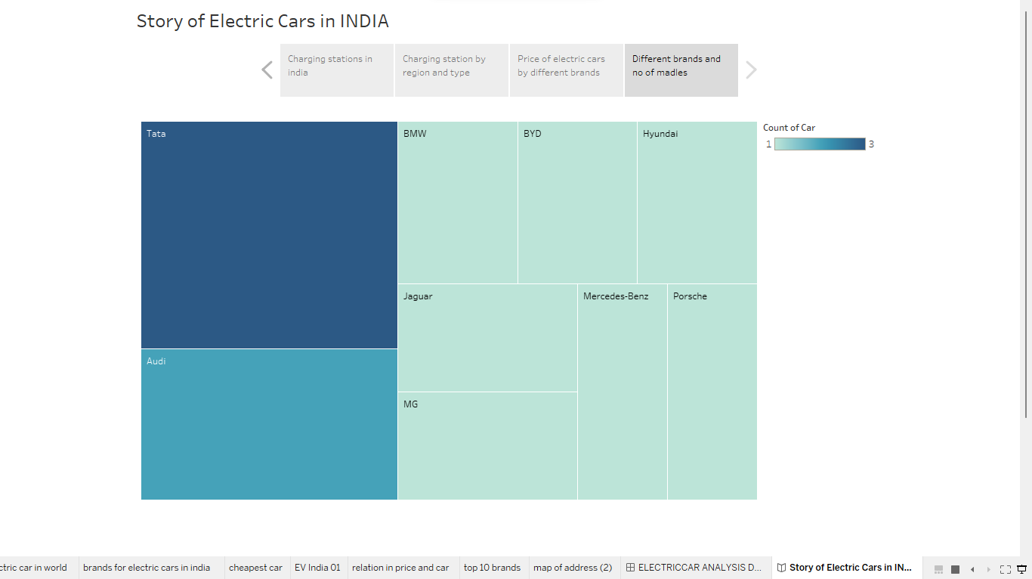

Milestone 8:

Upload in tableau public server.

Go to dashboard or story click the share option and publish it.

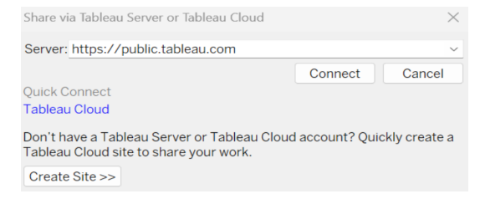

After this we need to enter the email ID and password to login.

Then we can see this page where we have published.

We need to create a web page:

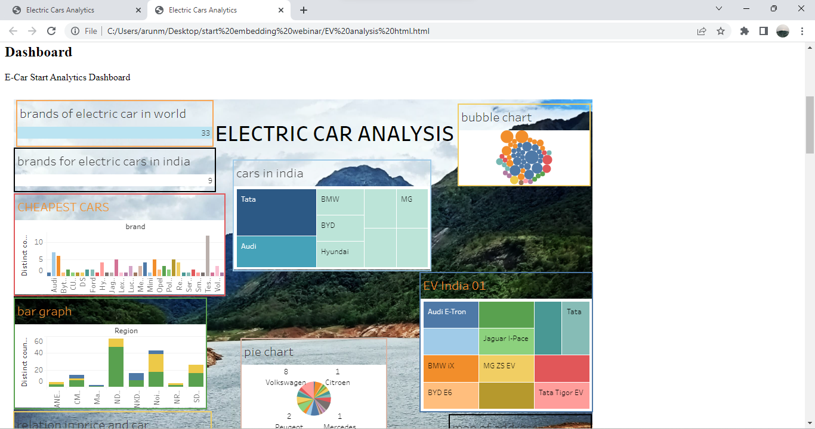

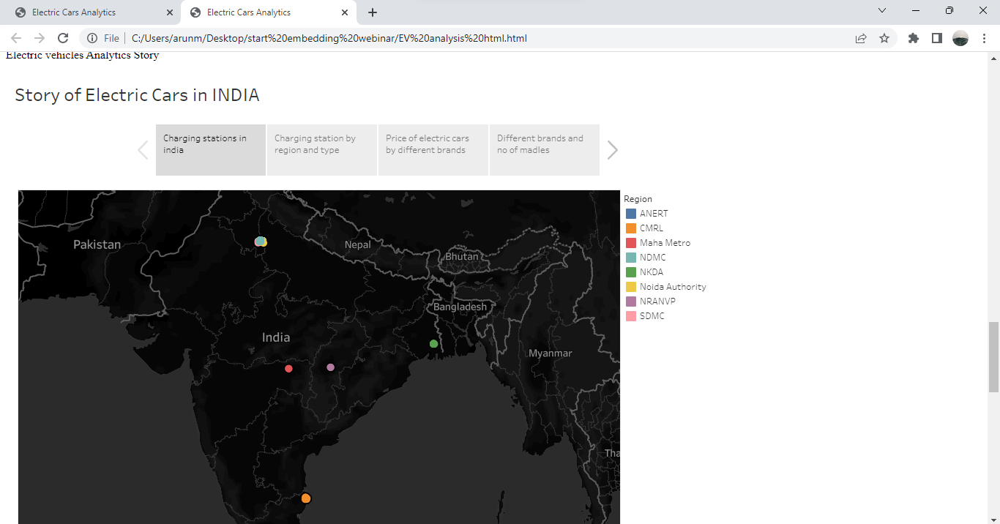

**Milestone 9: Project Demonstration & Documentation**

Below mentioned deliverables to be submitted along with other deliverables.

**Activity 1: - Record explanation Video for project end to end solution.**

**Activity 2: - Project Documentation-Step by step project development**

**procedure**