**Rayat Shikshan Sansthan’s**

**C. D. JAIN COLLEGE OF COMMERCE, SHRIRAMPUR**



A project Report On

**“INFINITY SERVICES”**

Submitted To



**University of Pune**

**In Partial Fulfilment of the Requirement Of**

**BBA (CA) – III**

*(Bachelor of Business Administration in Computer Application)*

Submitted By

**Mr. GOHIL KUSHAL Mr. AANAND VARUN**

Under Guidance Of

**Mr. Lande R.D Sir**

During Academic Year: **2021-22**

**RAYAT SHIKSHAN SANSTHAN ’S**

**C. D. JAIN COLLEGE OF COMMERCE, SHRIRAPUR**



**CERTIFICATE**

**(Department Of Computer Application)**

This is certify that project entitled **“ INFINITY SERVICES ”** submitted by **Mr. Gohil Kushal Harish & Mr. Aanand Varun Indrajit** student of **BBA(CA) - III ( Bachelor of Business Administration And Computer Application)** had satisfactorily completed the project during the academic year 2021-22 .

Date:

**Project Guide: Head of Department**

Mr. Lande R.D. Sir Mr. Chandratre Y. V.

**Internal Examiner External Examiner**

**Acknowledgement**

**We are happy to present the project** “INFINITY SERVICES”

How much the statement this project is the result of our hard work is true, the support from all of our guide **Mr. Lande Sir** along with other respective teachers is worthy as too!

We, throughout this project get many bugs, but as motivated by **Mr. Lande Sir** about the project management & debugging of the bugs, we tried overcame them all.

Apart from all, we would glad to make acknowledgement towards the supportive teachers, non-teaching personnel, and our classmate to keep a **creative** and “**bounce back”** environment for us.

* **Kushal Gohil & Varun Aanand**

**DECLARATION**

We , **Mr. Gohil Kushal** and **Mr. Aanand Varun** student of BBA (CA)-III,C D Jain College of Commerce, Shrirampur declare that the project entitled **“infinity service”** have been completed successfully & This project is submitted towards the partial fulfilment of the requirement Of the degree of BBA(CA). This project is not submitted for any other degree, Diploma or other similar title or prize in any other university.

**Place: Shrirampur**

**Date: / /2022**

**Name of student :** Aanand Varun Indrajit

**Signature**

**Name of student :** Gohil Kushal Harish

**Signature**

**INDEX**

|  |  |  |
| --- | --- | --- |
| **Sr. No** | **Index Name** | **Page No** |
| 1 | Introduction :   * Motivation * Problem Statement * Purpose/objective and goals * Project Scope & limitations | 06-08 |
| 2 | System Analysis :   * Existing Systems * Scope & limitation of Existing System * Project Perspective , features * Requirement Analysis | 09-13 |
| 3 | Implementation Details   * Software/Hardware Specifications | 14 |
| 4 | System Design :   * Design Constraints [ERD DFDs & Data Dictionary * System Model : UML Diagrams * User Interfaces | 15-38 |
| 5 | Output & Reports Testing   * Test Plan , Black Box Testing or data validation test cases , White Box Testing or Functional validation test cases and results | 39-42 |
| 6 | Conclusion and Recommendations | 43 |
| 7 | Future Scope | 44 |
| 8 | Bibliography and References | 45 |

**INTRODUCTION**

Welcome today infinity where we are to serve you the most prominent professional services, these services are of your daily routine life.

Assume you have an important meeting with your boss in one hour, and you go to the bathroom to be fresh and what?

You got leakage in your tap, ohh! Now what to do this will be a great made as the meeting is very important if you don't know your boss will be angry over you and you can also lose your job but don't worry when you have Infinity services.

In this situation, you have just to go to the Infinity services portal and ask for the plumbing service and within a few minutes our service provider come to your location and check the situation and solve your problem so now you can go to the office within the time your boss will not angry you and make it to you so always remember what I will success person every person has Infinity service experience!!

Want to know more about Infinity services, so now go further in this documentation.

I must say you will have a very get fine with the knowledge about the services and how the Infinity services system work.

Ok, then it was just an introduction about the project system you can now plan over others' benefits and details about the project.

**COMPANY PROFILE**

Here is our company profile in which will get to know about how our company structure follows and what are the objectives on which we working,

History of the company - In the beginning, we were a service-based company and we used to develop software for small businesses but we got many queries from small service providers that we are running out of business and not able to go profitable so we thought about it and decided to develop a prototype where anyone as a user can book a service they need and service provider will get the respective orders as per his business type. We registered our startup in Spain Barcelona. Established in 2021 our startup has raised 200k dollars from investors in Pre Seed round. Our motive is to bridge the gap between a service provider and a consumer help user find good service and help the service provider by providing him orders on daily basis.

**SCOPE OF SYSTEM**

Within the boundary of the project, The System aims in having the following aspects:

**SYSTEM - BOUNDARY:**

Existing system facilities and to sustain the market with a system for a particular locality as if you are from a particular location, for example, you can say you are from Mumbai then it will be easy for you to operate our system as we provide specialized our system for only a particular location of the user who logs into our system.

**SYSTEM - END-USER:**

 The end-user of our application is a general public who won a service for their efficient work just like if you are a housewife or person come from out of town to the town which is not familiar with him so he can ask us where to go for the best hotel or if you are a person who needs a plumbing service you can contact us so in this scenario you can you state that our end-user is in a very large scale. It will be very beneficial for our service company

**HOW IS THIS BUILT?**

Please make sure to glance over the documentation, to get the answer of questions like how our system is built and what are the facilities and the services our system provide also you get to know about which study is done by us to deal with this awesome service application so let's go forward

**NEED & EXISTING System**

**EXISTING SYSTEM:**

Until now if we have any miscellaneous work of our home E.g. Plumbing, Painting, etc was done by the owner of the house himself or we used to call a person to do the work but most the people are busy in their office work and tend to have less time to monitor the service provider's work time to time and to keep a watch on his progress and charges of the service provider are high sometimes and as we know most of the people can't afford that.

**NEED:**

We need to fill this gap between user and service provider. We need some kind of place where users can book any service and get good quality service and assurance that if you have booked your service from this place you don't need to worry about quality and money all that will be solved by us.

**PROPOSED SYSTEM**

FOR WHO DID THE SYSTEM DESIGNED? :

As Mentioned Already to the System – End User Before, This Is Just To Emphasize It More Clearly,

Our application mostly targets the two different criteria of society.

Explaining in detail the first one is the service finder who wants or who is in the search of professional service and the other criteria is of the professional service providers who are mostly distributed or spread over the locality in a different location.

This makes what the criteria to come into one platform and access Each Other services

To clarify this let's take an example, if you are a car manufacturer and you are factory is on strike now what you will do you go to our portal and access the service of skilled professional workers it just like outsourcing

HOW THIS SYSTEM WORKS? :

This application works on three categories of users:

* The user who want the service will come to us and request for service after the acceptance from the service provider he can access the service within a few minutes
* The service provider gets the facility of platform for his service he can manage his profile and accept this request from the service consumer he has an opportunity to make or to build communication for the consumer with chat or direct contact.
* And admin panel will help the admin to optimize the application and also give them information about the services provided by the service provider and the user access to which type of case services on particular date or time and how much the service provider recharge if it is not in the objective defined by the admin he can alter it by its own

**FEASIBILITY STUDY**

• TECHNICAL FEASIBILITY:

The technical aspect is the most important part of the system development.

As the system is web-based. HTML, CSS, JavaScript is used to develop the interface and

PHP for the functions with the database. For the database aspect, MySQL will be

Used which will link the system interface with the data storage.

The exposure gained in the ‘business system development’ subject through

The course curriculum has given us the credibility to develop the program as specified. Moreover, online tutorials on system development are also vastly available on

The internet which will help us in the development stage.

**•** ECONOMICAL FEASIBILITY:

Basic analysis has been done in investigating the economical feasibilities

of the project. the financial analysis demonstrates that the new system will

Reveal positive economic feasibility. In terms of software design and license,

It can be found the open-source on the internet thus, the owner does not need to

Purchase the software from the vendor. The new system will be requiring

Extra cost on the hardware implementation part. In terms of special staff training,

The new system will not need any extra cost. Normally, the newly developed system will

Need special training for the user, however in this case the system handling part is very easy and eliminate the need for training. Besides, a friendly interface

Makes staff work with less stress.

**•** OPERATIONAL FEASIBILITY:

The risk of familiarity with the application is medium because the users/staff

Never used to computerized system. thus, there is a need for a brief introduction

on handing the system to implement the system. Besides, as most of

The staffs in the store are not it literate.

**FACT FINDING TECHNIQUE**

QUESTIONARIES:

We have to design a questionnaire and provided them to the general public asking questions related to problems in their routine life when they get stuck into a situation like where they want the service by plumbing cleaner and any other services.

Based on this question we design the objective and the boundary of the system

GROUND-LEVEL ANALYSIS:

The application also target the social criteria of service provider depending upon another one service provider that means to say a business to business communication, for that we provide a ground analysis in our own company when the company won Outsourcing services for our IT infrastructure we go to the IT service providers this makes us acknowledge about how dependency work in a business level

**SOFTWARE & HARDWARE REQUIREMENTS**

As This Is a Web Based Application,

End-User System Specification Does Not Affect But Still,

**|| HARDWARE REQUIREMENT ||**

**• Processor**

Intel Pentium +

[Prefer At Least Quad Core to Support Network Connectivity]

**• RAM**

2 GB +

[8 GB Preferred For Large Scaled Business]

**• Hard Disk**

10 GB +

**|| SOFTWARE REQUIREMENT ||**

**• Operating System**

Windows, Mac, Linux, UNIX, Raspberry Pi, Etc

**• Front-End Tech Used**

HTML, CSS, JavaScript

**• Back-End Support**

PHP, MySQL

**ERD**

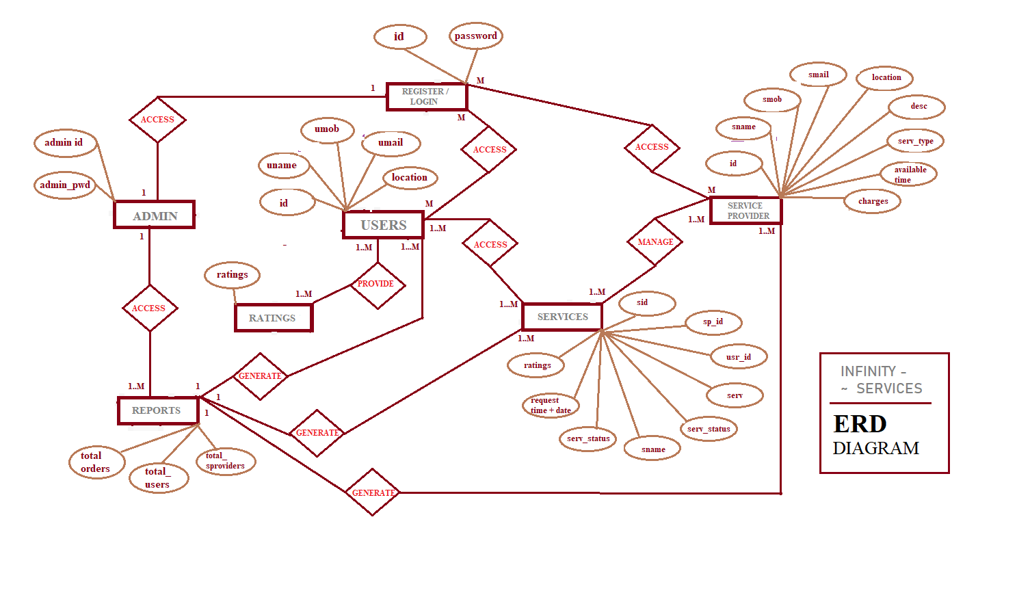

**DFD Level - 0**

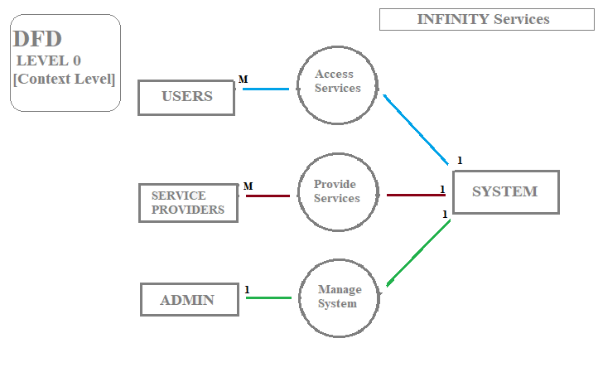

**DFD Level – 1**

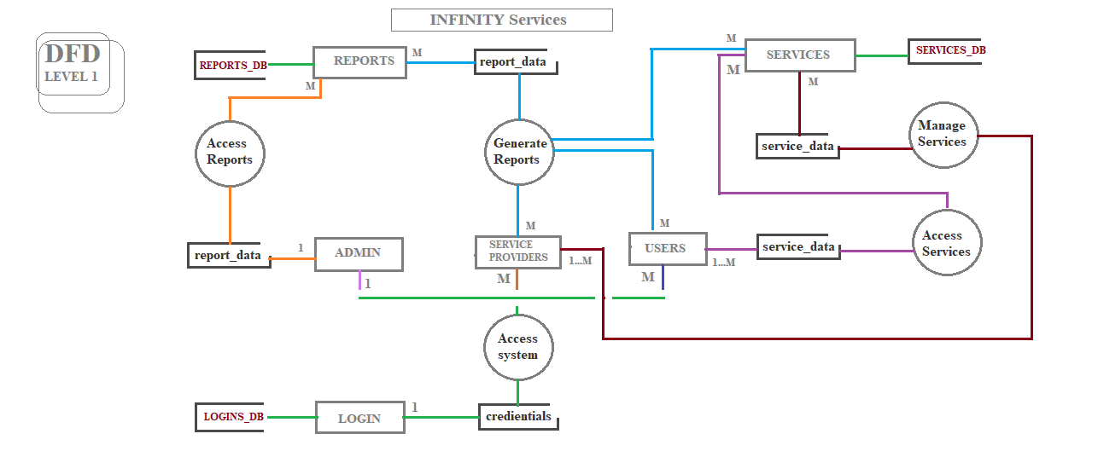

**DFD Level – 2**

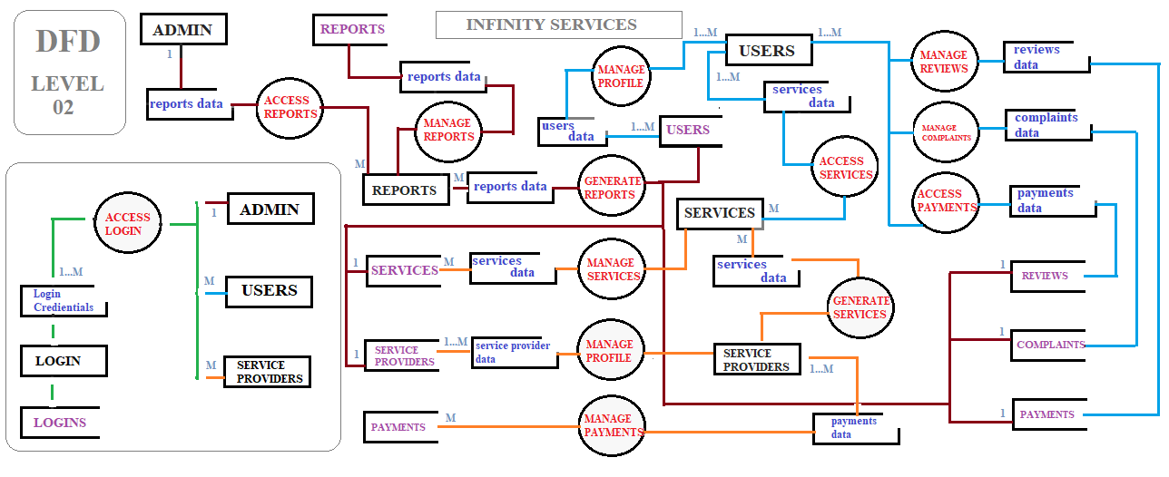

**UML Class diagram**

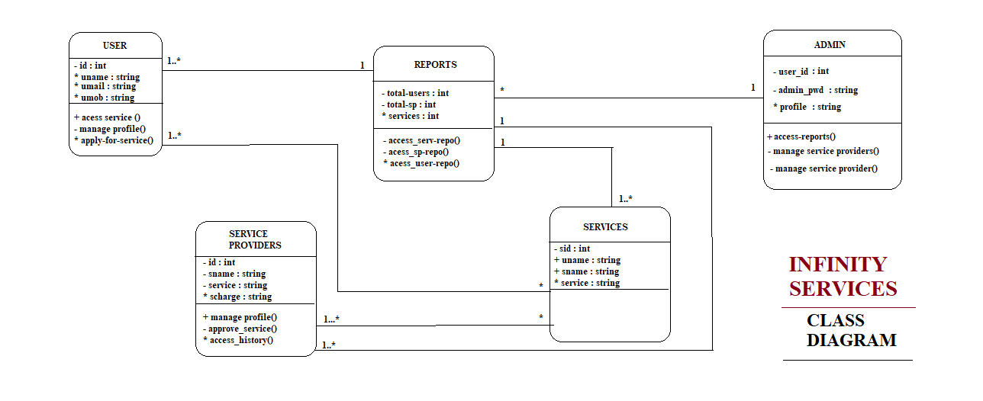

**UML object diagram**

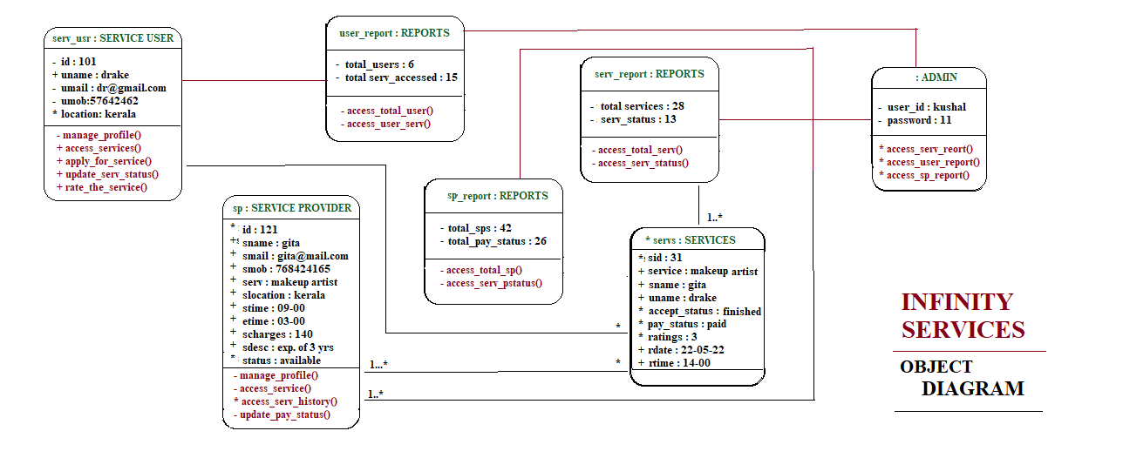

**UML Use Case diagram**

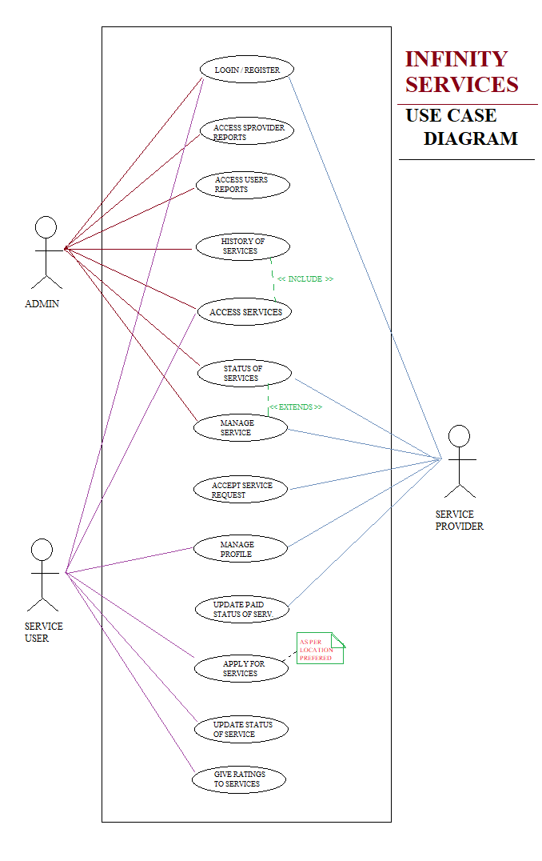

**UML Sequence diagram**

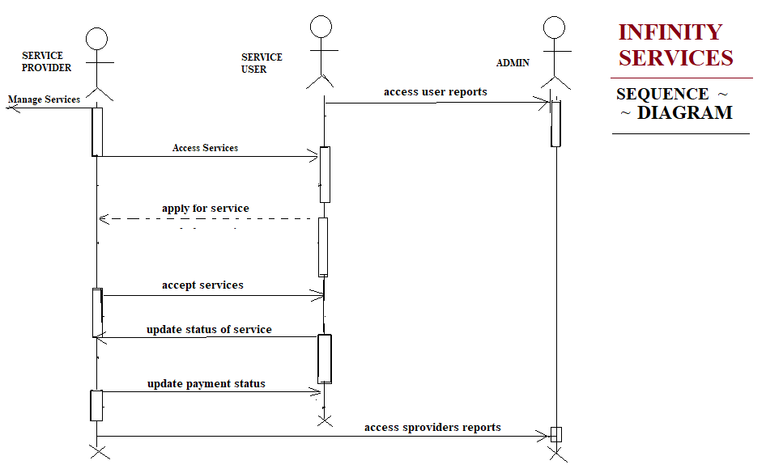

**UML activity diagram**

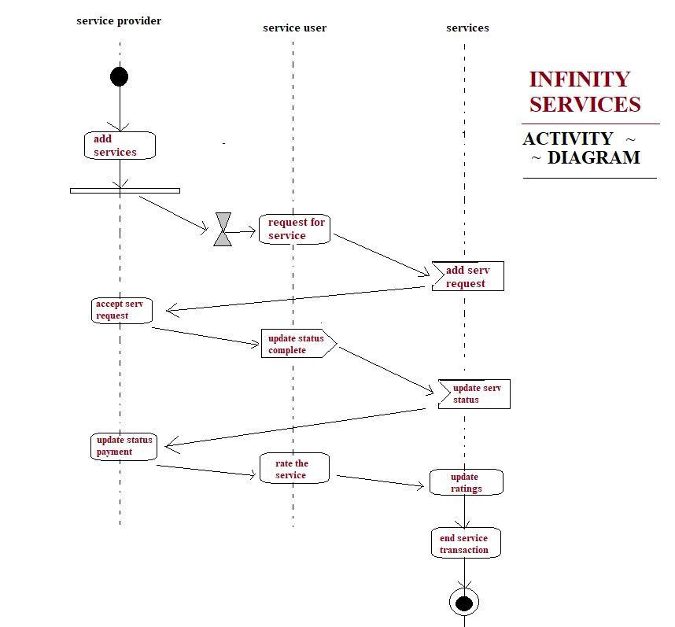

**UML STATE CHART diagram**

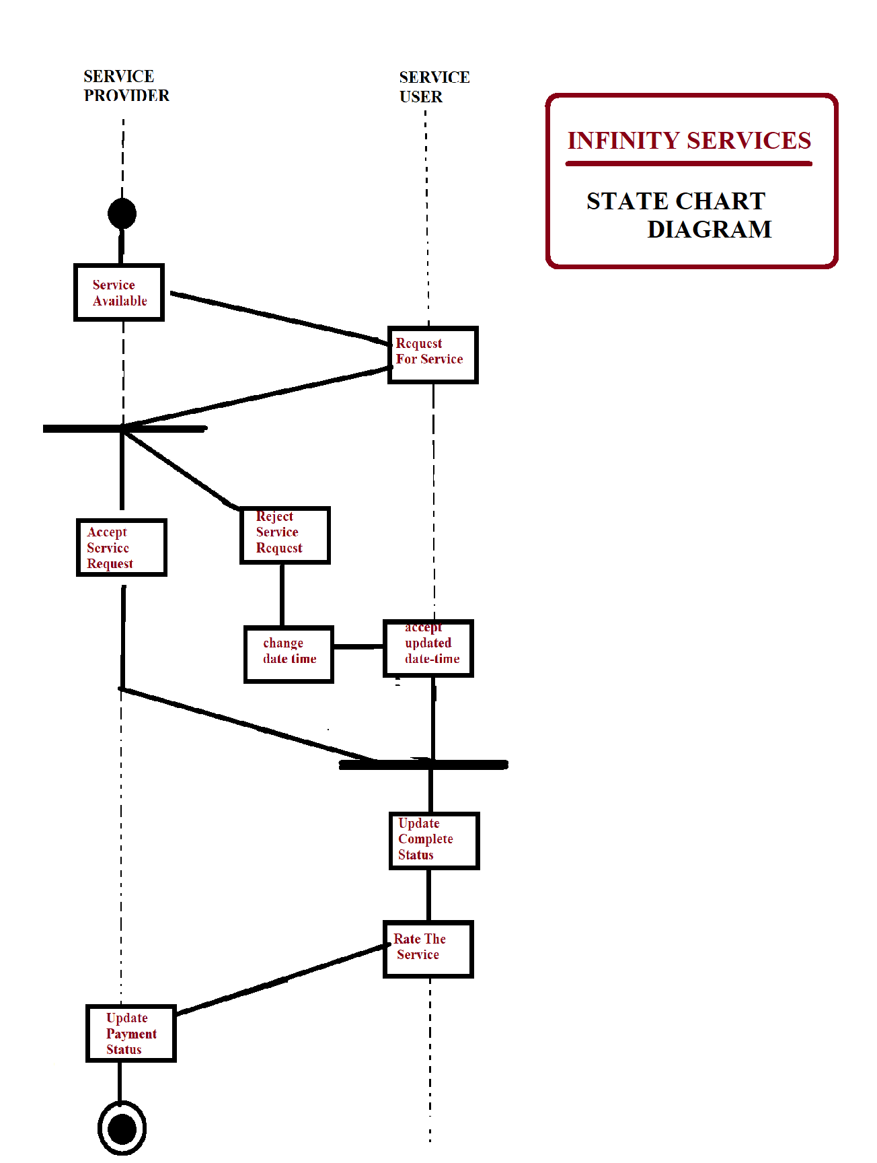

**UML COMPONENTS DIAGRAM**

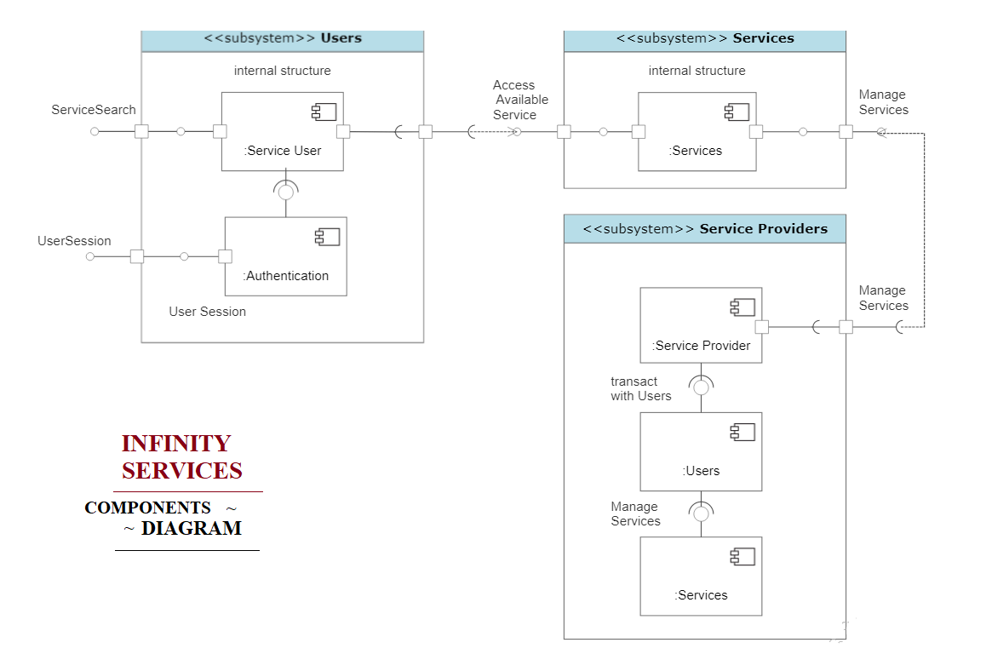

**UML COLLABORATION DIAGRAM**

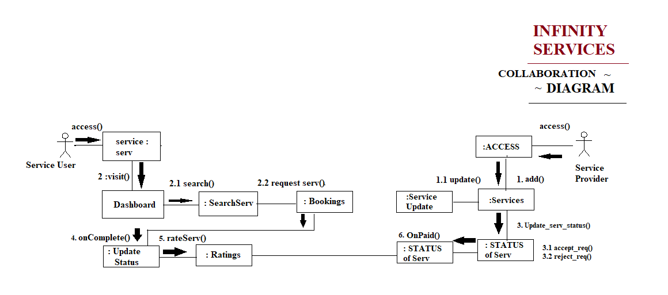

**DATA dictionary**

Login:-

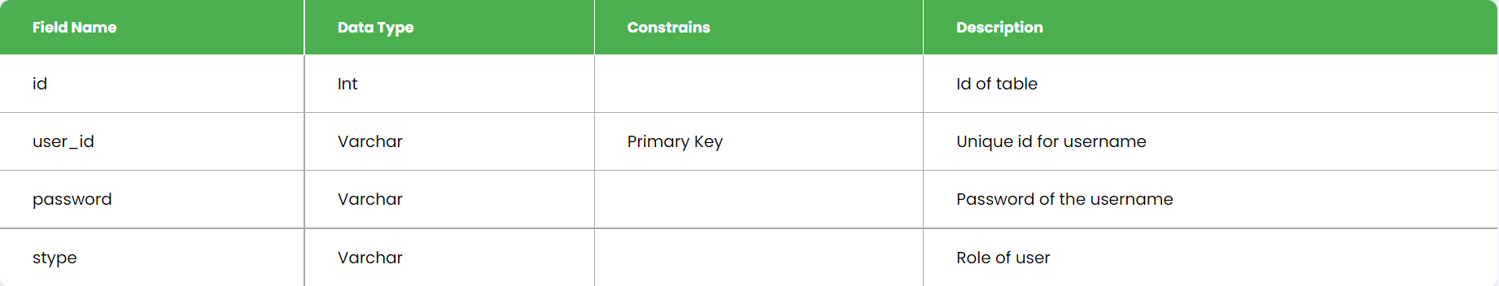

Service provider:-

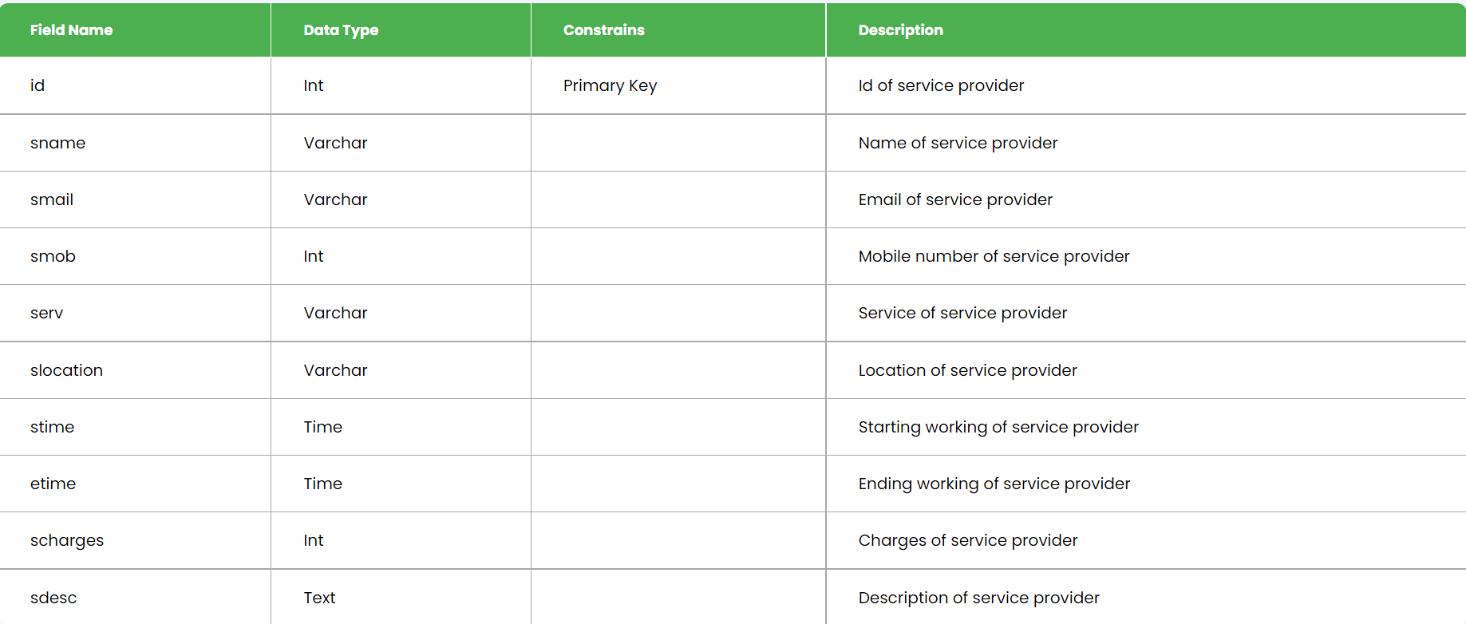

User:-

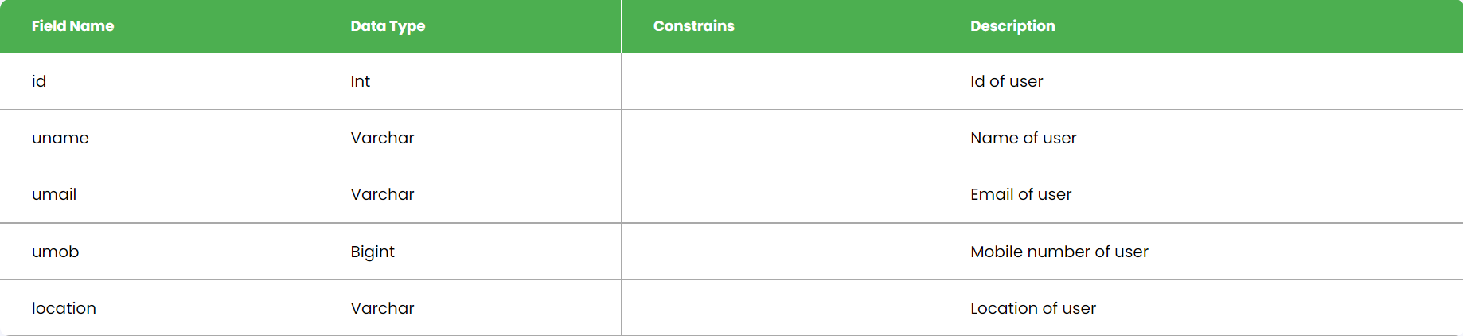

Services:-

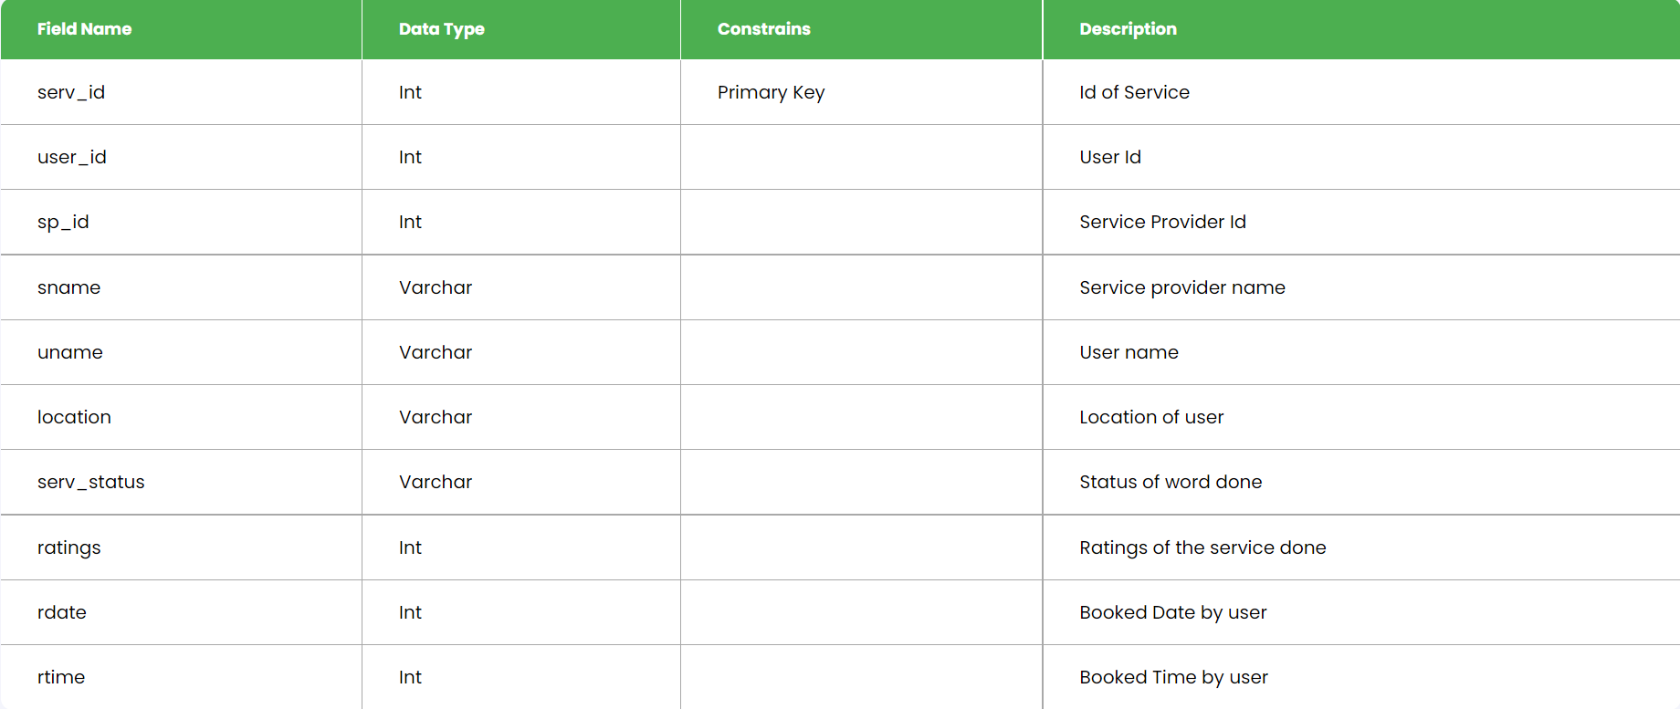

**screenshots**

Home:-

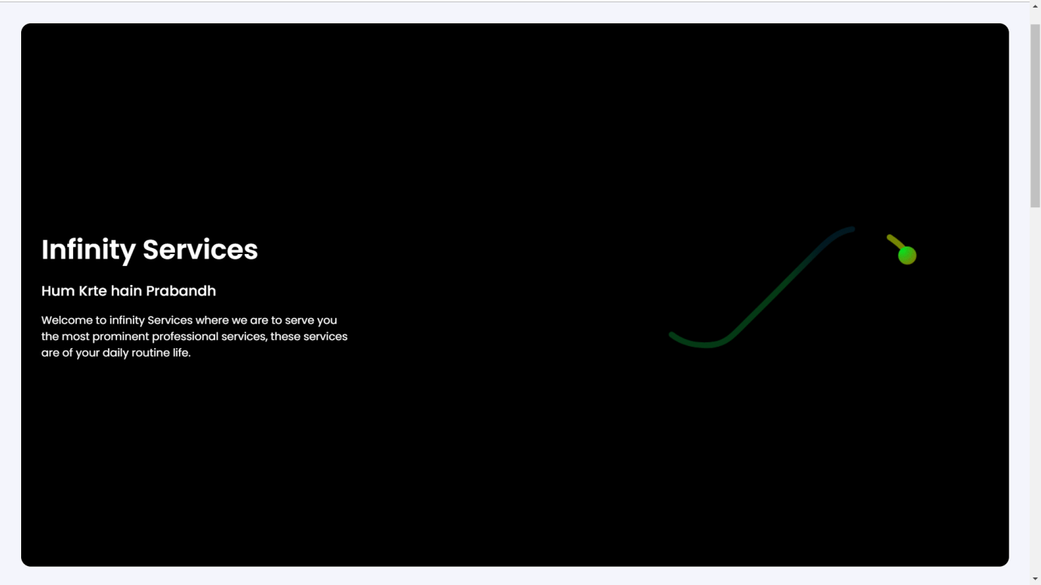

About us:-

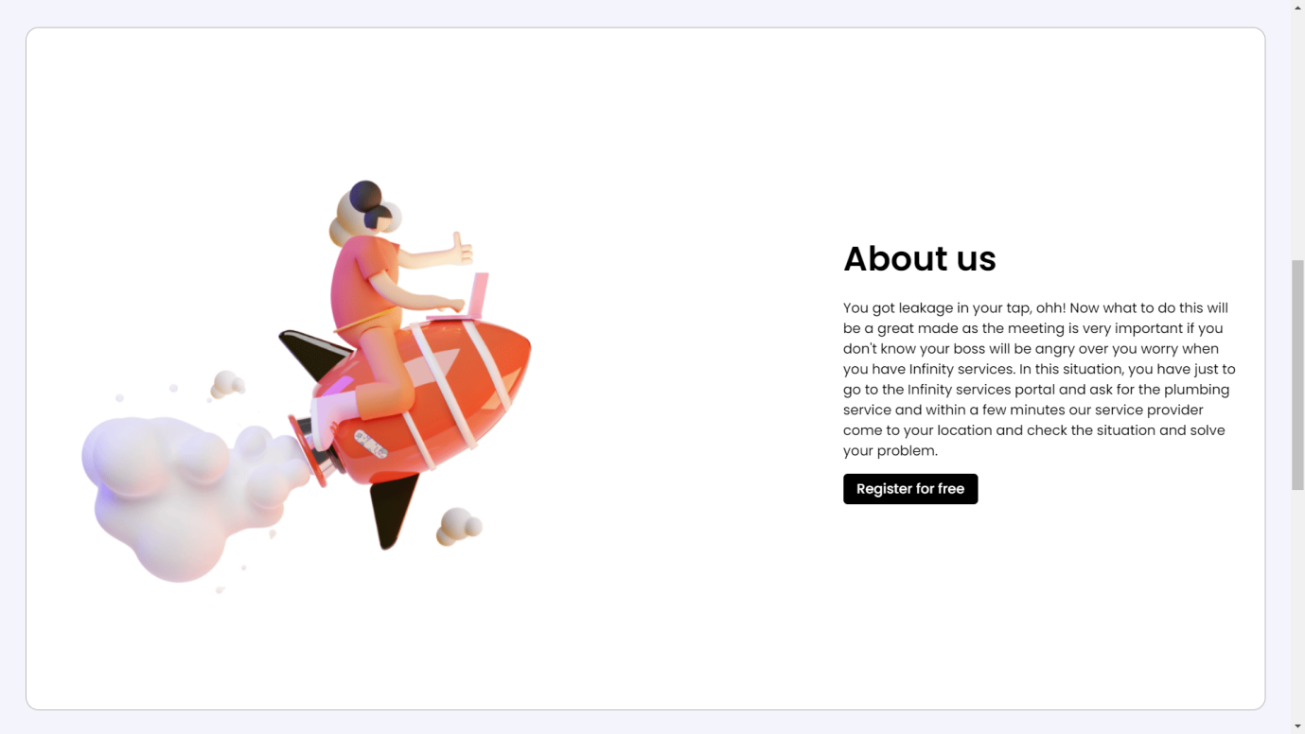

Steps to book:-

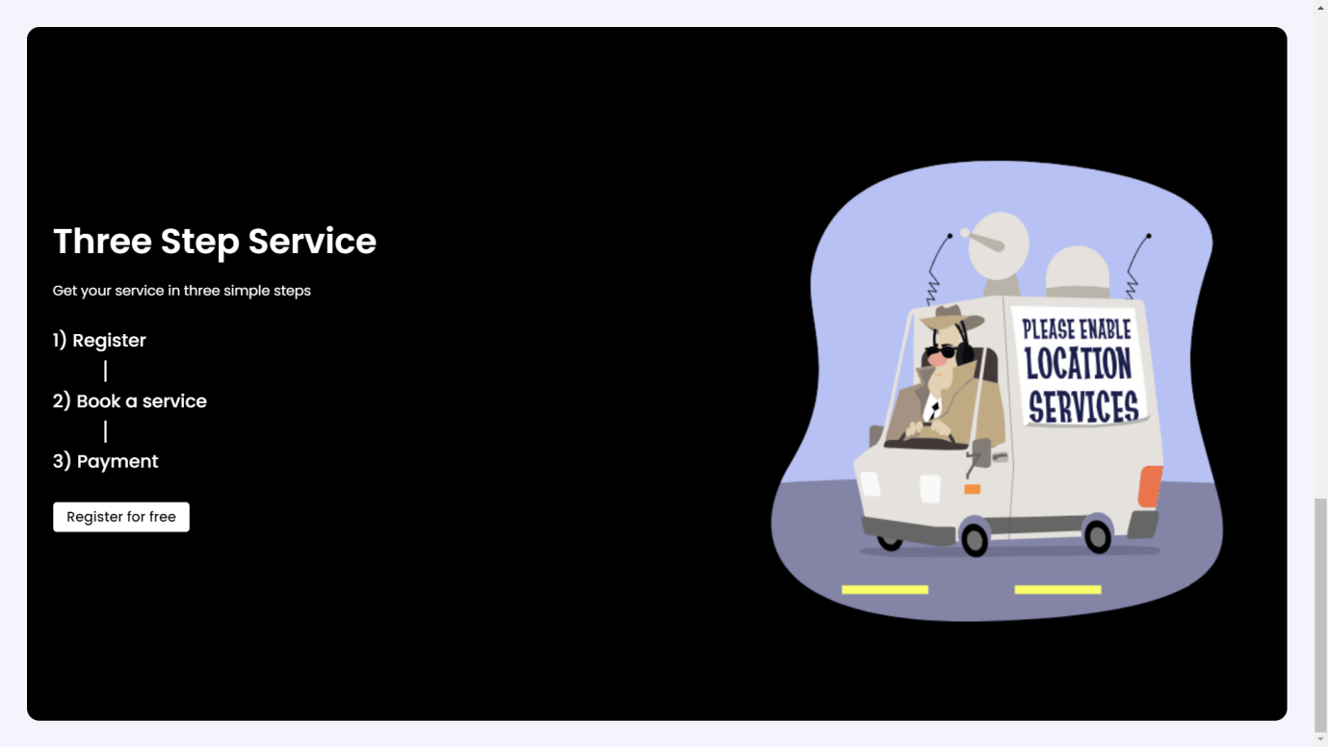

Register:-

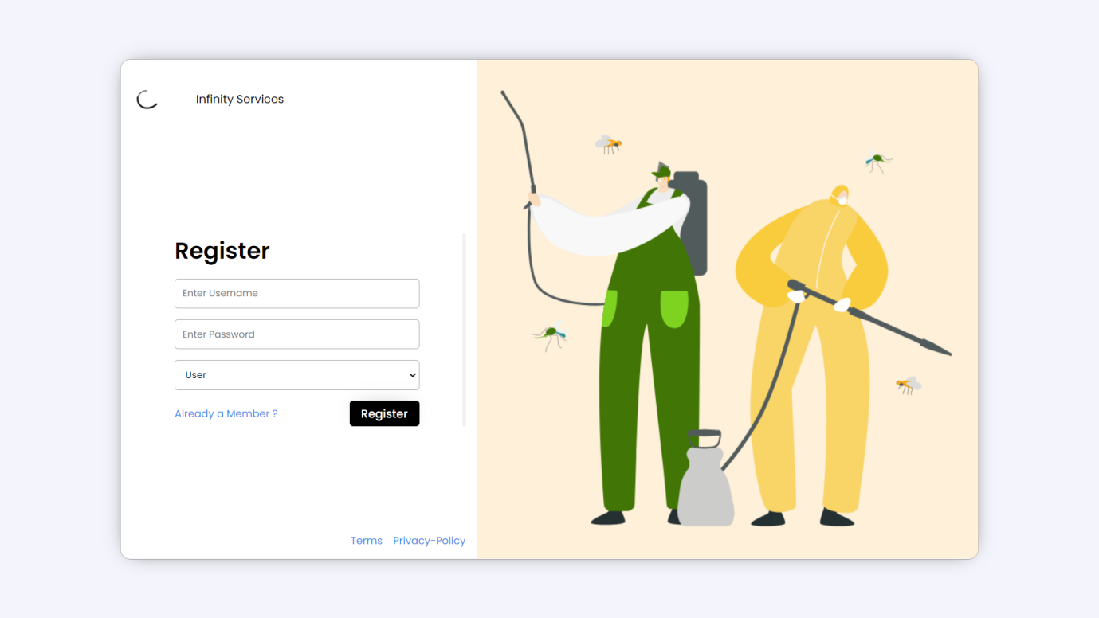

Login:-

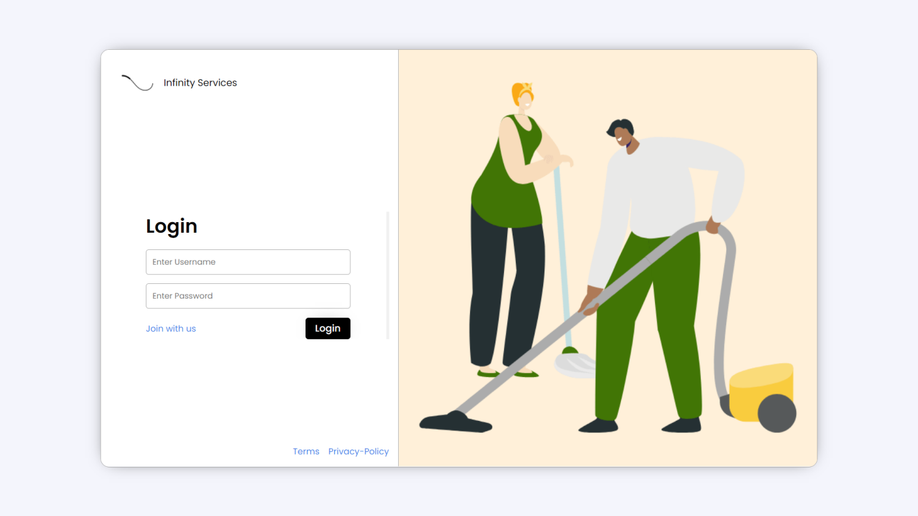

Service provider account setup:-

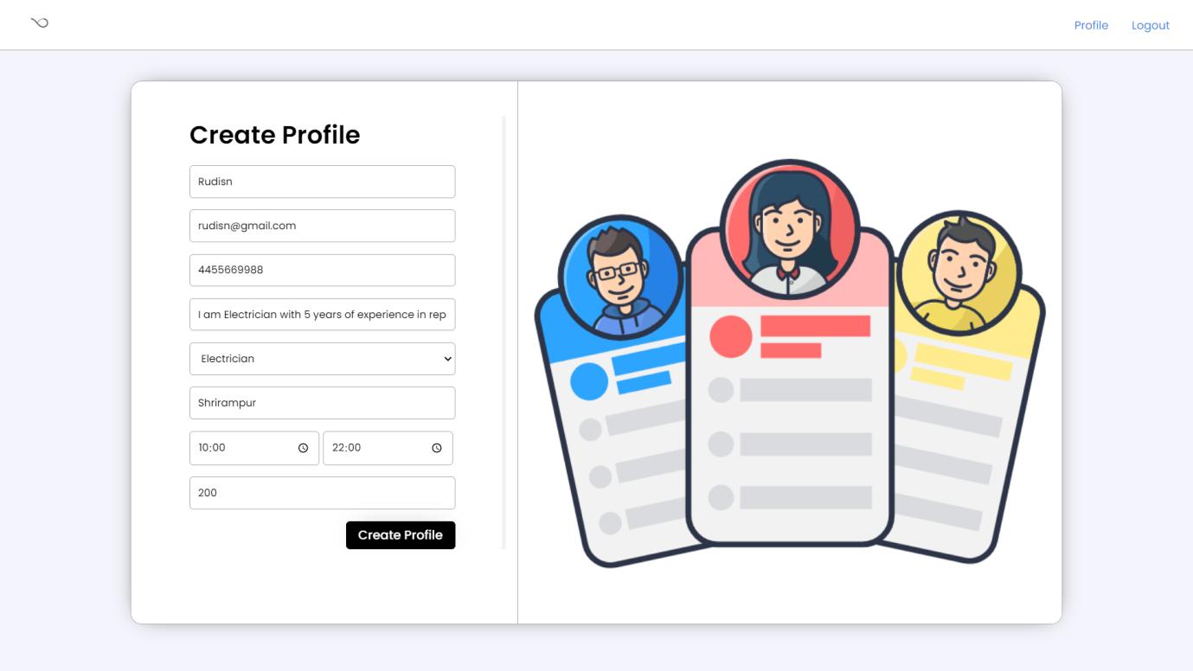

Service provider profile:-

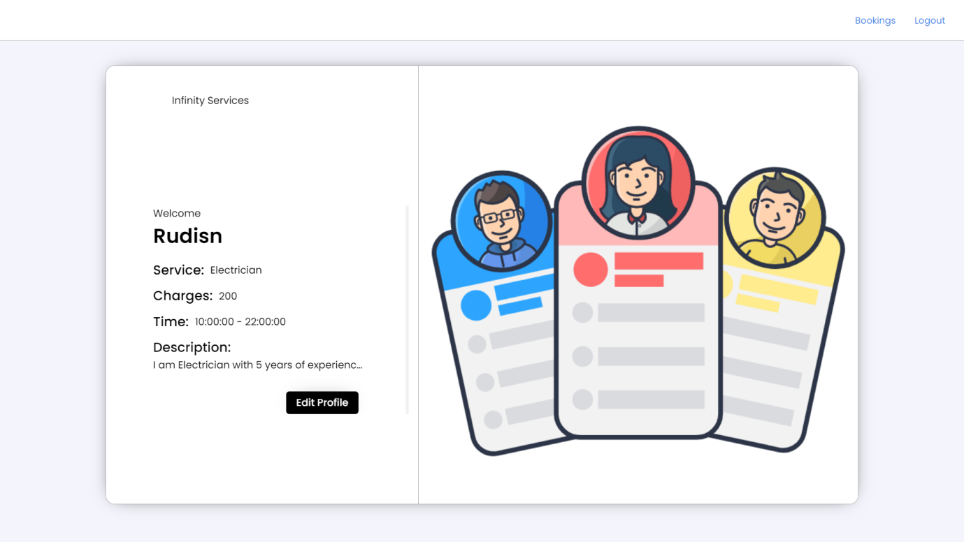

User account setup:-

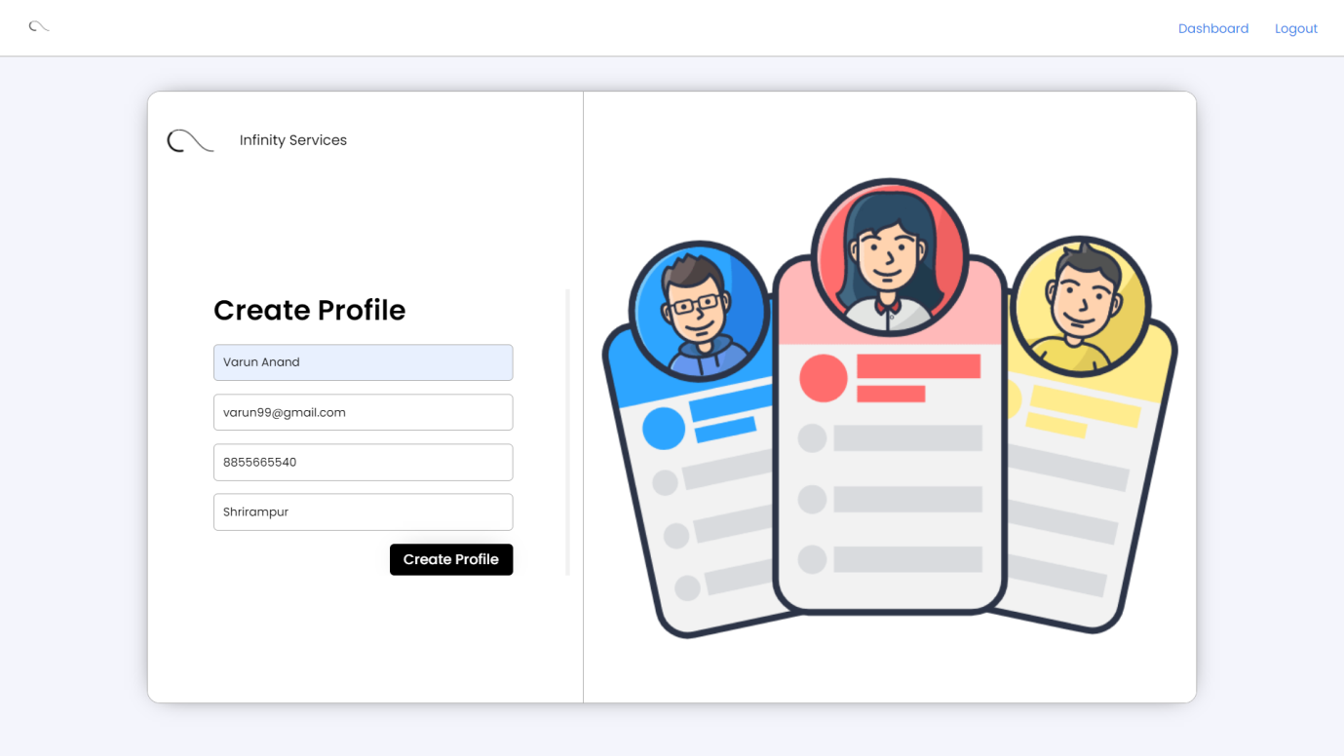

User profile:-

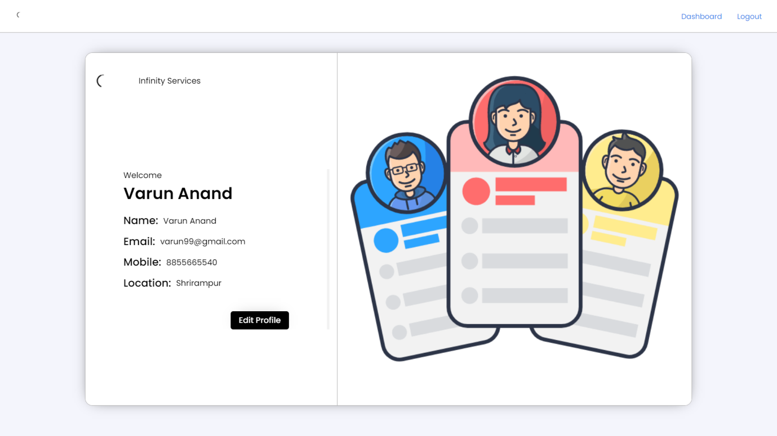

User dashboard:-

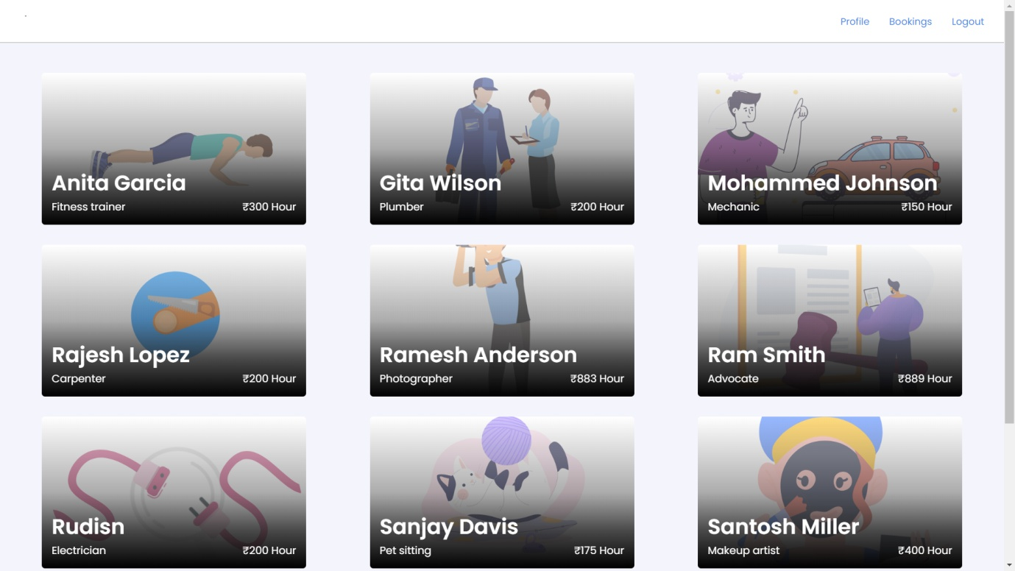

User dashboard more info:-

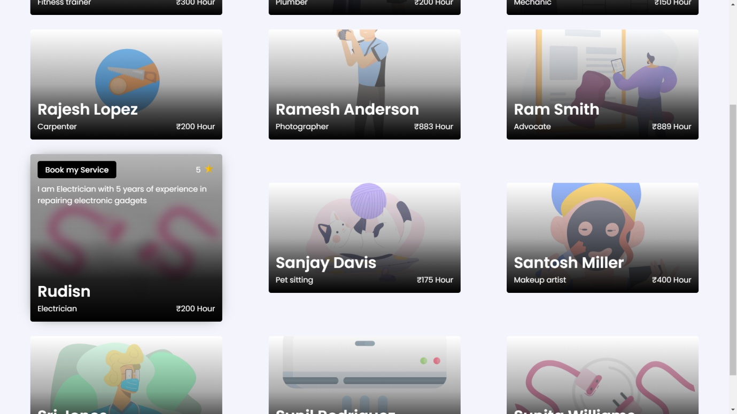

User booking a service:-

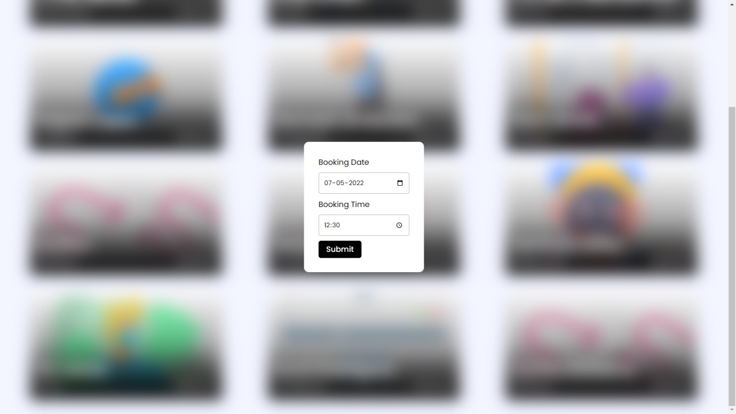

User all bookings status:-

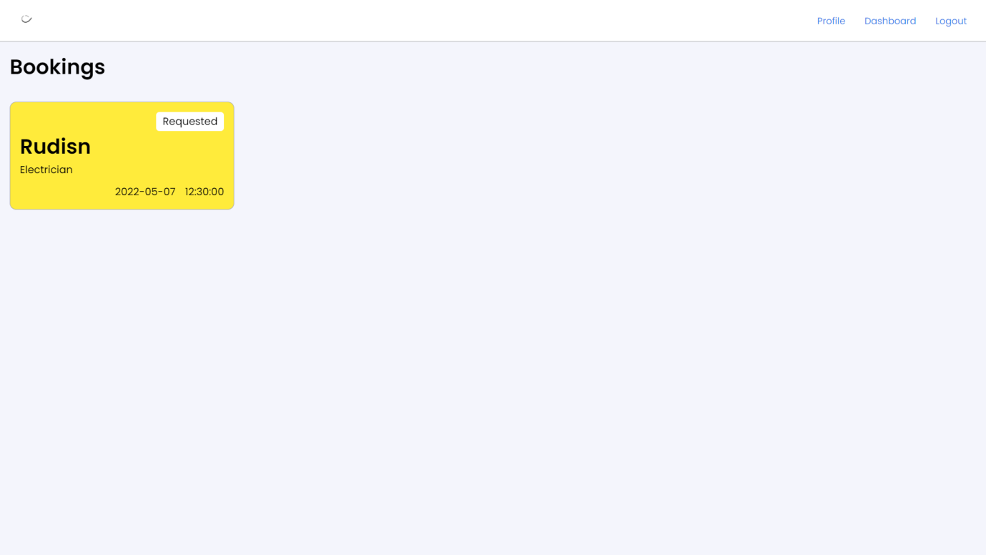

Service provider all requests:-

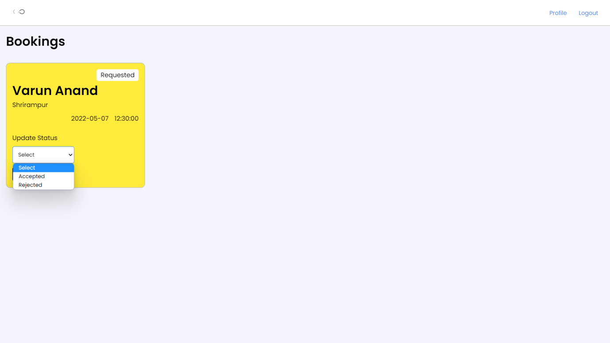

User update status of work done:-

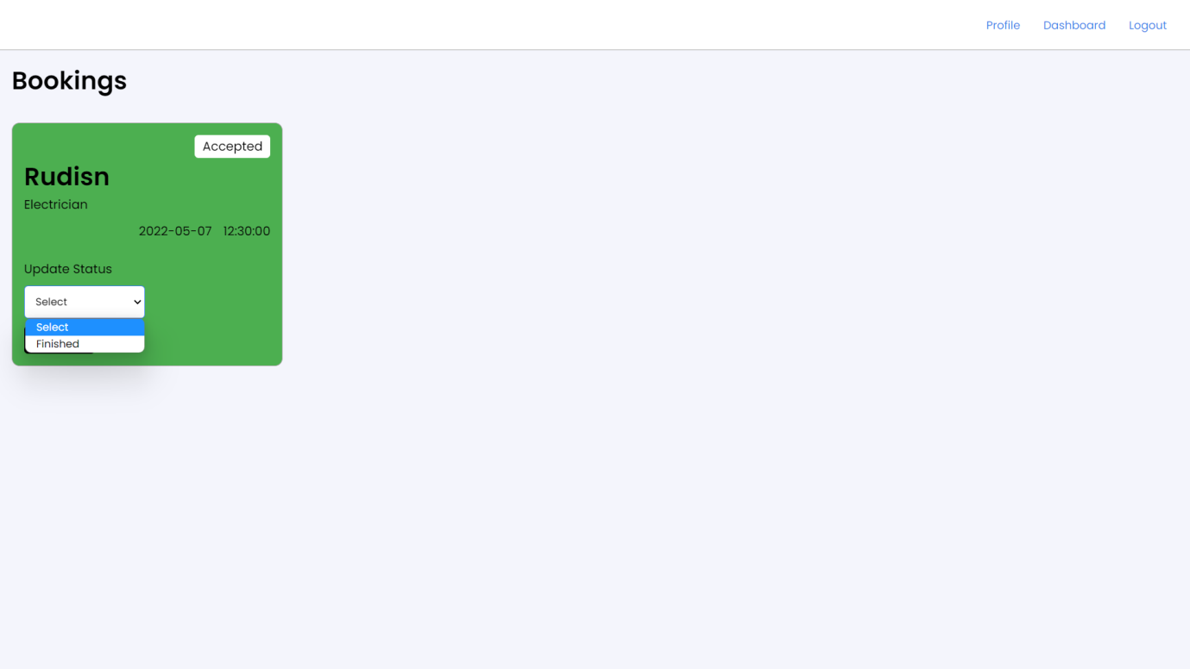

User update ratings of the service received:-

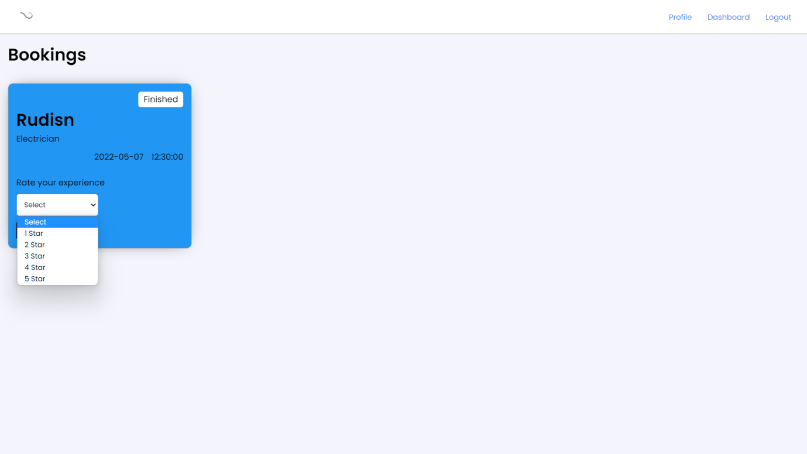

Service provider update payment status:-

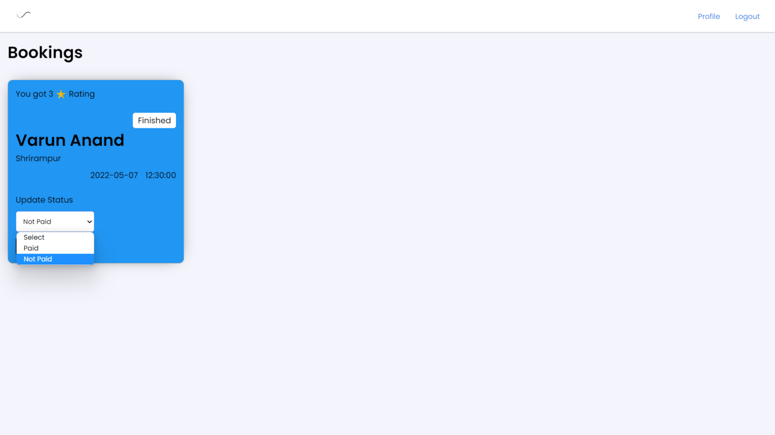

Service work finished and paid:-

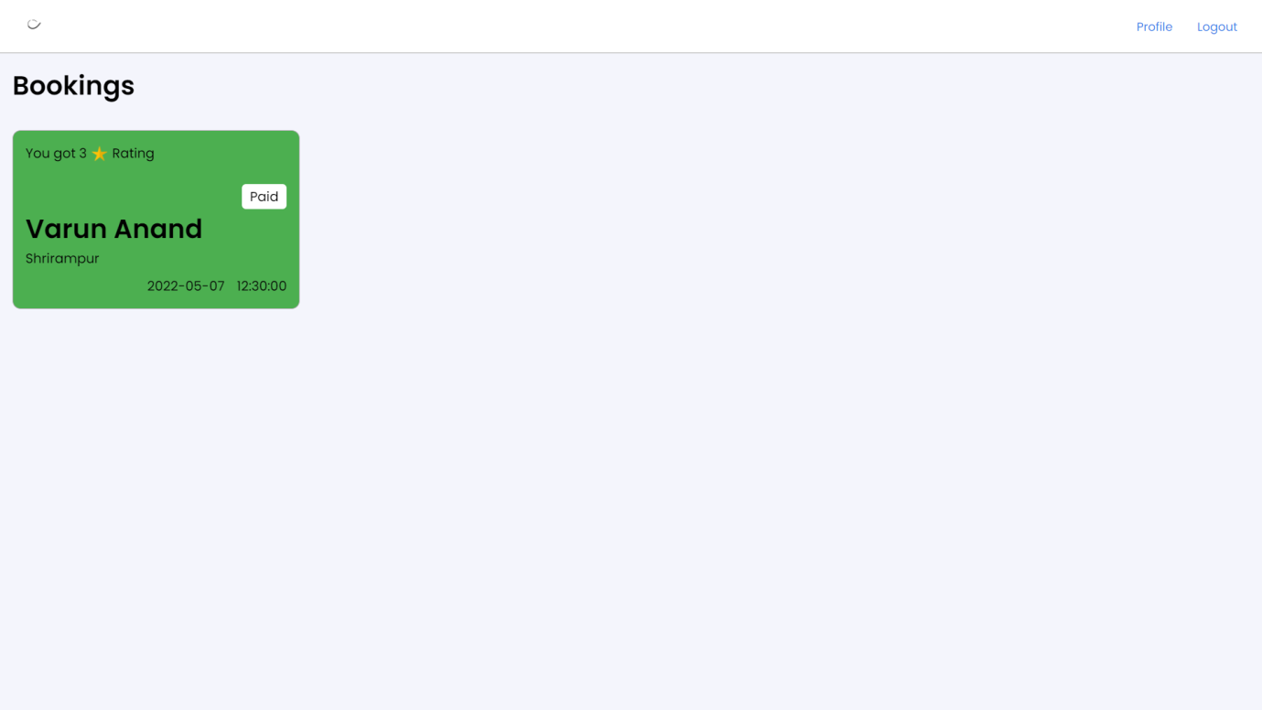

Admin dashboard:-

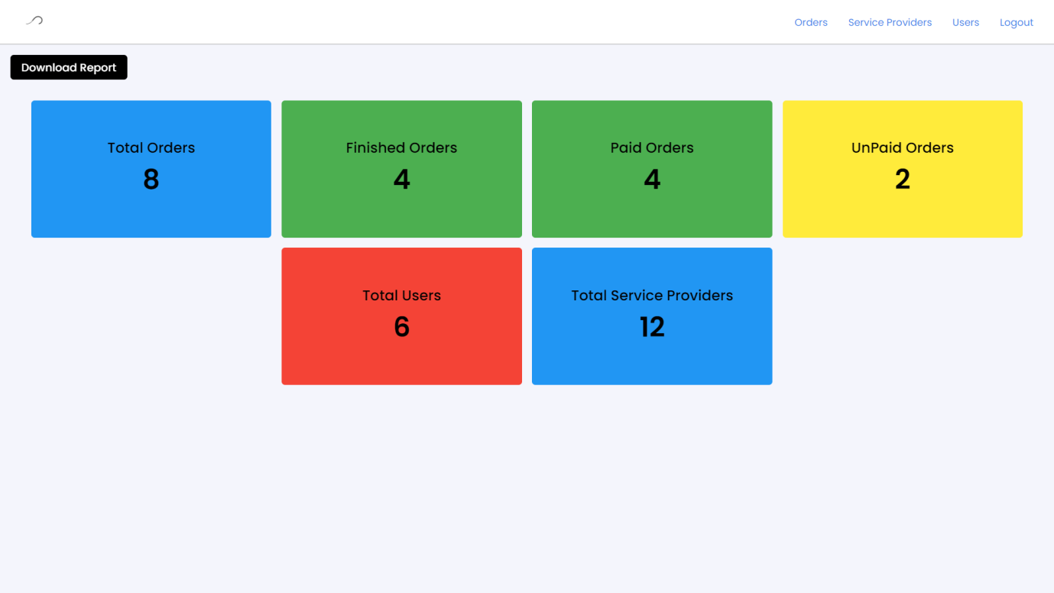

Admin total orders details:-

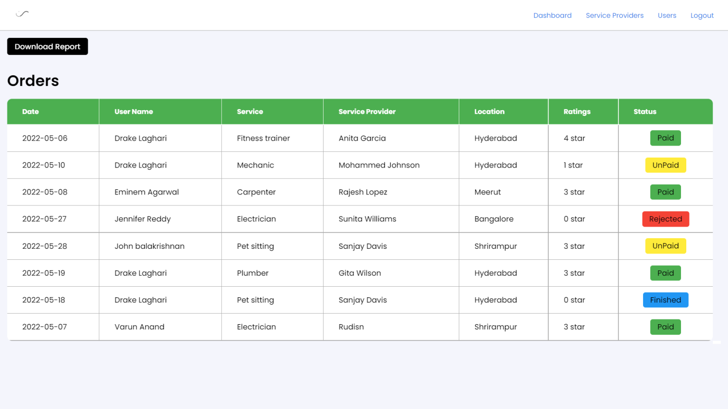

Admin total service providers:-

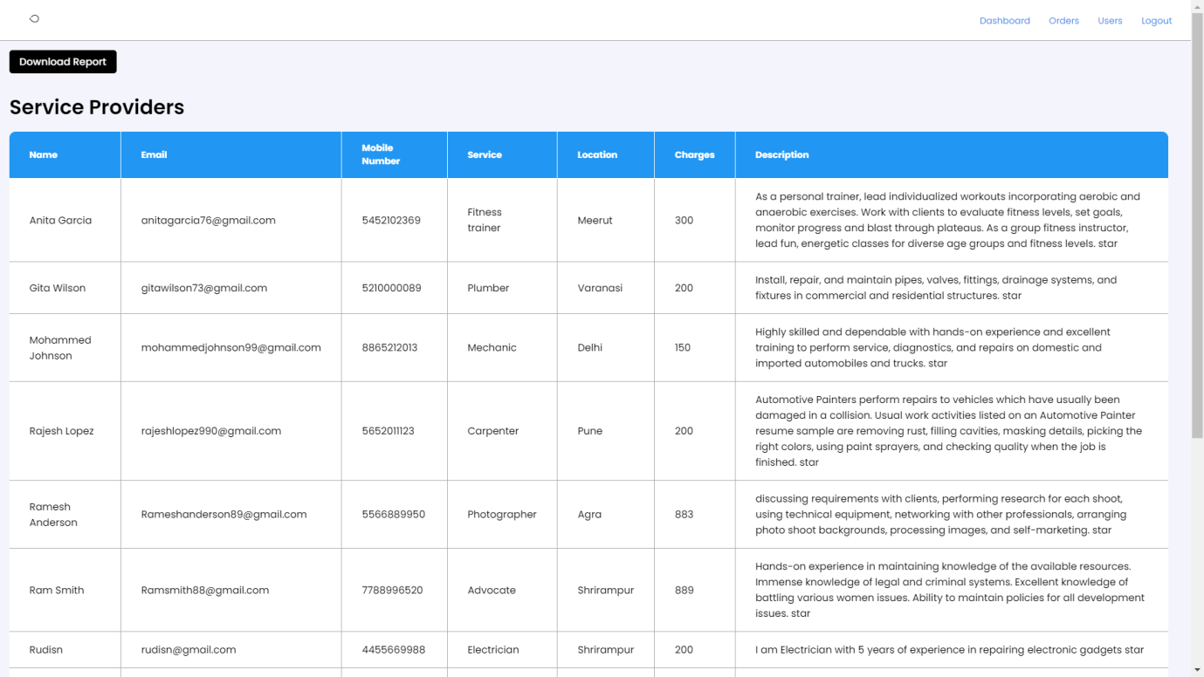

Admin total users:-

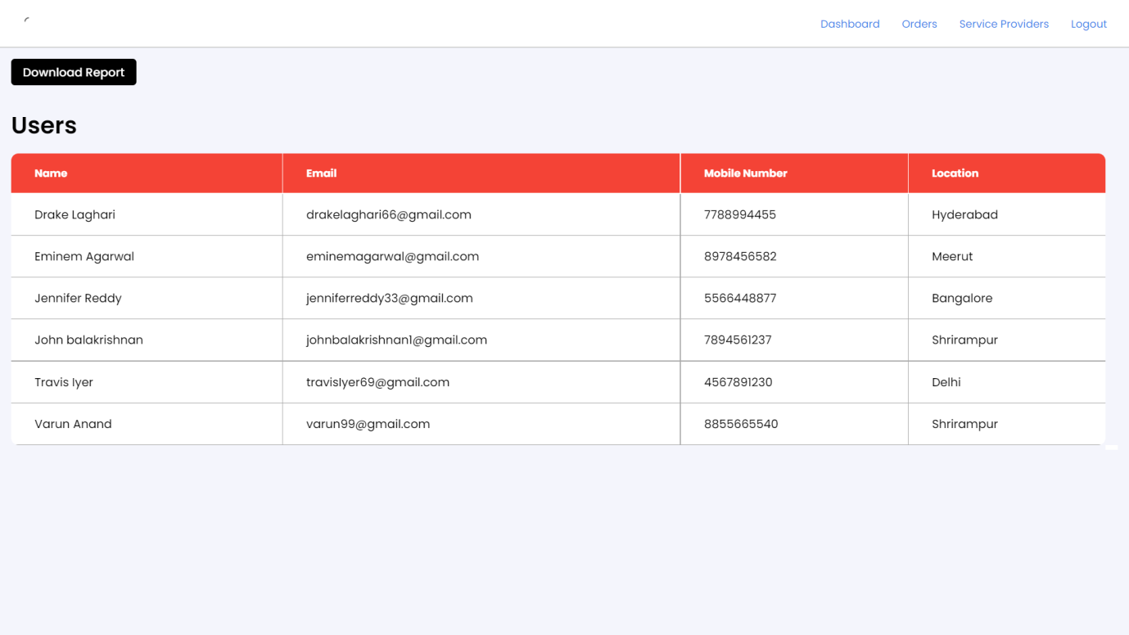

Admin dashboard exported report:-

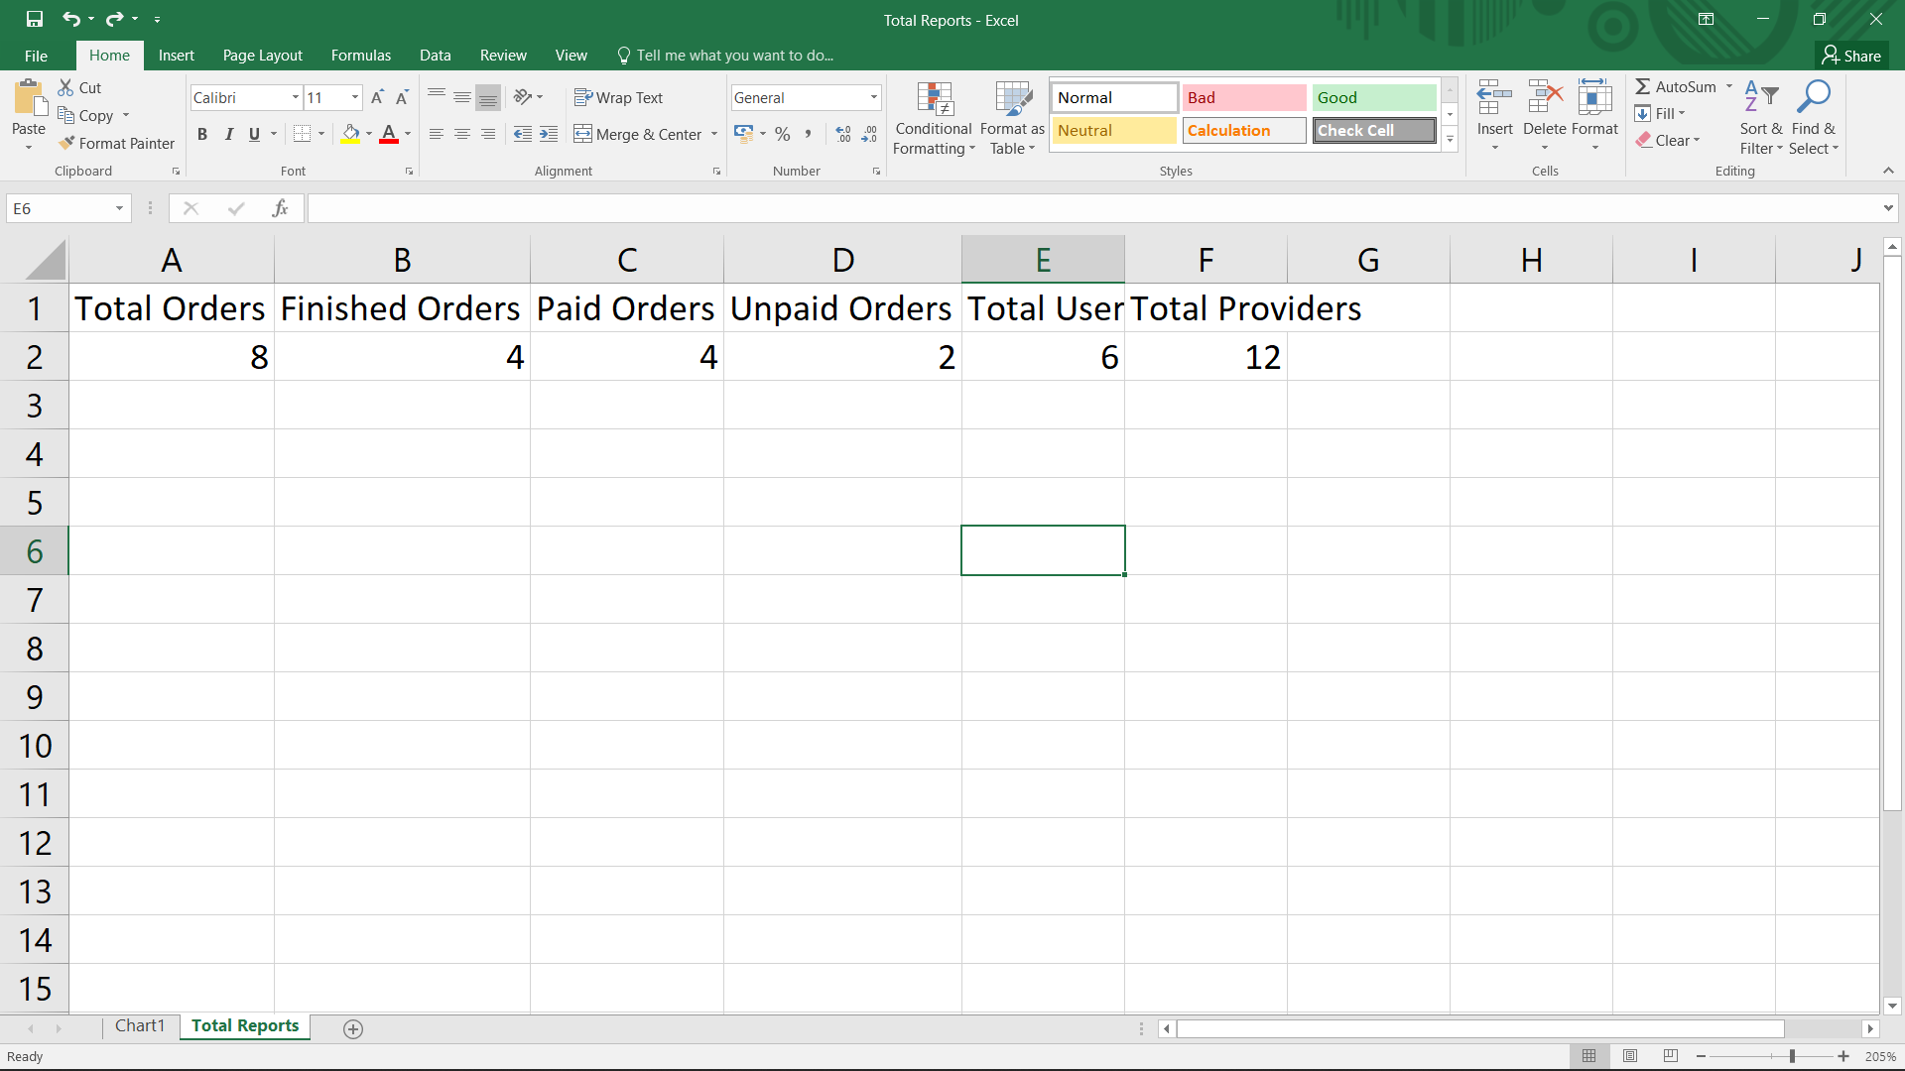

Admin orders exported report:-

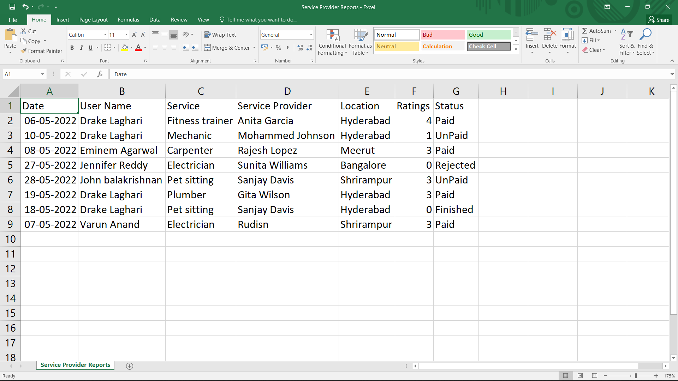

Admin total service providers exported data:-

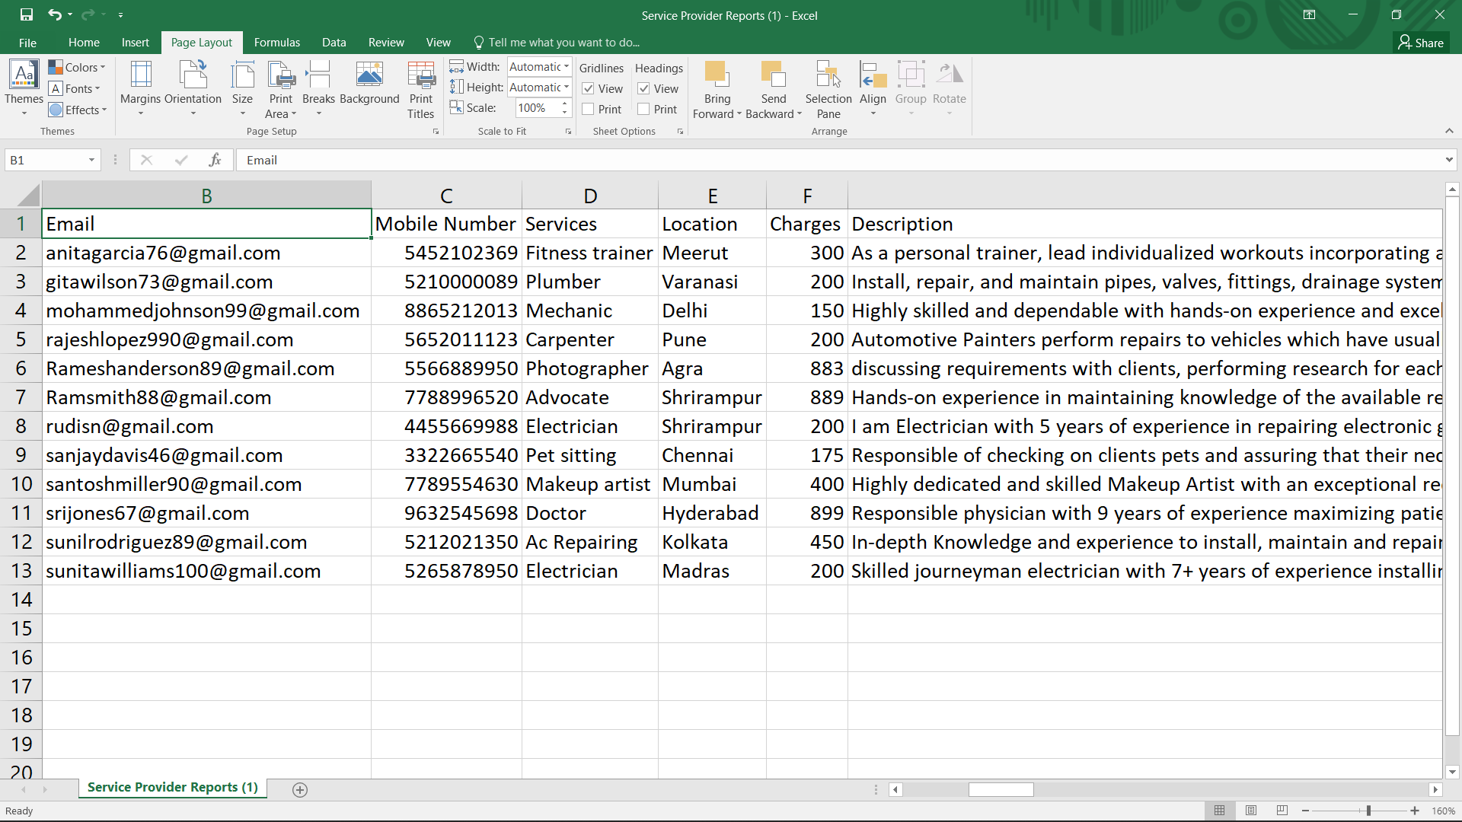

Admin total users exported data:-

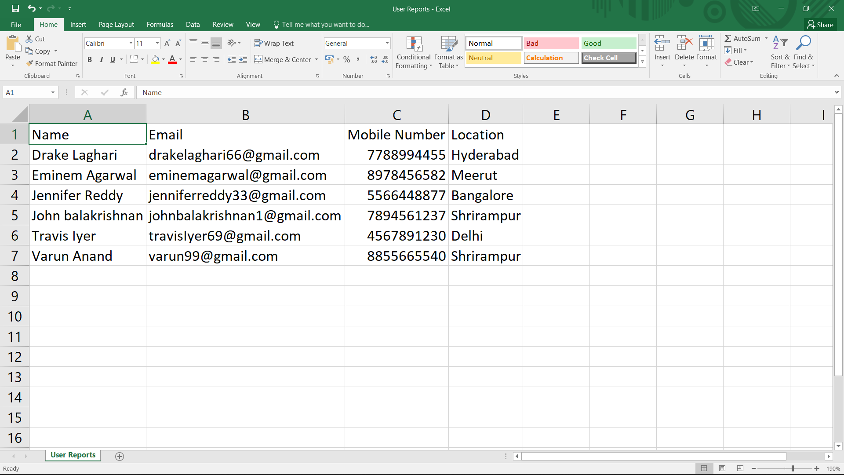

# 

# TEST PLAN

# *Introduction*

For our project , testing is not 100% exhausted as it is principle of software testing . Our main focus would be on GUI Testing as our project is a web application where is users have highly interaction direct with website . In short , we prefer to functional testing rather than non-functional testing . testing be like load testing , compatibility testing and etc are exceptions in our scope of testing scenario .

## Scope

### In Scope

An in-scope for testing of AUT, is functional requirements validation and testing using white-box approach .

### Out of Scope

Out Of Scope defines the features, non-functional requirements of the software that **will NOT be** tested

## Quality Objective

Here make a mention of the overall objevtie that you plan to achive withou your testing

Some objectives of your testing project could be

* Ensure the Application Under Test conforms to functional and non-functional requirements
* Ensure the AUT meets the quality specifications defined by the client
* Bugs/issues are identified and fixed before go li

## Roles and Responsibilities

Detail description of the Roles and responsibilities of different team members like

* QA Analyst
* Developers

# *Test Methodology*

## Overview

**Waterfall Model :**

As this project is at an acedemic level , rather making development more complex decided to go with traditional approach of Waterfall model . Where we first go through all the steps of develpopment from the methodology and now at testing phaseee we are moving ahead .

## Test Levels

**Test Levels define the Types of Testing to be executed on the Application Under Test (AUT**). The Testing Levels primarily depends on the scope of the project, time and budget constraints.

Time Duration is about a week as per recommended by college for testing . and our budget over testing is with no-cost so we prefering manual testing than using automated testing using softwares like Selenium , Jira , Load runner etc . levels are as first of all to do GUI testing and afterone move to functional testing .

## Bug Tria

The goal of the triage is to

* To define the type of resolution for each bug
* To prioritize bugs and determine a schedule for all “To Be Fixed Bugs’.

## Test Completeness

Here you define the criterias that will deem your testing complete.

For instance, a few criteria to check Test Completeness would be

* 100% test coverage
* All Manual Test cases executed
* All open bugs are fixed or will be fixed in next release

# *Test Deliverables*

Here mention all the Test Artifacts that will be delivered during different phases of the testing lifecycle.

Here are the deliverables

|  |
| --- |
| * Test Plan * Test Cases * Bug Reports * Customer Sign Off |
|  |

# *Resource & Environment Needs*

## Testing Tools

No external tools are used as like Jira or selenium , test cases , bug reports are designed in MS Office 2007.

## Test Environment

It mentions the minimum **hardware** requirements that will be used to test the Application.

Following **software’s** are required in addition to client-specific software.

1. Windows 8 and above
2. Office 2007

# TEST CASES

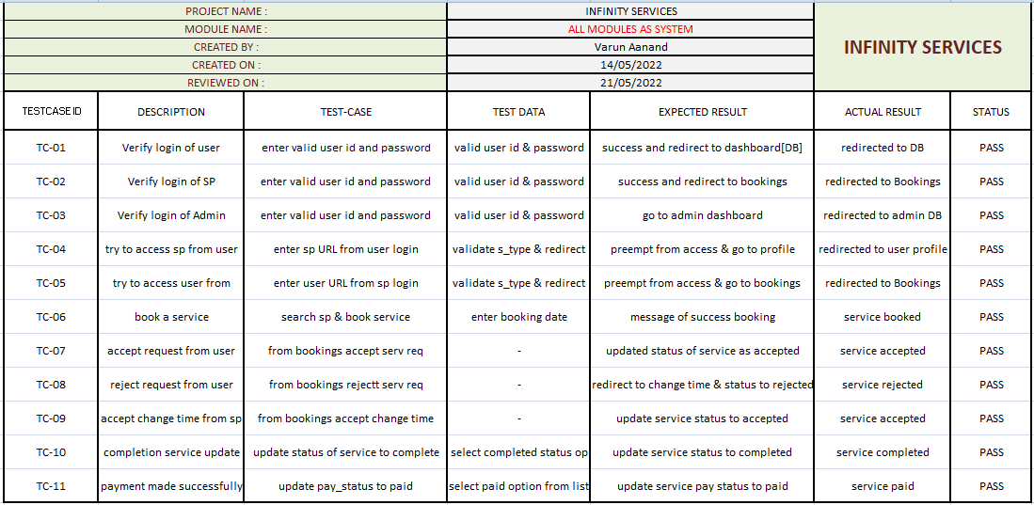

**Conclusion and recommendations**

In summary, the project works are relevant to the objectives set. The project is designed based on a preliminary study that had been carried on with NITL. Thus activities of developing the system which is planning and analysis are based on the result retrieved from the interview on observation. Not only that, as this would be the first computerized system that will be used by the small service providers, the functions only focused on solving the major problem which is not finding quality service at an aggressive price. The interface design is also categorized as user-friendly due to the lack of IT background of the service providers which means the system can be handled by people not even from an IT background. Due to time constraints, the developer can't implement many functions in the system, thus the developer has few future works suggestions for continuation.

**future scope**

1. Location wise services.
2. Payment gateway.
3. Cloud services.
4. UI/UX update as per feedback.
5. Add more services for user.
6. AL & ML for service provider for getting the right data that in which location which service is needed.

**Bibliography**

1. Web Development – Andy Vickler
2. Php & MySQL: Server side web development – Jon Duckett

**references**

1. Web security study: <https://github.com/topics/session-hijacking>
2. PHP study: <https://www.youtube.com/c/CodeWithHarry/videos>