**Rayat Shikshan Sansthan’s**

**C. D. JAIN COLLEGE OF COMMERCE, SHRIRAMPUR**



A project Report On

**“INFINITY SERVICES”**

Submitted To



**University of Pune**

**In Partial Fulfillment of the Requirement Of**

**BBA (CA) – III**

*(Bachelor of Business Administration in Computer Application)*

Submitted By

**Mr. GOHIL KUSHAL Mr. AANAND VARUN**

Under Guidance Of

**Mr. Chandratre Y. V. Mr. Nabage A. D.**

**Mr. Joshi P. D Mr. Lande R.D Mrs. Bhawsaar B. S**

During Academic Year: **2021-22**

**RAYAT SHIKSHAN SANSTHAN ’S**

**C. D. JAIN COLLEGE OF COMMERCE, SHRIRAPUR**



**CERTIFICATE**

**(Department Of Computer Application)**

This is certify that project entitled **“ INFINITY SERVICES ”** submitted by **Mr. Gohil Kushal Harish & Mr. Aanand Varun Indrajit** student of **BBA(CA) - III ( Bachelor of Business Administration And Computer Application)** had satisfactorily completed the project during the academic year 2021-22 .

Date:

**Project Guide: Head of Department**

Mr. Chandratre Y. V.

**Internal Examiner External Examiner**

**Acknowledgement**

**We are happy to present the project** “INFINITY SERVICES”

How much the statement this project is the result of our hard work is true, the support from all of our guide **Mr. Lande Sir** and **Mr. Joshi Sir** along with other respective teachers is worthy as too!

We, throughout this project get many bugs, but as motivated by **Mr. Nabage Sir** about the project management & debugging of the bugs, we tried overcame them all.

Apart from all, we would glad to make acknowledgement towards the supportive teachers , non-teaching personnel, and our classmate to keep a **creative** and “**bounce back”** environment for us.

* **Kushal Gohil & Varun Aanand**

**DECLARATION**

We , **Mr. Gohil Kushal** and **Mr. Aanand Varun** student of BBA (CA)-III, C D Jain College of Commerce,Shrirampur declare that the project entitled **“infinity service”** have been completed successfully & This project is submitted towards the partial fulfillment of the requirementOf the degree of BBA(CA). This project is not submitted for any other degree , Diploma or other similar title or prize in any other university .

**Place : Shrirampur**

**Date : / / 2022**

**Signature**

**Name of student :** Gohil Kushal Harish

**Signature**

**Name of student :** Aanand Varun Indrajit

**INDEX**

|  |  |  |
| --- | --- | --- |
| **Sr. No** | **Index Name** | **Page No** |
| 1 | Introduction :   * Motivation * Problem Statement * Purpose/objective and goals * Project Scope & limitations |  |
| 2 | System Analysis :   * Existing Systems * Scope & limitation of Existing System * Project Perspective , features * Requirement Analysis |  |
| 3 | System Design :   * Design Constraints [ERD DFDs & Data Dictionary ] * System Model : UML Diagrams * User Interfaces |  |
| 4 | Implementation Details   * Software/Hardware Specifications |  |
| 5 | Output & Reports Testing   * Test Plan , Black Box Testing or data validation test cases , White Box Testing or Functional validation test cases and results |  |
| 6 | Conclusion and Recommendations |  |
| 7 | Future Scope |  |
| 8 | Bibliography and References |  |

INTRODUCTION

Welcome today infinity where we are to serve you the most prominent professional services, these services are of your daily routine life.

Assume you have an important meeting with your boss in one hour, and you go to the bathroom to be fresh and what?

You got leakage in your tap, ohh! Now what to do this will be a great made as the meeting is very important if you don't know your boss will be angry over you and you can also lose your job but don't worry when you have Infinity services.

In this situation, you have just to go to the Infinity services portal and ask for the plumbing service and within a few minutes our service provider come to your location and check the situation and solve your problem so now you can go to the office within the time your boss will not angry you and make it to you so always remember what I will success person every person has Infinity service experience!!

Want to know more about Infinity services, so now go further in this documentation.

I must say you will have a very get fine with the knowledge about the services and how the Infinity services system work.

Ok, then it was just an introduction about the project system you can now plan over others' benefits and details about the project.

COMPANY PROFILE

Here is our company profile in which will get to know about how our company structure follows and what are the objectives on which we working,

The first to know about the history of the company - the company is now situated in all over the world but earlier it was best in Spain and the company is in title with the name "NITL"

And our company has 8 photos which are we explain in our logo and that tagline that "Ham kartehainprabandha " which means that we are here to make your problem with the very optimized solution our services makes you comfortable in a very critical zone.

The objective of our company -

1. Our first objective is to serve society with an efficient and effective service-providing facility.

2. Have stated to enhance our services for the people who are not at a capability to utilize high charging services which are mostly provided by various existing systems.

3. Companies also want their employees to be the part of the management for that we provide our implied scheme to invest in our company's shares so that they can be part of a management system also.

4. For our special users who always come into our interaction are benefited from various beneficiary rewards.

SCOPE OF SYSTEM

Within the boundary of the project, The System aims in having the following aspects:

**SYSTEM - BOUNDARY:**

Existing system facilities and to sustain the market with a boundary power system for a particular locality as if you are from a particular location, for example, you can say you are from Mumbai then it will be easy for you to operate our system as we provide specialized our system for only a particular location of the user who logs into our system.

**SYSTEM - END-USER:**

 The end-user of our application is a general public who won a service for their efficient work just like if you are a housewife or person come from out of town to the town which is not familiar with him so he can ask us where to go for the best hotel and if you are a person who needs a plumbing service you can contact us so in this scenario you can you state that our end-user is in a very large scale. It will be very beneficial for our service company

**HOW IS THIS BUILT?**

Please make sure to glance over the documentation, to get the answer of questions like how our system is built and what are the facilities and the services our system provide also you get to know about which study is done by us to deal with this awesome service application so let's go forward

NEED & EXISTING System

**WHY DO WE NEED THIS? :**

• As we will further explain more details of our system’s objective.

• This system provides end-user miscellaneous services for his routine life

• And to make a cost-efficient service providing company.

• The cost-effectiveness and particularity in the location for the user are our system's key points to Remember and which make us different from the existing system.

**EXISTING SYSTEM:**

Before this, many companies are providing the facility of miscellaneous professional services, this is a new market where not hundreds of companies involve the competition is not purely perfect.

And the existing system is providing these services at a very high cost for the users which is not particularly capable for the person who is a worker or a person who works daily.

Also targeting the market of upper-class families who works continuously for their financial settlement so for such kind of miscellaneous services they don't have much time so apart from the existing systems we decided to provide within a minute service today.

NEED & EXISTING System

As the available existing system provides limited functions to the user,

thus this project will contain enhanced and more flexible functions To provide professional services.

Our company objectives included :

• Application provides you the facility to access the various services provided by experienced service providers in your particular locality.

With the view of the service provider, we can get efficient and relevant charges to the service he provides also not required to go in the search for a customer which is a very time consuming and lengthy process.

Admin can manage this application with effective dashboards showing the number of service providers and the service access by the end-user

1. The service provider can add his service, can create update his profile
2. The service provider can also access the information about the service provided to whom.
3. He also has the right to provide efficient charges to the service but the charges should be managed by or approved by the admin also
4. For the extreme user our application firstly glance them our various beautiful services and if they want to request for a service they need to log in before login if they are new they have to the disturb with our portal

PROPOSED SYSTEM

FOR WHOM DID THE SYSTEM DESIGNED? :

As Mentioned Already to the System – End User Before, This Is Just To Emphasize It More Clearly,

Our application mostly targets the two different criteria of society.

Explaining in detail the first one is the service finder who wants or who is in the search of professional service and the other criteria is of the professional service providers who are mostly distributed or spread over the locality in a different location.

This makes what the criteria to come into one platform and access Each Other services

To clarify this let's take an example, if you are a car manufacturer and you are factory is on strike now what you will do you go to our portal and access the service of skilled professional workers it just like outsourcing

HOW THIS SYSTEM WORKS? :

This application works on three categories of users ::

* The user who want the service will come to us and request for service after the acceptance from the service provider he can access the service within a few minutes
* The service provider gets the facility of platform for his service he can manage his profile and accept this request from the service consumer he has an opportunity to make or to build communication for the consumer with chat or direct contact.
* And admin panel will help the admin to optimize the application and also give them information about the services provided by the service provider and the user access to which type of case services on particular date or time and how much the service provider recharge if it is not in the objective defined by the admin he can alter it by its own

FEASIBILITY STUDY

• TECHNICAL FEASIBILITY:

the technical aspect is the most important part of the system development.

as the system is web-based. HTML, CSS, Javascript is used to develop the interface and

PHP for the functions with the database. for the database aspect, MySQL will be

used which will link the system interface with the data storage.

the exposure gained in the ‘business system development’ subject through

the course curriculum has given us the credibility to develop the program as specified. moreover, online tutorials on system development are also vastly available on

the internet which will help us in the development stage.

**•** ECONOMICAL FEASIBILITY:

basic analysis has been done in investigating the economical feasibilities

of the project. the financial analysis demonstrates that the new system will

reveal positive economic feasibility. in terms of software design and license,

it can be found the open-source on the internet thus, the owner does not need to

purchase the software from the vendor. the new system will be requiring

extra cost on the hardware implementation part. in terms of special staff training,

the new system will not need any extra cost. normally, the newly developed system will

need special training for the user, however in this case the system handling part is very easy and eliminate the need for training. besides, a friendly interface

makes staff work with less stress.

**•** OPERATIONAL FEASIBILITY:

the risk of familiarity with the application is medium because the users/staff

never used to computerized system. thus, there is a need for a brief introduction

on handing the system to implement the system. besides, as most of

the staffs in the store are not it literate.

FACT FINDING TECHNIQUE

QUESTIONARIES:

We have to design a questionnaire and provided them to the general public asking questions related to problems in their routine life when they get stuck into a situation like where they want the service by plumbing cleaner and any other services.

Based on this question we design the objective and the boundary of the system

GROUND-LEVEL ANALYSIS:

The application also target the social criteria of service provider depending upon another one service provider that means to say a business to business communication, for that we provide a ground analysis in our own company when the company won Outsourcing services for our IT infrastructure we go to the IT service providers this makes us acknowledge about how dependency work in a business level

SOFTWARE & HARDWARE REQUIREMENTS

As This Is a Web Based Application,

End-User System Specification Does Not Affect But Still,

**|| HARDWARE REQUIREMENT ||**

**• Processor**

Intel Pentium +

[Prefer At Least Quad Core to Support Network Connectivity]

**• RAM**

2 GB +

[8 GB Preferred For Large Scaled Business]

**• Hard Disk**

10 GB +

**|| SOFTWARE REQUIREMENT ||**

**• Operating System**

Windows, Mac, Linux, UNIX, Raspberry Pi, Etc

**• Front-End Tech Used**

HTML, CSS, JavaScript

**• Back-End Support**

PHP, MySQL

ERD

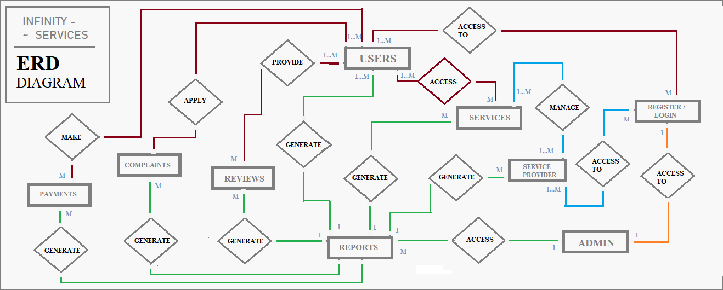

DFD Level - 0

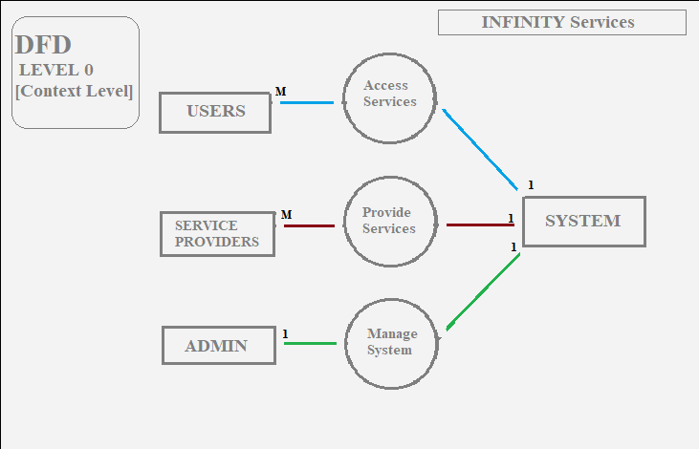

DFD Level – 1

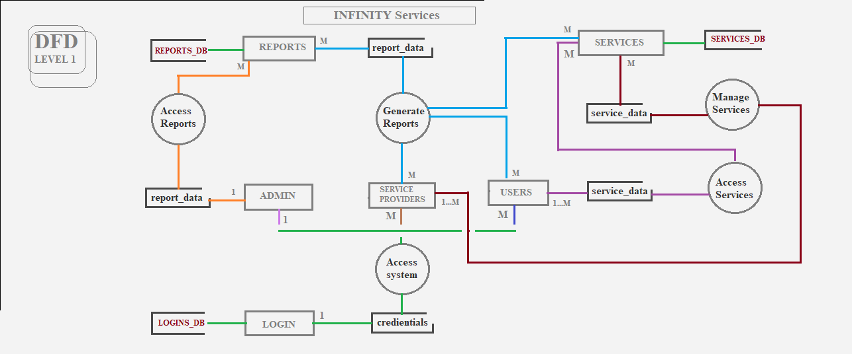

DFD Level – 2

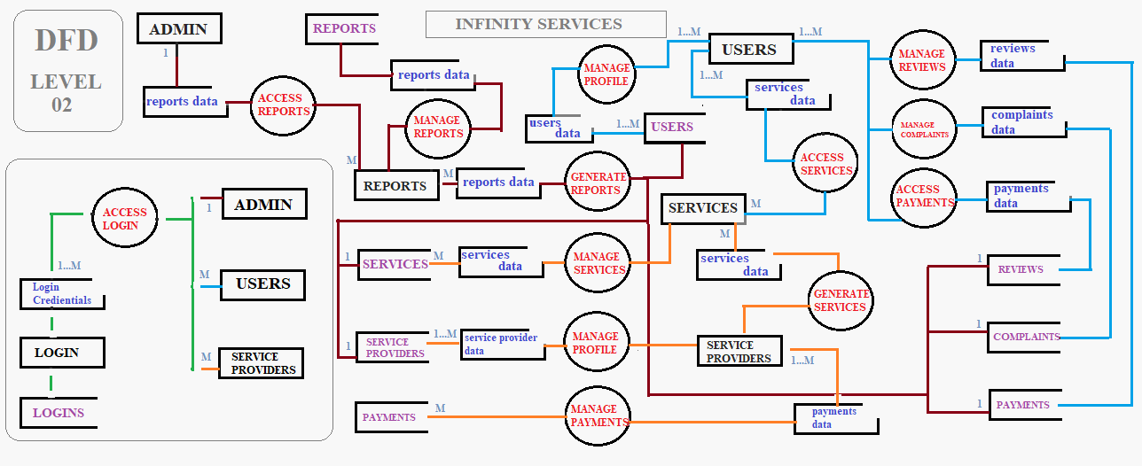

UML Class diagram

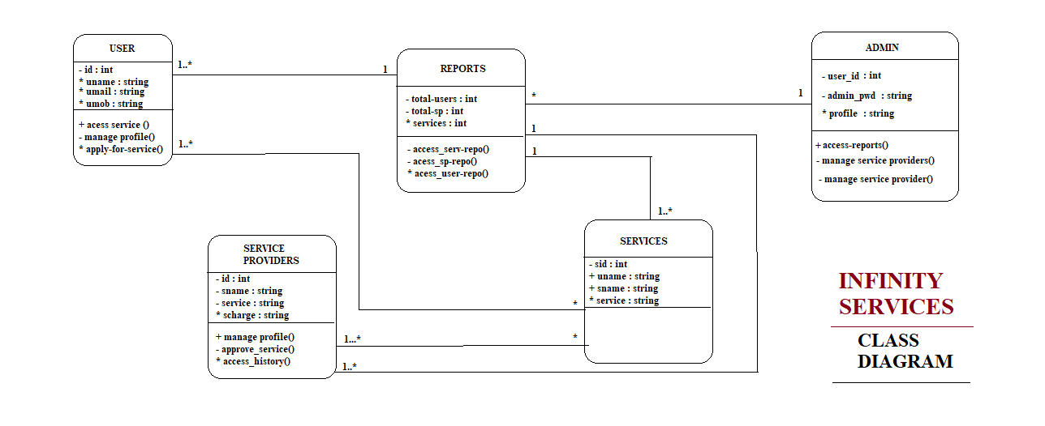

UML object diagram

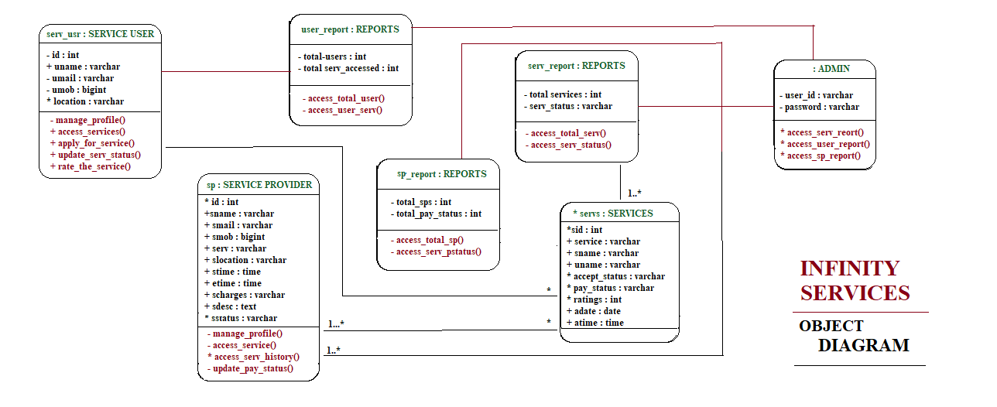

UML Use Case diagram

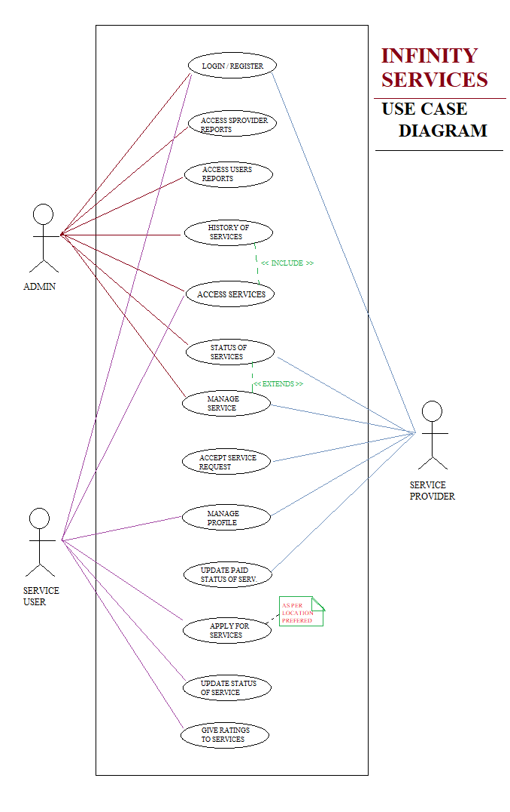

UML Sequence diagram

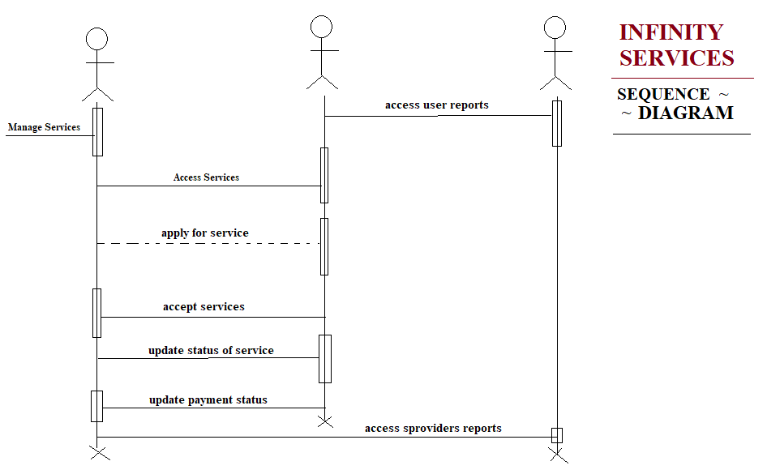

UML activity diagram

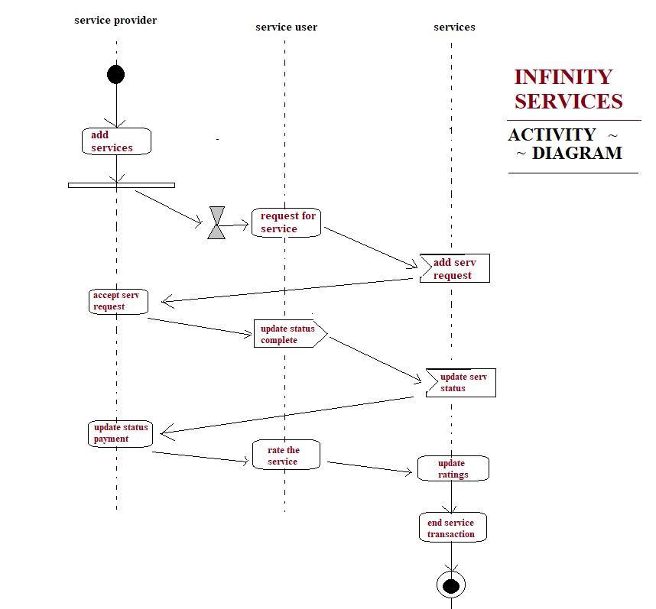

UML STATE CHART diagram

