**Rayat Shikshan Sansthan’s**

**C. D. JAIN COLLEGE OF COMMERCE, SHRIRAMPUR**



A project Report On

**“SALES ACCOUNT MANAGEMENT [SAM] SYSTEM”**

Submitted To



**University of Pune**

**In Partial Fulfillment of the Requirement Of**

**BBA (CA) – III**

*(Bachelor of Business Administration in Computer Application)*

Submitted By

**Mr. GOHIL KUSHAL Mr. AANAND VARUN**

Under Guidance Of

**| Mr. Chandratre Y. V. | | Mr. Nabage A. D. |**

**| Mr. Joshi P. D | Mr. Lande R.D | Mrs. Bhawsaar B. S**

During Academic Year: **2021-22**

**RAYAT SHIKSHAN SANSTHAN ’S**

**C. D. JAIN COLLEGE OF COMMERCE, SHRIRAPUR**



**CERTIFICATE**

**(Department Of Computer Application)**

This is certify that project entitled **“ SALES ACCOUNT MANAGEMENT SYSTEM ”** submitted by **Mr. Gohil Kushal Harish & Mr. Aanand Varun Indrajit** student of **BBA(CA) - III ( Bachelor of Business Administration And Computer Application)** had satisfactorily completed the project during the academic year 2021-22 .

Date:

**Project Guide: Head of Department**

Mr. Joshi P.D | Mr. Lande R.D Mr. Chandratre Y. V.

**Internal Examiner External Examiner**

***Acknowledgement***

**We are happy to present the project**

“SALES ACCOUNT MANAGEMENT SYSTEM”

How Much the Statement This Project Is the Result Of

Our Hard Work Is True, the Support from All of Our Guide

**Mr. Lande Sir** and **Mr. Joshi Sir** Along With Other

Respective Teachers Is Worthy As Too!

We, Throughout This Project Get Many Bugs,

But As Motivated By **Mr. Nabage Sir** About The

Project Management & Debugging Of the Bugs,

We Tried Overcame Them All.

Apart From All, We Would Glad To Make Acknowledgement

Towards The Supportive Teachers

, Non-Teaching Personnel, And Our Classmate

To Keep A **Creative** And

“BOUNCE **BACK”** Environment For Us.

* **Kushal Gohil & Varun Aanand**

**DECLARATION**

We **Mr. Gohil Kushal** and **Mr. Aanand Varun** Student of BBA (CA)-III,

C D Jain College of Commerce ,Shrirampur Declare That the Project Entitled

**“Sales Account Management System”** Have Been Completed Successfully &

This Project Is Submitted Towards the Partial Fulfillment of the Requirement

Of The Degree of BBA(CA). This Project Is Not Submitted For Any Other Degree ,

Diploma or Other Similar Title or Prize in Any Other University .

**Place : Shrirampur**

**Date : / / 2022**

**Signature**

**Name of student :** Gohil Kushal Harish

**Signature**

**Name of student :** Aanand Varun Indrajit

**INDEX**

|  |  |  |
| --- | --- | --- |
| **Sr. No** | **Index Name** | **Page No** |
| 1 | Introduction |  |
| 2 | Company Profile |  |
| 3 | Scope of system |  |
| 4 | Need for system & existing system |  |
| 5 | Objective of system |  |
| 6 | Proposed system |  |
| 7 | Feasibility study |  |
| 8 | Fact Finding Technique |  |
| 9 | Software/Hardware Requirement |  |
| 10 | Analysis & Design ER Diagram |  |
| 11 | Data Dictionary / Table Specification |  |
| 12 | Screenshot |  |
| 13 | Advantage of system |  |
| 14 | Limitation of system |  |
| 15 | Future Enhancement |  |
| 16 | Report |  |
| 17 | Bibliography & References |  |



INTRODUCTION

INTRODUCTION

**The retail industry** is one of the industries that is growing at in fast pace

Where the number of retail business keep on increasing from time to time to meet

The demand from consumers of specified areas. There are different types of retail shops available for a consumer to choose ranging from hypermarket to mini market according to their convenience. Most of the shops can be found in

Residential areas, streets, or shopping malls.

A retail store sells a wide range of goods and services from wholesalers or suppliers

To end-user. Thus, **the nature of the retail business required good management of inventory** levels to meet the demand of the customers.

The traditional way retailer keeps their sales details is in spreadsheets which

Are not effective anymore when the size of the shop gets bigger. This is because more

Items will be made available in a larger quantity, **thus tracking the sales made**

**With inventory level in the shop would be complicated and time consuming for the retailer.**

Besides, the situation gets worst when the retailer does not have a proper method to determine items purchased by their customers. Thus, this project will provide **the solution for retailers that are still using traditional ways in keeping their inventory data creating an inventory system.**

**Shop Sales Management System is a computer-based system that provides**

**The shop structure for maintaining and controlling goods to be stocked.**

The approach of Shop Sales Management System is commonly used to avoid

Product overstock or outrages by integrating daily ‘Point of Sales’ with

Store’s inventory level.

COMPANY PROFILE

Our company was introduced in the year 2009 entitled to “Sales & Marketing Solutions ltd.”

Initialy based in Gurgaon Haryana . now with efforts of all supporters , we are now a pan india networked company .

 an Information Technology Enabled Services organization concentrated on executing Lead Generation and white paper syndication programs by utilizing Innovation to drive beneficial income development for our clients over the globe.

We are gifted and experienced experts who are knowledgeable with the test of giving financially savvy Deals and Advertising QUALIFIED Leads. We have enthusiasm for building, adjusting, and overseeing groups crosswise over differing and complex associations and utilize this energy to make the best lead gen campaigns.

* We are gifted and experienced experts
* We have enthusiasm for building, adjusting and overseeing groups
* Utilize energy to make the best lead generation campaigns.

 essential capability is to utilize mechanical advancement on a key dimension to enable customers to get to where they should be all the more effectively through new and current records. Our record based profiling arrangements give extensive business favorable circumstances in two key zones:

We offer administration with understanding into business sectors and lead accounts so they can ceaselessly refine deals and showcasing technique.

We proactively illuminate account supervisors of offers issues and convey new business openings empowering them to move all the more viably and astutely.

SCOPE OF SYSTEM

Within the boundary of the project, The System aims in having the following aspects:

**SYSTEM - BOUNDARY:**

To Overcome Various Issue Mentioned In Introduction Of Desktop-Based Application, We Here Make One Changes To Put The Data On Server, It Can Be Remote Anywhere, Recently “Cloud Servers” Can Be Used Which Make Our End User A Cost Efficient Deal.

**SYSTEM - END USER:**

The End User Of The System Is The Admin Of Shop Instead Of The Consumer Of The Shop, Where In General System Is The End User.

**DATABASE:**

This Contains 2 Tables Where One Table Will Contain User Registration Data And The Second Will Contain User Input Data.

**LOGIN / SIGNUP:**

Here Is The Twist In Our System, The User Of System Is The Admin Of The Shop Who Maintaining The Inventory. He Is Authorized To Register Himself Or Subordinate And Manage The System.

**HOW IS THIS BUILD?**

Make Sure To Glance Over The Documentation, To Get Answers To The Queries Like Duration Of The Overall Project, What Technology Used, How The Analysis Done And Etc.

NEED & EXISTING SYSTEM

**WHY WE NEED THIS? :**

* As We Will Further Explained More Details of Our System’s Objective.
* We Need This System To Manage An Inventory And Sales Simultaneously In A Synchronous Manner.
* To Overcome The Drawbacks Of Existing System Till The Date.
* And As The Concept WEB Is Building In Various Other Industries, So We Try To Create A WEB Based Retail Industry Software.

**EXISTING SYSTEM:**

There Are Hundreds of ERP Software Already In Market Providing

Facility of Inventory & Sales Management Like

**TALLY ERP9, EASYSHOP, RETAILWARE 5.0, MARG 9+**, etc

BUT,

*They are not a specialized* in this facility,

From Personal Experience to Handling This Software, They Provide

Other Facilities Like Accounts Management, Retail Counter Billing Etc.

So Cause Of, Not Focused, There Are Some Functional Bugs in Them,

*We try to conceptualize this bug into a new solution to the Inventory management.*

OBJECTIVE OF SYSTEM

As The Available Existing System Provides Limited Functions to the User,

Thus This Project Will Contain Enhanced And More Flexible Functions To The Store. The Objectives Include:

• To Provide A Function To Manage Goods In The Store More Efficiently. Basic Functions Such As ‘Add’, ‘Delete’, And ‘Update’ For Data Management Will Be Made Available.

• To Provide A Function To Add A Customer In The Database So That Next Time Customer Comes To Shop Again We Can Get His Previous Data.

• To Provide A Function To Add A Product In The Database So That Users Can Select The Product From The Dropdown And It Will Easy For Us To Get The Report.

1. To provide function to manage goods in the store more efficiently. Basic functions such as ‘add’, ‘delete’, and ‘update’ for data management will be made available.
2. ii. Filling system in managing all transactions and documents that are relevant as the aid in the stock tracking routines.
3. iii. To automatically generate weekly report on sales and inventory activities
4. iv. To provide notifications on the goods’ expiring date for clearance activity.
5. v. To generate receipt with proper format for customer references
6. vi. To provide point of sales for each day
7. vii. To reduce time and cost to control and manage inventory



PROPOSED SYSTEM

PROPOSED SYSTEM

**FOR WHOM DID SYSTEM DESIGN? :**

As Mentioned Already the System – End User Before, This Is Just To Emphasize It More Clearly,

Our System Target the Owners or Sole Traders Who Mostly Unable To Manage Their Inventory Whole Manually, And As Business Expands This Issue Get More Complex,

So To Make Them to Focus on Growth and Expansion of Business to Give Our Country’s Economy Strength to Be *‘VISHWA GURU ‘Again*!

**HOW THIS SYSTEM WORKS? :**

* Admin Will Need Just To Keep Himself Online While Working With Our Application.
* When Ever His Consumer Buy Something From His Inventory Enter Respective Data In Our System.
* If Admin Want Also Add Stock Of Products In Inventory, He Can Do It Efficiently.
* As The **Business** Is **A Legal Fight** For **Customer Satisfaction**, Our End User Can Analysis The Data As Per His Filter Of Choices And Get Help In Process Of Decision Making!

FEASIBILITY STUDY

**• TECHNICAL FEASIBILITY:**

Technical Aspect Is The Most Important Part In The System Development.

As The System Is Web Based, HTML CSS JS Used To Develop the Interface And

PHP for the Functions with the Database. For The Database Aspect, MSQL Will Be

Used Which Will Link The System Interface With The Data Storage.

The Exposure Gain in ‘Business System Development’ Subject Through

Course Curriculum Has Given Us the Credibility to Develop the Program as Specified

. Moreover, Online Tutorial on System Development Also Vastly Available On

The Internet Which Will Helps Us in Development Stage.

**• ECONOMICAL FEASIBILITY:**

Basic Analysis Has Been Done In Investigating the Economical Feasibilities

Of The Project. The Financial Analysis Demonstrates That the New System Will

Reveals A Positive Economic Feasibility. In Term of Software Designing and License

It Can Be Found On Open Source in the Internet Thus, Owner Does Not Need To

Purchase The Software From The Vendor. New System Will Be Requiring

Extra Cost on the Hardware Implementation Part. In Term of Special Staff Training,

The New System Will Not Need Any Extra Cost. Normally, Newly Develop System Will

Need For Special Training for the User, However In This Case the System the Handling

Part Is Very Easy And Eliminate The Need For Training. Besides, a Friendly Interface

Makes Staff Work With Less Stress.

**• OPERATIONAL FEASIBILITY:**

The Risk of Familiarity with the Application Is Medium Because the Users/Staff

Never Used To Computerized System. Thus, There Is a Need for Brief Introduction

On Handing the System In Order To Implement the System. Besides, As Most Of

The Staffs in the Store Are Not IT Literate, the To-Be System Will Be

User-Friendly And Easy To Operate.

FACT FINDING TECHNIQUE

**QUESTIONARIES:**

We Have Designed A Questionary With Some Basics Questions Regarding To Solve Our Facts About How Exactly The Retail Market Is Work, How They Manage Inventory Manually Etc.

**GROUND LEVEL ANALYSIS:**

Although Have Experienced Issue Of **‘Stock Is Not Available ‘,** We Go At Local Businesses To Help Us Analyze Their Daily Routine Business Activities, This Make Us To Find Where We Can Use Hit The Stroke Theory In Manual Inventory System.

**MEETING WITH END USER:**

As Most Of The End User Directly Relate To Our System, We Decides To Meet Them And Go At Deep To Solve The System Issue. They Told Us, Their Market Affect As Consumer Get Dissatisfied Due To Lack Of Products Consumer Want From Them.

SOFTWARE & HARDWARE REQUIREMENT

As This Is a Web Based Application,

End-User System Specification Does Not Affect But Still,

**Why to Take Risk at Initial!**

So Here Is,

**|| HARDWARE REQUIREMENT ||**

**• Processor**

Intel Pentium +

[Prefer At Least Quad Core to Support Network Connectivity]

**• RAM**

2 GB +

[8 GB Preferred For Large Scaled Business]

**• Hard Disk**

10 GB +

**|| SOFTWARE REQUIREMENT ||**

**• Operating System**

Windows, Mac, Linux, UNIX, Raspberry Pi, Etc

**• Front-End Tech Used**

HTML, CSS, JavaScript

**• Back-End Support**

PHP, MySQL



ANALYSIS & DESIGN

ANALYSIS & DESIGEN

**ERD [ How Entity Relates? ]**

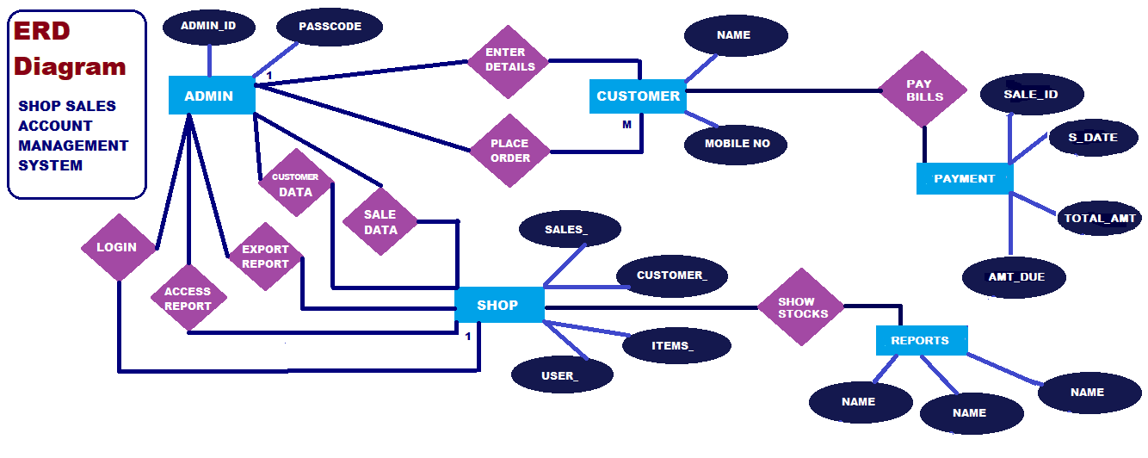

**DFD [ How Data Flows? ]**

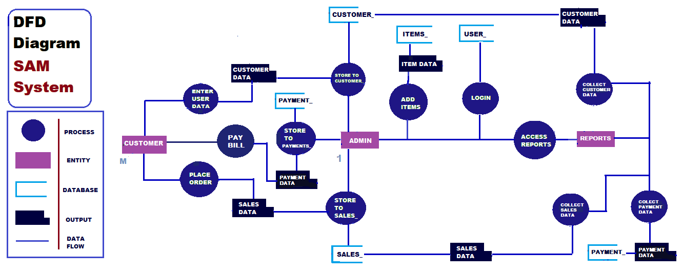

DATA DICTIONARY

**USER TABLE**

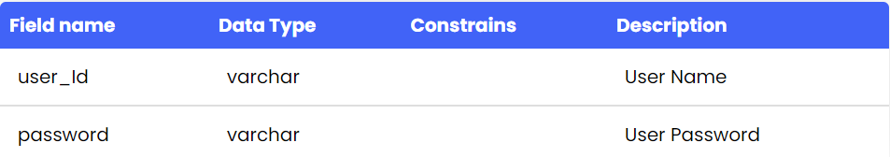

**CUSTOMER TABLE**

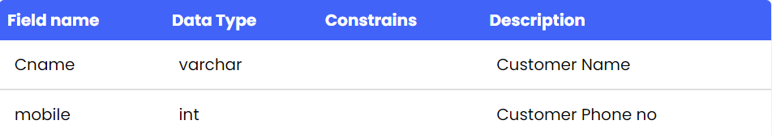

**ITEM TABLE**

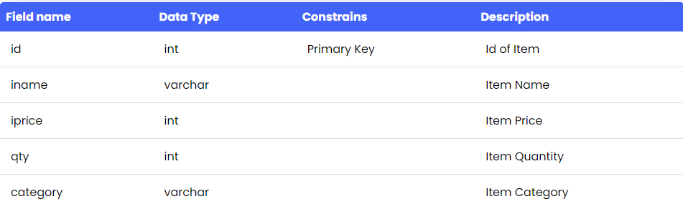

**SALES TABLE**

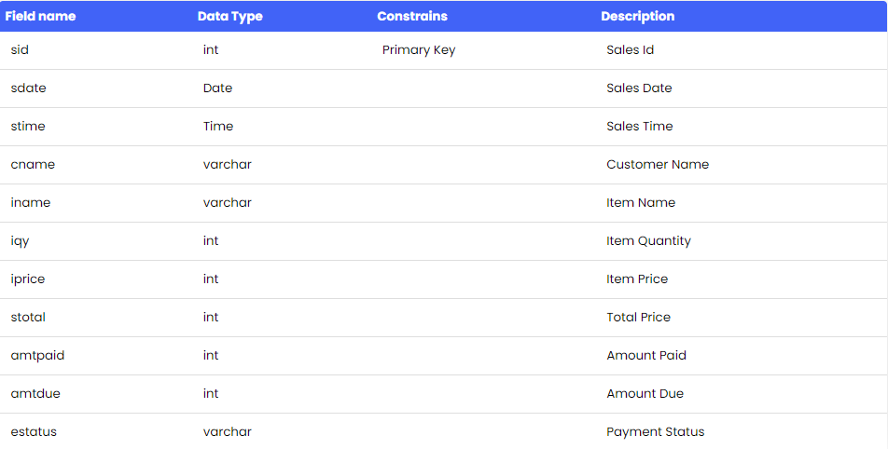



UI / UX of the System

SCREENSHOTS

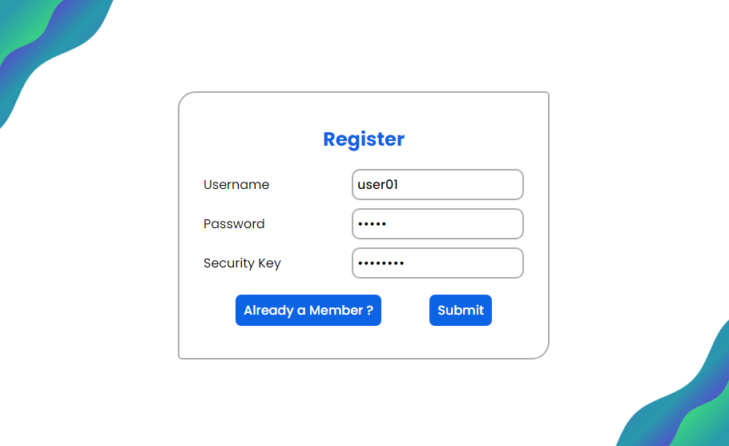

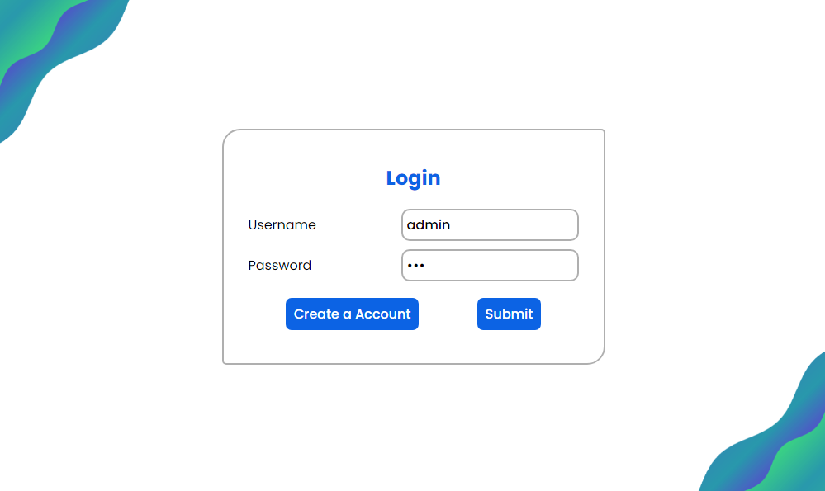

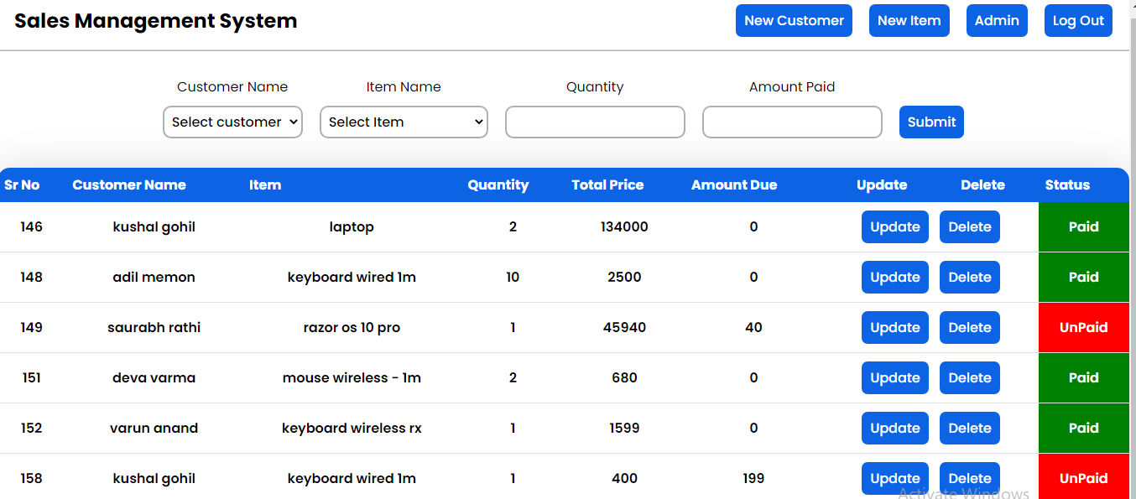

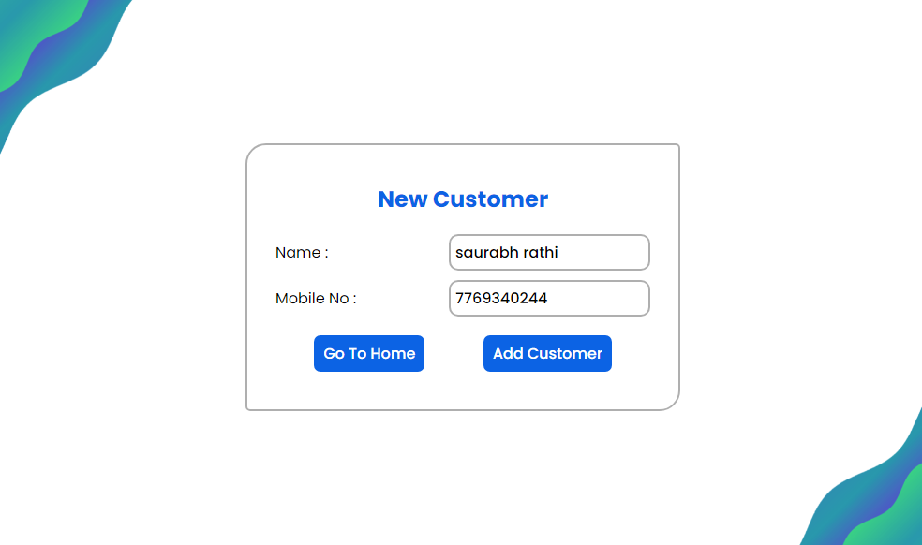

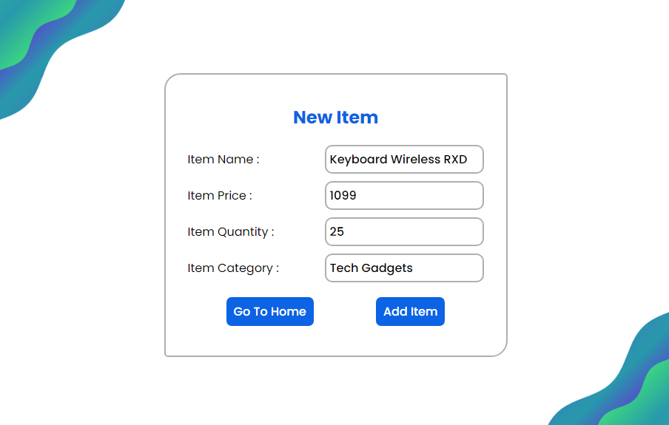

**ALERTS!!**

**Success Message for Insertion of Sale Entry!**

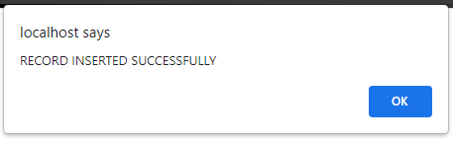

**Success Message for Sub-User Registration!**

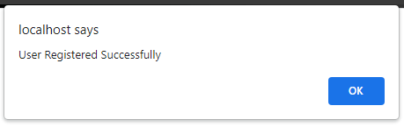

**Alert for Unauthorized Registration without Key!**

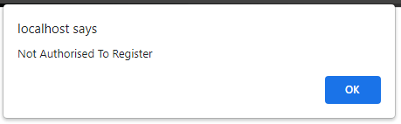



ADVANTAGES & LIMITATIONS

ADVANTAGE OF SYSTEM

As The Advantages Of Switching To Modern Inventory Control System Clearly Proven By Many Businesses, Identified Few Benefits As Follows:

* Sales Management Increases Profitability: Activities Such As Forecasting, Controlling and Managing Inventory Increase Sales and Productivity of the Store Resulting In Greater Profitability. Besides, Accuracy Improvements On The Inventory Level Will Result In Reduction Of Fixing Costly Mistakes.
* Sales Management Improves Cash Flow: Purchasing The Correct Inventory In The Right Amount To Meet Customer Demand And At The Same Time Eliminating Slow Moving, Obsolete Inventory Leads To Better Cash Flow And Eventually To Higher Profits.
* Sales Management Improves Decision-Making: Real-Time Business Intelligence Across All Areas Of The Store Is Possible With Rapid, Accurate Data Collection. Not Only That, Issues And Events Integrated With The System Enables To Proactively Identify And Solve The Issues.
* Sales Management Increases Customer Satisfaction: Anticipating In Seasonal Promotion And Changing Marketing Conditions By Having The Right Products In Stock For Customers

LIMITATION OF SYSTEM

* As No one can be perfect 100%, we too have some limitations those are targets of our future enhancements.

* First, we encountered initial level limit is the reports are not yet available for the admin as this panel is under construction!!
* Another one is, we have to use API of payment gateway, so User’s consumer satisfaction for his consumers will grow with 30 – 40 %.
* Are some of points we encountered during the manual testing, so as AGILE methodology, our Next Inception Model will be to overcome this drawbacks.
* Updates of new version will be soon available on our consumer federal panel.



FUTURE ENHANCEMENT

FUTURE ENHANCEMENT

1. **Admin Dashboard Panel.**
2. **Payment Gateway.**
3. **Cloud Server Service [CSC].**
4. **UI / UX Updates As Per Feedbacks.**
5. **AI & ML for Stock Predictions.**



REPORT of project

REPORT

**INTERVIEW QUESTIONS:**

1. What is your name?

2. How long Rahmath Store is in operation?

3. What is current method of recording inventory level?

4. What is the method used in carrying out customer sales?

5. What problems faced by the store in managing inventory?

6. Did customers complain of the products that out of stock?

7. How do you monitor the performance of the store?

8. What if the customer wish to exchange the item purchased?

9. How you detect the expired products in the store?

10. Why never use any system in doing business?

11. Will you use system that will help you in managing the inventory?

12. What are your requirements in the system to be developed?

CONCLUSION

In summary, the project works is relevancy to the objectives set. The project is designed based on preliminary study that had been carried on with Rahmath Store. Thus activities of developing the system which is planning and analysis is based on the result retrieved from the interview on observation. Not only that, as this would be the first computerized system that will be used by the store, the functions only focused on solving major problem which is inventory management problem. The interfaces design is also categorized as user friendly due to lack of IT background of the workers which means the system can be handle by people not even from IT background. Due to time constraints, it is not possible for the developer to implement many functions in the system, thus the developer have few future works suggestion for continuation.

Firstly, the development of integration between the system with the supplier system of shop. By integrating the both systems, Store system can directly send the request of inventory order to the supplier when the stock level is low. Thus, shop does need to order manually from the supplier which can cause delay in the delivery of the products. By having this integration, Rahmath Store can practices Just-In-Time inventory where the store does not need to hold many stocks which is not a good practice of inventory control. Secondly, the implementation of decision support functions in the system.

For examples, data mining techniques or approach can be used to study the pattern of sales made. From the pattern analysis, Rahmath Store can be used it to do marketing strategies to its customer or even stock arrangement management can be done from the result. All this action is believed to boost the sales of the store greater than the current.



BIBLIOGRAPHY & REFERENCES

BIBLIOGRAPHY

01 Web Development - Andy *Vickler*

02 Professional JavaScript for Web Developers - Nicholas *Zakas*

03 PHP & MySQL: Server-side Web Development - *Jon Duckett*

REFERENCES

**Web Security Study:**

[*https://github.com/topics/session-hijacking*](https://github.com/topics/session-hijacking)

**Payment Gateway:**

<https://www.geeksforgeeks.org/top-7-payment-gateway-apis-that-every-developer-must-know/>

THANK YOU!!

Mr. Gohil Kushal Mr. Aanand Varun