# Ex No:01 IMPLEMENT RSA ASYMMETRIC (SECRET KEY ENCRYPTION) ALGORITHM

# Date:

## AIM:

To execute RSA Algorithm Using python and encrypt and decrypt.

## ALGORITHM:

1. Start.
2. **Key Generation:**
   1. Choose two distinct prime numbers, p and q.
   2. Compute n = p*q.
   3. Compute Φ (n)=(p-1)*(q-1).where Φ is Eucler’s totient function.
   4. Choose an integer e such that 1 < e < Φ (n) and e is coprime to Φ (n).
   5. Compute the integer d such that d*e ≡1(modΦ (n)), i.e., d is the modular multiplicative inverse of e modulo Φ (n).
   6. The public key is (n,e) and the private key is (n,d).
3. Encryption:
   1. Encrypt the message M using public key(n,e).
      1. Compute C ≡ Me (mad n).
4. Decryption:
   1. Decrypt the ciphertext C using the private key (n, d).
      1. Compute M ≡ cd (mod N).
5. Stop

## PROGRAM:

import random

def gcd(a, b):

while b != 0:

a, b = b, a % b

return a

def multiplicative_inverse(e, phi):

d = 0

x1, x2, y1, y2 = 0, 1, 1, 0

temp_phi = phi

while e > 0:

temp1 = temp_phi // e

temp2 = temp_phi - temp1 * e

temp_phi = e

e = temp2

x = x2 - temp1 * x1

y = y2 - temp1 * y1

x2 = x1

x1 = x

y2 = y1

y1 = y

if temp_phi == 1:

d = y2 + phi

return d

def generate_keypair(p, q):

if not (is_prime(p) and is_prime(q)):

raise ValueError("Both numbers must be prime.")

elif p == q:

raise ValueError("p and q cannot be equal")

n = p * q

phi = (p - 1) * (q - 1)

e = random.randrange(1, phi)

g = gcd(e, phi)

while g != 1:

e = random.randrange(1, phi)

g = gcd(e, phi)

d = multiplicative_inverse(e, phi)

return ((e, n), (d, n))

def encrypt(pk, plaintext):

key, n = pk

cipher = [pow(ord(char), key, n) for char in plaintext]

return cipher

def decrypt(pk, ciphertext):

key, n = pk

plain = [chr(pow(char, key, n)) for char in ciphertext]

return ''.join(plain)

def is_prime(num):

if num == 2 or num == 3:

return True

if num < 2 or num % 2 == 0:

return False

for n in range(3, int(num**0.5)+2, 2):

if num % n == 0:

return False

return True

# Example usage:

p = 61

q = 53

public_key, private_key = generate_keypair(p, q)

print("Public Key:", public_key)

print("Private Key:", private_key)

message = "Hello, World!"

print("Original Message:", message)

encrypted_msg = encrypt(public_key, message)

print("Encrypted Message:", ''.join(map(lambda x: str(x), encrypted_msg)))

decrypted_msg = decrypt(private_key, encrypted_msg)

print("Decrypted Message:", decrypted_msg)

## OUTPUT:

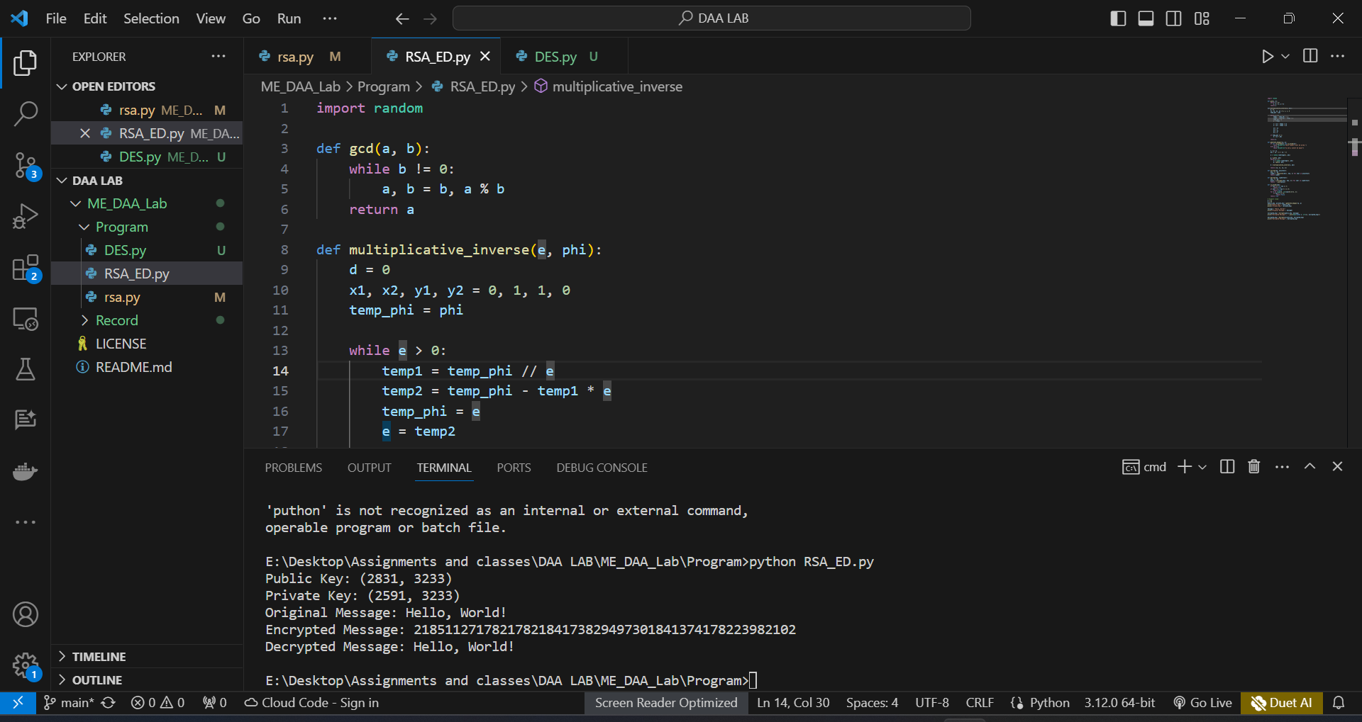

## RESULT:

This RSA algorithm was executed successfully.

# Ex No:02 IMPLEMENT DATA ENCRYPTION STANDARD (DES) A SYMMETRIC ENCRYPTION ALGORITHM

# Date:

## AIM:

To implement DES to encode and decode a plain text using key in python.

## ALGORITHM:

1. Start.
2. Get the values of Li, Ri, Ci, Di in hex format from the user.
3. Perform left circular shift of Ci Di with respective to the round with table values.
4. Using PC2 table arrange the elements in the same order.
5. Compute expansion permutation of ith round (Ri) and arrange elements in 6x8 matrix.
6. Convert PC2 matrix in 8x6 order.
7. Perform A=PC2 EX-OR E/P(Ri)
8. Find the value of ‘A’ in S-Box Table.
9. Arrange the ‘A’ Matrix in permutation Function table order.
10. Li+1=Ri Ri+1=Li EX-OR P32.
11. To decrypt, apply the same algorithm with subkey used in reverse order.
12. Stop.

## PROGRAM:

def main():

print()

# Taking inputs from the user

plaintext = input("Enter the message to be encrypted : ")

key = input("Enter a key of 8 length (64-bits) (characters or numbers only) : ")

print()

# Checking if key is valid or not

if len(key) != 8:

print("Invalid Key. Key should be of 8 length (8 bytes).")

return

# Determining if padding is required

isPaddingRequired = (len(plaintext) % 8 != 0)

# Encryption

ciphertext = DESEncryption(key, plaintext, isPaddingRequired)

# Decryption

plaintext = DESDecryption(key, ciphertext, isPaddingRequired)

# Printing result

print()

print("Encrypted Ciphertext is : %r " % ciphertext)

print("Decrypted plaintext is : ", plaintext)

print()

# Permutation Matrix used after each SBox substitution for each round

eachRoundPermutationMatrix = [

16, 7, 20, 21, 29, 12, 28, 17,

1, 15, 23, 26, 5, 18, 31, 10,

2, 8, 24, 14, 32, 27, 3, 9,

19, 13, 30, 6, 22, 11, 4, 25

]

# Final Permutation Matrix for data after 16 rounds

finalPermutationMatrix = [

40, 8, 48, 16, 56, 24, 64, 32,

39, 7, 47, 15, 55, 23, 63, 31,

38, 6, 46, 14, 54, 22, 62, 30,

37, 5, 45, 13, 53, 21, 61, 29,

36, 4, 44, 12, 52, 20, 60, 28,

35, 3, 43, 11, 51, 19, 59, 27,

34, 2, 42, 10, 50, 18, 58, 26,

33, 1, 41, 9, 49, 17, 57, 25

]

def DESEncryption(key, text, padding):

"""Function for DES Encryption."""

# Adding padding if required

if padding == True:

text = addPadding(text)

# Encryption

ciphertext = DES(text, key, padding, True)

# Returning ciphertext

return ciphertext

def DESDecryption(key, text, padding):

"""Function for DES Decryption."""

# Decryption

plaintext = DES(text, key, padding, False)

# Removing padding if required

if padding == True:

# Removing padding and returning plaintext

return removePadding(plaintext)

# Returning plaintext

return plaintext

# Initial Permutation Matrix for data

initialPermutationMatrix = [

58, 50, 42, 34, 26, 18, 10, 2,

60, 52, 44, 36, 28, 20, 12, 4,

62, 54, 46, 38, 30, 22, 14, 6,

64, 56, 48, 40, 32, 24, 16, 8,

57, 49, 41, 33, 25, 17, 9, 1,

59, 51, 43, 35, 27, 19, 11, 3,

61, 53, 45, 37, 29, 21, 13, 5,

63, 55, 47, 39, 31, 23, 15, 7

]

#Expand matrix to get a 48bits matrix of datas to apply the xor with Ki

expandMatrix = [

32, 1, 2, 3, 4, 5,

4, 5, 6, 7, 8, 9,

8, 9, 10, 11, 12, 13,

12, 13, 14, 15, 16, 17,

16, 17, 18, 19, 20, 21,

20, 21, 22, 23, 24, 25,

24, 25, 26, 27, 28, 29,

28, 29, 30, 31, 32, 1

]

def DES(text, key, padding, isEncrypt):

"""Function to implement DES Algorithm."""

# Initializing variables required

isDecrypt = not isEncrypt

# Generating keys

keys = generateKeys(key)

# Splitting text into 8 byte blocks

plaintext8byteBlocks = nSplit(text, 8)

result = []

# For all 8-byte blocks of text

for block in plaintext8byteBlocks:

# Convert the block into bit array

block = stringToBitArray(block)

# Do the initial permutation

block = permutation(block, initialPermutationMatrix)

# Splitting block into two 4 byte (32 bit) sized blocks

leftBlock, rightBlock = nSplit(block, 32)

temp = None

# Running 16 identical DES Rounds for each block of text

for i in range(16):

# Expand rightBlock to match round key size(48-bit)

expandedRightBlock = expand(rightBlock, expandMatrix)

# Xor right block with appropriate key

if isEncrypt == True:

# For encryption, starting from first key in normal order

temp = xor(keys[i], expandedRightBlock)

elif isDecrypt == True:

# For decryption, starting from last key in reverse order

temp = xor(keys[15 - i], expandedRightBlock)

# Sbox substitution Step

temp = SboxSubstitution(temp)

# Permutation Step

temp = permutation(temp, eachRoundPermutationMatrix)

# XOR Step with leftBlock

temp = xor(leftBlock, temp)

# Blocks swapping

leftBlock = rightBlock

rightBlock = temp

# Final permutation then appending result

result += permutation(rightBlock + leftBlock, finalPermutationMatrix)

# Converting bit array to string

finalResult = bitArrayToString(result)

return finalResult

# Matrix used for shifting after each round of keys

SHIFT = [1, 1, 2, 2, 2, 2, 2, 2, 1, 2, 2, 2, 2, 2, 2, 1]

# Permutation matrix for key

keyPermutationMatrix1 = [

57, 49, 41, 33, 25, 17, 9,

1, 58, 50, 42, 34, 26, 18,

10, 2, 59, 51, 43, 35, 27,

19, 11, 3, 60, 52, 44, 36,

63, 55, 47, 39, 31, 23, 15,

7, 62, 54, 46, 38, 30, 22,

14, 6, 61, 53, 45, 37, 29,

21, 13, 5, 28, 20, 12, 4

]

# Permutation matrix for shifted key to get next key

keyPermutationMatrix2 = [

14, 17, 11, 24, 1, 5, 3, 28,

15, 6, 21, 10, 23, 19, 12, 4,

26, 8, 16, 7, 27, 20, 13, 2,

41, 52, 31, 37, 47, 55, 30, 40,

51, 45, 33, 48, 44, 49, 39, 56,

34, 53, 46, 42, 50, 36, 29, 32

]

def generateKeys(key):

"""Function to generate keys for different rounds of DES."""

# Inititalizing variables required

keys = []

key = stringToBitArray(key)

# Initial permutation on key

key = permutation(key, keyPermutationMatrix1)

# Split key in to (leftBlock->LEFT), (rightBlock->RIGHT)

leftBlock, rightBlock = nSplit(key, 28)

# 16 rounds of keys

for i in range(16):

# Do left shifting (different for different rounds)

leftBlock, rightBlock = leftShift(leftBlock, rightBlock, SHIFT[i])

# Merge them

temp = leftBlock + rightBlock

# Permutation on shifted key to get next key

keys.append(permutation(temp, keyPermutationMatrix2))

# Return generated keys

return keys

# Sboxes used in the DES Algorithm

SboxesArray = [

[

[14, 4, 13, 1, 2, 15, 11, 8, 3, 10, 6, 12, 5, 9, 0, 7],

[0, 15, 7, 4, 14, 2, 13, 1, 10, 6, 12, 11, 9, 5, 3, 8],

[4, 1, 14, 8, 13, 6, 2, 11, 15, 12, 9, 7, 3, 10, 5, 0],

[15, 12, 8, 2, 4, 9, 1, 7, 5, 11, 3, 14, 10, 0, 6, 13],

],

[

[15, 1, 8, 14, 6, 11, 3, 4, 9, 7, 2, 13, 12, 0, 5, 10],

[3, 13, 4, 7, 15, 2, 8, 14, 12, 0, 1, 10, 6, 9, 11, 5],

[0, 14, 7, 11, 10, 4, 13, 1, 5, 8, 12, 6, 9, 3, 2, 15],

[13, 8, 10, 1, 3, 15, 4, 2, 11, 6, 7, 12, 0, 5, 14, 9],

],

[

[10, 0, 9, 14, 6, 3, 15, 5, 1, 13, 12, 7, 11, 4, 2, 8],

[13, 7, 0, 9, 3, 4, 6, 10, 2, 8, 5, 14, 12, 11, 15, 1],

[13, 6, 4, 9, 8, 15, 3, 0, 11, 1, 2, 12, 5, 10, 14, 7],

[1, 10, 13, 0, 6, 9, 8, 7, 4, 15, 14, 3, 11, 5, 2, 12],

],

[

[7, 13, 14, 3, 0, 6, 9, 10, 1, 2, 8, 5, 11, 12, 4, 15],

[13, 8, 11, 5, 6, 15, 0, 3, 4, 7, 2, 12, 1, 10, 14, 9],

[10, 6, 9, 0, 12, 11, 7, 13, 15, 1, 3, 14, 5, 2, 8, 4],

[3, 15, 0, 6, 10, 1, 13, 8, 9, 4, 5, 11, 12, 7, 2, 14],

],

[

[2, 12, 4, 1, 7, 10, 11, 6, 8, 5, 3, 15, 13, 0, 14, 9],

[14, 11, 2, 12, 4, 7, 13, 1, 5, 0, 15, 10, 3, 9, 8, 6],

[4, 2, 1, 11, 10, 13, 7, 8, 15, 9, 12, 5, 6, 3, 0, 14],

[11, 8, 12, 7, 1, 14, 2, 13, 6, 15, 0, 9, 10, 4, 5, 3],

],

[

[12, 1, 10, 15, 9, 2, 6, 8, 0, 13, 3, 4, 14, 7, 5, 11],

[10, 15, 4, 2, 7, 12, 9, 5, 6, 1, 13, 14, 0, 11, 3, 8],

[9, 14, 15, 5, 2, 8, 12, 3, 7, 0, 4, 10, 1, 13, 11, 6],

[4, 3, 2, 12, 9, 5, 15, 10, 11, 14, 1, 7, 6, 0, 8, 13],

],

[

[4, 11, 2, 14, 15, 0, 8, 13, 3, 12, 9, 7, 5, 10, 6, 1],

[13, 0, 11, 7, 4, 9, 1, 10, 14, 3, 5, 12, 2, 15, 8, 6],

[1, 4, 11, 13, 12, 3, 7, 14, 10, 15, 6, 8, 0, 5, 9, 2],

[6, 11, 13, 8, 1, 4, 10, 7, 9, 5, 0, 15, 14, 2, 3, 12],

],

[

[13, 2, 8, 4, 6, 15, 11, 1, 10, 9, 3, 14, 5, 0, 12, 7],

[1, 15, 13, 8, 10, 3, 7, 4, 12, 5, 6, 11, 0, 14, 9, 2],

[7, 11, 4, 1, 9, 12, 14, 2, 0, 6, 10, 13, 15, 3, 5, 8],

[2, 1, 14, 7, 4, 10, 8, 13, 15, 12, 9, 0, 3, 5, 6, 11],

]

]

def SboxSubstitution(bitArray):

"""Function to substitute all the bytes using Sbox."""

# Split bit array into 6 sized chunks

# For Sbox indexing

blocks = nSplit(bitArray, 6)

result = []

for i in range(len(blocks)):

block = blocks[i]

# Row number to be obtained from first and last bit

row = int( str(block[0]) + str(block[5]), 2 )

# Getting column number from the 2,3,4,5 position bits

column = int(''.join([str(x) for x in block[1:-1]]), 2)

# Taking value from ith Sbox in ith round

sboxValue = SboxesArray[i][row][column]

# Convert the sbox value to binary

binVal = binValue(sboxValue, 4)

# Appending to result

result += [int(bit) for bit in binVal]

# Returning result

return result

def addPadding(text):

"""Function to add padding according to PKCS5 standard."""

# Determining padding length

paddingLength = 8 - (len(text) % 8)

# Adding paddingLength number of chr(paddingLength) to text

text += chr(paddingLength) * paddingLength

# Returning text

return text

def removePadding(data):

"""Function to remove padding from plaintext according to PKCS5."""

# Getting padding length

paddingLength = ord(data[-1])

# Returning data with removed padding

return data[ : -paddingLength]

def expand(array, table):

"""Function to expand the array using table."""

# Returning expanded result

return [array[element - 1] for element in table]

def permutation(array, table):

"""Function to do permutation on the array using table."""

# Returning permuted result

return [array[element - 1] for element in table]

def leftShift(list1, list2, n):

"""Function to left shift the arrays by n."""

# Left shifting the two arrays

return list1[n:] + list1[:n], list2[n:] + list2[:n]

def nSplit(list, n):

"""Function to split a list into chunks of size n."""

# Chunking and returning the array of chunks of size n

# and last remainder

return [ list[i : i + n] for i in range(0, len(list), n)]

def xor(list1, list2):

"""Function to return the XOR of two lists."""

# Returning the xor of the two lists

return [element1 ^ element2 for element1, element2 in zip(list1,list2)]

def binValue(val, bitSize):

"""Function to return the binary value as a string of given size."""

binVal = bin(val)[2:] if isinstance(val, int) else bin(ord(val))[2:]

# Appending with required number of zeros in front

while len(binVal) < bitSize:

binVal = "0" + binVal

# Returning binary value

return binVal

def stringToBitArray(text):

"""Funtion to convert a string into a list of bits."""

# Initializing variable required

bitArray = []

for letter in text:

# Getting binary (8-bit) value of letter

binVal = binValue(letter, 8)

# Making list of the bits

binValArr = [int(x) for x in list(binVal)]

# Apending the bits to array

bitArray += binValArr

# Returning answer

return bitArray

def bitArrayToString(array):

"""Function to convert a list of bits to string."""

# Chunking array of bits to 8 sized bytes

byteChunks = nSplit(array, 8)

# Initializing variables required

stringBytesList = []

stringResult = ''

# For each byte

for byte in byteChunks:

bitsList = []

for bit in byte:

bitsList += str(bit)

stringBytesList.append(''.join(bitsList))

result = ''.join([chr(int(stringByte, 2)) for stringByte in stringBytesList])

return result

if __name__ == '__main__':

main()

## OUTPUT:

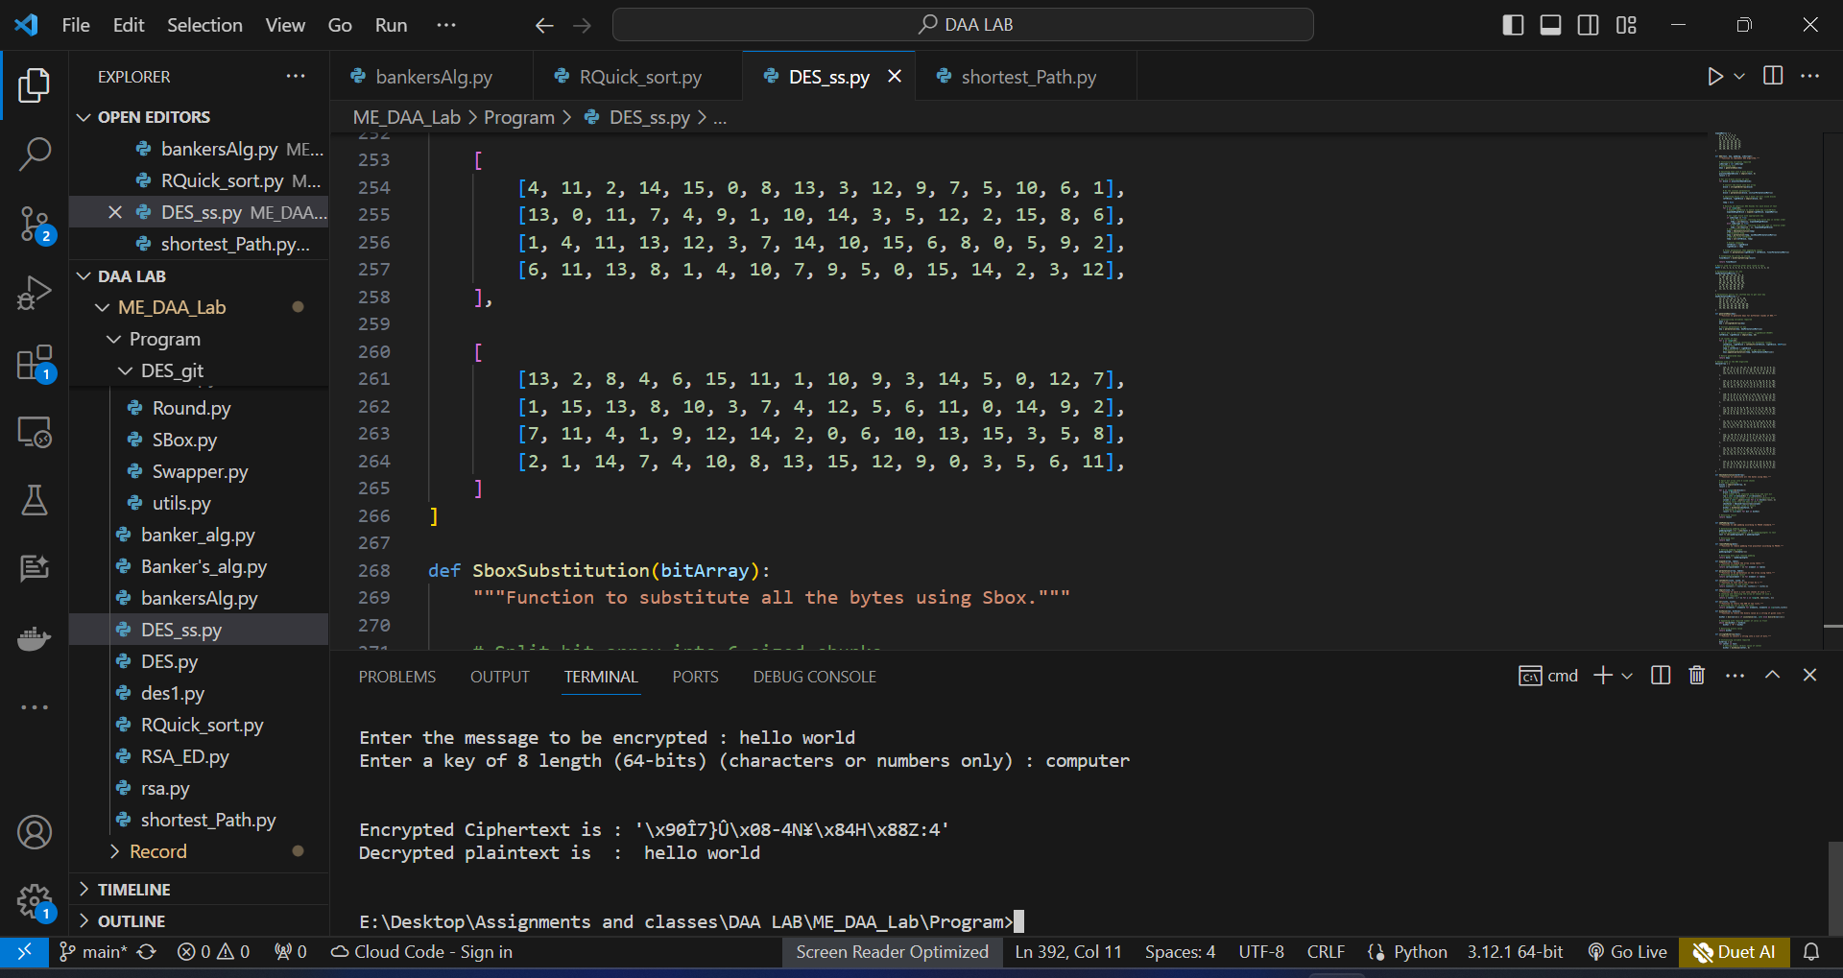

## RESULT:

Thus implementation of DES algorithm was completed successfully.

# Ex No:03 IMPLEMENTATION OF BANKER’S ALGORITHM FOR DEADLOCK AVOIDANCE

# Date:

## AIM:

To implement Banker’s algorithm for deadlock avoidance using python.

## ALGORITHM:

1. Start.
2. Get the input from the user.
3. If request<=need, go to step 4, else it shows an error.
4. If request<=available, go to step 5, else it must wait as the resource it requires is not
5. available.
6. If the resulting resource allocation is safe, the process is allocated to resources.
7. If it is unsafe, the old state process is restored.
8. Stop .

## PROGRAM:

def main():

# Get input from the user

n = int(input("Enter the number of processes: ")) # Number of processes

m = int(input("Enter the number of resource types: ")) # Number of resource types

# Allocation Matrix

print("Allocation matrix")

alloc = []

for i in range(n):

alloc.append(list(map(int, input(f"Enter allocation for Process {i}: ").split())))

# MAX Matrix

print("MAX matrix")

max = []

for i in range(n):

max.append(list(map(int, input(f"Enter MAX for Process {i}: ").split())))

# Available Resources

avail = list(map(int, input("Enter the available resources: ").split()))

# Initialization

f = [0] * n

ans = [0] * n

ind = 0

for k in range(n):

f[k] = 0

need = [[0 for i in range(m)] for i in range(n)]

for i in range(n):

for j in range(m):

need[i][j] = max[i][j] - alloc[i][j]

# Applying Banker's Algorithm

for k in range(n):

for i in range(n):

if f[i] == 0:

flag = 0

for j in range(m):

if need[i][j] > avail[j]:

flag = 1

break

if flag == 0:

ans[ind] = i

ind += 1

for y in range(m):

avail[y] += alloc[i][y]

f[i] = 1

# Determine whether the system is safe or unsafe

safe = all(f)

if safe:

print("The system is in a safe state.")

print("The safe sequence:")

for i in range(n - 1):

print("P", ans[i], " -> ", sep="", end="")

print("P", ans[n - 1], sep="")

else:

print("The system is in an unsafe state.")

if __name__ == "__main__":

main()

## OUTPUT:

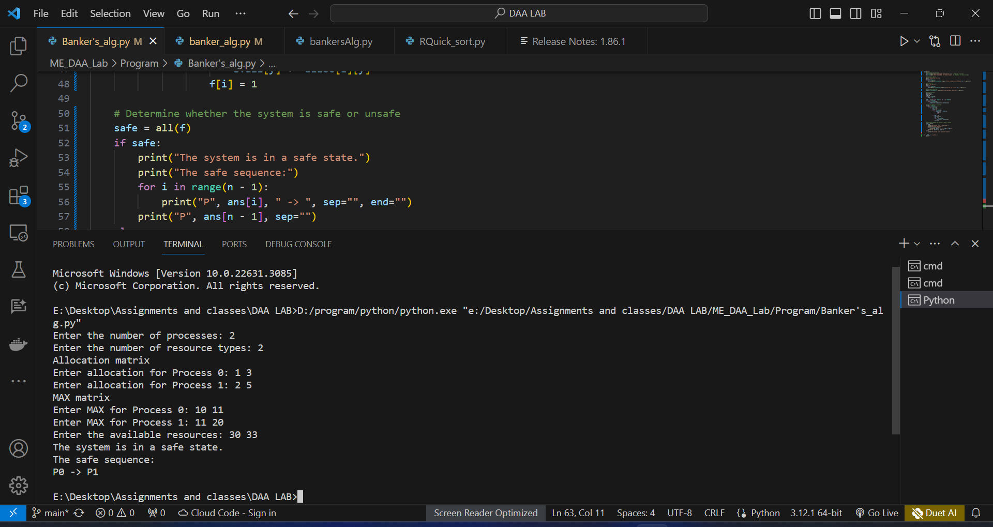

## RESULT:

Thus implementation of bancker’s algorithm was completes successfully.

# Ex No:04 IMPLEMENTATION OF RANDOMIZED QUICK SORT USING DIVIDE AND CONQUER STRATEGY

# Date:

## AIM:

To implement randomized quick sort using divide and conquer strategy.

## ALGORITHM:

1. Start the program.
2. Read an input array.
3. Select a pivot randomly, then swap it with the right most position of the array.
4. Fix two pointers i.e., pivot element and the left most element.
5. Pivot is now compared with all other elements, if any number smaller than pivot is found,

swap that element with the greatest number found.

1. Repeat step 5 until it reaches the end of the array, then swap the pivot element with the second pointer.
2. Pivot elements are again chosen for the left and right sub arrays separately.
3. Repeat steps from 3 to 6.
4. Print the sorted array.
5. Stop the program.

## PROGRAM:

import random

# Function to find the partition position

def partition(array, low, high):

# Choose a random pivot position

randomNumber = random.randint(low, high)

# Swap the pivot element with the last element of the array

array[randomNumber], array[high] = array[high], array[randomNumber]

# Choose the rightmost element as pivot

pivot = array[high]

# Pointer for the greater element

i = low - 1

swap = 0

# Traverse through all elements

# Compare each element with pivot

for j in range(low, high):

if array[j] <= pivot:

# If element smaller than pivot is found

# Swap it with the greater element pointed by i

i += 1

array[i], array[j] = array[j], array[i]

swap += 1

# Swap the pivot element with the greater element specified by i

array[i + 1], array[high] = array[high], array[i + 1]

# Return the position from where partition is done

return i + 1

# Function to perform quicksort

def quickSort(array, low, high):

if low < high:

# Find pivot element such that

# elements smaller than pivot are on the left

# elements greater than pivot are on the right

pi = partition(array, low, high)

# Recursive call on the left of pivot

quickSort(array, low, pi - 1)

# Recursive call on the right of pivot

quickSort(array, pi + 1, high)

# Input

data = []

n = int(input("\nEnter number of elements: "))

for i in range(n):

ele = int(input("Enter the element: "))

data.append(ele)

print("\nOriginal array:", data)

# Sorting

quickSort(data, 0, n - 1)

print("\nSorted Array in Ascending Order:", data)

## OUTPUT:

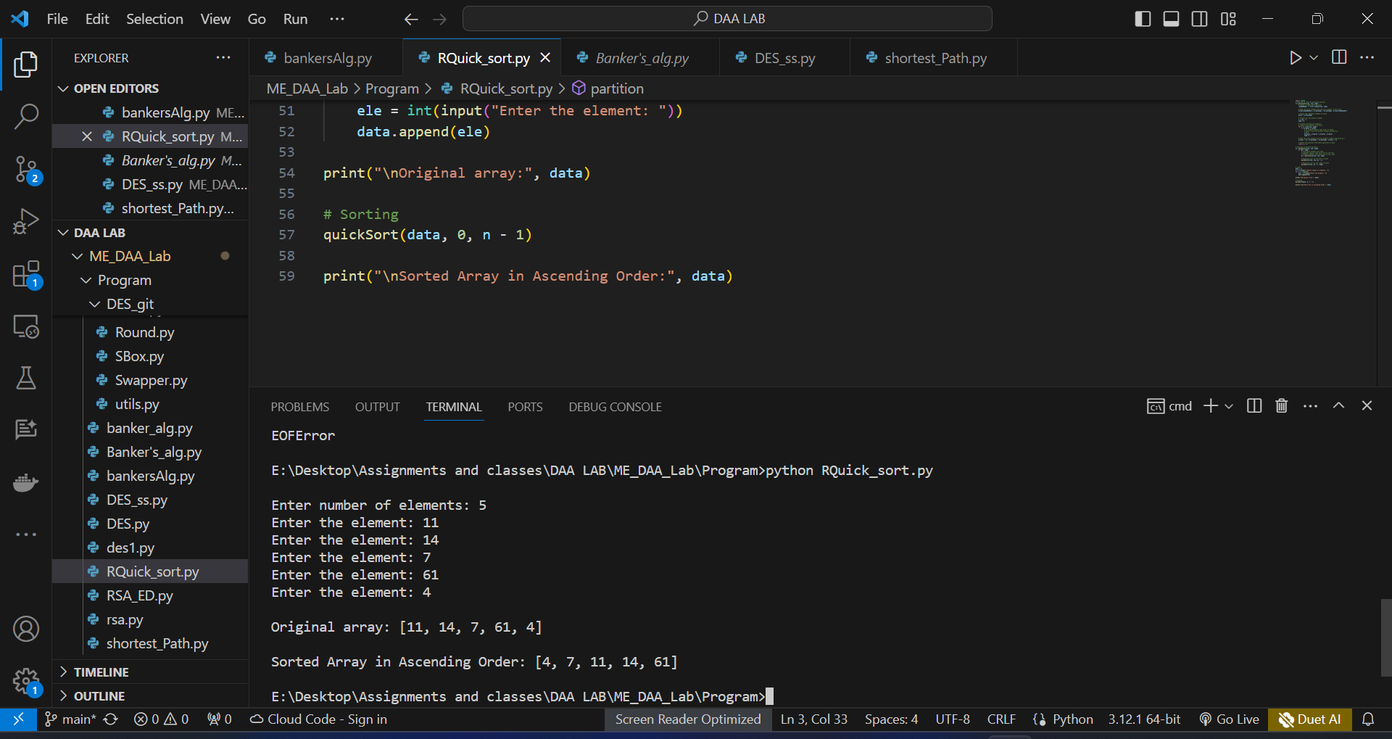

## RESULT:

Thus, the implementation of randomized quick sort using divide and conquer strategy in python was executed and verified successfully.

|  |  |
| --- | --- |
| Ex No :DATE: | IMPLEMENT SHORTEST PATH USING DYNAMIC PROGRAMMING IN A MULTI-STAGED GRAPH |

## AIM:

To implement shortest path using dynamic programming in a multi staged graph using python.

## ALGORITHM:

1. Start.
2. Create a cast table with dimensions (num stages+1)*min-nodes.
3. Initialize all entries to positive infinity except for the destination node in the last stage which is initialize to 0.
4. Iterate through each stage starting from the second-to last stage down to the first.
5. For each node in the current stage starting.
   1. Calculate the minimum cost to reach each neighbor in the next stage.
   2. Update the cost table with the minimum cost to reach each node.
6. The entry at position (0,0) in the cost table represents the shortest path cost from source node to the destination node..
7. Return the shortest path cost.
8. Stop.

## PROGRAM:

# Define a function to find the minimum cost and optimal path in a multistage graph

def min_cost_multistage_graph(graph, stages):

num_stages = len(stages)

num_nodes = len(graph)

# Initialize cost and parent arrays

cost = [float('inf')] * num_nodes

parent = [None] * num_nodes

# Set costs for nodes in the first stage to 0

for node in stages[0]:

cost[node] = 0

# Dynamic Programming approach to calculate minimum cost

for i in range(1, num_stages):

for node in stages[i]:

min_cost = float('inf')

for parent_node in stages[i - 1]:

edge_cost = graph[parent_node][node]

total_cost = cost[parent_node] + edge_cost

if total_cost < min_cost:

min_cost = total_cost

parent[node] = parent_node

cost[node] = min_cost

# Reconstruct the shortest path

path = [None] * num_stages

path[num_stages - 1] = stages[num_stages - 1][0]

for i in range(num_stages - 2, -1, -1):

path[i] = parent[path[i + 1]]

return cost[stages[num_stages - 1][0]], path

# Get input from the user

num_nodes = int(input("Enter the number of nodes: "))

graph = [[0] * num_nodes for _ in range(num_nodes)]

# Input weights for edges

for i in range(num_nodes):

edges = input(f"Enter weights for edges from node {i}: ").split()

graph[i] = [int(weight) for weight in edges]

num_stages = int(input("Enter the number of stages: "))

stages = [list(map(int, input(f"Enter nodes for stage {i}: ").split())) for i in range(num_stages)]

# Call the min_cost_multistage_graph function with user input

min_cost, optimal_path = min_cost_multistage_graph(graph, stages)

# Print the results

print(f"Minimum cost: {min_cost}")

print("Optimal Path:", optimal_path)

## OUTPUT:

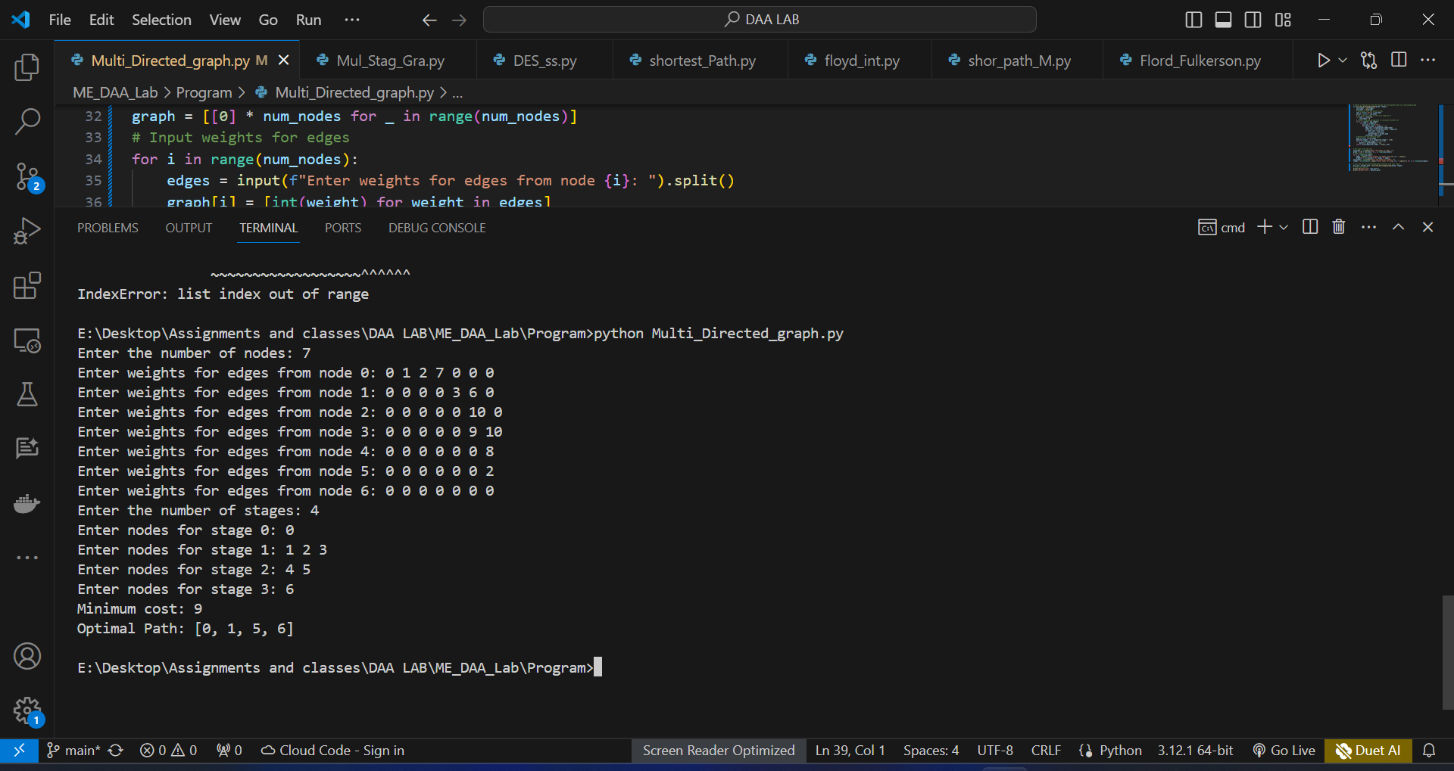

## RESULT:

Thus, the implementation of shortest path using dynamic programming in a multistage graph using python was executed and verified successfully.

|  |  |
| --- | --- |
| Ex No :DATE: | IMPLEMENTATION OF FORD FULKERSON ALGORITHM TO COMPUTE THE MAXIMUM FLOW IN A GRAPH |

## AIM:

To implement Ford Fulkerson algorithm to compute the maximum flow in a graph using python.

## ALGORITHM:

1. Start.
2. Initialize the flow in all the edges to 0.
3. While there is an augmenting path between the source and the sink and add this path to the flow.
4. Repeat search for an s-t path p while it exists.
5. Find if there is a path from s to t using breadth first search. A path exists if f(e) <c(e) for every edge e on the path.
6. If no path found, return max flow.
7. Else find minimum edge value for path p.
8. Flow=min(c(e)-f(e)) for path p, max_flow+=flow.
9. For all edge e of path incremented flow, f(e)+=flow.
10. Update the residual graph.
11. Stop.

## PROGRAM:

class Graph:

def __init__(self, vertices):

self.V = vertices

self.graph = [[0] * vertices for _ in range(vertices)]

def is_valid_edge(self, u, v, capacity):

return 0 <= u < self.V and 0 <= v < self.V and capacity >= 0

def add_edge(self, u, v, capacity):

if self.is_valid_edge(u, v, capacity):

self.graph[u][v] = capacity

def print_solution(self, flow):

print("Edge\tFlow")

for i in range(self.V):

for j in range(self.V):

if flow[i][j] > 0:

print(f"{i} -> {j}\t{flow[i][j]}")

def ford_fulkerson(self, source, sink):

parent = [-1] * self.V

max_flow = 0

flow = [[0] * self.V for _ in range(self.V)]

while self.bfs(source, sink, parent):

path_flow = float("inf")

s = sink

while s != source:

path_flow = min(path_flow, self.graph[parent[s]][s])

s = parent[s]

max_flow += path_flow

v = sink

while v != source:

u = parent[v]

flow[u][v] += path_flow

flow[v][u] -= path_flow

v = parent[v]

# Update the residual capacities of edges along the path

v = sink

while v != source:

u = parent[v]

self.graph[u][v] -= path_flow

self.graph[v][u] += path_flow

v = parent[v]

# Reset parent array for next BFS

parent = [-1] * self.V

self.print_solution(flow)

return max_flow

def bfs(self, source, sink, parent):

visited = [False] * self.V

queue = [source]

visited[source] = True

while queue:

u = queue.pop(0)

for ind, val in enumerate(self.graph[u]):

if not visited[ind] and val > 0:

queue.append(ind)

visited[ind] = True

parent[ind] = u

return visited[sink]

if __name__ == "__main__":

vertices = int(input("Enter the number of vertices: "))

g = Graph(vertices)

edges = int(input("Enter the number of edges: "))

print("Enter the edges (source, destination, capacity): ")

for _ in range(edges):

u, v, capacity = map(int, input().split())

g.add_edge(u, v, capacity)

source = int(input("Enter the source node: "))

sink = int(input("Enter the sink node: "))

max_flow = g.ford_fulkerson(source, sink)

print(f"The maximum flow is {max_flow}")

## OUTPUT:

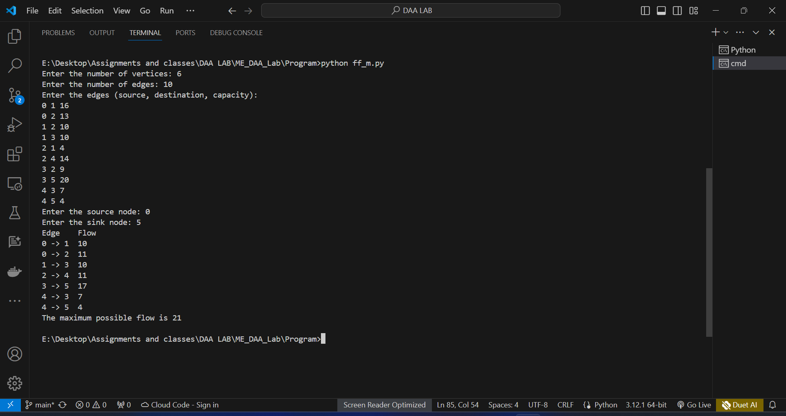

## RESULT:

Thus, the implementation of Ford Fulkerson algorithm to compute maximum flow in a graph using python was executed and verified successfully.

|  |  |
| --- | --- |
| Ex No :DATE: | IMPLEMENTATION OF BOYER-MOORE ALGORITHM FOR PATTERN SEARCHING |

## AIM:

Implementation of boyer-moore algorithm for pattern searching

## ALGORITHM:

1. Start.
2. Create Bad Character Shift table for pattern characters.
3. Create Good Suffix Shift table.
4. Start matching from the right end of the pattern.
5. If a mismatch occurs:
   1. Use Bad Character Shift to calculate the shift based on the mismatched character.
   2. Use Good Suffix Shift for additional shifts.
   3. Shift the pattern by the maximum of the calculated values.
6. Continue matching until a match is found or the end of the text is reached.
7. Return the starting index of the first occurrence if found, otherwise, return -1.
8. Stop.

## PROGRAM:

def preprocess_pattern(pattern):

bad_char_shift = {}

pattern_length = len(pattern)

for i in range(pattern_length - 1):

bad_char_shift[pattern[i]] = pattern_length - i - 1

return bad_char_shift

def boyer_moore_search(text, pattern):

bad_char_shift = preprocess_pattern(pattern)

text_length = len(text)

pattern_length = len(pattern)

occurrences = []

i = pattern_length - 1

while i < text_length:

j = pattern_length - 1

k = i

while j >= 0 and text[k] == pattern[j]:

k -= 1

j -= 1

if j == -1:

occurrences.append(k + 1)

bad_char_shift_value = bad_char_shift.get(text[i], pattern_length)

i += max(1, pattern_length - j, bad_char_shift_value)

else:

bad_char_shift_value = bad_char_shift.get(text[i], pattern_length)

i += max(1, bad_char_shift_value)

return occurrences

# Get input from the user

text = input("Enter the text: ")

pattern = input("Enter the pattern to search: ")

# Perform search

results = boyer_moore_search(text, pattern)

# Display result

if results:

print("Pattern found at indices:", results)

else:

print("Pattern not found in the text.")

## OUTPUT:

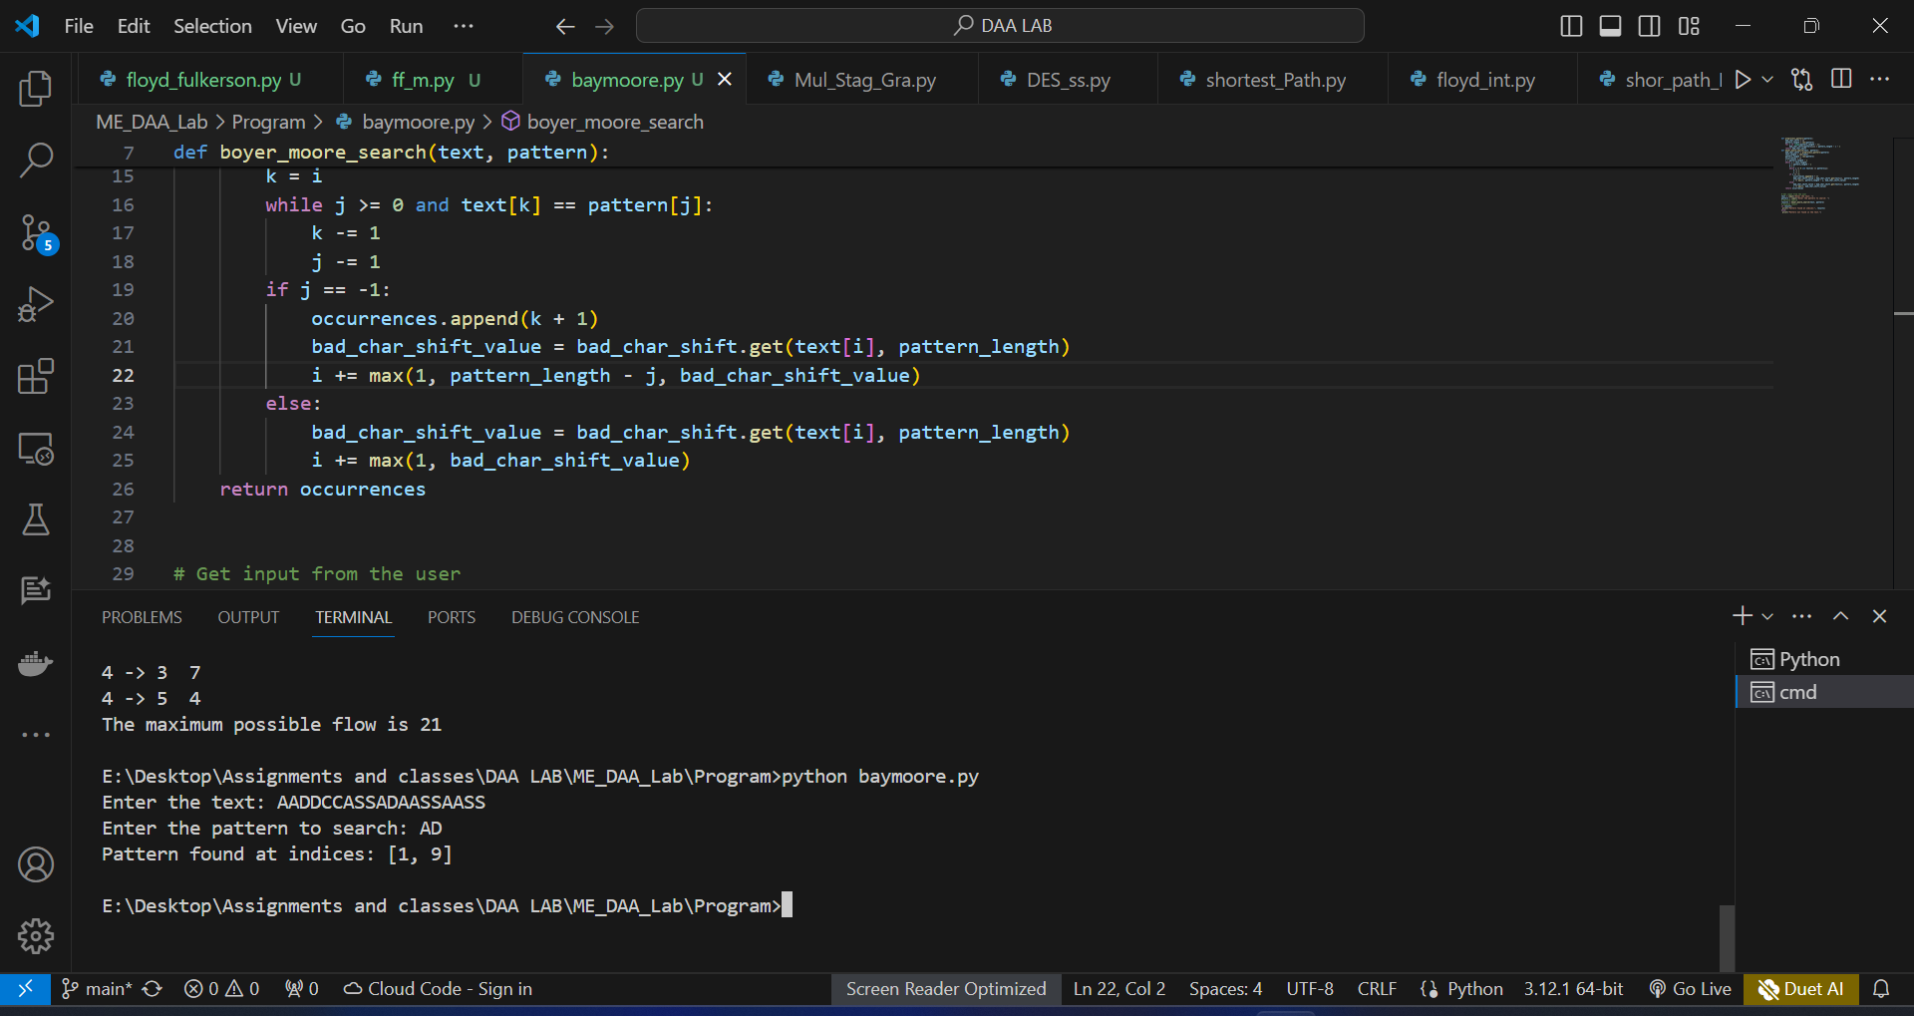

## RESULT:

Thus, the implementation of Boyer-Moore algorithm for pattern searching was executed and verified successfully.

|  |  |
| --- | --- |
| Ex No :DATE: | SOLVE THE GRAPH COLORING PROBLEM BY BACKTRACKING AND CONSTRAINT PROPAGATION (USING HEURISTICS) |

## AIM:

To solve the graph colouring problem by backtracking and constraint propagation using heuristics in python.

## ALGORITHM:

1. Start.
2. Get the number of vertices and edges from the user.
3. If the nearby edge is adjacent, colour the edge with different colour.
4. Else nearby edge is not adjacent, colour the edge with same colour.
5. Create a recursive function that takes the graph, current index, number of vertices and output colour array.
6. If the current index is equal to the number of vertices, print the color configuration in the output array.
7. Assign a colour to vertex (1 to m).
8. For every assigned colour, check if the configuration is safe.
9. If any recursive function returns the true, break the loop and return true.
10. If no recursive function returns true, then return false.
11. Stop.

## PROGRAM:

import matplotlib.pyplot as plt

import networkx as nx

class Graph:

def __init__(self, vertices):

self.vertices = vertices

self.graph = [[0 for _ in range(vertices)] for _ in range(vertices)]

def add_edge(self, u, v):

self.graph[u][v] = 1

self.graph[v][u] = 1

def is_safe(self, v, color, c):

for i in range(self.vertices):

if self.graph[v][i] == 1 and color[i] == c:

return False

return True

def graph_coloring_util(self, m, color, v):

if v == self.vertices:

return True

for c in range(1, m + 1):

if self.is_safe(v, color, c):

color[v] = c

if self.graph_coloring_util(m, color, v + 1):

return True

color[v] = 0

def graph_coloring(self, m):

color = [0] * self.vertices

if not self.graph_coloring_util(m, color, 0):

print("No solution exists")

return False

print("Solution exists with the following coloring:")

for c in color:

print(c, end=" ")

# Plotting the colored graph

G = nx.Graph()

for i in range(self.vertices):

G.add_node(i)

for i in range(self.vertices):

for j in range(i + 1, self.vertices):

if self.graph[i][j] == 1:

G.add_edge(i, j)

node_colors = [color[i] for i in range(self.vertices)]

nx.draw(G, with_labels=True, node_color=node_colors, cmap=plt.cm.rainbow, node_size=1000)

plt.show()

return True

if __name__ == "__main__":

# Get input from the user

vertices = int(input("Enter the number of vertices: "))

edges = int(input("Enter the number of edges: "))

g = Graph(vertices)

# Get edges from the user

print("Enter the edges (vertex1 vertex2):")

for _ in range(edges):

u, v = map(int, input().split())

g.add_edge(u, v)

m = 3 # Number of colors

g.graph_coloring(m)

## OUTPUT:

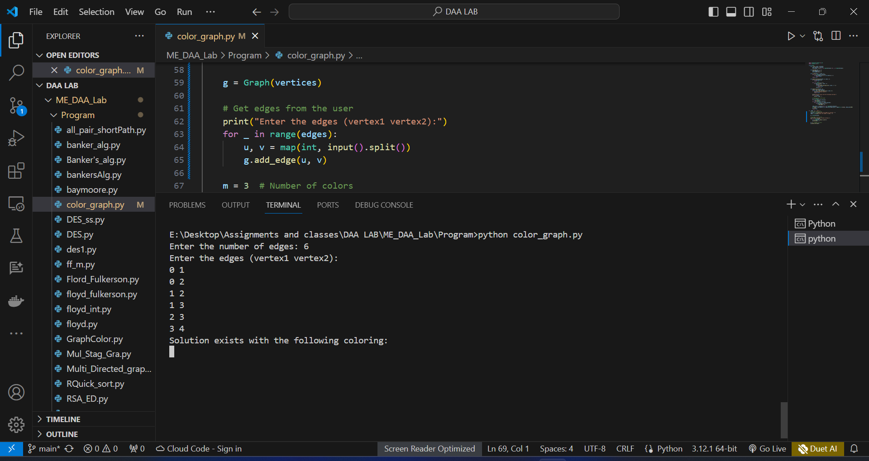

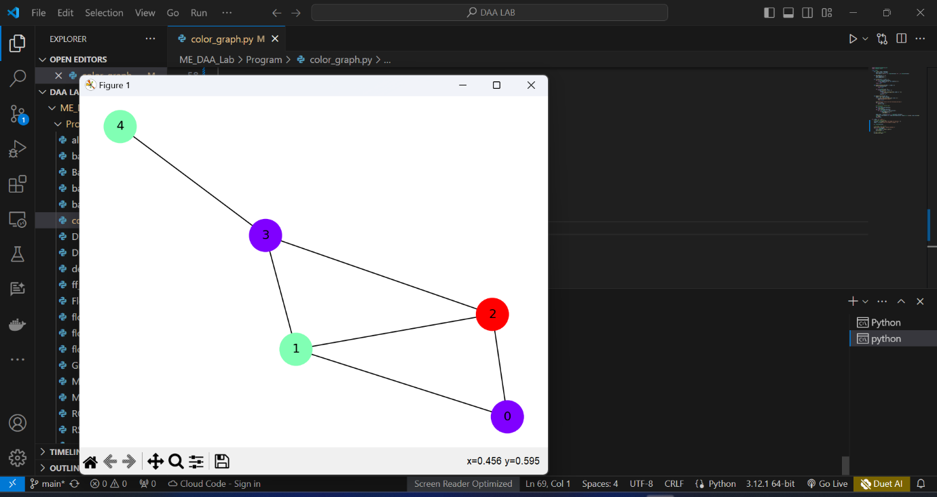

## RESULT:

Thus, the graph colouring problem by backtracking and constraint propagation using heuristics in python was executed and verified successfully