1. What is software? What is software engineering?

-🡪 Software collection of programs, data, and instructions that tell a computer how to perform specific tasks. It can be classified into two main types:

1. System Software: Includes operating systems (e.g., Windows, macOS, Linux,) and utilities that manage hardware and run the computer.
2. Application Software: Includes programs designed to perform specific tasks for the user, such as word processors, web browsers, and games.

software engineering:--

Software Engineering is the disciplined approach to designing, developing, testing, and maintaining software. It involves applying engineering principles to software creation to ensure that the software is reliable, efficient, and scalable.

Requirement analysis: Understanding what the software needs to do.

Design: Creating architectures and detailed designs.

Implementation: Writing the code.

Testing: Ensuring the software works as expected.

Maintenance: Fixing bugs and updating the software over time.

2. Explain types of software.?

1. System Software

Definition: System software serves as a foundation, managing and operating computer hardware. It acts as an intermediary between hardware and user applications

Examples

Operating Systems (OS), Device Drivers, Utility Programs.

2. Application Software

Definition: Application software is designed to perform specific tasks for users, such as word processing, web browsing, or gaming.

Examples:--

Productivity Software, Web Browsers, Media Players.

**3. Development Software**

* **Definition**: Development software provides tools for developers to create, debug, and maintain other software applications.
* **Examples**

Integrated Development Environments (IDEs), Code Editors, Version Control Software.

1. What is SDLC? Explain each phase of SDLC ?

The Software Development Life Cycle (SDLC) is a structured process that guides the development of software applications.Here are the typical phases of SDLC:

1. Planning

In this initial phase, the project goals, scope, resources, timelines, and feasibility are defined. Stakeholders gather to discuss requirements and analyze potential risks. This phase lays the groundwork for the entire project.

2. Requirements Gathering and Analysis

During this phase, detailed requirements are collected from stakeholders through interviews, surveys, and observations. The requirements are analyzed to ensure they are clear, complete, and feasible. This phase results in a requirements specification document that serves as a foundation for design.

3. Design

The design phase involves creating the architecture of the software system. This includes high-level design (HLD), which outlines the overall system architecture, and low-level design (LLD), which details individual components and modules. Design specifications are created to guide the development team.

4. Implementation (or Development)

In this phase, the actual coding takes place. Developers write the code based on the design specifications. This phase often includes unit testing, where individual components are tested for functionality. Collaboration and version control are essential to manage the code effectively.

5. Testing

Once the software is developed, it undergoes rigorous testing to identify defects and ensure it meets the specified requirements. This phase may include different types of testing, such as functional, integration, system, and user acceptance testing (UAT). The goal is to ensure the software is reliable and ready for deployment.

6. Deployment

After successful testing, the software is deployed to a production environment. This phase may involve a staged rollout, where the software is released to a limited audience before full deployment. Users are trained, and documentation is provided to support the transition.

7. Maintenance

Post-deployment, the software enters the maintenance phase, where it is monitored for issues and updated as needed. This phase includes bug fixes, performance enhancements, and adding new features based on user feedback. Continuous maintenance is essential for keeping the software functional and relevant

1. 4. What is DFD? Create a DFD diagram on Flipkart

A Data Flow Diagram (DFD) is a visual representation of the flow of data within a system. It illustrates how data moves between processes, data stores, and external entities, providing a clear overview of how information is handled within the system.

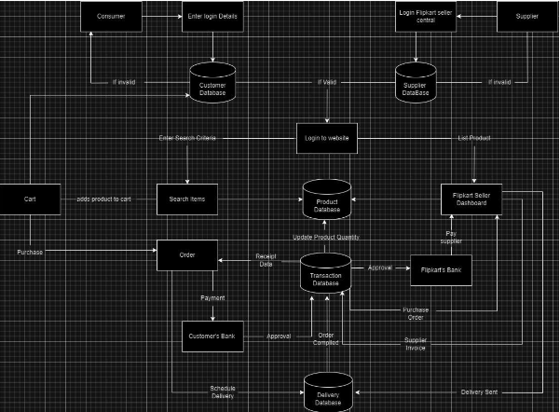

1. What is Flow chart? Create a flowchart to make addition of two numbers.?

A flowchart is a diagram that represents a process, algorithm, or workflow in a visual format.

It uses symbols and arrows to illustrate steps and the sequence in which they occur, helping to simplify complex tasks and make them easier to understand.

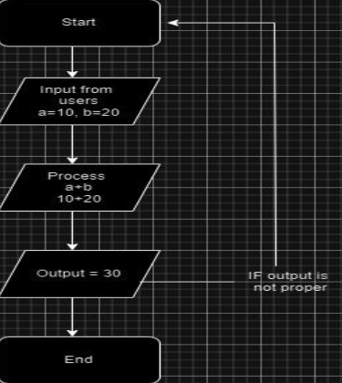

1. What is Use case Diagram? Create a use-case on bill payment on paytm.?

A Use Case Diagram is a visual representation of how a user interacts with a system.

It shows the relationships between different actors (users or other systems) and various use cases (actions or processes) that the system provides.

Use case diagrams help to clarify system requirements and illustrate the scope and functionality of a system.

