兰州交通大学
电信学院上机实验（作业）报告

实验课程： Java企业级开发技术

实验地点： 2教102

专 业 软件工程
班 级 2001班
学生姓名 闫凌飞
学 号 20203206130

上机实验1

1.实验目的
1）掌握Mybatis环境配置
2）熟悉Mybatis基本开发流程
3）能够开发简单的入门程序

2.实验内容
创建1个学生(student)表,包括学号(num)，姓名(name)，年龄(age)，通过Mybatis框架实现如下数据库访问功能：
1)根据num查询学生信息；
2)查询所有学生信息；
3)查询年龄大于20的所有学生；
用两种方式（基于映射文件、基于注解）

分析、代码及运行结果
数据库：
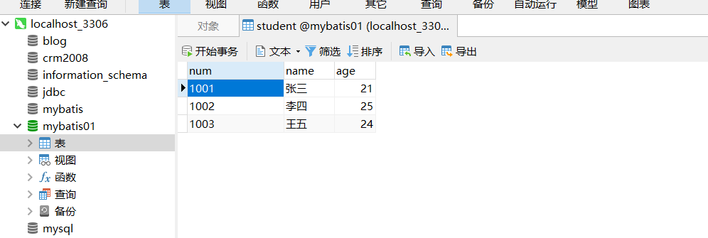
Jdbc.properties
jdbc.driver = com.mysql.cj.jdbc.Driver
jdbc.url = jdbc:mysql://localhost:3306/mybatis01
jdbc.username = root
jdbc.password = root
Mybatis-config.xml
<?xml version="1.0" encoding="UTF-8" ?>
<!DOCTYPE configuration
PUBLIC "-//mybatis.org//DTD Config 3.0//EN"
"https://mybatis.org/dtd/mybatis-3-config.dtd">
<configuration>
<properties resource="jdbc.properties"/>
<!-- &lt;!&ndash;打印sql&ndash;&gt;
<settings>
&lt;!&ndash; 打印查询语句 &ndash;&gt;
<setting name="logImpl" value="STDOUT_LOGGING" />
</settings>-->
<environments default="development">
<environment id="development">
<transactionManager type="JDBC"/>
<dataSource type="POOLED">
<property name="driver" value="${jdbc.driver}"/>
<property name="url" value="${jdbc.url}"/>
<property name="username" value="${jdbc.username}"/>
<property name="password" value="${jdbc.password}"/>
</dataSource>
</environment>
</environments>
<mappers>
<mapper resource="StudentMapper.xml" />
<mapper class="com.yan.mybatis.mapper.StudentMapper"/>
</mappers>
</configuration>
接口StudentMapper
package com.yan.mybatis.mapper;
import com.yan.mybatis.pojo.Student;
import org.apache.ibatis.annotations.Select;
import java.util.List;
public interface StudentMapper {
//根据num进行查询
@Select("select * from student where num = #{num}")
Student selectByNum1(String num);
//查询所有
@Select("select * from student")
List<Student> selectAll1();
@Select("select * from student where age > #{age}")
List<Student> selectByAge1(int age);
}

Stutent.java
package com.yan.mybatis.pojo;
public class Student {
private String num;
private String name;
private Integer age;
public String getNum() {
return num;
}
public void setNum(String num) {
this.num = num;
}
public String getName() {
return name;
}
public void setName(String name) {
this.name = name;
}
public Integer getAge() {
return age;
}
public void setAge(Integer age) {
this.age = age;
}
@Override
public String toString() {
return "Student{" +
"num='" + num + '\'' +
", name='" + name + '\'' +
", age=" + age +
'}';
}
}
StudentMapper.xml
<?xml version="1.0" encoding="UTF-8" ?>
<!DOCTYPE mapper
PUBLIC "-//mybatis.org//DTD Mapper 3.0//EN"
"https://mybatis.org/dtd/mybatis-3-mapper.dtd">
<mapper namespace="Student">
<!-- 根据num查询-->
<select id="selectByNum" parameterType="String" resultType="com.yan.mybatis.pojo.Student">
select * from student where num = #{num}
</select>
<!-- 查询所有学生信息-->
<select id="selectAll" resultType="com.yan.mybatis.pojo.Student">
select * from student
</select>
<!-- 查询年龄大于一个参数的学生-->
<select id="selectByAge" resultType="com.yan.mybatis.pojo.Student">
select * from student where age > #{age}
</select>
</mapper>
测试代码
工具类
package com.yan.mybatis.utils;
import org.apache.ibatis.io.Resources;
import org.apache.ibatis.session.SqlSession;
import org.apache.ibatis.session.SqlSessionFactory;
import org.apache.ibatis.session.SqlSessionFactoryBuilder;
import java.io.IOException;
public class SqlSessionUtil {
private SqlSessionUtil(){}
private static SqlSessionFactory sqlSessionFactory;
static {
try {
sqlSessionFactory = new SqlSessionFactoryBuilder().build(Resources.getResourceAsStream("mybatis-config.xml"));
} catch (IOException e) {
e.printStackTrace();
}
}
public static SqlSession openSession(){
return sqlSessionFactory.openSession();
}
}

基于映射文件的
@Test
public void testSelectByNum(){
SqlSession sqlSession = SqlSessionUtil.openSession();
Object selectByNum = sqlSession.selectOne("selectByNum", "1001");
System.out.println(selectByNum);
sqlSession.close();
}
@Test
public void testSelectAll(){
SqlSession sqlSession = SqlSessionUtil.openSession();
List<Object> students = sqlSession.selectList("selectAll");
students.forEach(student -> System.out.println(student));
sqlSession.close();
}
@Test
public void testSelectAge(){
SqlSession sqlSession = SqlSessionUtil.openSession();
List<Object> students = sqlSession.selectList("selectByAge", 22);
students.forEach(student-> System.out.println(student));
sqlSession.close();
}
基于注解的
@Test
public void testSelectByNum1(){
SqlSession sqlSession = SqlSessionUtil.openSession();
StudentMapper mapper = sqlSession.getMapper(StudentMapper.class);
Student student = mapper.selectByNum1("1001");
System.out.println(student.toString());
sqlSession.close();
}
@Test
public void testSelectAll1(){
SqlSession sqlSession = SqlSessionUtil.openSession();
StudentMapper mapper = sqlSession.getMapper(StudentMapper.class);
List<Student> students = mapper.selectAll1();
students.forEach(student -> System.out.println(student));
sqlSession.close();
}
@Test
public void testSelectByAge1(){
SqlSession sqlSession = SqlSessionUtil.openSession();
StudentMapper mapper = sqlSession.getMapper(StudentMapper.class);
List<Student> students = mapper.selectByAge1(22);
students.forEach(student -> System.out.println(student));
sqlSession.close();
}

测试结果
- 基于映射文件
根据num进行查询
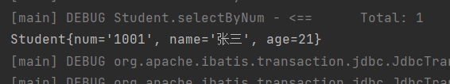
查询所有
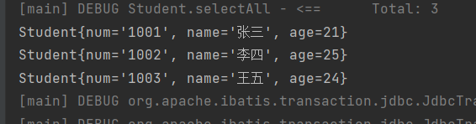
查询年龄大于22的所有信息
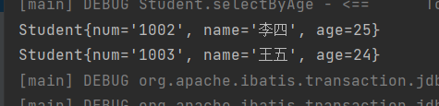

- 基于注解
根据num进行查询
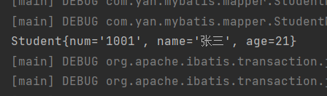
查询所有
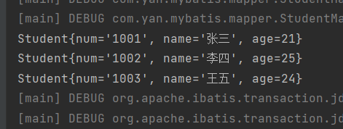
查询年龄大于22的所有信息
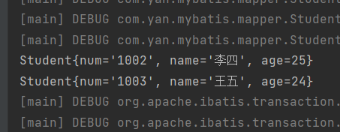
总结：
在这次上机过程中，明白了如何搭建一个见得mybatis入门程序，以及数据源的配置和各种配置文件的配置，以及他们之间的属性。并且引入了logback依赖，更清楚的展现出了mybatis后台是如何运行的，并且为查找错误提供了方便。同时，采用了映射文件和注解这两种方式实现了最基本的功能。

