Position properties in css

1**.static**

*By default browser ki hoti h*

Isme koi top bottom left right kuch nhi set kr skte h hm

2.**relative**

a🡪 window ke corsponding rhta h viewport

b🡪 top bottom left right set kr skte h

c🡪 space jo hota h element ka ghere rhta h positioning ke baad bhi

2

3

1

2 ka space

3. ***absolute***

It uses for Overlapping something

Isme koi GAP maintain nhi hota h

Imp🡪 it uses on its closest insester

<div> closed intester set position relative

<img>

<img>

<img> -🡪 set position absolute

<img>

</div>

For example below imgae

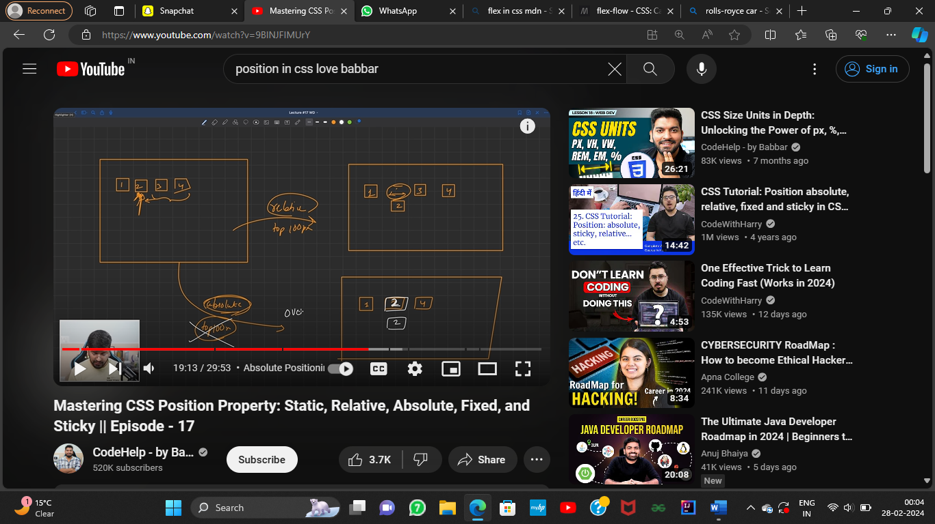

**Other position properties --🡪 Fixed and sticky**

***Flex box properties***

flex box is used to make lay-out of a web page

* It is more usefull than float and other layout properties
* To use this “display:flex” on container class
* We should use flex-item properties

<div class="flex-container">

<div>1</div>

<div>2</div>

<div>3</div>

</div>

Style---

.flex-container {

display: flex;

background-color: DodgerBlue;

}

**The flex container properties are:**

* [flex-direction](https://www.w3schools.com/csS/css3_flexbox_container.asp#flex-direction)
* [flex-wrap](https://www.w3schools.com/csS/css3_flexbox_container.asp#flex-wrap)
* [flex-flow](https://www.w3schools.com/csS/css3_flexbox_container.asp#flex-flow)
* [justify-content](https://www.w3schools.com/csS/css3_flexbox_container.asp#justify-content)
* [align-items](https://www.w3schools.com/csS/css3_flexbox_container.asp#align-items)
* [align-content](https://www.w3schools.com/csS/css3_flexbox_container.asp#align-content)

**javascrtipt GET and SET methods**

GET methods

* **innerText get all only text from html**
* **innerHTML get all HTML with its content**

**getAttribute**

 var tem=document.getElementById("frm").getAttribute("class");

kon se attribute ka chahiye as a string pass krna hoga class id other

style other all attributes

* **getAttributeNode**
* var tem=document.getElementById("frm").getAttributeNode("class");
* Ye method attribute ka name and value ek sath print ked eta h
* Ex: class:container and only value chahiye tb hm use krenge
* getAttributeNode(“class”).value
* this methods is not suggest to use
* **Attributes**
* var tem=document.getElementById("frm").attributes;
* Returns all attributes as an array object and we can do indexing on it to get values
* Attributes[2].value get index 2 attribute value
* Attributes[2].name get attribute name

SET METHODS IN DOM

* innerText set only text part not html
* innerHTML set html part
* document.getElementById("f1").innerHTML="<label>vinit</label>";
* This can only set “vinit” but in terms of innerTEXT
* <label>…..</label> element also print
* setAttribute
* document.getElementById("frm").setAttribute("class","xyz1");
* console.log(document.getElementById("frm").getAttribute("class"));

“attributeName”,”what value want to set”

* Attribute attribute[index].value=new value;
* removeAttribute removeAttribute(“name of attribute”)

 CSS Overflow

The overflow property specifies whether to clip the content or to add scrollbars when the content of an element is too big to fit in the specified area.

The overflow property has the following values:

* visible - Default. The overflow is not clipped. The content renders outside the element's box
* hidden - The overflow is clipped, and the rest of the content will be invisible
* scroll - The overflow is clipped, and a scrollbar is added to see the rest of the content
* auto - Similar to scroll, but it adds scrollbars only when necessary

 .container {

            height: 150px;

            width: 200px;

            background-color: red;

 overflow:auto;

}

**Note: Remember that the height and width properties do not include padding, borders, or margins! They set the height/width of the area inside the padding, border, and margin of the element!**

The CSS background properties are used to add background effects for elements.

In these chapters, you will learn about the following CSS background properties:

* background-color
* background-image
* background-repeat
* background-attachment
* background-position
* background (shorthand property)