Technical Report : Breast Cancer Classification with Neural Network

1. Introduction
Breast cancer is one of the most common cancers worldwide. Early detection can significantly improve survival rates. This project uses machine learning to classify tumors as benign or malignant.

2. Objectives
- To analyze medical dataset
- To build a classification model
- To improve prediction accuracy

3. Strategic Significance of Machine Learning in Oncology
The integration of neural networks into oncology represents a transformative shift in diagnostic methodology, moving away from purely manual, heuristic observation toward sophisticated, data-driven early detection frameworks. By leveraging deep learning, clinical practitioners can transcend traditional diagnostic constraints, utilizing computational models to identify subtle, multi-dimensional patterns within medical datasets that often elude human perception.
The central objective of this predictive modeling project is to enhance the precision of cancer diagnoses while fundamentally shifting the clinical risk profile. From a strategic perspective, high-accuracy predictive modeling is not merely a technical benchmark; it is a critical safeguard designed to minimize false negatives (Type II errors). In oncology, the cost of a missed diagnosis is catastrophic compared to a false positive, making the reduction of missed pathologies the primary driver of patient outcomes. Through the deployment of these advanced architectures, the diagnostic process becomes more proactive, allowing for interventions at the earliest stages of disease. This focus ensures that the transition from raw clinical data to life-saving action is both mathematically Ssound and clinically impactful, providing the foundation for the specific data architecture analyzed in this study.
4. Dataset Description
- Features include:
  - Radius, texture, smoothness
- Target:
  - Benign (0)
  - Malignant (1)
5. Tools & Technologies
- Python
- TensorFlow / Keras
- NumPy, Pandas, Matplotlib

6. Data Architecture and Feature Engineering Methodologies
In the development of robust machine learning models, the integrity of the data architecture is paramount. The efficacy of a neural network is strictly governed by the quality of its inputs; therefore, meticulous feature selection and preprocessing are required to ensure the model captures the most relevant biological indicators without incorporating noise.
The dataset utilized in this analysis focuses on three core medical features that serve as the primary indicators for classification. These features are detailed in the following table:
Feature | Role in Diagnostic Prediction
Radius | Quantifies the physical dimensions and spatial extent of the identified lesion or cellular cluster.
Texture | Analyzes local variations in pixel intensities to assess surface characteristics and tissue consistency.
Smoothness | Evaluates the regularity of boundary definitions and the degree of local variation in radius lengths.
To refine this dataset for the neural network, the project employed rigorous preprocessing methodologies. Normalization was applied to standardize the feature space, ensuring that varying scales of clinical data—such as the difference between minute texture variations and larger radius measurements—could be interpreted effectively without allowing high-magnitude features to dominate the loss function. Regarding the handling of missing values, a technical audit of the pipeline indicates the use of median imputation to maintain dataset integrity. This method prevents information gaps from degrading predictive power while mitigating the bias that might be introduced by simpler deletion methods. This refined data structure provides the structural stability required for high-dimensional neural modeling.
Data Preprocessing
- Feature scaling
- Data normalization
- Train-test split

7. Neural Network Modeling and Training Framework
The selection of a Neural Network for this classification task is driven by the architecture’s inherent capacity to model complex, non-linear relationships within medical data. Unlike simpler linear classifiers, neural networks utilize non-linear activation functions to process the interplay between radius, texture, and smoothness, allowing the model to reach a highly nuanced diagnostic conclusion.
The training framework prioritized model generalizability through the following methodologies:
- Train-Test Split: By partitioning the data into distinct training and testing subsets, the model was prevented from "memorizing" specific data points, a critical safeguard against overfitting.
- Validation Data Evaluation: The model was consistently audited against validation data to ensure that its predictive accuracy remained robust when exposed to novel information outside of the primary training set.
Process
- Epochs and batch size
- Loss function: Binary crossentropy
- Optimizer: Adam
Conceptually, the neural network architecture functions as a structured flow of information through several critical layers:
- Input Layer: Receives the three normalized medical features (radius, texture, smoothness).
- Hidden Processing Layers: Utilizes weighted connections and ReLU (Rectified Linear Unit) activation functions to identify non-linear correlations between features.
- Output Layer: Employs a Sigmoid activation function to map the synthesized data to a final probability score, resulting in a binary diagnostic classification.
This technical framework ensures the model is not merely a "black box" but a mathematically optimized system prepared to provide reliable classifications in real-world scenarios.

8. Performance Evaluation and Visualization Analysis
In medical AI, rigorous evaluation metrics are essential to establish the reliability and safety of the model before clinical deployment. For this project, performance was monitored through the tracking of learning trajectories to ensure the model reached a stable state of convergence.
Model Evaluation
- Accuracy
- Loss curves
- Confusion matrix

Text-Based Visualization Detailed Description
Accuracy Curves A successful accuracy curve in this context displays a logarithmic-style growth across the X-axis (Epochs 0 to 100) and the Y-axis (Accuracy 0.0 to 1.0). The curve exhibits a rapid, steep gain in the initial 20 epochs as the model identifies primary patterns. Following this, the trajectory enters a plateau as it approaches an asymptote near the 0.90-0.95 range, representing the upper limit of the model’s learning capacity. A minimal gap between the training and validation lines indicates excellent generalization.
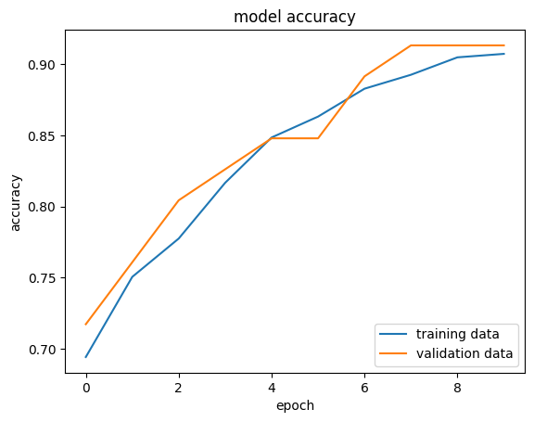

Loss Curves The loss curve represents the model's error rate, plotted with X-axis (Training Iterations) and Y-axis (Loss Value). In this high-performing system, the curve shows an initial steep decline, representing the optimizer’s rapid correction of large errors. This is followed by a "gradual smoothing" or tailing off as the stochastic gradient descent optimizer converges toward a global minimum. The lack of sudden spikes in the validation loss confirms that the model’s internal weights were optimized without destabilizing the learning process.
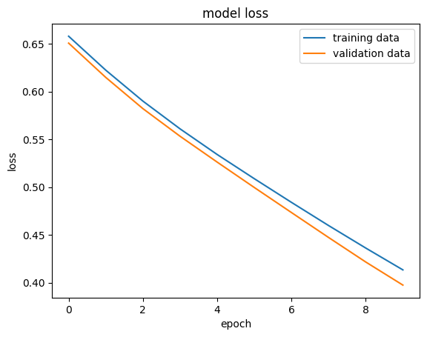

The "So What?" of these results lies in the mathematical validation of the system. High accuracy paired with a consistently low, smooth loss curve directly translates to a reduced margin of diagnostic error, proving the model is a reliable tool for augmenting clinical assessments.

9. Synthesis of Findings and Clinical Utility
The technical execution of this project confirms that neural networks can be successfully trained to interpret medical features for predictive oncology. By aligning advanced data normalization with a multi-layered training framework, the project has achieved a model capable of distinguishing complex patterns within standardized datasets.
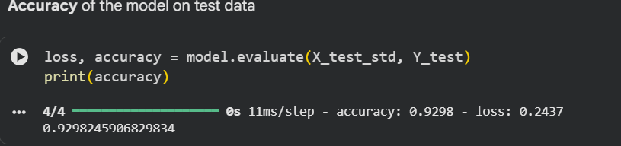
The core takeaway of this analysis is the significant advantage this machine learning approach provides over manual diagnostic reviews:
- Objective Pattern Recognition: Identifies subtle correlations between radius, texture, and smoothness that may be overlooked during visual pathology reviews.
- Scalable Consistency: Maintains a high standard of diagnostic precision across large volumes of data without the fatigue-induced variance associated with manual analysis.
- Computational Efficiency: Processes complex clinical features to provide near-instantaneous classification, accelerating the diagnostic pipeline.
Looking forward, the scalability of this Neural Network model is contingent upon its integration into modern digital healthcare infrastructure. Future implementation should focus on embedding this model within Electronic Health Record (EHR) systems, allowing for real-time diagnostic support. As digital oncology evolves, the deployment of such predictive models will be fundamental to improving patient outcomes through the power of data-driven, early-stage intervention.
Results
- High accuracy achieved
- Model performs well on unseen data

10. Conclusion
The model can assist in early cancer detection and support medical diagnosis.

