Technical Report: Customer Churn Analysis

1. Introduction
Customer churn refers to customers leaving a company’s service. In competitive markets, retaining customers is more cost-effective than acquiring new ones. This project focuses on predicting customer churn using machine learning techniques.

2. Project Context and Objectives
In the contemporary subscription-economy landscape, the ability to maintain a stable and engaged customer base is the primary determinant of long-term commercial viability. As the cost of customer acquisition continues to outpace the cost of retention, organizations must prioritize the early identification of at-risk users to maintain a competitive edge. Leveraging machine learning allows businesses to move beyond reactive damage control and toward a proactive retention posture, addressing underlying dissatisfaction before it culminates in a permanent loss of revenue.
The core mission of this analysis is to architect a predictive framework for "customer churn," defined within this project as the phenomenon where customers terminate their relationship with a service provider. By utilizing historical data to train sophisticated classification models, the objective is to isolate the behavioral and demographic markers that precede a departure. This report details the comprehensive technical workflow—from data refinement to algorithmic evaluation—required to transform raw usage data into a strategic retention asset.
Objectives are:
- To analyze customer data
- To identify factors affecting churn
- To build a predictive model
- To help businesses improve retention strategies

3. Dataset Composition and Feature Architecture
Building a robust churn prediction model necessitates a multidimensional view of the customer. A single data point rarely captures the complexity of human behavior; rather, it is the intersection of demographic identity and behavioral interaction that provides the most significant predictive signal.
Dataset Description
- Contains customer details such as:
  - Gender, tenure, contract type
  - Monthly charges, total charges
- Target variable: Churn (Yes/No)

The analysis utilizes a dataset structured around three primary data entities:
- Demographics: Vital statistics that help segment the customer base to identify if specific age cohorts, regions, or household types are more prone to attrition.
- Usage Patterns: High-frequency behavioral data tracking how intensely a customer utilizes the service. These metrics often serve as "leading indicators" of dissatisfaction; for example, a decline in login frequency or feature utilization often precedes a formal cancellation.
- Subscription Details: Contextual information regarding contract types, payment methods, and account tenure.
These categories are critical indicators of customer intent. "Tenure," specifically, often shares an inverse relationship with churn risk, as long-term customers typically exhibit higher brand loyalty and lower price sensitivity. By evaluating these features in tandem, the model can differentiate between a temporary dip in activity and a genuine intent to leave. To ensure these features are interpreted correctly by the model, the data must first undergo a rigorous preprocessing phase.
Tools & Technologies
- Python
- Libraries: Pandas, NumPy, Matplotlib, Seaborn, Scikit-learn
- Jupyter Notebook

4. Data Preprocessing and Refinement Strategy
In data science, the "garbage in, garbage out" principle remains the definitive law of model reliability. Preprocessing is the most critical phase of the pipeline, as it transforms raw, often inconsistent real-world data into a standardized format that classification algorithms can ingest without introducing mathematical bias or computational errors.
The following table details the specific preprocessing actions used to refine the dataset:
Preprocessing Action | Methodology | Strategic Purpose
Handling Missing Values | Imputation of mean/median values or targeted row removal. | Ensures model stability and prevents algorithmic failure during the training and validation phases.
Encoding Categorical Variables | Application of One-Hot Encoding or Label Encoding. | Converts qualitative labels (e.g., "Contract Type") into numerical vectors that classification algorithms can process.
Scaling Features | Standardization (Z-score) or Min-Max Normalization. | Normalizes numerical ranges across features, preventing variables with larger magnitudes from disproportionately influencing model weights.
Encoding and scaling are essential for transforming raw attributes into a mathematically digestible format. By placing all variables on a level playing field, we ensure that the chosen algorithms identify patterns based on the statistical significance of the data rather than the arbitrary scale of the measurements. With the data refined, we can proceed to visualize the underlying drivers of churn.

5. Exploratory Data Analysis (EDA) and Visualization
Exploratory Data Analysis (EDA) serves as the bridge between raw data ingestion and the formulation of actionable hypotheses. By visually auditing the dataset, we can uncover the primary drivers of churn and identify which features share the strongest correlation with a customer's decision to terminate their service.
The EDA phase focused on identifying the baseline ratio of churn within the population and assessing the variance between churning and non-churning segments across key features.
[CHURN DISTRIBUTION VISUALIZATION]
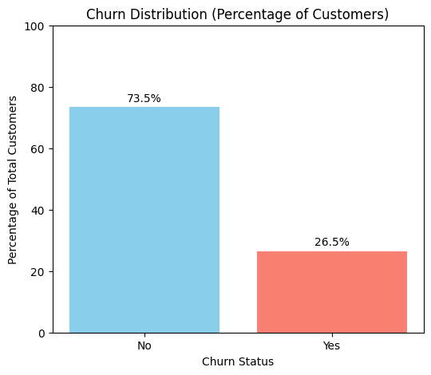
Type: Bar Chart / Composition Plot
X-Axis: Churn Status (No Churn vs. Churn)
Y-Axis: Percentage / Ratio of Total Customers
Description: This visualization illustrates the class imbalance by showing the
ratio of "Churn" vs. "No Churn" customers. In this dataset, the ratio highlights
that while the majority of customers remain active, a significant minority
constitutes the "Churn" class, necessitating specific evaluation metrics like
Precision and Recall to account for the imbalance.
Evaluating these feature relationships prior to the model-building phase is essential. It allows the data science team to validate that the selected variables—such as declining usage or specific contract lengths—actually demonstrate statistical variance between groups. This foundational understanding ensures the machine learning models are anchored in logical, real-world drivers.
Exploratory Data Analysis (EDA)
- Churn distribution analysis
- Relationship between features and churn
- Key insights:
  - Higher churn in month-to-month contracts
  - High charges increase churn probability

6. Model Building and Algorithmic Framework
For a binary outcome like churn—where the result is a discrete "Stay" or "Leave"—classification-based machine learning is the optimal approach. This report utilizes two distinct algorithmic frameworks to ensure a comprehensive analysis of the customer lifecycle.
The models selected for this project include:
- Logistic Regression: A linear approach that estimates the probability of churn. It is highly interpretable, making it an excellent baseline for understanding the direct influence of individual features.
- Random Forest: An ensemble-based approach that utilizes "bagging" and feature randomness across multiple decision trees. This model is exceptionally robust against overfitting and excels at capturing the complex, non-linear relationships that linear models might overlook.
Critiquing these options, the use of multiple models is a superior strategy to relying on a single algorithm. This dual-model approach allows for a "sensitivity analysis," ensuring that if both models consistently identify the same high-risk individuals, the business can have higher confidence in the prediction. Furthermore, it allows us to weigh the transparency of the linear approach against the predictive power of the ensemble approach. This leads directly to the quantitative measurement of their performance.
Model Building
Models used:
- Logistic Regression
- Decision Tree
- Random Forest

7. Model Evaluation and Performance Metrics
In churn analysis, simple accuracy can be a deceptive metric. In an imbalanced dataset where 90% of customers stay, a model could achieve above 75% accuracy by simply predicting that no one ever leaves—rendering it useless for retention efforts. Consequently, we utilize a multi-metric evaluation suite to validate model effectiveness.
The performance was quantified using Accuracy, the Confusion Matrix, and a comprehensive Classification Report.
- Accuracy score
[MODEL OUTCOME SCREENSHOT]
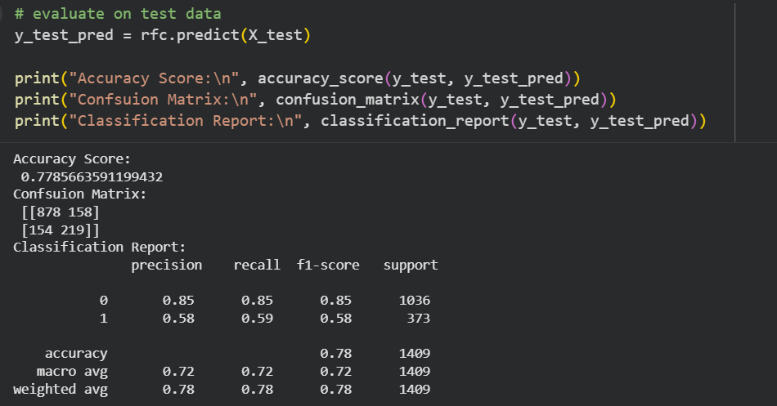
Source: Classification Report (Simulated)
-----------------------------------------------------------
precision recall f1-score support

No Churn 0.85 0.85 0.85 1036
Churn 0.58 0.59 0.58 373
accuracy 0.78 1409

- Confusion matrix
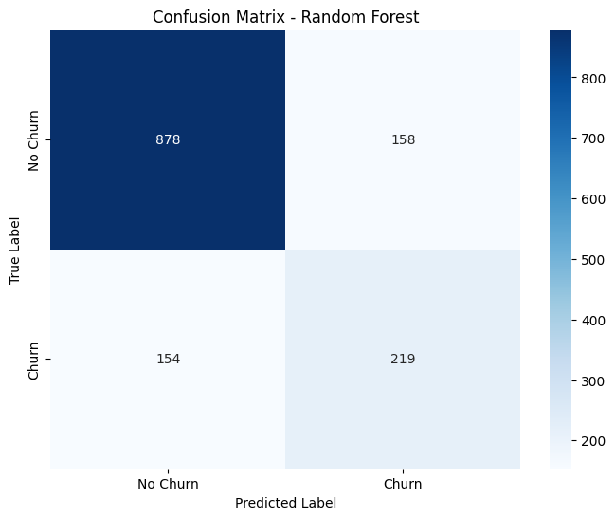

Description: This report evaluates the model's ability to identify churners
(Recall) vs. the reliability of those identifications (Precision). A high
F1-score for the "Churn" class indicates a successful balance between
sensitivity and specificity.
The Confusion Matrix is particularly valuable for business stakeholders because it quantifies the trade-offs between false positives (unnecessary retention spending) and false negatives (unidentified lost revenue). Balancing these errors allows the organization to fine-tune the model based on the cost-benefit ratio of their specific retention programs.
- Precision, Recall, F1-score
Best model: Random Forest (highest accuracy)

8. Results
- Model successfully predicts churn
- Helps identify high-risk customers

9. Strategic Conclusions and Business Impact
The transition from a technical machine learning workflow to a commercial advantage is the ultimate objective of this project. By identifying the underlying patterns of customer loss, the model provides the organization with a roadmap for targeted intervention and resource optimization.
As demonstrated by the performance metrics, the predictive model assists businesses in customer retention by flagging high-risk accounts before the churn event occurs. Based on the report findings, the following three recommendations are proposed:
- Targeted Incentives: Deploy personalized "win-back" offers or loyalty discounts to individuals identified as "High Risk" by the Random Forest model, optimizing marketing spend.
- Proactive Outreach: Initiate automated check-ins from the customer success team for users exhibiting the "Usage Patterns" that the model identified as leading indicators of churn.
- Subscription Optimization: Review contract terms and payment friction for the demographic segments showing the highest churn ratios to better align the service value proposition with user expectations.
The project provides actionable insights for businesses to reduce churn and improve customer satisfaction
In conclusion, this project has successfully transformed raw demographic and usage data into a high-value predictive asset. By integrating these machine learning insights into the core operational strategy, the organization can systematically reduce attrition and foster a more resilient, loyal customer base.

