
- Subject Name and Code:
- ICT712 Information Technology Project Management
- Tutor Name: Dr Fadi Kotob
- Assessment Title: Assessment 3 - A Helping Hand Volunteer and Donor Management System

Academic Misconduct & Plagiarism Declaration
We declare that this assessment is our own original work and complies with the Academic Integrity Policy of King’s Own Institute. We have not:
- Plagiarised the work of others (intentionally or unintentionally),
- Submitted work prepared by someone else or copied from unauthorised sources,
- Used unauthorised collaboration or assistance,
- Submitted this or similar work for credit in another subject without permission.
We understand that a breach of academic integrity may result in penalties including failure of the assessment, disciplinary action, or further institutional consequences.

AI Use Acknowledgement & Disclosure
We acknowledge that we have read and understood the subject’s AI Use Guidelines, including what is permitted, restricted, or prohibited in relation to generative AI tools.
We confirm that any AI use in this assessment:
- Follows the permitted uses outlined in the subject guidelines,
- Is properly cited using Harvard referencing,
- Is transparently disclosed below,
- Does not replace our own academic thinking or original writing,
- Is our sole responsibility, and we understand that undisclosed or inappropriate use may be a breach of academic integrity.
AI Use Disclosure Table

AI Tool Used (e.g. ChatGPT, GrammarlyGO) | How It Was Used (brief description) | Why We Chose to Use It
ChatGPT  Claude | It is Used to help understand concepts in Task 1 (PMBOK Project Management ) and Task 4 ( Ethical Use of Client Data). It was also used to check grammar and improve the clarity of some sentences.  Used to review Task 2 – Agile Project Management and Task 3 – PMBOK and Kanban Comparison. It helped us check the structure and clarity of some sections. | We chose it to help us understand difficult concepts and present our own ideas in a clearer way.  We chose it to get another perspective on our work and improve the organisation and readability of the content.

☐ We did not use any AI tools in the preparation of this assessment.
✓ We used AI tools as described above in accordance with the subject’s AI Use Guidelines.

Student Declaration
By signing below, we confirm that the information provided is accurate, and the work submitted complies with academic integrity standards.
Family Name | Given Name | Student ID | Contribution % | Signature
KHAKURAL | PRATIBHA | 20038823 | 20% | 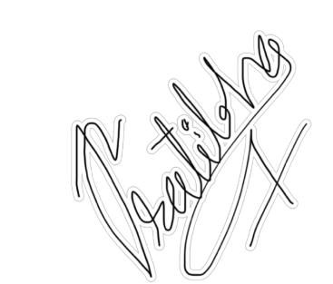
BIST | SANIYA | 20039183 | 20%
SUBEDI | TRISHNA | 20038978 | 20% | 
SHAHI | ANUSHKA | 20037934 | 20% | 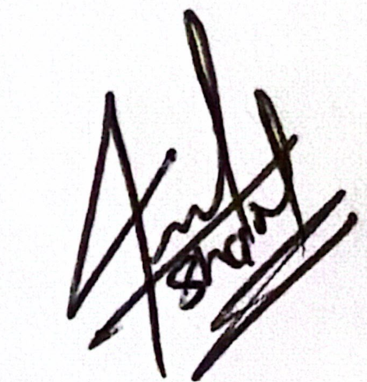
KHATIWADA | RITIKA | 12201779 | 20% | Ritika

Executive summary

This report describes a proposed A Helping Hand Volunteer & Donor Management System which is a Mobile and Web-based system that will enhance the Charity's Volunteer and Donor Management, Rostering, Communication, and Organizational Information. Many of A Helping Hand's activities are currently performed manually, which can be challenging for coordinating, communicating and managing information, so the system is proposed. The intended system is to pool these activities together and enhance efficiency, communication and compliance.

The report use principles and concept of PMBOK project management for planning and controlling the project, such as project charter, stakeholders, project communication, and project risk management. It will take 20 week to complete project and it will cost $148,760. Flexible development using user stories and four development sprints is also helped by agile practices.

The report also makes a comparison of PMBOK and Kanban and concludes using both of them would be a suitable approach for this project. PMBOK is for overall project control and Kanban can assist the development team in managing daily activities and promptly addressing changes and user feedback in the development process.

Lastly, the ethical use of client information is discussed. This is especially vital since sensitive information like WWCC and background check details, family information and donor payment information will be managed by the system. The report suggests that only relevant information should be gathered, there should be clarity regarding the use of information and it is essential to obtain proper consent before the use or sharing of personal information.

The report overall suggests that PMBOK, Agile and Kanban is necessary to maintain structure of project and then leave room for flexibility when developing it. Data protection, informed consent and responsible use of client information should also continue to be important throughout the project.

Table of Contents
2 Introduction of A Helping Hand Volunteer and Donor Management System 7
2.1 Introduction 7
2.2 Business Case 7
3 Task 1 – PMBOK Project Management 7
3.1 Project Initiating 7
3.1.1 Project Charter 7
3.1.2 Stakeholder Register 7
3.1.3 Preliminary Scope Statement 7
3.2 Project Planning 7
3.2.1 Work Breakdown Structure 7
3.2.2 Gantt Chart and Project Schedule 7
3.2.3 Communication Plan 7
3.2.4 Project Budget 7
3.2.5 Risk Assessment and Management Plan 7
3.3 Project Execution 7
3.4 Project Monitoring and Controlling 7
3.5 Project Closing 7
4 Task 2 – Agile Project Management 7
4.1 Introduction to Agile 7
4.1.1 System Users 7
4.1.2 User Stories and Acceptance Criteria 7
4.1.3 Product Vision 7
4.1.4 Product Backlog 7
4.1.5 Sprint Planning 7
4.2 Kanban Board 7
4.3 Slack Communication 7
5 Task 3 – PMBOK and Kanban Comparison 7
6 Task 4 – Ethical Use of Client Data 7
7 Conclusion and Recommendations 7
8 References 7
9 Appendices 7

List of Figures
Figure 1: Project Milestone 6
Figure 2: Work Breakdown Structure 2
Figure 3: Gantt Chart 1
Figure 4: Full informative Gantt Chart 3
Figure 5: Direct Project Cost 2
Figure 6: Direct Overhead Cost 2
Figure 7: General and Contingency Costs 3
Figure 8: Trello (Backlog – Sprint 4) 13
Figure 9: Trello (Sprint 3 - Release) 13
Figure 10: US - B1 14
Figure 11: User Stories 1 14
Figure 12: User Stories 4 15
Figure 13: User Stories 10 15
Figure 14: User Stories 12 16
Figure 15: Team and Slack Communication 19

List of Tables
Table 1: Project Business Case 2
Table 2: General Project Information 4
Table 3: Stakeholder Register 5
Table 4: Project Milestones 1
Table 5: Communication table 1
Table 6: Risk Assessment and Management Plan 5
Table 7: User Definition 7
Table 8: User Stories and Acceptance Criteria 11
Table 9: Product Backlog 12
Table 10: Sprint Table 12
Table 11: PMBOK and Kanban Comparison 20
Table 12: Sample Monthly Status Report 24
Table 13: Sample Change Request Form 25

Introduction of A Helping Hand Volunteer and Donor Management System

Introduction
A Helping Hand is an Australian non-profit that offers humanitarian and community assistance services both locally and internationally. It distributes food and food packs to people in need in Australia, visits people in hospital with sick children and older people and carries out nursing and therapy for the Naga Community in the Philippines.

Many of these activities are currently done manually, which can make volunteer coordination and information management challenging. The proposed Volunteer and Donor Management System (VDMS) offer mobile and web-based administration, donations and purchases, roster and event management, group communication, knowledge management and reporting. Project management is the process of applying the knowledge, skills, tools and techniques of project management in structured manner to meet project requirements and expectations (Larson 2024).

Business Case

The business case for the A Helping Hand Volunteer and Donor Management System is centred on the need for efficiency, to coordinate volunteers and comply with regulations. The proposed mobile/web-based system will aim to look at these concerns by having key components of charity integrated into one system.

Project Business case | Details
Project Name | A Helping Hand – Volunteer and Donor Management System.
Contribution to business Strategy | An integrated mobile and web-based system to improve the coordination and management of charity activities.
Features | Administration; Donations and Purchases; Roster and Event Management; Group Communication; Reporting.
Benefits | Saves administration time, better volunteer coordination, better compliance monitoring, better communication
Timescale | 20 weeks
Cost | $148,760
Risks | Integration issue , cost overrun issue , data security concern, project delay

Table 1: Project Business Case

This aligns with research that show digital technology can improve volunteer matching and reduce administrative workload (Chui & Chan 2019) and usability and flexible management support nonprofit digital transition (ProjectManager 2025).

Task 1 – PMBOK Project Management
The Project Management Body of Knowledge (PMBOK) refers to the standard or rule of project management, established by the Project Management Institute (PMI). PMBOK divides a project into five process groups - Initiating, Planning, Executing, Monitoring and Controlling, and Closing – followed below for A Helping Hand’s system (PMI 2025).

Project Initiating
The phase ensures that project objectives meet stakeholder needs and development team capabilities and is used to authorize the project.

Project Charter
This is the Project charter, which is a formal description of the project, its stakeholders and project management. This charter will be used as a reference throughout the project (Larson 2024).

General Project Information
Project Name | A Helping Hand Volunteer & Donor Management System
Project Sponsor | Margaret Chen, Executive Director, A Helping Hand
Project Manager | Robert Cooper
Internal Project Stakeholders | Project Manager - manages development team and work directly with Sponsor;  Business Analyst - communicate with Program/Home Visits/Food Run Coordinators TO requirement validate  Developers - create mobile and web application;  QA Tester - confirm functionality with acceptance criteria;  Trainer - create material for Volunteers and Super Users
Resources | Development (Frameworks) | Figma (UX/UI design);  GitHub (version control);  Trello (Kanban board);  Slack (team communication);  AWS (cloud hosting)
Resources | Tools | Laptop  Adobe XD  Adobe Photoshop
Project Budget Allocation | $148,760
Expected Start Date | 24 August 2026
Expected End Date | 24 January 2027
Table 2: General Project Information

Technical Requirements: It should be compatible for mobile device (iOS and Android). many use AWS for secure cloud hosting. WWCC status and family background information will be stored encrypted in the system.

Limits/Exclusions: Physical hardware is not use for A Helping Hand employees project, this project provide only software use. Maintenance od system (post-paunch) after 4 week hyper care is not included too.

Customer Review: reviewd by Margaret Chen (Sponsor) and Daniel Reyes (Operations Manager) from A Helping Hand.

Stakeholder Register
The table show internal and external stakeholder based on level of influence of their and interest too (Larson 2024). This is shown as its own register separate from Charter because assessment want stakeholder register.
Stakeholder | Category | Interest | Influence | Engagement Strategy
Margaret Chen (Sponsor) | Charity Leadership | Very High | Very High | Fortnightly status reports; sign on major milestone
Daniel Reyes (Operations) | Charity Leadership | High | High | Weekly check-ins; day-to-day requirements contact
Super Users | Internal Customer | High | Medium | Consulted during design
Program/Home Visits/Food Run Coordinators | Internal Customer | High | Low | Consulted during design; involve in UAT
Shift Leaders & Volunteers | End User | Medium | Low | Informed via training session
Prospective Volunteers | End User | Low | Low | Informed via registration form and onboarding tasks
Donors/Customers | External | Low | Low | Informed via app store listing
Development Team | Project Team | Very High | High | Daily stand-ups; sprint reviews
Regulatory Bodies (WWCC/OAIC) | Compliance | Low | High | Compliance checked at design and pre-launch stages

Table 3: Stakeholder Register

Preliminary Scope Statement
Project Goal:
We need to build mobile app for iOS and Android, along with web interface for A Helping Hand. It will support administration, donations, purchases, rosters, events etc. The project must be completed within 5 months and stay within $148,760 budget.

Deliverable:
Mobile applications and web application with following modules:
- Admin
- donations and purchases
- roster and event management
- groups and communication
- knowledge management
- reporting ( Compliance, expiry and volunteer tenure report)

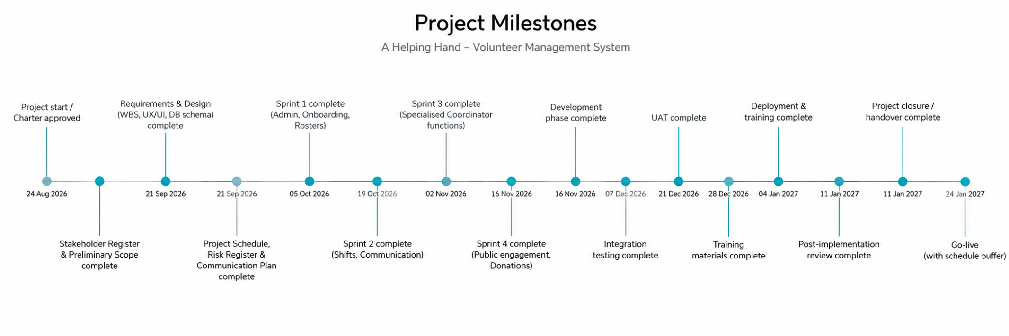
Milestones:
Figure 1: Project Milestone

Date | Milestone | Assigned To
24/08/2026 | Project start / Charter approved | Sponsor
07/09/2026 | Stakeholder Register & Preliminary Scope complete | Project Manager
21/09/2026 | Requirement & Design (WBS, UX/UI, DB schema) complete | Business Analyst
21/09/2026 | Project Schedule complete (MS Project) | Project Manager
21/09/2026 | Risk Register complete | Project Manager
21/09/2026 | Communication Plan complete | Project Manager
05/10/2026 | Sprint 1 complete (Admin, Onboarding, Rosters) | Development Team
19/10/2026 | Sprint 2 complete (Shifts, Communication) | Development Team
02/11/2026 | Sprint 3 complete (Specialised Coordinator functions) | Development Team
16/11/2026 | Sprint 4 complete (Public engagement, Donations) | Development Team
16/11/2026 | Development phase complete | Project Manager
07/12/2026 | Integration testing complete | QA Tester
21/12/2026 | UAT complete | Sponsor,Operations Manager
28/12/2026 | Training materials complete | Trainer
04/01/2027 | Deployment & training complete | Trainer, Project Manager
11/01/2027 | Post-implementation review complete | Project Manager
11/01/2027 | Project closure / handover complete | Project Manager
24/01/2027 | Go-live (with schedule buffer) | Project Manager
Table 4: Project Milestones

Project Planning
Project Planning prepares WBS, schedule, budget, communication plan, risk register for project delivery.

Work Breakdown Structure
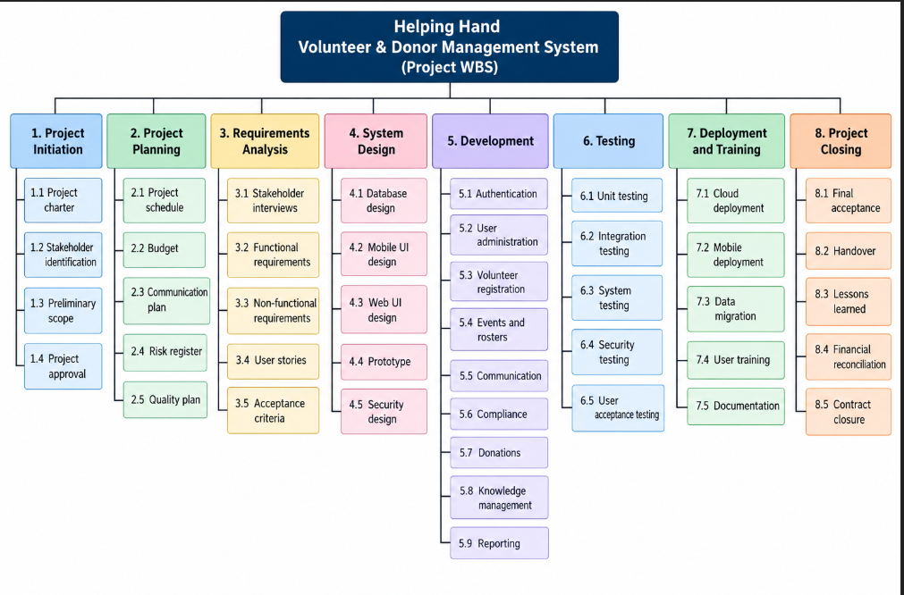
The Work Breakdown Structure (WBS) breaks down project scope into deliverable work packages.

Figure 2: Work Breakdown Structure

Gantt Chart and Project Schedule
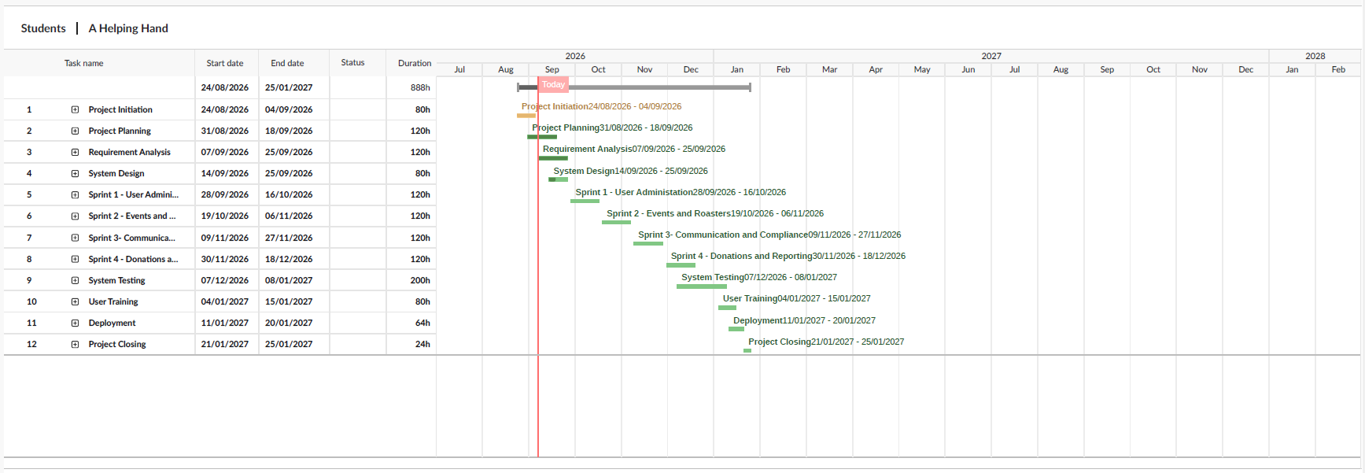
The schedule was built in MS Project using project network to identify the critical path — the longest sequence of dependent activities and therefore shortest possible project duration (Larson 2024). The project run late August 2026 to 24 January 2027 in three phases:

Figure 3: Gantt Chart
- Planning Phase (late August–September 2026): Project Initiation (80 hours) followed by Project Planning (120 hours) and Requirement Analysis (120 hours) and System Design (80 hours).
- Development Phase (late September–December 2026): four sprints of about 3 weeks each (120 hours per sprint) — Sprint 1 (User Administration and Onboarding), Sprint 2 (Events and Rosters), Sprint 3 (Communication and Compliance) and Sprint 4 (Donations and Reporting).
- Testing and Closure (December 2026–January 2027): System testing (200 hours ) largest phase because testing is important for system that handle donation and volunteer data
- The critical keep project within 20-week timeframe which finish on 24 January before deadline with small buffer.

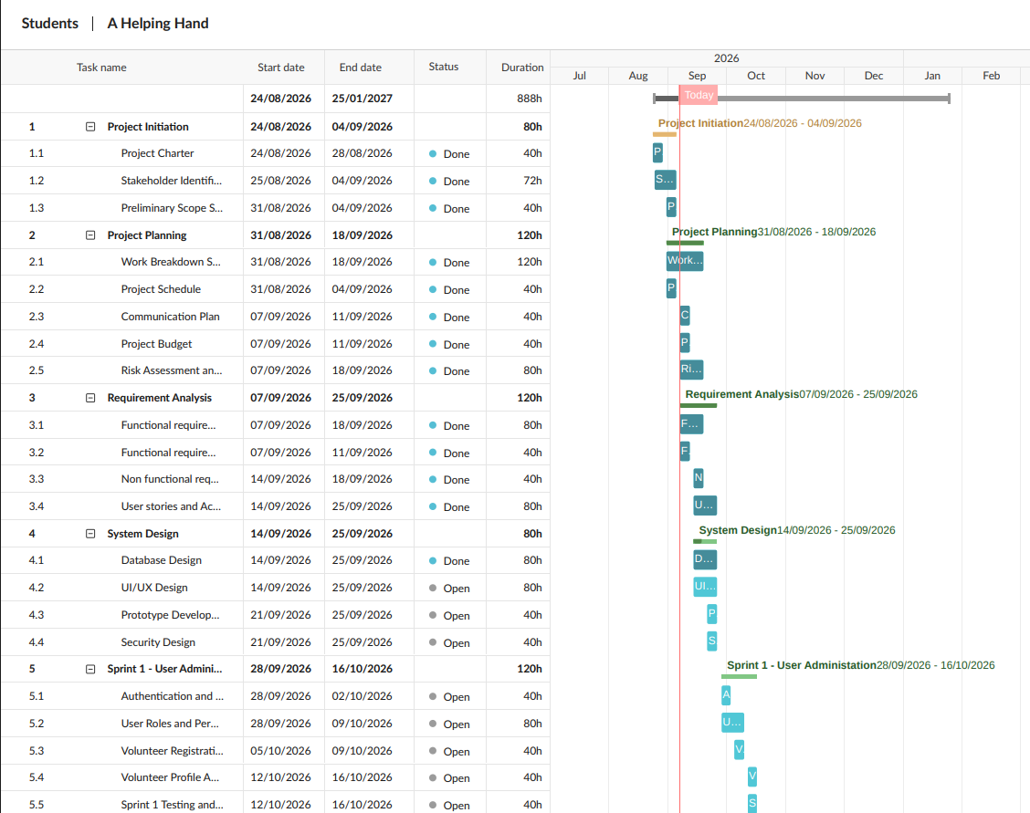

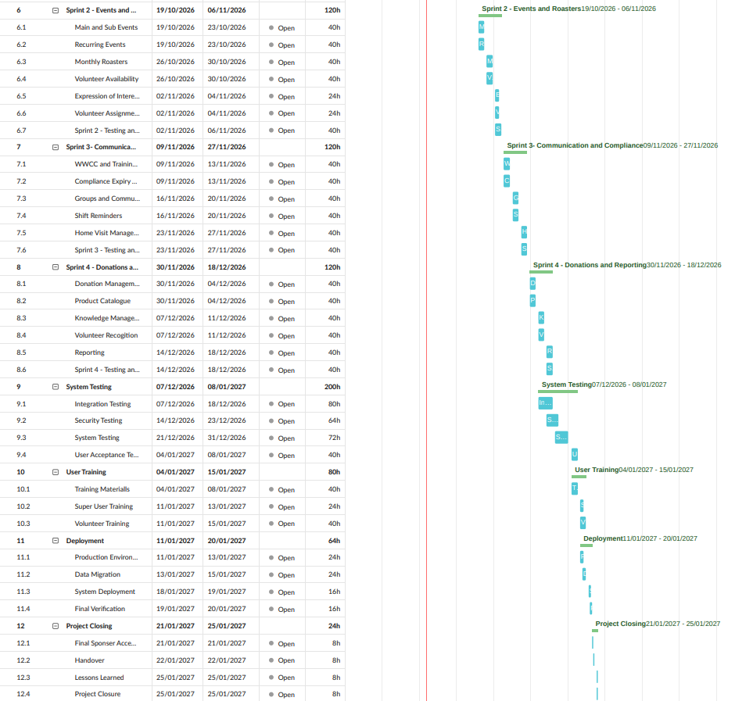
Figure 4: Full informative Gantt Chart

Communication Plan
Communication plan is defined important as there are technical and non-technical member involved in project. We used and will use Slack as primary method of team communication as requirement and project decision will be recorded.

Information | Target Audience | Frequency | Method | Provider
Project Status Report | Sponsor, Project Manager | Weekly | Slack / Whatsapp | Project Manager
Sprint Status | Development Team | Daily / Weekly | Slack / Trello | Project Manager
Requirements Update | BA, Developers, Coordinators | As Required | Slack / Meeting | Business Analyst
Risk Report | Sponsor, Project Manager | Weekly | Report / Meeting | Project Manager
Change Requests | Sponsor, PM, BA | As Required | Formal Document | Project Manager
Testing Report | PM, Developers | Each Sprint | Trello / Report | QA Tester
Training Update | Sponsor, Users | Fortnightly | Whatsapp/ Meeting | Trainer
Final Acceptance | Sponsor and Project Team | End of Project | Meeting / Document | Project Manager

Table 5: Communication table

Project Budget
It require project budget based on market research because there is no existing budget proposal and also project use fixed price agreement.
The national Project Manager salary range is $140,000–$175,000, while Technology Business Analyst range is $115,000–$140,000.

Direct Project Cost – Project Team Salary
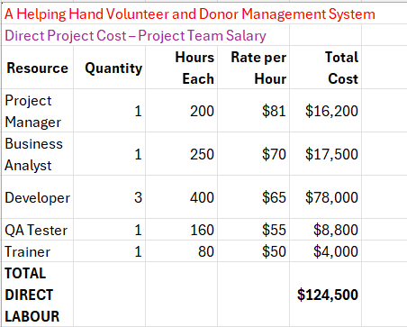
Figure 5: Direct Project Cost
These rates are project estimates that show current market conditions and five-month timeframe only.

Direct Project Overhead Costs
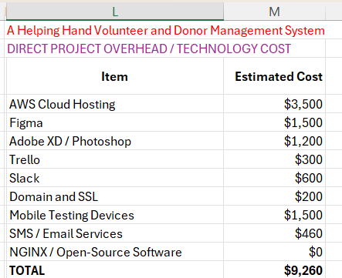
Figure 6: Direct Overhead Cost

General and Administrative / Contingency Costs
For any unexpected technical or organisational issue we have included $15,000 contingency amount.

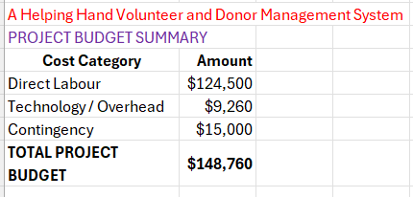
Figure 7: General and Contingency Costs

Based on above it is recommended that fixed-price contract value is at AUD $148,760 , contingent upon formal scope and change-control agreements.

Risk Assessment and Management Plan
Risk refers to events that have negative consequence for project scope, time, cost or quality (Hillson 2002). The project manager is responsible for risk register throughout project duration.

Risk ID | Risk | Category | Likelihood | Impact | Risk Level | Response / Mitigation | Risk Owner
R1 | Requirements change during development | Scope | High | High | High | Use formal change-control process and prioritise backlog | PM / BA
R2 | Development delays | Schedule | Medium | High | High | Monitor milestones and prioritise critical features | PM
R3 | Data breach or security incident | Security | Medium | Very High | Critical | Encryption, access control, security testing and reviews | Developers
R4 | Poor user adoption | People | Medium | High | High | User involvement, training and feedback | Trainer / BA
R5 | Integration problems | Technical | Medium | High | High | Conduct early integration testing | Developers
R6 | Budget overrun | Cost | Medium | High | High | Cost tracking, fixed scope and contingency | PM
R7 | Incorrect volunteer information | Data | Medium | High | High | Data validation and quality controls | BA
R8 | AWS / service outage | Technical | Low | High | Medium | Backup, monitoring and recovery plan | Developers
R9 | Compliance documents expire without action | Operational | Medium | High | High | Automated reminders reports | Super User
R10 | Communication failure | Management | Medium | Medium | Medium | Slack channels and weekly meetings | PM

Table 6: Risk Assessment and Management Plan

Project Execution
The approved project plan will transform into deliverables during the execution phase. Requirements will be validated by Business Analysts working with Program Coordinators, Home Visits Coordinators and Food Run Coordinators. Developers will code the application according to approved backlog and QA Tester will confirm functionality is working as expected.
The development team will use GitHub for source-code management and Trello for task visibility. Team members will communicate daily with Slack. Figma and Adobe will be used to design the interface.

Project Monitoring and Controlling
Monitoring and controlling will track actual progress versus the approved baseline.
Specifically, the Project Manager will monitor:
- Schedule.
- Budget.
- Milestone achievements.
- Open risks.
- Change requests.
- Sprint progress.
- Stakeholder satisfaction.
- Quality acceptance.
Quality will be measured by acceptance criteria, code review, unit testing, integration testing, system testing and user acceptance testing.

Project Closing
Closure will occur when system has been accepted by A Helping Hand.
Activities include:
- Final user acceptance testing.
- Final sponsor approval.
- Verification of deployment.
- Training.
- Transfer of documentation and system administration information.
- Financial reconciliation.
- Contract closure.

Task 2 – Agile Project Management

Introduction to Agile
Our approach will be Agile project management an iterative development methodology developed to address the shortcomings of traditional models in software development. Agile focuses on the four values of the Agile Manifesto and is suitable for this project as exact specifications for several will likely be better determined once feedback has been provided by actual users (Blair 2020) .

Regarding the scrum ceremonies that will be used to manage development these will be to three Scrum positions. Product Owner (who prioritises the backlog and speaks for A Helping Hand's interests), Scrum Master (facilitates the process and clears roadblocks) and Development Team (Blair 2020).

System Users
The project's first step, preceding user story development, involves detailing the personas interacting with A Helping Hand. A persona is an archetypal system user - a concrete profile for the developers to design for, instead of creating features for a vague and undefined audience (Ambler n.d.). This spans from full system administrators down to public with no account.

Define Users
User | User Definition
Super User | Super Users are your primary admin. They can edit users, program, roaster, contact other users, assign tasks, create reports and access volunteers.,
Volunteer | Volunteers are your users who are able to maintain the roaster, register interest, view/ access shifts and family history.
Program Coordinator | Program Coordinators normally will setup the programs and communicate with the volunteers and team.
General User | General Users are able to view what programs and activities are offered. They will see information that will be applicable to what they are looking for.
Food Run Coordinator | Food Run Coordinators are in charge of the food run events. They will assign volunteers and Shift Leaders to shifts. This can be done by selecting from the people who registered interest or by manualy entering them through the eBay.
Shift Leader | Shift Leaders are volunteers that lead a shift. They can register for shifts as any other volunteer would but they are also able to post a summary of the shift. (ex. attendance, feedback, incidents)
Home Visits Coordinator | Home Visit Coordinators are in charge of the home visit roster. They can copy the previous months roster over and use that as the new roster for the month.
Prospective Volunteer | Prospective Volunteers are users that have filled out a registration form but have not been approved yet.
Donor /Customer | Donors and Customers are basically just your public users that utilize the app to donate or purchase things from your sales.

Table 7: User Definition

User Stories and Acceptance Criteria
Below are all users stories that meet the INVEST criteria (Independent, Negotiable, Valuable, Estimated, Small, Testable). Each narrative is sized using t-shirt style estimation (XS=1–3, S=5, M=8, L=13, XL=21 points) (Blair, 2020). We chose tale points rather than hours, because points are an indication of how vast or intricate a task is, rather than actual time. This is more suitable for a project in which the requirements may vary (Coelho & Basu 2012).

Table 2: User Stories and Acceptance Criteria (13 stories, 73 total story points)

ID | User | User Story | Acceptance Criteria | Value | Pts
US-B1 | Volunteer | As a Volunteer, I want to manage my profile information, so that my contact and availability details stay current. | Edit name/contact/availability; changes saved immediately; visible to assigned Coordinator | Medium | 5
US-B2 | Volunteer | As a Volunteer, I want to receive notifications and reminders before upcoming shifts. | Reminder sent ahead of shift; notification preferences configurable | Medium | 8
US1 | Prospective Volunteer | As a Prospective Volunteer, I want to submit a registration form so that I can be considered for onboarding. | Form captures required details; User review task; status shows Pending | High | 5
US2 | Super User | As a Super User, I want to create logins for approved users, so that they can access the system. | Account created with role assignment; confirmation email sent; username unique | High | 5
US3 | Volunteer | As a Volunteer, I want to view open shifts, so that I can pick ones that suit me. | Open-shifts list updates in real time; one-tap register | High | 3
US4 | Program Coordinator | As a Program Coordinator, I want to create rosters/events, so that Volunteers can register interest. | Create parent/sub-events; scoped to assigned roster; Volunteers can register | High | 8
US5 | Program Coordinator | As a Program Coordinator, I want to assign Volunteers to a roster, so that shifts are filled with confirmed people. | Select from registered-interest list; assign or manually add; assignees notified | High | 8
US6 | Volunteer | As a Volunteer, I want to accept or decline an assigned shift, so that I can manage my own availability. | Assigned shifts show in 'My Shifts'; accept/decline updates in real time; Coordinator notified | High | 3
US7 | Program Coordinator | As a Program Coordinator, I want to broadcast messages to my roster. | Select recipients by roster; sends via notification/SMS/email; delivery logged | High | 5
US8 | Super User | As a Super User, I want to see expiring WWC/training documents, so that I can act before they lapse. | Report filters by expiry date; expiring volunteers flagged; exportable | High | 8
US9 | Home Visits Coordinator | As a Home Visits Coordinator, I want to copy last month's roster. | Copy duplicates structure/assignments; editable copy; saves under current month | Medium | 5
US10 | Food Run Coordinator | As a Food Run Coordinator, I want to assign interested Volunteers to a Food Run event so that shifts are filled efficiently. | List shows interested Volunteers; assign or manually add; assignees notified | Medium | 5
US11 | Shift Leader | As a Shift Leader, I want to log attendance feedback, and incidents after a shift. | Form captures attendees/feedback/incidents; timestamped; visible to Coordinator | Medium | 5
US12 | General User | As a General User, I want to view public programs without account. | Public pages accessible without login, matches Knowledge Management content; clear CTA to register/donate | Medium | 3
US13 | Donor/Customer | As a Donor/Customer, I want to donate or purchase items as a guest, so that I can support A Helping Hand without a volunteer account. | Browse/checkout as guest; payment processed securely; confirmation emailed | High | 13
Table 8: User Stories and Acceptance Criteria

Product Vision
“Give A Helping Hand a safe, convenient and connected solution make easier for volunteer management, communication, compliance reporting, donations and community management. “
Our solution should reduce time spent on manual administration while keeping users informed in timely manner and securing personal data.

Product Backlog
The Product Backlog is complete list of all user stories for project . The stories are ordered by priority with important features .

Priority | Story ID | Summary | Points
1 | US1 | Volunteer Registration | 5
2 | US2 | Create User Accounts | 5
3 | US3 | View Available Shifts | 3
4 | US4 | Create Rosters & Events | 8
5 | US5 | Assign Volunteers to Roster | 8
6 | US6 | Accept/Decline Shift | 3
7 | US7 | Send Broadcast | 5
8 | US8 | WWC Compliance Monitoring | 8
9 | US9 | Copy Monthly Roster | 5
10 | US10 | Assign Food Run Volunteers | 5
11 | US11 | Post-Shift Summary | 5
12 | US12 | Browse Public Info | 3
13 | US13 | Donate / Purchase | 13
14 | US-B1 | Volunteer Profile Management | 5
15 | US-B2 | Notifications & Reminders | 8
Table 9: Product Backlog

Sprint Planning
The table below shows which user stories were committed to each sprint based on team capacity and logical feature grouping. Sprint loads are kept balanced (13–24 points per sprint) so no single sprint is overloaded (Blair 2020).

Sprint | Sprint Goal | Stories | Points
Backlog | Not yet committed to a sprint | US-B1, US-B2 | 13
Sprint 1 | Enable registration, account creation, and rosters | US1, US2, US3, US4 | 21
Sprint 2 | Enable shift assignment, communication, and compliance | US5, US6, US7, US8 | 24
Sprint 3 | Enable specialised coordinator functions | US9, US10, US11 | 15
Sprint 4 | Enable public engagement and donations | US12, US13 | 16

Table 10: Sprint Table

Kanban Board
To manage our workflow in Agile our team used Trello as our Kanban board. The Trello board show Backlog and all four Sprint columns with each card that match user stories. We have added Doing and Release column for workflow as development is not started yet.

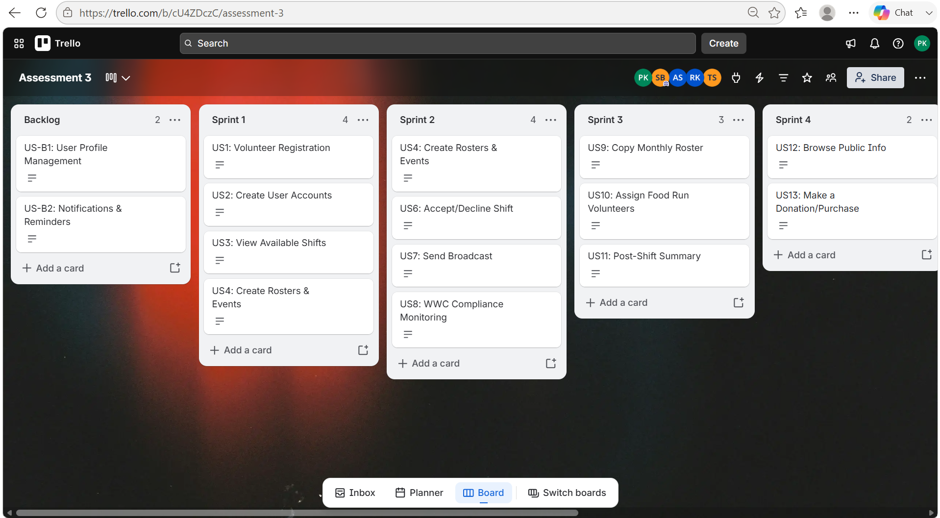
Figure 8: Trello (Backlog – Sprint 4)

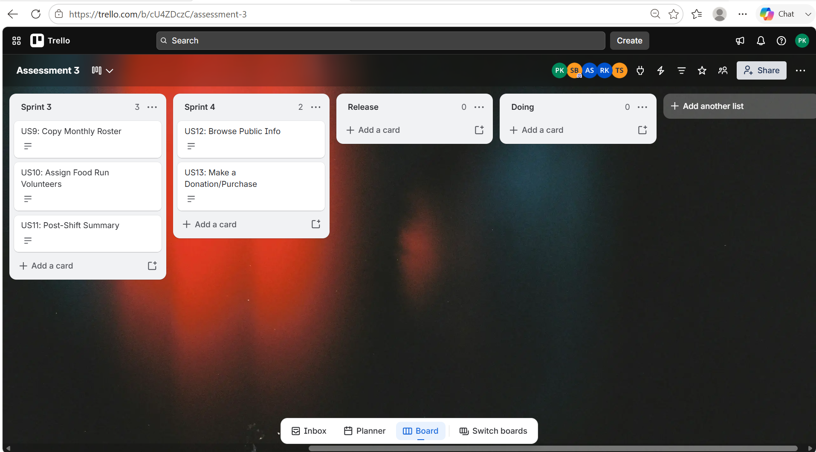
Figure 9: Trello (Sprint 3 - Release)
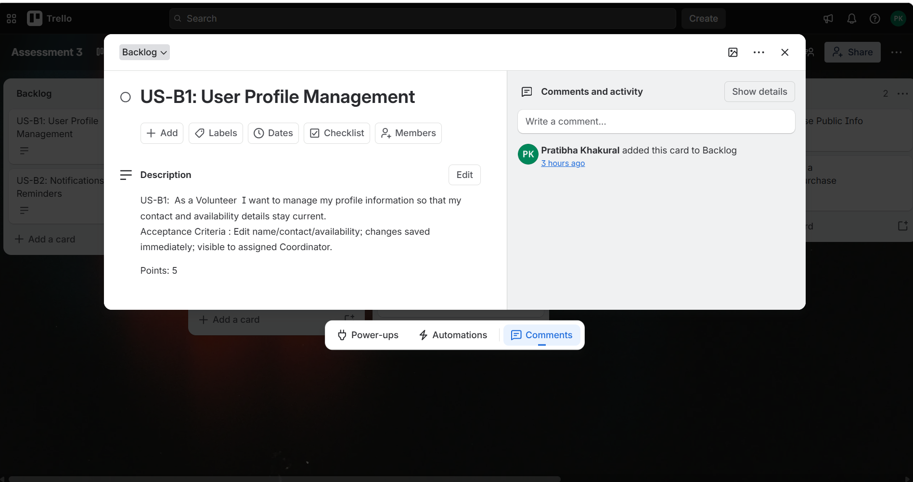
Figure 10: US - B1
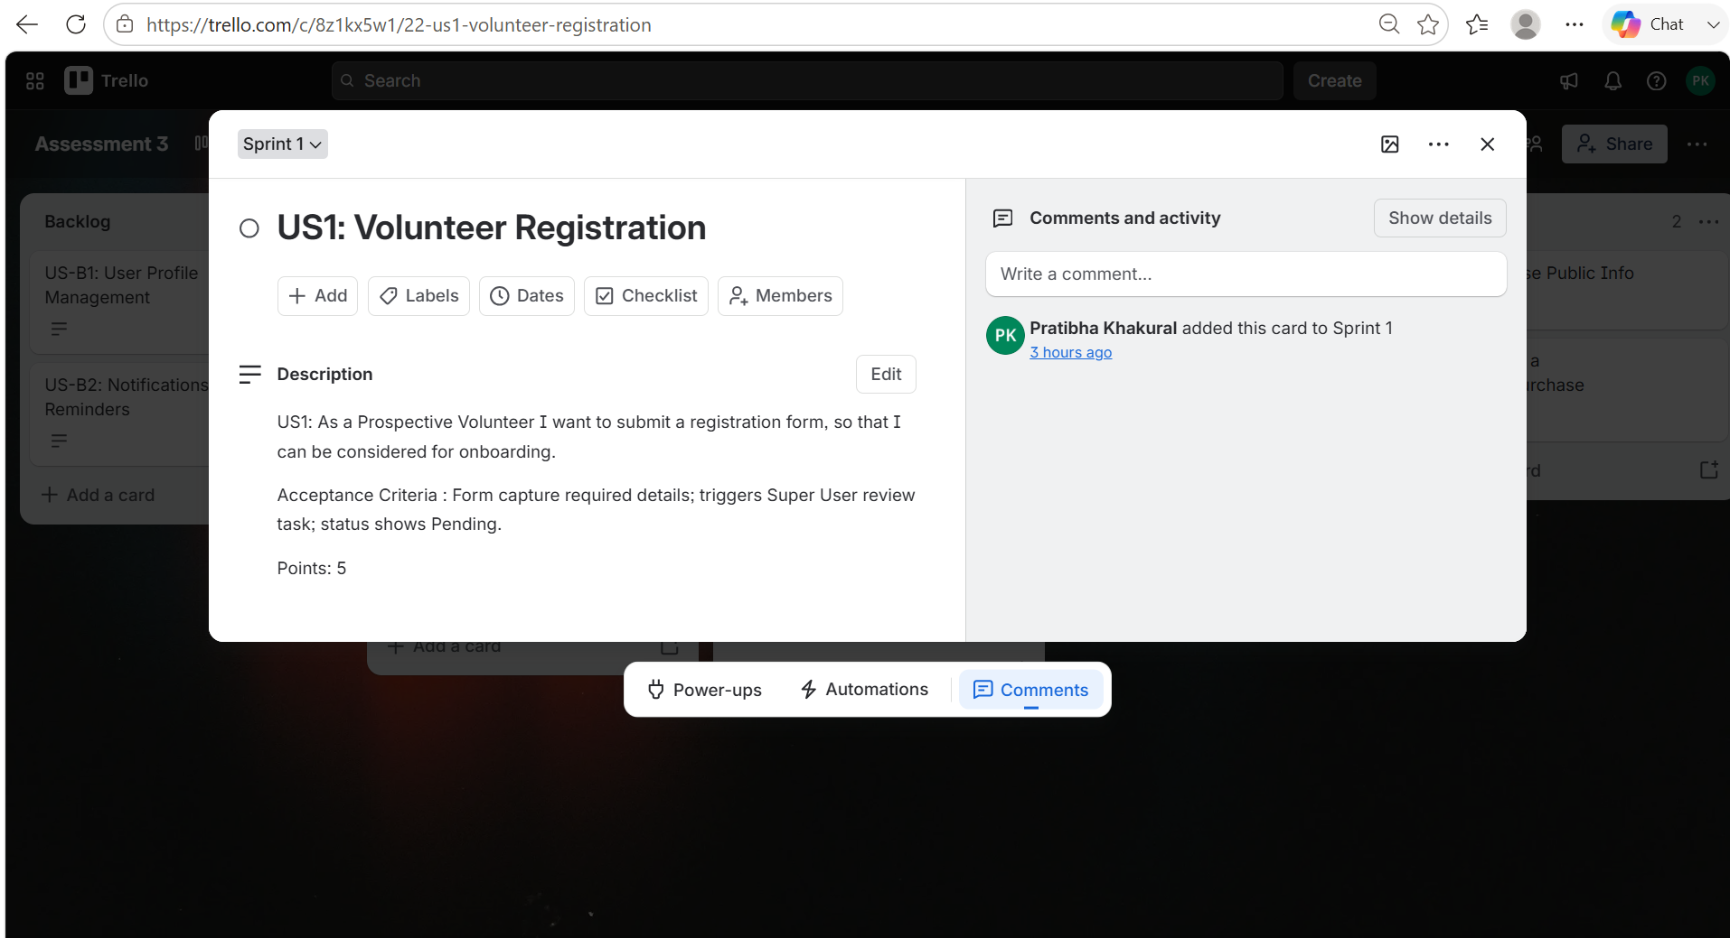
Figure 11: User Stories 1

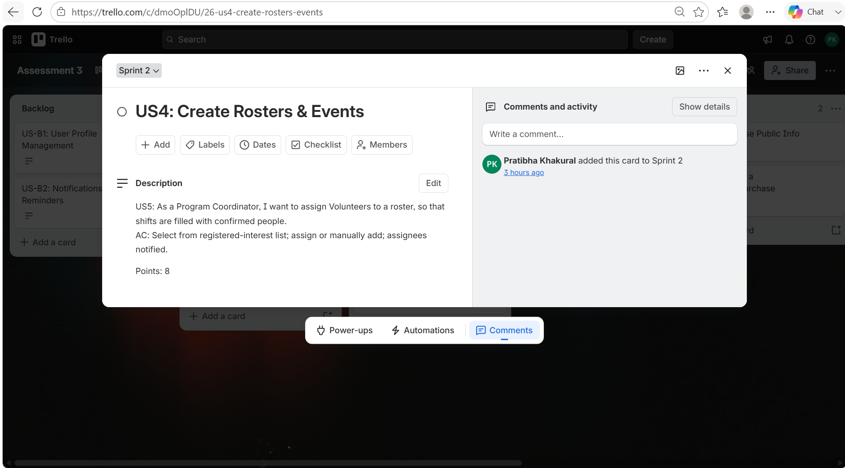
Figure 12: User Stories 4
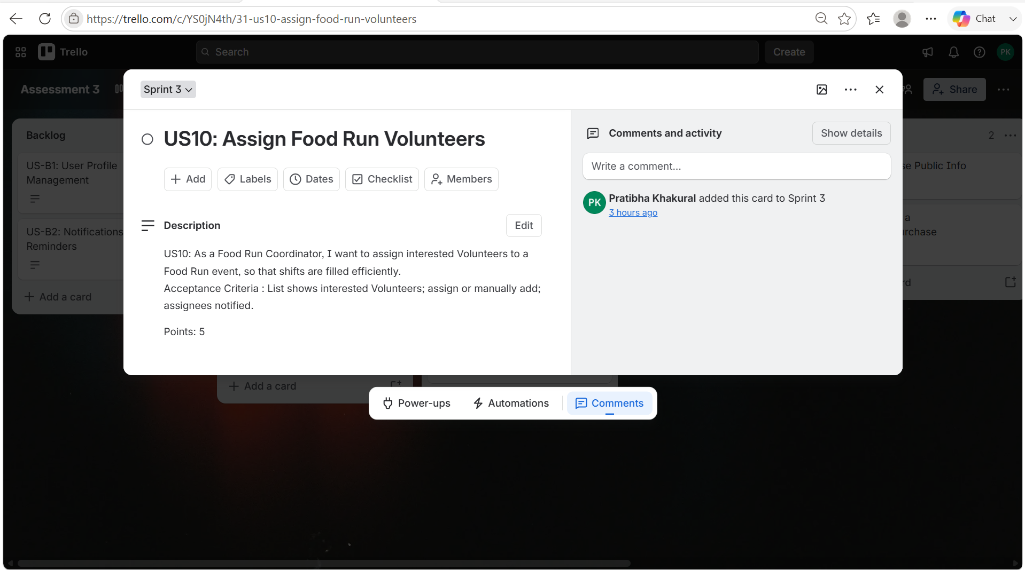
Figure 13: User Stories 10
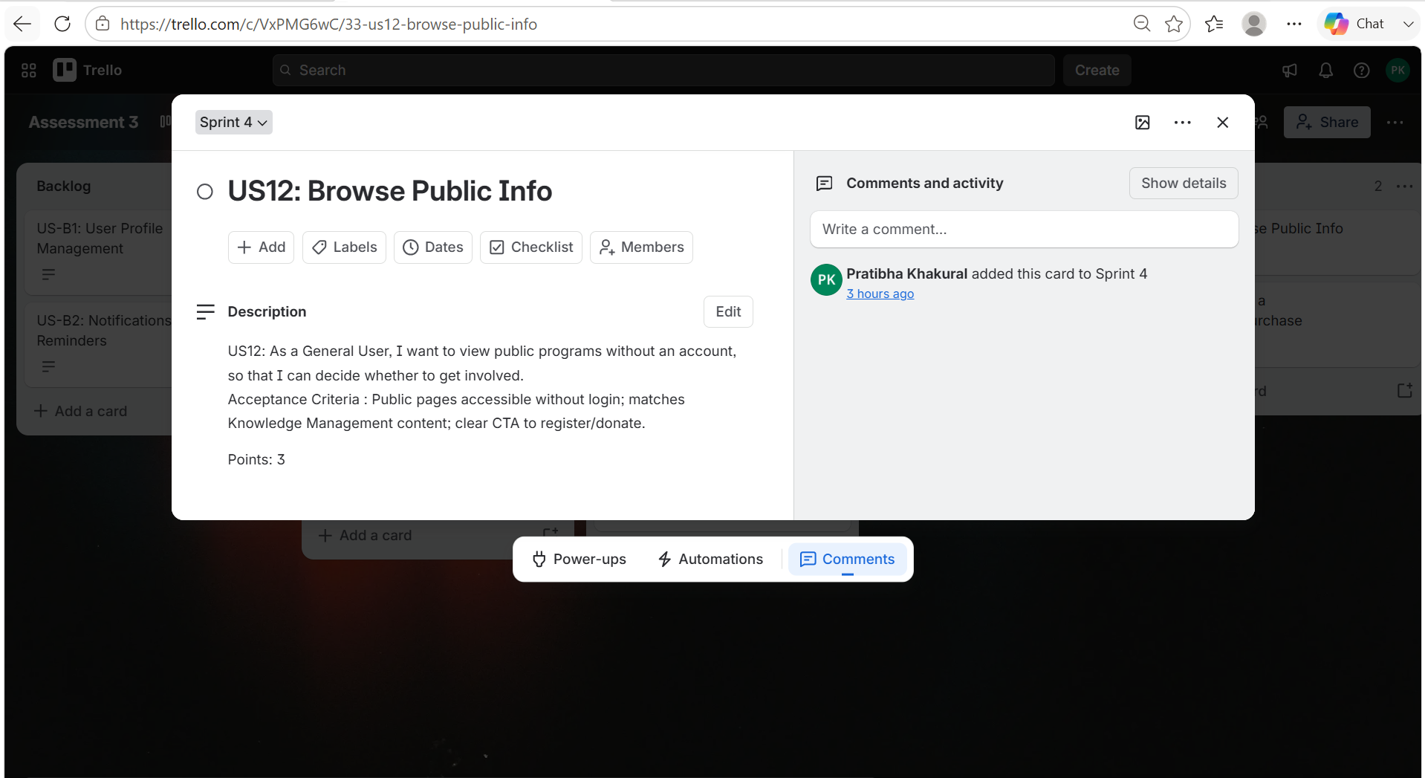
Figure 14: User Stories 12

Slack Communication
For the team communication we used slack channel to divide and allocate task , to organize our meeting for project. The screenshot below show message we had between team which include work breakdown, meetings and even asking question for confused parts like ethics discussion, gantt chart etc.

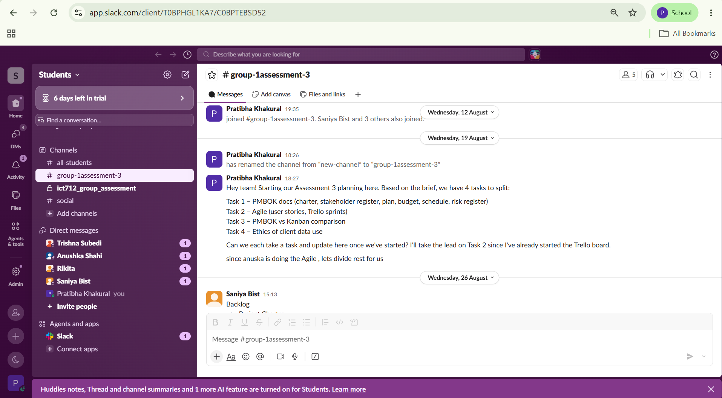

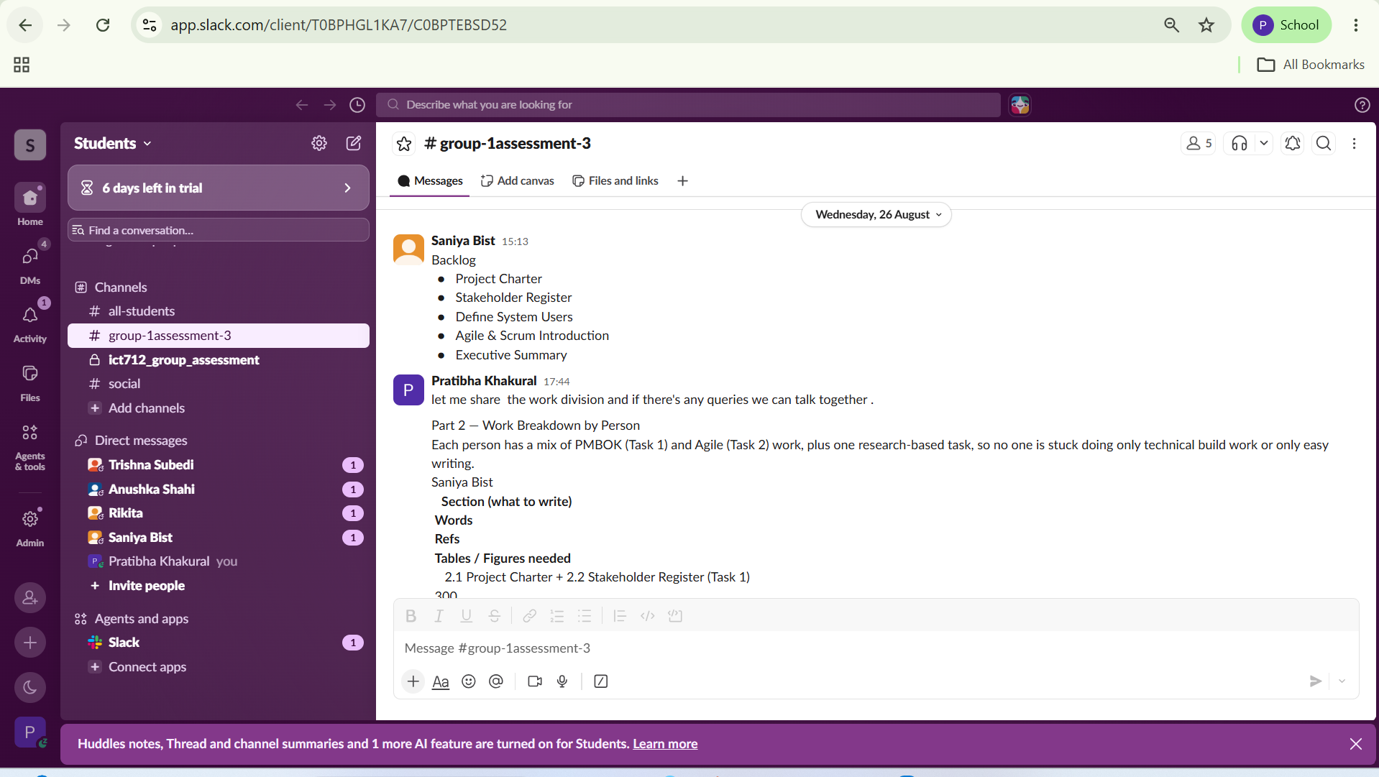
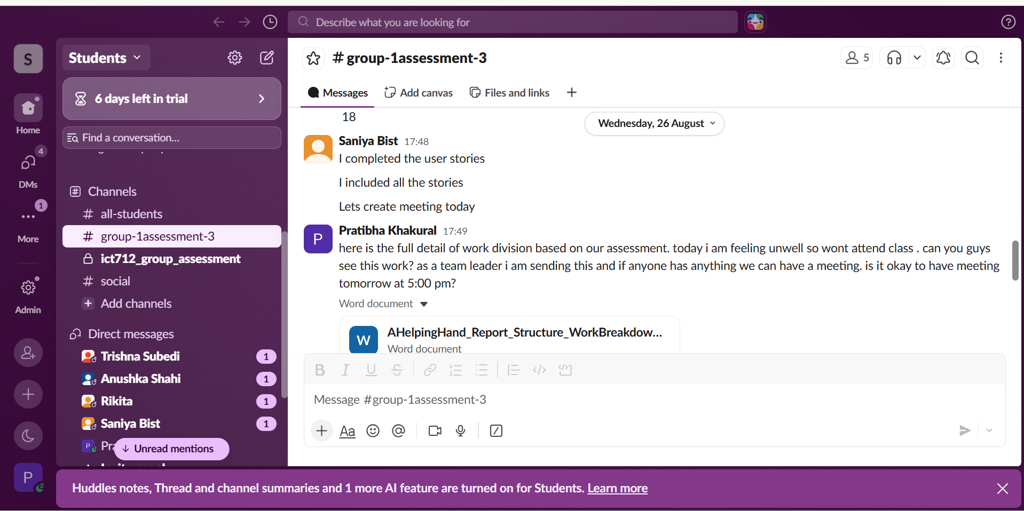

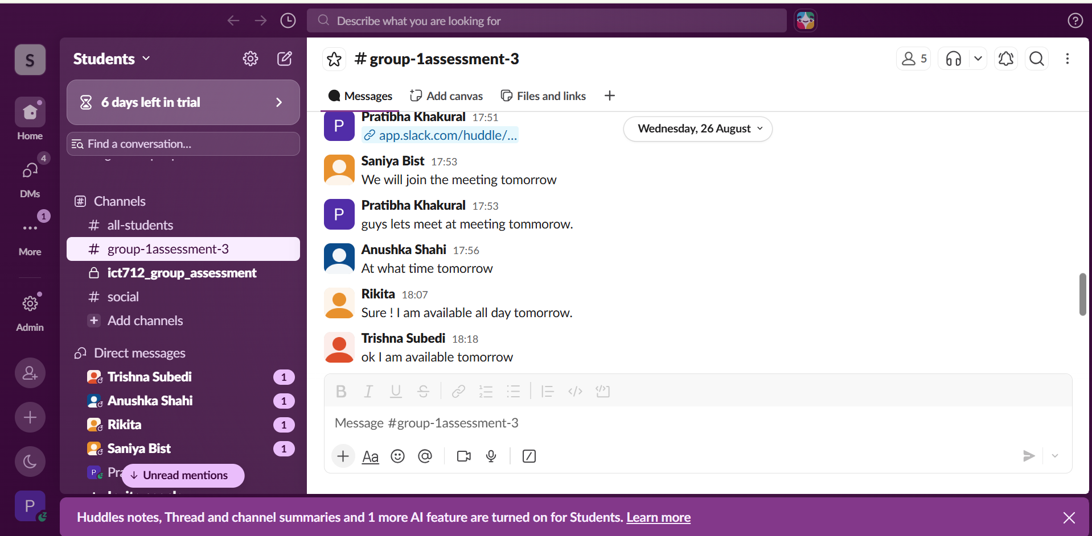
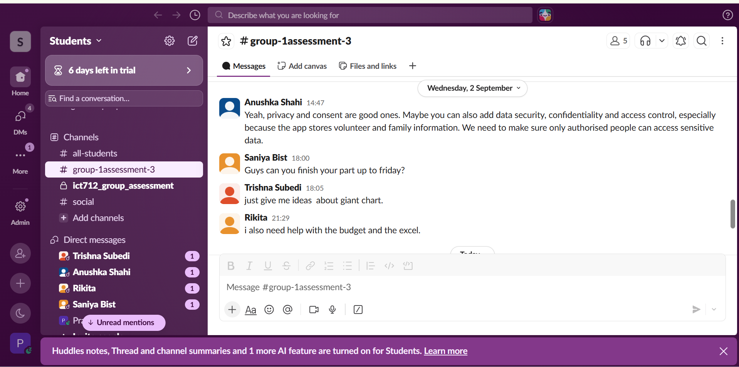

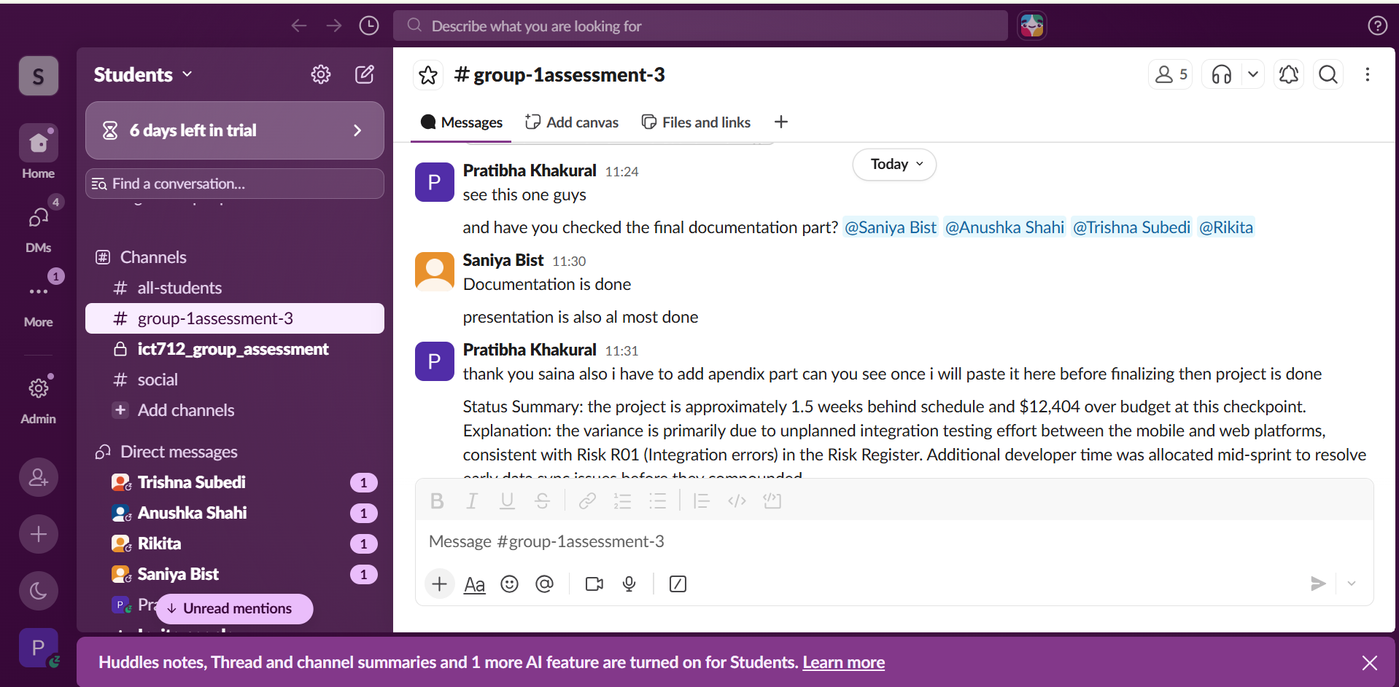

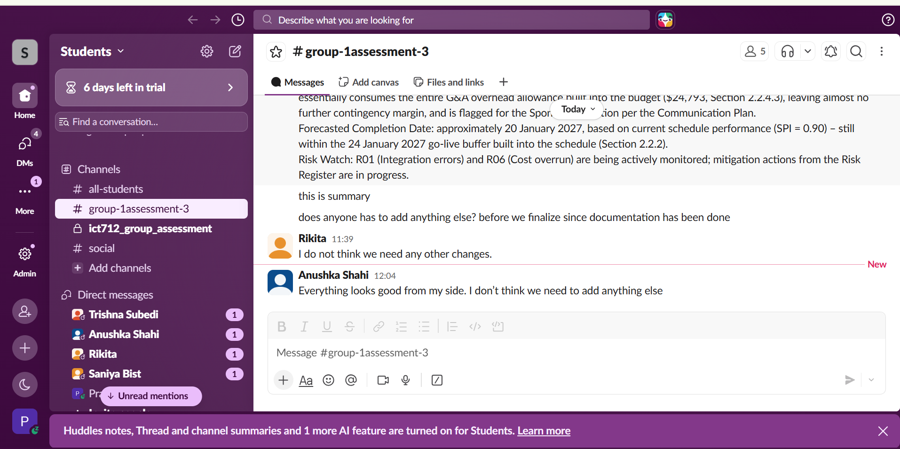
Figure 15: Team and Slack Communication

Task 3 – PMBOK and Kanban Comparison
The PMBOK and Kanban are two different method for managing IT project (Fitsilis 2008). In PMBOK main difference is on managing scope, schedule, cost in structured way. Kanban focus on visualising task, workflow management and limit work in process (Develop4Agility 2026).

Factor | PMBOK | Kanban | In this project
Planning | Activities are planned and organized in advance of work. | Work can be modified as it is carried out | PMBOK assists in management of overall project plan
Workflow | Works is organized according to project plan and agreed activities. | Tasks are placed visually on a Kanban board. | The team can follow the development tasks in Trello. |
Change | Changes are reviewed and managed. | Changes can be introduced gradually. | Useful when user feedback changes a feature.
Monitor | Monitors areas like time, cost, scope and risk | Monitors how work flows throughout the workflow, | Both monitor project progress.
Flexibility | Provides structure and is adaptable to project. | Allows work practices to evolve over time. | Is useful during four development sprints.
Best Use | Overall project management and control. | Day-to-day development workflow. | Using both is suitable for A Helping Hand.
Table 11: PMBOK and Kanban Comparison
The comparison show that PMBOK can be helpful in managing overall A Helping Hand project as it offer framework for handling scope, schedule, cost and risk. This is essential as project need to complete in 20 weeks and has budget of $148,760. And Kanban is useful tool to manage daily development activities by making work visible and limiting work in progress (Kanban University 2021).

Task 4 – Ethical Use of Client Data
One of the biggest ethical issues in IT today is how company collect and use client data. Personal information is now often treated as a business asset instead of something that belongs to the person it is about. The main concern is consent. The main concern is consent for example if people understand what's being collected, how it’s used and who access it (OpenStax 2025). In reality people don't read the whole privacy policy and even the company following it don’t assure full transparency.

Another issue is "data enrichment" which mean companies can use information from different place to create detail profile of person from different sources. In Australia this is restricted under Australian Privacy Principle 3.6 of Privacy Act 1988 (Cth) say personal info should come straight from person and not from other places should be collected. This rule is not enforced always properly and that's ethical problem here: as companies may use data which can break privacy rules as there chances of being caught is low in this case (UNSW Newsroom 2022).
Another issue is selling or sharing client data with third parties. Under Australian law this is considered disclosure and requires clear consent. Some companies use unclear consent hidden in sign-up term but not asking users directly (Sprintlaw, 2025). This create a gap between what is legally allowed and people can guess it is right as when users have to agree to the terms to use an app.

The app can store sensitive information like:
- WWCC and background check status
- Family background details for home visits
- Donor payment information

If this kind of information is sold, shared or used for any other things than its purpose originally had without any proper consent then it would break the trust of vulnerable people and also breach the Australian Privacy Principles around data use (OAIC 2024). Ethical data use mean only collecting needed information ,clear communication with volunteers and families about their information’s being used like the purpose .

Conclusion and Recommendations

The A Helping Hand project show the need for structured project management approach with flexible development practices when developing digital system for a non-profit organization. PMBOK gives clear foundation for managing project scope, schedule, budget, communication, stakeholders and risks and the Agile practices were used to provide afoundation for developing the project, using user stories, prioritized requirements and four planned sprints.

PMBOK and Kanban can also work well together. Kanban provides flexibility in managing daily development tasks and PMBOK provides overall project control.

Responsible handling of client information is also crucial that include issues of privacy, informed consent and appropriate use of sensitive data. Overall a hybrid approach in A Helping Hand is recommended for A helping hand because it support effective project delivery, stakeholder necessity respond and protect community that is served by charity.

References
Ambler, S n.d., Personas: an agile introduction, Agile Modeling, viewed 2 September 2026, https://agilemodeling.com/artifacts/personas.htm.
Blair, AA 2020, Agile project delivery: a practical approach for corporate environments beyond software development, Canadian Scholars, Toronto.
hui, CH-K & Chan, CH 2019, 'The role of technology in reconfiguring volunteer management in nonprofits in Hong Kong: benefits and discontents', Nonprofit Management and Leadership, vol. 30, no. 1, pp. 89–111, doi: 10.1002/nml.21369.
Coelho, E & Basu, A 2012, 'Effort estimation in agile software development using story points', International Journal of Applied Information Systems, vol. 3, no. 7, pp. 7–10, doi: 10.5120/ijais12-450574.
Develop4Agility 2026, Integrating Kanban method with PMBOK, Develop4Agility Consulting Ltd, viewed 2 September 2026, https://develop4agility.com/integrating-kanban-method-with-pmbok/.
Fitsilis, P 2008, 'Comparing PMBOK and agile project management software development processes', in T Sobh (ed.), Advances in computer and information sciences and engineering, Springer, Dordrecht, pp. 378–383, viewed 2 September 2026, https://www.academia.edu/2953419/Comparing_PMBOK_and_Agile_Project_Management_software_development_processes.
Kanban University 2021, The official Kanban guide, Mauvius Group Inc., viewed 2 September 2026, https://kanban.university/kanban-guide/.
Hillson, D 2002, Use a risk breakdown structure (RBS) to understand your risks, Project Management Institute, Newtown Square, PA, viewed 2 September 2026, https://www.pmi.org/learning/library/risk-breakdown-structure-understand-risks-1042.
Larson, E 2024, Project management: the managerial process, McGraw-Hill US Higher Ed ISE, New York.
Project Management Institute 2025, A guide to the project management body of knowledge (PMBOK guide), 8th edn, PMI, Newtown Square, PA.
OAIC 2024, Guide to data analytics and the Australian Privacy Principles, Office of the Australian Information Commissioner, viewed 2 September 2026, https://www.oaic.gov.au/privacy/privacy-guidance-for-organisations-and-government-agencies/more-guidance/guide-to-data-analytics-and-the-australian-privacy-principles.
OpenStax 2025, Principles of data science, 8.1 Ethics in data collection, OpenStax, viewed 2 September 2026, https://openstax.org/books/principles-data-science/pages/8-1-ethics-in-data-collection.
ProjectManager 2025, The triple constraint in project management: time, scope & cost, viewed 2 September 2026, https://www.projectmanager.com/blog/triple-constraint-project-management-time-scope-cost.
Sprintlaw 2025, Selling personal information: what's allowed?, Sprintlaw Australia, viewed 2 September 2026, https://sprintlaw.com.au/articles/trading-in-personal-information/.
UNSW Newsroom 2022, This law makes it illegal for companies to collect third-party data to profile you, UNSW Sydney, viewed 2 September 2026, https://www.unsw.edu.au/newsroom/news/2022/09/this-law-makes-it-illegal-for-companies-to-collect-third-party-d.

Appendices

Appendix A: Sample Monthly Status Report

Field | Detail
Project | A Helping Hand Volunteer and Donor Management System
Project Manager | Mr. Robert Cooper
Status as of | 16 November 2026 (end of Development Phase)

Metric | Value
PV (Planned Value) | $89,256
EV (Earned Value) | $80,330
AC (Actual Cost) | $93,407
SV (Schedule Variance) | −$8,926
CV (Cost Variance) | −$13,077
BAC (Budget at Completion) | $148,760
EAC(f) (Estimate at Completion) | $172,977
VAC (Variance at Completion) | −$24,217
CPI (Cost Performance Index | 0.86
SPI (Schedule Performance Index) | 0.90
Table 12: Sample Monthly Status Report
Status Summary: the project is about 1.5 weeks behind schedule and over budget by $13,077 due to unplanned integration testing (Risk R01). If this is continuing project can be over budget by around $24,217.

Appendix B: Sample Change Request Form

Field | Detail
Project Name | A Helping Hand Volunteer and Donor Management System
Sponsor | Margaret Chen
Request Number | CR-001
Date | 10 November 2026
Originator | Daniel Reyes, Operations Manager
Description of Requested Change | Reminding Super Users and Coordinators when upcoming Volunteers work anniversary is coming so that it can be recognized
Reason for Change | We noticed that thanking long-term Volunteers helps keep them around longer. It came up early on but got left out of the original plan
Areas of Impact | Scope , Cost (Minor) , Schedule (Minor)
Disposition | Approved, but pushed to Sprint 4 instead of doing it right away
Priority | Low
Funding Source | Budget Reserve
Sign – off | Robert Cooper (PM) 14/11/2026; Margaret Chen (Sponsor) 14/11/2026; Daniel Reyes (Customer) 14/11/2026
Table 13: Sample Change Request Form

