**Create a chatbot in python**

**Team member:**

**J Dinesh,**

**CSE-III year,**

**AI101(IBM-Artificial Group1),**

**Team Name: The enthusiastic coders,**

**Adhi college of engineering and technology.**

**Problem Definition:**

The challenge is to create a chatbot in Python that provides exceptional customer service, answering user queries on a website or application. The objective is to deliver high-quality support to users, ensuring a positive user experience and customer satisfaction.

**Aim/objective:**

In the realm of app and website development, users today expect nothing less than exceptional service when interacting with digital platforms. The challenge at hand lies in addressing user inquiries promptly and effectively, as failure to do so can lead to user disengagement and the potential loss of valuable customers. To safeguard against the erosion of user trust and its adverse impact on the financial bottom line, it becomes imperative to prioritize and consistently deliver the highest quality service throughout the entire lifecycle of website and application development.

It emphasizes the importance of developing web and app solutions that not only meet but exceed user expectations, fostering user retention and sustained organizational success.

**Design Techniques:**

**1) Functionality:**

Natural Language Understanding (NLU): Implement advanced NLP techniques for understanding user inputs.

Intent Recognition: Develop algorithms for accurately identifying user intentions.

Entity Extraction: Extract relevant entities from user queries for context-aware responses.

Context Management: Implement mechanisms to maintain conversation context for seamless interactions.

**2) User Interface:**

Intuitive Design: Prioritize intuitive and user-friendly interface design to enhance usability.

Accessibility: Ensure the app or website is accessible to users with diverse needs.

Responsive Design: Create designs that adapt to different devices and screen sizes.

Voice Interface: Optionally, include voice-based interactions with speech recognition and text-to-speech capabilities.

**3) Natural Language Processing (NLP):**

Data Preprocessing: Preprocess user inputs by tokenizing, cleaning, and normalizing text.

NLP Model Selection: Choose appropriate NLP models (e.g., spaCy, BERT) for specific tasks.

Intent Classification: Develop models for accurately classifying user intents.

Sentiment Analysis: Implement sentiment analysis to understand user emotions.

**4) Responses:**

Response Generation: Develop algorithms to generate contextually relevant, coherent responses.

Personalization: Customize responses based on user preferences and historical interactions.

Fallback Responses: Implement fallback responses for unrecognized queries.

Error Handling: Develop mechanisms to gracefully manage errors and maintain conversation flow.

**5) Integration:**

External APIs: Integrate with external services and APIs to provide real-time data or perform actions.

Multi-Platform Support: Ensure seamless functionality across various platforms and devices.

Security: Implement robust security measures to protect user data, including input validation and encryption.

**6) Testing and Improvement for Design Techniques:**

Unit Testing: Conduct unit tests to validate individual components, including NLP models and intent recognition.

Integration Testing: Test the entire chatbot system to ensure cohesive operation.

User Testing: Gather user feedback and usability data for iterative design improvements.

Performance Monitoring: Continuously monitor response times, accuracy, and user satisfaction metrics.

Iterative Development: Embrace iterative development cycles to incorporate user feedback and adapt to changing requirements

**Project Model:**

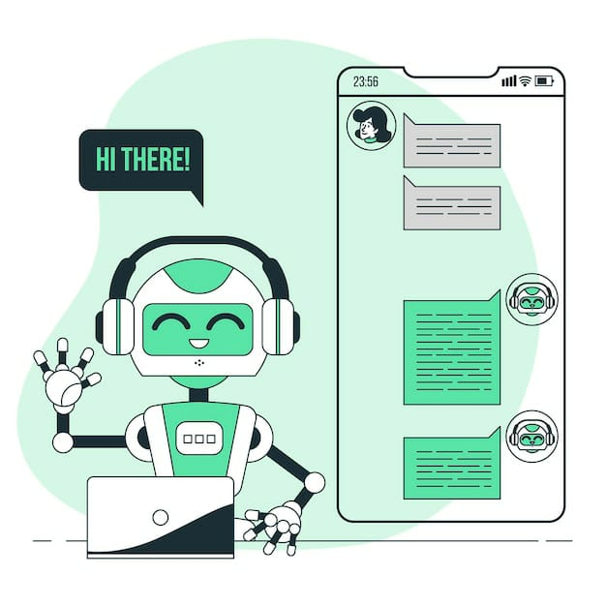

**Source:**

<https://www.kaggle.com/datasets/grafstor/simple-dialogs-for-chatbot>

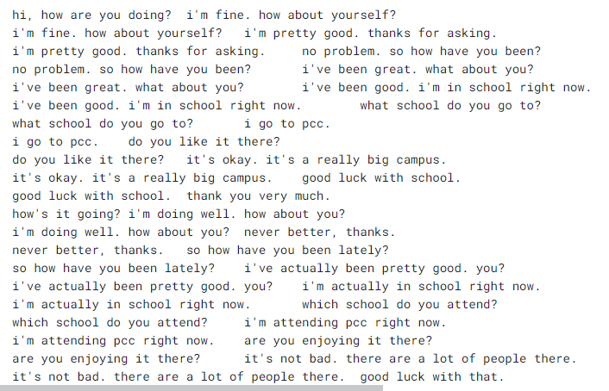

**Conclusion:**

In conclusion, the "Create a Chatbot in Python" project has provided a foundational understanding of chatbot development using Python and natural language processing techniques. By leveraging NLTK for text processing and TF-IDF for response generation, we have built a simple yet functional chatbot. This project serves as a stepping stone for more complex and advanced chatbot implementations. Further enhancements could include incorporating machine learning models, deep learning techniques, and larger, domain-specific datasets to improve the chatbot's accuracy and conversational abilities. As technology continues to evolve, the potential for chatbots in various applications remains substantial, making this project a valuable starting point for those interested in exploring the field of conversational AI.

**Thank you**