**QUADRATURE DOWN COVERTER:-**

# **MANAS SACHIN DESHMUKH**

**IIIT HYDERABAD**

**ROLL NO:2022102040**

**manas.deshmukh@students.iiit.ac.in**

# **HARSHVARDHAN SINGH**

# **IIIT HYDERABAD**

# **ROLL NO:2022112004**

# **harshvardhan.singh@students.iiit.ac.in**

1. **INTRODUCTION**

This project is about designing , simulating ,understanding and making of a quadrature down converter used very frequently in wireless receivers(Wifi, Bluetooth etc). Quadrature down conversion helps in interference mitigation and improves the quality of communication. In this project, we will implement a prototype of QDC for given specifications:-

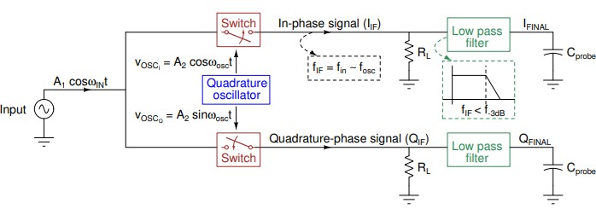(circuit diagram attached below)

Here first we give input signal as Vin=A1cos(Wint) which is modulated or mixed with Vosc1=A2cos(Wosct) and Vosc2=A2sin(Wosct) ,through a switch gives us A) in-phase signal and B) quadrature-phase signal have a phase difference of 90 degrees, this mixing basically does the function of producing two signals with frequencies W1+W2 and W1-W2 then these signals are passed through a RC circuit low pass filter which allows signal with frequency W1-W2 (lower frequency) to pass through which is much much smaller than W1+W2 considering higher values of W1 and W2.

1. **DESIGNING OF THE QUADRATURE OSCILLATOR MODEL**

**Design of the model:-**

The design of the quadrature oscillator consists of recording two outputs one producing a sine wave and other producing a cosine wave of the exact same frequency and amplitude, in the design we have two operational amplifiers and we also have a collection of resistors and capacitors who output is given as a feedback to the input of the opam and now circuit acts as an integrator

QUADRATURE OSCILLATOR DESIGN CIRCUIT:-

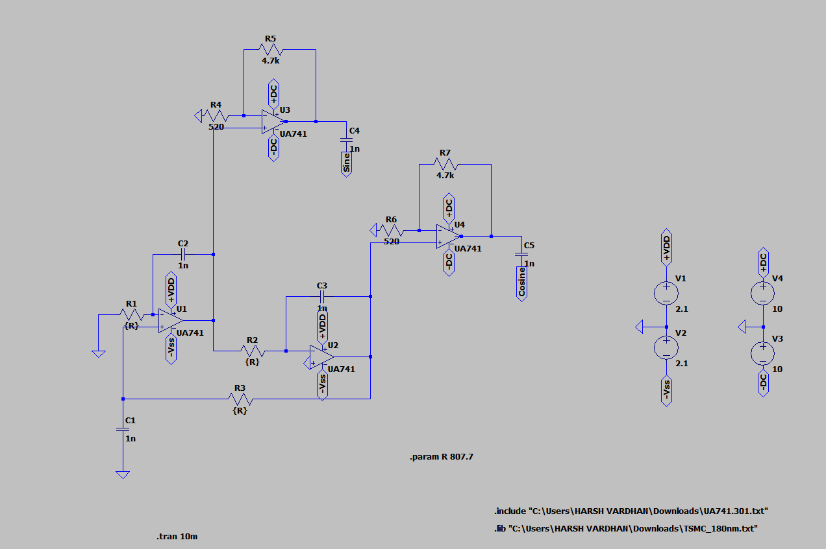

The distrurbance or noise signal passed through gets amplified by opams and gets integrated with the help of integrator we designed by opams then while recording output we receive a sinusoidal wave(saturated) this wave is now given as a feedback to one more opam integrator which integrated it to give cosine wave.

Hence we receive both sine and cosine waves at the ouput having phase difference of 90 degrees as discussed in the introduction section.

* The circuit is setup so that The criterias for oscillations are met at only a certain frequency, The criterias for positive feed back oscillations are->
* 1. loop gain>=1
* 2.Phase shift after crossing the entire loop should be 360degrees.
* 3. to generate sine and cosine waves we set up 3 sections in such a way that each section is able to phase shift the output by 90 degrees
* This gives the final frequency of oscillation to be equal to f=1/2πRC

The basic idea of this is that the circuit catches AWGN noise of (100kHz) from the environment and repeatedly amplifies it via the feedback loop

1. **CALCULATIONS:-**

For the RC circuits used to give feedback or to capture the low frequency the cutoff frequency for the low pass filter will be 1/(2*pi*R*C)

Which in our case is which is 15.92 kilo hertz in our case considering (R=10 kilo ohm and C as 10 nano farad)

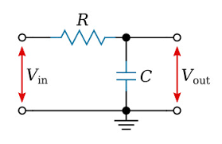

* A low-pass filter is a filter that passes signals with a frequency lower than a selected cutoff frequency and attenuates signals with frequencies higher than the cutoff frequency. The exact frequency response of the filter depends on the filter design. Here the cutoff frequency is 1/2* pi*R*C
* It is based on considering capacitance impedence as Zc=1/j*W*C and simple voltage distribution among impedences in series.
* IV) **LT SPICE SIMULATIONS AND RESULTS:-**

**FFT OF THE INPHASE COMPONENT DISCUSSED EARLIER:-**

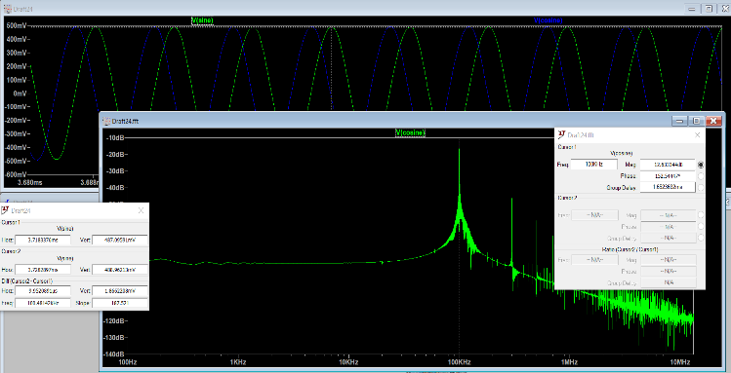

**FFT OF THE QUADRATURE COMPONENT AS DISCUSSED EARLIER:-**

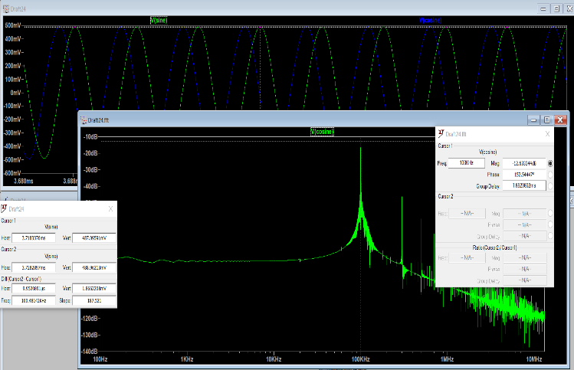

**THE LTSPICE OUTPUT OF QUADRATURE OSCILLATOR:-**

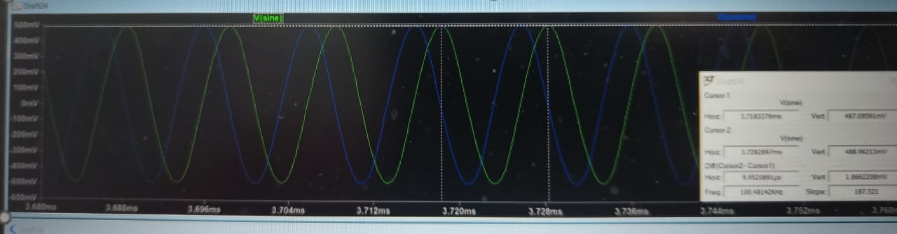

TWO WAVES WITH PHASE DIFFERENCE OF 90 DEGREES THE FFT OF BOTH IN PHASE AND QUADRATURE PHASE COMPONENT IS SAME WITH FIRST PEAK AT OUTPUT SIGNAL FREQUENCY.

THE PHASE DIFFERENCE BETWEEN THE TWO WAVES CAN EASILY BE FOUND BY KEEPING CURSORS BETWEEN TILL WHEN BOTH SIGNALS REACH UPTO THE SAME LEVEL AND THEN THE PHASE DIFFERENCE IS THAT TIME DIFFERNCE DELTA T DIVIDED BY TIME PERIOD OF BOTH THE WAVES(SAME FOR BOTH) MULTIPLIED BY 360 DEGREES

1. **DESIGN OF MIXER OR SWITCH:-**
2. A mixer is basically a multiplier of two signals for example m(t) and x(t) and gives m(t)*x(t) . Our mixer design consists of a MOSFET(whose functioning is as a switch),AC coupling capacitors , load resistors , and bias voltage DC supply.

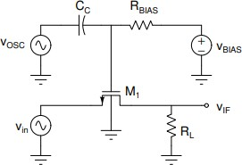

The above is the circuit diagram of the mixer. Now we are passing output of quadrature oscillator to the switch we are making use AC coupling capacitance , a coupling capacitor is used to connect two circuits such that only the AC signal from the first circuit can pass through to the next while DC is blocked and it acts a source of buffer. Now we bias the MOSFET to take control of the state in which it can be , also we need the output signal of the previous component to go to Gate terminal of the MOSFET so we will have a high or large value of Rbias and the value of Vbias is adjusted such that the on-off transition of states of the MOSFET is utilized proprerly.

**MOSFET PARAMTERS:-**

Parameter Specifications Model CMOSN

Length 0.18*µ*m

Width 1.8*µ*m

Drain Area 1*pm*2

Source Area 1*pm*2

Drain Perimeter 5*µ*m

Source Perimeter 5*µ*m

TABLE I

CHARACTERISTIC OF NMOS.

**B . THE WORKING OF**

**MIXER:-**

The mixer is a circuit that combines two input signals by modulating one signal with the other. In the case of the given circuit, the mixer utilizes an NMOS (N-channel Metal-Oxide-Semiconductor) transistor.

At the gate terminal of the NMOS transistor, the voltage is determined by the sum of the oscillator signal voltage (VOSC) and the bias voltage (VBIAS), which is equal to the threshold voltage (VT) of the transistor.

During the positive half cycle of the oscillator signal, when VOSC + VT is greater than VT, the NMOS transistor is turned on. This allows the source signal to pass through the drain terminal of the transistor, which acts as the output of the mixer.

Conversely, during the negative half cycle of the oscillator signal, when VOSC + VT is less than VT, the NMOS transistor is turned off. This blocks the source signal from passing through the drain terminal of the transistor.

Since the frequency of the oscillator signal is high, it rapidly alternates between positive and negative half cycles. This results in the NMOS transistor turning on and off quickly. As a result, the output of the mixer exhibits a mixing of the input signal with a square pulse generated by the on/off behavior of the transistor.

In summary, the mixer circuit combines two signals by modulating one signal with the other. The NMOS transistor acts as a switch, allowing the source signal to pass through during the positive half cycle of the oscillator signal and blocking it during the negative half cycle. The output of the mixer exhibits a mixing of the input signal with a square pulse due to the rapid on/off switching of the transistor

C.**RESULT/SIMULATIONS:-**

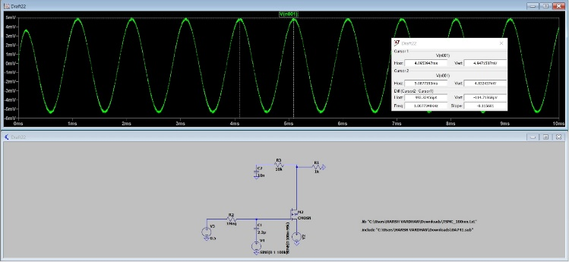

**THE CIRCUIT COMBINED FOR USING MOSFET AS A SWITCH AND A LOW PASS FILTER(FOR SWITCH)**

**Combined :MOSFET AS A SWITCH WITH LOW PASS FILTER CATCHING FREQUENCY 1 KILO HERTZ from the ORIGINAL SIGNAL:-**

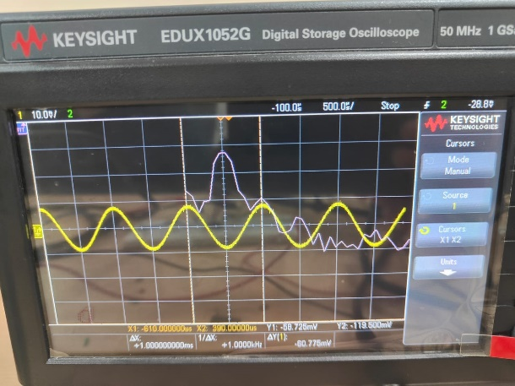

**The mixer sinusoid and output after passing through LPF:-**

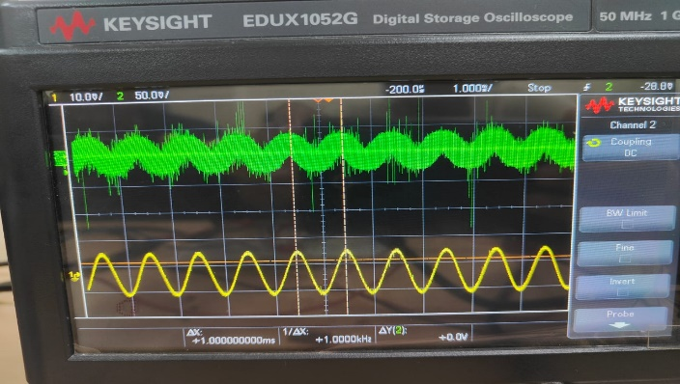

A.

**LOW PASS FILTER:-**

**THE DESIGN OF THE CIRCUIT:-**

**THE DESIGN IS BASICALLY A SERIES RC CIRCUIT**

**TAKING OUPUT AT PLATES OF CAPACITOR WITH -3dB as cutoff frequency (WE KNOW THAT Fc=1/(2*pi*R*C)**

**THE WORKING OF LOW PASS FILTER RC CIRCUIT:-**

The cutoff frequency of an RC circuit is the frequency at which the output voltage or current is attenuated by 3 decibels (dB) compared to its maximum value. This frequency is also known as the -3dB cutoff frequency or the half-power frequency.

In an RC circuit, the resistor and capacitor interact to create a low-pass filter. The resistor controls the rate at which the capacitor charges and discharges, and the capacitor acts as a storage element for energy. At low frequencies, the capacitor charges and discharges relatively slowly, allowing most of the input signal to pass through the circuit.

However, as the frequency increases, the capacitor cannot charge and discharge quickly enough, causing the output signal to be attenuated. At the cutoff frequency, the voltage or current amplitude is reduced by 3dB, which corresponds to a 50% reduction in power.

The cutoff frequency (f_c) of an RC circuit can be calculated using the formula:

f_c = 1 / (2*pi*R*C)

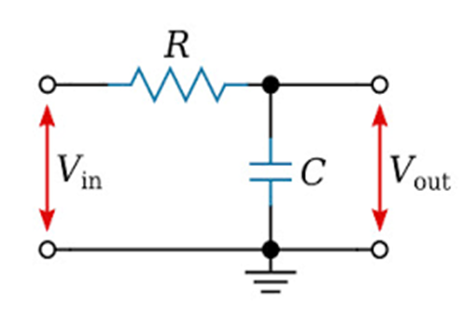

1. **FUNCTIONING OF LPF ALONG WITH MIXER:-**
2. After mixing the oscillator and the input signal, the resulting signal contains two frequency components: one at the sum of the input frequency (win) and the oscillator frequency (wOSC), and the other at the difference of these frequencies.
3. To extract the desired frequency component, we pass the mixed signal through a low-pass filter (LPF). The LPF is designed to allow only frequencies below a certain cutoff frequency to pass through effectively, while attenuating higher frequencies.
4. In this context, the LPF is used to remove the undesired frequency component at win + wOSC and retain the component at win - wOSC, which corresponds to the down-converted frequency. The cutoff frequency of the LPF determines the extent of attenuation of the undesired frequency component. By setting the cutoff frequency appropriately, we can ensure that only the desired down-converted frequency component is passed through the filter.
5. The output of the LPF consists of the desired down-converted frequency component, with the unnecessary frequency component effectively removed. This allows for further processing or analysis of the signal, specifically focusing on the down-converted frequency of interest.
6. In summary, the low-pass filter in the mixer circuit removes unwanted frequency components, allowing only the desired down-converted frequency component to pass through, enabling frequency down-conversion and subsequent processing
7. Id versus Vds graph for nmos on observing the graph we get Vt=0.61mV

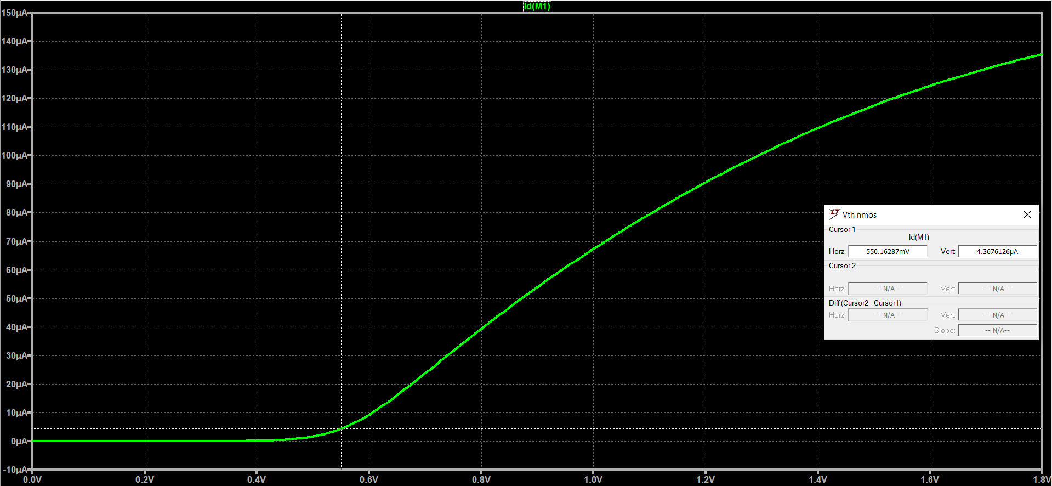

*Some Common Mistakes*

* + The word “data” is plural, not singular.
  + The subscript for the permeability of vacuum *µ*0, and other common scientific constants, is zero with subscript formatting, not a lowercase letter “o”.
  + In American English, commas, semicolons, periods, ques- tion and exclamation marks are located within quotation marks only when a complete thought or name is cited, such as a title or full quotation. When quotation marks are used, instead of a bold or italic typeface, to highlight a word or phrase, punctuation should appear outside of the quotation marks. A parenthetical phrase or statement at the end of a sentence is punctuated outside of the closing parenthesis (like this). (A parenthetical sentence is punctuated within the parentheses.)
  + A graph within a graph is an “inset”, not an “insert”. The word alternatively is preferred to the word “alternately” (unless you really mean something that alternates).
  + Do not use the word “essentially” to mean “approxi- mately” or “effectively”.
  + In your paper title, if the words “that uses” can accurately replace the word “using”, capitalize the “u”; if not, keep using lower-cased.
  + Be aware of the different meanings of the homophones “affect” and “effect”, “complement” and “compliment”, “discreet” and “discrete”, “principal” and “principle”.
  + Do not confuse “imply” and “infer”.
  + The prefix “non” is not a word; it should be joined to the word it modifies, usually without a hyphen.
  + There is no period after the “et” in the Latin abbreviation “et al.”.
  + The abbreviation “i.e.” means “that is”, and the abbrevi- ation “e.g.” means “for example”.

An excellent style manual for science writers is [7].

1. *Authors and Affiliations*

**The class file is designed for, but not limited to, six authors.** A minimum of one author is required for all confer- ence articles. Author names should be listed starting from left to right and then moving down to the next line. This is the author sequence that will be used in future citations and by indexing services. Names should not be listed in columns nor group by affiliation. Please keep your affiliations as succinct as possible (for example, do not differentiate among departments of the same organization).

1. *Identify the Headings*

Headings, or heads, are organizational devices that guide the reader through your paper. There are two types: component heads and text heads.

Component heads identify the different components of your paper and are not topically subordinate to each other. Examples include Acknowledgments and References and, for these, the correct style to use is “Heading 5”. Use “figure caption” for your Figure captions, and “table head” for your table title. Run-in heads, such as “Abstract”, will require you to apply a style (in this case, italic) in addition to the style provided by the drop down menu to differentiate the head from the text.

Text heads organize the topics on a relational, hierarchical basis. For example, the paper title is the primary text head because all subsequent material relates and elaborates on this one topic. If there are two or more sub-topics, the next level head (uppercase Roman numerals) should be used and, conversely, if there are not at least two sub-topics, then no subheads should be introduced.

1. *Figures and Tables*

*a) Positioning Figures and Tables:* Place figures and tables at the top and bottom of columns. Avoid placing them in the middle of columns. Large figures and tables may span across both columns. Figure captions should be below the figures; table heads should appear above the tables. Insert figures and tables after they are cited in the text. Use the abbreviation “Fig. 1”, even at the beginning of a sentence

TABLE I

TABLE TYPE STYLES

|  |  |  |  |
| --- | --- | --- | --- |
| **Table**  **Head** | **Table Column Head** | | |
| ***Table column subhead*** | ***Subhead*** | ***Subhead*** |
| copy | More table copya |  |  |

aSample of a Table footnote.



Fig. 1. Example of a figure caption.

Figure Labels: Use 8 point Times New Roman for Figure labels. Use words rather than symbols or abbreviations when writing Figure axis labels to avoid confusing the reader. As an example, write the quantity “Magnetization”, or “Magnetiza- tion, M”, not just “M”. If including units in the label, present them within parentheses. Do not label axes only with units. In the example, write “Magnetization (A/m)” or “Magnetization A[m(1)] ”, not just “A/m”. Do not label axes with a ratio of quantities and units. For example, write “Temperature (K)”, not “Temperature/K”.

*{ }*

ACKNOWLEDGMENT

The preferred spelling of the word “acknowledgment” in America is without an “e” after the “g”. Avoid the stilted expression “one of us (R. B. G.) thanks *. . .*”. Instead, try “R. B. G. thanks*. . .*”. Put sponsor acknowledgments in the unnumbered footnote on the first page.

REFERENCES

Please number citations consecutively within brackets [1]. The sentence punctuation follows the bracket [2]. Refer simply to the reference number, as in [3]—do not use “Ref. [3]” or “reference [3]” except at the beginning of a sentence: “Reference [3] was the first *. . .*”

Number footnotes separately in superscripts. Place the ac- tual footnote at the bottom of the column in which it was cited. Do not put footnotes in the abstract or reference list. Use letters for table footnotes.

Unless there are six authors or more give all authors’ names; do not use “et al.”. Papers that have not been published, even if they have been submitted for publication, should be cited as “unpublished” [4]. Papers that have been accepted for publication should be cited as “in press” [5]. Capitalize only the first word in a paper title, except for proper nouns and element symbols.

For papers published in translation journals, please give the English citation first, followed by the original foreign-language citation [6].

REFERENCES

1. G. Eason, B. Noble, and I. N. Sneddon, “On certain integrals of Lipschitz-Hankel type involving products of Bessel functions,” Phil. Trans. Roy. Soc. London, vol. A247, pp. 529–551, April 1955.
2. J. Clerk Maxwell, A Treatise on Electricity and Magnetism, 3rd ed., vol.

2. Oxford: Clarendon, 1892, pp.68–73.

1. I. S. Jacobs and C. P. Bean, “Fine particles, thin films and exchange anisotropy,” in Magnetism, vol. III, G. T. Rado and H. Suhl, Eds. New York: Academic, 1963, pp. 271–350.
2. K. Elissa, “Title of paper if known,” unpublished.
3. R. Nicole, “Title of paper with only first word capitalized,” J. Name Stand. Abbrev., in press.
4. Y. Yorozu, M. Hirano, K. Oka, and Y. Tagawa, “Electron spectroscopy studies on magneto-optical media and plastic substrate interface,” IEEE Transl. J. Magn. Japan, vol. 2, pp. 740–741, August 1987 [Digests 9th Annual Conf. Magnetics Japan, p. 301, 1982].
5. M. Young, The Technical Writer’s Handbook. Mill Valley, CA: Univer- sity Science, 1989.