3-DOF Robot Arm
Product of Exponentials (POE) & Forward Kinematics
Documentation of the work completed so far — from space screws to body screws

1. Robot Schematic
The following schematic is the robot model used in this derivation. The physical chain is θ₁ → l₁ → θ₂ → l₂ → θ₃ → l₃ → end effector.
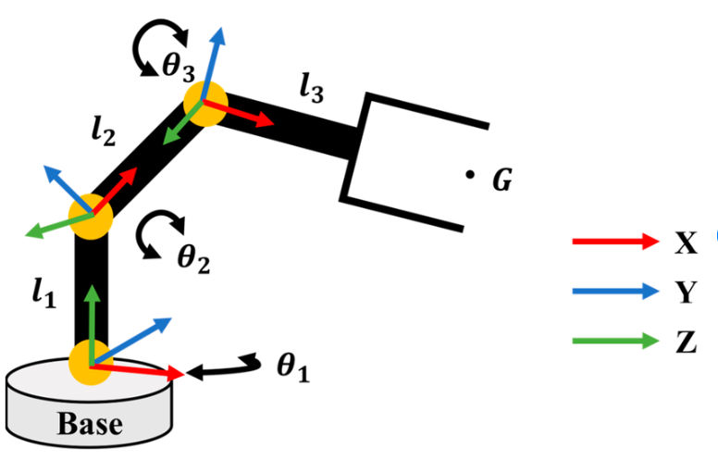
Figure 1. 3-DOF robot arm schematic.

2. Robot Dimensions and Convention
The link lengths used for the mathematical model are:
Parameter | Meaning | Value
l₁ | Base to Joint 2 | 0.30 m
l₂ | Joint 2 to Joint 3 | 0.40 m
l₃ | Joint 3 to end effector | 0.30 m
The space frame is fixed at the robot base. The body frame is attached to the end effector. The home configuration is θ₁ = θ₂ = θ₃ = 0.

3. POE Building Blocks

3.1 Homogeneous Transformation Matrix
A homogeneous transformation contains orientation and position:
T = [ R p ; 0 1 ]
R is the 3×3 rotation matrix and p is the 3×1 position vector.

3.2 Space Frame
The space frame is the fixed coordinate frame attached to the robot base. It does not move when the robot joints move.

3.3 Body Frame
The body frame is attached to the end effector and therefore moves with the robot.

3.4 qᵢ, ωᵢ and vᵢ
qᵢ is a point on joint i's rotation axis. ωᵢ is the unit vector along its rotation axis. For a revolute joint:
vᵢ = −ωᵢ × qᵢ
The 6×1 screw axis is:
Sᵢ = [ ωᵢ ; vᵢ ]

4. Space-Frame Screw Axes
The values obtained for the current model are:

Joint 1
q₁ = [0, 0, 0]ᵀ
ω₁ = [0, 0, 1]ᵀ
v₁ = [0, 0, 0]ᵀ
S₁ = [0, 0, 1, 0, 0, 0]ᵀ

Joint 2
q₂ = [0, 0, 0.30]ᵀ
ω₂ = [1, 0, 0]ᵀ
v₂ = [0, 0.30, 0]ᵀ
S₂ = [1, 0, 0, 0, 0.30, 0]ᵀ

Joint 3
q₃ = [0.40, 0, 0.30]ᵀ
ω₃ = [1, 0, 0]ᵀ
v₃ = [0, 0.30, 0]ᵀ
S₃ = [1, 0, 0, 0, 0.30, 0]ᵀ

4.1 Total Space Screw Matrix
S = [ S₁ S₂ S₃ ] =
[ 0 1 1 ]
[ 0 0 0 ]
[ 1 0 0 ]
[ 0 0 0 ]
[ 0 0.30 0.30]
[ 0 0 0 ]
Important: with the current interpretation, S₂ and S₃ are identical. This is the result used in the work so far; the physical joint-3 axis should be checked against the schematic before using the model for a final numerical robot implementation.

5. Home Configuration M
The home configuration is:
M = T(0, 0, 0)
At zero angles, the chain gives z = l₁ = 0.30 m and x = l₂ + l₃ = 0.40 + 0.30 = 0.70 m.
Therefore:
pₑ = [0.70, 0, 0.30]ᵀ m
Assuming the end-effector axes are aligned with the space axes at home, R = I.
M =
[ 1 0 0 0.70 ]
[ 0 1 0 0 ]
[ 0 0 1 0.30 ]
[ 0 0 0 1 ]

5.1 Inverse of M
M⁻¹ =
[ 1 0 0 −0.70 ]
[ 0 1 0 0 ]
[ 0 0 1 −0.30 ]
[ 0 0 0 1 ]

6. Product of Exponentials Forward Kinematics
The space-frame POE formula calculates the end-effector pose from the joint angles:
T(θ₁, θ₂, θ₃) = exp([S₁]θ₁) exp([S₂]θ₂) exp([S₃]θ₃) M
For S = [ω; v], its 4×4 se(3) matrix is:
[S] = [ [ω] v ; 0 0 ]
where [ω] is the skew-symmetric matrix:
[ω] = [ 0 −ωz ωy ; ωz 0 −ωx ; −ωy ωx 0 ].
Once numerical values of θ₁, θ₂ and θ₃ are supplied, T gives the end-effector position and orientation expressed relative to the fixed space/base frame.

7. Body Screw Axes
Body screws describe the same physical joint motions, but expressed in the body/end-effector frame at the home configuration.
The conversion is:
Bᵢ = Ad(M⁻¹) Sᵢ

7.1 Adjoint Transformation
For T = [R p; 0 1]:
Ad(T) = [ R 0 ; [p]R R ].
Because the current M has R = I, the conversion is especially simple. For M⁻¹, the linear component can be written as:
vᴮ = vˢ − p × ω

7.2 Body Screw Results
B₁ = [0, 0, 1, 0, 0.70, 0]ᵀ
B₂ = [1, 0, 0, 0, 0, 0]ᵀ
B₃ = [1, 0, 0, 0, 0, 0]ᵀ

7.3 Total Body Screw Matrix
B = [ B₁ B₂ B₃ ] =
[ 0 1 1 ]
[ 0 0 0 ]
[ 1 0 0 ]
[ 0 0 0 ]
[ 0.70 0 0 ]
[ 0 0 0 ]

8. Body-Frame POE
The equivalent body formulation is:
T(θ₁, θ₂, θ₃) = M exp([B₁]θ₁) exp([B₂]θ₂) exp([B₃]θ₃)
Notice the distinction: M⁻¹ is used to convert space screws into body screws, but the original M is used in the body POE forward-kinematics equation.

9. Space vs Body — Quick Comparison
 | Space | Body
Reference | Fixed base frame | End-effector frame
Screws | S₁, S₂, S₃ | B₁, B₂, B₃
Conversion | — | Bᵢ = Ad(M⁻¹)Sᵢ
POE | exp(S₁θ₁) exp(S₂θ₂) exp(S₃θ₃) M | M exp(B₁θ₁) exp(B₂θ₂) exp(B₃θ₃)

10. What Has Been Completed
- Defined the space/base frame and body/end-effector frame.
- Identified q₁, q₂, q₃ and ω₁, ω₂, ω₃.
- Calculated vᵢ = −ωᵢ × qᵢ.
- Constructed S₁, S₂, S₃ and the total space screw matrix.
- Constructed the home transformation M = T(0,0,0).
- Established the space-frame POE forward-kinematics equation.
- Converted the space screws into body screws using Bᵢ = Ad(M⁻¹)Sᵢ.
- Established the equivalent body-frame POE equation.

11. Current Results — One-Page Reference
Space screws:
S₁ = [0,0,1,0,0,0]ᵀ
S₂ = [1,0,0,0,0.30,0]ᵀ
S₃ = [1,0,0,0,0.30,0]ᵀ
Home configuration:
M = [ [1,0,0,0.70], [0,1,0,0], [0,0,1,0.30], [0,0,0,1] ]
Body screws:
B₁ = [0,0,1,0,0.70,0]ᵀ
B₂ = [1,0,0,0,0,0]ᵀ
B₃ = [1,0,0,0,0,0]ᵀ
This document intentionally stops here. Velocity kinematics, Jacobians, inverse kinematics, dynamics and control are not included.

