Michael Kelly 20041540 Computer Systems Lab 11

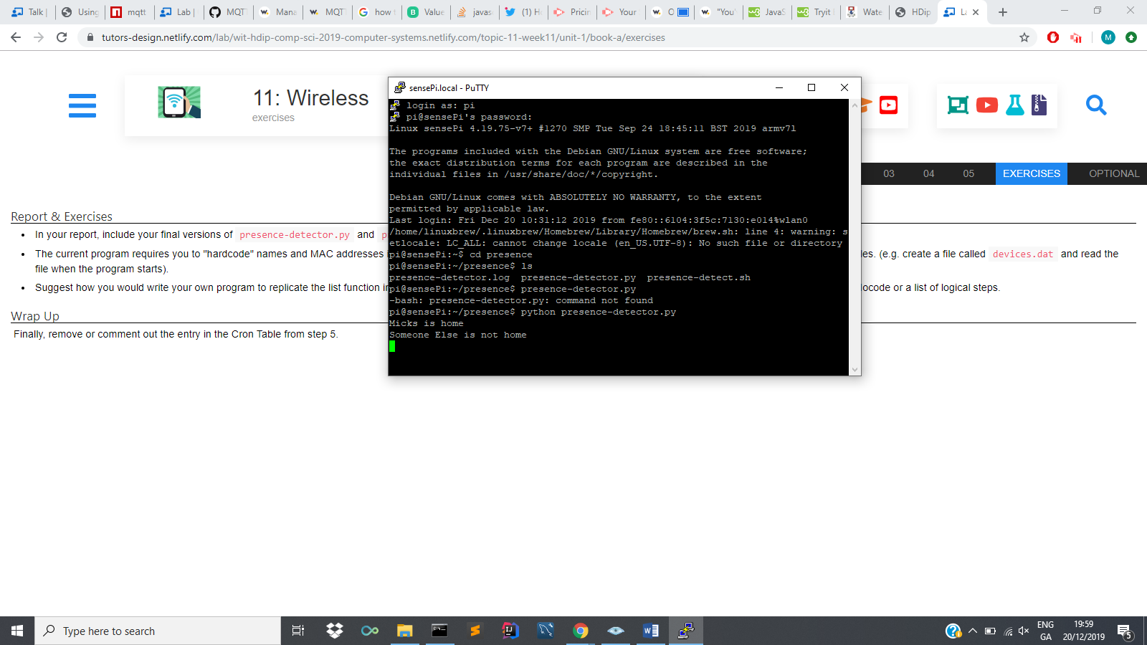

Presence-detector.py

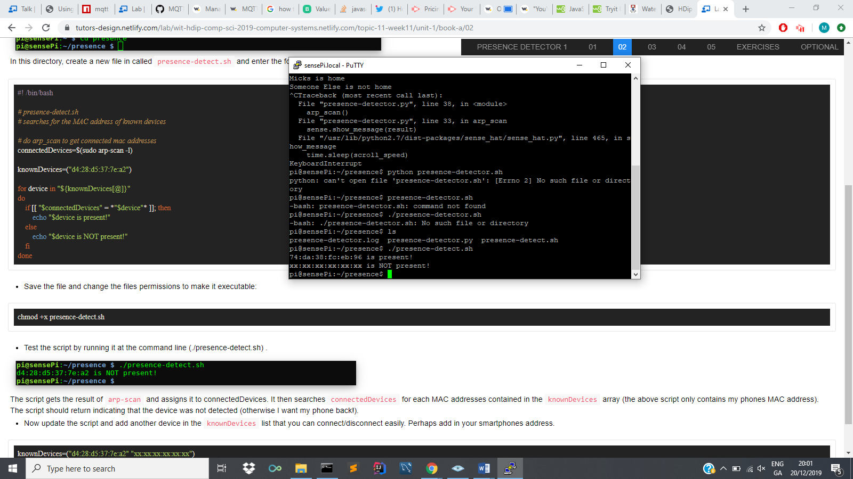

presence-detect.sh