**D. Jared Chase Project 1 erd and endpoints**

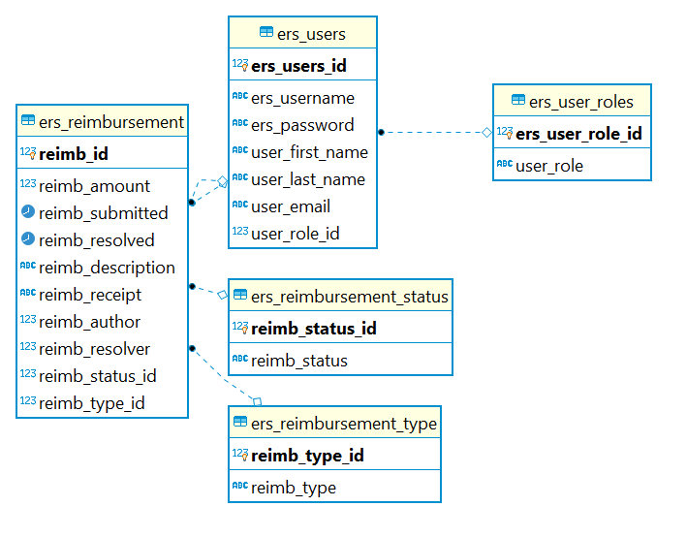

Endpoints:

* Users
  + GET/users – retrieves all users
  + GET/users/:id – retrieves user by id
  + POST/users – creates new user
  + PATCH/users – updates user info
  + DELETE/users – deletes user
* Reimbursements
  + GET/reimbursements – retrieves all reimbursements
  + GET/reimbursements/author – retrieves reimbursements by author
  + GET/reimbursements/author/status – retrieves reimbursements by status for specific author
  + GET/reimbursements/status – retrieves reimbursements by status
  + GET/reimbursements/:id – retrieves reimbursements by id
  + POST/reimbursements – creates new reimbursement
  + PATCH/reimbursements – updates reimbursement
* POST/login – for user login
* GET/logout – for user logout