

PROJECT 1 – checkpoint 1

Michel Charles – mcharl05@nyit.edu



June 1, 2020

Revature

**ERD DIAGRAM**

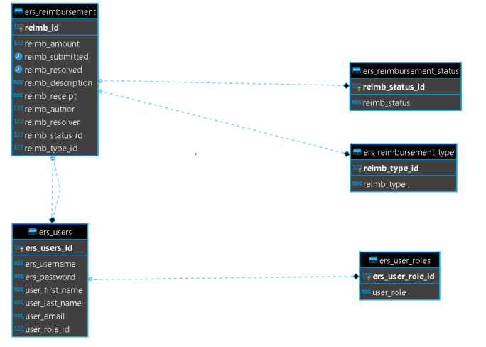

**API DESIGN**