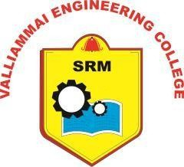
SRM VALLIAMMAI ENGINEERING COLLEGE
(An Autonomous Institution) ESTD. 1999 - Accredited by NBA - Approved by AICTE
‘A’ Grade Accreditation by NAAC ISO 9001:2015 Certified - Affiliated to Anna University Chennai

CENTRE OF EXCELLENCE IN SUSTAINABILITY

SDG CERTIFICATE
This is to certify that the project work titled “PRNU – BASED IMAGE SOURCE VERIFICATION AND FORGERY DETECTION” has been successfully completed by “LOKESH S (142222128033), MANOJ D (142222128038), and HARIHARAN K (142222128046)” of B.E. – Cyber Security, during the academic year 2025-26. This project aligns with the United Nations Sustainable Development Goals and mapped to the following Sustainable Development Goal (SDG):
SDG Number | Name | Brief Justification
SDG 9 | Industry, Innovation, and Infrastructure | By driving technological innovation in digital forensics through advanced PRNU algorithms.
SDG 16 | Peace, Justice, and Strong Institutions | By scientifically verifying digital images to combat forgery and misinformation.

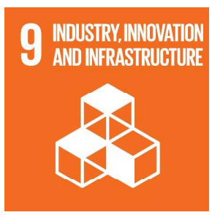


PROJECT SUPERVISOR

SRM Nagar, Kattankulathur - 603203, Chengalpattu District, Tamil Nadu, India Phone : 044 - 27454784, 27454726 & 27451498 Fax : 044 – 27451504
Website : www.srmvalliammai.ac.in Email: srmvec@srmvalliammai.ac.in

CES COORDINATOR

HOD/CYS

