Case Study Report



**Tech Saksham**

Data Analytics with Power BI

**“Power BI powered Global Terrorism”**

**“Ambai Arts College”**

|  |  |
| --- | --- |
| **NM ID** | **NAME** |
| 47C130D7A854E0492C84FFBD51368C3A | B.Priyadharshini |

Trainer Name: R. Umamaheshwari

Master Name: R. Umamaheshwari

|  |  |
| --- | --- |
|  |  |
|  |  |
|  |  |

**ABSTRACT**

This report provides an analysis of global terrorism trends using the Power BI platform. Analyzing the global terrorism dataset using Power BI provides insights into patterns, trends, and correlations within the data. Through visualizations and interactive dashboards, this analysis uncovers geographical hotspots, attack methods, and trends over time, aiding in understanding the dynamics of terrorism worldwide. It highlights the utilization of various platform and tools for gathering, storing and processing terrorism-related data, enabling comprehensive insights into global terrorism trends and patterns.

**INDEX**

|  |  |  |
| --- | --- | --- |
| **Sr. No.** | **Table of Contents** | **Page No.** |
| 1 | Chapter 1: Introduction | 4 |
| 2 | Chapter 2: Services and Tools Required | 6 |
| 3 | Chapter 3: Project Architecture | 7 |
| 4 | Chapter 4: Modeling and Result | 8 |
| 5 | Conclusion | 11 |
| 6 | Future Scope | 12 |
| 7 | Reference link | 13 |

**CHAPTER 1**

**INTRODUCTION**

* 1. **Problem Statement**

Despite concerted efforts to combat terrorism, understanding its evolving nature remains a Challenge. Current strategies often lack he permission needed to effectively address emerging threats. This study seeks to full this gape by leveraging Power BI to analyze and comprehensive global terrorism dataset. The problem lies in deciphering complex patterns and trends within this data to inform more targeted and proactive counterterrorism measures. By identifying key hotspots, attack methods, and temporal shifts, this research aims to empower decision-makers with actionable insights for enhancing global security efforts.

* 1. **Proposed Solution**

To address the aforementioned problem, this study proposes the utilization of Power BI for in-depth analysis of the global terrorism dataset. By leveraging its interactive visualization capabilities and advanced analytics tools, stakeholders can gain deeper insights into terrorism trends. The solution involves creating customizable dashboards and reports that allow users to explore various aspects of terrorism, including geographical patterns, attack methods, casualty statistics, and temporal trends. Additionally, machine learning algorithms can be employed to predict future trends and identify potential hotspots for preemptive actions. This holistic approach aims to empower policymakers and security professionals with actionable intelligence to enhance global counterterrorism efforts.

.

* 1. **Feature**
* **Geospatial visualization: Interactive** maps highlighting geographical hotspots of terrorist activity, allowing users to drill down to specific regions for further analysis.
* **Temporal Analysis:** Time-serious graphs illustrating trends in terrorist incidents overtime enabling users to identify patterns and seasonal variations.
* **Attack Methodology Breakdown**: Visualization categorizing terrorist attacks by method (e.g., bombings, shootings, kidnappings), providing insights into prevalent tactics.
  1. **Advantages**
* **Comprehensive Insights:** The use of Power BI enables the integration and visualizations of diverse dataset, providing holistic understanding

of global terrorism trends.

* **Cost-Efficiency:** Power BI is a cost effective solution compared to

traditional business intelligence tools, offering robust functionality

fraction of the cost.

* **Customization:** Dashboards and reports can be tailored to specific

user need and preference accommodating different level of analysis

expertise.

* 1. **Scope**

Gathering and preprocessing and comprehensive global terrorism

dataset for reputable sources such as global terrorism database or

start. Exploring the dataset to understand its structures, variables

and qualities and identifying relevant features for analysis. Validating

the insights generated through expect review and comparison with

existing literature and domain knowledge. Documenting the analysis

process, findings and insights in a comprehensive report or

presentation format for dissemination to stakeholders.

**CHAPTER 2**

**SERVICES AND TOOLS REQUIRED**

* 1. **Services Used**
* **Data Collection and Storage Services**: The Power BI powered analysis of

the global terrorism dataset utilized various data collection and storage services. The services encompassed data gathering platforms, cloud-based storage solutions, and data processing tools to compile, organize, and analyze the vast array of terrorism-related data.

* **Data Processing Services**: Services like Azure Stream Analytics or AWS Kinesis Data Analytics can be used to process the real-time data.
* **Machine Learning Services**: Azure Machine Learning or AWS Sage Maker can be used to build predictive models based on historical data.

**2.2 Tools and Software used**

**Tools**:

* **Power BI**: The main tool for this project is Power BI, which will be used to create interactive dashboards for real-time data visualization.
* **Power Query**: This is a data connection technology that enables you to discover, connect, combine, and refine data across a wide variety of sources.

**Software Requirements**:

* **Power BI Desktop**: This is a Windows application that you can use to create reports and publish them to Power BI.
* **Power BI Service**: This is an online SaaS (Software as a Service) service that you use to publish reports, create new dashboards, and share insights.
* **Power BI Mobile**: This is a mobile application that you can use to access your reports and dashboards on the go.

**CHAPTER 3**

**PROJECT ARCHITECTURE**

**3.1 Architecture**

**USER FRONTEND BACKEND**

|  |  |  |
| --- | --- | --- |
|  | **HTML 5** | **NODEJS 14.0**  **Database** |

Here’s a high-level architecture for the project:

1. **Data Collection**: Power BI, a powerful data visualization could be

utilized to analyze and present terrorism data collected from various

sources.

1. **Data Storage**: The collected data is stored in a database for processing. Azure SQL Database or AWS RDS can be used for this purpose.
2. **Data Processing**: The stored data is processed in real-time using services like Azure Stream Analytics or AWS Kinesis Data Analytics.
3. **Machine Learning**: Predictive models are built based on processed data using Azure Machine Learning or AWS Sage Maker. These models can help in predicting customer behavior, detecting fraud, etc.
4. **Data Visualization**: The processed data and the results from the predictive models are visualized in global terrorism using Power BI. Power BI allows you to create interactive dashboards that can provide valuable insights into the data.
5. **Data Access**: The dashboards created in Power BI can be accessed through Power BI Desktop, Power BI Service (online), and Power BI Mobile.

This architecture provides a comprehensive solution for Power BI global terrorism. However, it’s crucial to ensure ethical consideration and data privacy regulations or strictly adhered to when collecting an analyzing such sensitive data. It’s also important to ensure that all tools and services comply with relevant data privacy and security regulations.

**CHAPTER 4**

**MODELING AND RESULT**

**Manage relationship:**

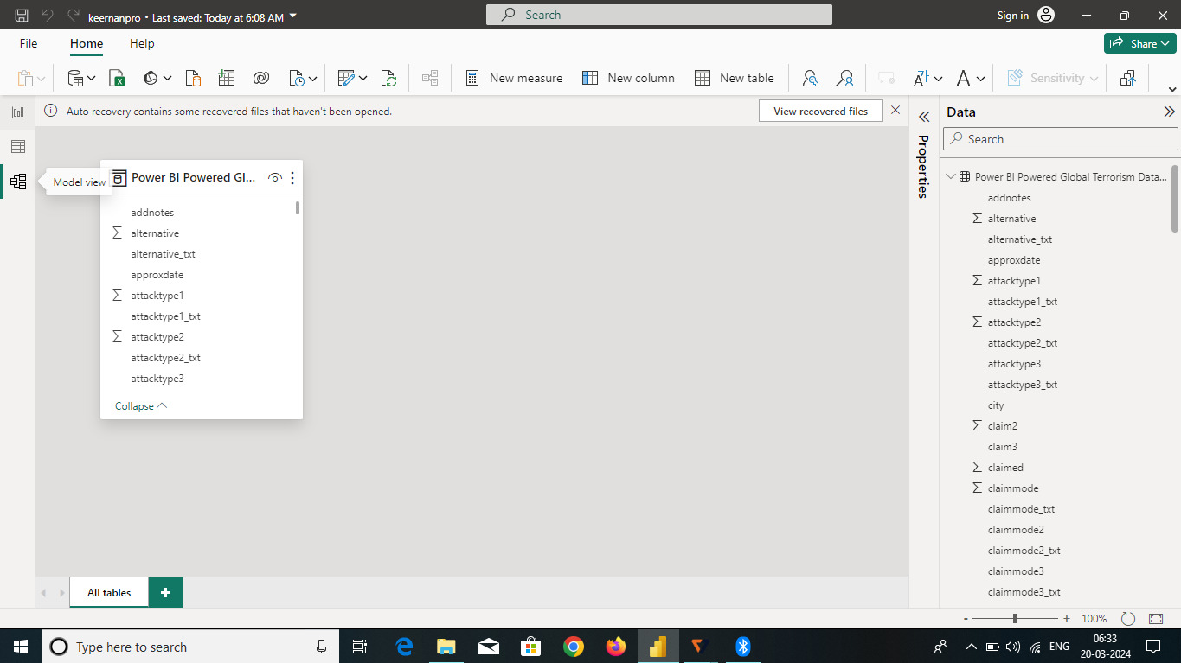

**Dashboard**

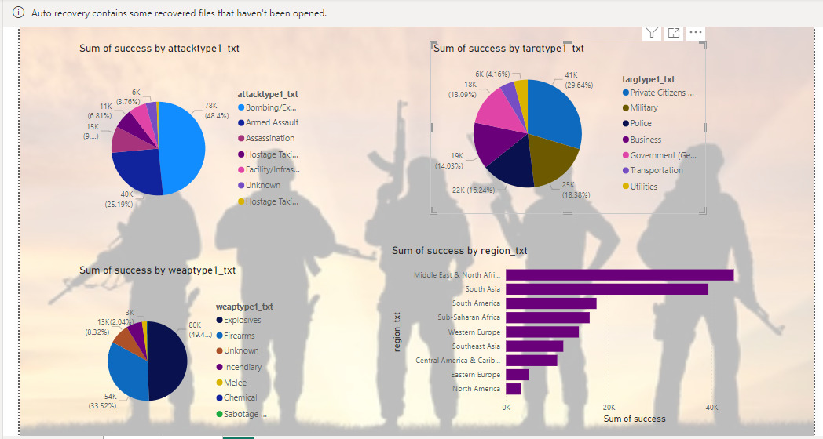

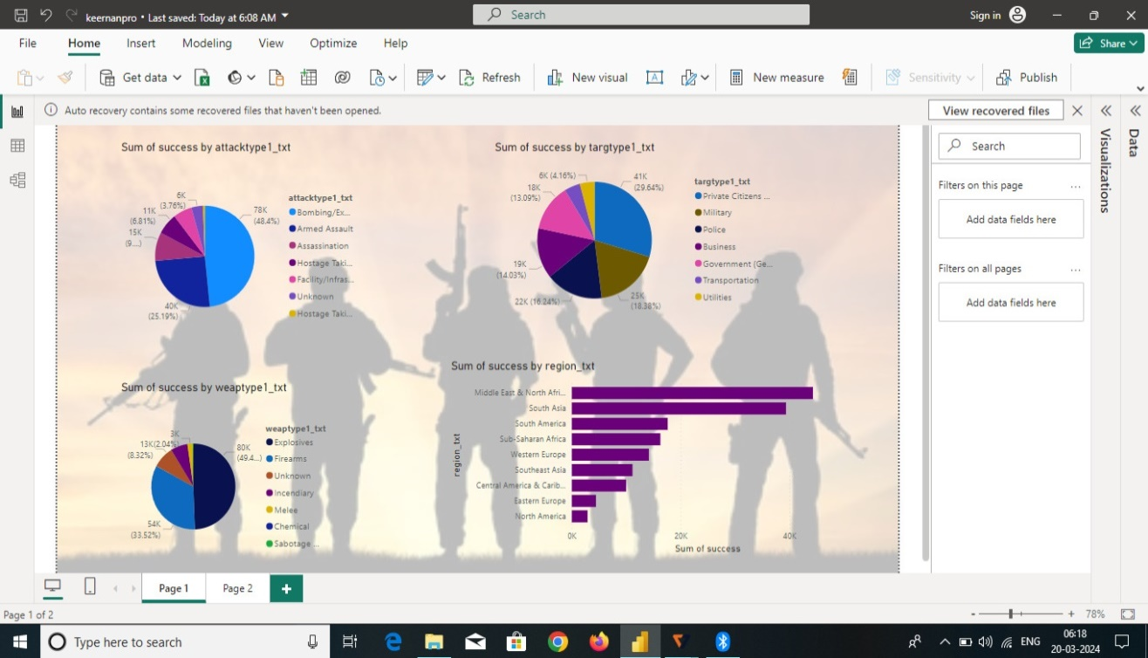

**CONCLUSION**

The project “Power BI powered global terrorism” offers significant potential for enhancing threat detection, risk assessment and policy making. By leveraging dynamic dashboards, predictive analytics, and machine learning algorithm, Power BI enables the visualization of trends and patterns in terrorism activities worldwide. This empowers stakeholders to make informed decisions and take proactive measures to address evolving threats effectively. As terrorism continues to pose challenges, Power BI stands as a valuable tool for mitigating Risks and ensuring global security

.

**FUTURE SCOPE**

The future scopeof using Power BI in analyzing global terrorism is promising can helpingcreating dynamic and interactive dashboards to visualize trends patterns of hotspots of terrorism activities worldwide. Integration with various data sources such as government reports, news articles, and social media can enhance predictive analytics and early warning systems. Moreover, incorporating machine learning can further improve the accuracy of the threat detection and risk assessment. As terrorism evolves, Power BI can adapt to provide timely insights for policymakers, security agencies, and researches to effectively combat terrorism.

**REFERENCES**

**<https://www.youtube.com/live/kbe61N-qQ-s?si=DCKu9jB87EMY2edP>**

**Link**

**<https://github.com/MuthuMaheswari2004/casstudynmpro.git>**

.